3. Retrieving Data

32. Oracle Data Types

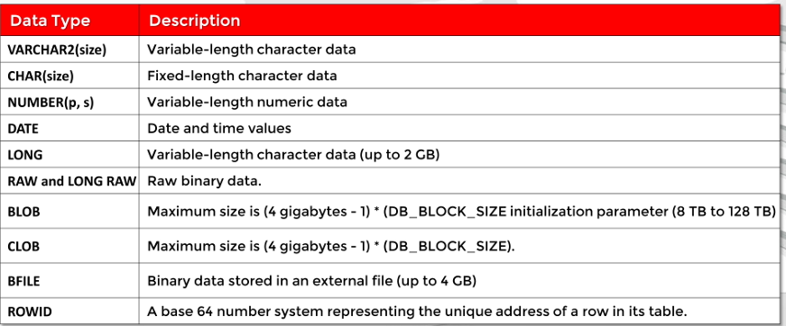

-NUMBER: 1<=p<=38

-BLOP used to store and manipulate large blocks of unstructured data: images, videos, sound and any other multimedia files. Oracle prefers using BLOB or CBLOB instead of LONG as it’s more flexible than LONG.

-CLOB: store large blocks of character data in database. It’s the same as LONG, but it has a higher capacity, faster.

-BFILE (External Large Objects): store binary data in an external file. BFILE column stores a pointer to actual file in OS. The size is limited by OS.

-ROWID: base-64 number and represents the physical unique address of a row in table. A record in a table is a row and each row must have a unique ID in system and this ID is ROWID. ROWID stored in hexadecimal format

33. Null Value

-NULL means unknown or nonexistent

-NULL values don’t take up any space in the disc.

34. DESCRIBE Command

-Provides a description of specified table.

-Returns column names, nullable or not, and data types.



-Can used DESC or DESCRIBE

-SHIFT+F4: See more describe

35, 36. INFORMATION Command

37, 38. SQL Statement Basics

39,40. Oracle Error Messages

41, 42. Using SELECT Statements

43, 44. Using Column Aliases

45,46. Quote (Q) Operator

47, 48. DISTINCT and UNIQUE Operator

50, 51. Concatenation Operators

52, 53. Arithmetic Expressions and NULL Values