Section 1: Database Concepts

2. Why ORACLE DATABASE

-Security: very secure database, it has both own security things and its design also enables to create really secure codes.

-Performance: optimizer, tuning options and hardwares to work fast with database

-Scalability: scale your data without any problems

-Powerful Coding: Oracle SQL and PL/SQL

-My Oracle Support:

-Are there any cons for this database

+You must know how to deal with that database

+It’s not free

+More than 95% of Fortune Companies using Oracle Database. We will base that course entirely on Oracle SQL, you can use that knowledge easily on other platforms. db-engines.com

3. Table

-Data is stored in tables with logical groups  
-Data is stored in cells in tables, each cell has only one data in it.

-The union of all horizontal cells is record (row): include all information of a specific element

-Vertical cells are columns.

-A record can have any different types of data, but a column can have only one specific type of data.

-All collections of values are table. A table stores data in tabular form.

-A database has many different types of objects, but the main object of databases are tables.

4. Use UDEMY and Tips

5. Working Document

6.Special Gifts

-SQL Cheatsheet

-SQL Certification Exam Samples

7. Relational Database Management System (RDBMS)

-Relational Databases: we store only the id of our table, and get related data from 2nd table using ID. We divide data in different tables, and establish some relations between these tables by parent-child relations.

-If we don’t do that: big table, retrieve data hard, repetitive data.

-Advantages of relational database

+Accurate: data is stored just once, it eliminates the data deduplication

+Flexible: get data easily, run complex queries

+Collaborative: Multiple users can access same database

+Trusted: Relational database models are being used for so long time, they are mature and well understood

+Secure: Data in tables can be limited to allow access by only particular uses.

8. Entity Relationship Login in Databases

-Entity: The smallest unit containing a meaningful set of data. Basically, think entities as tables, the data in tables as attributes

-Relationship: logical relationship between these entities

+A connection between 2 tables

+Some columns have some keys or ids to establish a connection with some other tables.

9. Pluggable Database

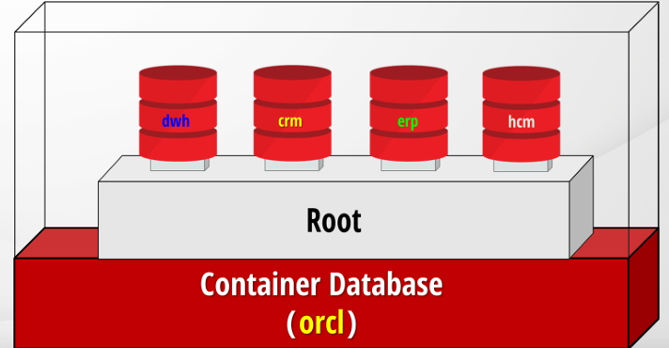

-Starting from Oracle database version 12c, Oracle has introduced Pluggable Database feature

+There is one big database: container database. You can think that the root database

+Inside container database, there are pluggable databases. There must be at least one pluggable database inside container database

+Each pluggable database has full attributes of a regular databases: users, objects, tables, applications.

+Container database doesn’t have any objects. It stores only metadata such as configuration files.

-Why use this database architecture

+In previously released databases, each database should be installed on a separate server.

+In companies, there are very small databases used for only some specific jobs

+So there is no reason to dedicate another server for such a small database. And each server is a lot of work for DBAs

->There can be many pluggable databases for specific tasks in one big container database.

10. Introduction to Database Objects

-Oracle Databases has many database objects categorized under 2 subjects: Schema and Nonschema objects

+Schema Objects: a schema is a collection of logical structures of data or objects. There are many schema objects (the logical structures created by users)

Table: the base unit of database to store data, formatted with columns and rows.

View: a virtual table that provides access to a subset of columns or some restricted rows from one or more tables. They’re just SQL scripts with a name like table. When you query from a view, it executes that query and retrieves data returning from that query. Views act like a real table, but don’t physically use any space for returning data

+Constraint: the rules for restricting invalid data entry into tables.