Part 1: React Fundamental

Section 5. Working with components, props and JSX

-Render the root component and Strict mode:

-Debug:

+Show errors on bag.

+Stack Overflow

+Output/ check Prettier/ESLint

-Create and reuse component

-Styling React App:

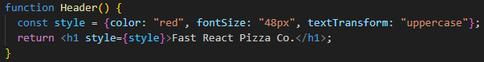

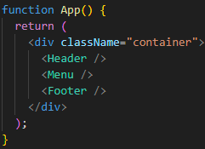

-Pass and receive props

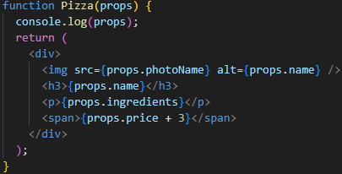

-Render List

-Conditional Rendering with &&

-Conditional Rendering with Ternaries

-Conditional Rendering with multiple returns

-Extract JSX into a new component

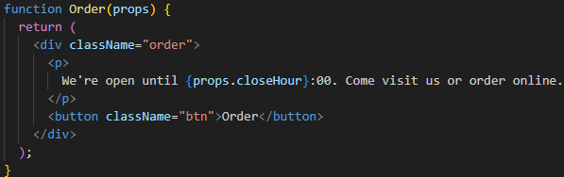

-Destruct prop

-React Fragment

<><> or <React.Fragment></React.Fragment>

-Set classes and text conditionaly

-useState(): create state variable

-Build a Form and handle submissions

-Thinking about state and Lifting state up

-Delete Item: Lift up state

