Master MUI
1. Introduction
1.1 MUI Ecosystem
-Base UI:
+Unstyled
+Foundational components
+Easy to extend and customize
+Use with MUI System to build your own custom component library.
-Material UI
+Many components.
+Implements Material Design spec.
-Joy UI
+Will eventually have all components.
+Implements custom design system.
-MUI X
+More complex, powerful components.
+Build with Material UI components.
+Highly optimized for performance.
+Suited for data-intensive apps.
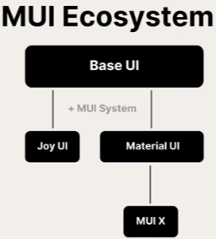
-Material UI Functionality
+Component Library.
+Layout System.
+Styling System.
+Theming System.
+Responsive Design System.
2. Material UI Core Concepts
2.1 MUI Component Basics
-Import the component
-Render the component with props
-Customize styles
-Common props:
+component: use HTML element component.
+onClick
+disableElevation (true/false)
+variant: contained/outlined/text/string
+sx: add off styles.
-Box: Like div
2.2 Material UI Styling – The Theme
-Theme: centralized location for storing all of mostly commonly styles: colors, fonts, styling helper function.
-Default theme viewer: https://mui.com/material-ui/customization/default-theme
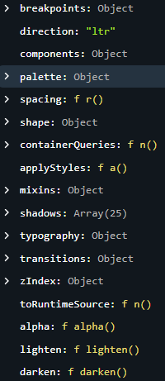
+breakpoints: contains values that relate to responsive design.

