1. Getting Started

-Welcome to Androidville

+**Android** is an **open source platform** based on **Linux** and **championed** by **Google**. It’s development **framework** using a mix of **Java** and **XML**. It enables to **deploy apps** to devices: phone, tablet…

+Android app is composed of **screens**. You **define** what each **screen looks like** by a **layout**. It’s defined in **XML** and **include GUI**: buttons, text fields, labels.

+**Activities**: **define** **what** **app does**. It’s special **Java class** that decides which layout to use and tell app how to respond to user.

+**Extra resources**: such as image files, app data

-The Android platform dissected

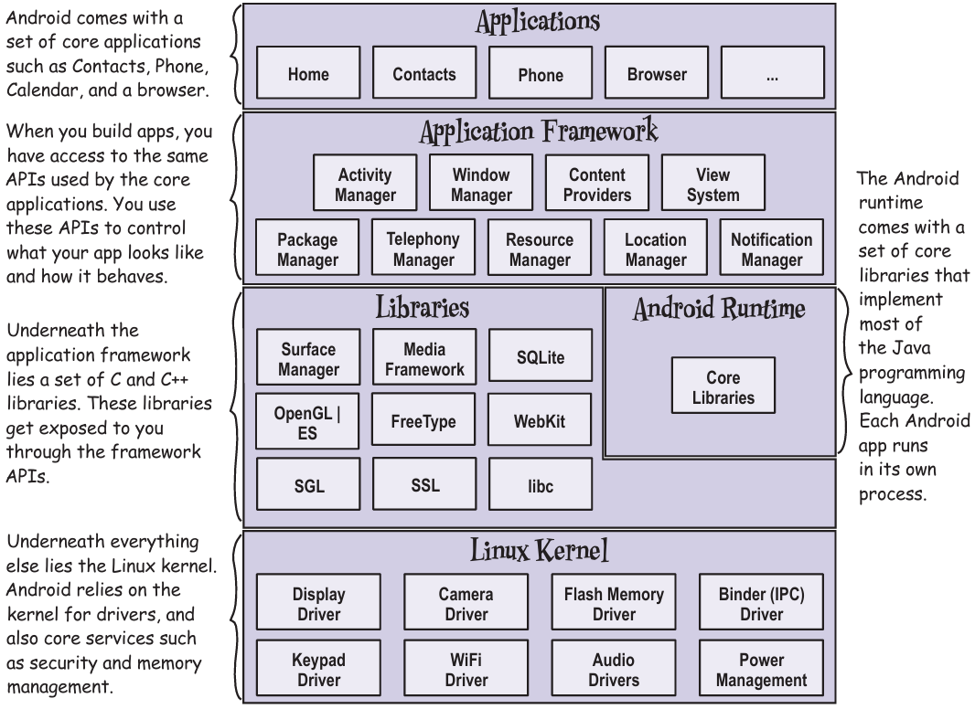

+All of **Android libraries** are **exposed** through **APIs** in **app framework**, these APIs used to **create apps**.

-Here’s what we’re going to do

+Set up a development environment->Build a basic app->Run the app in Android emulator->Change the app

-Your development environment

+Android devices don’t run .class +.jar ->Need a tool to write and compile Java code + other tools to convert compiled code into form that Android devices can run **Android SDK**

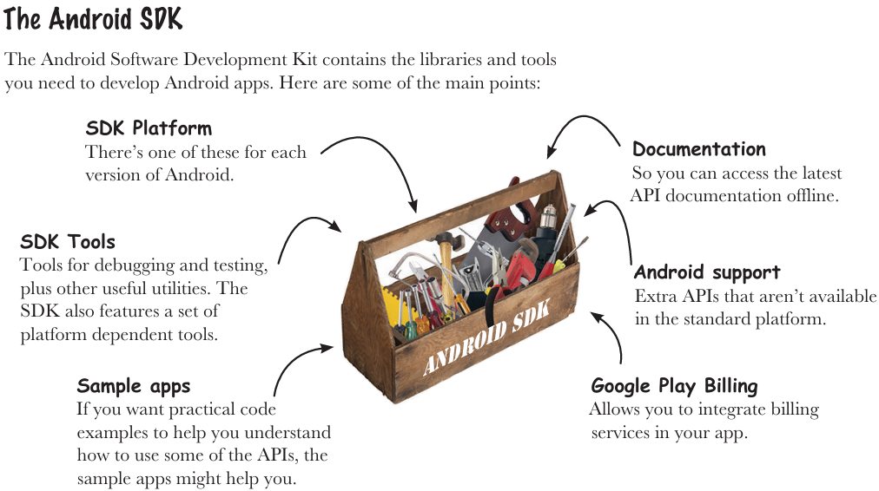

+Android Studio is a special version of IntelliJ IDEA that includes a version of Android SDK and extra GUI tools.

-Install Android Studio

<http://developer.android.com/sdk/index.html#Requirements>

https://developer.android.com/sdk/installing/index.html?pkg=studio

-Build a basic app

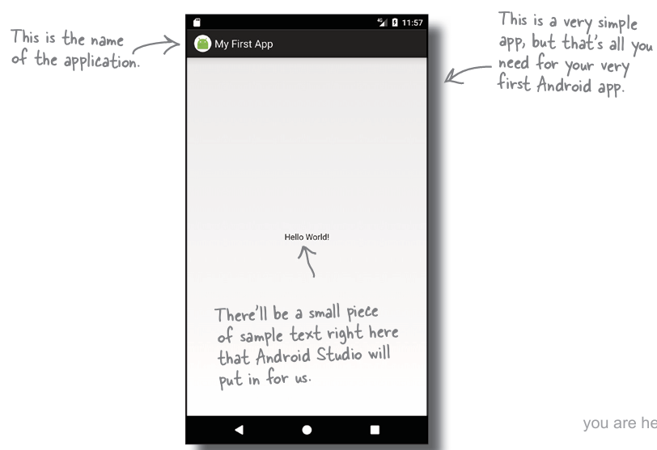

-How to build the app

+Create a new project: Start a new Android Studio project

+Configure the project: AS uses company domain + app name to form the name of package used for app ->uniquely identify the app.

+Specify the minimum SDK

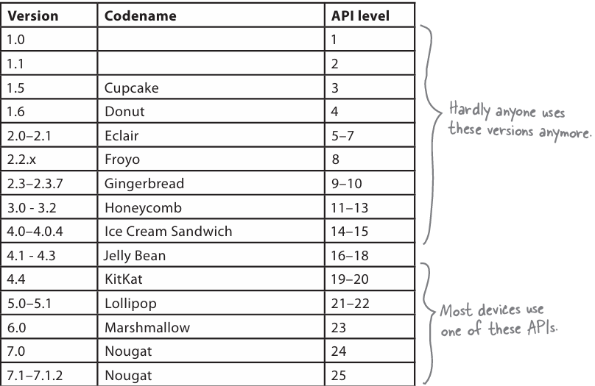

-Activities and layout from 50000 feet

+**Add** an **activity** to project. Android app is a collection of screens, each screen is composed of an activity and a layout.

+**Activity**: a single, defined thing that user can do. Activities are associated with one screen, written in Java

+**Layout**: the appearance of screen, written as XML files, tell Android how different screen elements are arranged

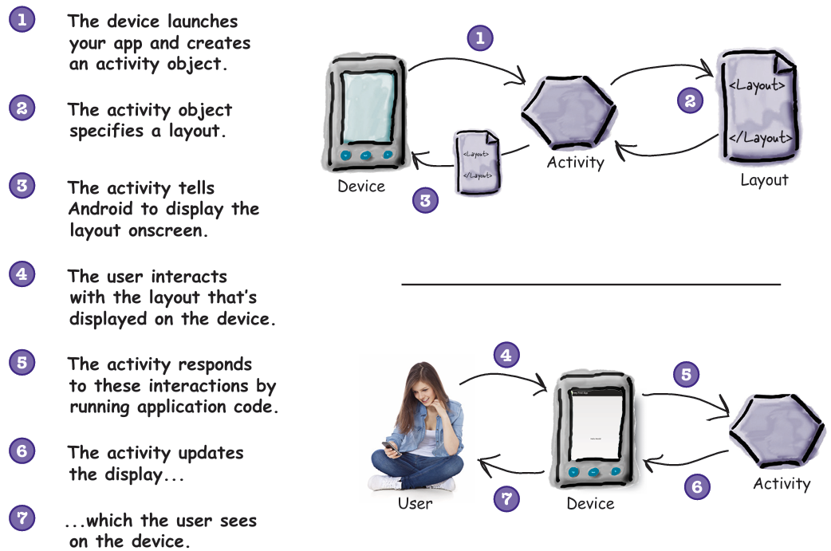

-How to build the app (continued)

+Add an activity: choose Empty Activity, uncheck Backwards Compatibility

-You’ve just created your first Android app

-Android Studio creates a complete folder structure for you

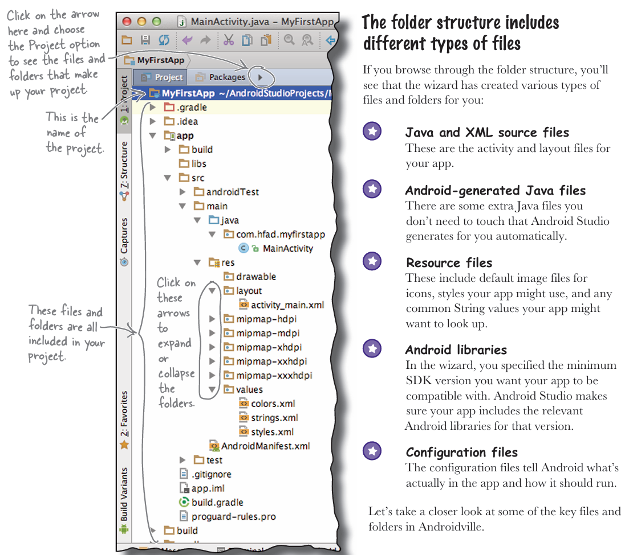

-Useful files in your project: Android Studio use Gradle build system to compile and deploy apps.

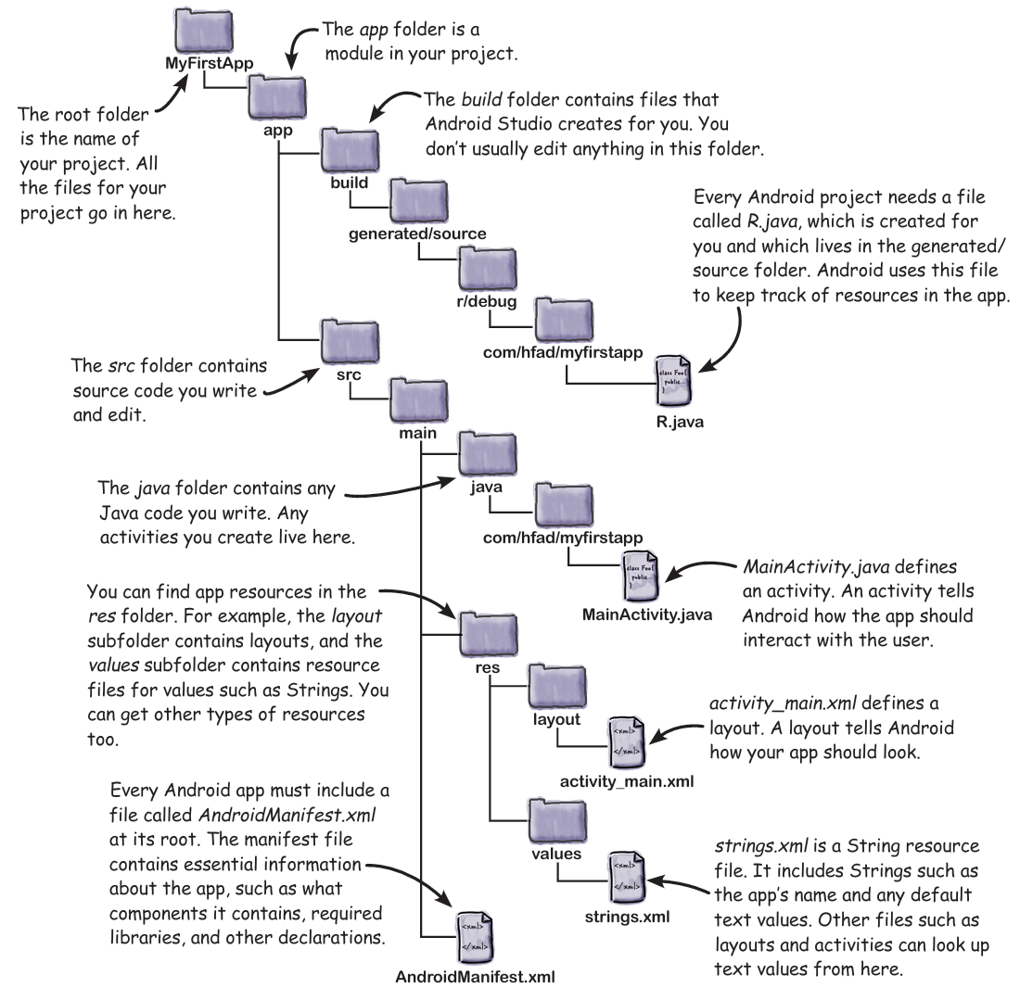

-Edit code with the Android Studio editors

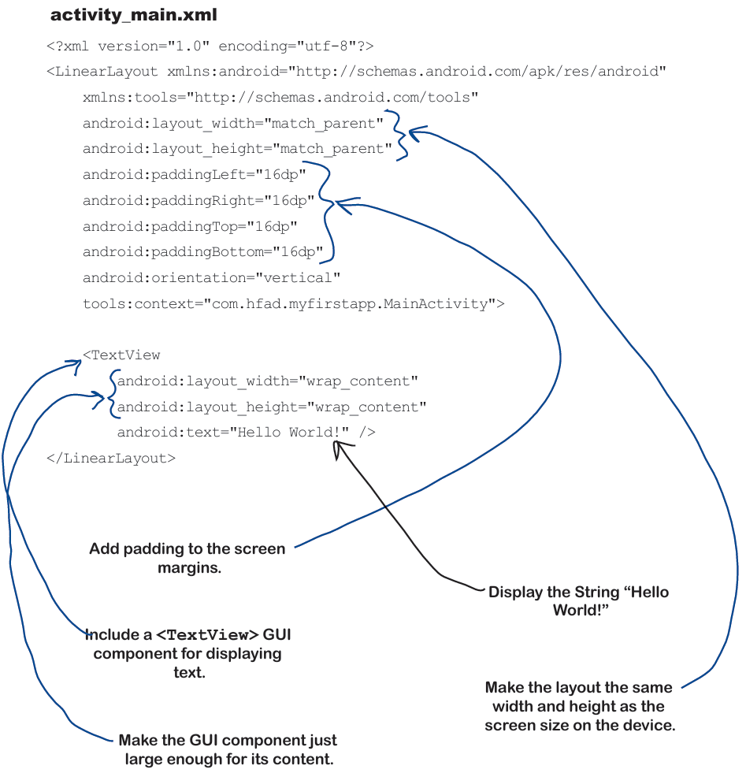

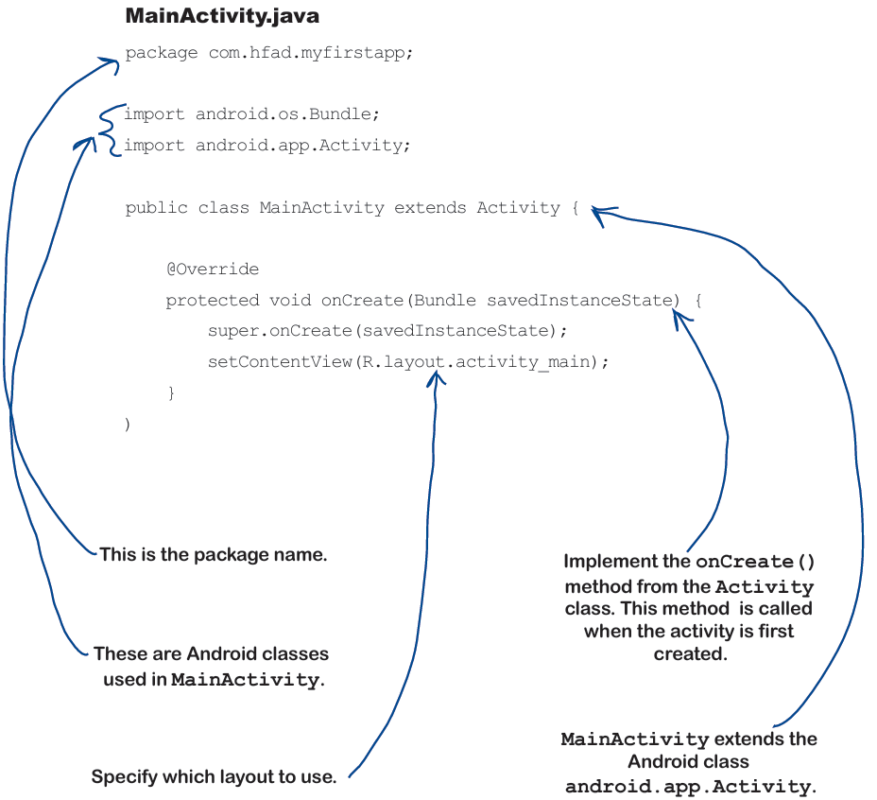

-Run the app in the Android emulator

+**Android emulator** in Android SDK enables you to **set up** more **Android virtual devices**.

-Creating an Android Virtual Device

+Open Android Virtual Device Manager:Tool->AVD Manager->Create…

+Select the hardware

+Select a system image: choose API level that’s compatible with app.

+Verify AVD configuration

-Run the app in the emulator

+Run app from Run menu ->Choose device

If have error: <https://stackoverflow.com/questions/68387270/android-studio-error-installed-build-tools-revision-31-0-0-is-corrupted>

+Compile, package, deploy, and run:

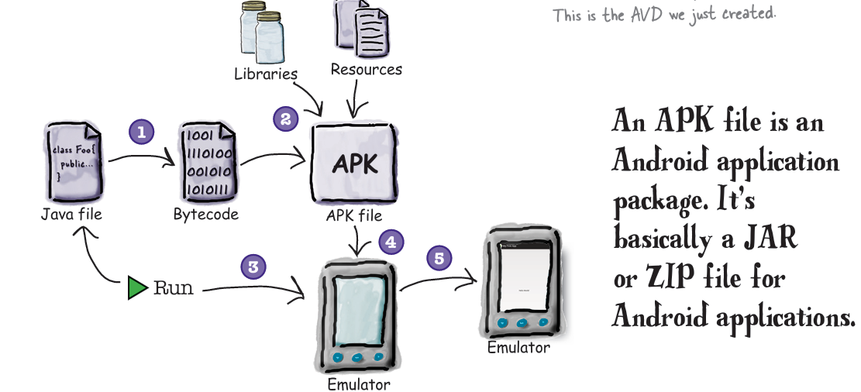

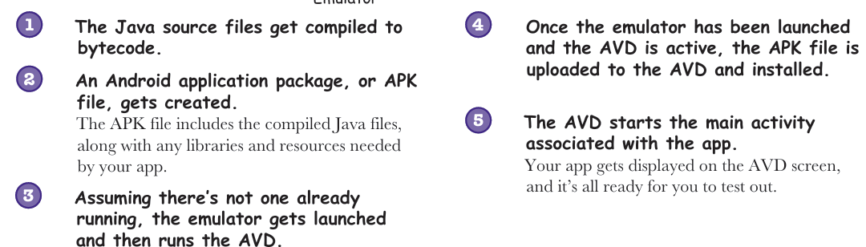

-You can watch progress in the console

+Test drive:

-What just happened?

-Refining the app

-What’s in the layout?

-activity_main.xml has two elements

-Update the text displayed in the layout

-Take the app for a test drive

-Your Android Toolbox