Fix loi NullPointerException: https://www.youtube.com/watch?v=Ecp8XUHb_CA

1. Getting Started
-Welcome to Androidville
+Android is an open source platform based on Linux and championed by Google. It’s development framework using a mix of Java and XML. It enables to deploy apps to devices: phone, tablet…
+Android app is composed of screens. You define what each screen looks like by a layout. It’s defined in XML and include GUI: buttons, text fields, labels.
+Activities: define what app does. It’s special Java class that decides which layout to use and tell app how to respond to user.
+Extra resources: such as image files, app data
-The Android platform dissected
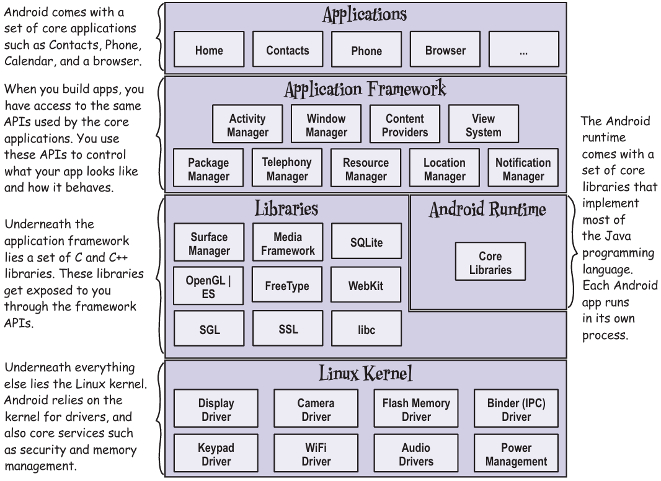
+All of Android libraries are exposed through APIs in app framework, these APIs used to create apps.
-Here’s what we’re going to do
+Set up a development environment->Build a basic app->Run the app in Android emulator->Change the app
-Your development environment
+Android devices don’t run .class +.jar ->Need a tool to write and compile Java code + other tools to convert compiled code into form that Android devices can run Android SDK
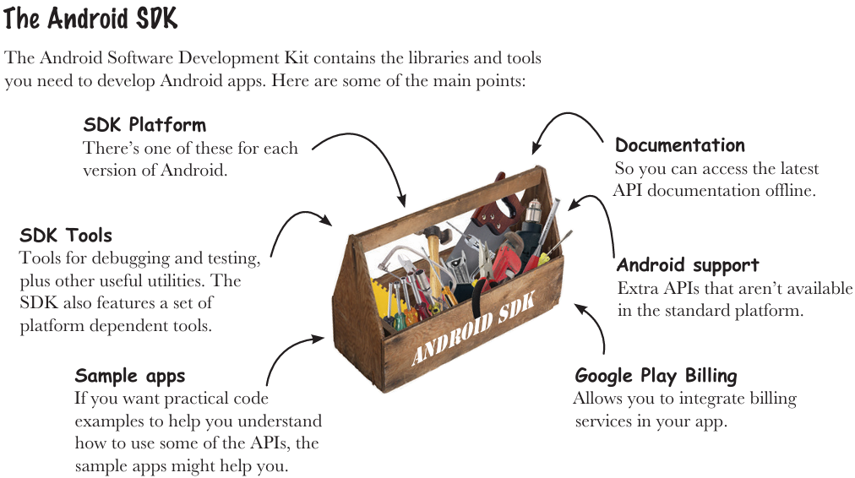
+Android Studio is a special version of IntelliJ IDEA that includes a version of Android SDK and extra GUI tools.
-Install Android Studio
http://developer.android.com/sdk/index.html#Requirements
https://developer.android.com/sdk/installing/index.html?pkg=studio
-Build a basic app
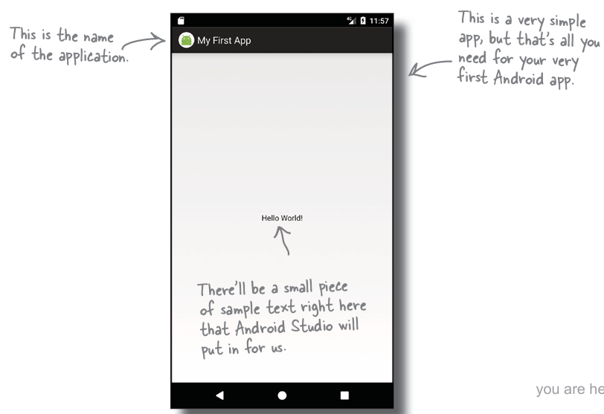
-How to build the app
+Create a new project: Start a new Android Studio project
+Configure the project: AS uses company domain + app name to form the name of package used for app ->uniquely identify the app.
+Specify the minimum SDK
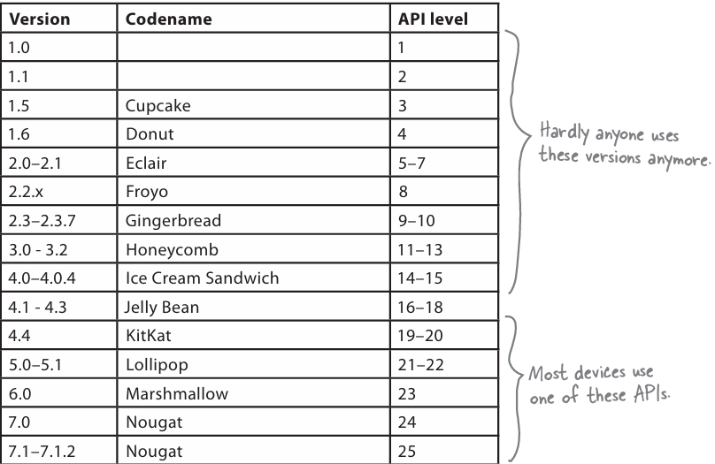
-Activities and layout from 50000 feet
+Add an activity to project. Android app is a collection of screens, each screen is composed of an activity and a layout.
+Activity: a single, defined thing that user can do. Activities are associated with one screen, written in Java
+Layout: the appearance of screen, written as XML files, tell Android how different screen elements are arranged
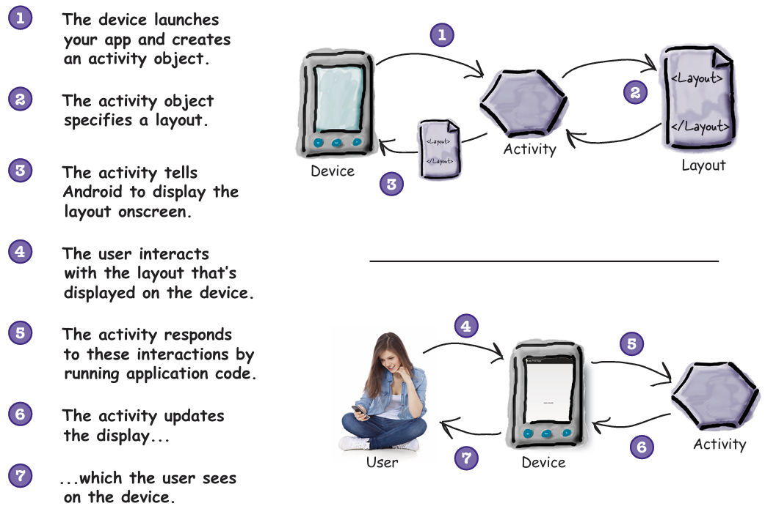
-How to build the app (continued)
+Add an activity: choose Empty Activity, uncheck Backwards Compatibility
-You’ve just created your first Android app
-Android Studio creates a complete folder structure for you
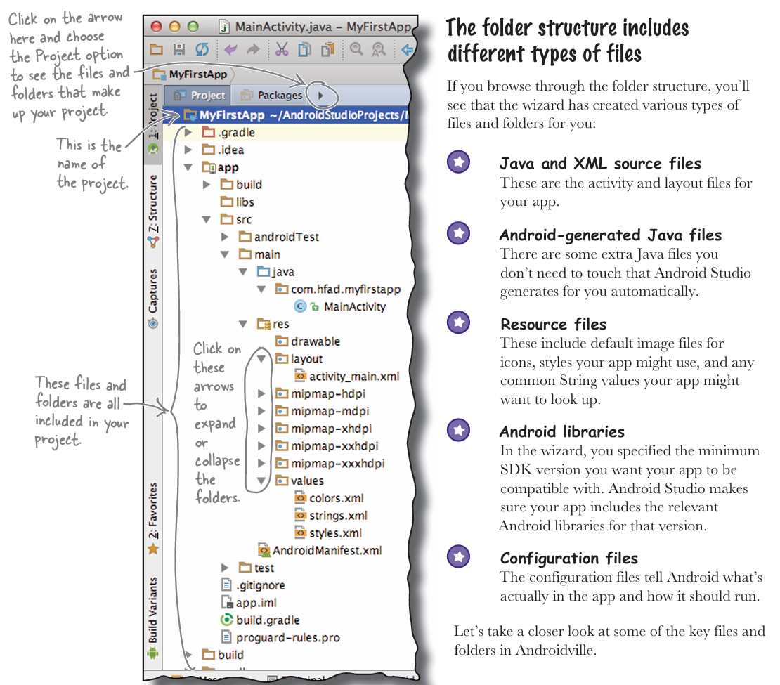
-Useful files in your project: Android Studio use Gradle build system to compile and deploy apps.
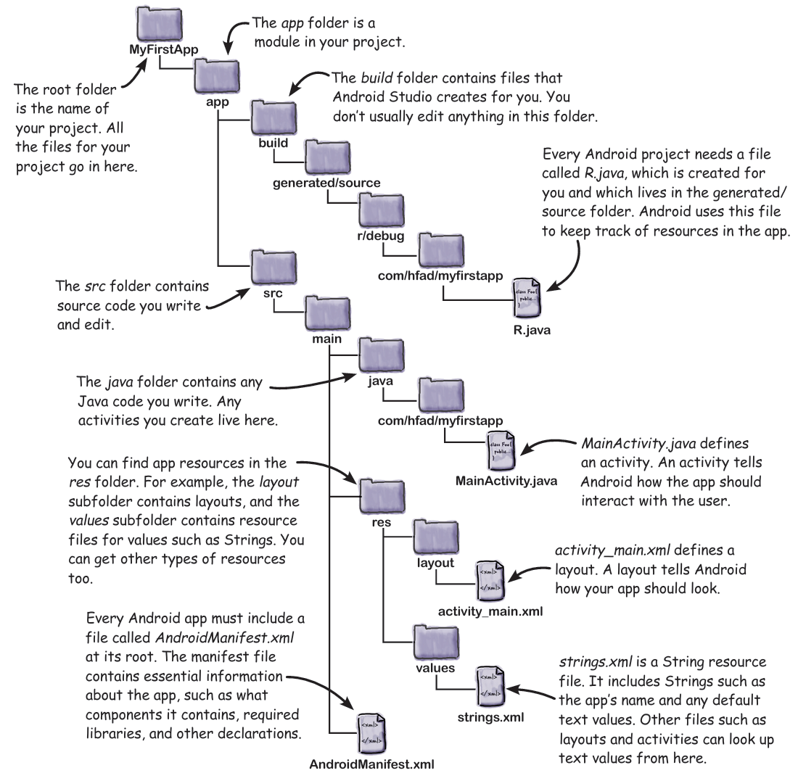
-Edit code with the Android Studio editors
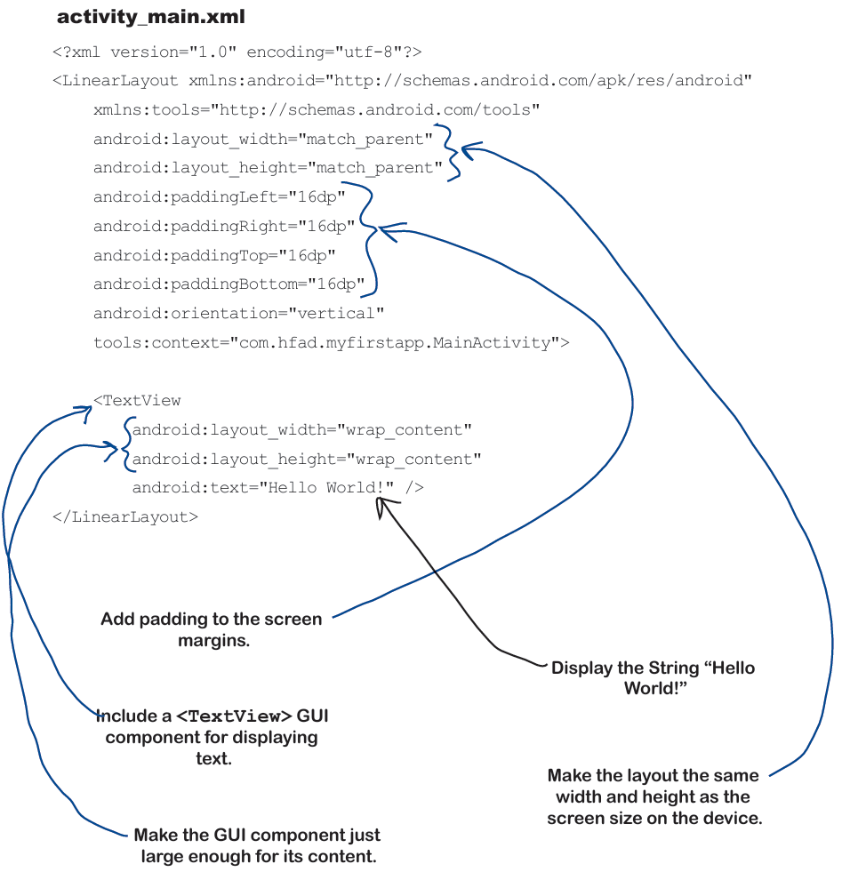
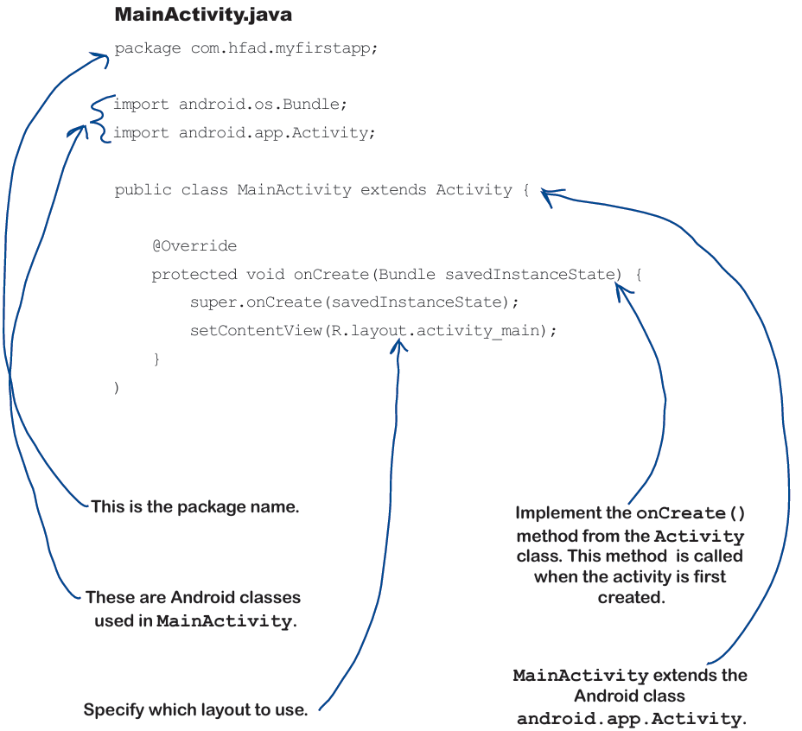
-Run the app in the Android emulator
+Android emulator in Android SDK enables you to set up more Android virtual devices.
-Creating an Android Virtual Device
+Open Android Virtual Device Manager:Tool->AVD Manager->Create…
+Select the hardware
+Select a system image: choose API level that’s compatible with app.
+Verify AVD configuration
-Run the app in the emulator
+Run app from Run menu ->Choose device
If have error: https://stackoverflow.com/questions/68387270/android-studio-error-installed-build-tools-revision-31-0-0-is-corrupted
+Compile, package, deploy, and run:
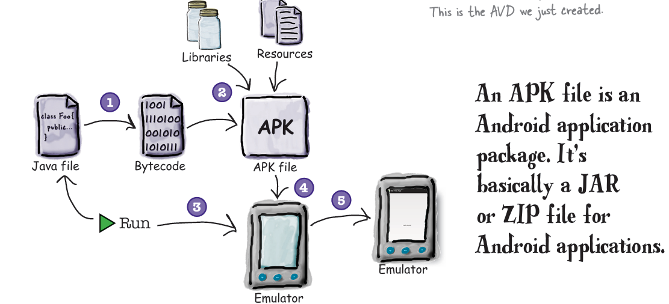
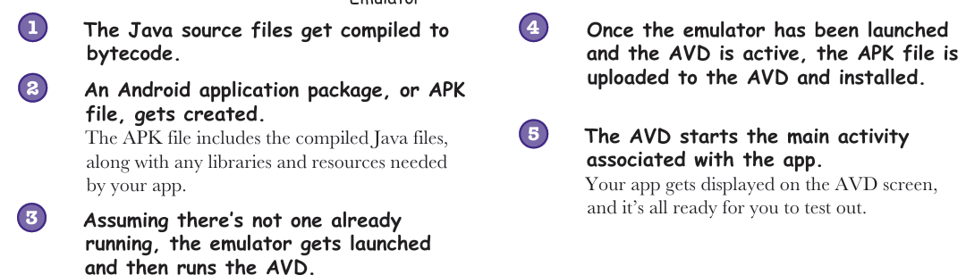
-You can watch progress in the console
+Test drive:
-What just happened?
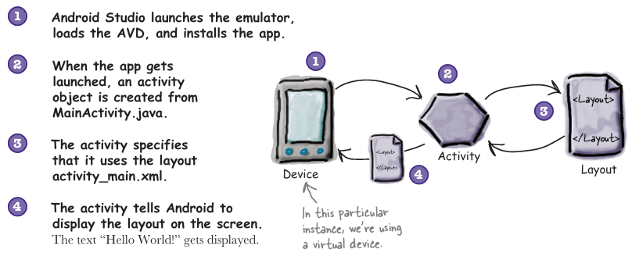
-Refining the app
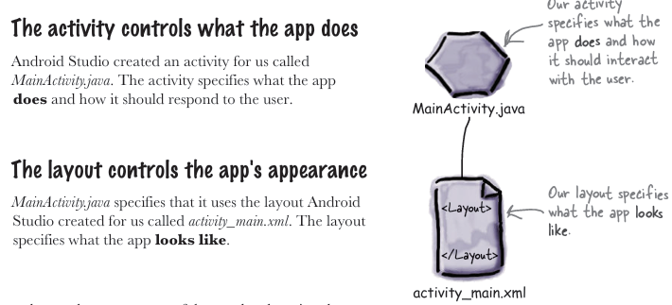
-What’s in the layout: 2 ways of viewing and editing layout files: design editor + code editor
-activity_main.xml has two elements
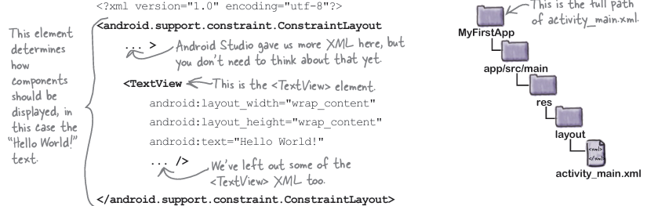
+…ConstraintLayout: type of layout element telling Android how to display components on device screen
+TextView: display text to user
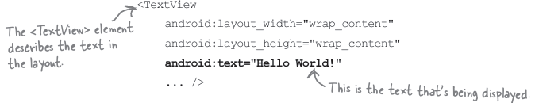
-Update the text displayed in the layout
-Take the app for a test drive
-Your Android Toolbox
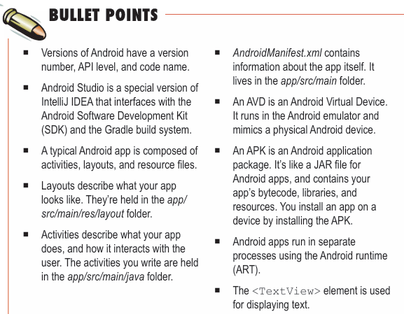

2. Building Interactive Apps
-In design editor, it features 2 different views of layout:
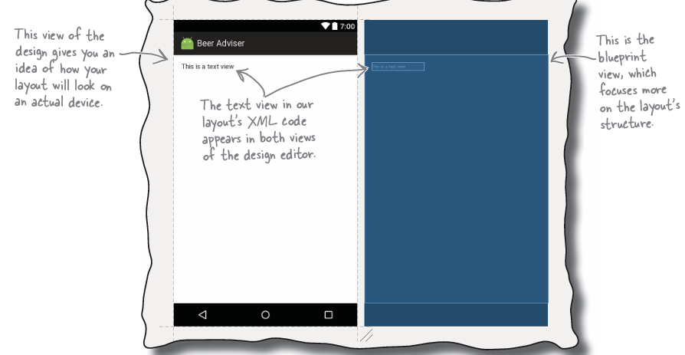
+To the left, there’s a palette:
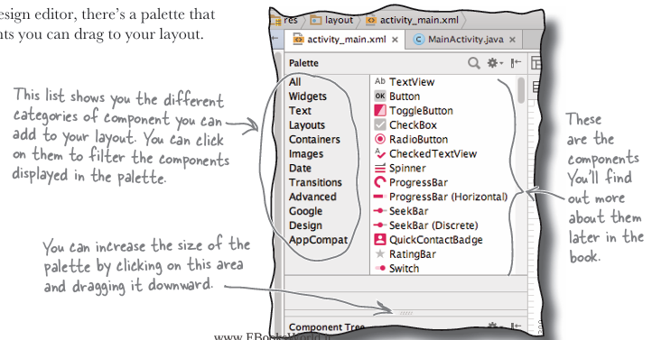
-Add a button:
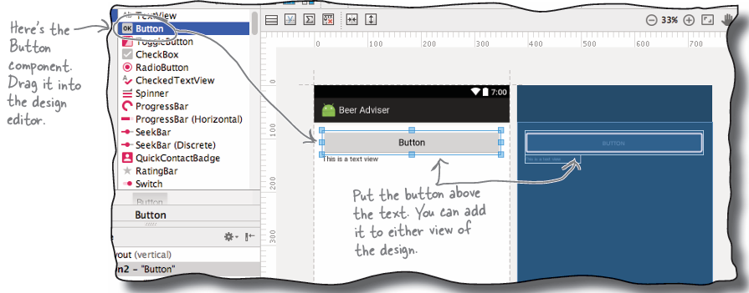
+Changes in design editor are reflected in XML:
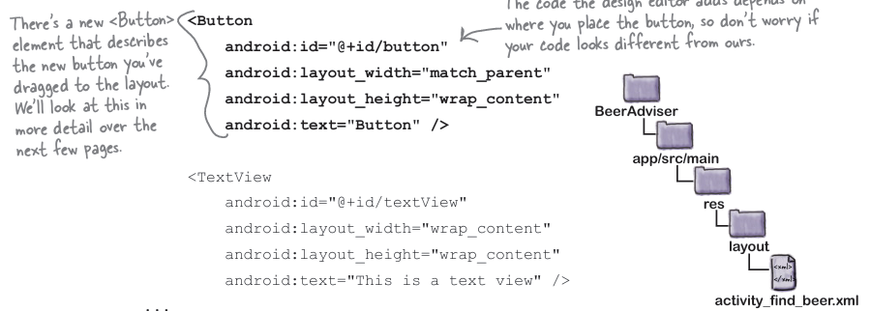
-Buttons and text views are subclasses of the same Android View class
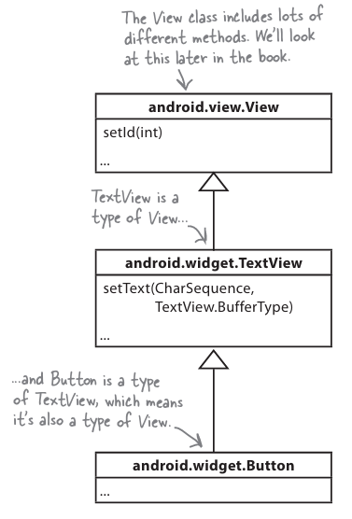
+component an identifying name
+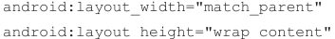: wrap content means it should be just big enough for content, match_parent means it should be as wide as layout containing it.
+: text display
-Look at layout code:
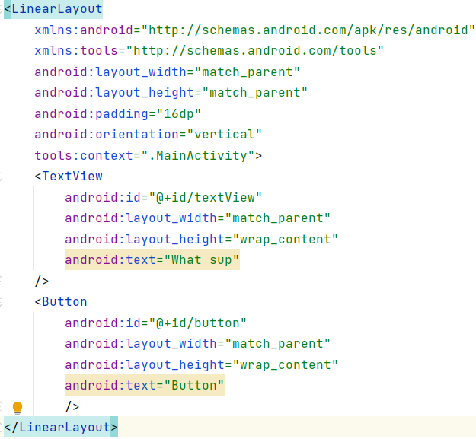
-LinearLayout element: tells Android that different GUI components in layout displayed next to each other in single row or column.
+: specify the orientation: components displayed in single vertical column
+LinearLayout contains Button + TextView
-Changes to XML:
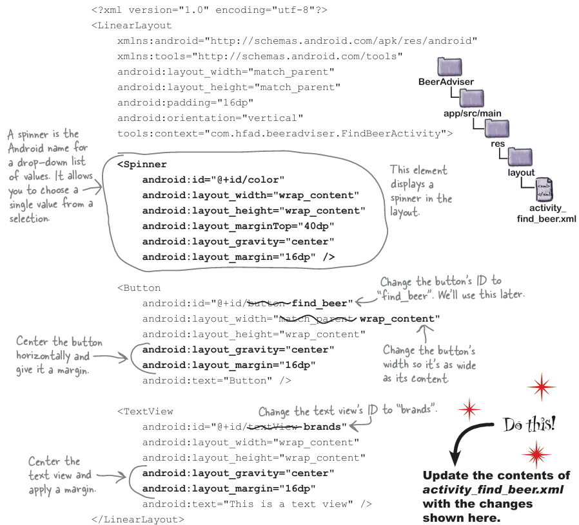
+Spinner is drop-down list.
-Hardcoding text makes localization hard
+Put the text in a String resource file: strings.xml
->internationalize the app.
+Find res/values/string.xml
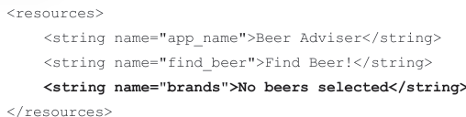
+Use String resource in layout:
: look up value of resource with name find_beer.
+Multiple resource files:res/values + res/values-fr
-Add values to spinner:
+Add array resource to strings.xml:
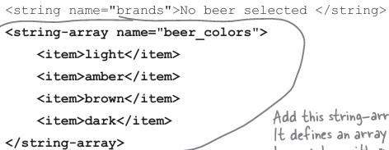
+Get the spinner to reference string-array:
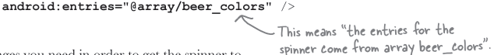

-Make the button to do sth:
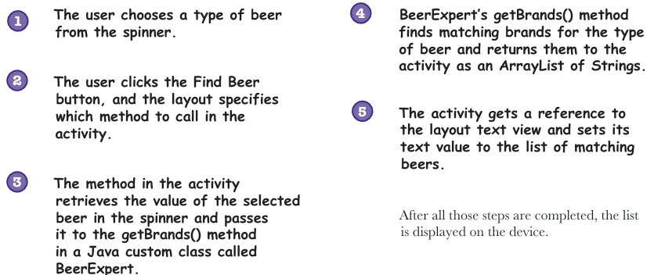
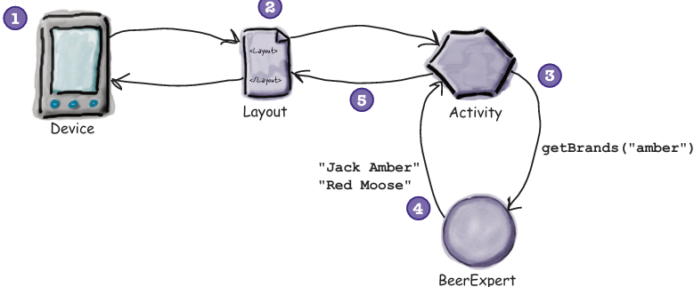
+Make the button call a method:
Use android:onClick:
+What activity code looks like:
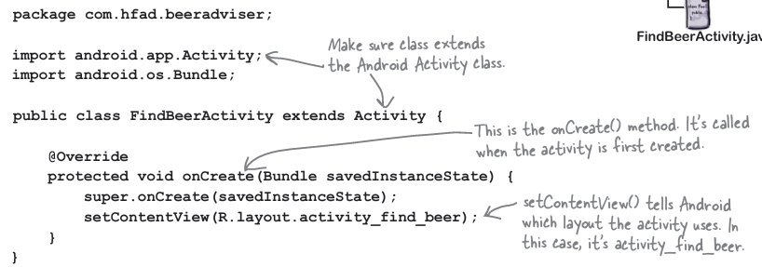
+Add onClickFindBeer() to activity:
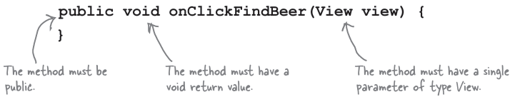
The parameter View refers to GUI component that triggers the method.
-Use findViewById(): get a reference to a view
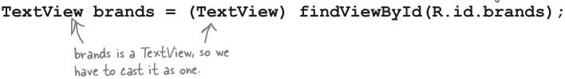
+R.java: special Java class that enables you to retrieve references to resources in app.
:
-Update the activity code:
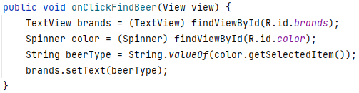
-Build the custom Java class:
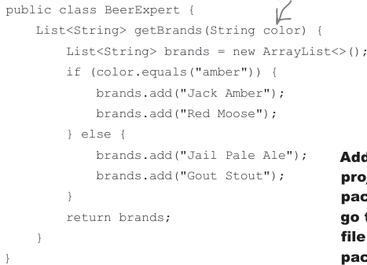
-Enhance the activity to call custom Java class:
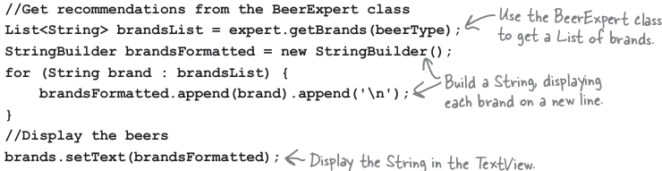
-Bullet Points:
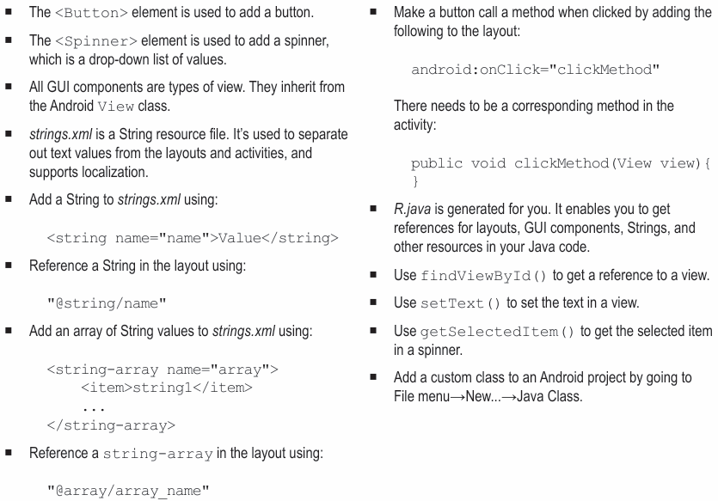

3. Multiple activities and intents
-Apps can contain more than one activity. If you chain multiple activities together to do sth -> task
-Update the layout:
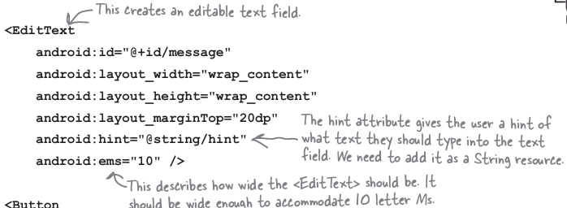
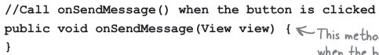
-Create the 2nd activity and layout: Choose package->add
-Android manifest file:
+Every Android app must include one AndroidManifest.xml.
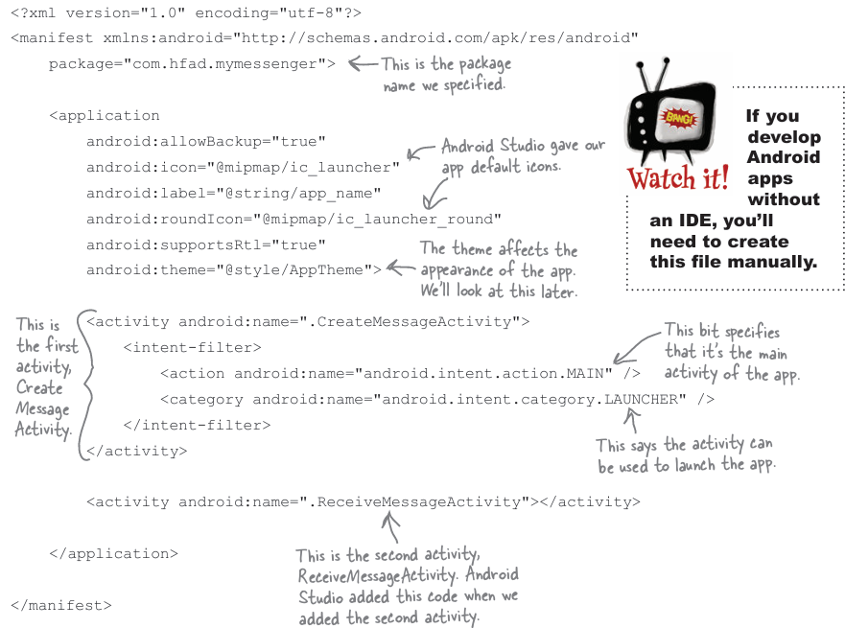
-Every activity needs to be declared in manifest
-Intent: a type of message that binds objects together at runtime.
+Create intent:
+Pass it to Android:
->ActivityNotFoundException
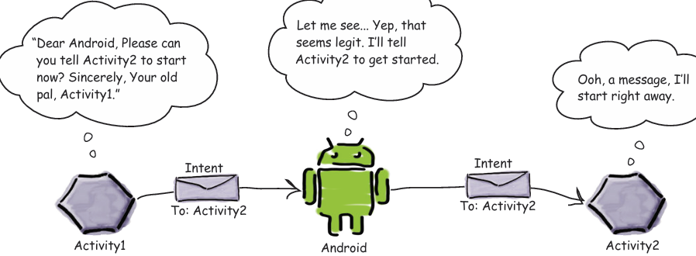
-Use intern to start 2nd activity:
-putExtra(): extra information to intent
-Retrieve extra information from an intent: getIntent(), getStringExtra(), getIntExtra()
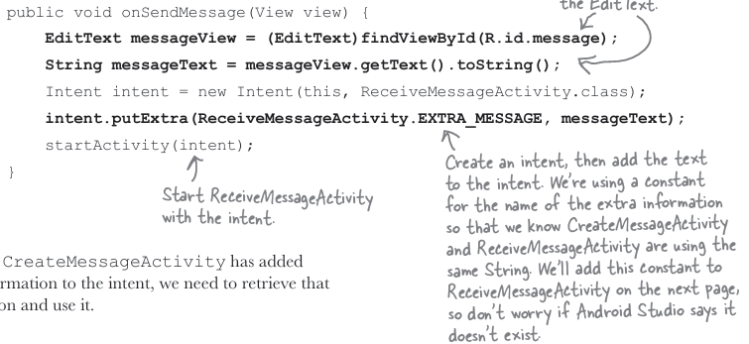
-Get ReceiveMessageActivity to use information intent:
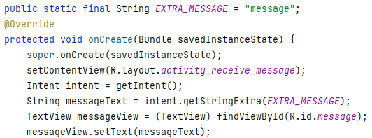
-How Android apps work
+Intents can start activities in other apps: The same principle applies to activities in other apps.
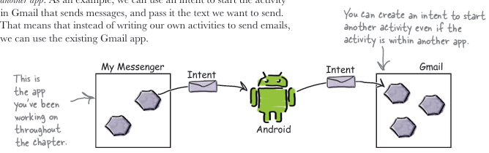
->Build apps that performs tasks by chaining together activities across device
-But we don’t know whaps apps are on user’s device:
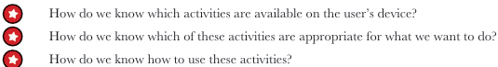
->Actions: way of telling Android what standard operations activities can perform.
-Create intent that specifies an action:
+: send a message.
https://developer.android.com/reference/android/content/Intent.html
+Add extra information:
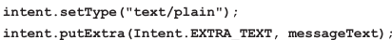
+Add additional information:
-Change the intent to use action:
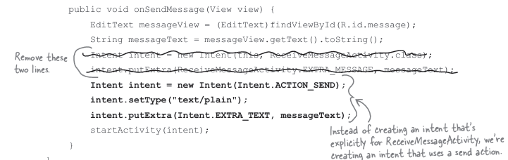
+When code run->intent created, pass it to Anroid->check all activities on device, look for ones that receive intent->If more than one activity to receive, display chooser dialog and asks user to choose->user choose
-Intent filter: specify what types of intents each component can receive.
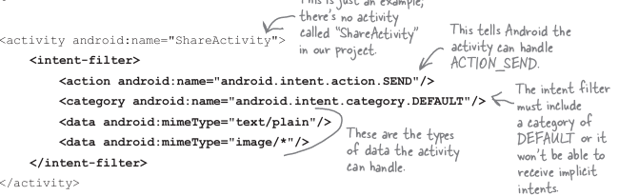
+category: must be DEFAULT to receive implicit intent
-Run app on REAL device:
+Enable USB debugging on device ->Set up system to detect your device
-createChooser(): specify a title for the chooser dialog and doesn’t give user the option of selecting activity to use by default. It also lets user know if there are no matching activities.
+Activity create:
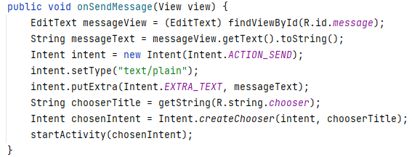
+Activity receive:
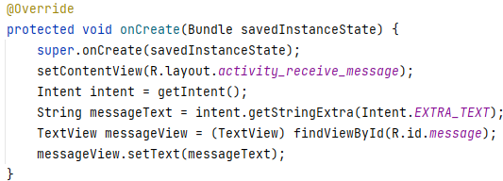
-Bullet Points:
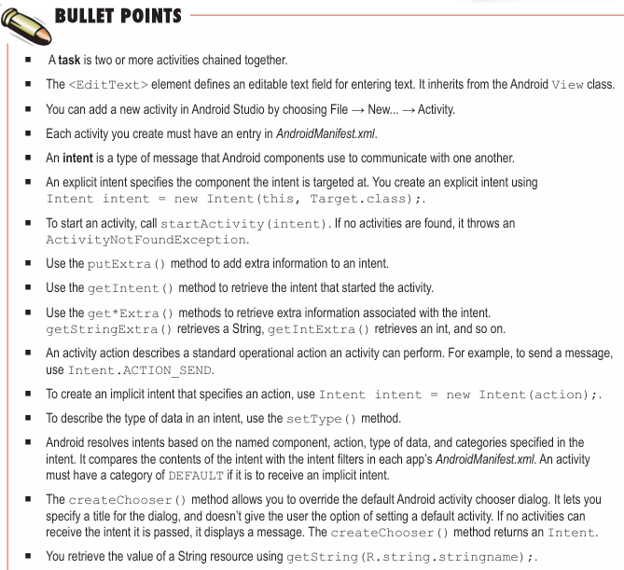

4. The Activity Lifecycle
-How do activities work:

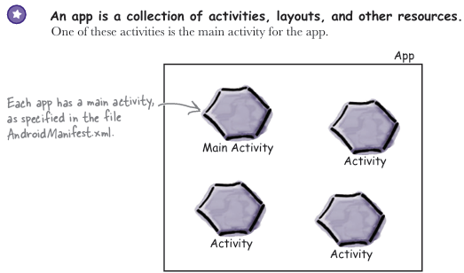
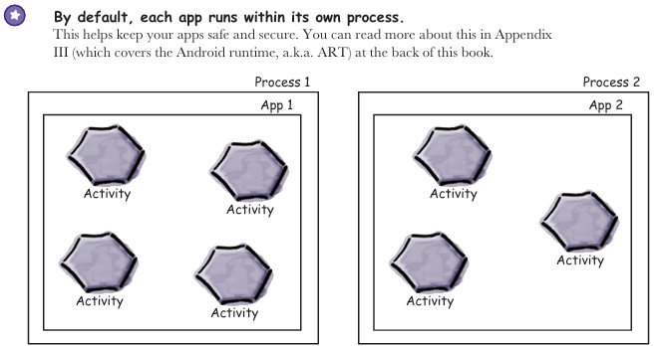

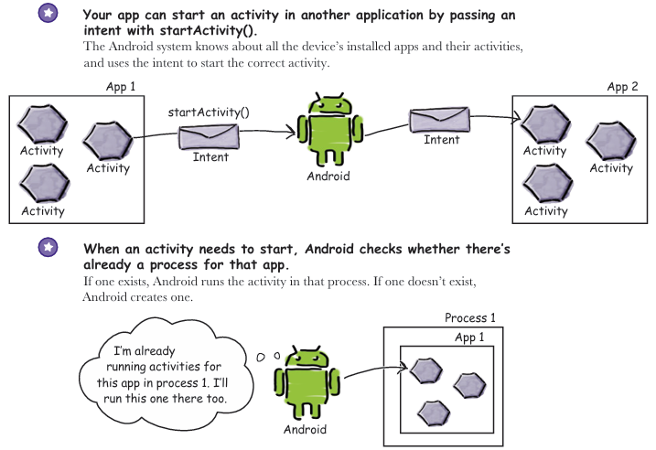
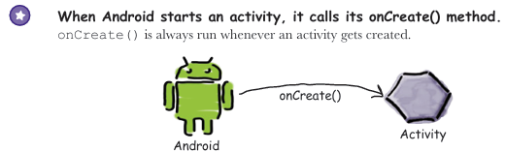
-Update stopwatch layout code:
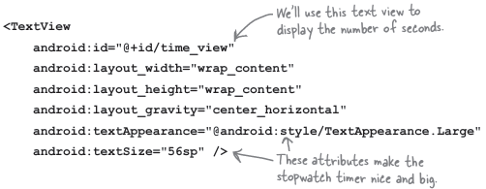
-Add code for buttons:
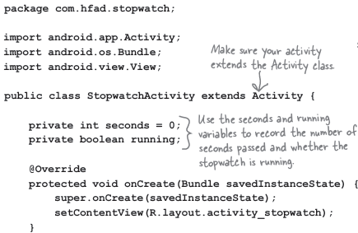
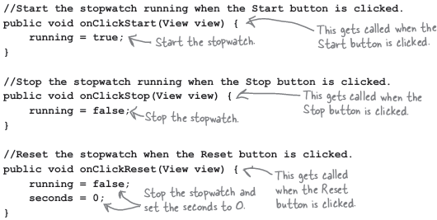
-Handlers: allow you to schedule code.
+post(Runnable): post code that needs to be run as soon as possible (almost immediately)
+postDelayed(Runnable, long)
->runTimer():
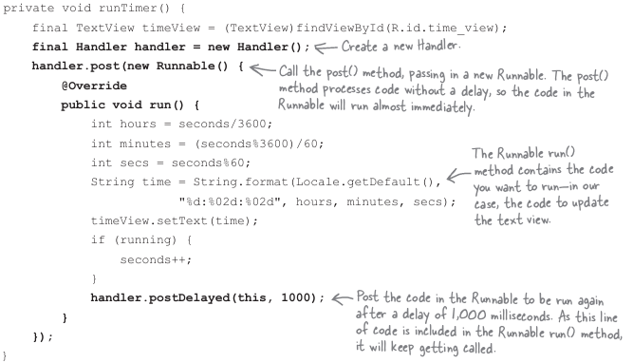
-We want runTimer() to start when StopwatchActivity gets created:
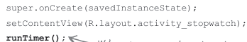
-When we rotate device->stopwatch set back to 0.
->Rotate the screen changes device configuration: include options specified by user (locale…) +physical device (orientation, screen size…). A change to any of these options ->activity destroyed + recreated
-The states of activity: 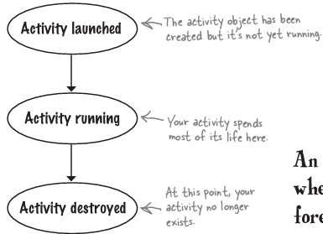
-The activity lifecycle:
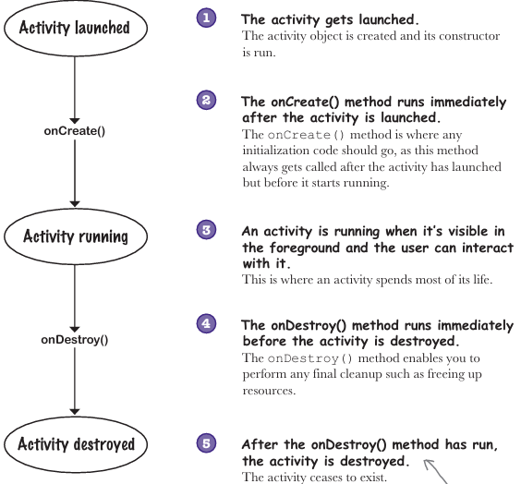
-Activity inherits the lifecycle methods:
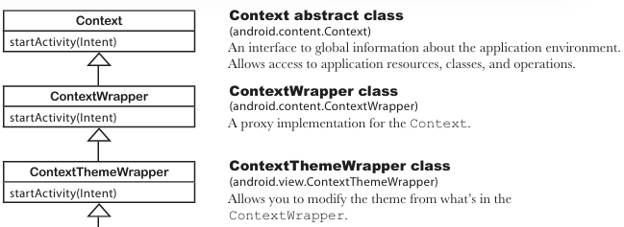
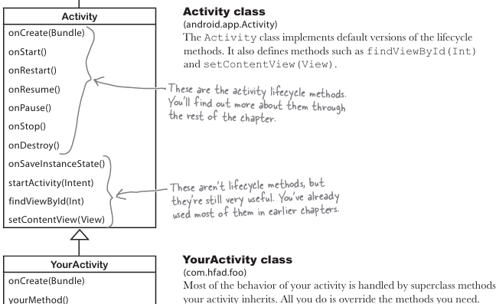
-Save current state: implement onSaveInstanceState(Bundle)
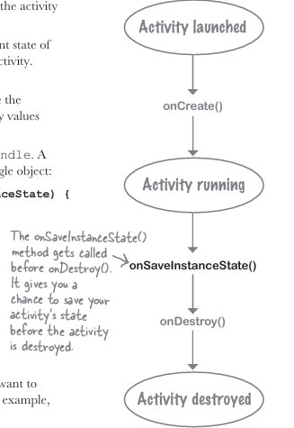
+”: Save name/value pairs of data (putInt, putBoolean…)
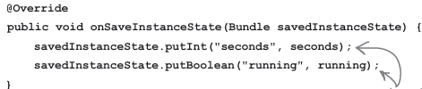
+Get data in bundle: bundle.get():
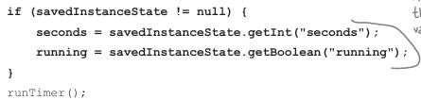
-There’s more to an activity’s life than create + destroy
+onStart(): called when activity becomes visible to user
+onStop(): called when activity has stopped being visible to user. (because hidden by another activity appeared on top of it, or it going to be destroyed)
+onRestart(): called after activity has been made invisible, before it gets made visible again
-The activity lifecycle: the visible lifetime
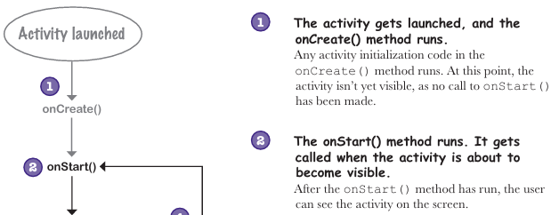
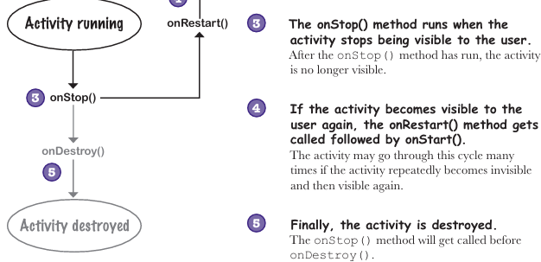
+Implement onStop() to stop timer:
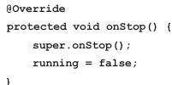
+Implement onStart():
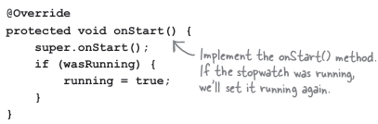
-The updated code:
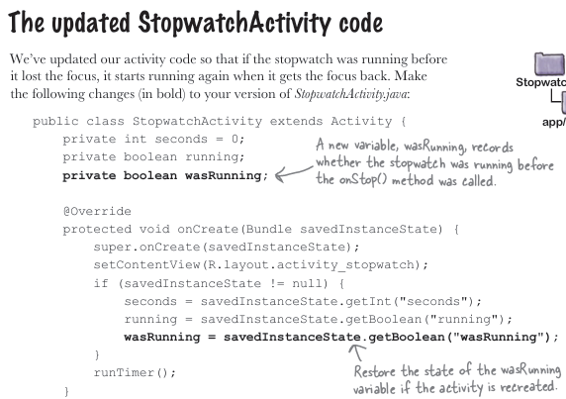
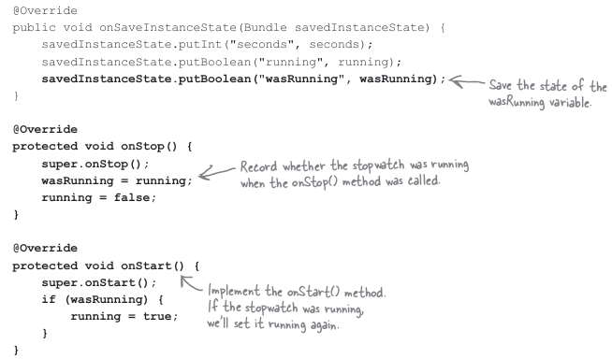
-What if an app is only partially visible:
+onPause(): activity is visible but another activity has the focus
+onResume(): called immediately before activity is about to start interacting with user
+onResume() is called irrespective of whether activity is resumed or started. ->we can remove onStart() and onStop()
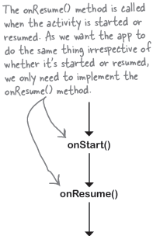
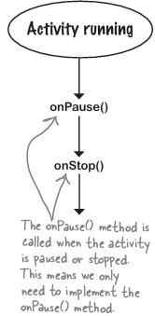
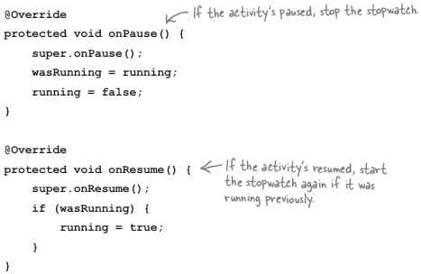
-Guide to the lifecycle methods:
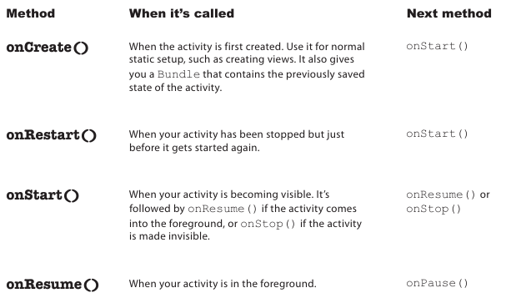
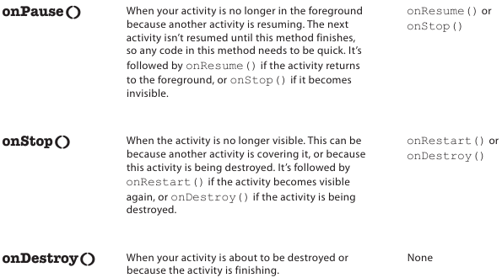
-Bullet points:
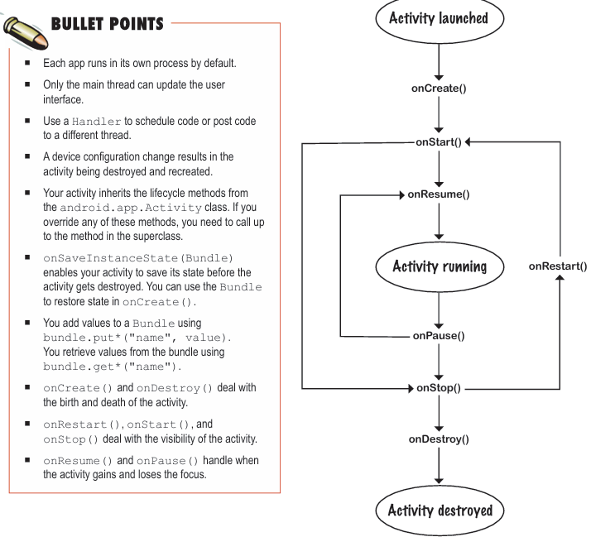

5. Views and View Groups
-User interface is made up of layouts+GUI components
-LinearLayout displays views in a single row or column
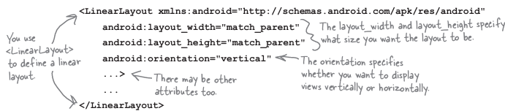
+You must set layout’s width and height: wrap_content, match_parent or specific size (8dp density-independent pixels)
+Orientation: vertical or horizontal
+SDK>=17: get views to rearrange themselves depending on language setting.
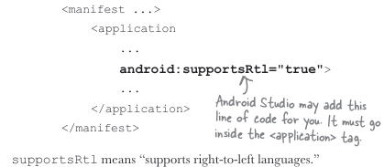
+Padding adds spaces:
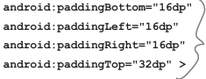
For support right-to-left languages:
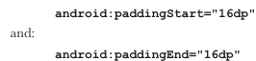
-Add a dimension resource file:
+In res/values, new->Values resource file
+Horizontal and vertical margins:
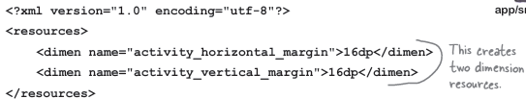
Then set the padding in layout file:
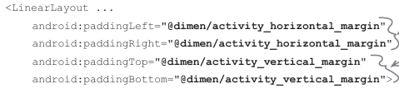
-Use margins to add distances between views:
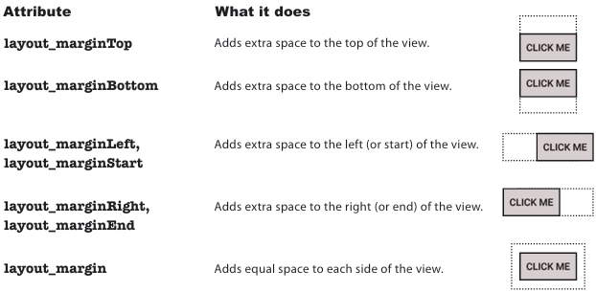
-Weight: Make a view stretch
+Add weight to one view:
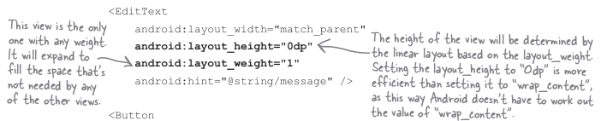
+Add weight to multiple views:
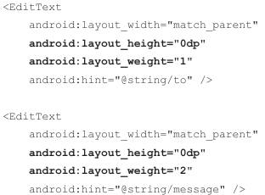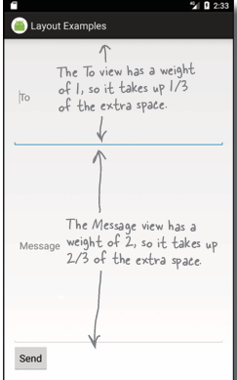
-Gravity: position the contents of a view inside the view
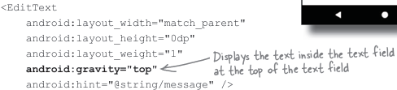
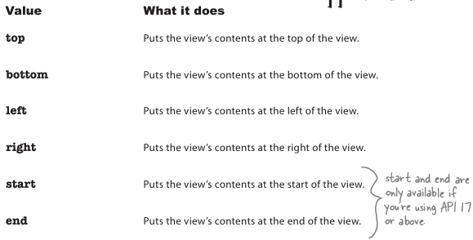
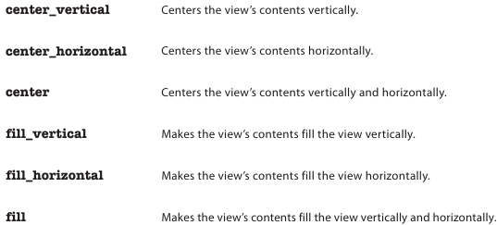
-layout_gravity: control postions of view within a layout
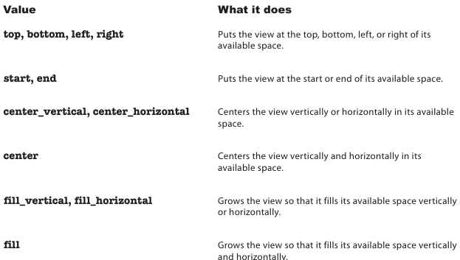
-Frame layouts: stack views on top of each other
+Define:
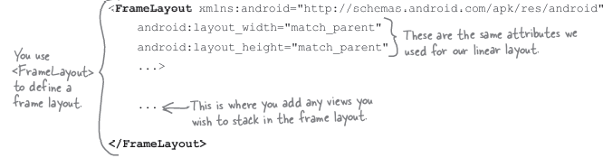
+Add image: in res/drawable
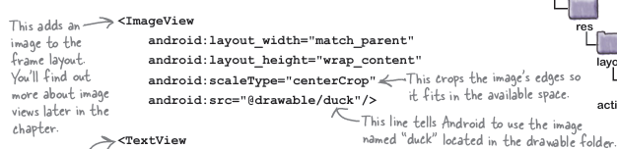
+A frame layout stacks views in the order they appear in the layout XML
-You can nest layouts
+Disadvantages: overlap views
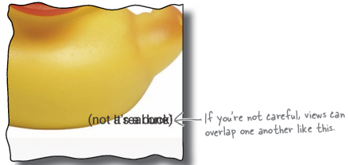
->Add a linear layout which you then nest inside frame layout.

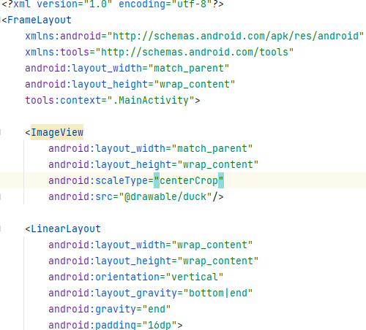
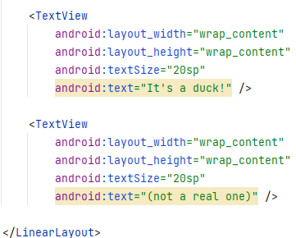
-GUI components are a type of View
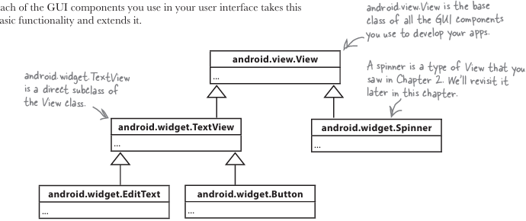
-Layouts are a type of View called ViewGroup:

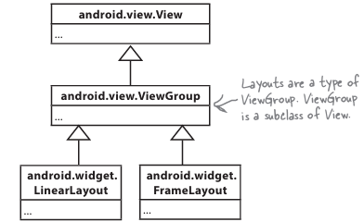
+Layout is a hierarchy of Views:
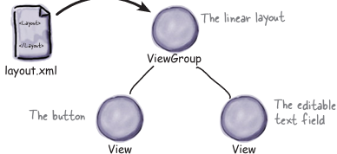
-Text view:
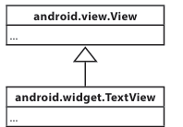
+Define:
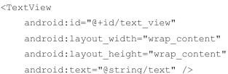
+Use:
-Editable text view:
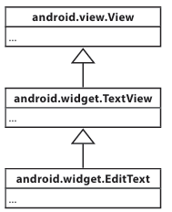
+Define:
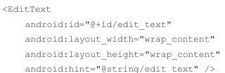
Define type of data:

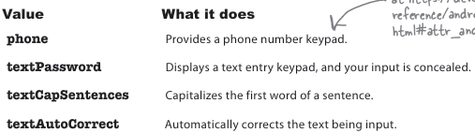
+Use:
-Button:
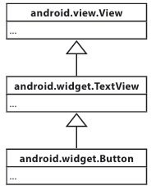
+Define:
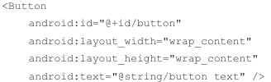
+Use:
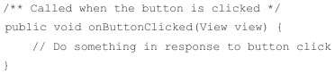
-Toggle button:
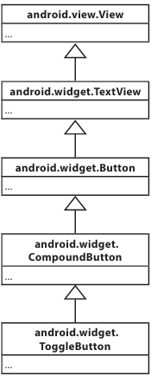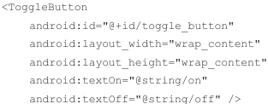
+Use:
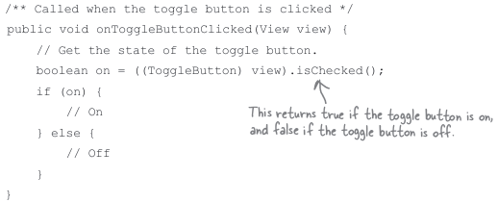
-Switch
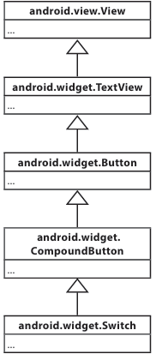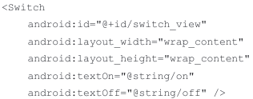
+Use: 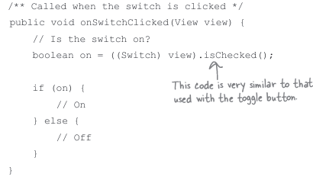
-Checkboxes
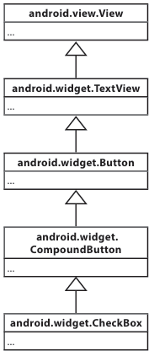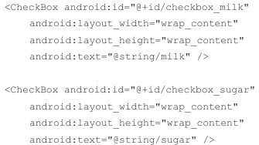
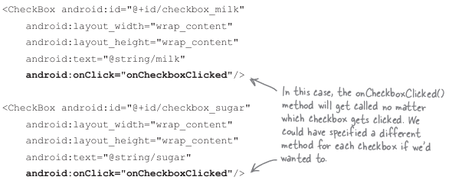
+Use:
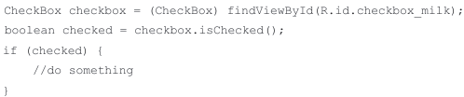
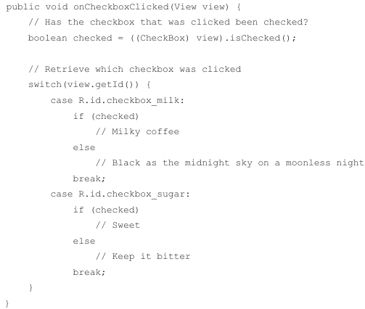
-Radio buttons:
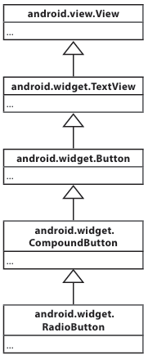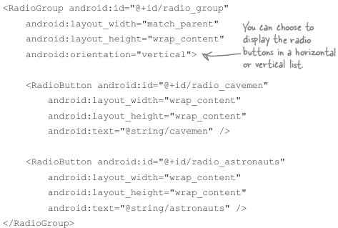\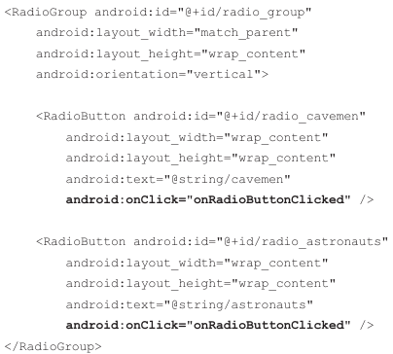
+Use:
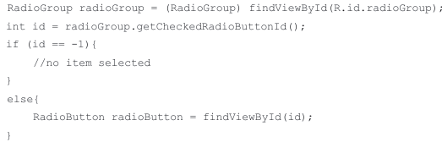
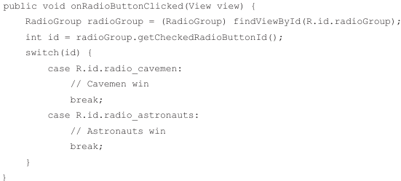
-Spinner:
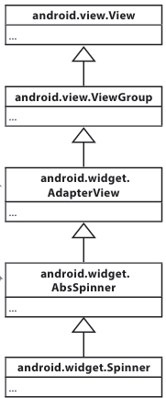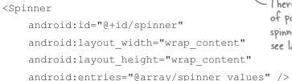
In resource file: 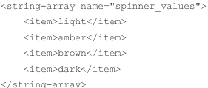
+Use:
-Image view:
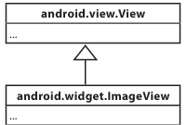
+You can use different image files depending on screen density of device:
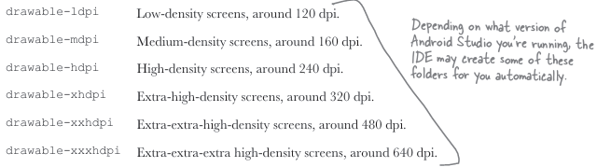
+Define:
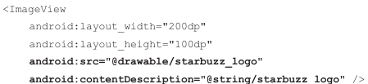
+Use:
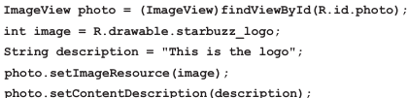
+Add images to buttons:
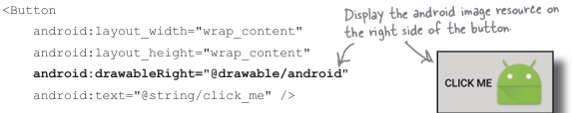
You can use drawableRight/Left/Bootm/Top
-Image button:
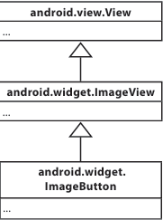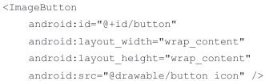
+Use:
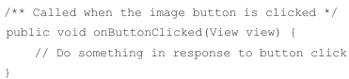
-Scroll view
+Linear layout don’t come with scrollbars.
+Define:
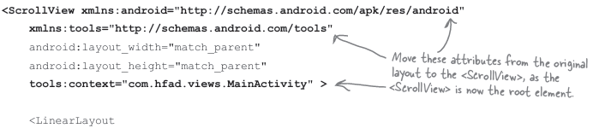
+HorizontalScrollView
-Toasts: a pop-up message you can display on screen
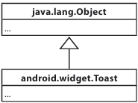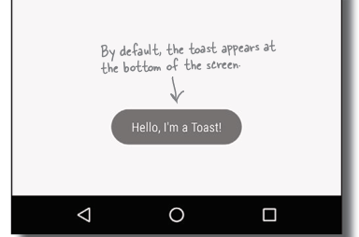
+Use:
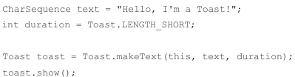
-Bullet Points:
