6 Constraint Layouts
-Nested layouts can be inefficient
+Complex UIs used by nest linear and frame layouts ->slow down app + code hard to read and maintain
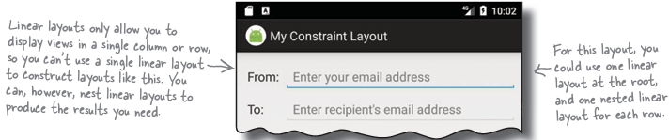
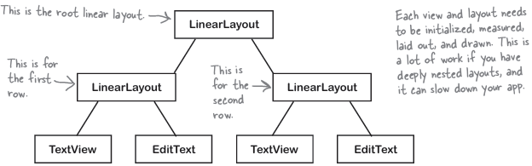
-Introduce the constraint layout:
+They’re specifically designed to work with AS’s design editor. We design it visually: drag and drop GUI components onto tool.
+Make sure project includes Constraint Layout library
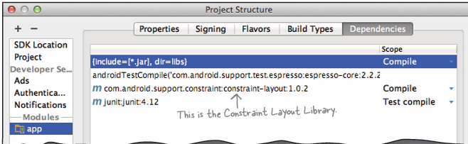
Click + button->Library Dependency->choose library
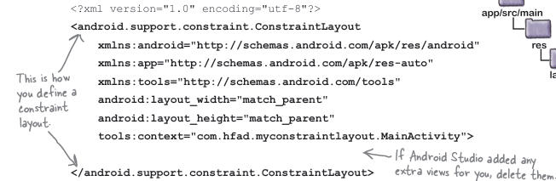
-Changes to blueprint are reflected in XML
-Attributes: 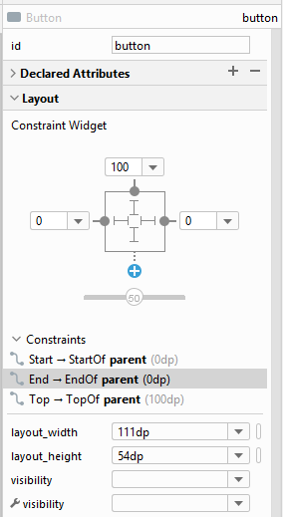
-Bias: control where constraints should be positioned relative to each size.
-Change a view’s size:
+Make the view a fixed size (bad idea)
+Make it just big enough (wrap_content)
+Match the view’s constraints: Set the width and/or height to 0dp.
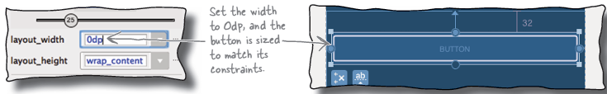
Infer Constraints: the middle one : guess which constraints to add.
-Bullet Points:
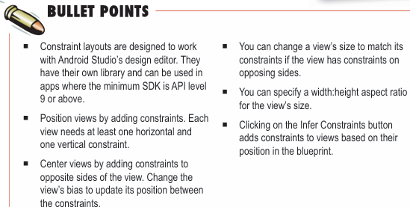

7 List views and Adapters
-Every app starts with ideas
-Organize ideas: top level, category, detail/edit activities
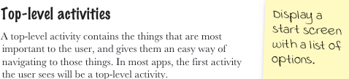
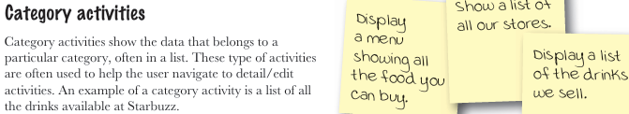

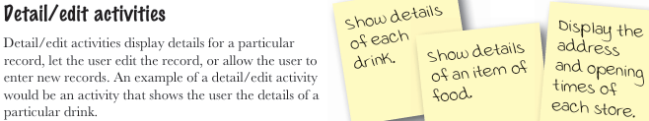
-Navigate through activities:
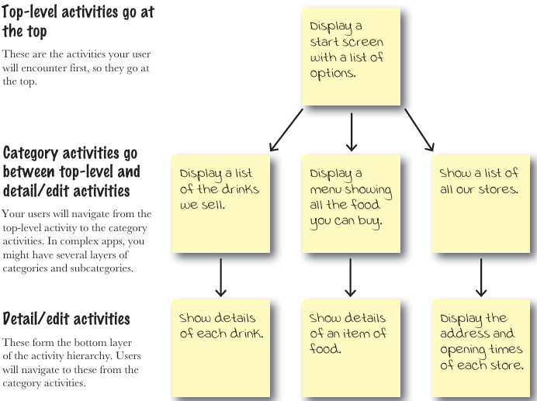
-Use list views to navigate to data:
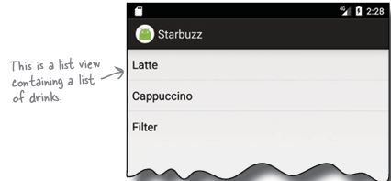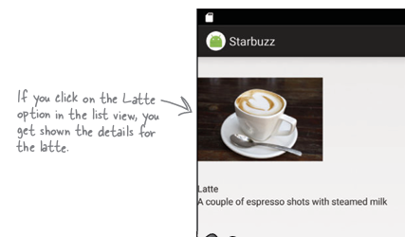
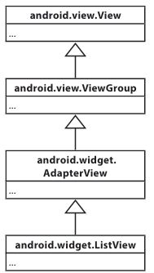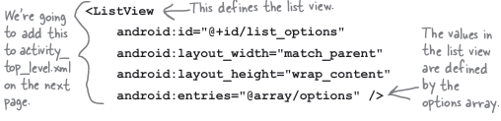
-Full top-level layout:
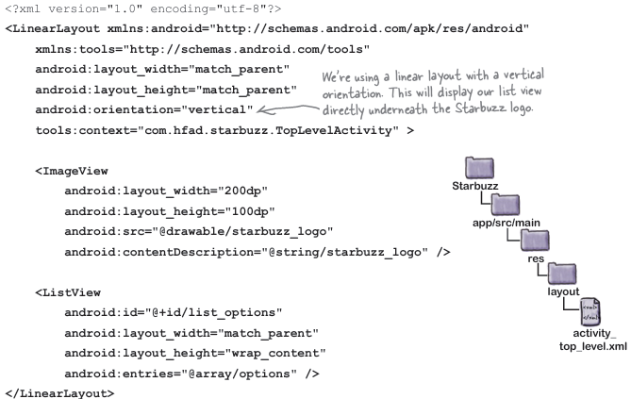
-Get list views to respond to clicks with a listener:
+OnItemListener listens for item clicks
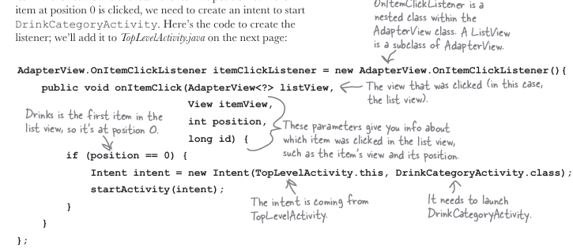
+Set the listener to list view:
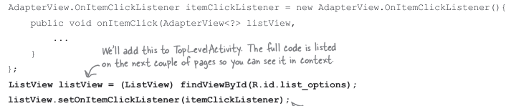
-android:entries: only work with static array in strings.xml, not work with array created in Java code or database. -> Use adapter for nonstatic data
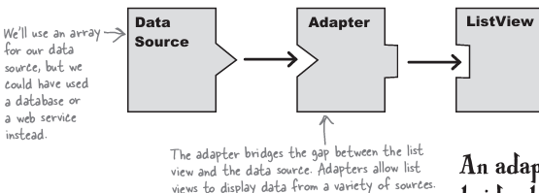
-Connect list views to arrays with an array adapter:
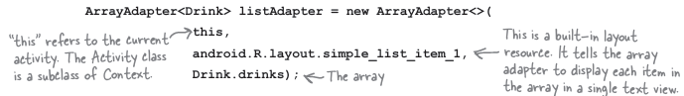
-Pass Id of item that was clicked by adding it to an intent:
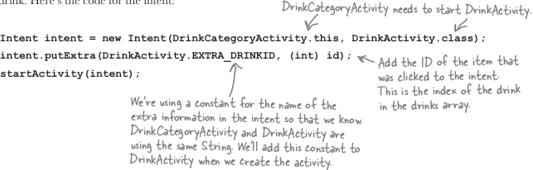
+Get Intent information:
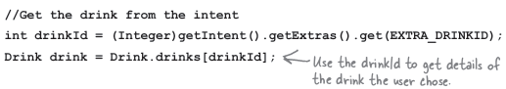
+Populate the views with drink data:
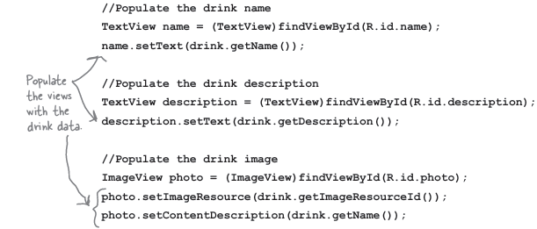
-Bullet Points:
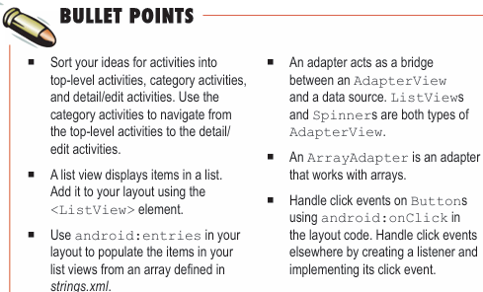

8 Support Libraries and App Bars
-Great apps have a clear structure:
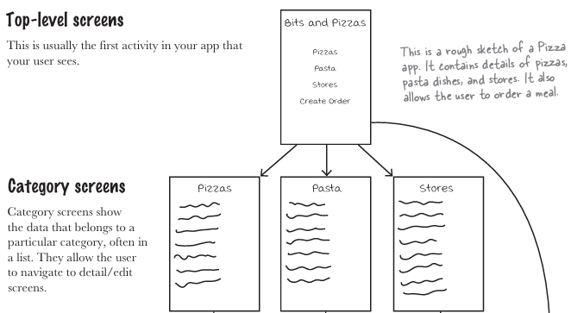
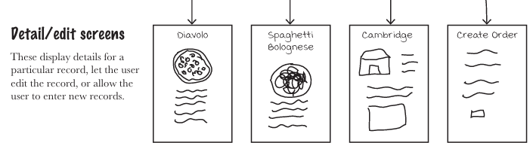
-Different types of navigation:
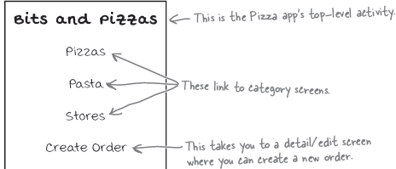
+4th option links to detail/edit activity that allows user to create order ->enable user to perform an action
-app bar/action bar: the bar you often see at the top of activities
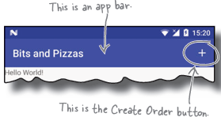
+Use:
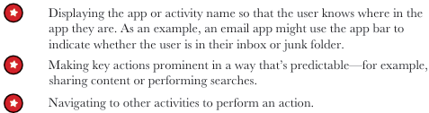
-Add an app bar by applying a theme:
+theme: a style that’s applied to an activity or app so that app has a consistent look and feel. It controls such things
+Android have number of built-in themes : Hole, Mate
-Support Libraries: allow to use new features in older versions of Android
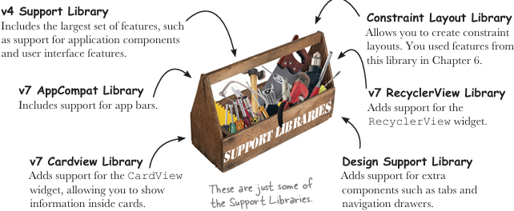
-You need to add v7 AppCompat Support Library ->Let you use AppCompat themes
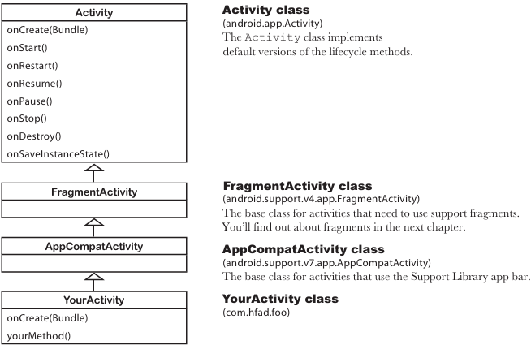
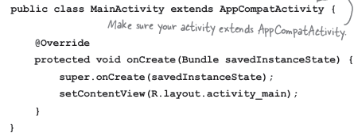
-manifest can change app bar’s appearance:
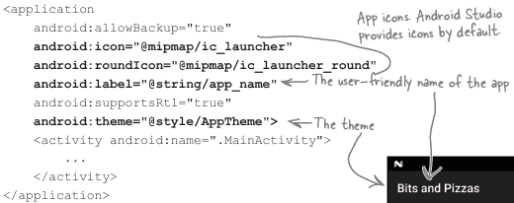
+android:icon: assigns an icon to app, android:roundIcon: may used instead of device running Android >=7.1. mimap resource in res/mimap for app icons.
+android:label: describe a label that get displayed in app bar. android:theme specifies the theme
-Apply a theme:
+Hardcoding the theme:
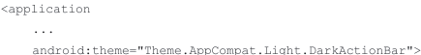
+Use a style to apply the theme
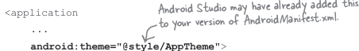
@style in style resource file.
-Defines styles in a style resource file:
+styles.xml located in res/values
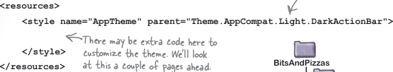
-Theme Gallery:
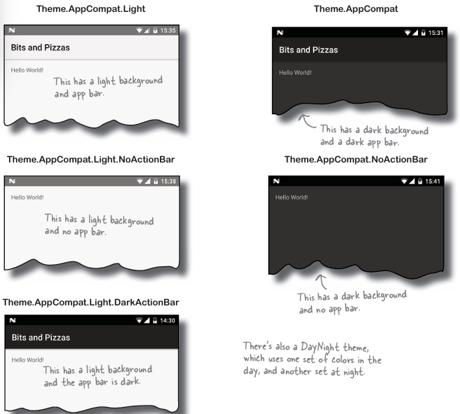
-Customize the look of your app in styles.xml:
+Override 3 colors:
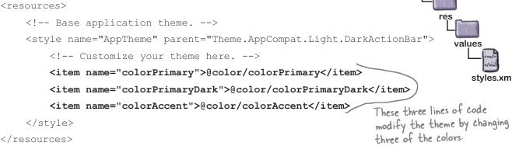
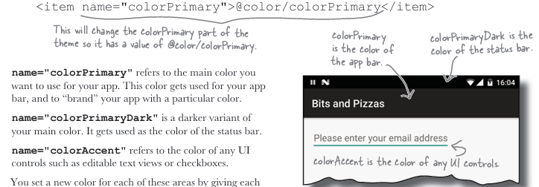
+Define colors in color resource file colors.xml:
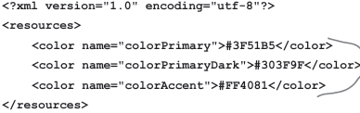
-ActionBar vs Toolbar
+Activity acquires an app bar via a theme uses ActionBar for its app bar.
+ToolBar give more flexibility: a type of view that add to layout, make it easier to position and control than a basic app bar.
-Add toolbar:
+add AppCompat Support Library, extend AppCompatActivity class
+Remove app bar in styles.xml: change to NoActionBar
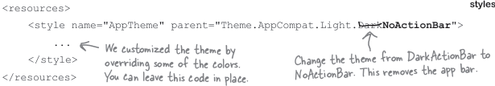
+Add toolbar to layout:
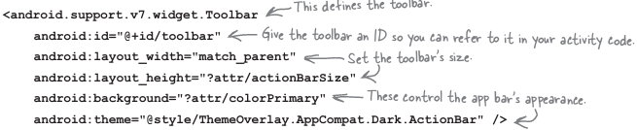
?attr means you use attribute from current theme.
Change background color by apply theme overlay:
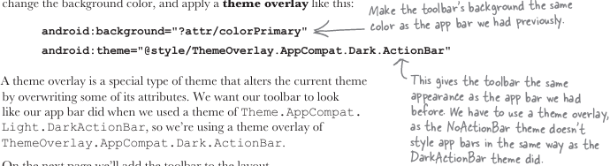
-We can add toolbar to the layout or define it as a separate layout: toolbar_main.xml
+Include toolbar in layout:
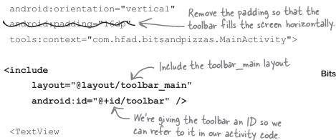
+Set toolbar as the activity’s app bar:
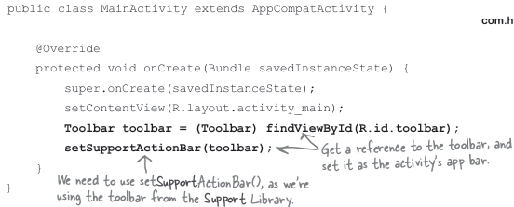
-Add actions to app bar:
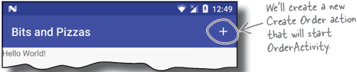
+Create OrderActivity: 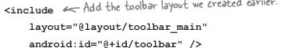
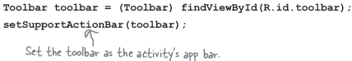
-Change app bar text by adding a label:
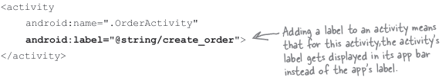
-Add an action to an app bar:
+Add action’s resources:
Add the icon to drawable: Google icons https://fonts.google.com/icons
Add action’s title as a String resource:
+Create menu resource file: tell Androids what actions you want to appear on app bar.
Create menu_main.xml in res/menu
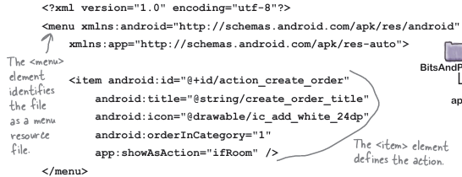
Control action’s appearance:
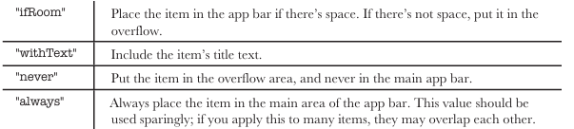
+Add menu to app bar with onCreateOptionsMenu():
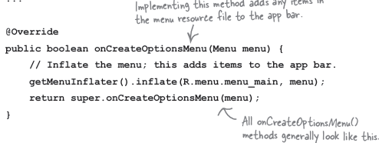
+React to action item clicks with onOptionsItemSelected()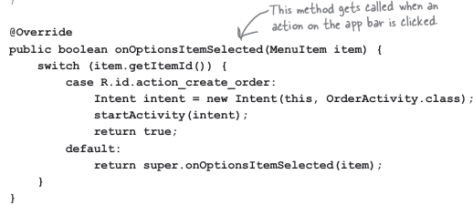
-Enable Up navigation:
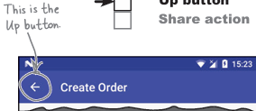
+Set an activity’s parent in manifest:
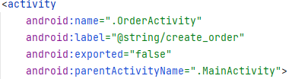
+Add Up button in OrderActivity:
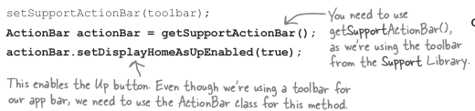
-Sharing content on app bar:
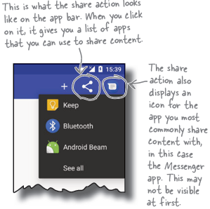
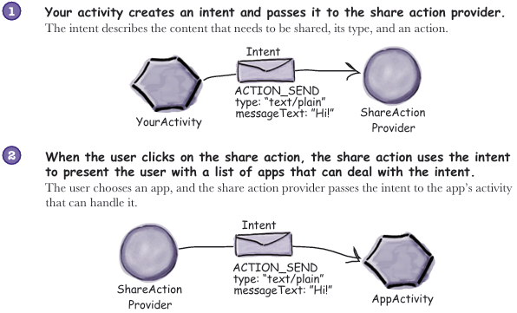
+Add a share action provider to menu_main.xml:
In strings.xml:
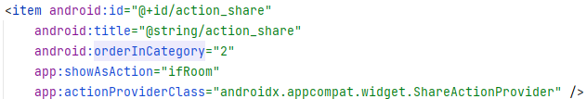
+Specify content with an intent in MainActivity:
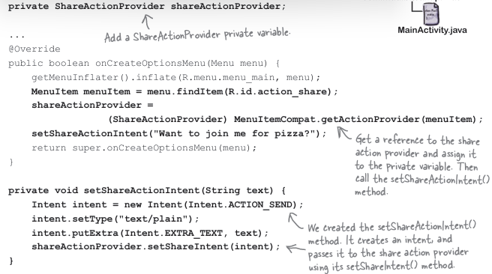
-Bullet Points:
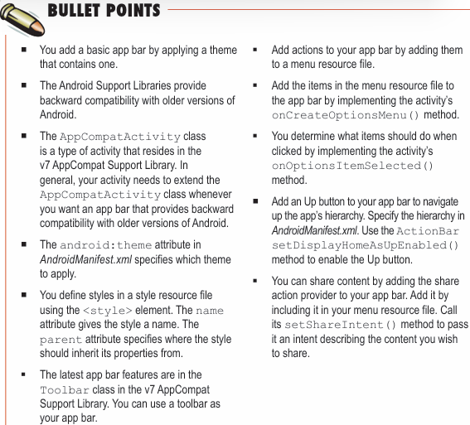

9 Fragments
-Your app needs to look great on all devices
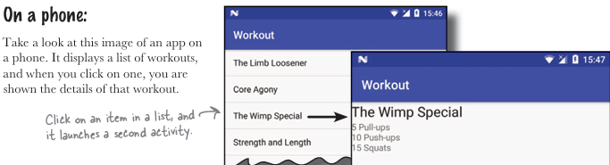
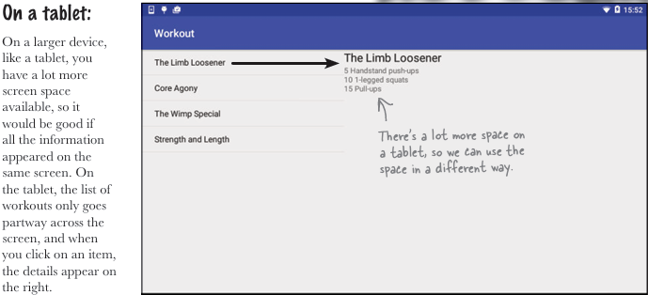
-Your app may need to behave differently too:
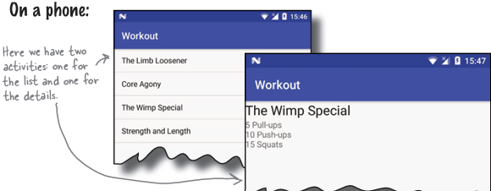
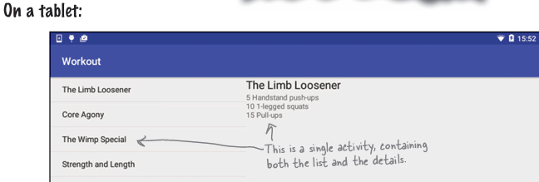
->That means you might duplicate code
-Fragments allow to reuse code: like reusable components or subactivities, control part of a screen, and can be reused between screens.
+A fragment has a layout
-The phone version of app:
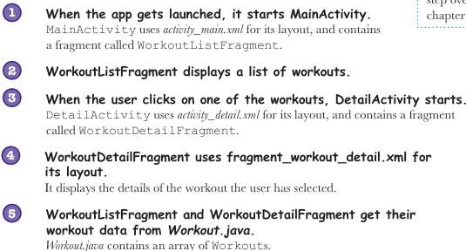
-Add fragment to project:
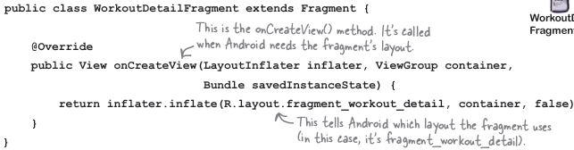
+onCreateView(): called when Android is ready to instantiate UI.
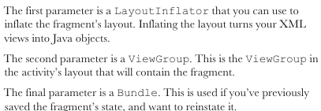
-Add fragment to activity’s layout:
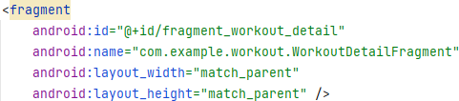
Must have android:id
+Simplify the layout if layout comprises a single fragment with no other views:
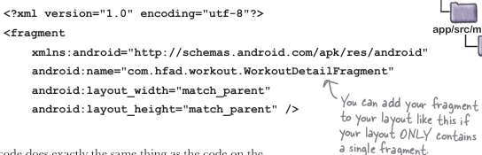
+Make sure activity used with fragment extends FragmentActivity class or its subclasses.
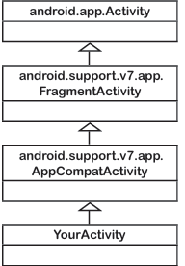
-Get fragment and activity to interact:
+Pass workout Id to fragment:
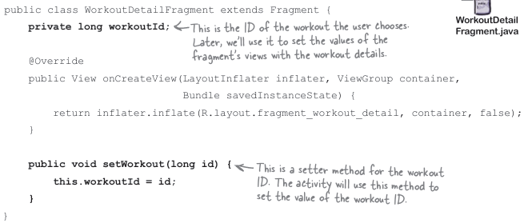
+Use fragment manager to manage fragments: keep track of and deal with fragments used by activity
Get activity to set workout ID:
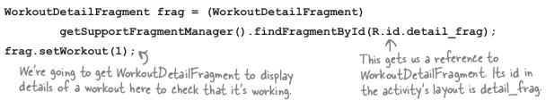
-The fragment lifecycle:
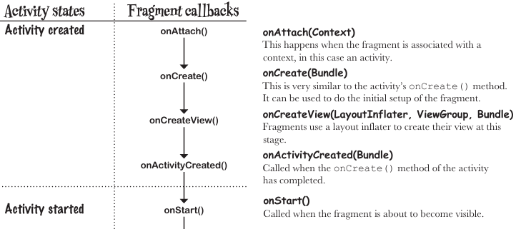
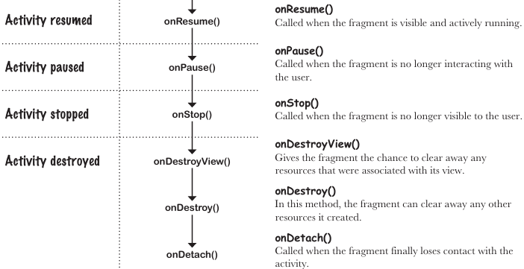
-Fragments inherit lifecycle methods:
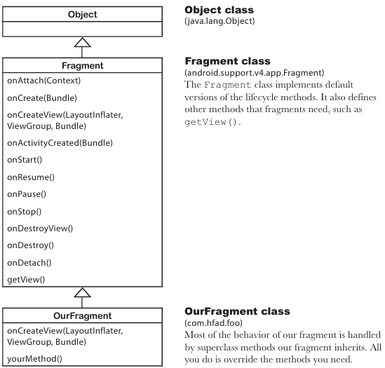
-Set view’s values in fragment’s onStart() in fragment:
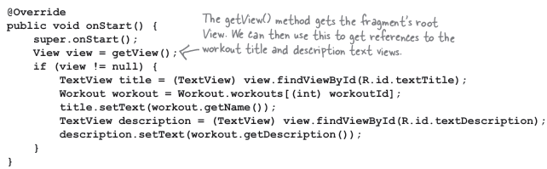
-List fragment: type of fragment that specializes in working with a list, it contains only a list
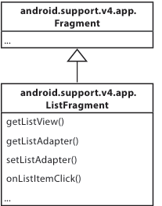
+Create fragment list: don’t need layout
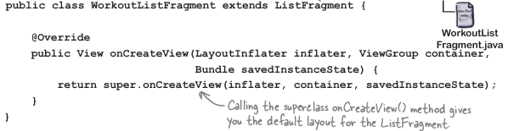
+Use adapter to connect data to list view:
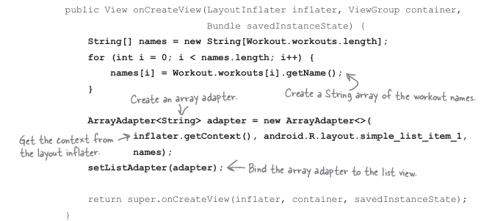
+Add list fragment in activity_main.xml:
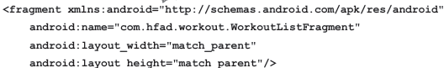
-Connect the list to detail in list fragment:
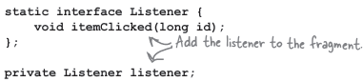
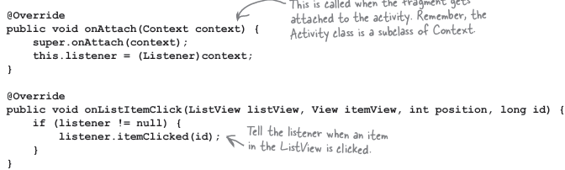
+Implement interface in MainActivity:
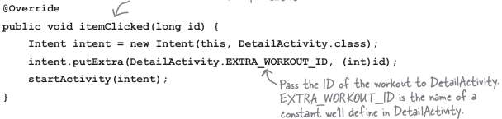
+In DetailActivity needs to pass ID to WorkoutDetailFragment:
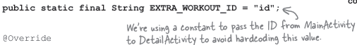
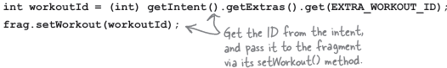
-Bullet Points:
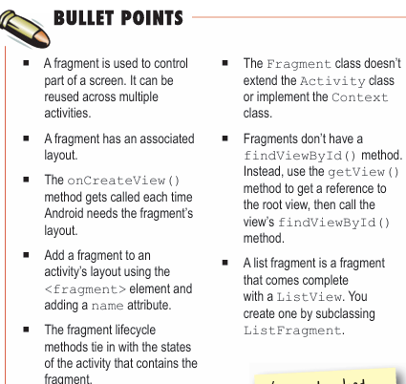

10 Fragments for Larger Interfaces

