11. Dynamic Fragments
-Create TempActivity:
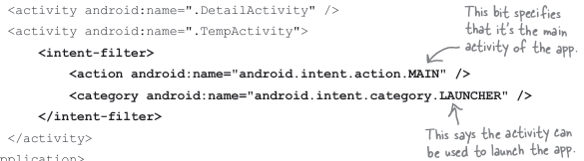
-Fragments and activities have similar lifecycles
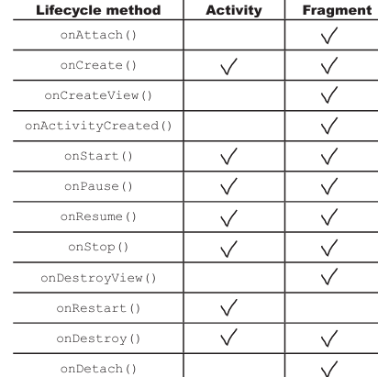
+The methods are different
-Add StopwatchFragment to TempActivity layout:
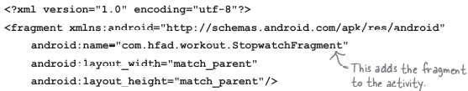
->The app crashes if you click on button, because onClick() call methods in activity, not fragment.
-Make button clicks call methods in fragment:
+Remove onClick() from fragment layout
+Change onClick… signatures
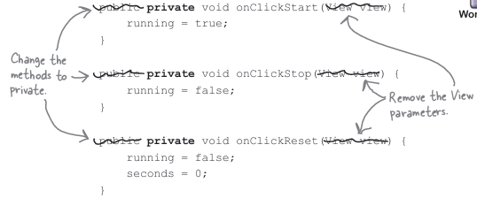
+Make fragment implement OnClickListener
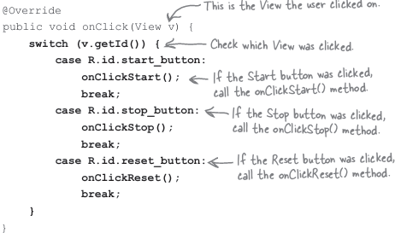
+Attach OnClickListener() to buttons in StopwatchFragment

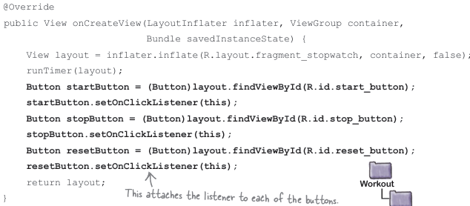
-Rotate the device resets the stopwatch
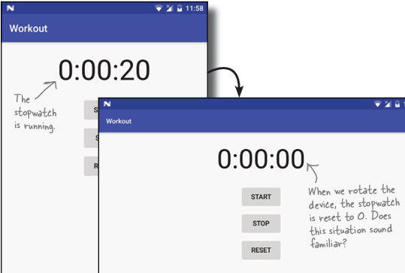
+When you rotate the device, Android recreates activity. If activity contains <fragment>, it reinserts a new version of fragment each time the activity is recreated
-Dynamic fragments need a fragment transaction
+Change activity_temp.xml to use FrameLayout:
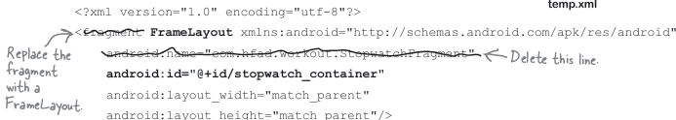
+Add a fragment transaction to TempActivity:
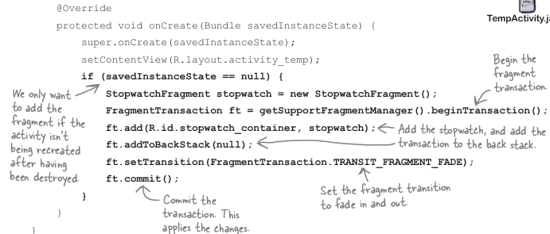
-Add stopwatch to WorkoutDetailFragment
+Start MainActivity when the app launches
+Add FrameLayout where the fragment should appear
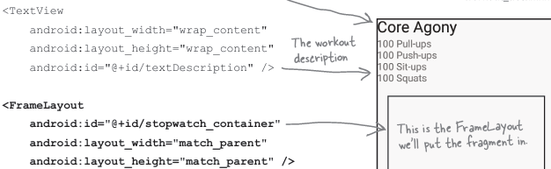
-So far, we’ve only used fragment transactions in activities. Using fragment transactions in fragments uses most of the same code.
-In order to create fragment transaction, we need to get a reference to a fragment manager: +getFragmentManager(): create extra transactions on the back stack
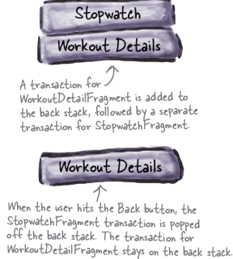
+getChildFragmentManager(): create nested transactions instead
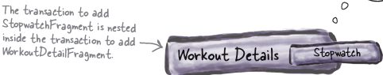
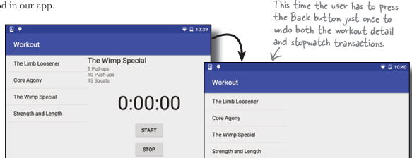
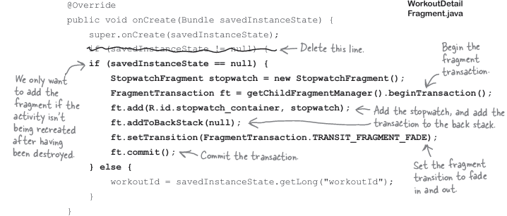
-Bullet Points:
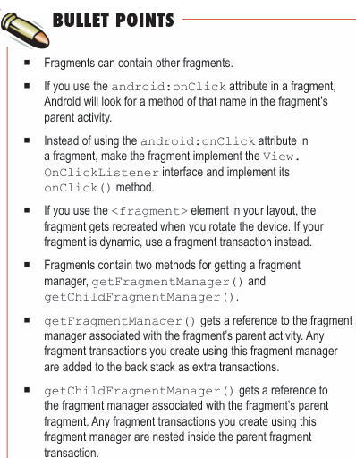

12. Design Support Library
-App Structure: use tab navigation
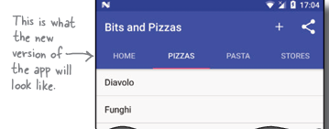
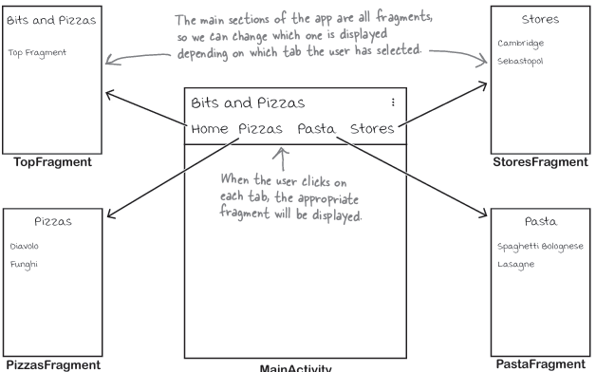
-Create TopFragment
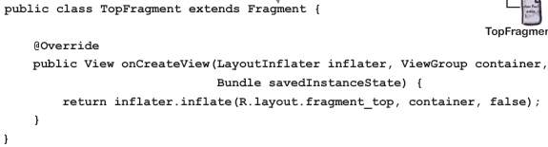

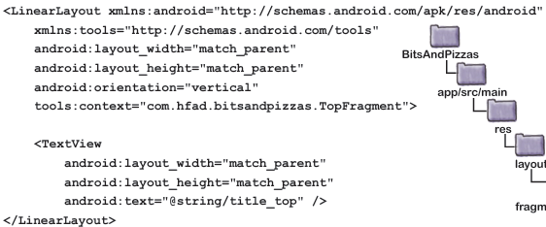
-Create PizzaFragment
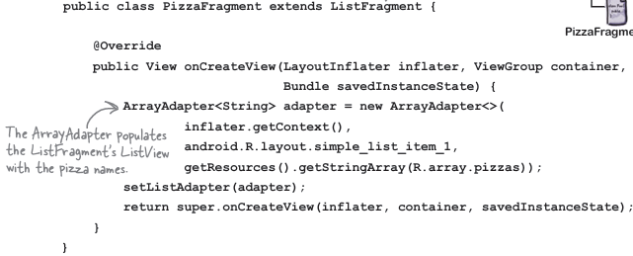
-Create PastaFragment
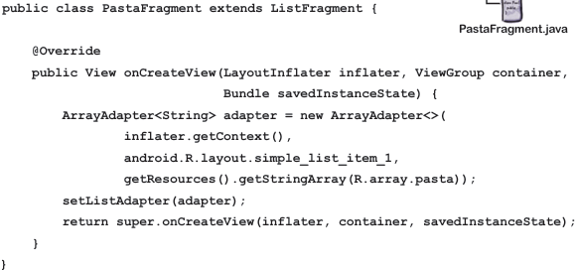
-Create StoresFragment
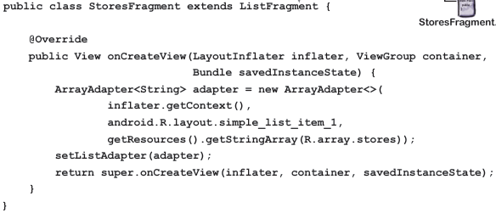
-View pager: a view group that allows you to swipe through different pages in a layout, each page containing a separate fragment
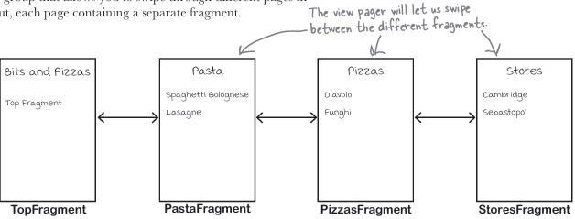
+Add view pager to MainActivity layout:
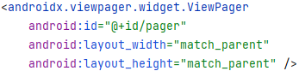
+Fragment pager adapter: a type of adapter that specializes in adding fragments to pages in a view pager. Use it when you want to have a small number of pages that are static, as each fragment the user visits in kept in memory.
+Override: getCount() + getItem()
+Add fragment pager adapter to MainActivity:
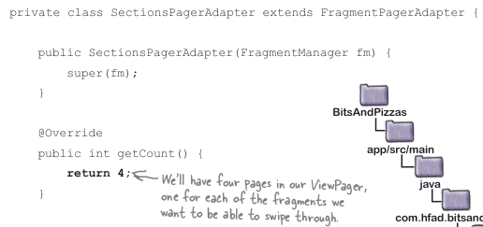
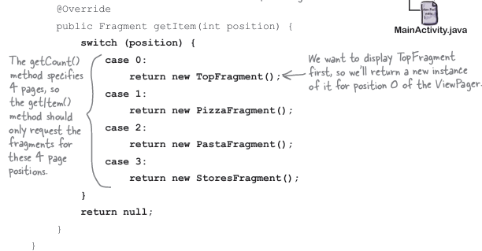
+Attach the fragment pager adapter to view pager in MainActivity:
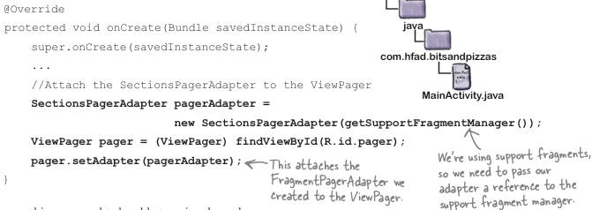
-Add tap navigation to MainActivity:
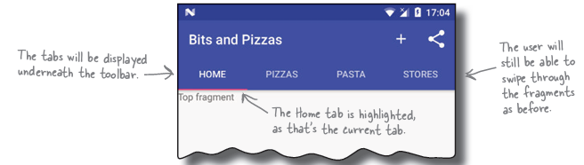
-Add tabs to layout: TabLayout add the tabs, AppBarLayout group the tabs and toolbar together.
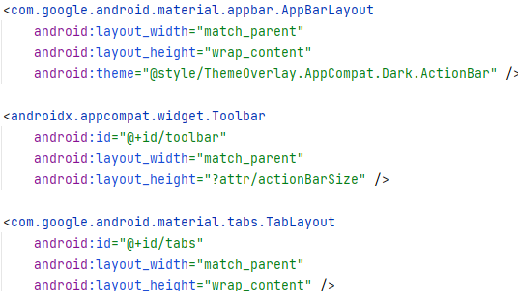
+Toolbar and TabLayout both have IDs because you need to be able to reference them in activity code.
-Link the tab layout to view pager in MainActivity:
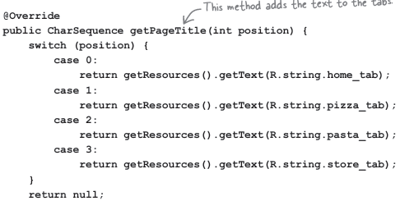
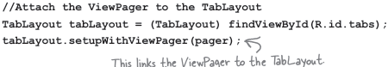
-Design Support Library helps you implement material design: give a consistent look and fell to all Android apps.
-Make the toolbar respond to scrolls:
+Use CoordinatorLayout: coordinate animations between views. Add it to MainActivity layout:
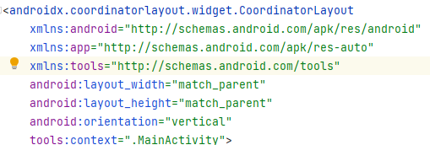
+Mark the view the user will scroll:
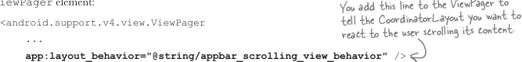
+Tell the toolbar to respond to scroll events:
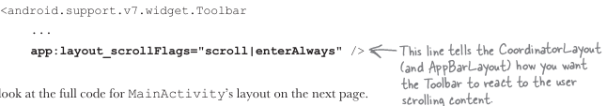
+Add scrollable content to TopFragment
-Use a nested scroll view to make layout content scrollable:
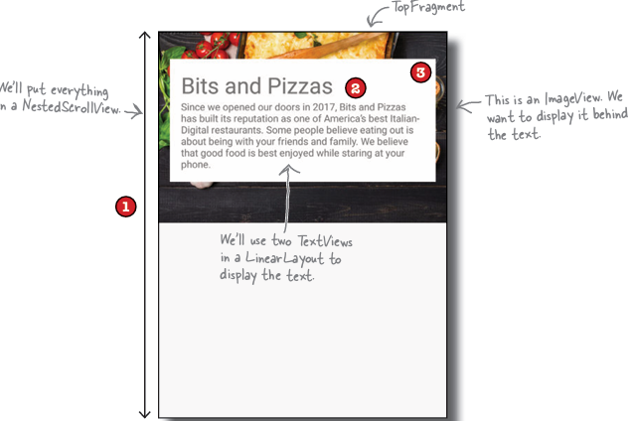
-Add a collapsing toolbar to OrderActivity:
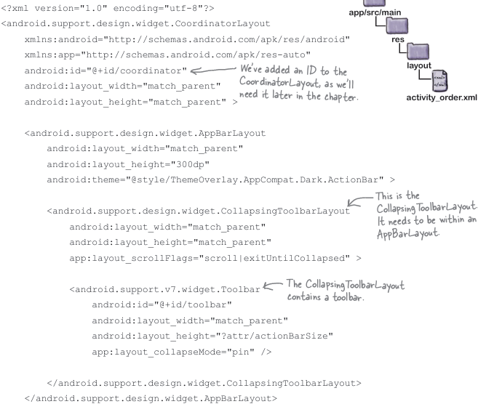
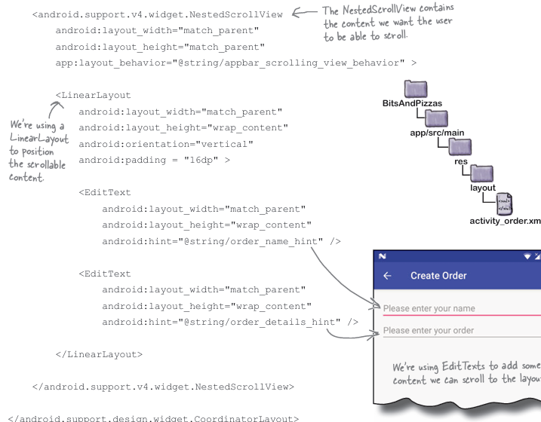
+Add image to collapsing toolbar:
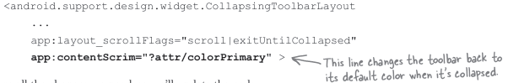
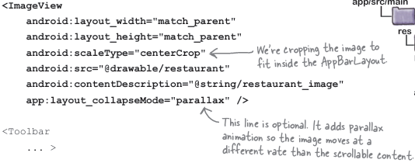
-FAB and snackbars:
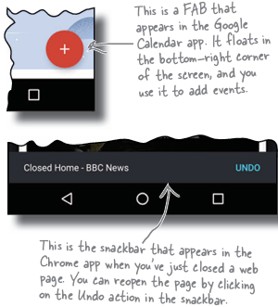
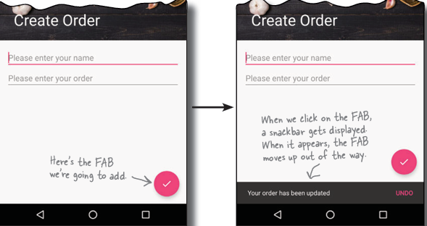
+Add FAB to layout:
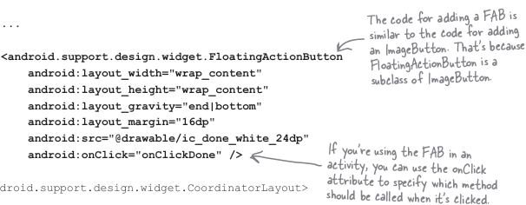
+Add onClickDone() to OrderActivity:
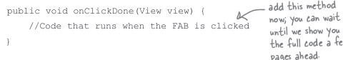
-Create a snackbar in OrderActivity:
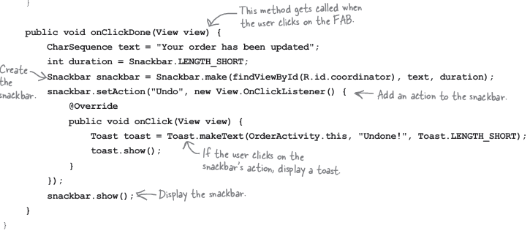
-Bullet Points
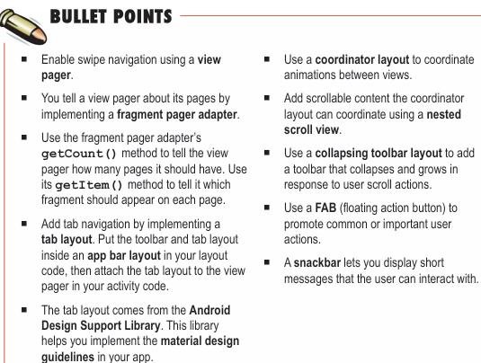

13. Recycle Views and Card Views
-Recycler view: list view that implements nested scrolling
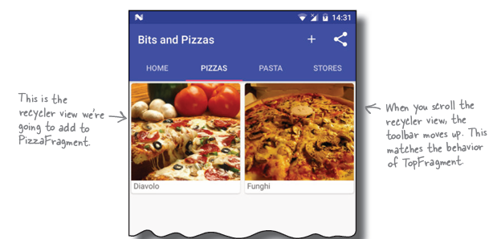
+Recycler view accesses data using an adapter. Items are positioned using a layout manager.
-Add Pizza data
-Display pizza data in card: card_captioned_image.xml
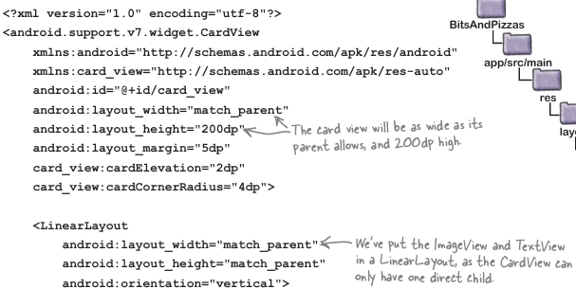
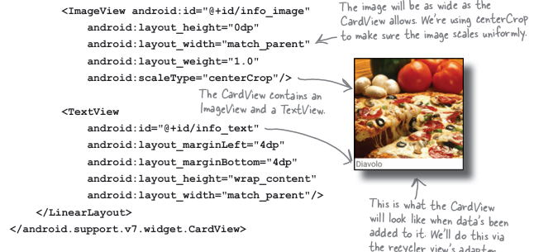
-Add a recycler view adapter: CaptionedImagesAdapter
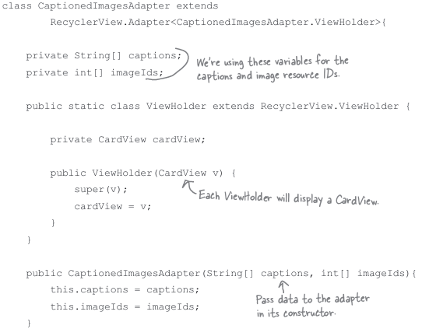
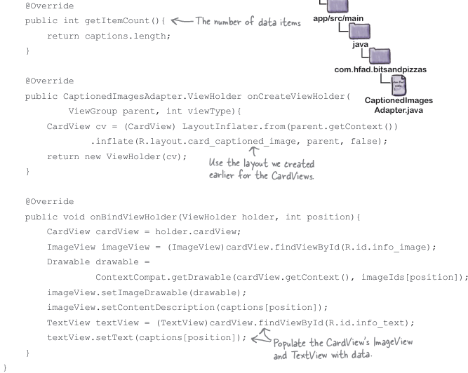
-Create recycler view
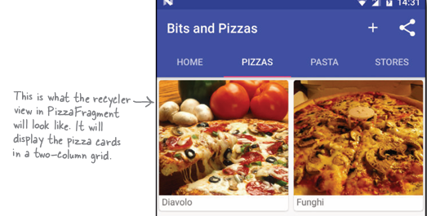
+Add RecyclerView to PizzaFragment layout: fragment_pizza.xml
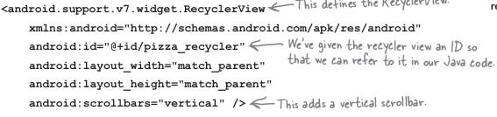
+Get the recycler view to use adapter in PizzaFragment.java 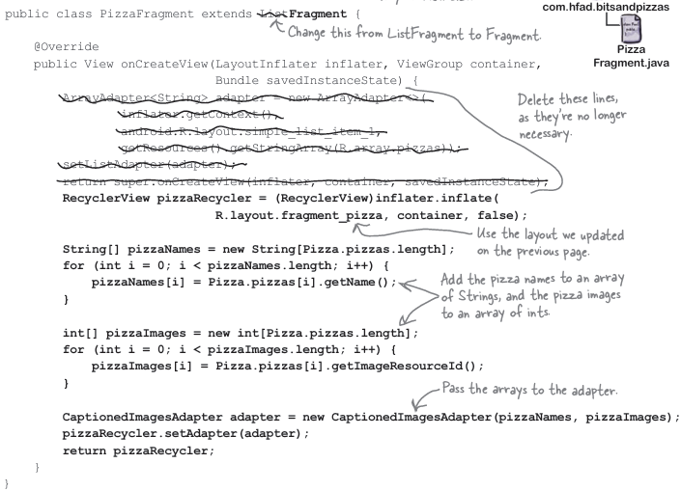
-A recycler view uses a layout manager to arrange its view:
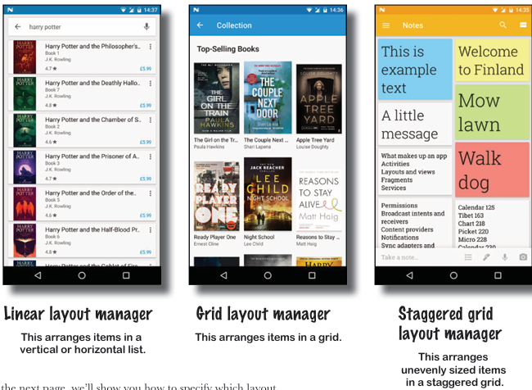

+Specify the layout manager in PizzaFragment:
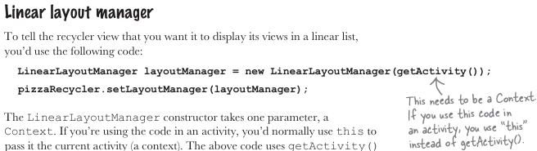
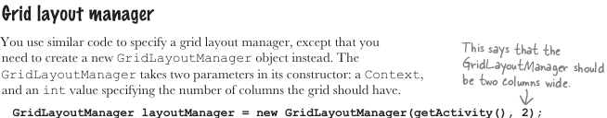
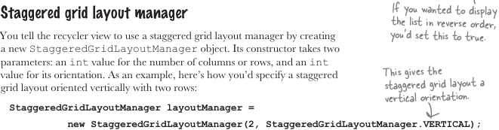
-Make the recycler view respond to clicks:
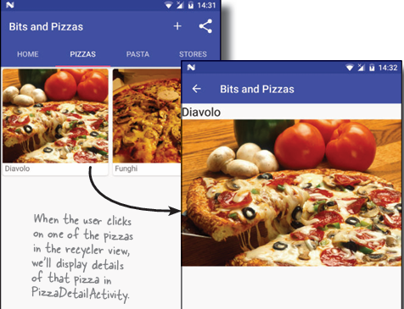
+Create PizzaDetailActivity
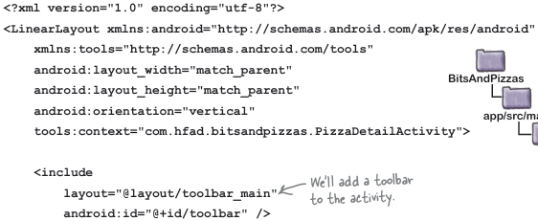
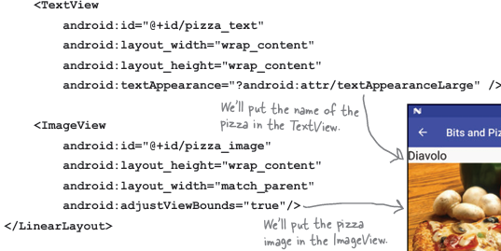
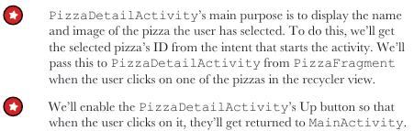
+Update manifest.xml to give PizzaDetailActivity a parent
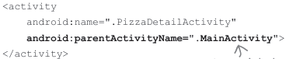
+Code for PizzaDetailActivity.java
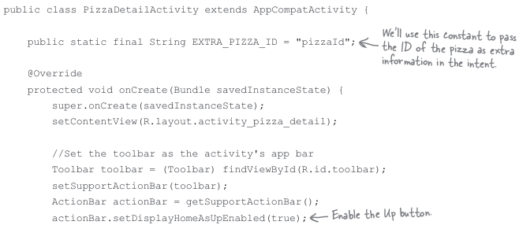
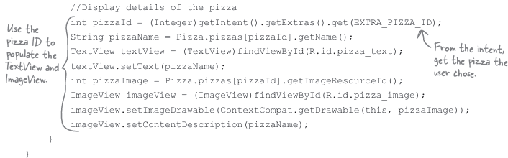
-Get a recycler view to respond to clicks:
+You can listen for view events from the adapter:
Add the interface to adapter:
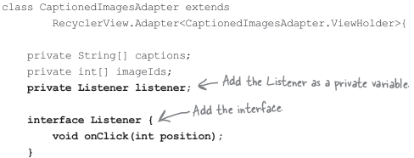
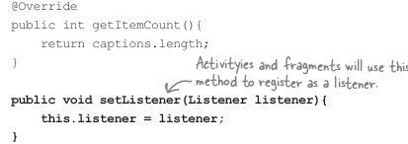
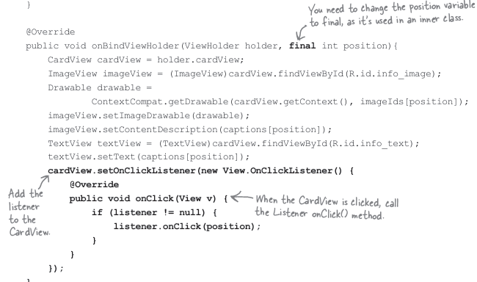
+Implement listener in PizzaFragment:
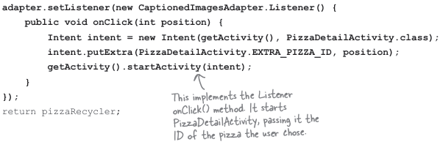
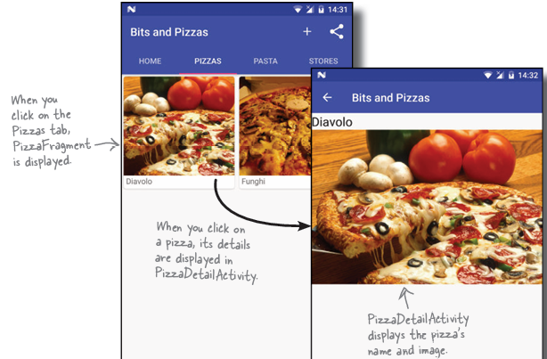
-Bullet Points:
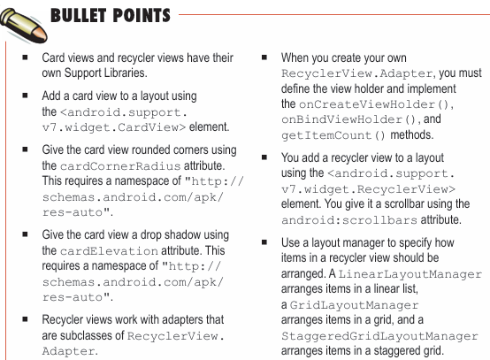

14. Navigation Drawers
-Create InboxFragment:
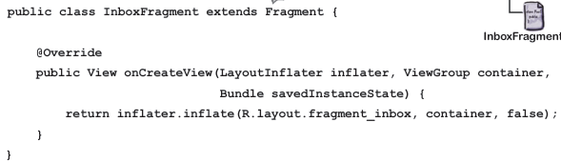
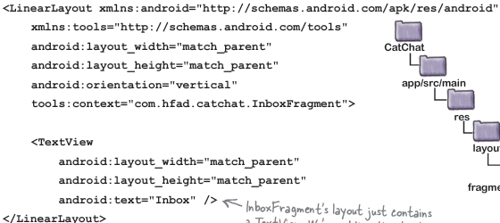
-Create DraftsFragment
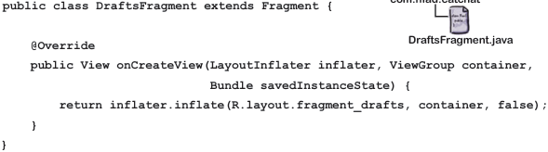
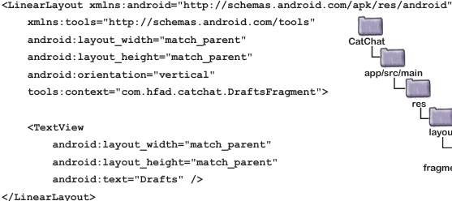
-Create SentItemsFragment
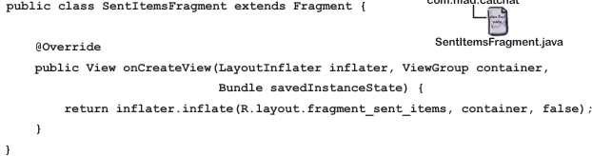
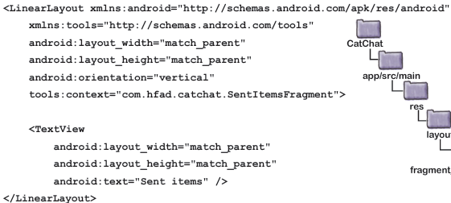
-Create TrashFragment
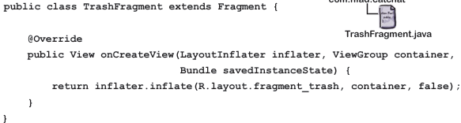
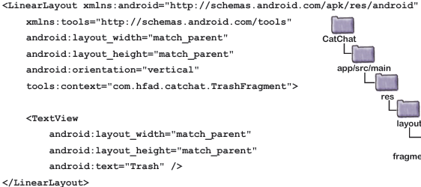
-Create a toolbar layout: toolbar_main.xml
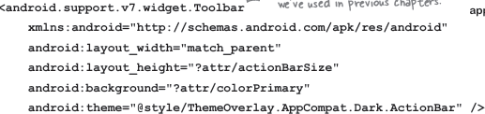
+In manifest:
+Update app’s theme: styles.xml in res/values
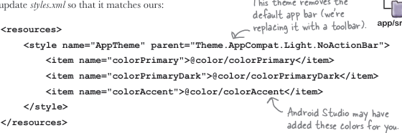
In res/values colors.xml:
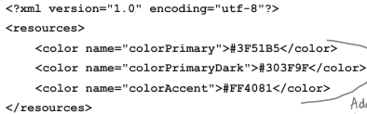
-Create HelpActivity:
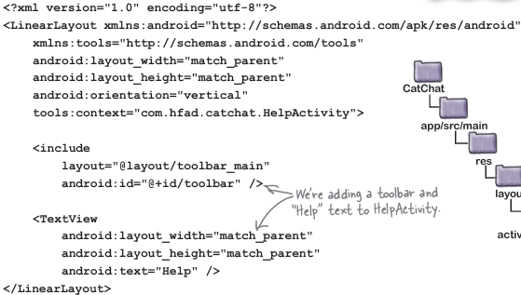
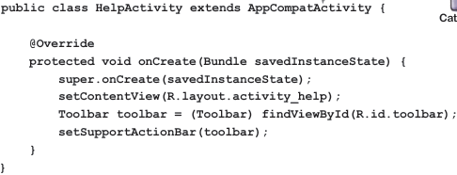
-Create FeedbackActivity
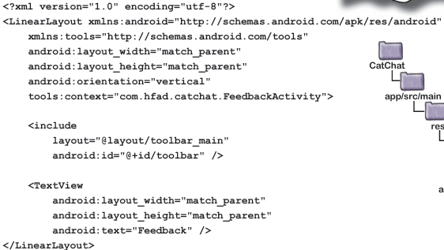
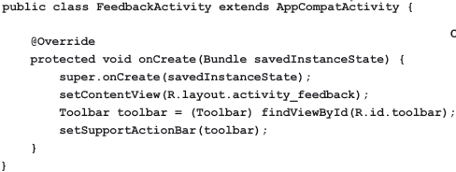
-Build a navigation drawer:
+Create the navigation drawer’s header: nav_header.xml
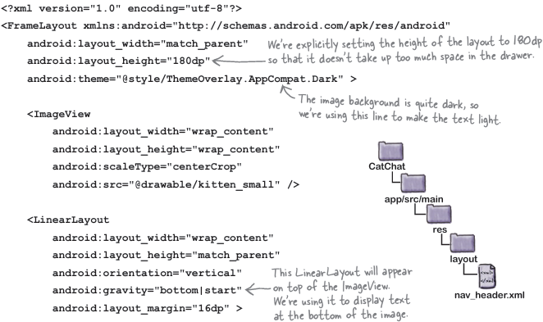
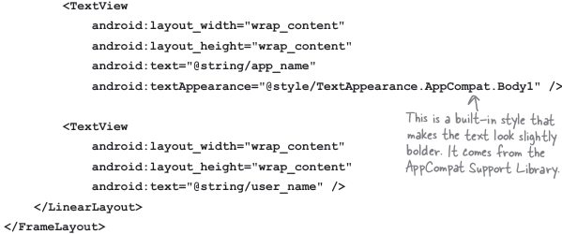
-The drawer gets its option from a menu. We need to create a menu with 2 sections:
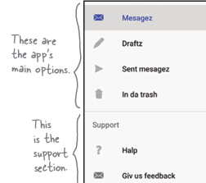
+Create menu_nav.xml in res/menu
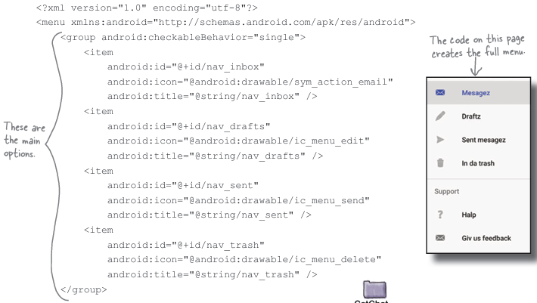
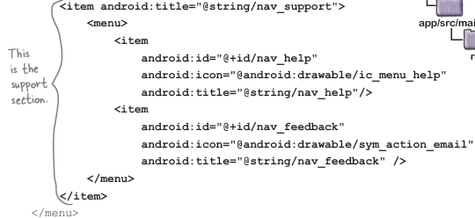
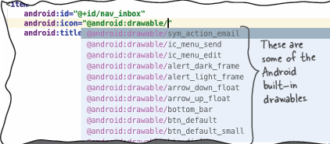
-Create a navigation drawer by adding drawer layout to activity’s layout: a view or view group for activity’s content and a navigation view.
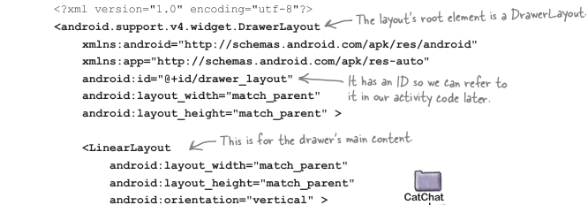
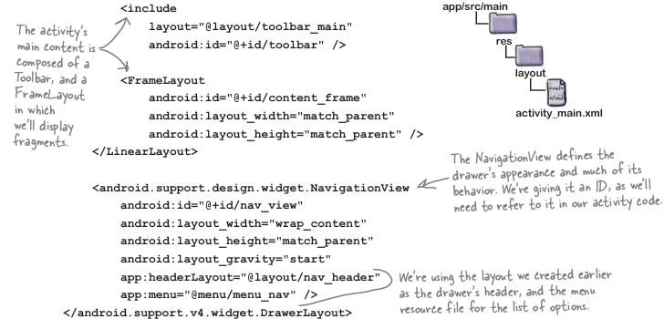
+Add InboxFragment to MainActivity layout:
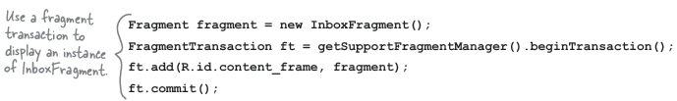
-Add a drawer toggle, respond to user clicking items in drawer, implement onNavigationItemSelected(), close drawer when user presses the Back button:
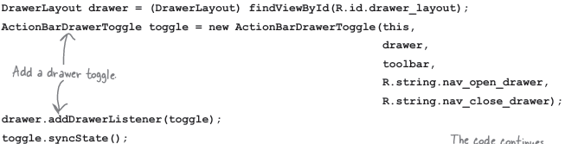
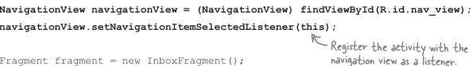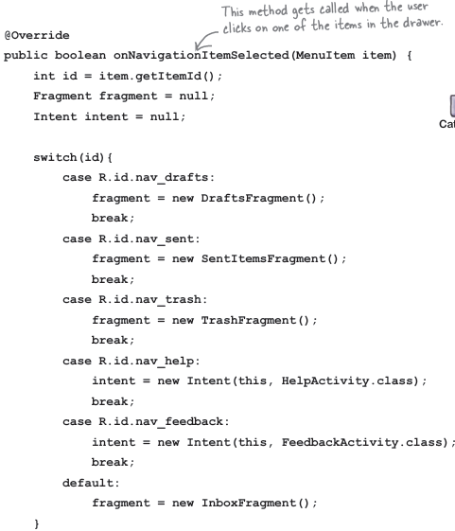
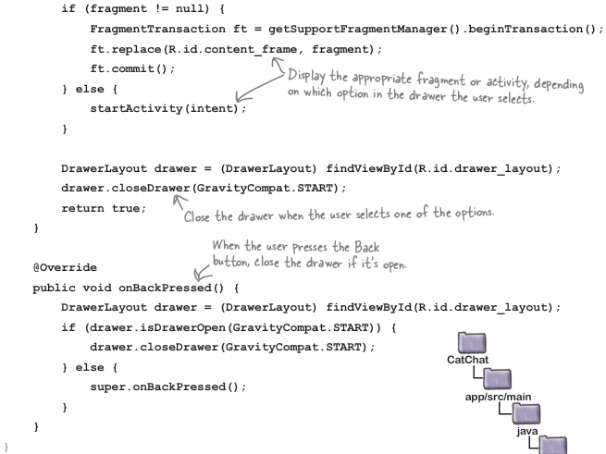
-Bullet Points:
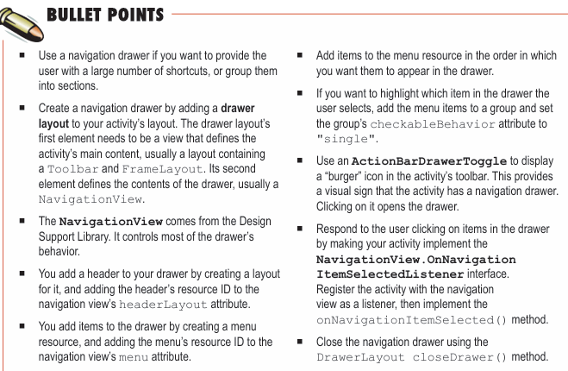

15. SQLite Database
-Android uses SQLite databases to persist data.
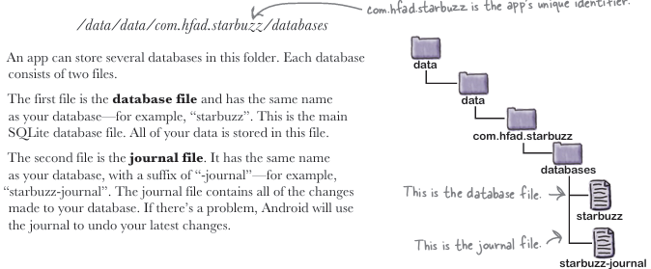
-Android uses set of classes that allows you to manage SQLite database
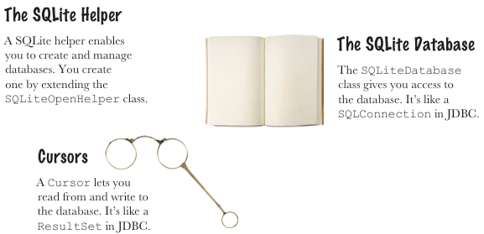
-Create SQLite Helper
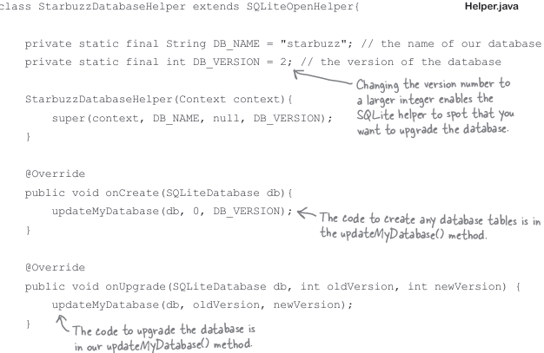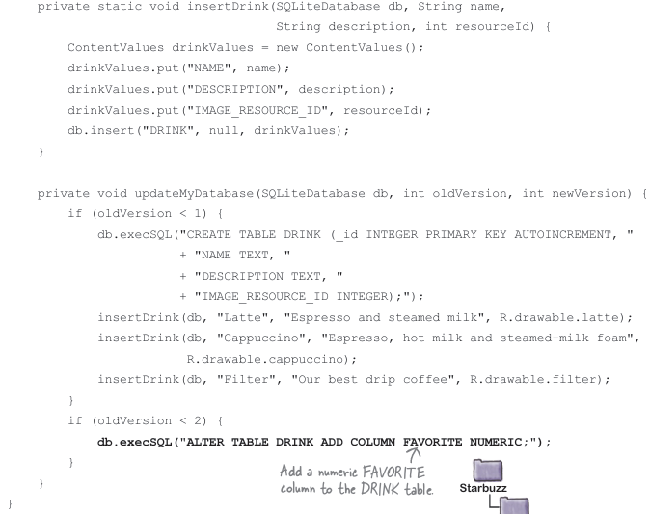
-Bullet Points
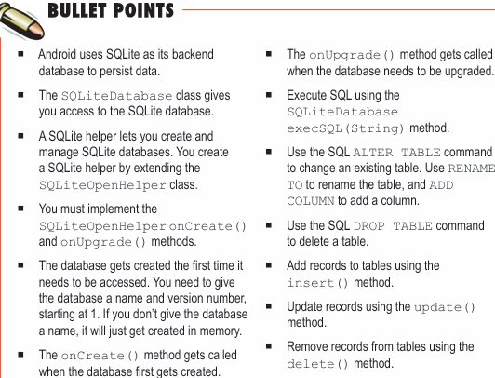

16. Basic Cursors
-Get a reference to database:
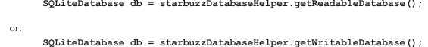
-Get data from database with cursor
+Return all records:
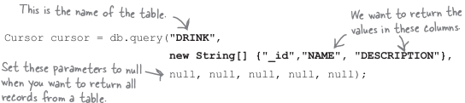
+Return selected records:
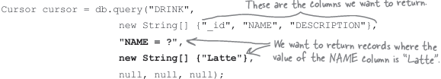
-Navigate cursors: moveToFirst(), moveToLast(), moveToPrevious(), moveToNext()
-Get cursor values:
-Close the cursor and database:
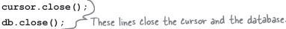
-The code:
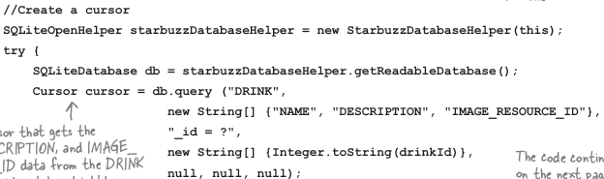
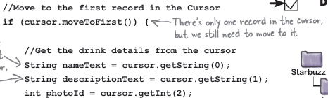
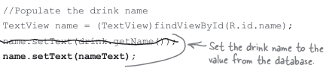
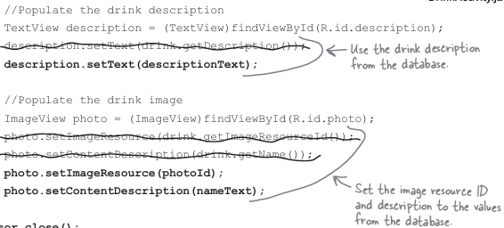
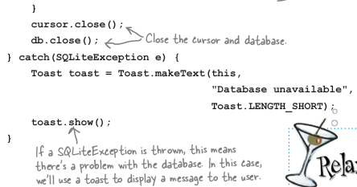
-Cursor adapter: like array adapter, instead of getting data from array, it reads data from cursor.
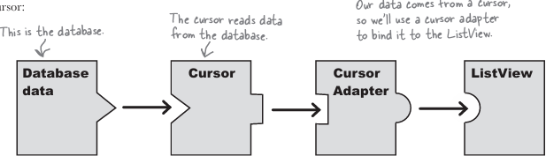
+Use a simple cursor adapter:
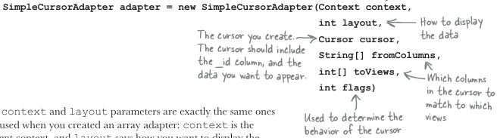
+DrinkCategoryActivity:
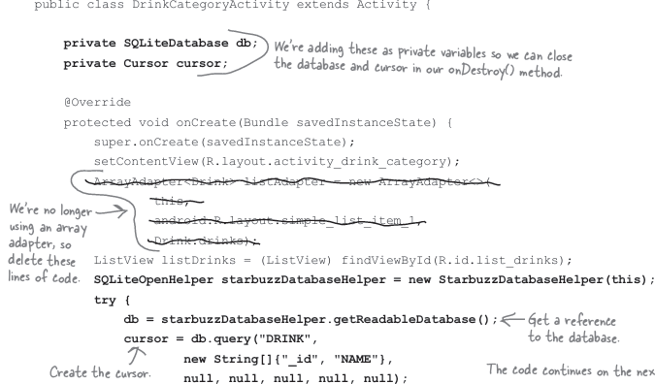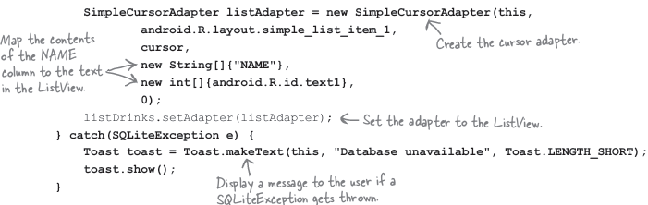
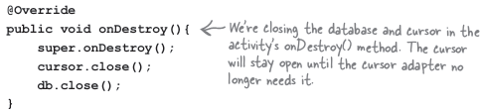
-Bullet Points
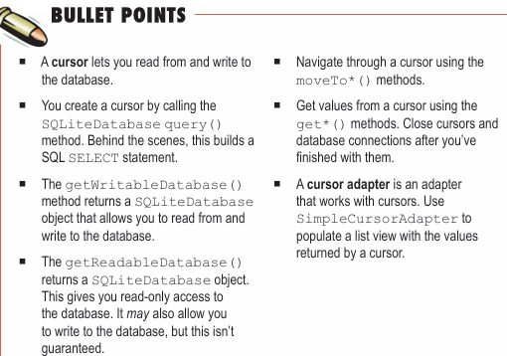

17. Cursors and Asynctasks
-Update DrinkActivity:
+Layout:
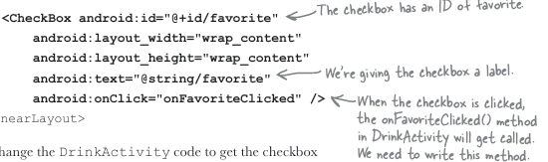
+Code:
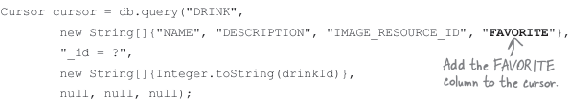
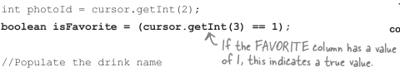
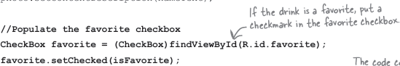
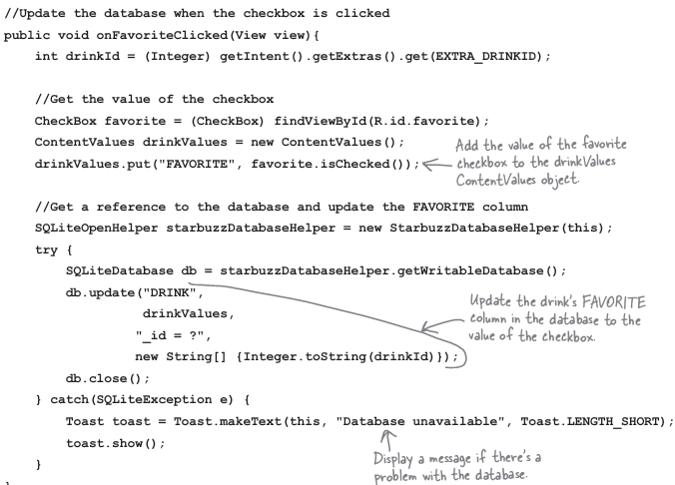
-Display favorite drinks in activity_top_level:
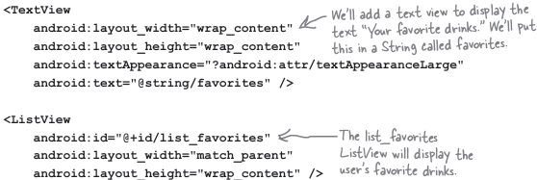
+Automatically refresh:
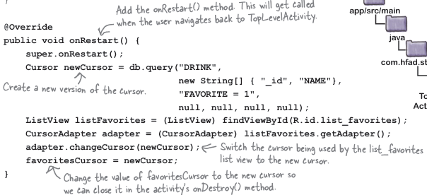
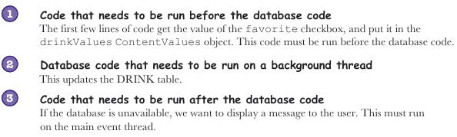
-AsyncTask performs asynchronous tasks
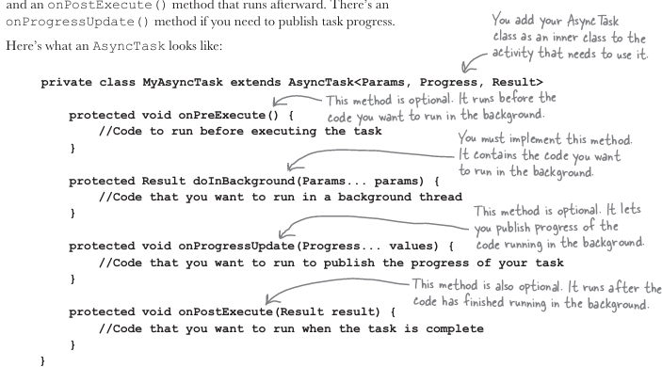
-Bullet Points:
