Project CS-301: Electric Vehicle Range Prediction
Author: Arda Ayna, Neel Patel, Jake Neibart, Edison Mak

1. Problem Definition and Objective
As the automotive industry shifts toward sustainable energy, understanding the specific variables that influence modern Electric Vehicle (EV) battery range is critical. The objective of this project is to build a robust machine learning pipeline that can accurately predict the electric range of a vehicle based on its specific attributes (such as Make, Model Year, and Base MSRP) and deploy this predictive model into a fully interactive web dashboard.

2. Dataset Description and Preprocessing Steps
The dataset contains specifications for various electric vehicles. To ensure mathematical accuracy for the machine learning algorithms, the following preprocessing steps were applied:
- Handling Missing Data: Rows with missing categorical data (County, City, Make, Model) were removed to prevent skewed representations.
- Data Cleaning: Duplicate entries were dropped. Domain knowledge was applied to filter out logical errors, specifically removing vehicles with an Electric Range of 0 or a Model Year set beyond 2025.
- Encoding & Scaling: Handled automatically via a Scikit-Learn Pipeline. A ColumnTransformer applied a SimpleImputer and OneHotEncoder to categorical features, and a median imputer with a StandardScaler to numerical features.

3. Exploratory Data Analysis (EDA)
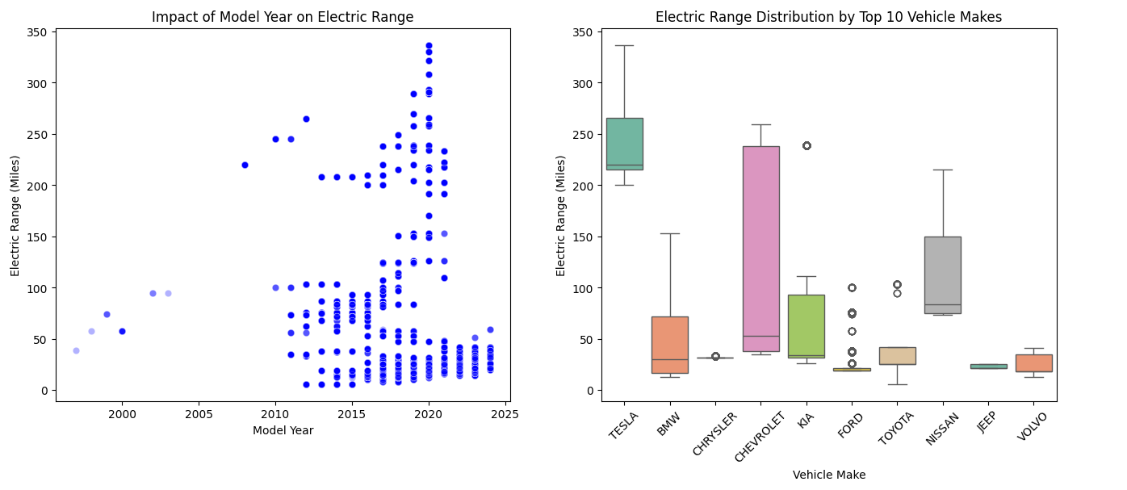Visualizations were generated to uncover underlying data patterns:
- Numerical Trends: A scatter plot of Model Year vs. Electric Range highlighted the historical progression and recent exponential growth of battery technology.
- Categorical Distributions: Box plots filtering for the Top 10 Vehicle Makes revealed the distribution and outliers among top manufacturers, demonstrating clear variations in average range capabilities between brands.
- Correlations: A correlation matrix confirmed the relationships between numerical features, specifically evaluating how variables like Base MSRP correlate with battery capacity.

4. Model Selection and Justification
To establish a performance floor, a Multiple Linear Regression model was trained first. However, linear models often struggle to capture the complex, non-linear relationships inherent in manufacturing data. To optimize performance, two advanced models were selected:
- Polynomial Regression: Selected to explicitly handle feature engineering by applying a degree-2 transformation, allowing the algorithm to capture the curved, non-linear growth in range over recent model years.
- Random Forest Regressor: Selected for its Ensemble Learning capabilities. Decision trees naturally handle the massive dimensionality introduced by one-hot encoding dozens of car makes and resist overfitting better than standard linear models.

5. Evaluation Metrics and Performance Comparison
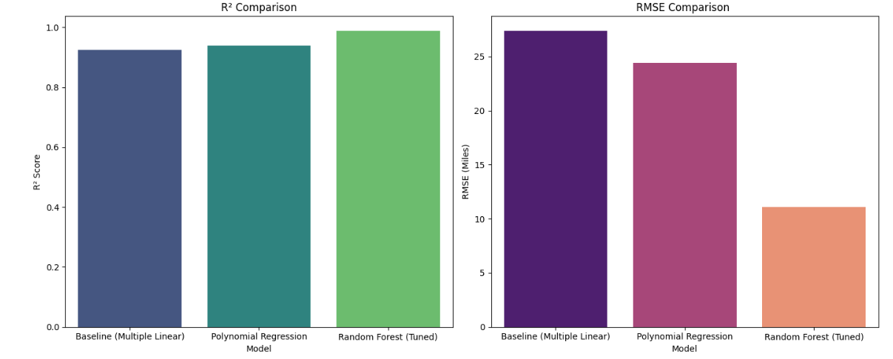
The models were evaluated using two primary metrics:
- R-squared (R²): To measure the proportion of variance in the electric range explained by the features (Higher is better).
- Root Mean Squared Error (RMSE): To measure the average prediction error in actual miles (Lower is better).
GridSearchCV was utilized with 5-fold cross-validation to tune the Random Forest's hyperparameters (n_estimators, max_depth, min_samples_split). When compared visually, the Tuned Random Forest significantly outperformed both the Baseline Linear and Polynomial models, yielding the highest R² score and the lowest RMSE.

6. Final Model Choice with Reasoning
The Tuned Random Forest Regressor was chosen as the final production model.
- Strengths: It expertly handles high-cardinality categorical data (like the various car 'Makes') and naturally captures non-linear relationships without requiring manual polynomial transformations.
- Limitations: It is computationally heavier than a linear model and acts as a "black box," making it difficult to extract the exact mathematical equation used for a specific prediction.
- Trade-offs: We traded a small amount of model interpretability (which a basic linear model provides) in exchange for a massive increase in predictive accuracy and generalizability to new data.

7. Deployed Application URL
- Application Link: https://ev-ml-predictor-742874600981.us-central1.run.app
- Deployment Details: The final Random Forest pipeline was successfully deployed into an interactive Dash web application, allowing users to perform dynamic EDA and input raw vehicle specifications to receive real-time, live-encoded electric range predictions. The website may take around 30 seconds to launch on initial access, after which the upload file button will appear.

