**Brainware University – Business Report**

**1. Executive Summary**

This analysis is done to explore the past data from Brainware University (2023 & 2024), total 17388 records and 16 fields to identify booking, admission and dropout dates, status of the candidate, responsible person and their respective groups, demographic details like country, state and gender.

The study reveals curtail details for both years, such as:

* Trends in Admission, Booking and Dropouts.
* Demographic details such as: Country, State and Gender.
* Courses with the highest demands
* Top performing Groups and Responsible persons.

**2. Business Problem**

Brainware University is seeking to strengthen its admission strategy and student retention framework. While the university has been successful in attracting students, the higher management is concerned about dropout rates and wants to identify underlying factors that influence both admissions and withdrawals.

The key objectives are:

* Identify trends in admissions and dropouts over time
* Demographic representation of the candidate
* Analyse which courses, sources, groups, and Responsible persons perform better

**3. Assumptions**

Assumptions made before the EDA: -

1. The dropouts were marked within the same date/month of being identified.
2. There are no Duplicate bookings of candidates.
3. There are no internal factors affecting dropouts.
4. Considering Dropout After Admission & Dropout After Paid Booking as same.
5. Targets for all groups are same.
6. External factors such as competitive exams, have an impact in dropouts.
7. There are no outliers in the data.

**4. Total Admissions, Dropouts & Seat Not Allotted.**

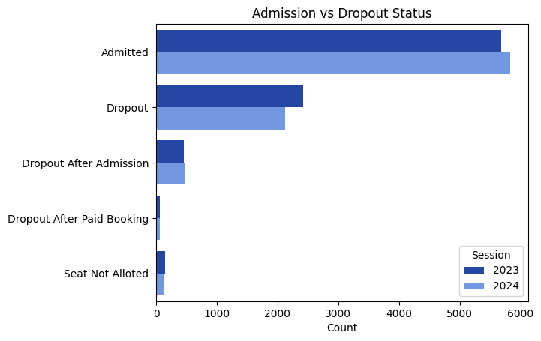

* Admissions have only increased by **2.8% in the year of 2024**
* Dropout count has seen a **dip of 13.5%** from 2023.
* However, Dropout after admission has gone up by a slight margin of **3.2%.**

**5.** **Time Trend Analysis**

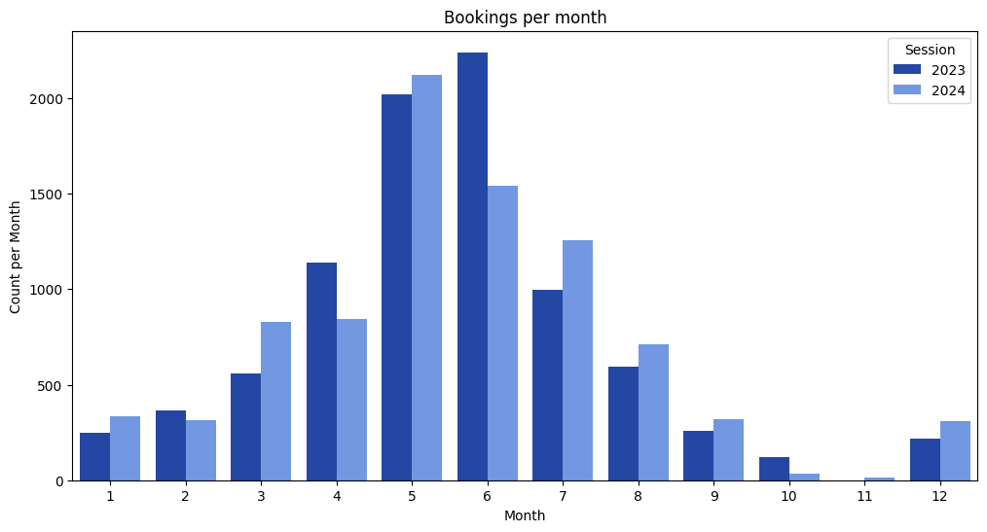

* There is a steady rise and dip through the season for both years, however the peak is to be experienced in the months of **(May & June),** significantly more than the rest of the months.

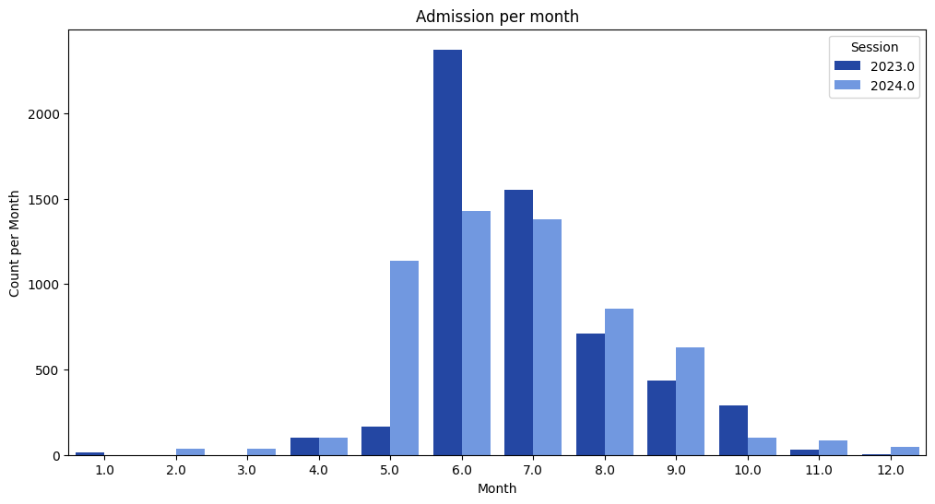

* Admission for both the years peak at the month of June, however, in 2023 the rate is almost 40% higher

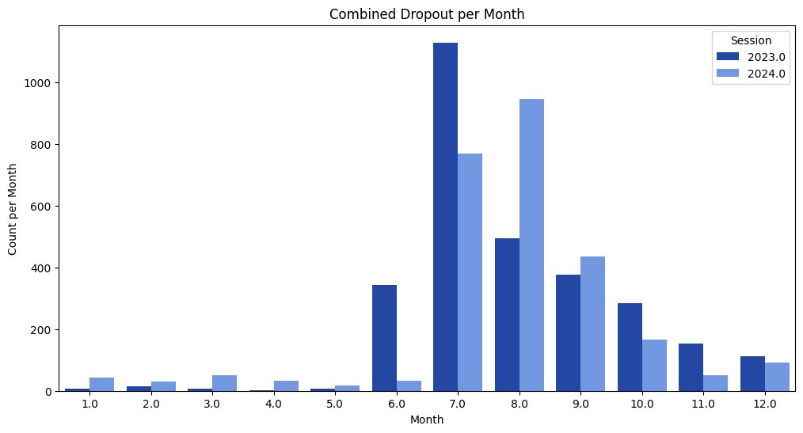

* The month of **July, August & September** experiences the highest dropouts, likely due to Joint entrance (**WBJEE/JEE Mains/JEE Advance**) results, **Placement/Job** also added to the cause.

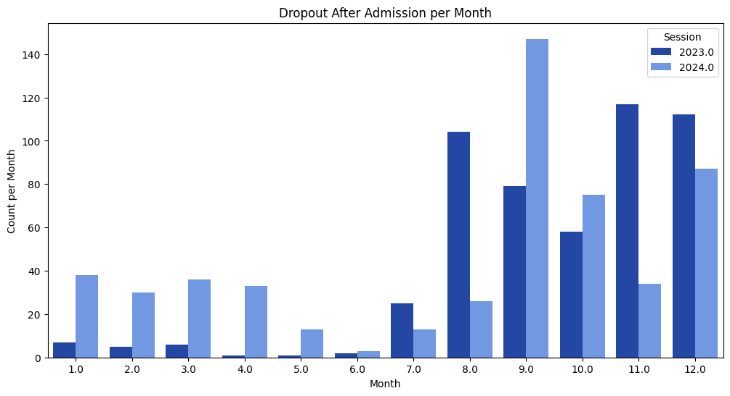

* Dropouts after admission have been significantly increased over the past year, after admission in the beginning of the year.

**6. Student Demographics Study (only admitted)**

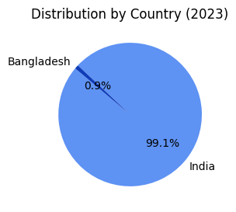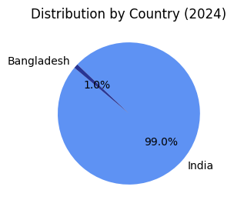

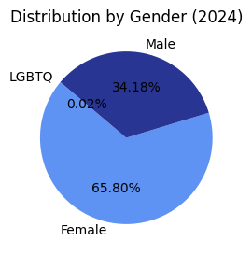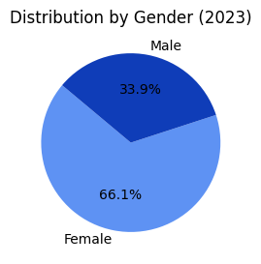

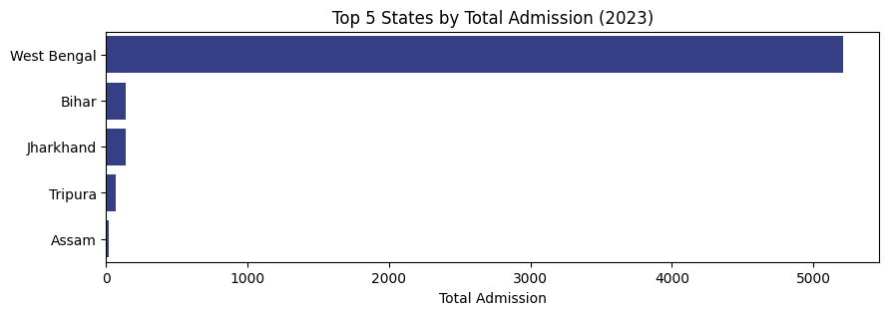 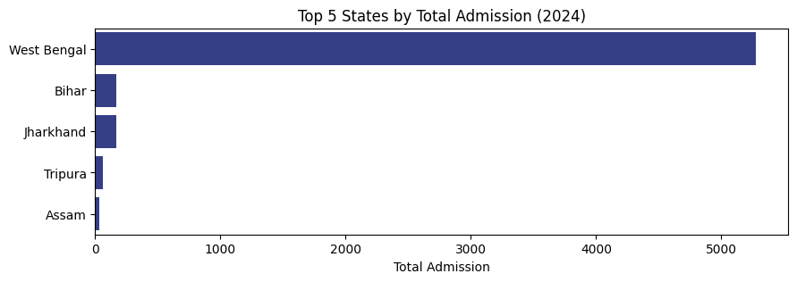

* There are no significant changes in the candidates’ demographics over both the years with respect to Country state and Gender.

**7. Course wise Analysis**

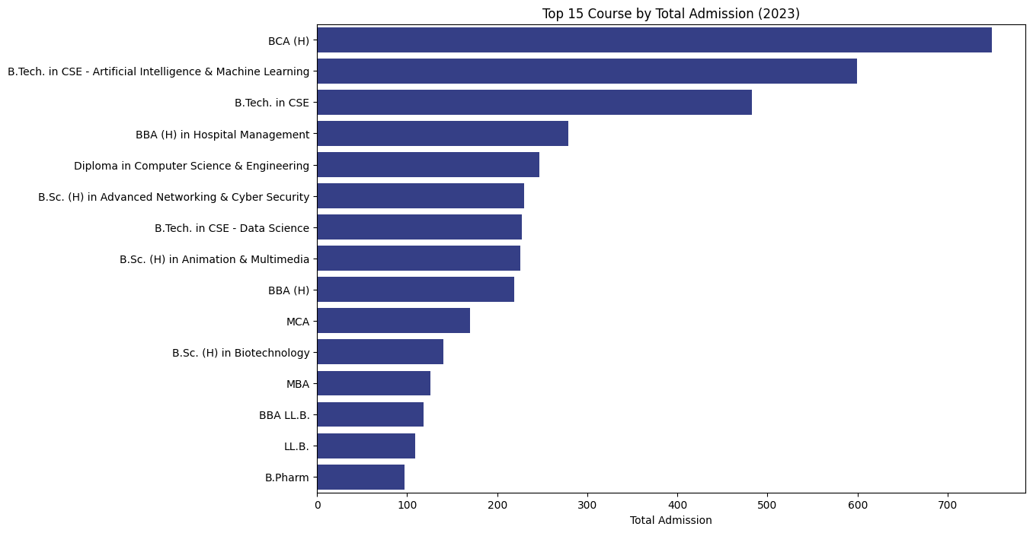

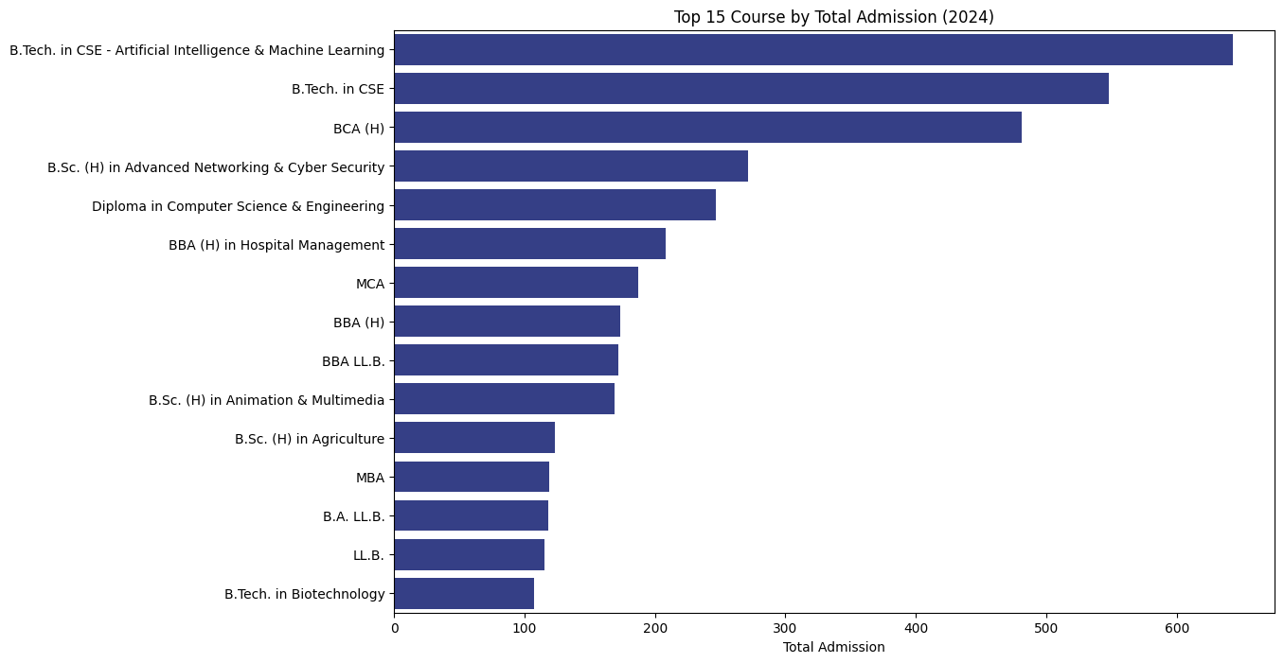

* **BCA, B. Tech CSE & B. Tech CSE AIML** have been consistently the top 3 courses of admission.

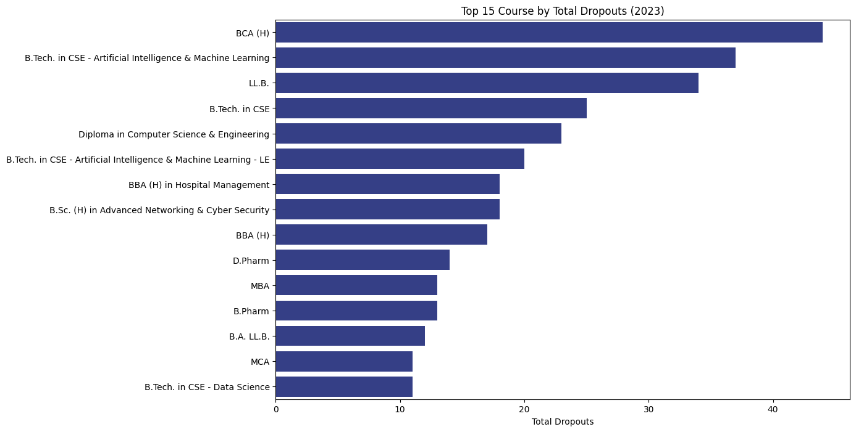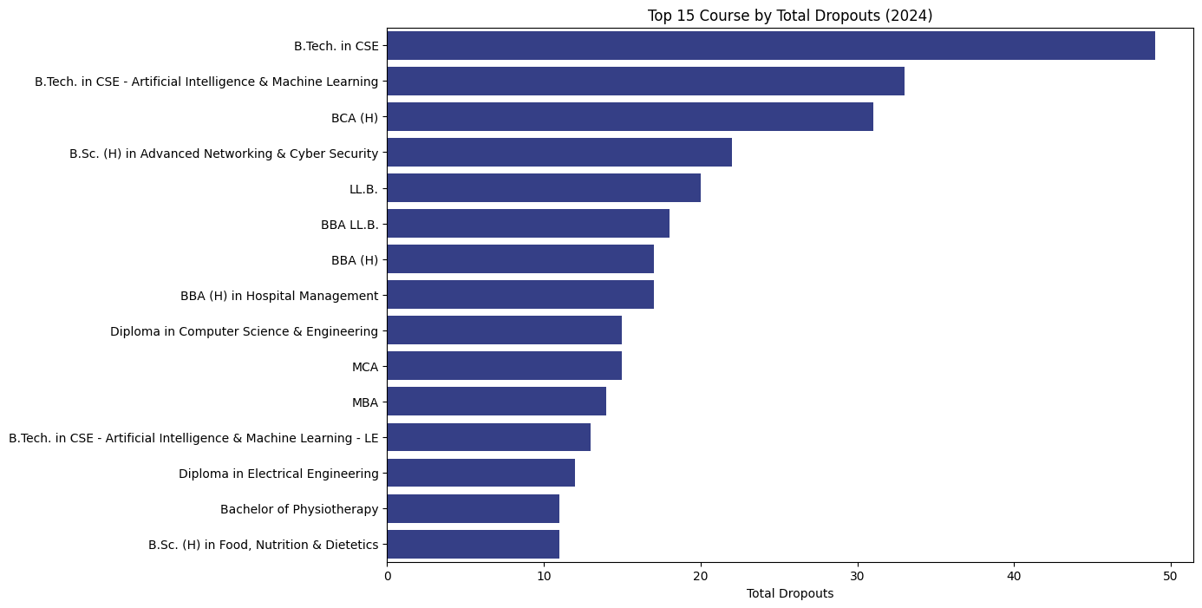

* Courses with highest admission are also the ones with highest dropouts after admission, this suggest that the candidate needs to be retained.

**Business Suggestions:** Certain Discounts, Industry relevant training programs and placement guarantees should be applied to build trust and loyalty between candidate and the organization.

**8. Admission Sources Analysis**

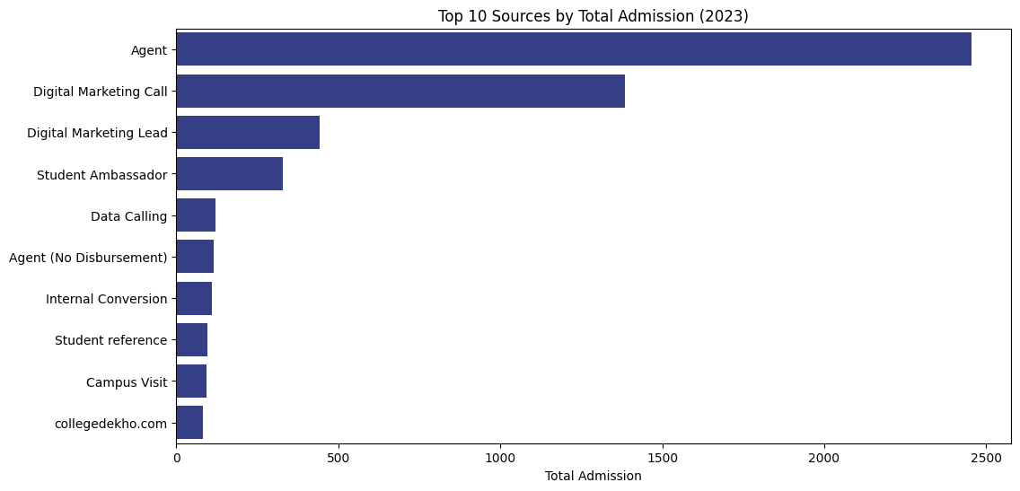

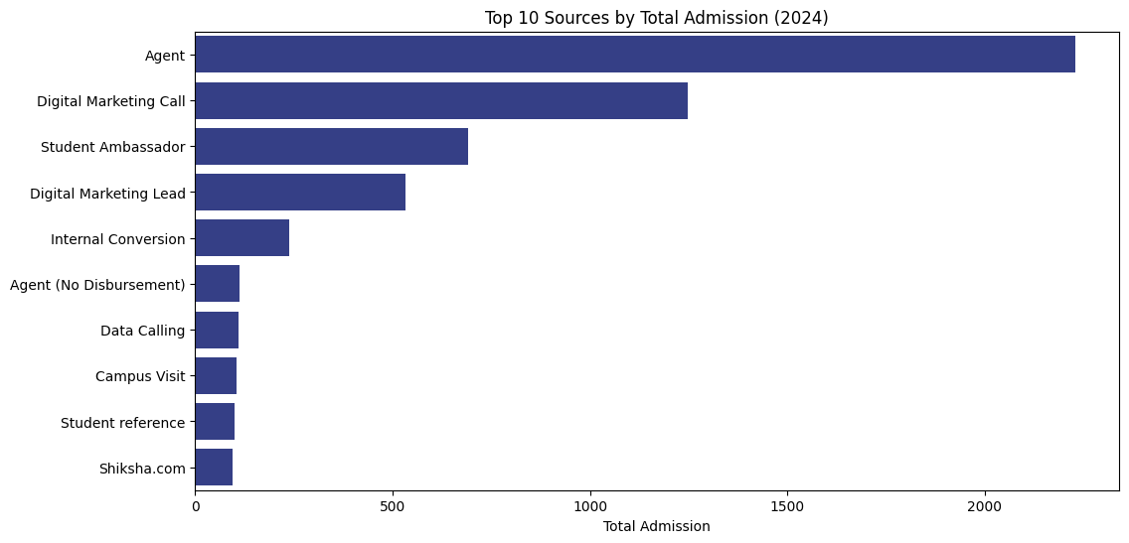

* Agents and DM Call have contributed most towards the admission consistently.
* Student Ambassadors have worked exceptionally well over the last year with more than double the number of admissions, **109.7%.**
* DM Lead has performed relatively well over the 2 years and shows potential for increase in the share for admission, but the sudden increase in Student ambassadors admissions are needed to be monitored.

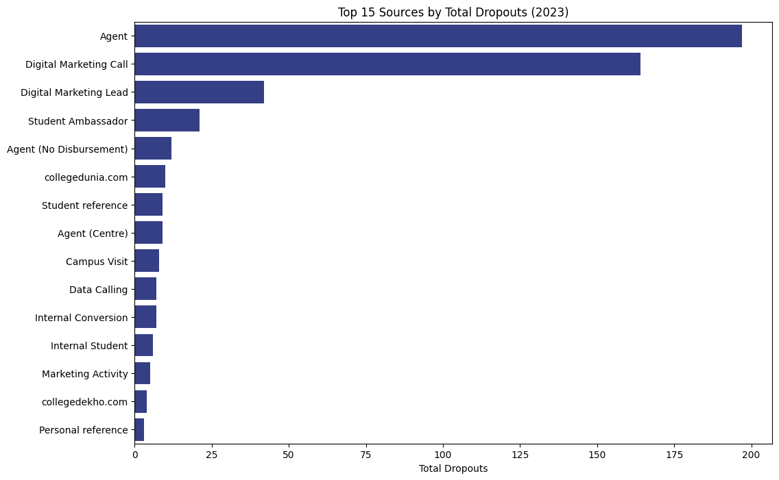

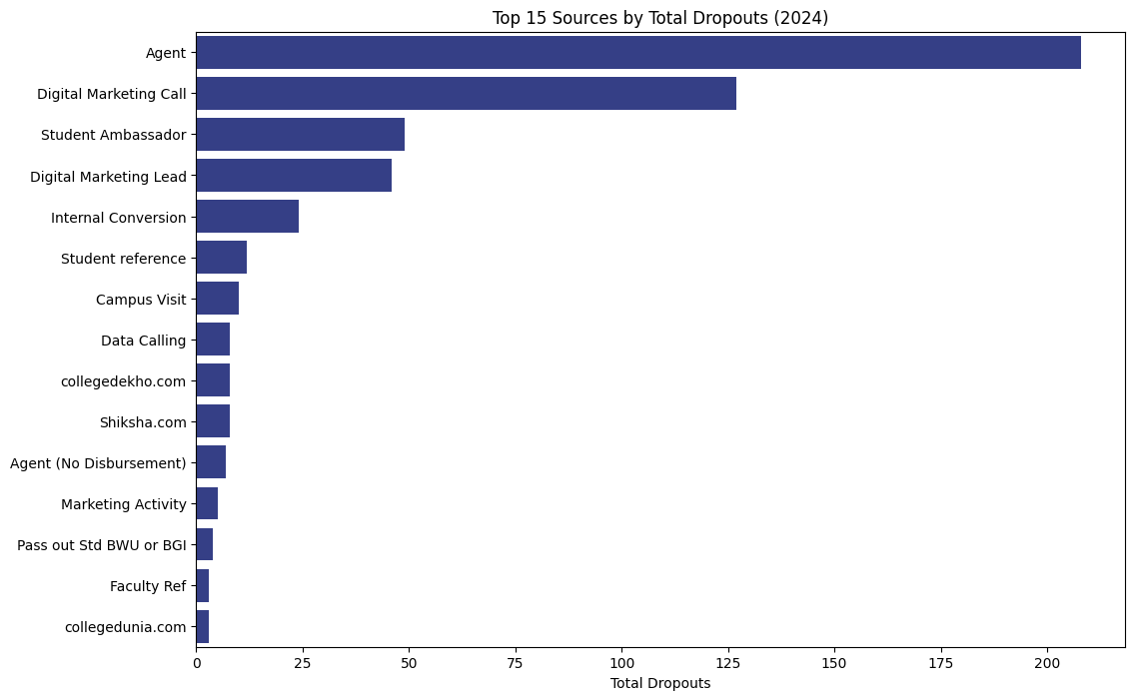

* Dropouts from Agents after admission are marginally higher in the 2024 session, which doesn’t play a significant role.
* Dropouts from DM Call and DM Lead has decreased which suggests more and more self-reliability over marketing.
* Dropouts of candidates with source Student Ambassador has increased significantly, from 2023 to 2024.

**Recommendation:** Admission needs to be diversified between more categories, Agents holds the major chunk of share, robust systems need to be placed to increase admission from self-reliable and sustainable sources like Data Calling, Campus visits and Marketing Activity.

* Our Top Agents in 2023 & 2024

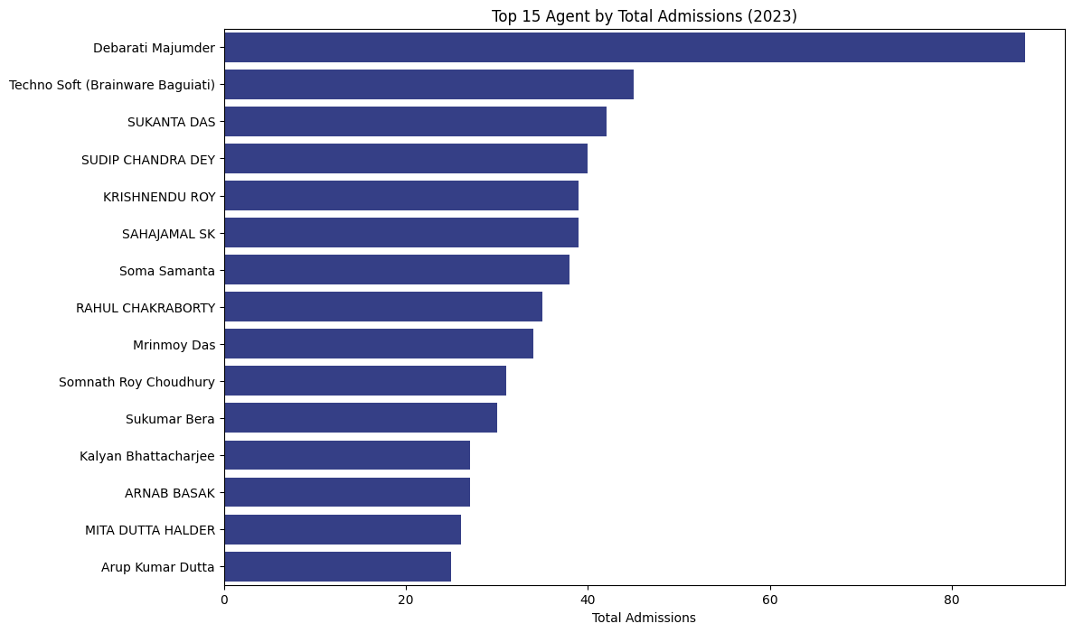

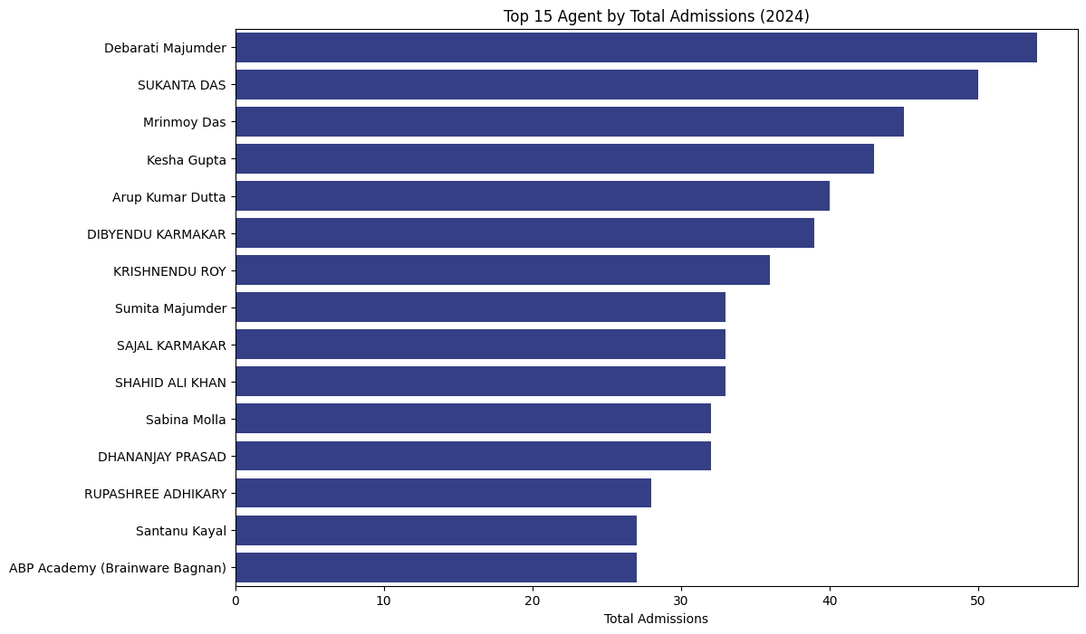

* Debarati Majumder has consistently outperformed other agents throughout both years, however in 2023 her admission peaked to 38.64% with respect to the year 2024.

**9. Group wise Analysis**

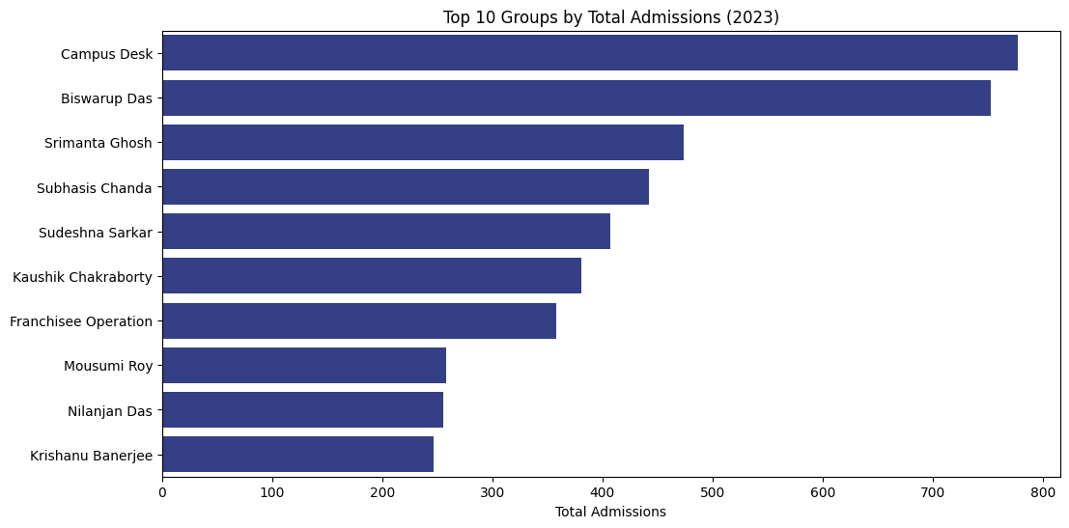

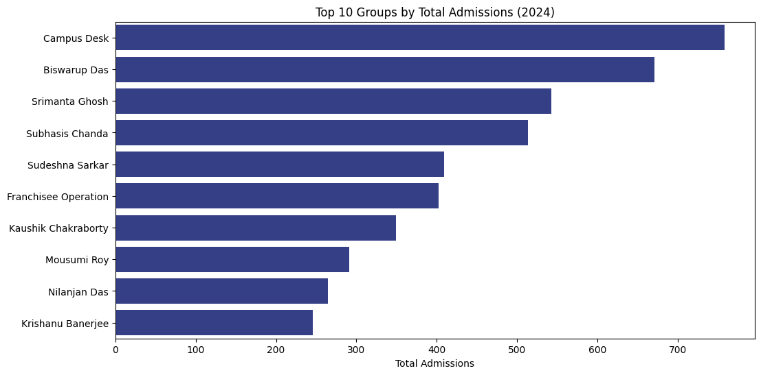

* Campus Desk & Biswarup Das groups are the top performers for both the years, however Campus desk has a moderate edge over the other group as can be seen in the chart.

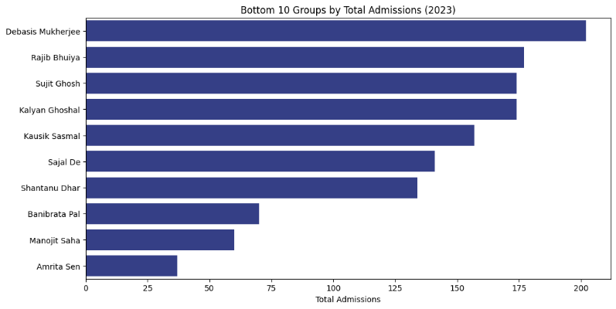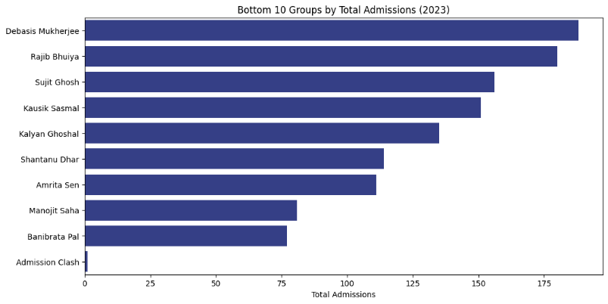

* These are the groups with the lowest admissions among all for the yar 2023 & 2024

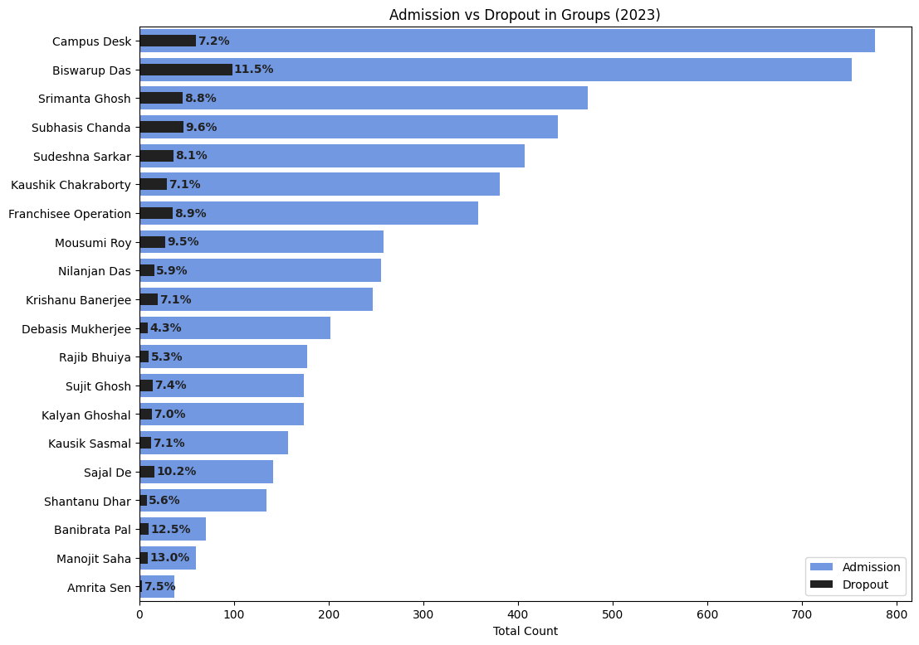

**10. Conclusion & Recommendations**

**Recommendations:**