1. Introduction to Restoring Division
The Restoring Division Algorithm is a fundamental binary division technique used in computer arithmetic. It mimics long division but operates on binary numbers, restoring the partial remainder when subtraction results in a negative value — hence the name 'Restoring'.

1.1 Key Concepts
- Dividend (Q): The number to be divided
- Divisor (M): The number dividing into the dividend
- Accumulator (A): Partial remainder register, initially set to 0
- Quotient Register (Q): Stores the dividend bits; quotient bits set here
- n: Number of bits (determines number of steps)

1.2 Algorithm Steps
- Initialize: Set A = 0 (n-bit accumulator), load Dividend into Q register
- Left Shift: Shift the combined [A, Q] register left by 1 bit
- Subtract: Compute A = A - M (subtract divisor from accumulator)
- Check Sign of A: If A >= 0 (MSB=0): Set Q[0] = 1 (quotient bit = 1), keep A as is (KEEP)
- If A < 0 (MSB=1): Set Q[0] = 0 (quotient bit = 0), RESTORE A = A + M (RESTORE)
- Repeat steps 2–4 for n iterations (n = number of bits in dividend)
- Result: Q holds the Quotient; A holds the Remainder

2. Algorithm Flowchart
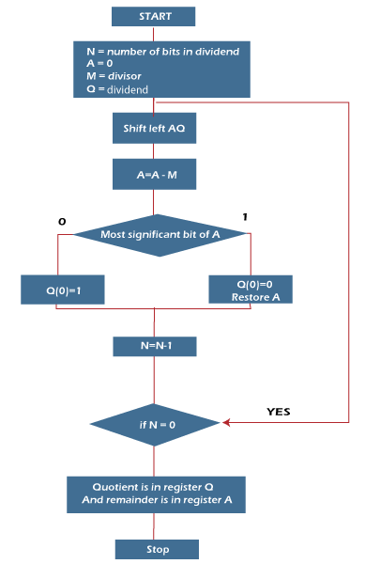

3. Overflow Condition
Overflow occurs in division when the quotient cannot be represented in the available number of bits. In restoring division, overflow is detected BEFORE beginning the algorithm.

3.1 Overflow Detection Rule
Overflow Condition: A[initial] >= M (i.e., if the upper half of the dividend >= divisor)
If the upper n bits of the 2n-bit dividend are greater than or equal to the divisor, the quotient would require more than n bits — causing overflow.

3.2 Divide-by-Zero Error
A special case of overflow: if the Divisor M = 0, division is undefined. The Verilog simulation output shows this as a 'Divide by zero error'.
From Verilog Output (Image 2): 'Divide by zero error'

3.3 Overflow Detection Table
Dividend | Divisor | Upper Half | Condition | Status
14 (1110) | 3 (0011) | 0000 | 0000 < 0011 | OK
9 (1001) | 2 (0010) | 0000 | 0000 < 0010 | OK
7 (0111) | 3 (0011) | 0000 | 0000 < 0011 | OK
78 (0100 1110) | 17 (0001 0001) | 0000 | 0000 < 0001 | OK
15 (1111) | 1 (0001) | 0111 | 0111 > 0001 | OVERFLOW
Any | 0 (0000) | — | M = 0 | DIV/0

4. Worked Example 1 — 14 ÷ 3 (From Verilog Simulation)
This example matches exactly the Verilog output shown in Image 1.

4.1 Setup
Parameter | Decimal | Binary (4-bit) | Notes
Dividend (Q) | 14 | 1110 | Loaded into Q reg
Divisor (M) | 3 | 0011 | Subtracted each step
Accumulator (A) | 0 | 00000 | 5-bit: MSB is sign
Expected Quotient | 4 | 0100
Expected Remainder | 2 | 0010

4.2 Step-by-Step Trace
Step | Operation | A (Accumulator) | Q (Quotient Reg) | Action
Init | Load Q=1110, A=00000 | 00000 | 1110 | Initialize
Step 1 | Left Shift | 00001 | 1100 | Shift
Step 1 | A-M = 00001-00011 | 11110 (30) | 1100 | Subtract
Step 1 | MSB=1 → RESTORE A=A+M | 00001 | 1100 | Restore → Q[0]=0
Step 1 End |  | 00001 | 1100
Step 2 | Left Shift | 00011 | 1000 | Shift
Step 2 | A-M = 00011-00011 | 00000 (0) | 1000 | Subtract
Step 2 | MSB=0 → KEEP | 00000 | 1001 | Keep → Q[0]=1
Step 2 End |  | 00000 | 1001
Step 3 | Left Shift | 00001 | 0010 | Shift
Step 3 | A-M = 00001-00011 | 11110 (30) | 0010 | Subtract
Step 3 | MSB=1 → RESTORE | 00001 | 0010 | Restore → Q[0]=0
Step 3 End |  | 00001 | 0010
Step 4 | Left Shift | 00010 | 0100 | Shift
Step 4 | A-M = 00010-00011 | 11111 (31) | 0100 | Subtract
Step 4 | MSB=1 → RESTORE | 00010 | 0100 | Restore → Q[0]=0
Step 4 End |  | 00010 | 0100
Final Quotient Q = Q = 0100 = 4 |  |  | Remainder R = A = 0010 = 2
Verilog Output confirms: Final Q=0100 (4) R=0010 (2) ✓

5. Worked Example 2 — 9 ÷ 2 (From Verilog Simulation)
This example matches the Verilog output shown in Image 2.

5.1 Setup
Parameter | Decimal | Binary (4-bit) | Notes
Dividend (Q) | 9 | 1001 | Loaded into Q reg
Divisor (M) | 2 | 0010
Expected Quotient | 4 | 0100
Expected Remainder | 1 | 0001

5.2 Step-by-Step Trace
Step | Operation | A (Accumulator) | Q (Quotient Reg) | Action
Init | Load Q=1001, A=00000 | 00000 | 1001 | Initialize
Step 1 | Left Shift | 00001 | 0010 | Shift
Step 1 | A-M = 00001-00010 | 11111 (31) | 0010 | Subtract
Step 1 | MSB=1 → RESTORE | 00001 | 0010 | Restore → Q[0]=0
Step 1 End |  | 00001 | 0010
Step 2 | Left Shift | 00010 | 0100 | Shift
Step 2 | A-M = 00010-00010 | 00000 (0) | 0100 | Subtract
Step 2 | MSB=0 → KEEP | 00000 | 0101 | Keep → Q[0]=1
Step 2 End |  | 00000 | 0101
Step 3 | Left Shift | 00000 | 1010 | Shift
Step 3 | A-M = 00000-00010 | 11110 (30) | 1010 | Subtract
Step 3 | MSB=1 → RESTORE | 00000 | 1010 | Restore → Q[0]=0
Step 3 End |  | 00000 | 1010
Step 4 | Left Shift | 00001 | 0100 | Shift
Step 4 | A-M = 00001-00010 | 11111 (31) | 0100 | Subtract
Step 4 | MSB=1 → RESTORE | 00001 | 0100 | Restore → Q[0]=0
Step 4 End |  | 00001 | 0100
Final Quotient Q = Q = 0100 = 4 |  |  | Remainder R = A = 0001 = 1
Verilog Output confirms: Final Q=0100 (4) R=0001 (1) ✓

6. OUTPUT:
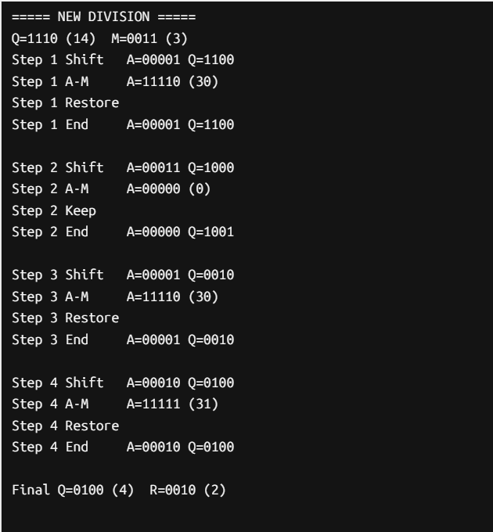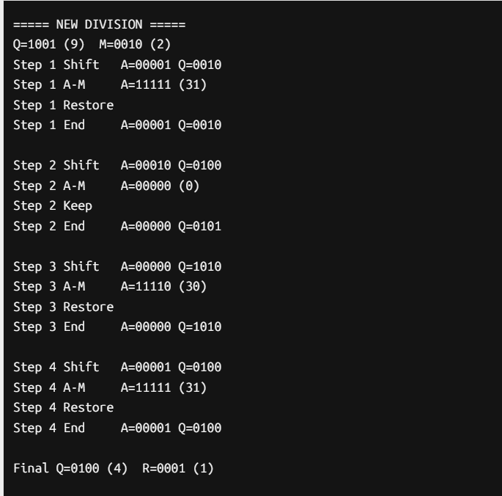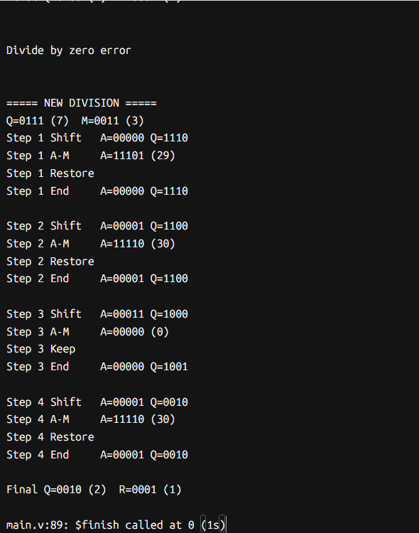

7. Comparison Chart — All Worked Examples
Dividend | Divisor | Binary Operation | Quotient | Remainder | Source
14 | 3 | 1110 ÷ 0011 | 0100 = 4 | 0010 = 2 | Verilog Img 1
9 | 2 | 1001 ÷ 0010 | 0100 = 4 | 0001 = 1 | Verilog Img 2
7 | 3 | 0111 ÷ 0011 | 0010 = 2 | 0001 = 1 | Verilog Img 3
78 | 17 | 01001110 ÷ 00010001 | 00000100 = 4 | 00001010 = 10 | Manual (8-bit)
Any | 0 | — ÷ 00000000 | N/A | N/A | Div/Zero Error

8. Restoring Division — Action Decision Chart
Condition | MSB of A | Sign of A | Action | Q[0] Set
A - M >= 0 | 0 | Positive | KEEP (no restore) | 1
A - M < 0 | 1 | Negative | RESTORE: A=A+M | 0
M = 0 | N/A | N/A | Divide by Zero ERROR | —
Overflow (A>=M initially) | N/A | N/A | OVERFLOW, halt | —

10. Verilog Simulation — Key Code Snippet
module restoring_division;

parameter N = 4;

reg [N-1:0] dividend;
reg [N-1:0] divisor;

reg [N:0] A;
reg [N-1:0] Q;
reg [N-1:0] M;

reg [N-1:0] quotient;
reg [N-1:0] remainder;

reg error;

integer i;

task run;
begin
A = 0;
Q = dividend;
M = divisor;
error = 0;

if (M == 0) begin
error = 1;
quotient = 0;
remainder = 0;
$display("\nDivide by zero error\n");
end
else begin
$display("\n===== NEW DIVISION =====");
$display("Q=%b (%0d) M=%b (%0d)", Q, Q, M, M);

for (i = 0; i < N; i = i + 1) begin

A = {A[N-1:0], Q[N-1]};
Q = {Q[N-2:0], 1'b0};

$display("Step %0d Shift A=%b Q=%b", i+1, A, Q);

A = A - M;
$display("Step %0d A-M A=%b (%0d)", i+1, A, A);

if (A[N] == 1) begin
A = A + M;
Q[0] = 0;
$display("Step %0d Restore", i+1);
end
else begin
Q[0] = 1;
$display("Step %0d Keep", i+1);
end

$display("Step %0d End A=%b Q=%b\n", i+1, A, Q);
end

quotient = Q;
remainder = A[N-1:0];

if (quotient > dividend)
$display("Overflow detected");

$display("Final Q=%b (%0d) R=%b (%0d)\n",
quotient, quotient, remainder, remainder);
end
end
endtask

initial begin

dividend = 4'b1110;
divisor = 4'b0011;
run();

dividend = 4'b1001;
divisor = 4'b0010;
run();

dividend = 4'b1010;
divisor = 4'b0000;
run();

dividend = 4'b0111;
divisor = 4'b0011;
run();

$finish;
end

endmodule

11. Summary
Feature | Description
Algorithm Type | Sequential shift-and-subtract, n iterations for n-bit numbers
Hardware | Adder/Subtractor, two registers (A and Q), counter
Time Complexity | O(n) — one step per bit of dividend
Overflow Detection | Check upper half of A against M before starting
Divide-by-Zero | Check M != 0 before starting; flag error if M = 0
Restoring Step | When subtraction gives negative result, add back divisor (restore A)
Final Result | Quotient in Q register; Remainder in A accumulator

— End of Document —

