A Project Report on

Electronics Shop Management System

“ ESMS ”

Developed By:

IT152 IT154 IT151

Solanki Apar Soni Neel Shinde Rahul

Guided By

Internal Guide:

**Prof. Archana N. Vyas**



Department of Information Technology Faculty of Technology,

DharmSinh Desai University College Road, Nadiad-387001

October-2022

CERTIFICATE

This is to certify that the project entitled

“Electronics Stock Management System” is,

a bonafide report of the work carried out by

1) Solanki Apar Student ID No: 20ITUOS 060

2) Shinde Rahul Student ID No: 20ITUOS004

3) Soni Neel Student ID No: 20ITUOS018

of Department of Information Technology, semester V, under the guidance and

supervision for the subject Database Management System. They were involved in Project training during the academic year 2022-2023.



Dharamsinh desai university nadiad

*COMMENDATION*

We would like to express our heartfelt gratitude to everyone who contributed to the successful completion of our project "ESMS"

The success and ultimate conclusion of this project necessitated a great deal of advice and support from a large number of individuals and we are incredibly fortunate to have received it all along with the project's completion.

We owe a debt of appreciation to **Prof. Archana N. Vyas,** our project guide, who took an interest in our project work and directed us through it till it was completed by giving all of the required assistance for creating a solid Database System.

We'd also want to express our gratitude to all of our speakers. Finally, we express our gratitude to all of our friends and colleagues.

INDEX

**I ) Certificate**

**II) Commendation**

**1) System** Overview 1

**1.**1) Current System & Objective of System

1.2) Advantage of System

**2) E-R Diagram 2**

**3) Schema Diagram 3**

**4) Data Dictionary 4**

**5) Database Implementation 8**

**5.1) Create Schema 8**

**5.2) Insert Data Values 12**

**5.3) Queries DBMS (Based on constructs) 16**

**5.4) Queries DBMS (Based On joins and Subqueries) 20**

**5.5) PL/SQL Blocks (Views) 24**

**5.6) Functions and Trigger 25**

**5.7) Cursors 29**

**6) Future Enhancement System 30**

**7) Bibliography 31**

**Source Code = >** [**Electronics_Stock_Management_System**](https://github.com/neel13062003/Electronics_Stocks_Management_System)

**1) SYSTEM OVERVIEW**

**1.1 ) Current System & Objectives**

Our database will be designed for companies or businessmen who are dealing with Clients and suppliers daily. Our major focus will be on structuring this data in such a way that the Person who is the owner of this Application/Database can easily manage their stocks up-to-date & also this help in maintaining whole Money transactions from both side Clients & Suppliers. It will also be done in an effective manner since we do not want our database to become redundant.

**1.2) Advantage of System**

ESMS is Server and Clients Side Application. All users can purchase Electronics systems online like Flip kart – Amazon. With Also Supplier Owner Can purchase Products from the Supplier or Dealer. Both Users and Supplier Details related to Products or Payments everything manages accurately.

**2) ER-Entity Relational Diagram**

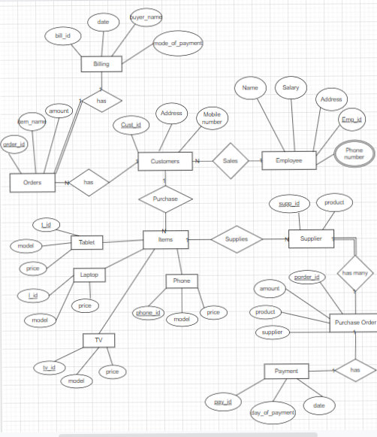

**Link =>** [**ER Diagram**](https://github.com/neel13062003/Electronics_Stocks_Management_System/blob/main/ERDiagram.png)

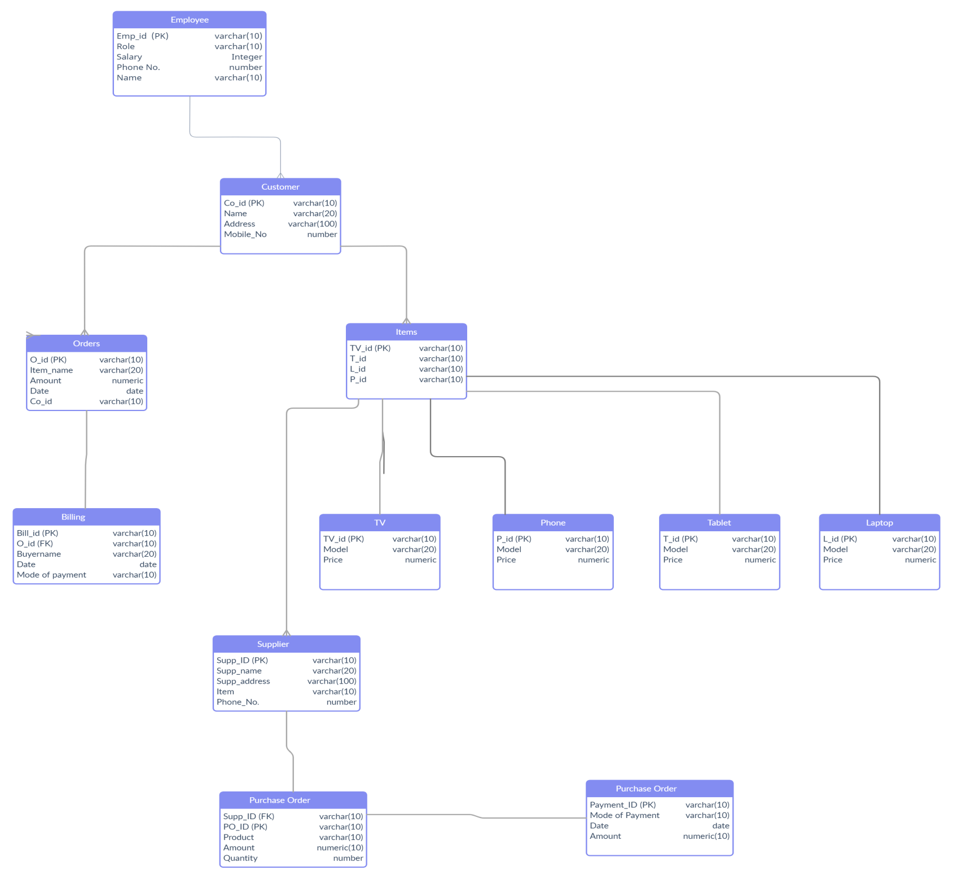**3) Relational Schema Diagram**

**Link =>** [**Relational_Schema**](https://github.com/neel13062003/Electronics_Stocks_Management_System/blob/main/Electronic%20shop.png)

**4) Data Dictionary**

**4.1) Billing**

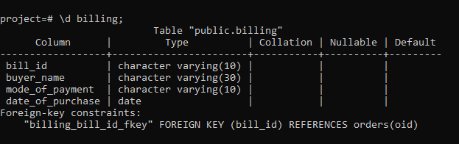

**4.2) Customer**

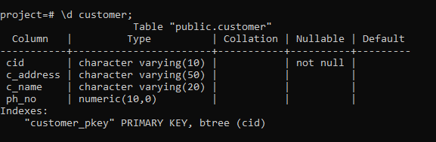

**4.3) Employee**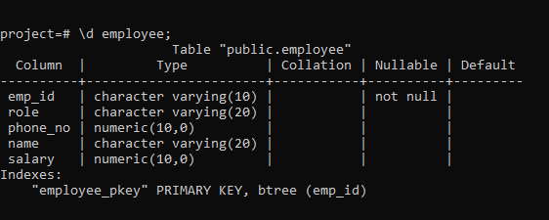

**4.4) Items**

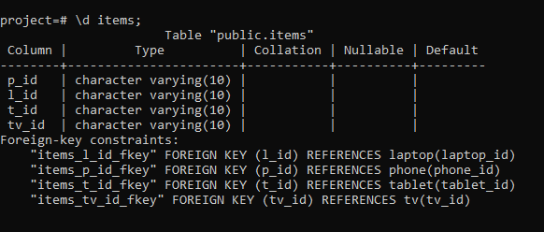

**4.5) Laptop**

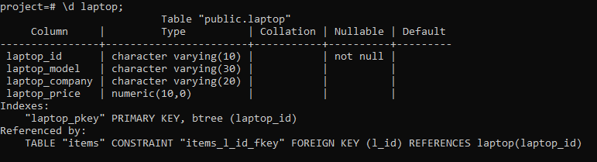

**4.6) Orders**

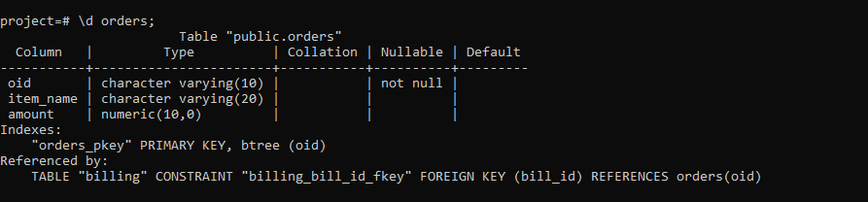

**4.7) Payment**

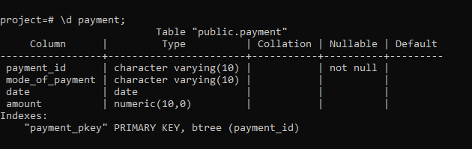

**4.8) Phone**

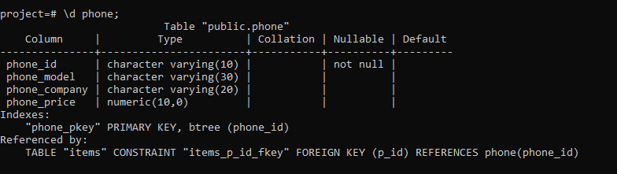

**4.9) Purchase_order**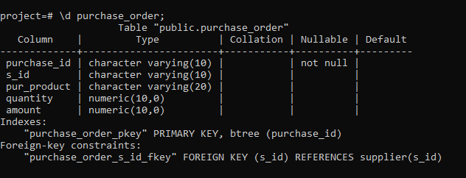

**4.10) Supplier**

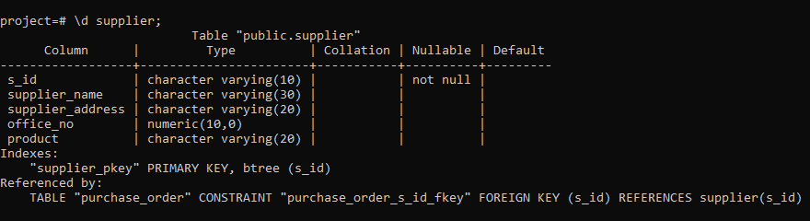

**4.11) Tablet**

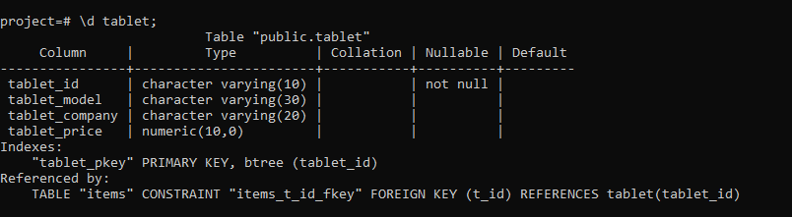

**4.12) Tv**

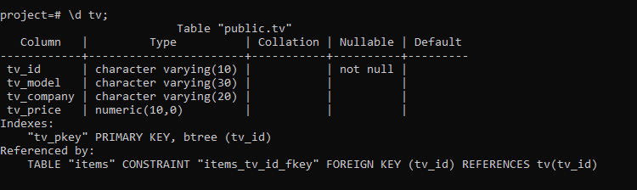

5) Data Implementation

* First Create Database name -> Project *

Creat Database Project;

5.1) Schema => Total 12 Table

1) Employee

CREATE table Employee( Emp_id varchar(10) PRIMARY KEY, role varchar(20), phone_no numeric(10),name varchar(20), salary numeric(10));

2)Customer

CREATE TABLE Customer (CID varchar(10) PRIMARY KEY,c_address varchar(50), c_name varchar(20), ph_no numeric(10));

3)Orders

create table Orders(OID varchar(10) PRIMARY KEY,Item_name varchar(20), amount numeric(10));

4)Billing

Create table Billing( Bill_ID varchar(10) REFERENCES Orders(OID),Buyer_name varchar(30),mode_of_payment varchar(10),date_of_purchase Date);

5) Tv

Create table Tv(Tv_id varchar(10) primary key,Tv_model varchar(30),Tv_company varchar(20),Tv_price numeric(10));

6) Phone

Create table Phone( Phone_id varchar(10) primary key, Phone_model varchar(30), Phone_company varchar(20), Phone_price numeric(10));

7) Laptop

Create table Laptop( Laptop_id varchar(10) primary key, Laptop_model varchar(30),Laptop_company varchar(20),Laptop_price numeric(10));

8) Tablet

Create table Tablet(Tablet_id varchar(10) primary key,Tablet_model varchar(30),Tablet_company varchar(20),Tablet_price numeric(10));

9) Items

Create table Items(P_id varchar(10) REFERENCES Phone(Phone_id), L_id varchar(10) REFERENCES Laptop(Laptop_id), T_id varchar(10) REFERENCES Tablet(Tablet_id), Tv_id varchar(10) REFERENCES Tv(Tv_id) );

10) Supplier

Create table Supplier(S_id varchar(10) primary key,supplier_name varchar(30),supplier_address varchar(20), office_no numeric(10),product varchar(20));

11) Purchaese_Order

  Create table Purchase_order(Purchase_id varchar(10) primary key,S_id varchar(10) REFERENCES Supplier(S_id), pur_product varchar(20), quantity numeric(10), amount numeric(10));

12)Payment

  Create table Payment( payment_id varchar(10)  PRIMARY KEY,mode_of_payment varchar(10), date DATE,amount numeric(10));

5.2) Inserting & Displaying Values

1) Billing

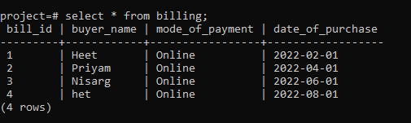

2) Customer

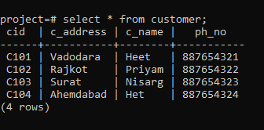

3) Employee

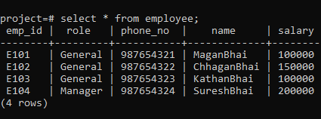

4) TV

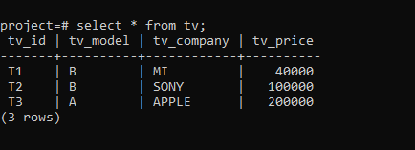

5) Tablet

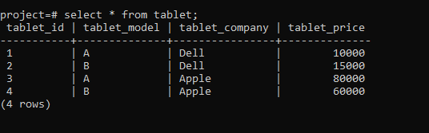

6) Supplier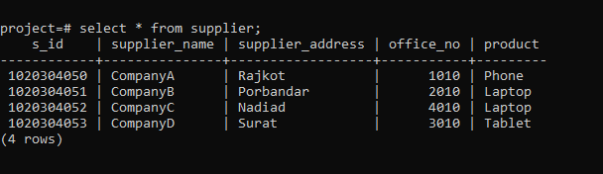

7) Purchase_Order

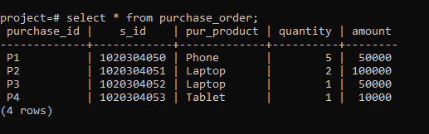

8) Phone

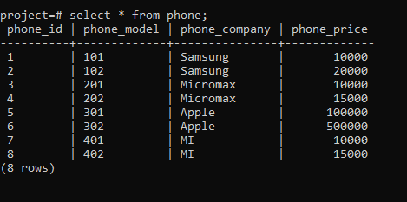

9) Orders

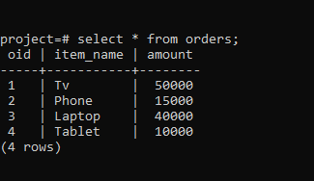

10) Payment

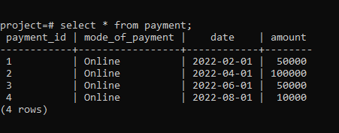

11) Laptop

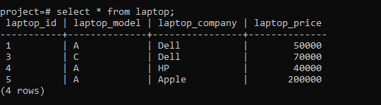

5.3) Queries Using Basic DBMS

 1) Display the Customers who are from vadodara.

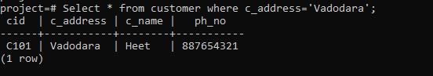

/*Between & And Operator*/

2)Display Payment recieve between 1 February to 1 April;

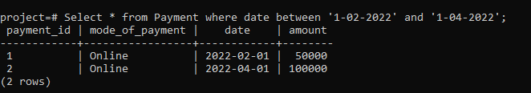

/*Like Operator*/

3)Display Customer Name start with 'A'

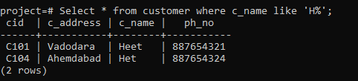

/*Order By => ordering in acending */

4)Display Employee Deatials accoring to sort their name

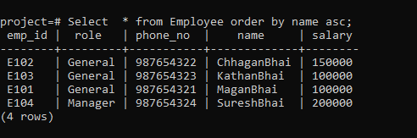

/*Aggregate function use & use of group by because we want alo display name with aggregate function*/

5)Disply count total sales of company in month of august 2022 with Buyer Name

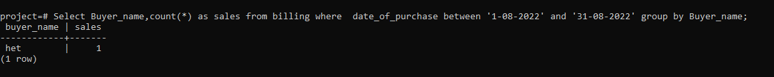

/*Simple Aggregate Function also use of alias*/

6)Disply count total sales of company in month of august 2022

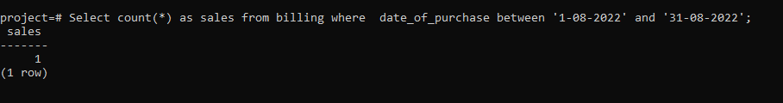

/*Aggregate Function + Group BY + Order by*/

7)Disply count total sales of company in month of august to April 2022 with Buyer Name with desceding order of name

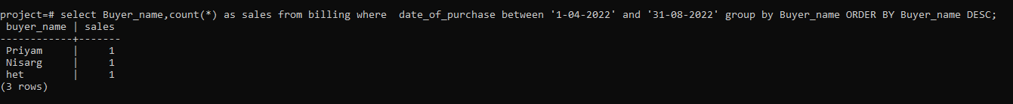

/*Aggregate Function with Inner join*/

8)Count Supplier name who purchase amount>25000

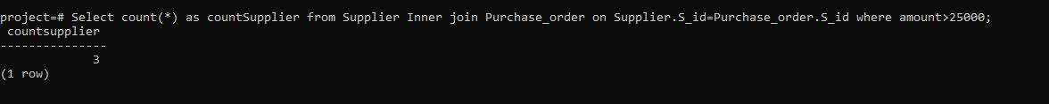

/*Order By*/

9)Display Laptop Detials with their price arranging in aceding order

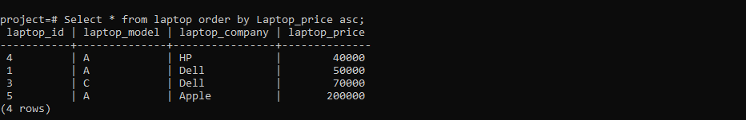

/*Left join*/

10)Display Detials of Customers who purchase laptop in 2022

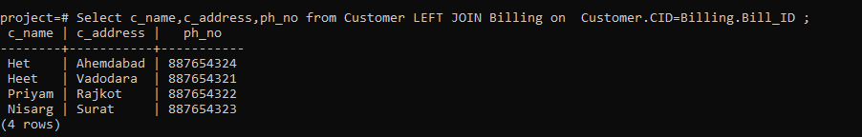

/*Full Outer Join*/

11)Display Details of Customer whose purchase is >2000;

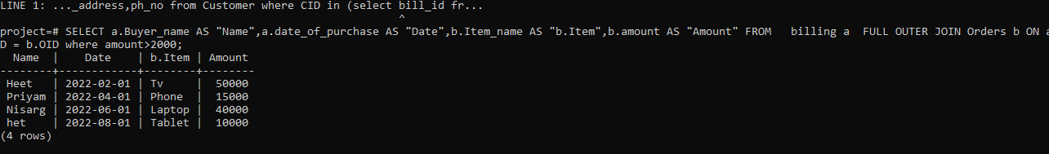

/*Cross Join*/

12)Give Customer Details having billing amount> 50K

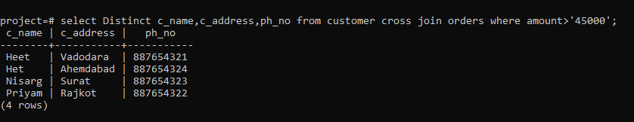

/*Using SubQuery*/

13)Display Supplier Deatails whose purchase amount > 50000

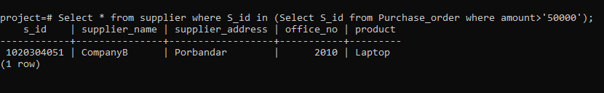

/*Using SubQuery*/

14)Display Details of Customer Who purchase Laptop in 2022

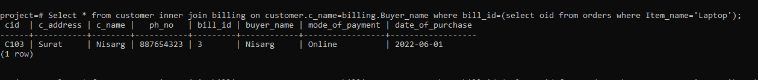

/*Using SubQuery*/

15)Display Details of Customer Who purchase Laptop in 2022

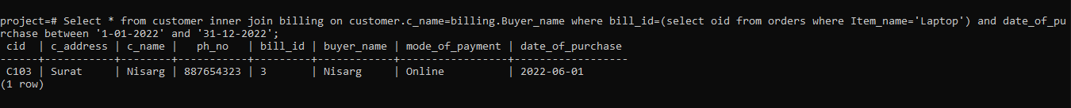

/*Using SubQuery*/

16)Display Supplier Detials Whose Supplying Tablet/Iphone as we wish

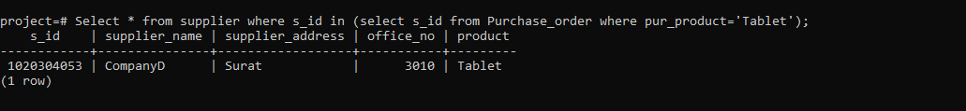

/*Using SubQuery*/

17)Give Customer Details having billing amount >1lakh



**5.5) PL/SQL Blocks (Views)**

**1) View**

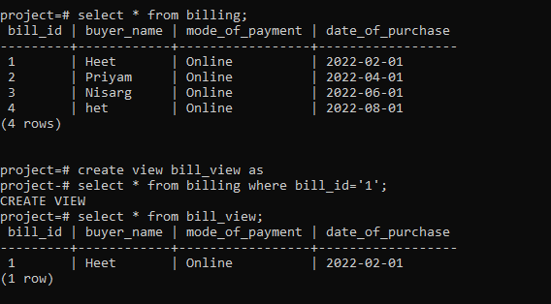

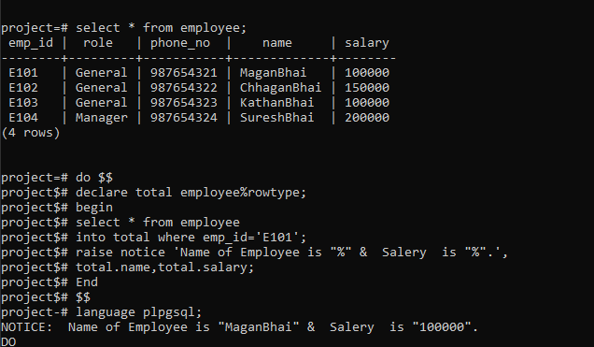2) RowType

**5.6) Functions & Trigger**

**1) Create order_audit for if any unauthentic person insert/update/delete our most important orders table then all actions sawn in order_audit table.**

*Function*

CREATE OR REPLACE FUNCTION do_order_audit() RETURNS TRIGGER AS $TriggerNameAsIWant$

    BEGIN

            INSERT INTO order_audit(oid_1,Item_name1,entry_date) values(NEW.oid,NEW.Item_name,current_timestamp);

            RETURN NEW;

    END;

$TriggerNameAsIWant$

LANGUAGE PLPGSQL;

*Trigger*

/*cust_audit trigger name , orders = table name*/

CREATE TRIGGER order_audit_here_trigger_name15

Before  INSERT OR UPDATE OR DELETE on Orders

FOR EACH ROW EXECUTE PROCEDURE

do_order_audit();

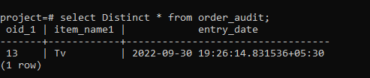

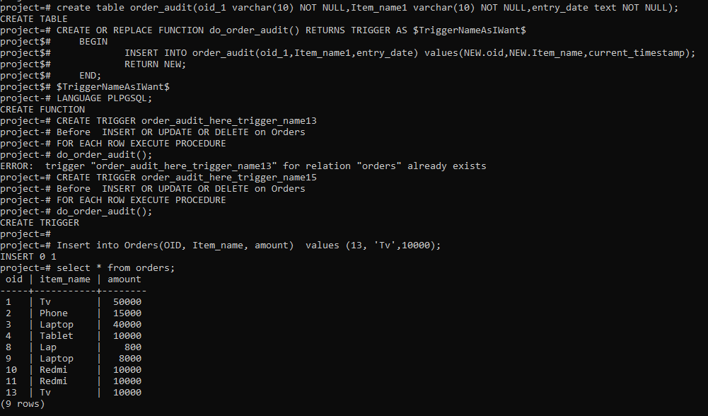

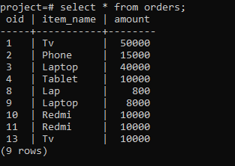

2) Create Function & Trigger for if supplier add wrong entry like negative value trigger shows.

*Trigger*

CREATE TRIGGER checkage11

Before INSERT OR UPDATE OR DELETE on Purchase_order

FOR EACH ROW EXECUTE PROCEDURE

fun();

*Function*

CREATE OR REPLACE FUNCTION fun() RETURNS TRIGGER AS $$

    BEGIN

        IF new.quantity < 0 THEN

            RAISE EXCEPTION 'You Must Order Something!!!';

            /*RETURN NEW;*/

        END IF;

        RETURN New;

    END;

$$

LANGUAGE PLPGSQL;

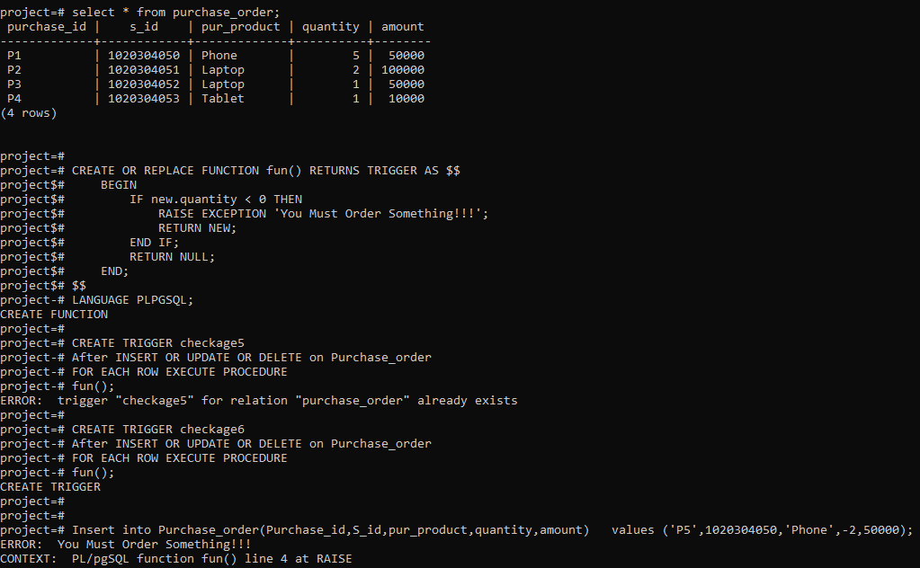

5.7) Cursor

Create a Cursor which traverses through users table where role is General.

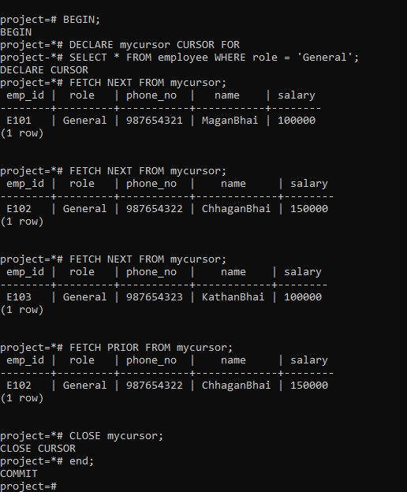

BEGIN;

DECLARE mycursor CURSOR FOR

SELECT * FROM employee WHERE role = 'General';

FETCH NEXT FROM mycursor;

FETCH PRIOR FROM mycursor;

CLOSE mycursor;

end;

6) Future Enhancements of this System

● We will design Front-end using React Framework and Develop Backend in NodeJS

● Methods and user data input will be a lot easy after the implementation of GUI.

● In the future, we can place the system on the cloud so the maintenance of the data can be reduced.

7) Bibliography

● We created ER-Model on Whimsical and Relational Schema on Creatively

● ***ER-MODEL*** created using

<https://whimsical.com/>

● ***RELATIONAL SCHEMA*** created using

<https://app.creately.com/d/yQAR0D8Dgpa/edit>

● For the implementation of this project, we referred to materials shared by

**Prof. Archana N.Vyas** & the following websites and books:

**Book:**

Database System Concepts

-Henry F. Korth & A. Silberschatz 2nd Ed. McGraw-Hill 1991

**Websites:**

=> <https://www.w3schools.com/sql/sql_syntax.asp>

=> <https://www.tutorialspoint.com/index.htm>

=> <https://dev.mysql.com/doc/>

=><ms-database-management-system-set-1/>

=>[https://www.geeksforgeeks.org/introduction-of-dbms- database-management-system-set-1/](https://www.geeksforgeeks.org/introduction-of-dbms-%09%09database-management-system-set-1/)