### **Comprehensive Linux Operations**

#### **Project Overview**

This project spans various aspects of Linux system administration, including file management, user and group management, service control, process handling, and more. You will be completing tasks that simulate real-world scenarios, providing hands-on experience with Linux commands and configurations.

### **Project Breakdown**

#### **Part 1: Creating and Editing Text Files.**

#### 

#### **Part 2: User & Group Management (20 minutes)**

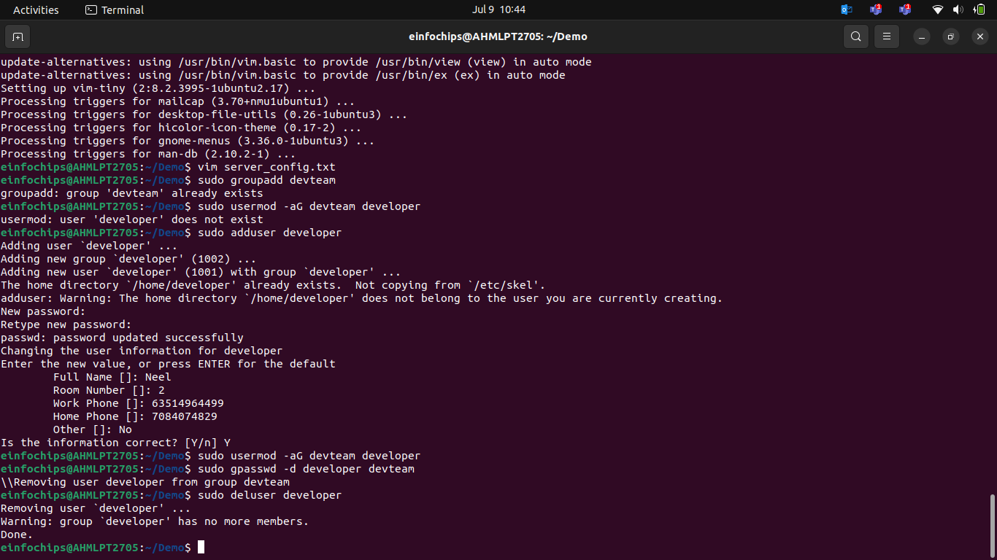

#### **Part 3: File Permissions Management (20 minutes)**

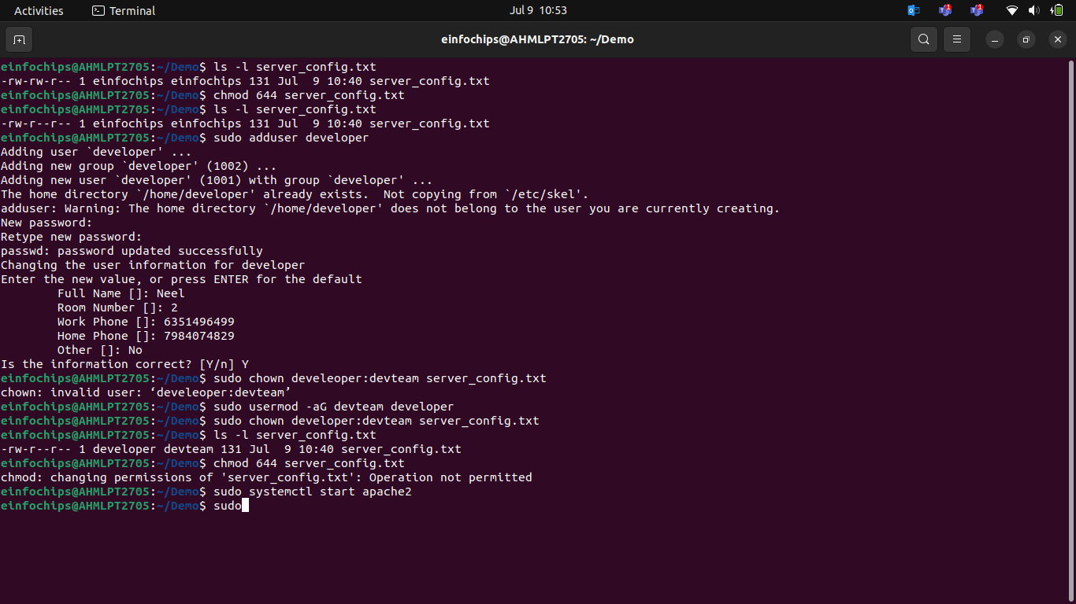

#### **Part 4: Controlling Services and Daemons (20 minutes)**

**Scenario:** Manage the web server service to ensure it is running correctly and starts on boot.

1. **Managing Services with systemctl**
2. **Understanding Daemons**

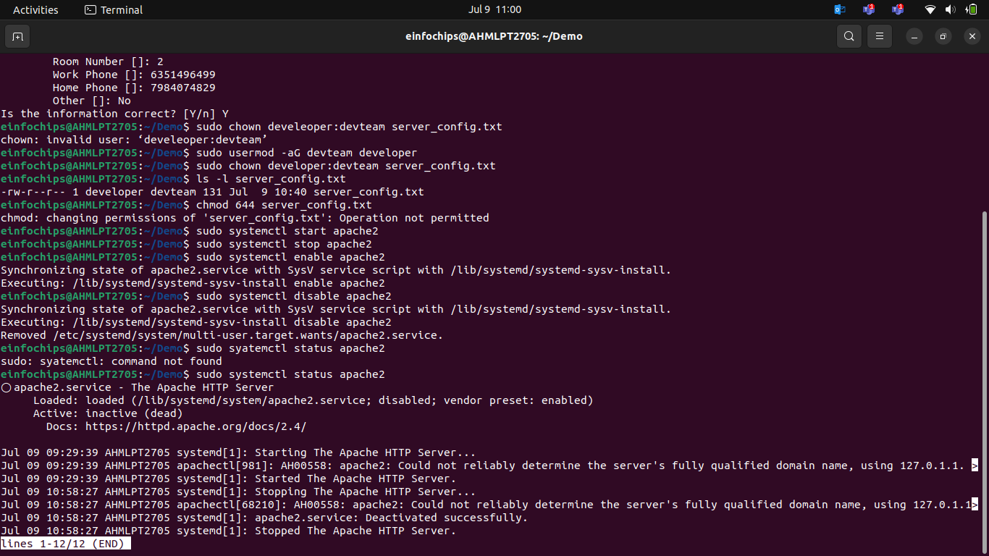

#### **Part 5: Process Handling (20 minutes)**

**Scenario:** Monitor and manage processes to ensure the server is performing optimal

### **Creating and Deploying a Static Website with Apache2**

#### **Part 1: Installing Apache2 (5 minutes)**

1. **Update Package Lists**
2. **Install Apache2**
3. **Start and Enable Apache2**
4. **Verify Installation**

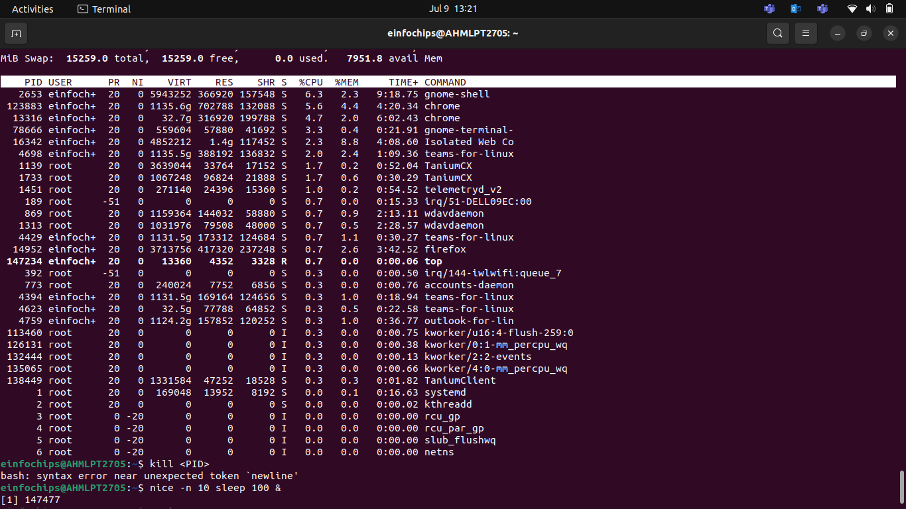

#### **Part 2: Creating the Website**

1. **Navigate to the Web Directory**
2. **Create a New Directory for the Website**
3. **Create HTML File**
4. **Create CSS File**
5. **Create JavaScript File**.
6. **Add an Image**

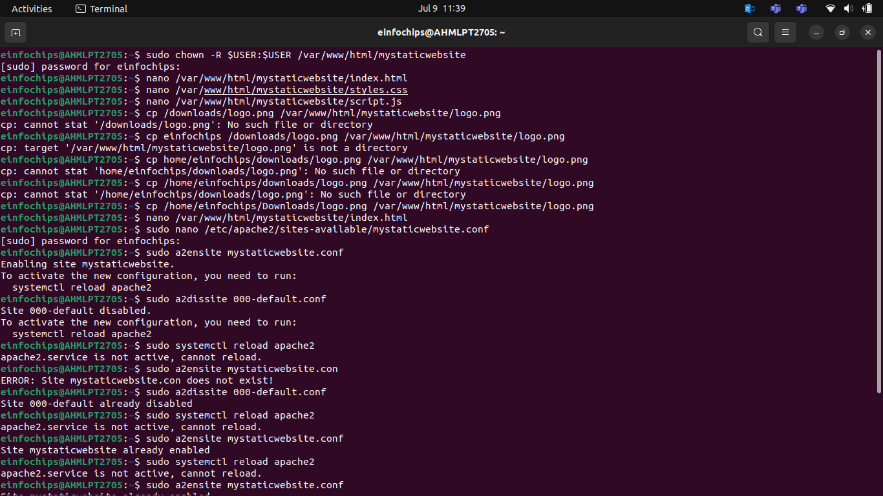

#### **Part 3: Configuring Apache2 to Serve the Website (10 minutes)**

1. **Create a Virtual Host File**
2. **Test the Configuration**.

