Assessment: Use Case Oriented Project

# Project Overview

You are tasked with setting up a CI/CD pipeline for a microservices-based application. The application will be containerized using Docker and orchestrated using Kubernetes. Ansible will be used for configuration management and deployment. The entire setup should be managed using Git for version control, and Jenkins will be used to automate the CI/CD process.

# Tasks and Deliverables

## **Task 1: Git Repository Setup**

## **Task 2: Dockerize Microservices**

## **Task 3: Kubernetes Deployment**

## 

## **File Structure**

**Exam**

**frontend**

**Dockerfile**

**front-end.yaml**

**index.html**

**backend**

**Dockerfile**

**back-end.yaml**

**index.html**

**testing**

**Dockerfile**

**testing.yaml**

**index.html**

**Frontend**

1. **index.html**
2. **front-end.yaml**
3. **index.html**

**Backend**

1. **index.html**
2. **Dockerfile**
3. **back-end.yaml**

**Testing**

1. **Dockerfile**
2. **testing.yaml**
3. **index.html**

**OUTPUT**

**frontned/index.html**

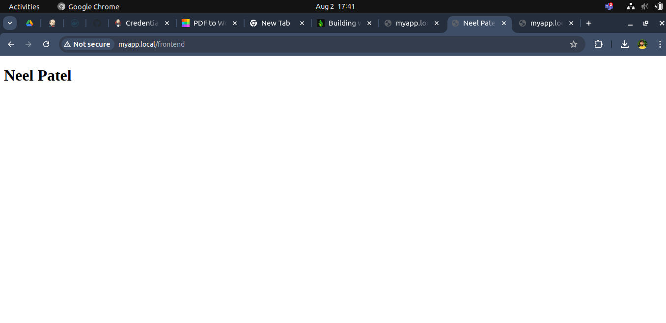

**production/index.html**

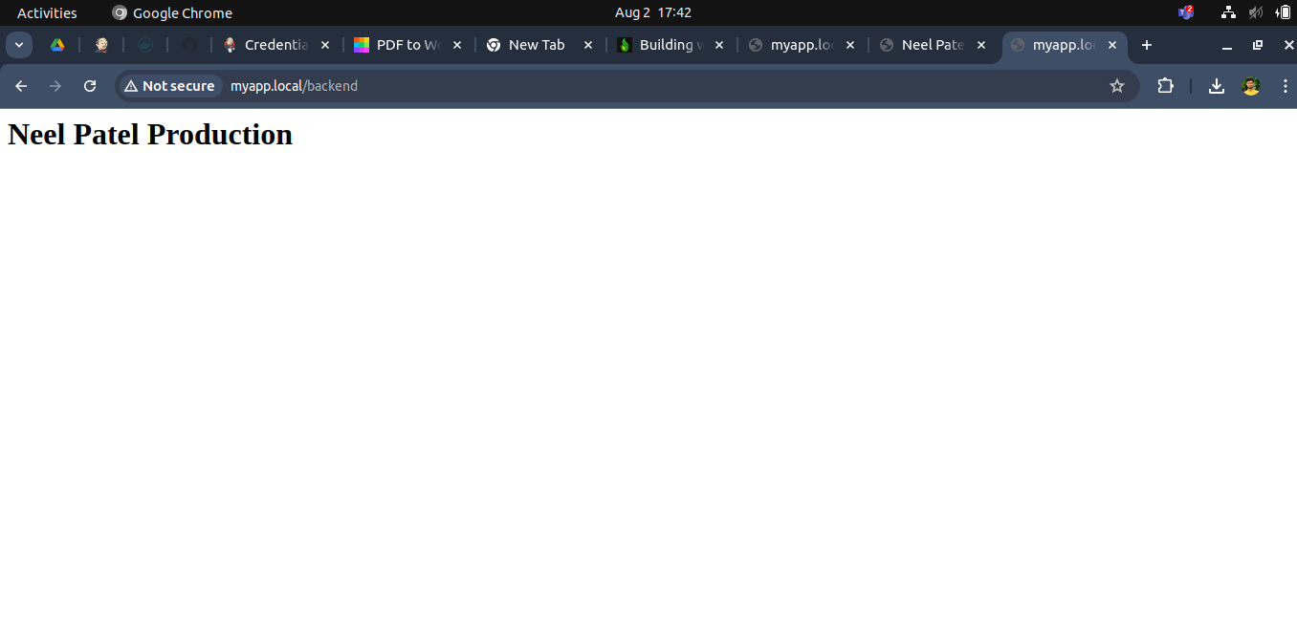

**testing/index.html**

