Comprehensive Linux Operations

Project Overview
This project spans various aspects of Linux system administration, including file management, user and group management, service control, process handling, and more. You will be completing tasks that simulate real-world scenarios, providing hands-on experience with Linux commands and configurations.

Project Breakdown

Part 1: Creating and Editing Text Files.
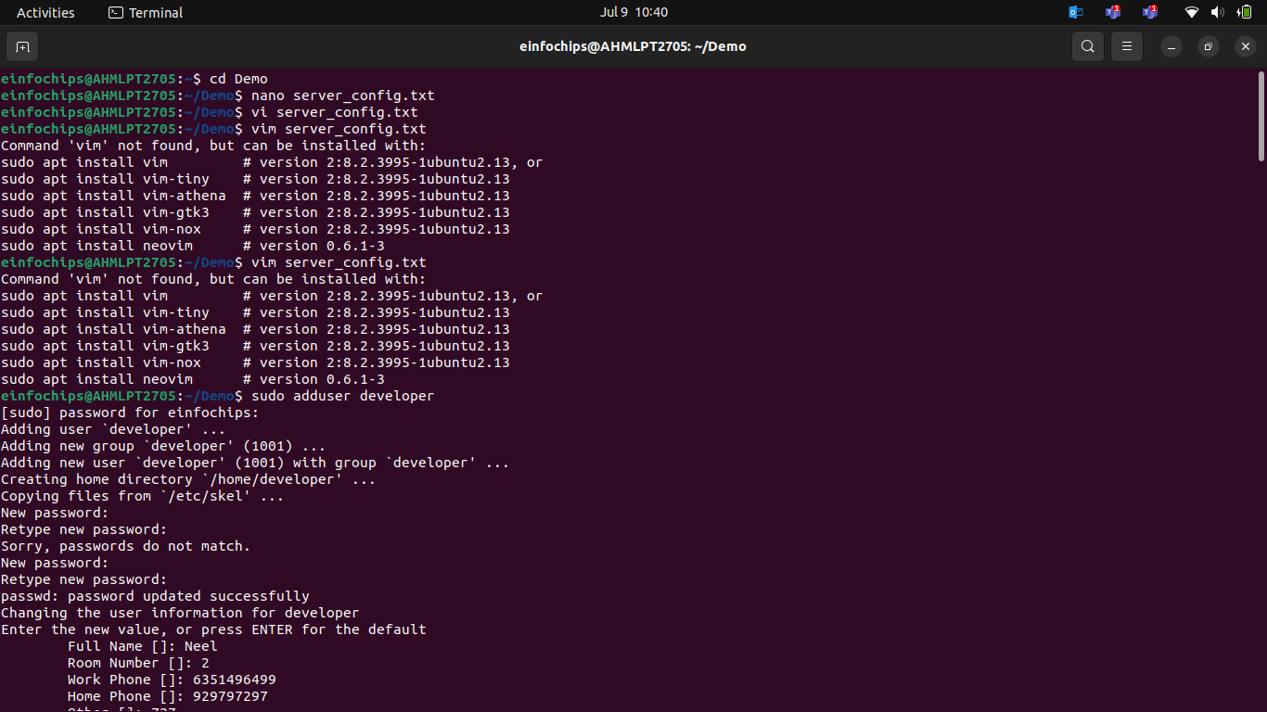

Part 2: User & Group Management (20 minutes)

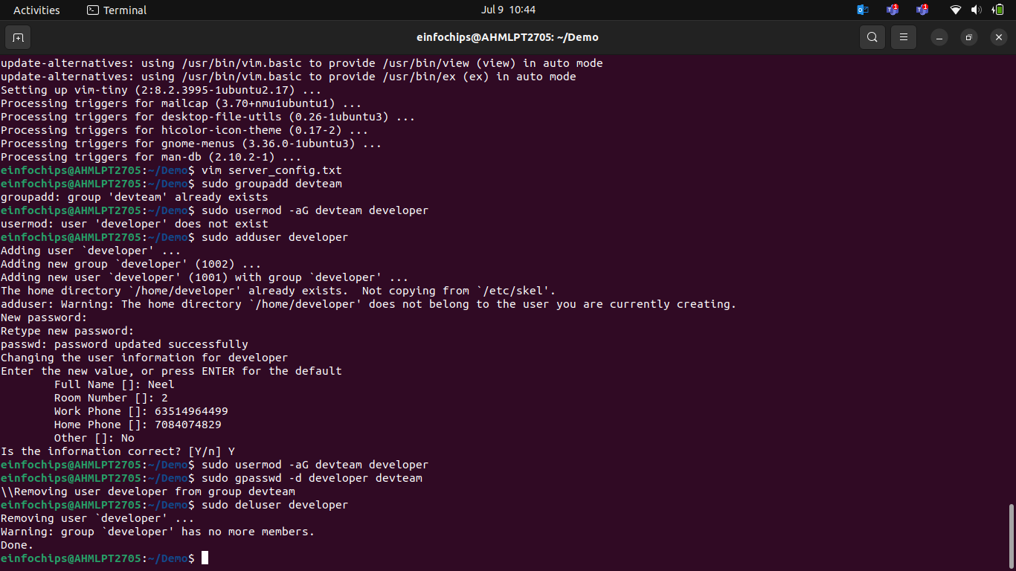

Part 3: File Permissions Management (20 minutes)

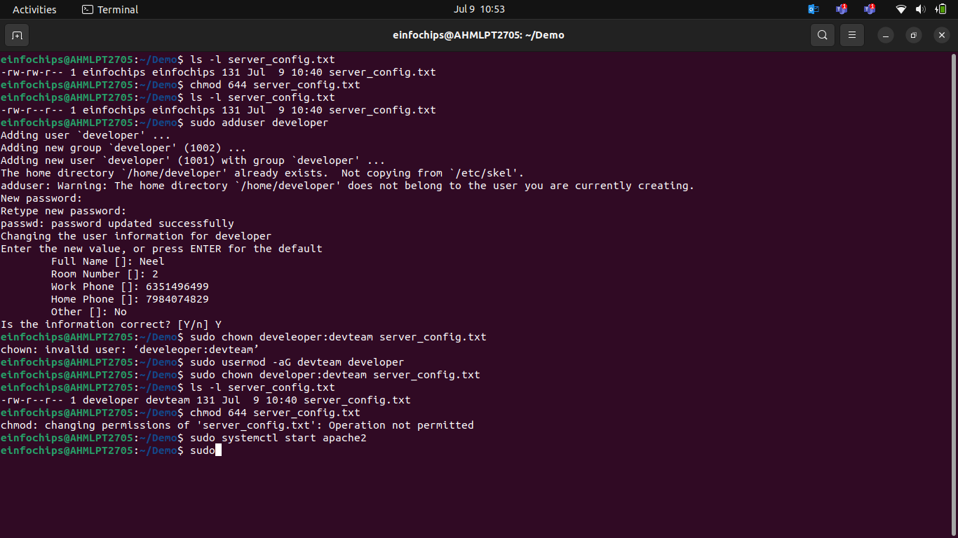

Part 4: Controlling Services and Daemons (20 minutes)
Scenario: Manage the web server service to ensure it is running correctly and starts on boot.
- Managing Services with systemctl
- Understanding Daemons

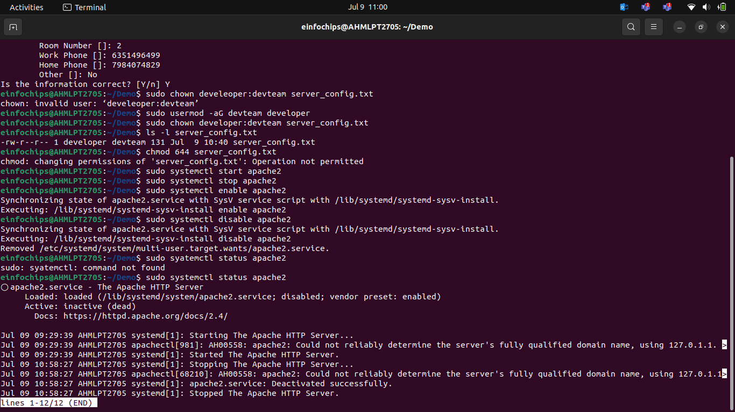

Part 5: Process Handling (20 minutes)
Scenario: Monitor and manage processes to ensure the server is performing optimal

Creating and Deploying a Static Website with Apache2

Part 1: Installing Apache2 (5 minutes)
- Update Package Lists
- Install Apache2
- Start and Enable Apache2
- Verify Installation

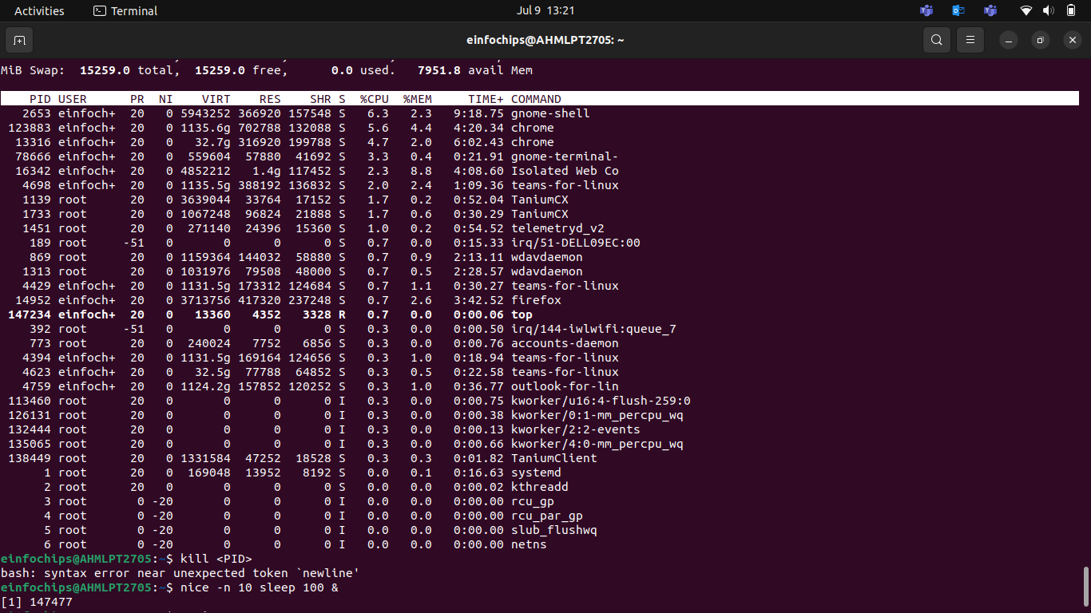

Part 2: Creating the Website
- Navigate to the Web Directory
- Create a New Directory for the Website
- Create HTML File
- Create CSS File
- Create JavaScript File.
- Add an Image
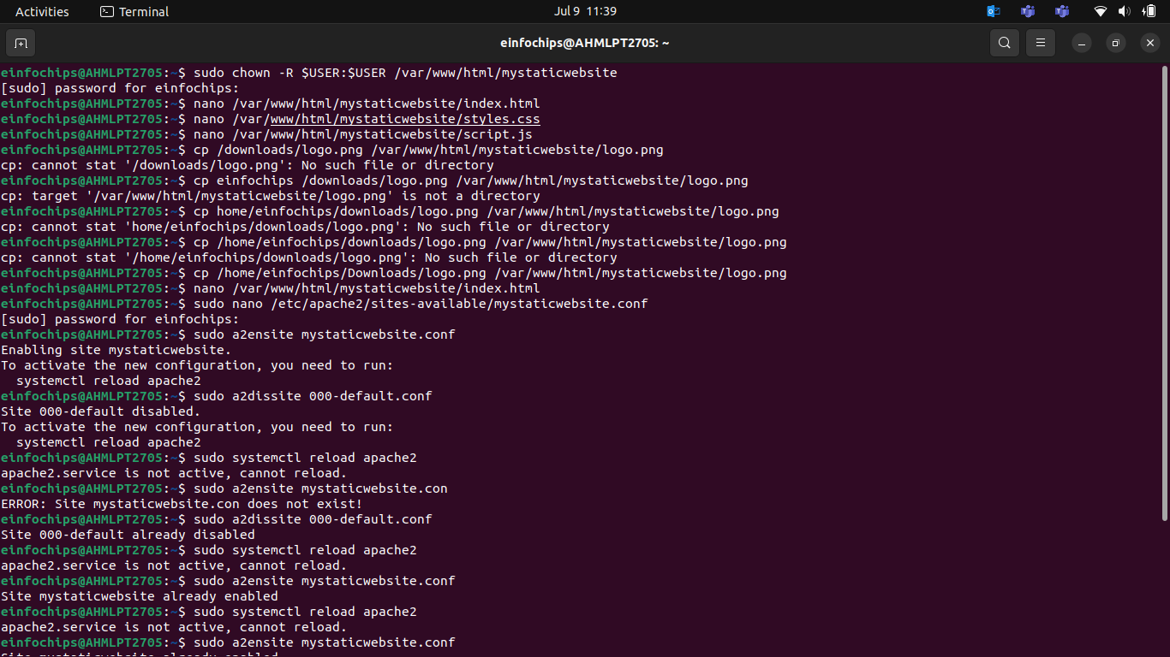

Part 3: Configuring Apache2 to Serve the Website (10 minutes)
- Create a Virtual Host File
- Test the Configuration.
