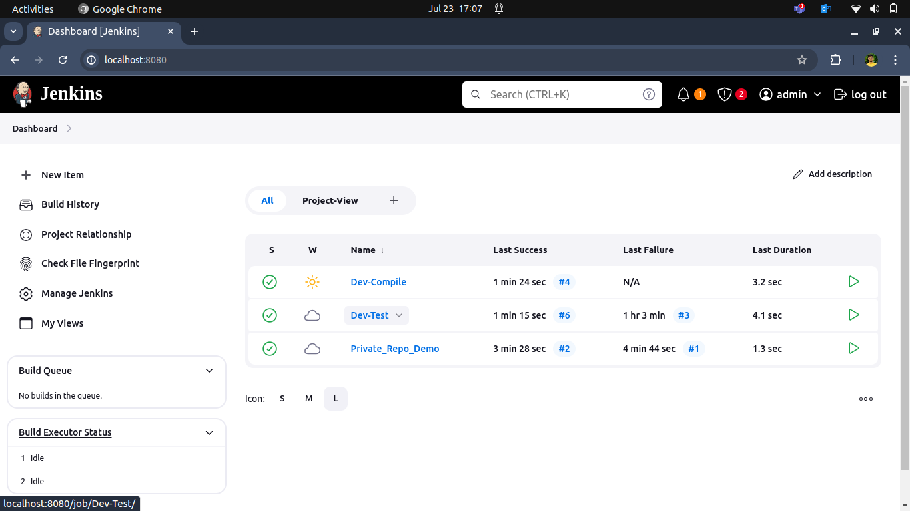
1. Create a dev compiled Build to Test maven sample code.

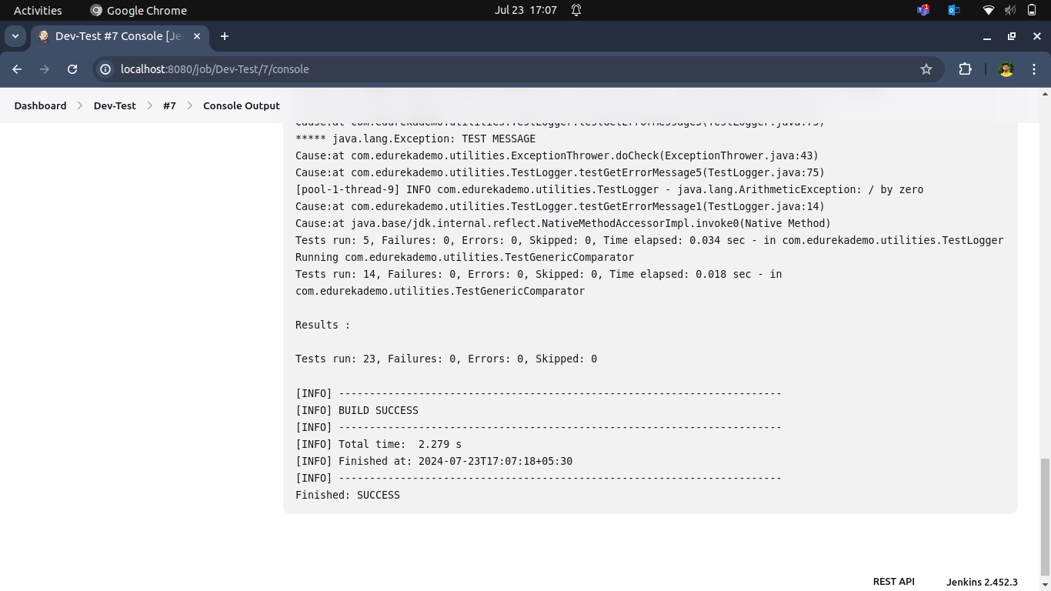

2. Craeate a dev compiled Build to Compile maven sample code.
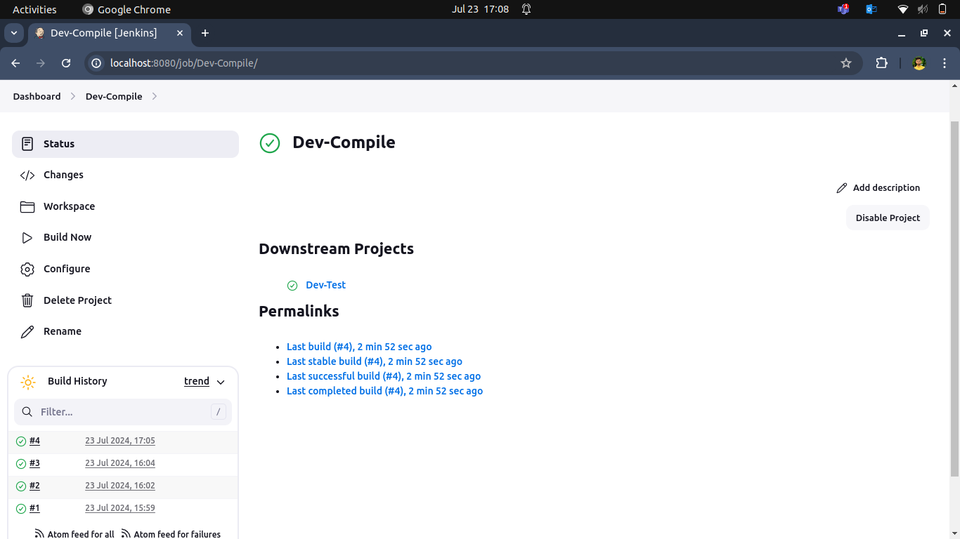
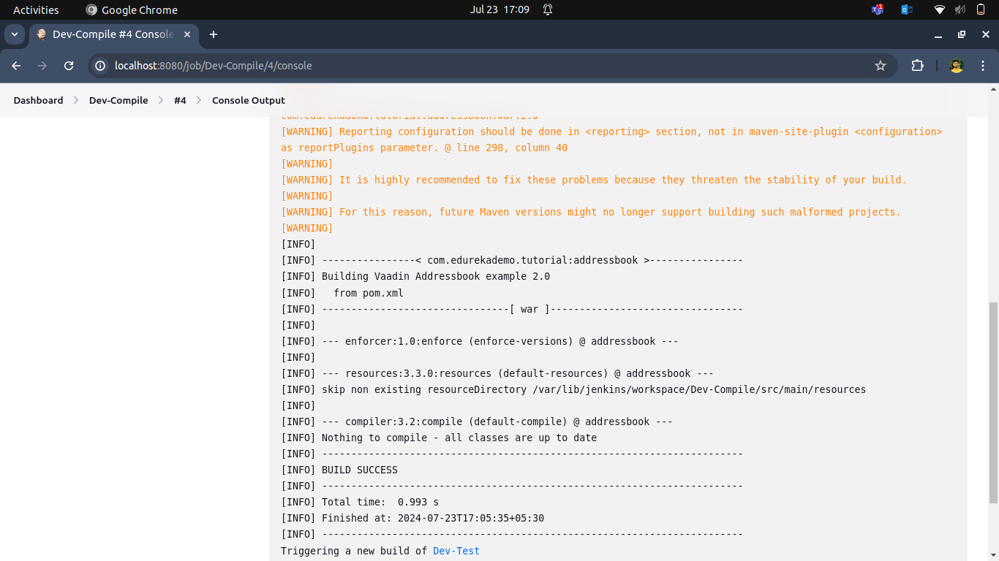

3. Create a Pipeline view to display contails build between dev-test and dev-compile.
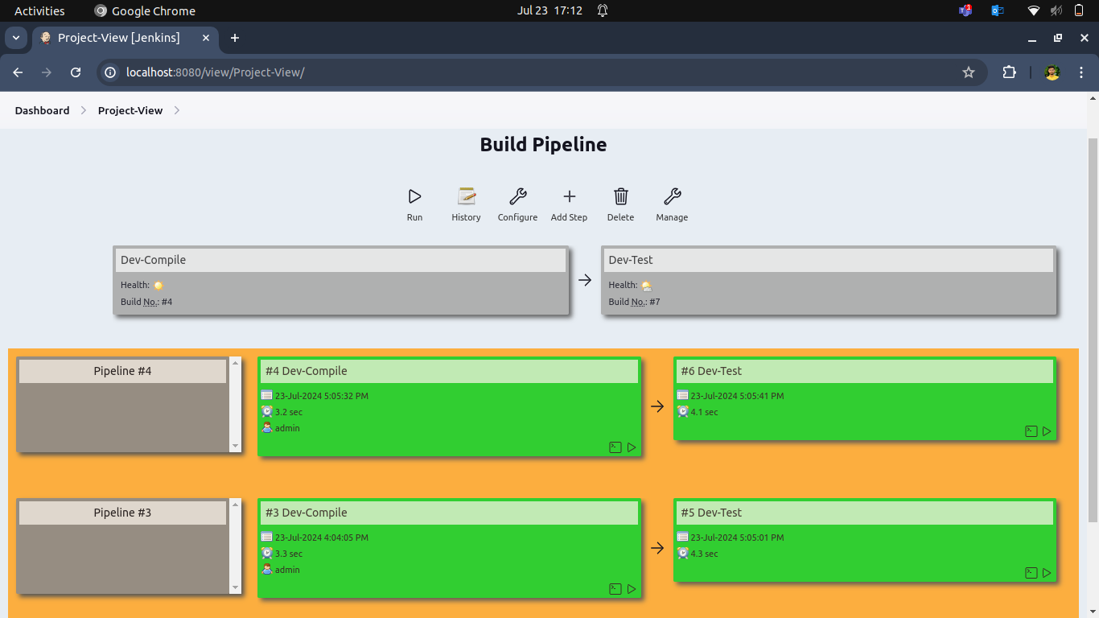
- Setup Jenkins Environment
- Create a Jenkinsfile
- Configure Jenkins Project
- Build Triggers
- Execute the Pipeline

4. Craeate a private private repo and private_repo_Demo Build
