Assessment: Use Case Oriented Project

Project Overview
You are tasked with setting up a CI/CD pipeline for a microservices-based application. The application will be containerized using Docker and orchestrated using Kubernetes. Ansible will be used for configuration management and deployment. The entire setup should be managed using Git for version control, and Jenkins will be used to automate the CI/CD process.

Tasks and Deliverables

Task 1: Git Repository Setup

Task 2: Dockerize Microservices

Task 3: Kubernetes Deployment

File Structure

Exam
frontend
Dockerfile
front-end.yaml
index.html
backend
Dockerfile
back-end.yaml
index.html
testing
Dockerfile
testing.yaml
index.html

Frontend

- index.html

- front-end.yaml

- index.html

Backend

- index.html

- Dockerfile

- back-end.yaml

Testing

- Dockerfile

- testing.yaml

- index.html

OUTPUT

frontned/index.html

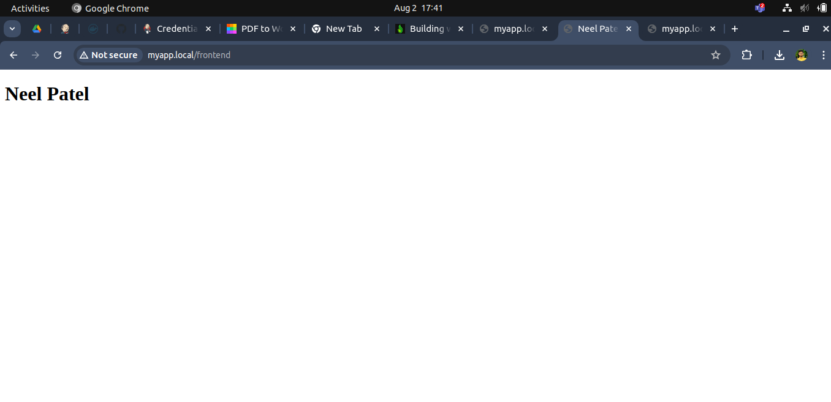

production/index.html

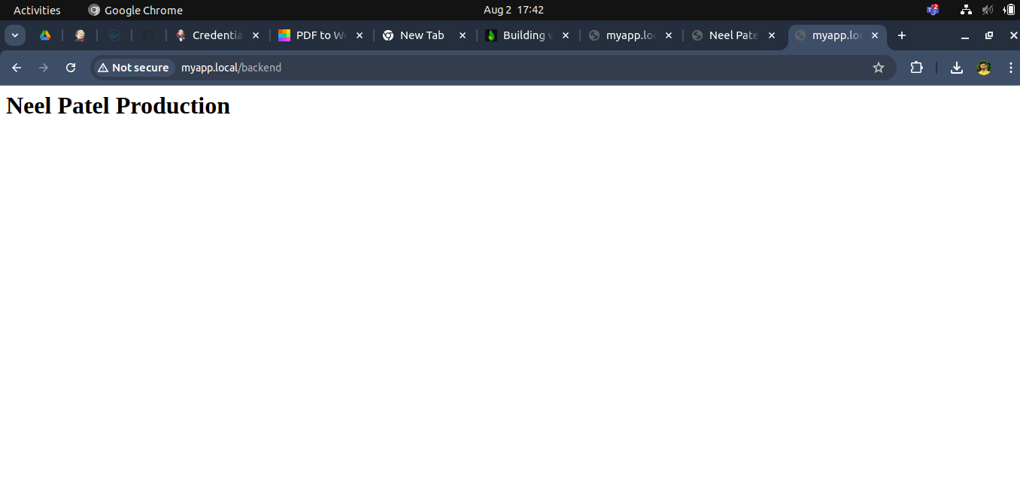

testing/index.html

