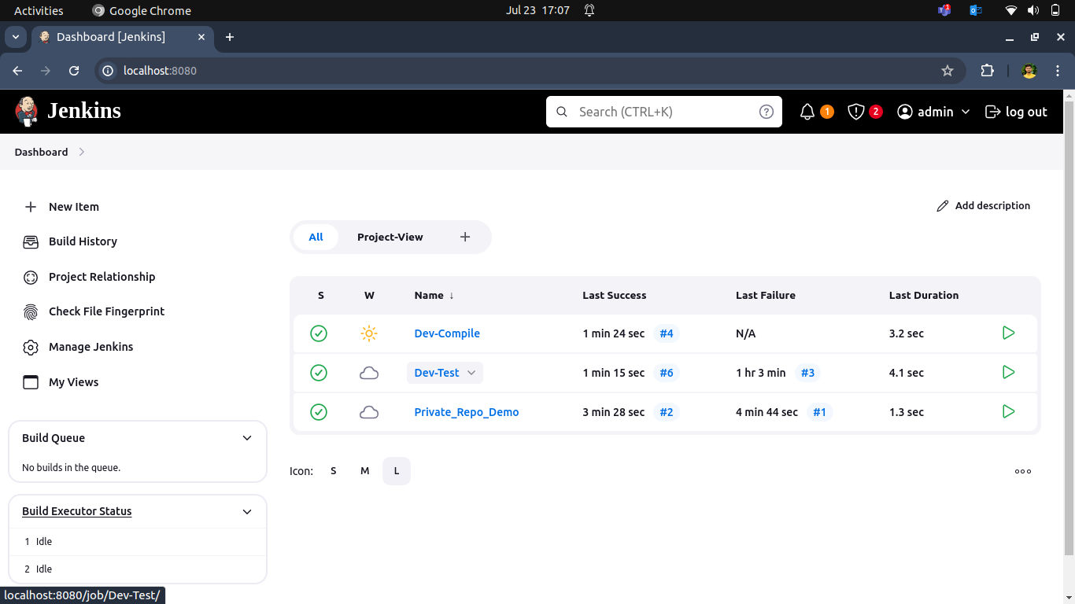1. **Create a dev compiled Build to Test maven sample code.**

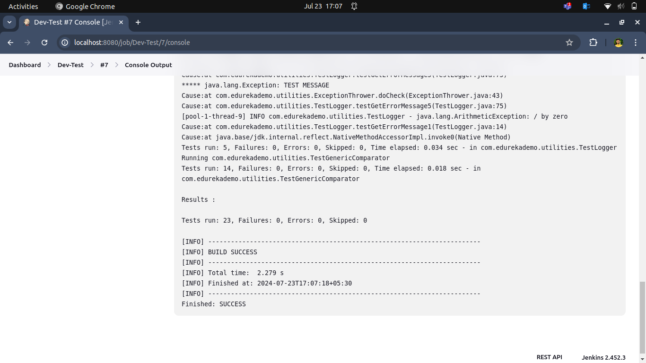

2. **Craeate a dev compiled Build to Compile maven sample code.**

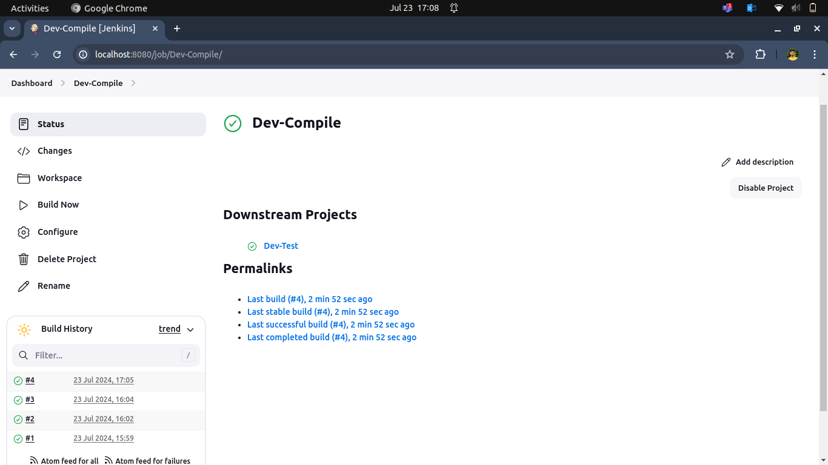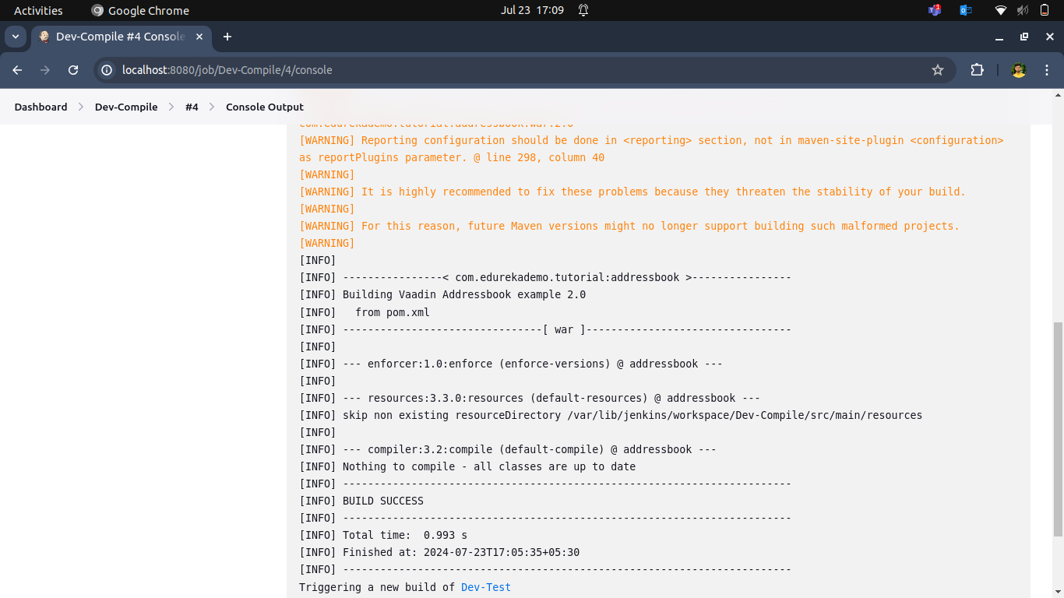

**3. Create a Pipeline view to display contails build between dev-test and dev-compile.**

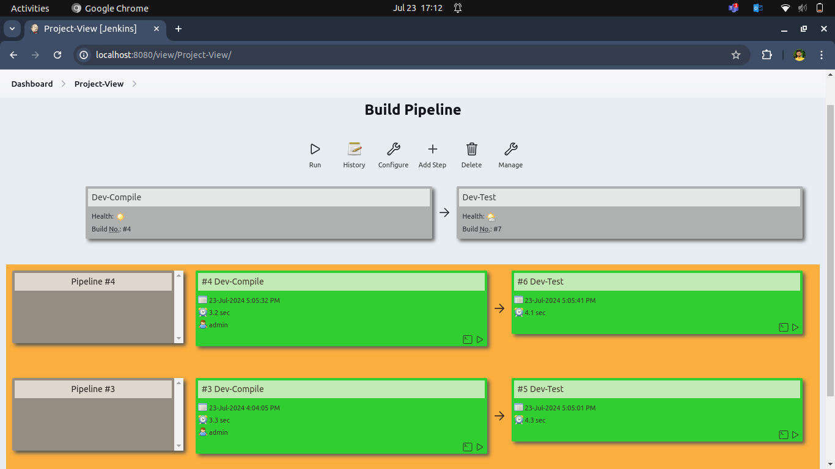

* Setup Jenkins Environment
* Create a Jenkinsfile
* Configure Jenkins Project
* Build Triggers
* Execute the Pipeline

4. **Craeate a private private repo and private_repo_Demo Build**

