

Assignment Code: DA-AG-014
Introduction to Tableau and Data
Visualization| Assignment

Question 1 : What is Tableau? Explain its importance in Business Intelligence and how it helps in data-driven decision-making.
Answer:
Tableau is a powerful data visualization and Business Intelligence (BI) tool that allows users to connect to various data sources, analyze data, and create interactive visualizations, dashboards, and reports. It enables users to transform raw data into meaningful insights through drag-and-drop functionality without requiring advanced programming skills.
Importance in Business Intelligence:
- Tableau helps organizations analyze large and complex datasets quickly.
- It provides real-time insights that support strategic and operational decisions.
- Businesses can identify trends, patterns, and outliers visually.
- It improves collaboration by allowing dashboards to be shared across teams.
Role in Data-Driven Decision-Making:
- Enables faster decision-making using interactive visuals.
- Helps management monitor KPIs and performance metrics.
- Supports predictive and descriptive analytics.
- Reduces dependency on IT teams for reporting.

Question 2 : Explain the role of the following Tableau components:
  - Data Pane
  - Worksheet
  - Dashboard
  - Story
Answer:

a) Data Pane
The Data Pane displays all available fields from the connected dataset. It is divided into Dimensions and Measures and allows users to drag fields into the worksheet to build visualizations.

b) Worksheet
A worksheet is where individual visualizations (charts, graphs, maps) are created. Each worksheet represents a single view of the data.

c) Dashboard
A dashboard is a collection of multiple worksheets displayed together on one screen. It allows users to compare data, apply filters, and interact with multiple visualizations simultaneously.

d) Story
A story is a sequence of worksheets or dashboards that narrates insights step-by-step. It is used for presentations and storytelling with data.

Question 3 : What is the difference between Dimensions and Measures in Tableau? Provide examples of each.
Answer :
Aspect | Dimensions | Measures
Definition | Qualitative data | Quantitative data
Usage | Categorize data | Perform calculations
Aggregation | Not aggregated | Aggregated by default
Examples:
- Dimensions: Country, Product, Segment, Discount Band
- Measures: Sales, Profit, Units Sold, Gross Sales

Question 4 : Define and explain the purpose of Filters, Parameters, and Sets in Tableau.
Answer :
Filters
Filters limit the data displayed in a visualization based on selected criteria (e.g., filtering data for a specific year or country).
Parameters
Parameters are user-controlled inputs that allow dynamic interaction, such as switching between Units Sold and Profit.
Sets
Sets define a subset of data based on conditions (e.g., Top 10 products by sales) or manual selection.

Question 5 : Create a bar chart showing Gross Sales by Country.
- 🔗 Dataset Link:Global_sales_dataset
- Sort the countries in descending order of sales
- Highlight or annotate the bar that represents the maximum and minimum Gross Sales.
- Add data labels and format the chart for presentation.

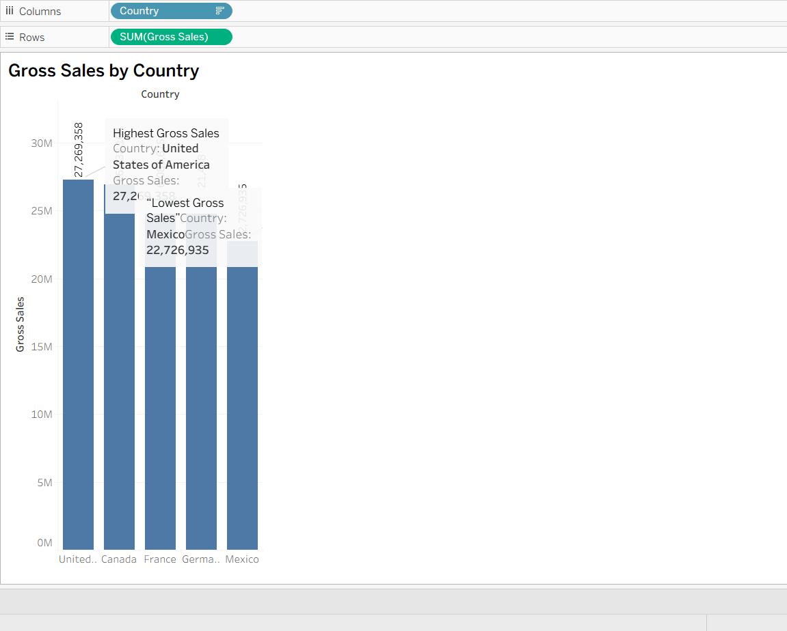

Question 6 : Using Tableau, create a dual-axis chart that displays:
- 🔗 Dataset Link:Global_sales_dataset
- Monthly Sales as bars

- Monthly Profit as a line

- Filter the data to include only records from the year 2014

- Ensure both axes are synchronized and properly labeled

- Add an appropriate chart title, and format the chart for clear visual presentation

- Paste a screenshot of the final chart in your submission
Answer :

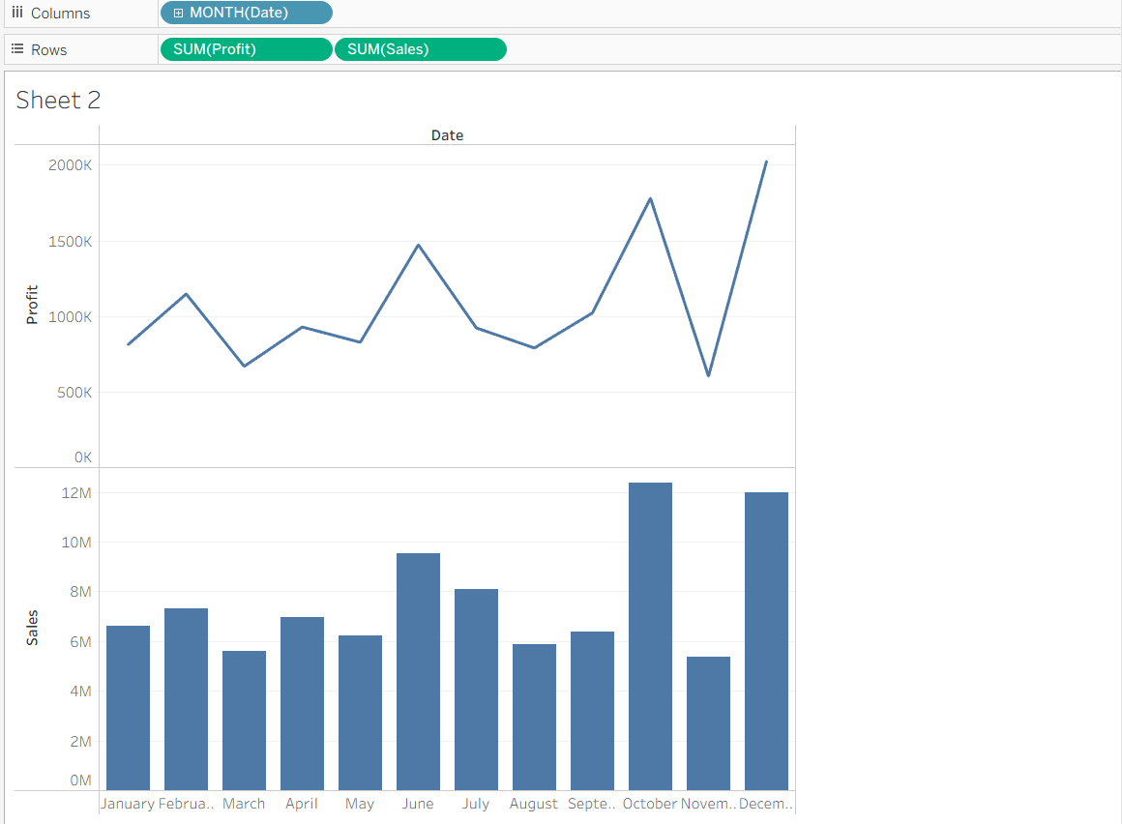

Question 7 : Create a filled map showing total Units Sold by Country.
- 🔗 Dataset Link:Global_sales_dataset
- Add a parameter to allow users to switch between Units Sold and Profit.
- Use the Discount Band as a filter in your visualization.

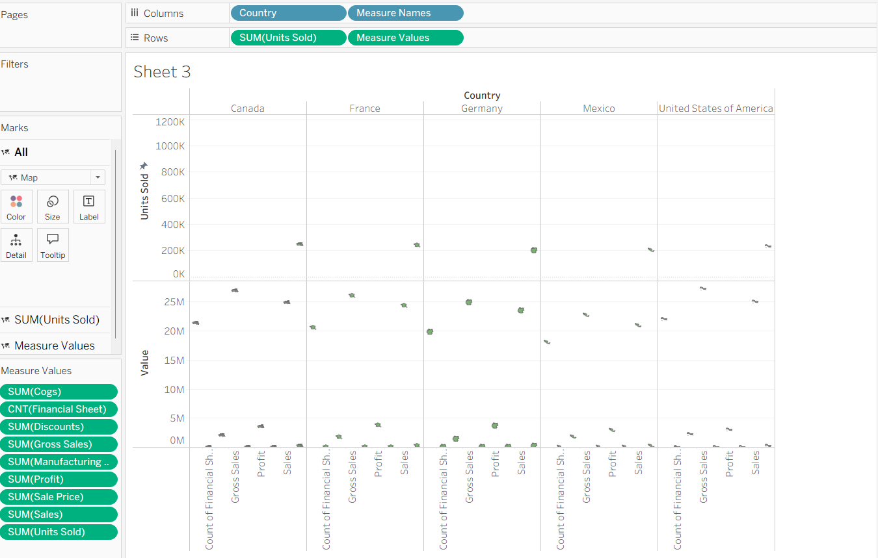

Question 8 : Create a dashboard that includes:
- 🔗 Dataset Link:Global_sales_dataset
- KPI tiles for Total Sales, Total Profit, and Total Units Sold

- A line chart for Profit trend over time

- Filters for Product and Country

Ensure your dashboard is interactive and visually appealing.

Answer :
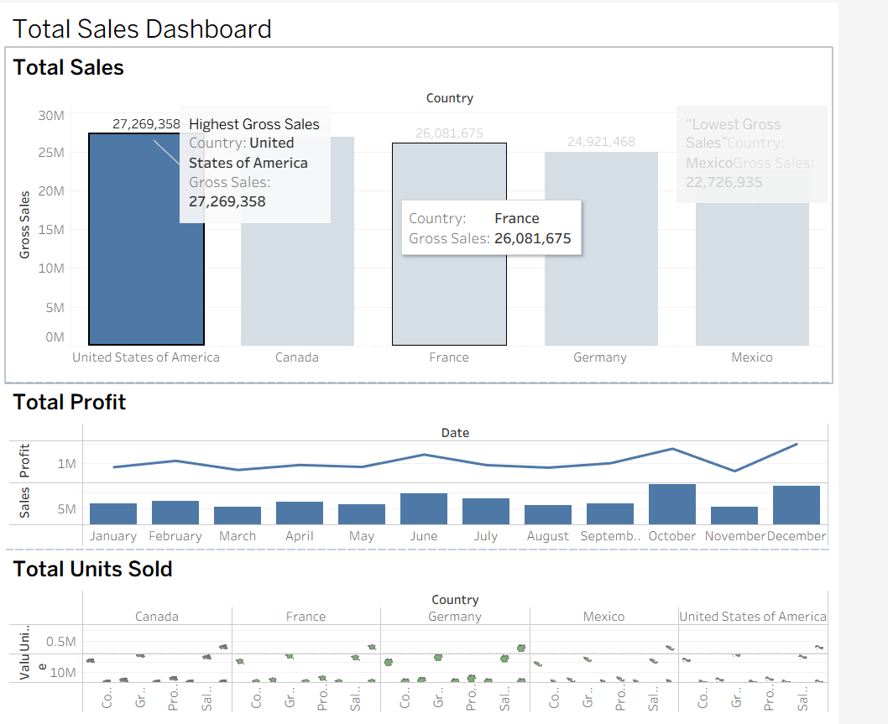
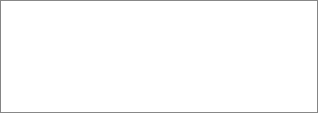

Question 9 : Your goal is to identify products that generate low profit despite high sales volume.
- 🔗 Dataset Link:Global_sales_dataset
- Use scatter plot or highlight table to identify such products.

- Add filters for Country and Segment.

- Write two business insights based on your chart.

Answer :

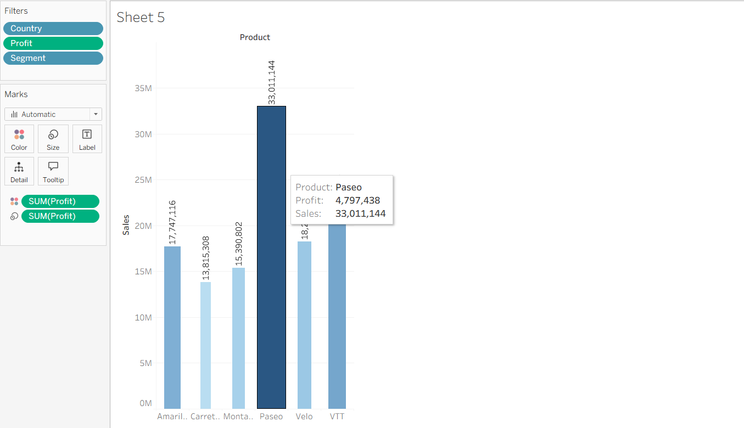

Question 10 :

[Scenario-Based – Customer Behavior & Retention Strategy]
Dataset to Use: online_retail_II
Dataset Name: Online Retail II
Dataset Source: UCI Machine Learning Repository – Online Retail II Dataset

Business Scenario:
You are a Data Analyst at an e-commerce company that sells home decor and gifts across multiple countries. The leadership team is concerned about customer churn and revenue loss due to inconsistent customer behavior.
They’ve asked you to investigate patterns in customer orders, returns, and geographic sales performance from the Online Retail II dataset.

Your Task in Tableau:
- Use Tableau to answer these questions:

  - Which countries have the highest number of repeat customers?

○ What is the return rate by product and Find top 10 countries?

○ What time of year do customers tend to buy the most (Seasonality) ?

○ Are there certain customers with high order value but also high return rates?

- Create visualizations:

  - A map showing Revenue by Country

○ A line chart of Monthly Sales Trend

○ A bar chart showing Top 10 customers by Total Revenue

○ A table/heatmap showing Top returned products by country

- Build a dashboard for business insights:

  - Allow filters for Country, Product, and Customer ID

○ Use KPIs for:

■ Total Revenue

■ Total Returns

■ Repeat Customer Count

- Write a short business insight (2–3 sentences):
Based on your Tableau dashboard, what recommendations would you make to help reduce churn and increase customer loyalty?

