Practical – 1
Array Operations: Traversal, Rotation, and Frequency Analysis

Practical Aim:
To implement fundamental array operations.

Problem 1:
A bakery prepares n items every morning and places them in a display row. At the end of each hour, the leftmost item is moved to the rightmost position to make room for fresh stock at the front. Given the initial row and the number of hours h, print the final display order. Describe the approach you used. How does it behave when h is very large, say 10 million? Is there a way to get the correct result without performing the operation h times?

CODE:
#include <iostream> using namespace std;

int main() { int n, h;
cout << "Enter the no. of bakery items: "; cin >> n;
cout << "Enter the no. of hours: "; cin >> h;

int hr[h]; int arr[n];

for (int i = 0; i < n; i++) {

arr[i] = i + 1;
}

for (int i = 0; i < h && (i + h) < n; i++) { int t = arr[i];
arr[i] = arr[i + h]; arr[i + h] = t;
}

for (int i = 0; i < n; i++) { cout << arr[i] << " ";
}

cout << endl; return 0;
}

OUTPUT:

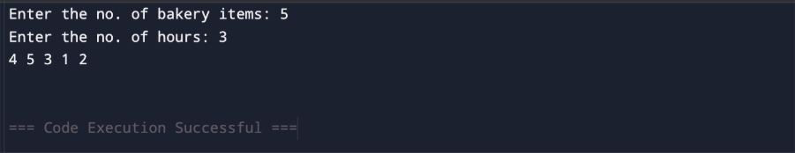

Problem 2:
A library issues books to students and records each book's ID every time it is borrowed. At the end of the month, the librarian wants to find all books that were borrowed more than once, as those need priority restocking. Given the borrowing log, print all such book IDs. Describe the approach you used. How many times does your solution scan the data? If the library had 100,000 borrow records, would your approach still be practical? Can you think of a way that requires fewer passes?

CODE:

#include <iostream> using namespace std;

int main() { int n;
cout << "Enter the no. of books borrowed: "; cin >> n;

int bookid[n];
for (int i = 0; i < n; i++) { cin >> bookid[i];
}

int count[n];

for (int i = 0; i < n; i++) { count[i] = 0;
}

for (int i = 0; i < n; i++) { for (int j = 0; j < n; j++) {
if (bookid[i] == bookid[j]) { count[i]++;
}
}
}

for (int i = 0; i < n; i++) { if (count[i] > 1) {
int alreadyPrinted = 0; for (int j = 0; j < i; j++) {
if (bookid[i] == bookid[j]) { alreadyPrinted = 1; break;
}
}

if (!alreadyPrinted) {
cout << "Book ID: " << bookid[i] << endl;
}
}
}
}

OUTPUT:
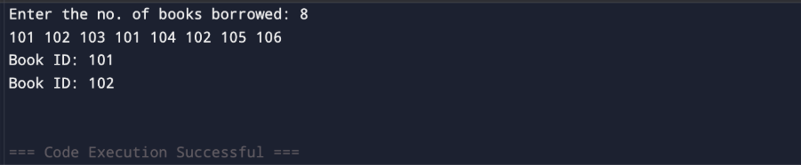

Problem 3:
A school newspaper editor wants to highlight the most impressive word from a submitted article on the front page. The word is chosen simply by length — the longest one wins. Given a sentence, print the winning word and how many letters it has. Describe the approach you used. What does your solution do when two words have the same length? Is that behavior intentional, and can you think of a way to handle it explicitly?

CODE:

#include <iostream> #include <string> using namespace std;

int main(){ string l;
cout << "Enter the line: "; getline(cin, l);

int count = 0; int count1 = 0; int indx;
for (int i = 0; i < l.length(); i++) {

if (l[i] != ' ') { count1++;
}
else {
if (count1 > count){ count = count1; indx = i - count;
}
count1 = 0;
}
}
if (count1 > count){ count = count1;
indx = l.length() - count;
}

for (int i = indx; i < indx + count; i++){ cout << l[i];
}
cout << endl;
cout << count << endl;
}

OUTPUT:
