Practical – 1
Array Operations: Traversal, Rotation, and Frequency Analysis

Practical Aim:
To implement fundamental array operations.

Problem 1:
A bakery prepares n items every morning and places them in a display row. At the end of each hour, the leftmost item is moved to the rightmost position to make room for fresh stock at the front. Given the initial row and the number of hours h, print the final display order. Describe the approach you used. How does it behave when h is very large, say 10 million? Is there a way to get the correct result without performing the operation h times?

CODE:
#include <iostream> using namespace std;

int main() { int n, h;
cout << "Enter the no. of bakery items: "; cin >> n;
cout << "Enter the no. of hours: "; cin >> h;

int hr[h]; int arr[n];

for (int i = 0; i < n; i++) {

arr[i] = i + 1;
}

for (int i = 0; i < h && (i + h) < n; i++) { int t = arr[i];
arr[i] = arr[i + h]; arr[i + h] = t;
}

for (int i = 0; i < n; i++) { cout << arr[i] << " ";
}

cout << endl; return 0;
}

OUTPUT:

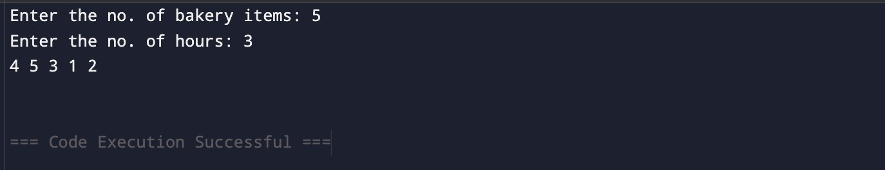

Problem 2:
A library issues books to students and records each book's ID every time it is borrowed. At the end of the month, the librarian wants to find all books that were borrowed more than once, as those need priority restocking. Given the borrowing log, print all such book IDs. Describe the approach you used. How many times does your solution scan the data? If the library had 100,000 borrow records, would your approach still be practical? Can you think of a way that requires fewer passes?

CODE:

#include <iostream> using namespace std;

int main() { int n;
cout << "Enter the no. of books borrowed: "; cin >> n;

int bookid[n];
for (int i = 0; i < n; i++) { cin >> bookid[i];
}

int count[n];

for (int i = 0; i < n; i++) { count[i] = 0;
}

for (int i = 0; i < n; i++) { for (int j = 0; j < n; j++) {
if (bookid[i] == bookid[j]) { count[i]++;
}
}
}

for (int i = 0; i < n; i++) { if (count[i] > 1) {
int alreadyPrinted = 0; for (int j = 0; j < i; j++) {
if (bookid[i] == bookid[j]) { alreadyPrinted = 1; break;
}
}

if (!alreadyPrinted) {
cout << "Book ID: " << bookid[i] << endl;
}
}
}
}

OUTPUT:

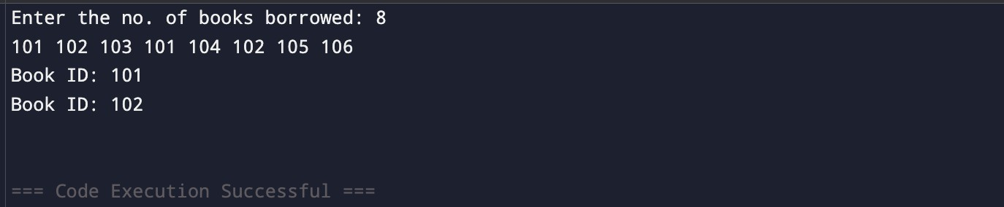

Problem 3:
A school newspaper editor wants to highlight the most impressive word from a submitted article on the front page. The word is chosen simply by length — the longest one wins. Given a sentence, print the winning word and how many letters it has. Describe the approach you used. What does your solution do when two words have the same length? Is that behavior intentional, and can you think of a way to handle it explicitly?

CODE:

#include <iostream> #include <string> using namespace std;

int main(){ string l;
cout << "Enter the line: "; getline(cin, l);

int count = 0; int count1 = 0; int indx;
for (int i = 0; i < l.length(); i++) {

if (l[i] != ' ') { count1++;
}
else {
if (count1 > count){ count = count1; indx = i - count;
}
count1 = 0;
}
}
if (count1 > count){ count = count1;
indx = l.length() - count;
}

for (int i = indx; i < indx + count; i++){ cout << l[i];
}
cout << endl;
cout << count << endl;
}

OUTPUT:
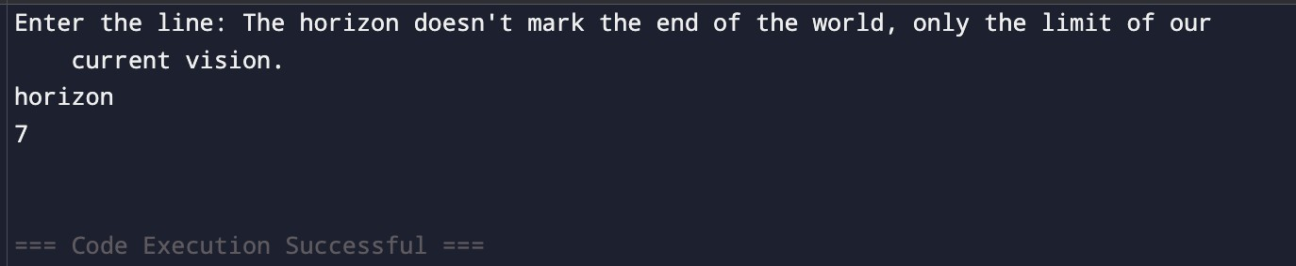

Practical – 2

Problem Aim:
To implement linear and binary search using both iterative and recursive approaches.

Problem 1:
A security guard at a parking lot checks vehicles one by one from the entrance to find a car with a specific license plate. Sometimes he starts from the entrance, sometimes he calls a helper who starts from where the guard left off. Given a list of license plates and a target plate, implement both approaches — one that checks plates one by one from the start, and one where the function calls itself to continue checking — and report the position of the target plate if found. Describe the approach you used. What happens in your solution if the target plate appears more than once in the list? Does it find the first occurrence, the last, or just any one?

CODE:

#include <iostream> using namespace std;

int search(int arr[], int n, int t) { for (int i = 0; i < n; i++) {
if (arr[i] == t) return i;
}
return -1;
}
int recsearch(int arr[], int n, int t, int indx) { if (indx >= n) return -1;
if (arr[indx] == t) return indx;

return recsearch(arr, n, t, indx + 1);
}

int main() { int n, ln; cin >> n; int licarr[n];
for (int i = 0; i < n; i++) { cin >> licarr[i];
}

cout << "Enter the license number: "; cin >> ln;

int nors = search(licarr, n, ln);
int recus = recsearch(licarr, n, ln, 0); if (nors != -1) {
cout << "The car is at " << nors + 1 << endl;
} else {
cout << "Not found" << endl;
}
}

OUTPUT:

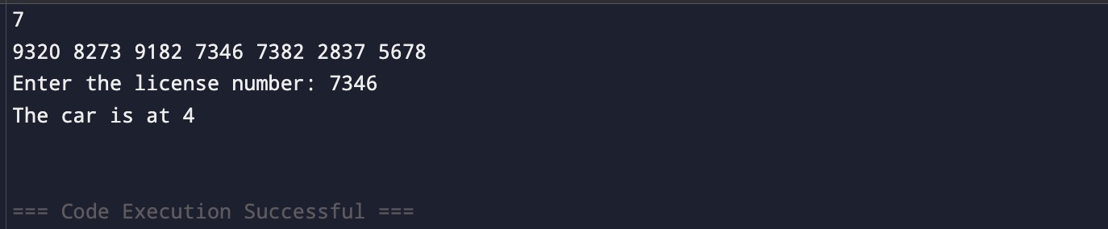

Problem 2:
A librarian maintains a sorted catalog of book codes and needs to locate a specific code quickly. Instead of going through every book, she opens the catalog to the middle, checks whether the target is to the left or right, and repeats. Given a sorted list of book codes and a target code, implement both approaches — one using a loop and one where the function calls itself — and report the position of the target code. Describe the approach you used. What is the one condition your input must satisfy for this approach to work correctly? What would go wrong if that condition was not met?

CODE:

#include <iostream> using namespace std;

int lsearch(int arr[], int n, int tar) { int l = 0, r = n - 1;
while (l <= r) {
int mid = r - (r - l) / 2;
if (arr[mid] == tar) return mid; if (arr[mid] < tar) l = mid + 1; else r = mid - 1;
}
return -1;
}
int recsearch(int arr[], int l, int r, int tar) { if (l > r) return -1;
int mid = r - (r - l) / 2;
if (arr[mid] == tar) return mid;
if (arr[mid] < tar) return recsearch(arr, mid + 1, r, tar); return recsearch(arr, l, mid - 1, tar);
}

int main() { int n, id; cin >> n; int barr[n];
for (int i = 0; i < n; i++) { cin >> barr[i];
}

cout << "Enter book code: "; cin >> id;

int lsear = lsearch(barr, n, id);
int recres = recsearch(barr, 0, n - 1, id); if (lsear != -1) {
cout << "The book is at " << lsear + 1 << endl;
} else {
cout << "Book not found" << endl;
}
}

OUTPUT:

