Practical -1
AIM: Part A — Practice Programs (Hour 1)
Work these in your lab-NN/ folder before the project: do the first one or two in the lab; the
last (For Advanced Learners) is for home.
1. Vending machine (VendingMachine.java, main in this file)
(a) Define an enum Coin with constants ONE, TWO, FIVE, TEN.
(b) In main, set a snack price of 15 and a running total of 0; create a Scanner.
(c) Loop: read a coin name, use a switch expression to convert the Coin to its value
(ONE→1, TWO→2, FIVE→5, TEN→10), add it to the total, and print the total so
far.
(d) Stop the loop once the total reaches 15 or more.
(e) Print the change to return (total − 15).
Expected output: TEN then FIVE prints “Paid. Change: 0”; TEN then TEN prints
“Paid. Change: 5”.

CODE:
import java.util.Scanner;

public class VendingMachine
{
enum Coin
{
ONE, TWO, FIVE, TEN
}

public static void main(String[] args)
{
Scanner sc = new Scanner(System.in);

int price = 15;
int total = 0;

while (total < price)
{
System.out.print("Enter Coin (ONE/TWO/FIVE/TEN): ");

Coin c = Coin.valueOf(sc.next().toUpperCase());

int value = 0;

switch (c)
{
case ONE:
value = 1;
break;
case TWO:
value = 2;
break;
case FIVE:
value = 5;
break;
case TEN:
value = 10;
break;
}

total += value;
System.out.println("Total Paid = " + total);
}

System.out.println("Paid.");
System.out.println("Change = " + (total - price));

sc.close();
}
}

OUTPUT:
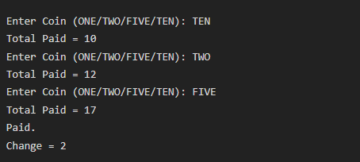

2. Toll booth (TollBooth.java, main in this file)
(a) Define a record Vehicle(String number, String type).
(b) In main, keep a running toll total and three counters (bike, car, truck).
(c) Loop until the user types “done” for the number: build a Vehicle, use a switch
expression on its type for the toll (bike→20, car→50, truck→150), add to the total,
and increment that type’s counter.
(d) After the loop, print the total toll and the type with the highest count.
Expected output: two cars + one bike → “Total toll: 120”, “Most frequent: car”.

CODE:
import java.util.Scanner;

record Vehicle(String number, String type) {}

public class TollBooth
{
public static void main(String[] args)
{
Scanner sc = new Scanner(System.in);

int total = 0;
int bike = 0;
int car = 0;
int truck = 0;

while (true)
{
System.out.print("Enter Vehicle Number (or done): ");
String number = sc.next();

if (number.equalsIgnoreCase("done"))
{
break;
}

System.out.print("Enter Vehicle Type (bike/car/truck): ");
String type = sc.next();

Vehicle v = new Vehicle(number, type);

if (v.type().equalsIgnoreCase("bike"))
{
total = total + 20;
bike++;
}
else if (v.type().equalsIgnoreCase("car"))
{
total = total + 50;
car++;
}
else if (v.type().equalsIgnoreCase("truck"))
{
total = total + 150;
truck++;
}

System.out.println("Current Toll = " + total);
}

System.out.println("\nTotal Toll = " + total);

if (bike >= car && bike >= truck)
{
System.out.println("Most Frequent : bike");
}
else if (car >= bike && car >= truck)
{
System.out.println("Most Frequent : car");
}
else
{
System.out.println("Most Frequent : truck");
}

sc.close();
}
}
}

OUTPUT:
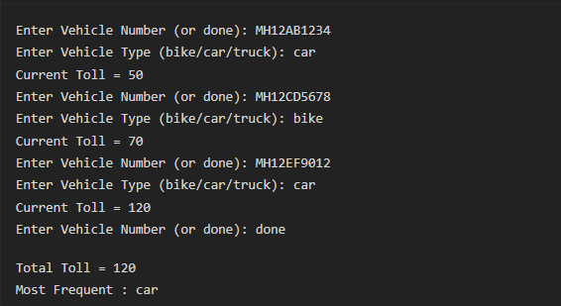

Part B — Project Work (Hour 2): MiniBank
MiniBank is the console banking application you will build across the whole semester. In
this first lab you set up your tools and create the project and its menu shell — the screen the
user navigates. Every later lab attaches one real banking feature behind these menu options.
1. Set up your environment: open the project in GitHub Codespaces (or install JDK 17+ and
an IDE locally), and create a private GitHub repository named oop-minibank-<rollno>;
add the faculty as a collaborator.
2. Create a public class named MiniBank that contains the main method.
3. Define a record named BankInfo with two String fields, name and branch (a record is a
short, read-only class; Java auto-generates its constructor and field accessors). Print one
BankInfo object as the application header.
4. Define an enum named MenuOption with the constants OPEN_ACCOUNT, DEPOSIT,
WITHDRAW, TRANSFER and EXIT — these are the actions MiniBank will offer.
5. Display the numbered menu to the user and read the chosen number with a Scanner.
6. Use a switch expression on the choice to print a short placeholder for that option (for
example, “Deposit — to be implemented in a later lab”). Keep showing the menu in a
loop until the user selects EXIT, then print a goodbye message.

Code :

import java.util.Scanner;

// Define the BankInfo record
record BankInfo(String name, String branch) {
}

// Define the MenuOption enum
enum MenuOption {
OPEN_ACCOUNT, DEPOSIT, WITHDRAW, TRANSFER, EXIT
}

public class MiniBank {
public static void main(String[] args) {
// Create Scanner for input
Scanner scanner = new Scanner(System.in);

// Create BankInfo object for header
BankInfo bank = new BankInfo("MiniBank", "Main Branch");

System.out.println("=========================================");
System.out.println("Welcome to " + bank.name() + " - " + bank.branch());
System.out.println("=========================================");
System.out.println();

// Loop until user exits
while (true) {
// Display menu
System.out.println("Please select an option:");
System.out.println("1. OPEN ACCOUNT");
System.out.println("2. DEPOSIT");
System.out.println("3. WITHDRAW");
System.out.println("4. TRANSFER");
System.out.println("5. EXIT");
System.out.print("Enter your choice (1-5): ");

int choice = scanner.nextInt();
System.out.println();

MenuOption option;
switch (choice) {
case 1:
option = MenuOption.OPEN_ACCOUNT;
break;
case 2:
option = MenuOption.DEPOSIT;
break;
case 3:
option = MenuOption.WITHDRAW;
break;
case 4:
option = MenuOption.TRANSFER;
break;
case 5:
option = MenuOption.EXIT;
break;
default:
System.out.println("Invalid choice! Please enter 1-5.");
System.out.println();
continue; // Go back to menu
}

switch (option) {
case OPEN_ACCOUNT:
System.out.println("OPEN ACCOUNT - to be implemented in a later lab");
System.out.println();
break;

case DEPOSIT:
System.out.println("DEPOSIT - to be implemented in a later lab");
System.out.println();
break;

case WITHDRAW:
System.out.println("WITHDRAW - to be implemented in a later lab");
System.out.println();
break;

case TRANSFER:
System.out.println("TRANSFER - to be implemented in a later lab");
System.out.println();
break;

case EXIT:
System.out.println("Thank you for using MiniBank. Goodbye!");
scanner.close();
return; // Exit the program
}
}
}
}

Output:

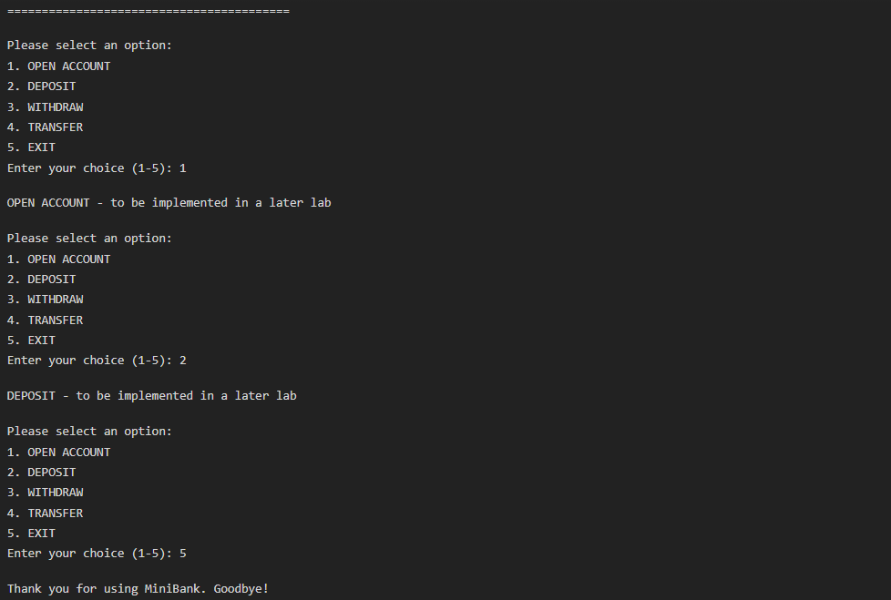

Practical 2

Part A — Practice Programs (Hour 1)
Work these in your lab-NN/ folder before the project: do the first one or two in the lab; the
last (For Advanced Learners) is for home.
1. Smart thermostat (Thermostat.java, main in this file)
(a) Create class Thermostat with private String location, private int temperature, private
static final int MIN=16 and MAX=30, and private static int activeCount=0.
(b) Constructor(location, startTemp): store location; set temperature to startTemp if it is
within MIN..MAX else 22; increment activeCount.
(c) Constructor(location): chain with this(location, 22).
(d) raise(): if temperature < MAX add 1, else print “Already at maximum (30)”.
(e) lower(): if temperature > MIN subtract 1, else print “Already at minimum (16)”.
(f) Add getTemperature() (no setter) and static getActiveCount().
(g) In main: create two thermostats, call raise() 10 times then lower() 20 times in loops
(printing the temperature each time), then print getActiveCount().

CO1
PO1,
PO2,
PO3
Practical
Number CO/PO

Expected output: temperature rises to 30 then “Already at maximum”, falls to 16
then “Already at minimum”, count 2.
Code:

public class Thermostat {

private String location;
private int temperature;
private static final int MIN = 16;
private static final int MAX = 30;
private static int activeCount = 0;

// Constructor
public Thermostat(String location, int startTemp) {
this.location = location;

// Set temperature if within range, otherwise 22
if (startTemp >= MIN && startTemp <= MAX) {
this.temperature = startTemp;
} else {
this.temperature = 22;
}

activeCount++;
}

public Thermostat(String location) {
this(location, 22); // Calls the first constructor
}

//raise temp
public void raise() {
if (temperature < MAX) {
temperature++;
} else {
System.out.println("Already at maximum (30)");
}
}

// Lower temperature by 1 if possible
public void lower() {
if (temperature > MIN) {
temperature--;
} else {
System.out.println("Already at minimum (16)");
}
}

// Getter for temperature (no setter)
public int getTemperature() {
return temperature;
}

// Static method to get active count
public static int getActiveCount() {
return activeCount;
}

// Main method
public static void main(String[] args) {
// Create two thermostats
Thermostat t1 = new Thermostat("Living Room", 20);
Thermostat t2 = new Thermostat("Bedroom");

System.out.println("=== Raising temperature 10 times ===");
for (int i = 0; i < 10; i++) {
t1.raise();
System.out.println("Living Room temperature: " + t1.getTemperature());
}

System.out.println();
System.out.println("=== Lowering temperature 20 times ===");
for (int i = 0; i < 20; i++) {
t1.lower();
System.out.println("Living Room temperature: " + t1.getTemperature());
}

System.out.println();
System.out.println("Active thermostats: " + Thermostat.getActiveCount());
}
}

Output:

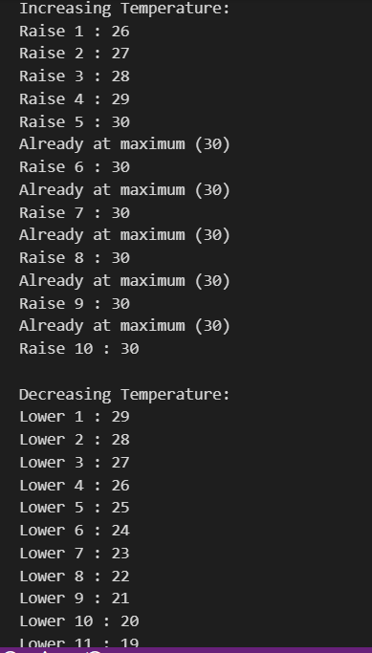

2. Cinema show (CinemaShow.java, main in this file)
(a) Create class CinemaShow with private String title, private int seatsAvailable, private
final int capacity, and private static int totalBooked=0.
(b) Constructor(title, capacity): set both and seatsAvailable = capacity.
Constructor(title): chain with this(title, 100).
(c) book(int n): if n ≤ seatsAvailable, reduce seatsAvailable by n, add n to totalBooked,
return true; else return false unchanged.
(d) cancel(int n): increase seatsAvailable by n but never above capacity.
(e) Add getSeatsAvailable() and static getTotalBooked().
(f) In main: run a sequence of book and cancel calls, printing the result and seats after
each, then print getTotalBooked().
Expected output: booking more than available prints false and leaves seats
unchanged; totalBooked equals the successful bookings.

Code:
public class CinemaShow {
// Private fields
private String title;
private int seatsAvailable;
private final int capacity;
private static int totalBooked = 0;

// Constructor with title and capacity
public CinemaShow(String title, int capacity) {
this.title = title;
this.capacity = capacity;
this.seatsAvailable = capacity; // Initially all seats are available
}

// Constructor with only title (default capacity 100)
public CinemaShow(String title) {
this(title, 100); // Calls the first constructor with capacity 100
}

// Book n seats
public boolean book(int n) {
if (n <= seatsAvailable) {
seatsAvailable = seatsAvailable - n;
totalBooked = totalBooked + n;
return true;
} else {
return false;
}
}

// Cancel n seats
public void cancel(int n) {
seatsAvailable = seatsAvailable + n;

// Make sure seatsAvailable doesn't exceed capacity
if (seatsAvailable > capacity) {
seatsAvailable = capacity;
}
}

// Getter for available seats
public int getSeatsAvailable() {
return seatsAvailable;
}

// Static getter for total booked
public static int getTotalBooked() {
return totalBooked;
// Main method
public static void main(String[] args) {
// Create two cinema shows
CinemaShow show1 = new CinemaShow("Avengers", 50);
CinemaShow show2 = new CinemaShow("Titanic");

System.out.println("=== SHOW 1: Avengers (Capacity: 50) ===");
System.out.println("Initial seats available: " + show1.getSeatsAvailable());
System.out.println();

// Try to book 30 seats
System.out.println("Booking 30 seats...");
boolean result = show1.book(30);
System.out.println("Booking successful? " + result);
System.out.println("Seats available now: " + show1.getSeatsAvailable());
System.out.println();

// Try to book 25 more seats (should fail)
System.out.println("Booking 25 more seats...");
result = show1.book(25);
System.out.println("Booking successful? " + result);
System.out.println("Seats available now: " + show1.getSeatsAvailable());
System.out.println();

// Cancel 5 seats
System.out.println("Cancelling 5 seats...");
show1.cancel(5);
System.out.println("Seats available now: " + show1.getSeatsAvailable());
System.out.println();

// Book 20 seats
System.out.println("Booking 20 seats...");
result = show1.book(20);
System.out.println("Booking successful? " + result);
System.out.println("Seats available now: " + show1.getSeatsAvailable());
System.out.println();

System.out.println("=== SHOW 2: Titanic (Capacity: 100) ===");
System.out.println("Initial seats available: " + show2.getSeatsAvailable());
System.out.println();

// Book 80 seats
System.out.println("Booking 80 seats...");
result = show2.book(80);
System.out.println("Booking successful? " + result);
System.out.println("Seats available now: " + show2.getSeatsAvailable());
System.out.println();

// Cancel 30 seats
System.out.println("Cancelling 30 seats...");
show2.cancel(30);
System.out.println("Seats available now: " + show2.getSeatsAvailable());
System.out.println();

// Try to cancel more than capacity (should cap at capacity)
System.out.println("Cancelling 100 seats (more than capacity)...");
show2.cancel(100);
System.out.println("Seats available now: " + show2.getSeatsAvailable());
System.out.println();

System.out.println("=== FINAL SUMMARY ===");
System.out.println("Total seats booked across all shows: " + CinemaShow.getTotalBooked());
}
}

Output :

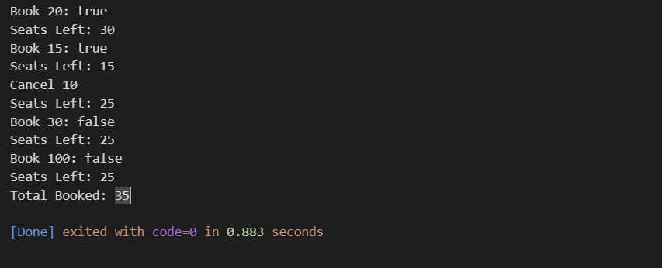

3. (For Advanced Learners – home) Parking lot (ParkingLot.java)
(a) Create class ParkingLot with private int twoWheelers and fourWheelers, private final
int twoCap and fourCap, and private static long revenue=0.
(b) park(String type): for “two”, if twoWheelers < twoCap increment and add 20 to
revenue; for “four”, if fourWheelers < fourCap increment and add 40; otherwise print
“Full” and reject.
(c) leave(String type): decrement the matching count but never below 0.
(d) In main: simulate a sequence of park/leave events, printing each outcome, then print
final occupancy and revenue.
Expected output: parking into a full section is refused; revenue = 20×(two parked)
+ 40×(four parked).

Code:

public class ParkingLot {
// Private fields
private int twoWheelers; // Current number of two-wheelers parked
private int fourWheelers; // Current number of four-wheelers parked
private final int twoCap; // Maximum capacity for two-wheelers
private final int fourCap; // Maximum capacity for four-wheelers
private static long revenue = 0; // Total revenue from all parking lots

// Constructor
public ParkingLot(int twoCap, int fourCap) {
this.twoCap = twoCap;
this.fourCap = fourCap;
this.twoWheelers = 0;
this.fourWheelers = 0;
}

// Park a vehicle
public void park(String type) {
if (type.equals("two")) {
// Check if space available for two-wheeler
if (twoWheelers < twoCap) {
twoWheelers++;
revenue = revenue + 20;
System.out.println("Two-wheeler parked successfully. Fee: 20");
} else {
System.out.println("Full - No space for two-wheeler");
}
} else if (type.equals("four")) {
// Check if space available for four-wheeler
if (fourWheelers < fourCap) {
fourWheelers++;
revenue = revenue + 40;
System.out.println("Four-wheeler parked successfully. Fee: 40");
} else {
System.out.println("Full - No space for four-wheeler");
}
} else {
System.out.println("Invalid vehicle type! Use 'two' or 'four'");
}
}

// Leave a vehicle
public void leave(String type) {
if (type.equals("two")) {
// Decrease count but never below 0
if (twoWheelers > 0) {
twoWheelers--;
System.out.println("Two-wheeler left the parking lot");
} else {
System.out.println("No two-wheelers to leave");
}
} else if (type.equals("four")) {
// Decrease count but never below 0
if (fourWheelers > 0) {
fourWheelers--;
System.out.println("Four-wheeler left the parking lot");
} else {
System.out.println("No four-wheelers to leave");
}
} else {
System.out.println("Invalid vehicle type! Use 'two' or 'four'");
}
}

// Get current occupancy
public void displayStatus() {
System.out.println("=== PARKING LOT STATUS ===");
System.out.println("Two-wheelers: " + twoWheelers + " / " + twoCap);
System.out.println("Four-wheelers: " + fourWheelers + " / " + fourCap);
System.out.println("Total revenue: " + revenue);
System.out.println();
}

// Static method to get total revenue
public static long getRevenue() {
return revenue;
}

// Main method
public static void main(String[] args) {
// Create parking lot with capacity: 3 two-wheelers, 2 four-wheelers
ParkingLot lot = new ParkingLot(3, 2);

System.out.println("=== PARKING LOT SIMULATION ===");
System.out.println("Capacity: Two-wheelers=3, Four-wheelers=2");
System.out.println();

lot.displayStatus();

// Park some vehicles
System.out.println("--- Parking vehicles ---");
lot.park("two"); // 2-wheeler 1
lot.park("two"); // 2-wheeler 2
lot.park("four"); // 4-wheeler 1
lot.park("two"); // 2-wheeler 3
lot.park("two"); // Should fail - full for two-wheelers
lot.park("four"); // 4-wheeler 2
lot.park("four"); // Should fail - full for four-wheelers

System.out.println();
lot.displayStatus();

// Some vehicles leave
System.out.println("--- Vehicles leaving ---");
lot.leave("two"); // One two-wheeler leaves
lot.leave("four"); // One four-wheeler leaves

System.out.println();
lot.displayStatus();

// Park again after some left
System.out.println("--- Parking after some left ---");
lot.park("two"); // Should succeed (space available)
lot.park("four"); // Should succeed (space available)
lot.park("four"); // Should fail (full again)

System.out.println();
lot.displayStatus();

// Final summary
System.out.println("=== FINAL SUMMARY ===");
System.out.println("Total revenue collected: " + ParkingLot.getRevenue());
System.out.println("Total two-wheelers parked: " + lot.twoWheelers);
System.out.println("Total four-wheelers parked: " + lot.fourWheelers);
System.out.println("Total vehicles parked: " + (lot.twoWheelers + lot.fourWheelers));
}
}

OutPut:
