Financial Engineering
Lab
(MA374)

Neelabh Tiwari
160123024
Department of Mathematics
IIT Guwahati

Assignment - 1
(10 January 2019)

- Question 1

S_{o} = 100, K (strike price) = 105, T = 5, r = 0.05, σ = 0.3

The initial Option prices for M = 1,5,10,20,50,100,200,400 are as following :

The above prices are calculated using the backtracking approach where the option price at any step is Expected discounted value of payoff with respect to risk-neutral probability measure.

q (risk-neutral probability) = (e^{(rt)} – d)/(u – d)
Pup = Payoff if stock goes up
Pdn = Payoff if stock goes down

Call Option Payoff = max(S_{n} – K,0)
Put Option Payoff = max(K-S_{n},0)

- Question 2

Following are the graphs of the initial option prices Vs number of subintervals :

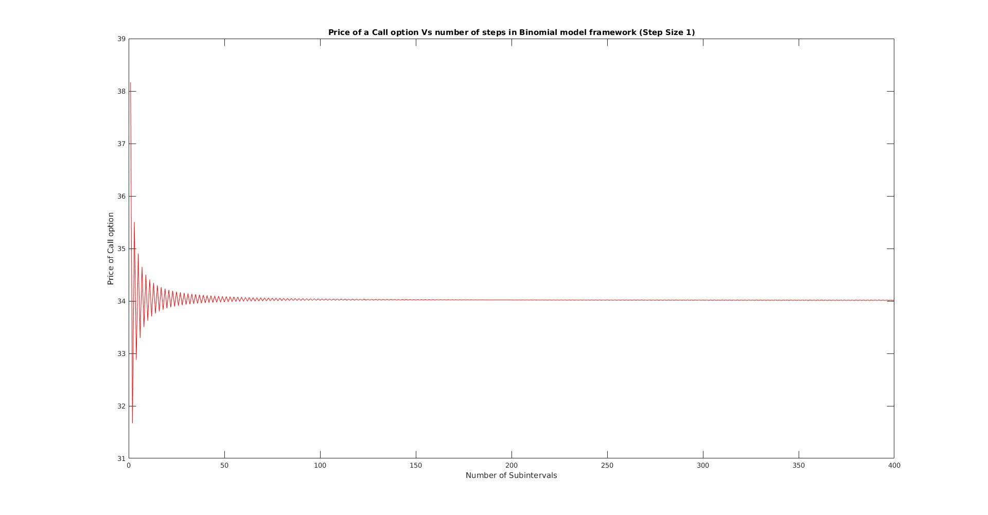
Price of Call Option Vs number of subintervals varied with step size 1
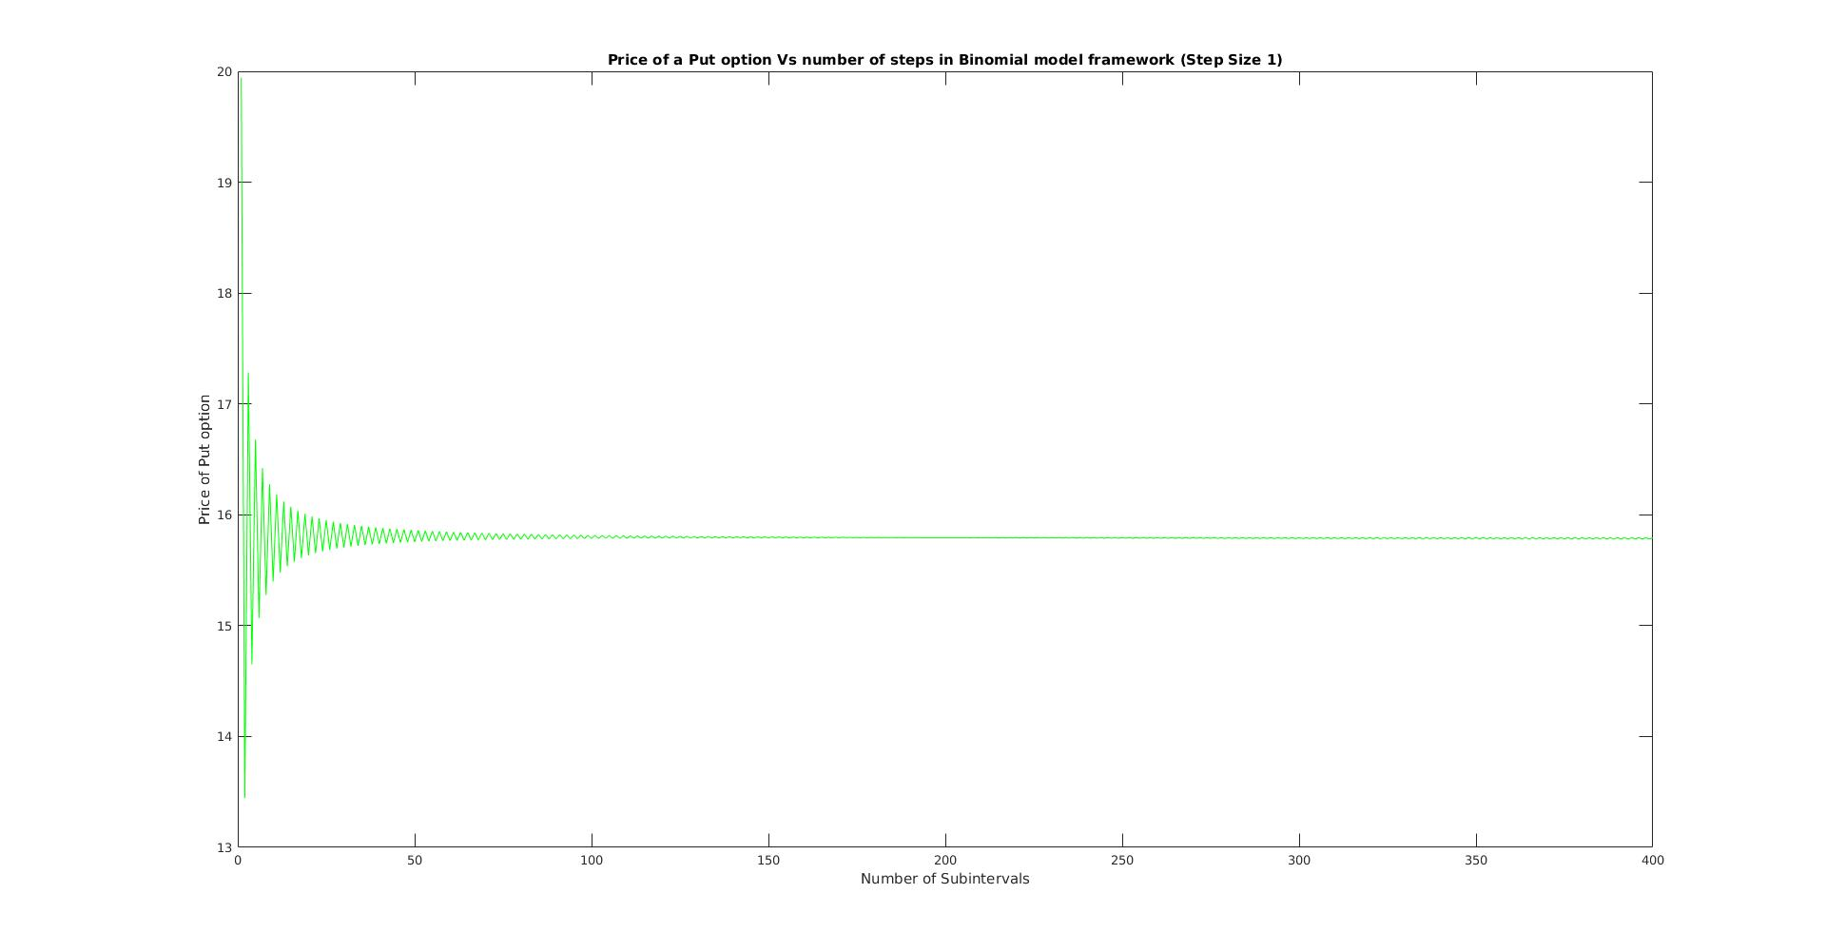
Price of Put Option Vs number of subintervals varied with step size 1
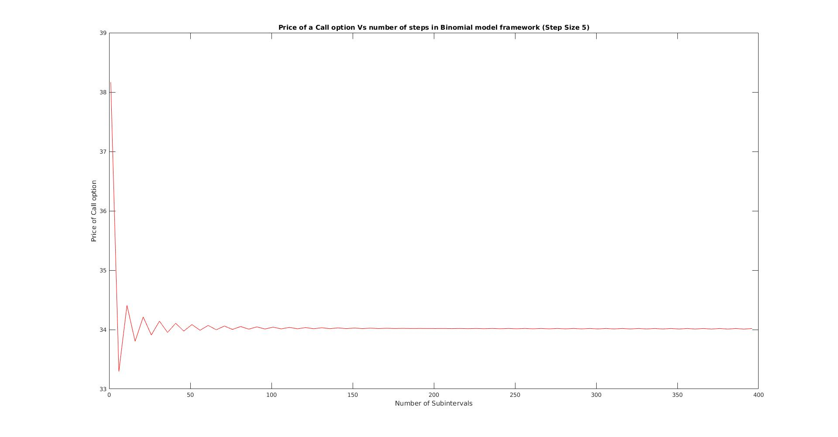
Price of Call Option Vs number of subintervals varied with step size 5

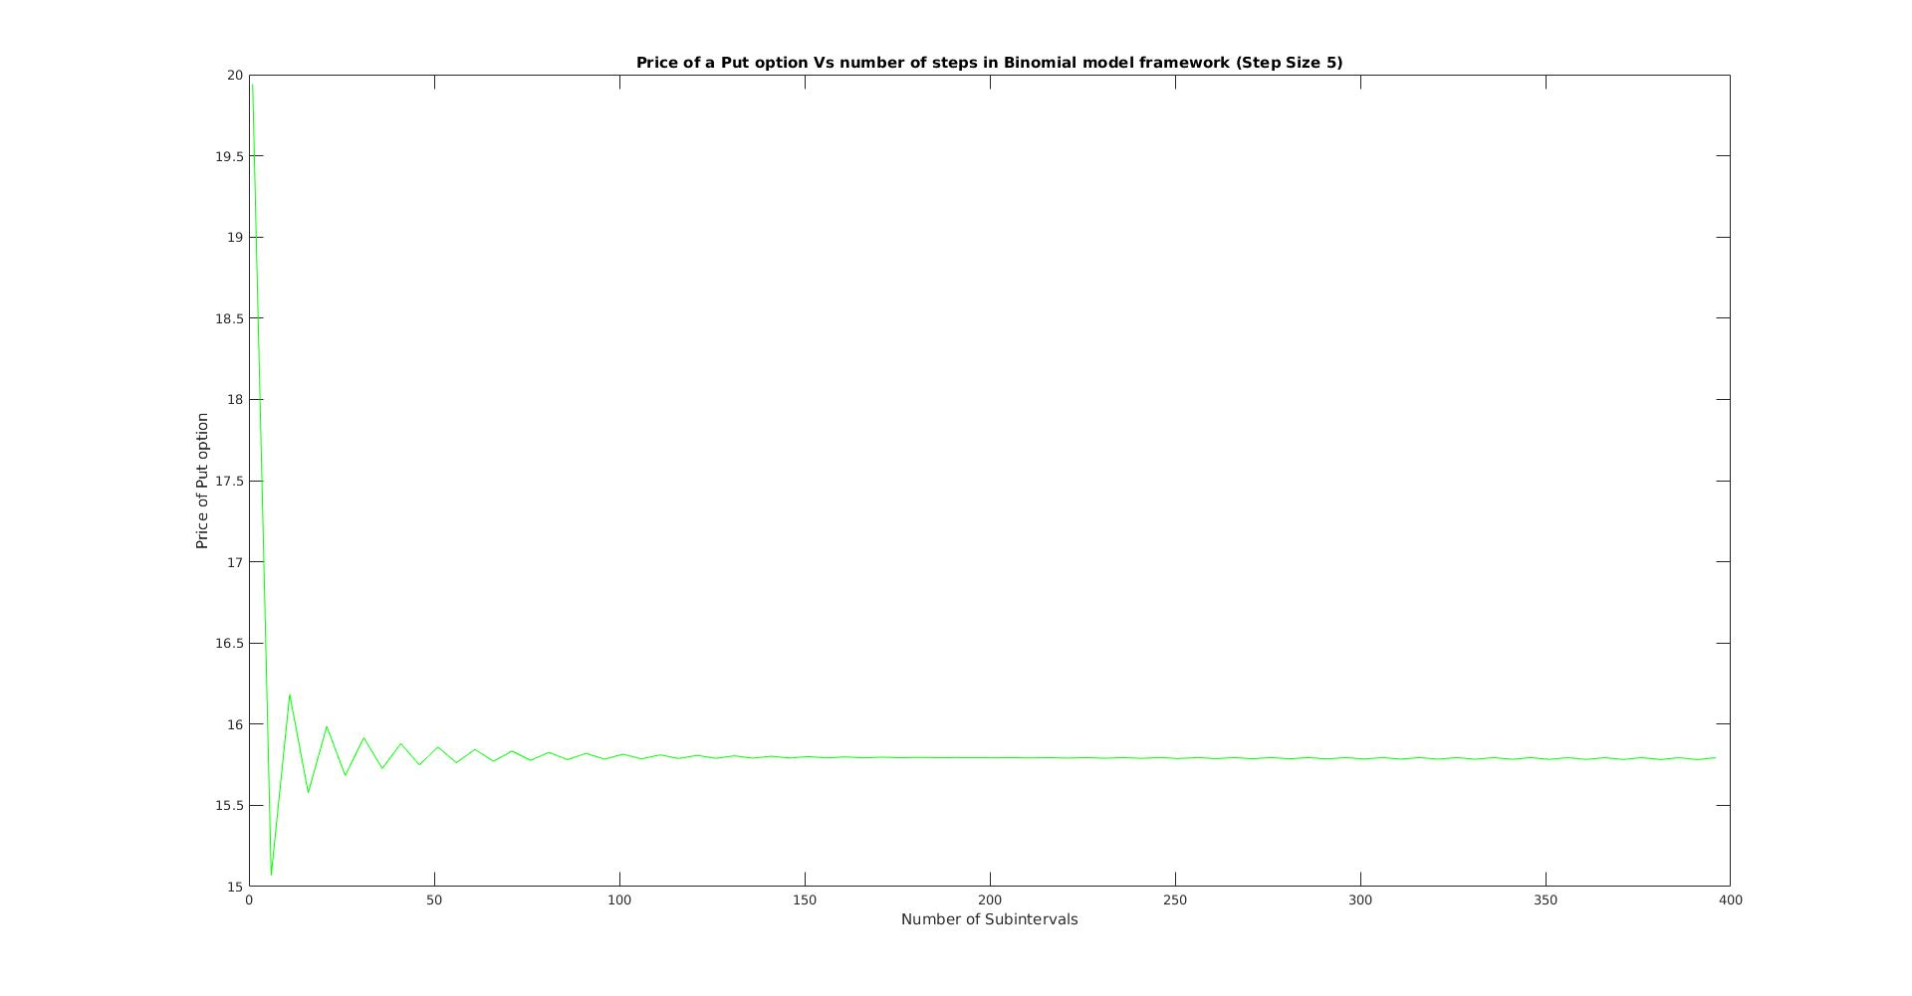
Price of Put Option Vs number of subintervals varied with step size 5
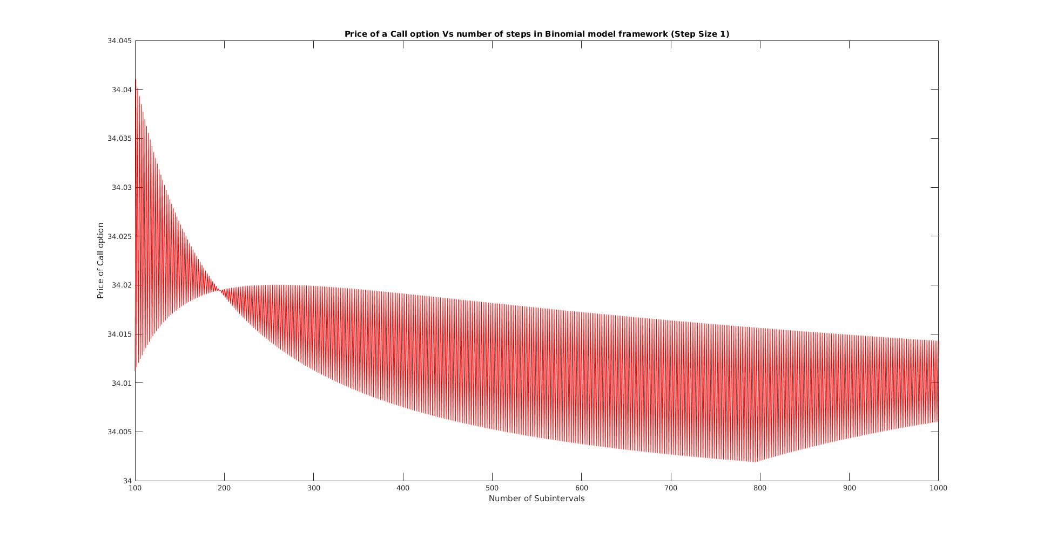
Price of Call Option Vs number of subintervals varied with step size 1

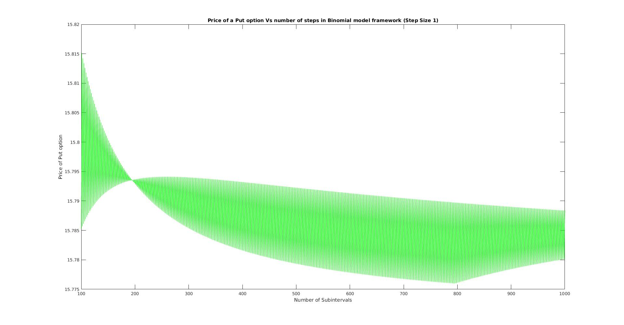
Price of Put Option Vs number of subintervals varied with step size 1
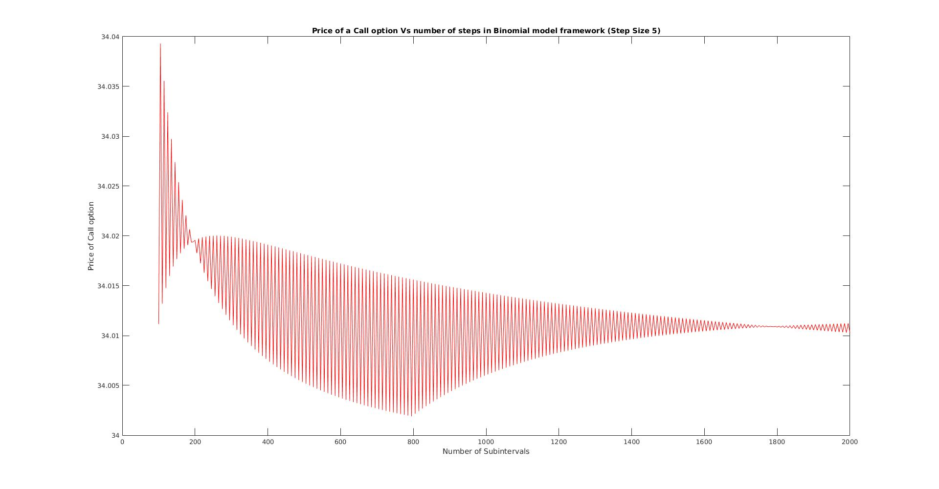
Price of Call Option Vs number of subintervals varied with step size 5

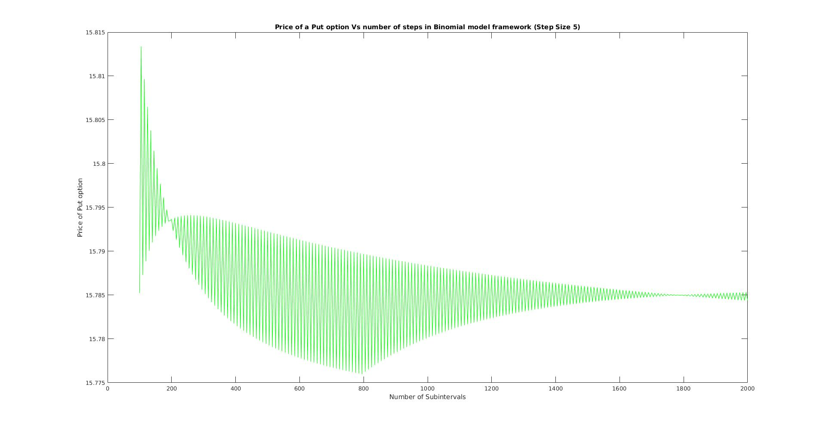
Price of Put Option Vs number of subintervals varied with step size 5

Observations from the plots -

- We observe that value of European call option converges to 34.012 and European put option converges to 15.785.

- We also observe that this convergesnce is not perfect. Some deviations occur from the converging values. For eg. , the call option price for M = 1 is 38.168 but it does not uniformly decreaces to 34.012 as M increaces. It fluctuates down to 34.003 for M = 800 and later increces to the converging value.

- However the deviations decreace as the value of M (number of subintervals) increces as can be seen in plots for higher values of M (~2000).

- Question 3

The price of the European call option at t = 0, 0.50, 1, 1.50, 3, 4.5 for M = 20 are as following :

The price of the European put option at t = 0, 0.50, 1, 1.50, 3, 4.5 for M = 20 are as following :

Note : The code checks for the arbitrage possibilities using the following conditions necessary for the market to be arbitrage free -

- d < e^{(rt)}

- e^{(rt)} < u

