Financial Engineering
Lab
(MA374)

Neelabh Tiwari
160123024
Department of Mathematics
IIT Guwahati

Assignment - 3
(24 January 2019)

- Question 1

The Option Prices for the data -

S(0) = 100; K = 100; T = 1; M = 100; r = 8%; σ = 20%

The American Call price is - 12.1230
The American Put price is - 5.2798

Sensitivity Analysis of option price variance with S(0), K, M, r, σ are done by plotting 2-D plots -

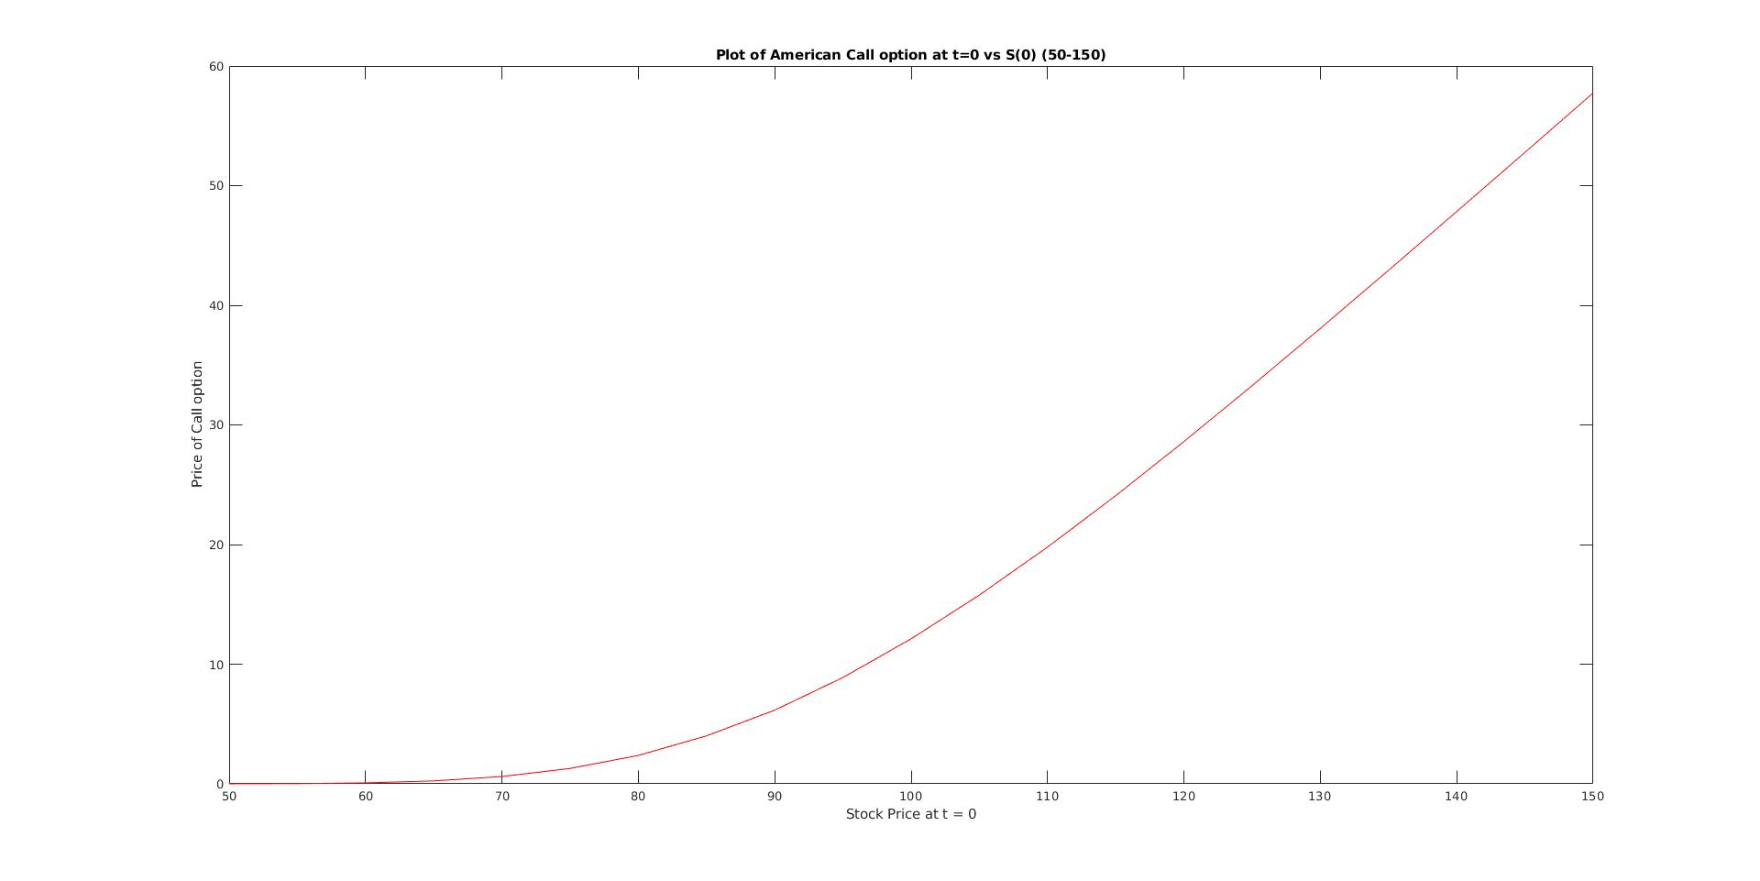

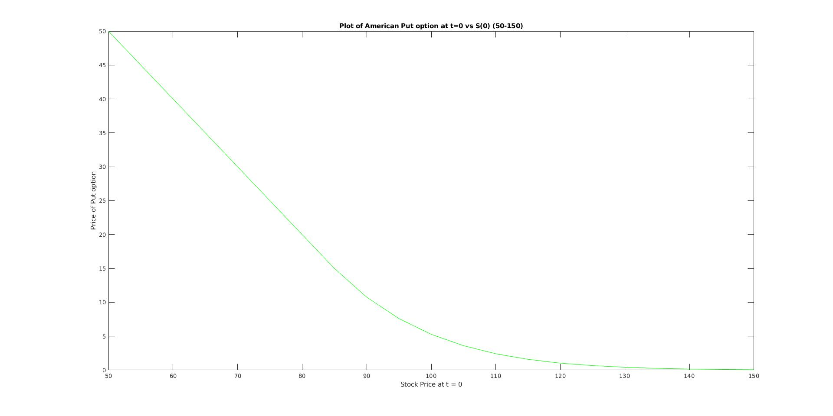
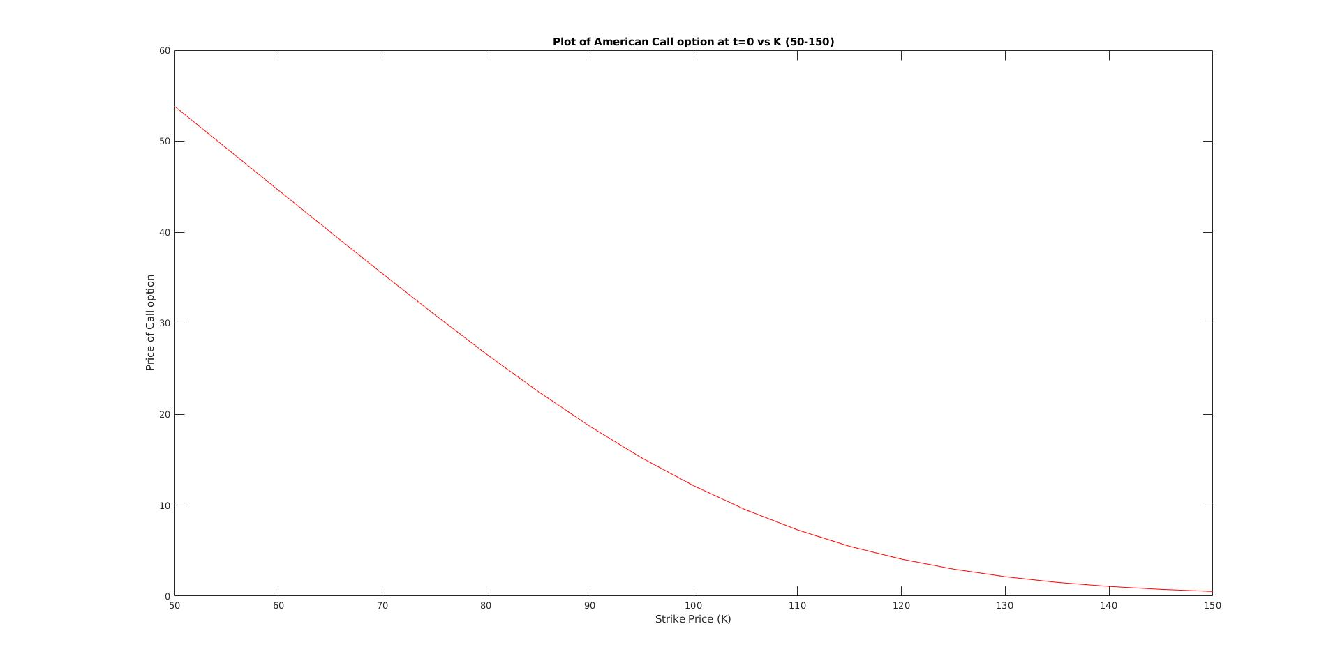

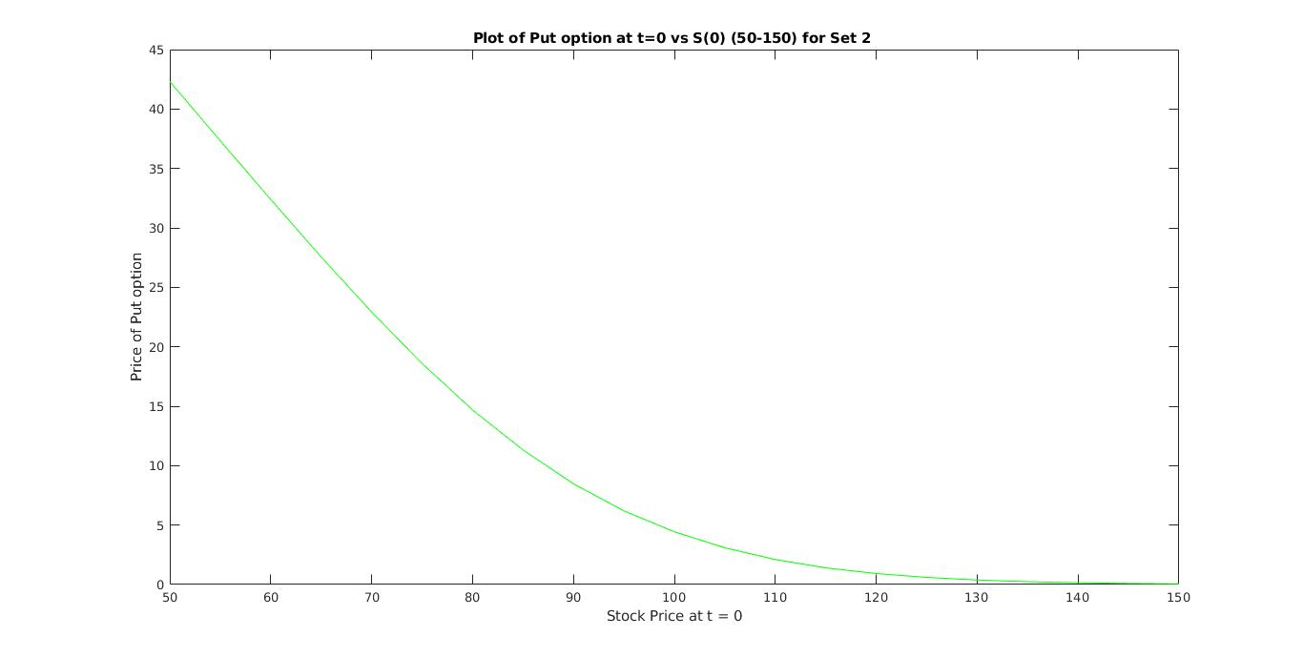

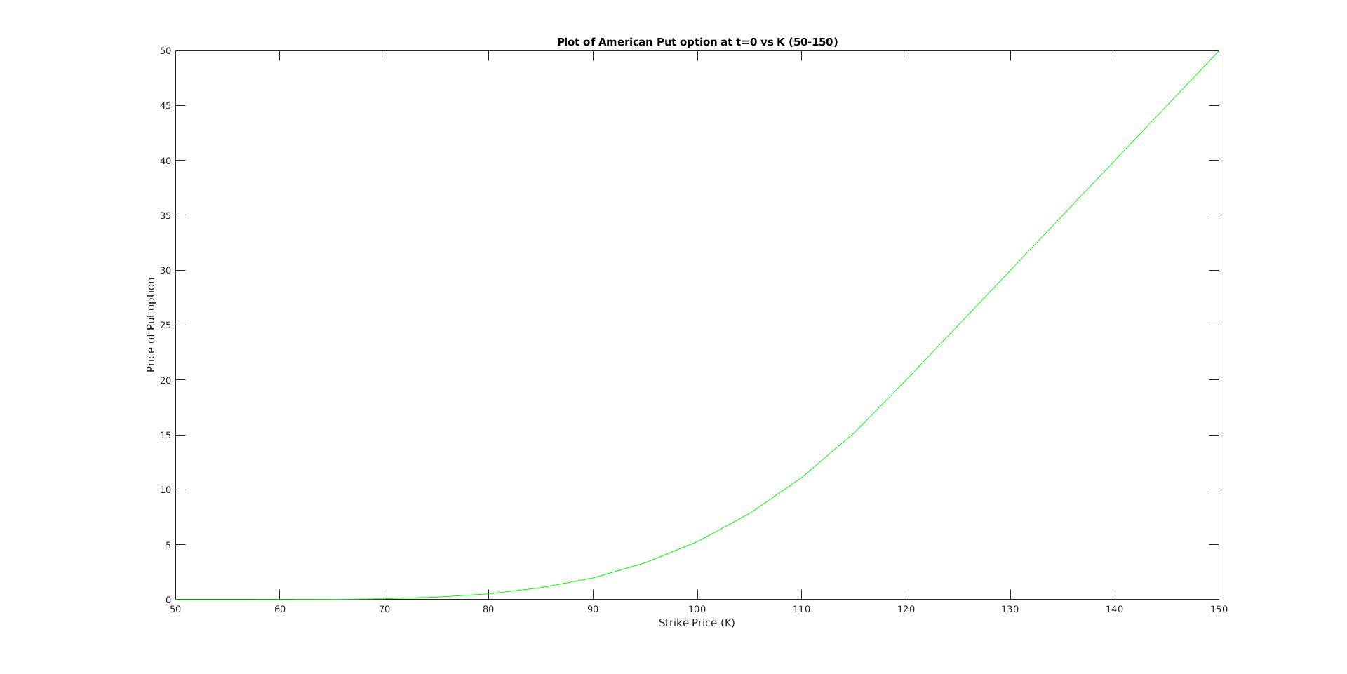
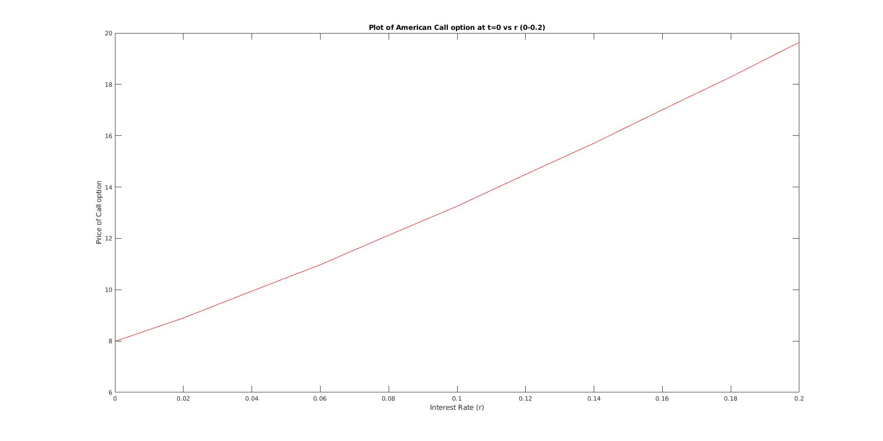

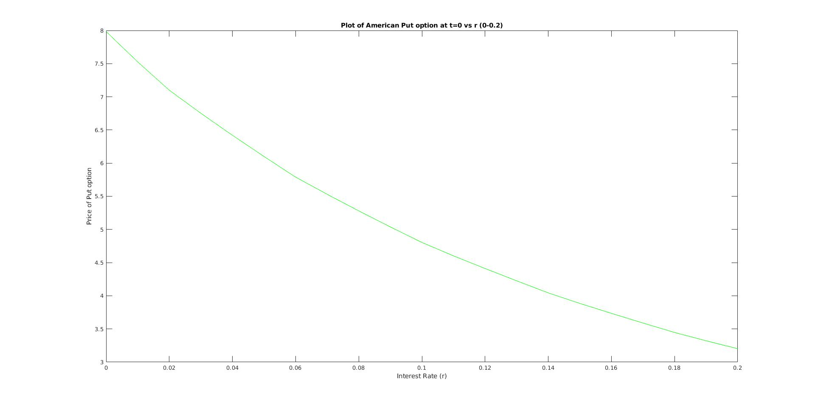
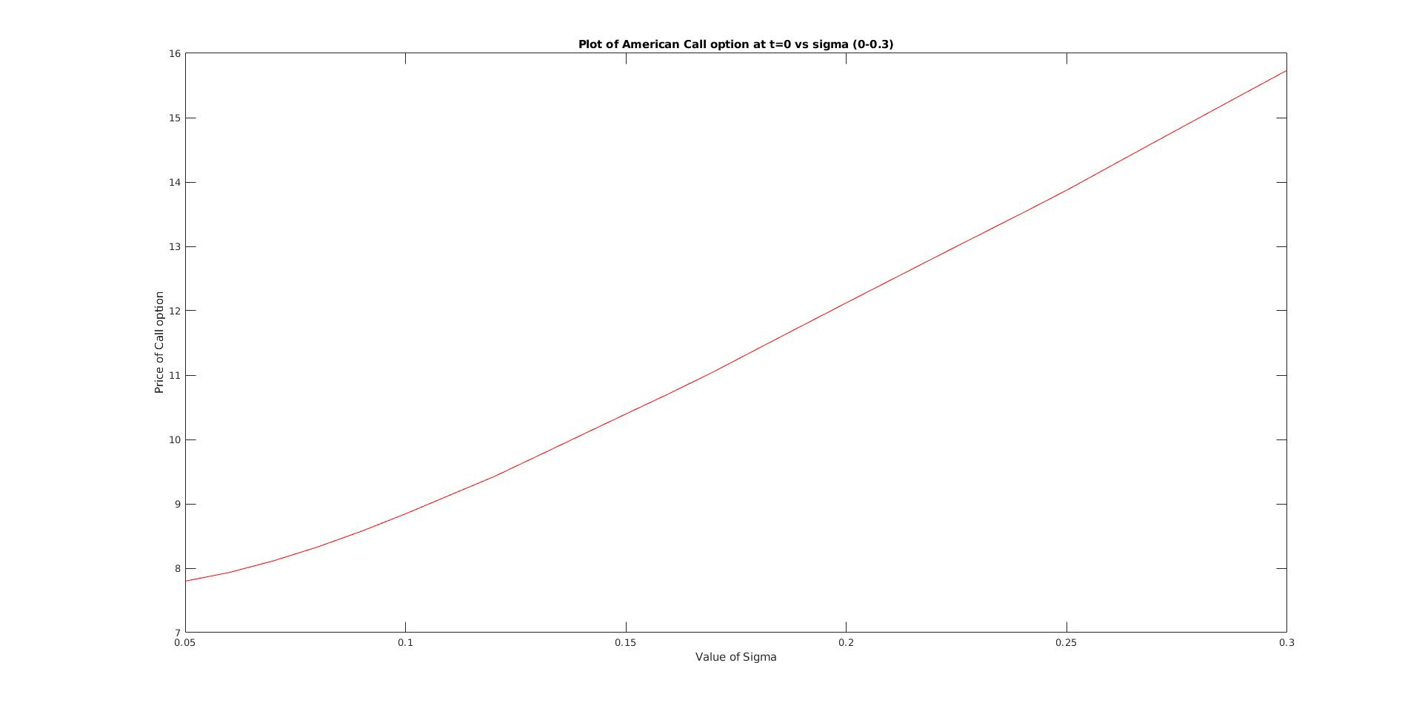

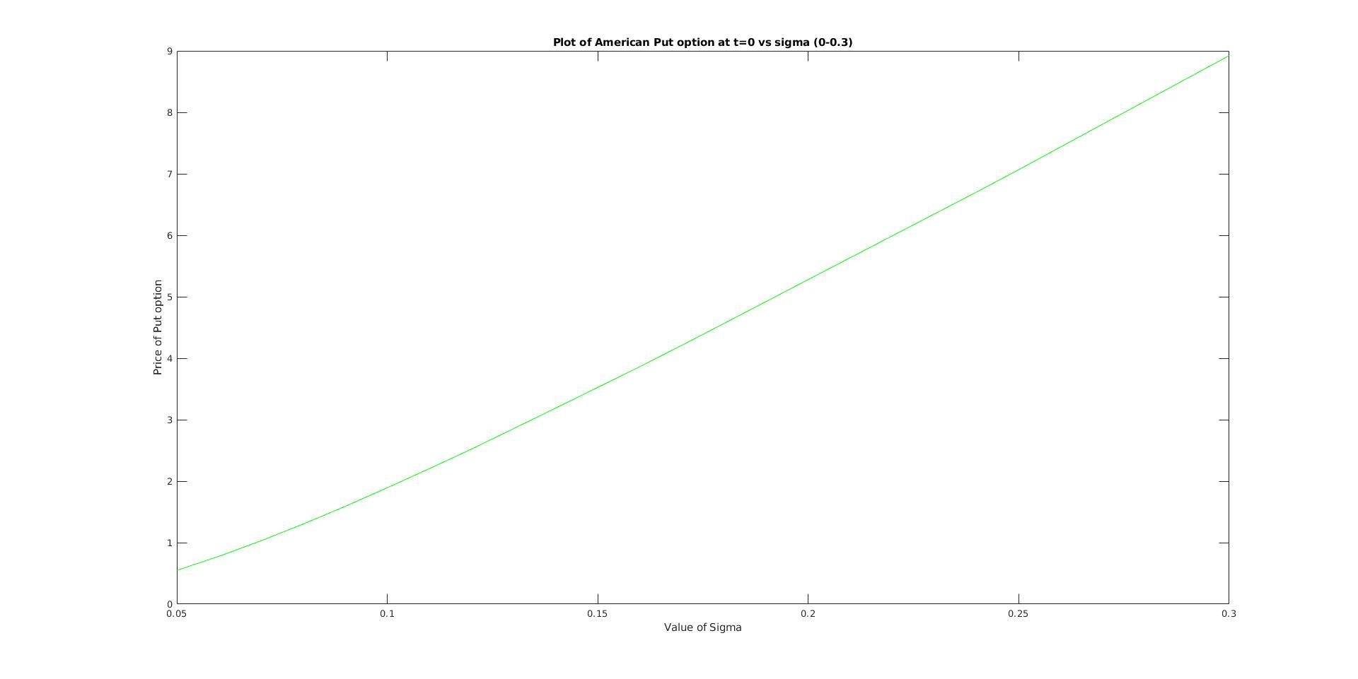
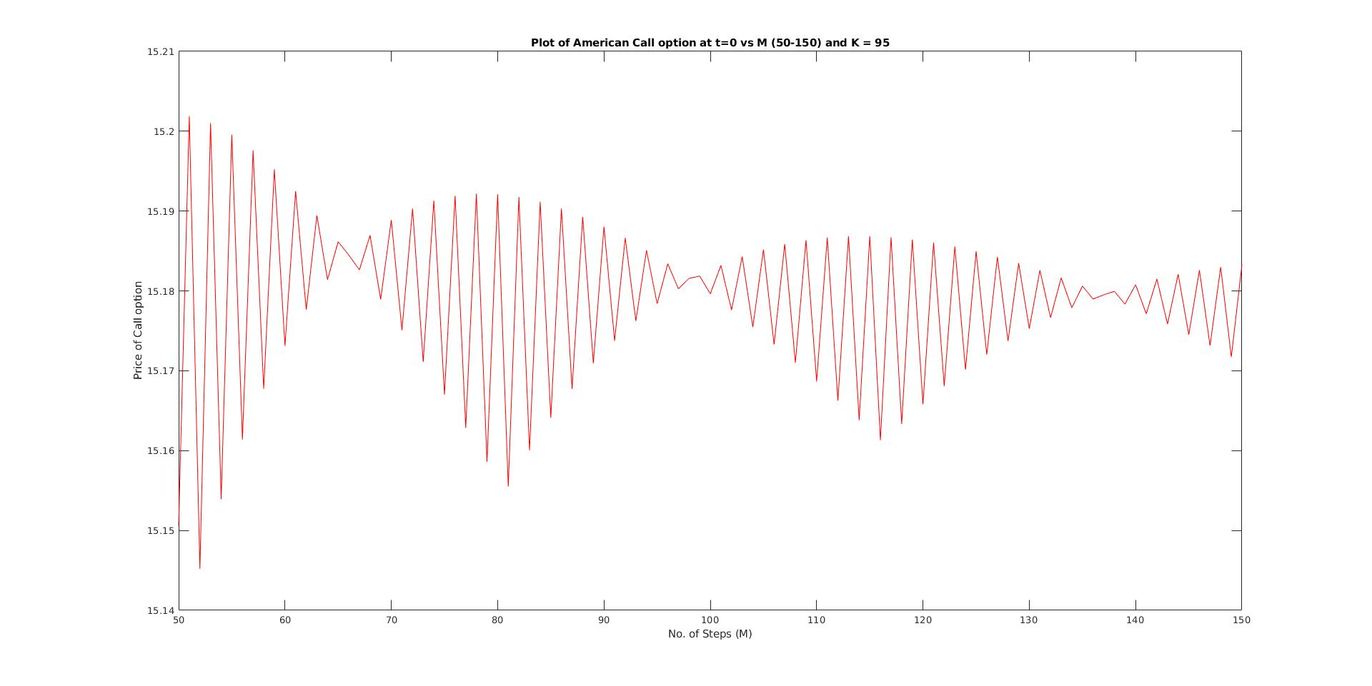

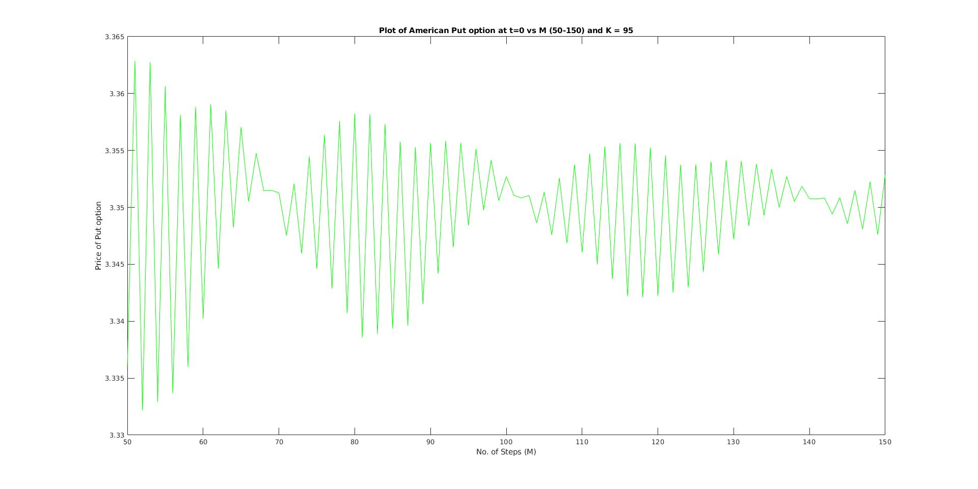

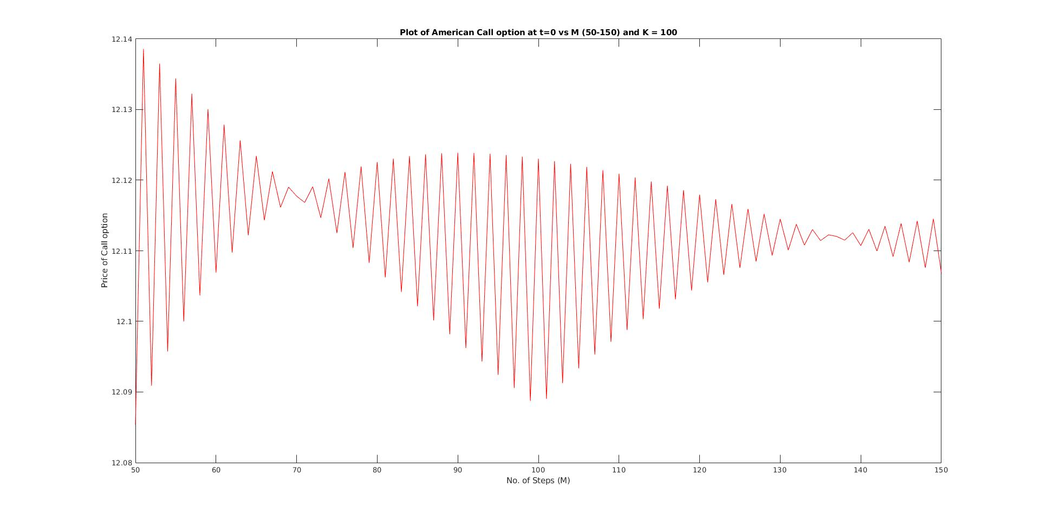

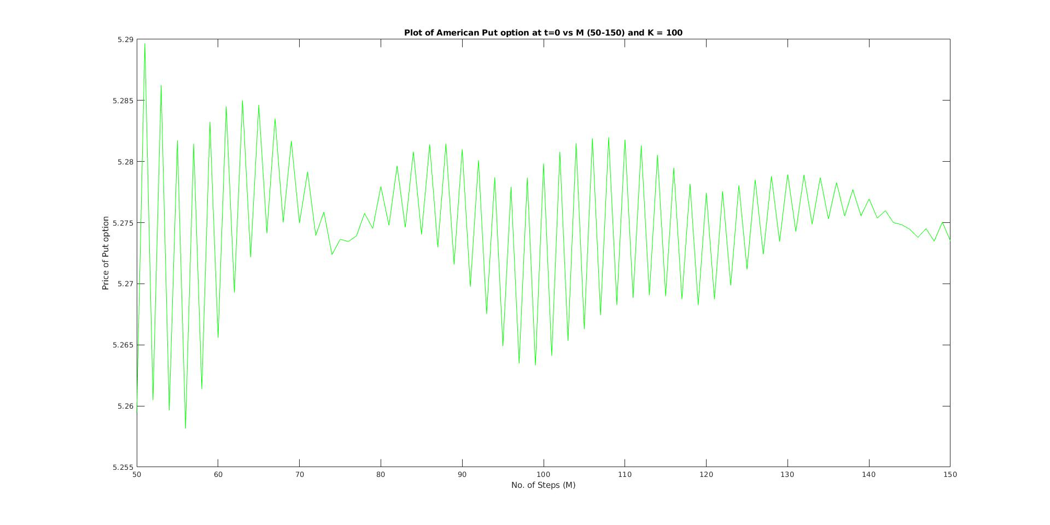
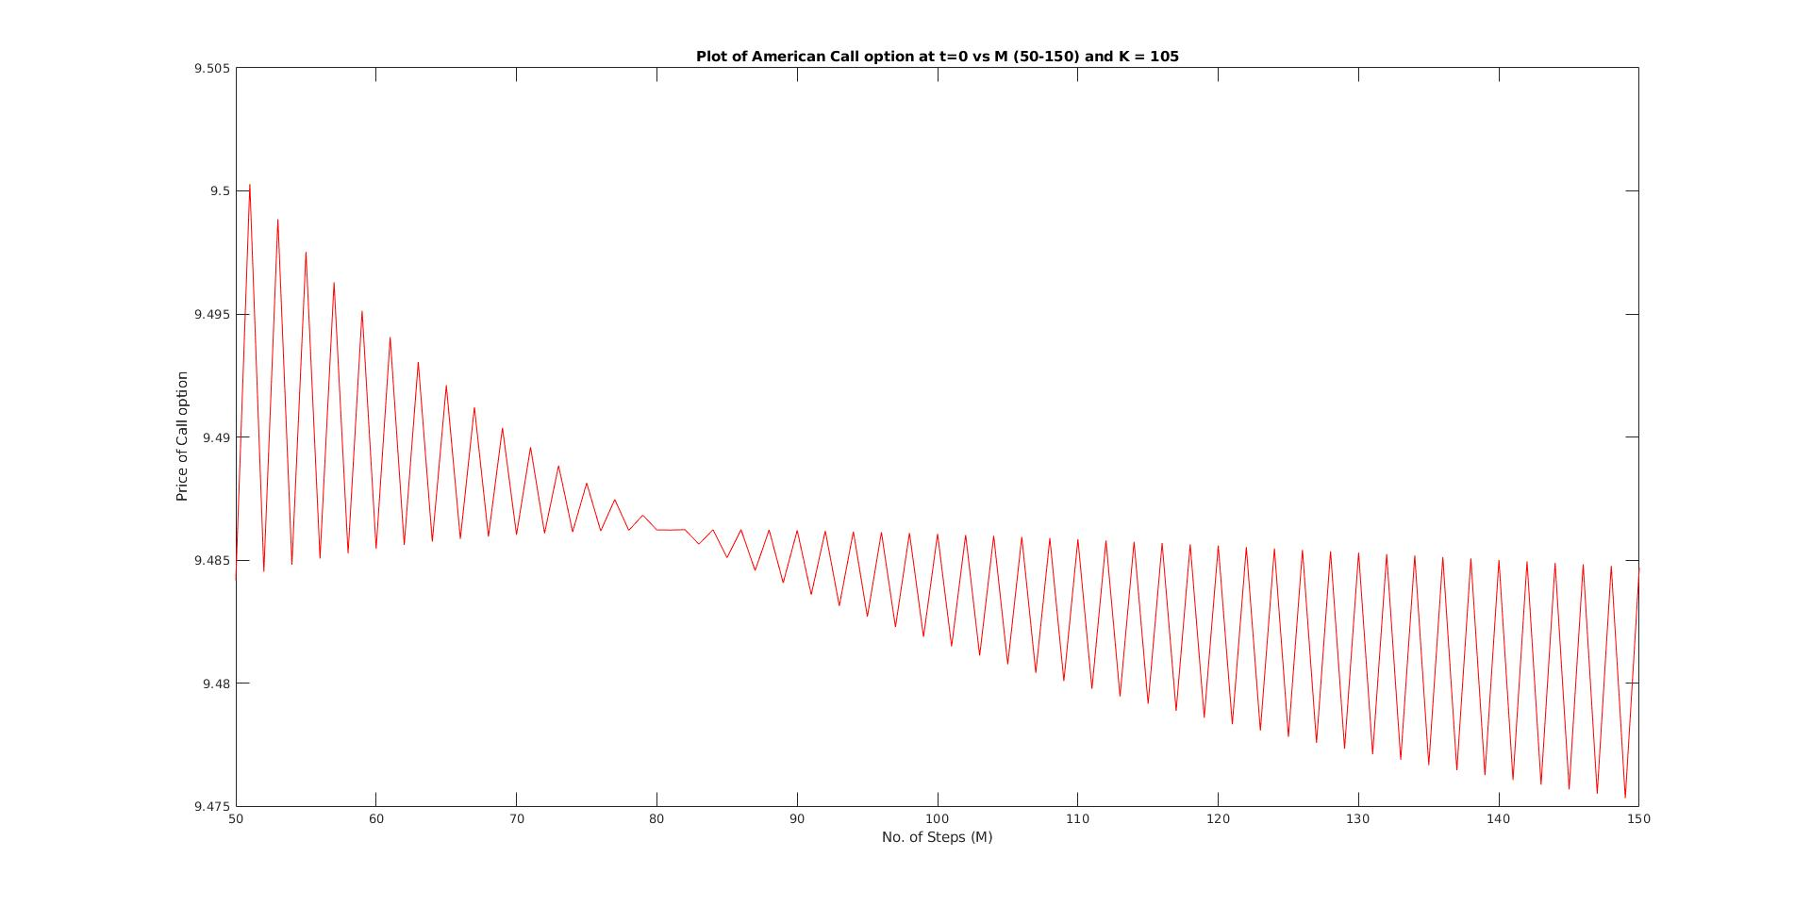

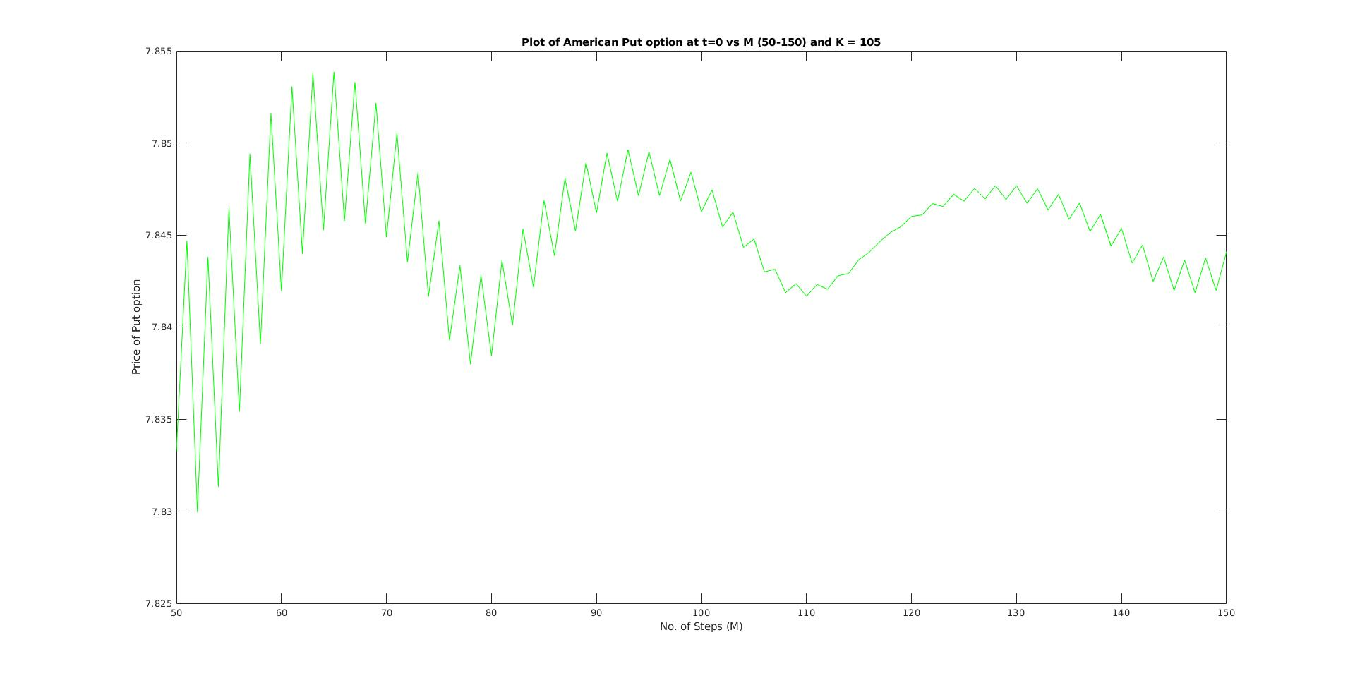
- Question 2

The payoff of the lookback option is given by

V=maxS(i)−S(M), 0<=i<=M

For M = 5, the initial price of Lookback Option = 9.1192989
For M = 10, the initial price of Lookback Option = 10.080582
For M = 15, the initial price of Lookback Option = 10.519165

For M = 25 and M = 50, the amount of data required was too large for MATLAB to handle (Space Complexity exceeded). This will be addressed in question 3 using Markov based computationally efficient binomial algorithm.

b) From the graph it is observed that the initial values of Lookback Option tend to converge. Moreover for the initial values of M, the increasing pattern of initial option value with M is observed.

Plot Of Initial option price Vs value of M -

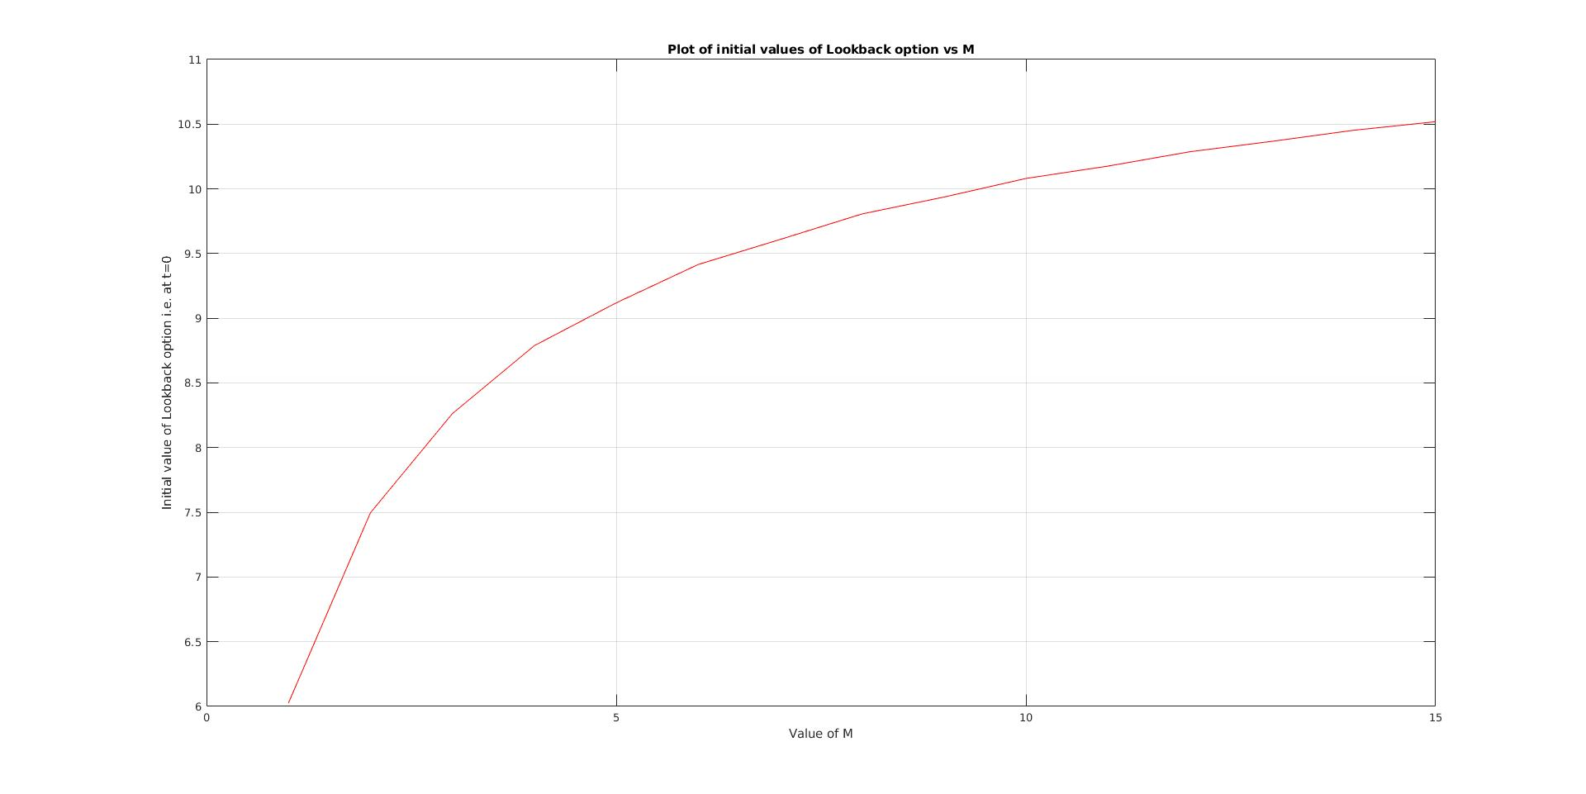
c) The values of the options at all intermediate time points for M = 5 -

T=0 | T=0.2 | T=0.4 | T=0.6 | T=0.8 | T=1
9.119299 | 9.027951 | 8.548076 | 7.416771 | 5.501638 | 0
 | 9.504840 | 9.799119 | 9.955271 | 9.5713915 | 11.181413
 |  | 7.147915 | 6.201916 | 4.6004796 | 0
 |  | 12.168664 | 13.712862 | 15.631851 | 19.452691
 |  |  | 6.201916 | 4.6004796 | 0
 |  |  | 8.324614 | 8.0036137 | 9.349916
 |  |  | 7.148418 | 6.6808429 | 6.374517
 |  |  | 17.582062 | 21.188089 | 25.394563
 |  |  |  | 4.6004796 | 0
 |  |  |  | 8.0036137 | 9.349916
 |  |  |  | 3.8469288 | 0
 |  |  |  | 13.071381 | 16.266373
 |  |  |  | 3.8469288 | 0
 |  |  |  | 10.680904 | 13.578002
 |  |  |  | 10.680904 | 13.578002
 |  |  |  | 25.051229 | 29.482597
 |  |  |  |  | 0
 |  |  |  |  | 9.349916
 |  |  |  |  | 0
 |  |  |  |  | 16.266373
 |  |  |  |  | 0
 |  |  |  |  | 7.8184160
 |  |  |  |  | 5.3303822
 |  |  |  |  | 21.234976
 |  |  |  |  | 0
 |  |  |  |  | 7.8184160
 |  |  |  |  | 2.9013505
 |  |  |  |  | 18.805945
 |  |  |  |  | 2.9013504
 |  |  |  |  | 18.805945
 |  |  |  |  | 18.805945
 |  |  |  |  | 32.105394

- Question 3

The algorithm implemented in the the second question can handle value of M only upto 15. By implementing the efficient Markov based algorithm presented in Shreve Vol – 1, the complexity has been brought down to O(n²) from O(2^{n}).

For M = 20, the initial price of Lookback Option = 10.7788
For M = 25, the initial price of Lookback Option = 10.2972
For M = 50, the initial price of Lookback Option = 10.5368

Note : Due to limited profiency in MATLAB, I have implemented the Markov based efficient algorithm in C++11 language as it required usage of maps, vectors and pair data types. If required please run the code using the command - ‘g++ -std=c++11 l3q3.cpp’.

