Financial Engineering
Lab
(MA374)

Neelabh Tiwari
160123024
Department of Mathematics
IIT Guwahati

Assignment - 5
(14 February 2019)

- Question 1

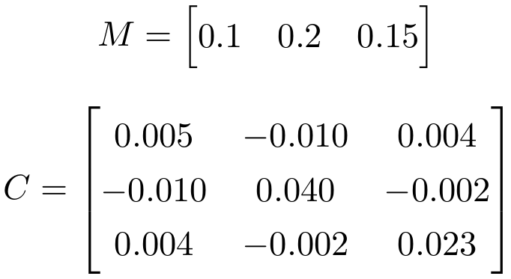

a) Markowitz Efficient Frontier and various MVLs -

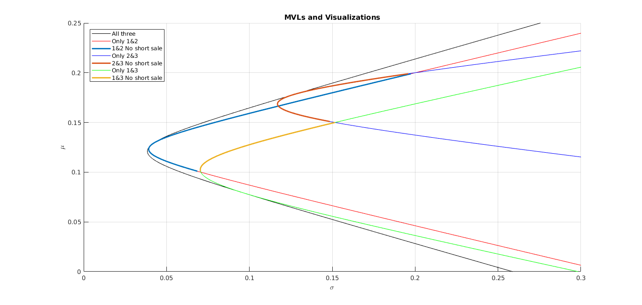

b) Portoflios belonging to feasible region of MVL without short selling -

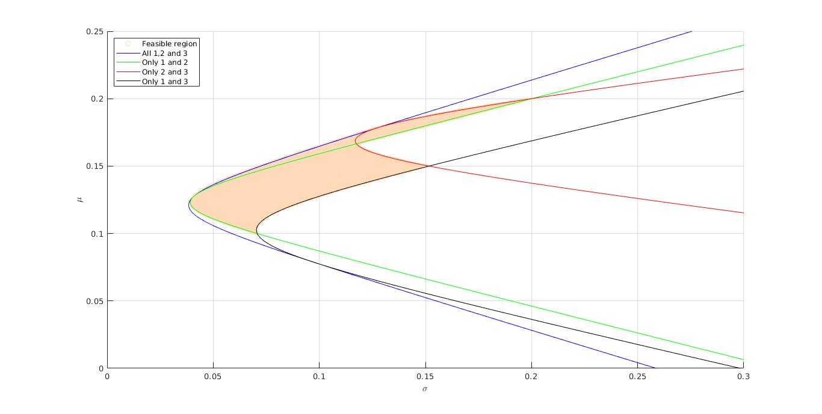
c) Weight Representations -

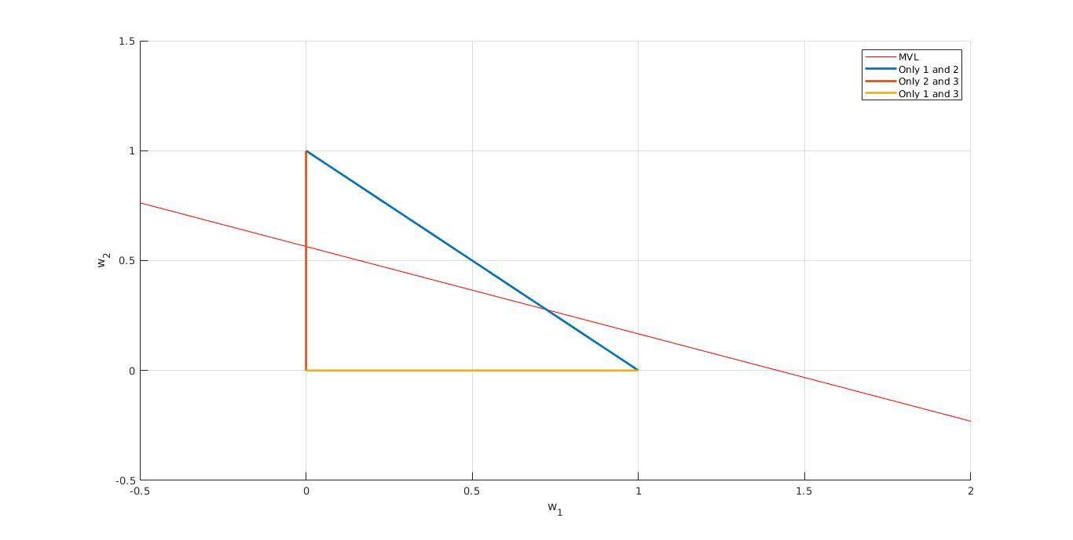
d) Weight Equations -
Let W₁ = x (parameter) :
W₁ = x
W₂ = -0.39744*x + 0.56410
W₃ = -0.60256*x - 0.43590

In terms of mu (return) = x (parameter) :

w1 = 2.5504 – 14.3119*x
w2 = 5.6880*x – 0.4495
w3 = 8.6238*x – 1.1009

- Question 2

Assets from BSE (Sensex) :

Assets from NSE (Nifty) :

SML of both BSE and NSE will go downwards as the mean return of the
market portfolio is less than the risk-free rate -

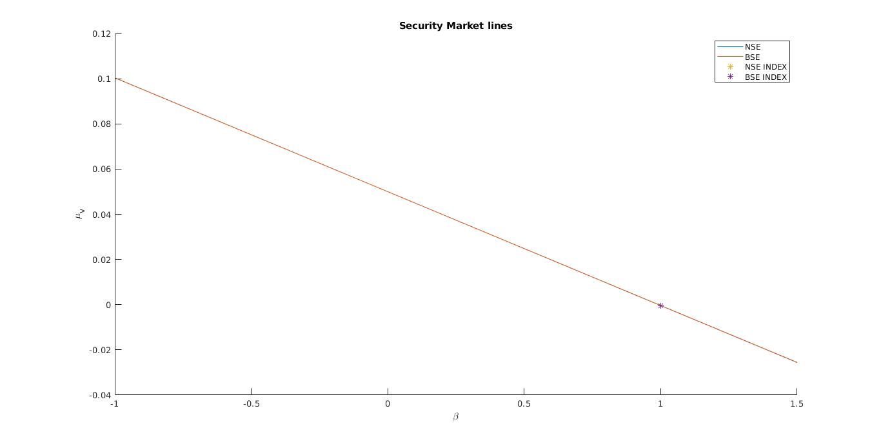
On Zooming --
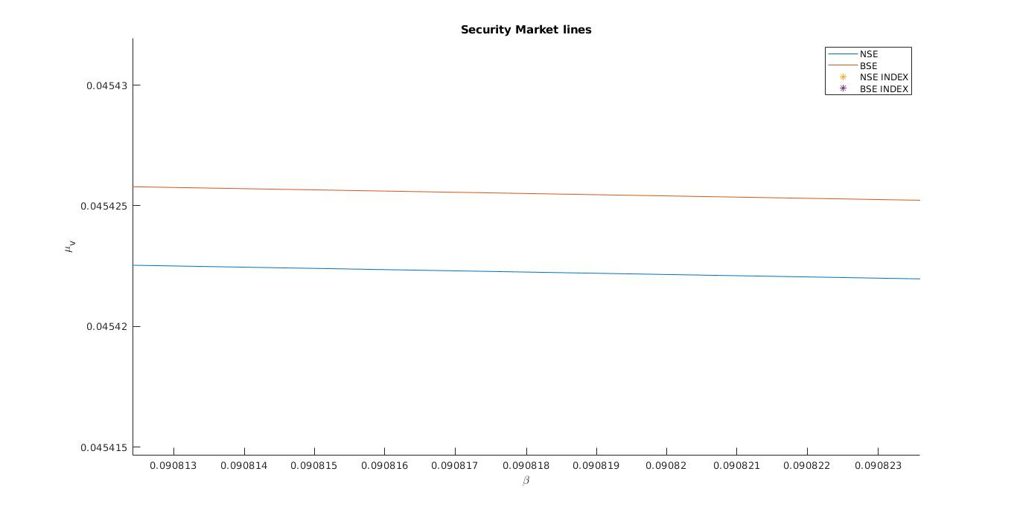
Difference in SML is very less ---
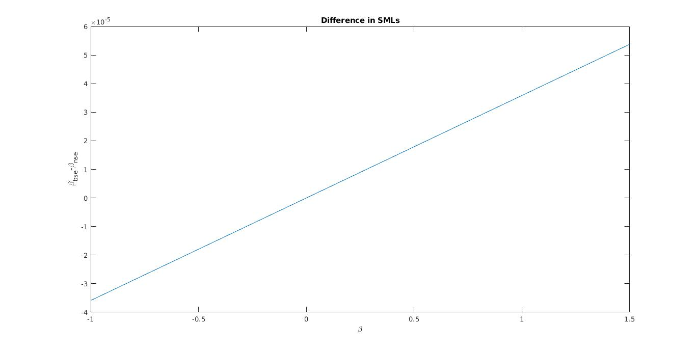

The market portfolio has beta value exactly equal to 1.

1. If the beta value is less than one then it implies that the underlying asset has less volatility or the value of the underlying asset isn’t highly correlated with the market value.
2. Beta above one thereby implies high volatility or high correlation with the market movements.
3. Beta less than one can occur when the asset price goes opposite to the market.

