Financial Engineering
Lab
(MA374)

Neelabh Tiwari
160123024
Department of Mathematics
IIT Guwahati

Assignment - 10
(18 April 2019)

- Question 1

Price of call option with strike price: 90 is 10.714566
Price of put option with strike price: 90 is 0.141943
Price of call option with strike price: 105 is 1.645191
Price of put option with strike price: 105 is 4.782734
Price of call option with strike price: 110 is 0.519963
Price of put option with strike price: 110 is 9.062596

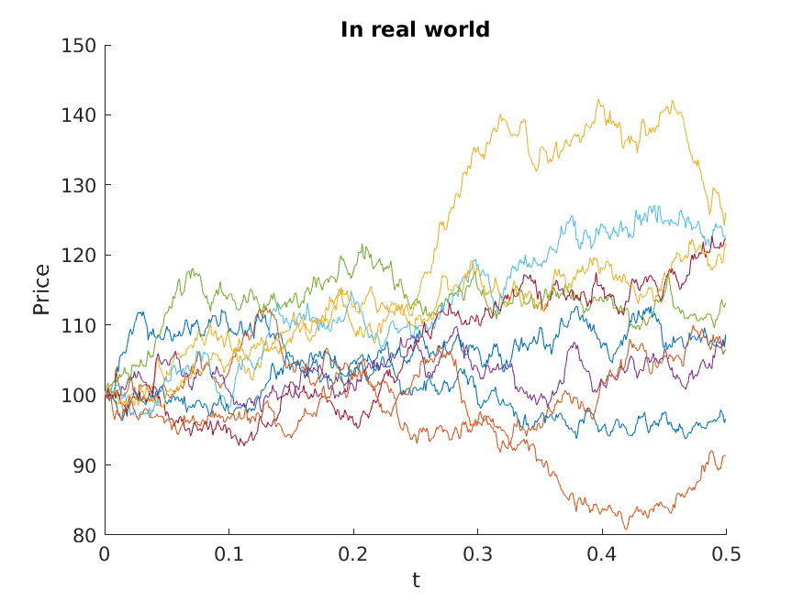

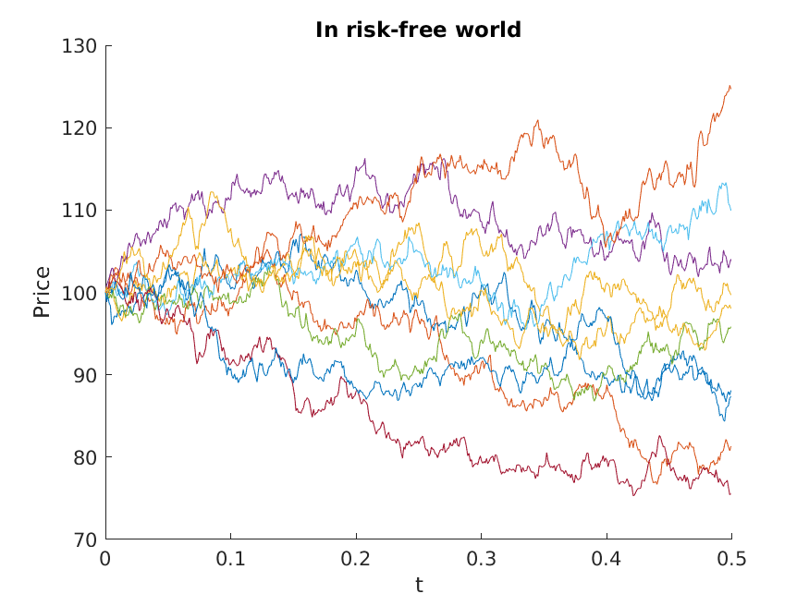
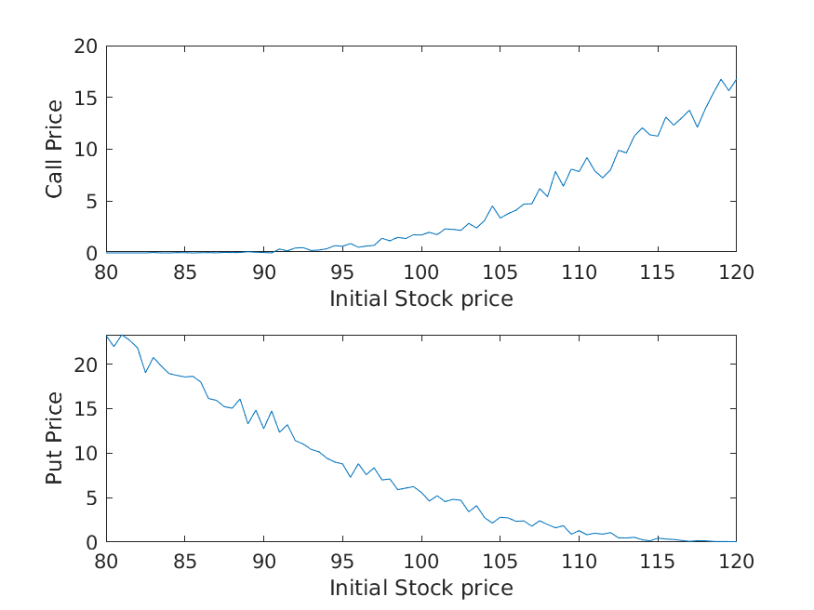

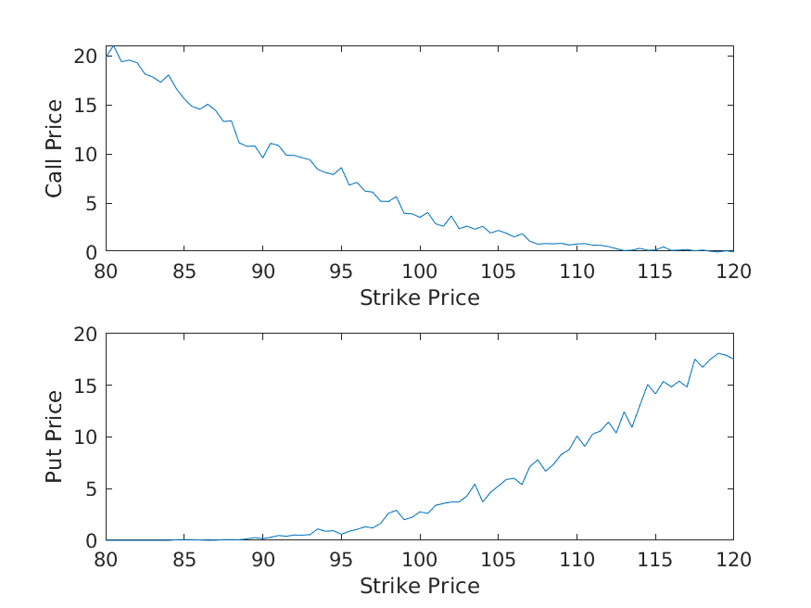

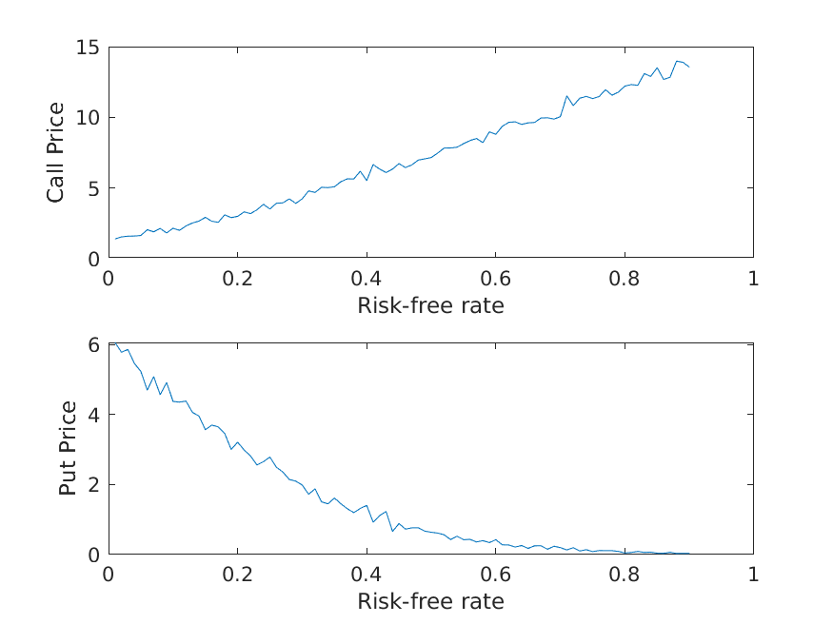
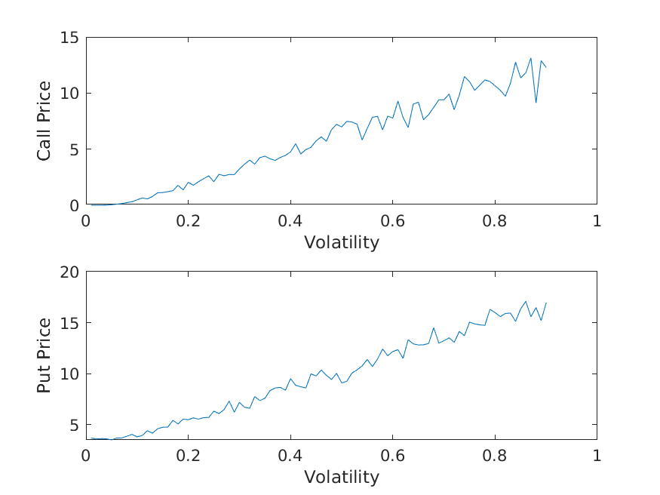
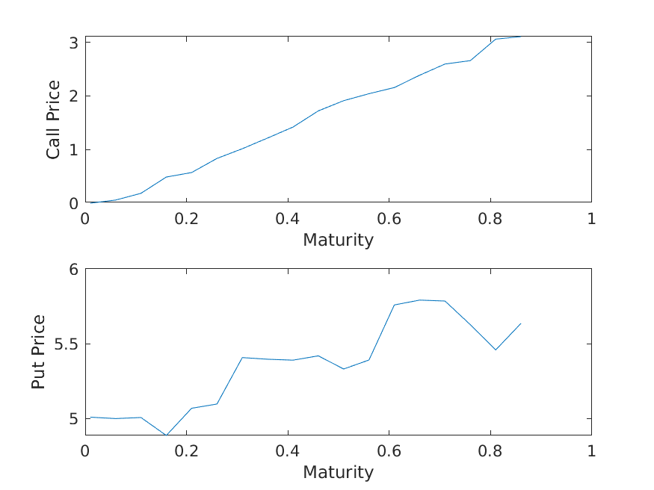

- Question 2
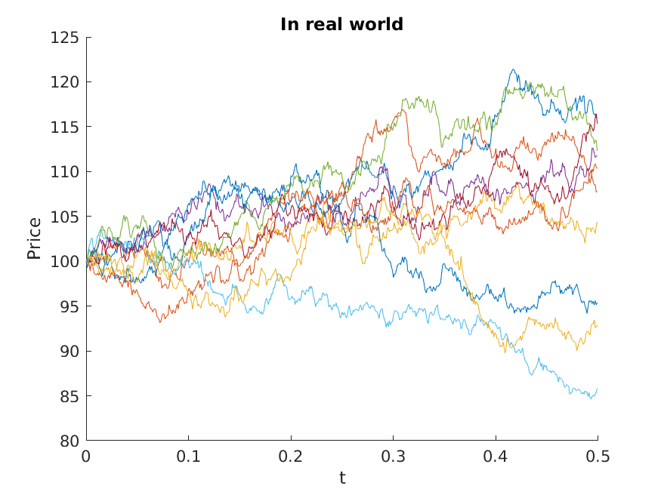
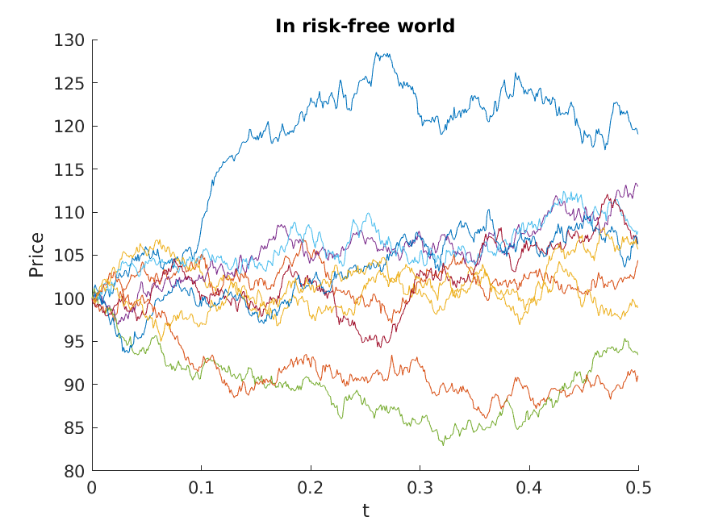

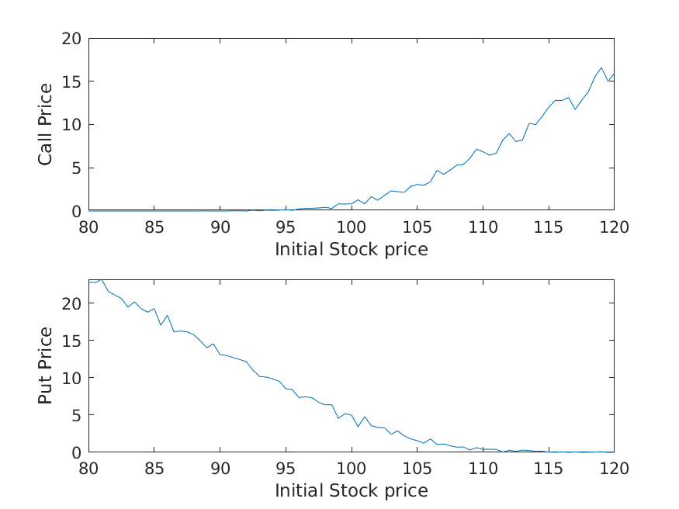

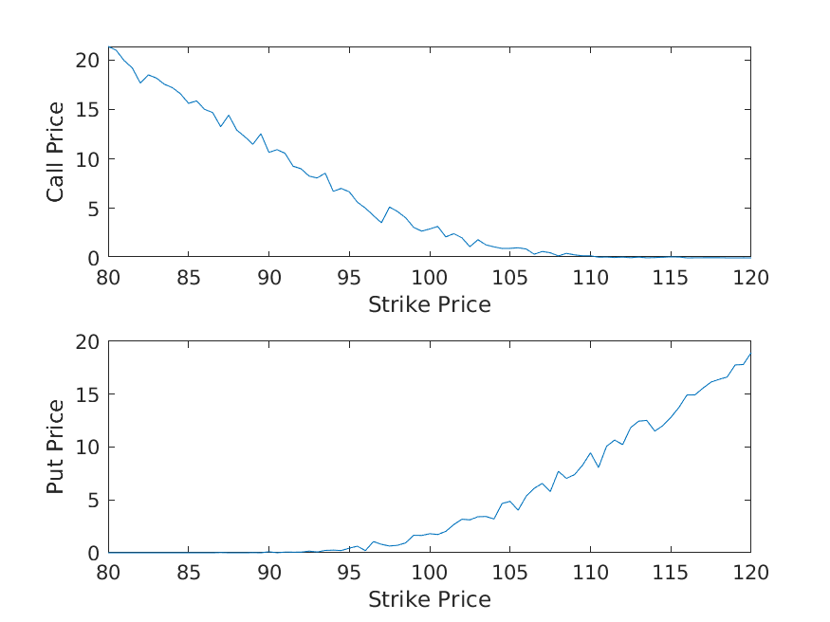
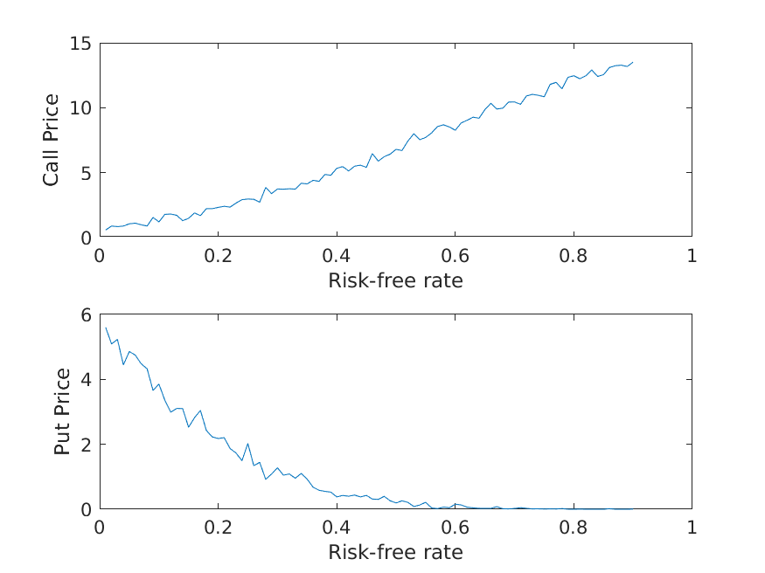
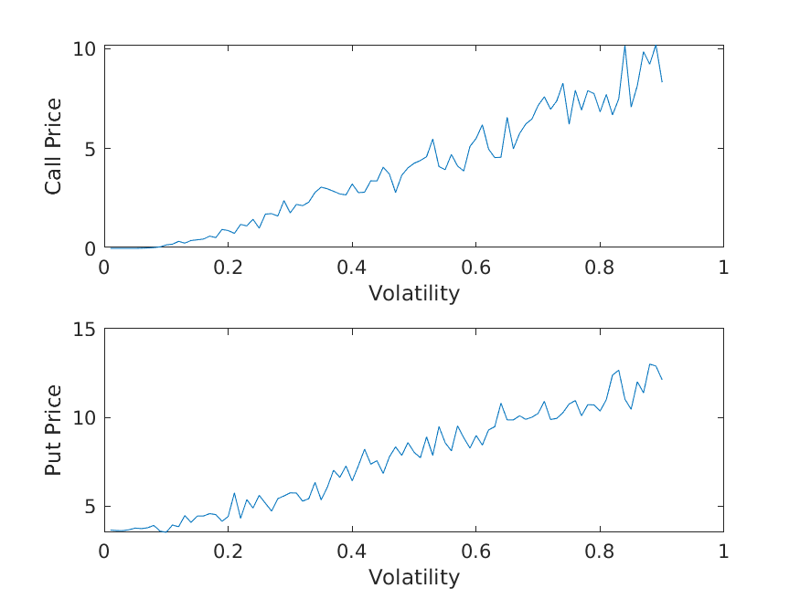

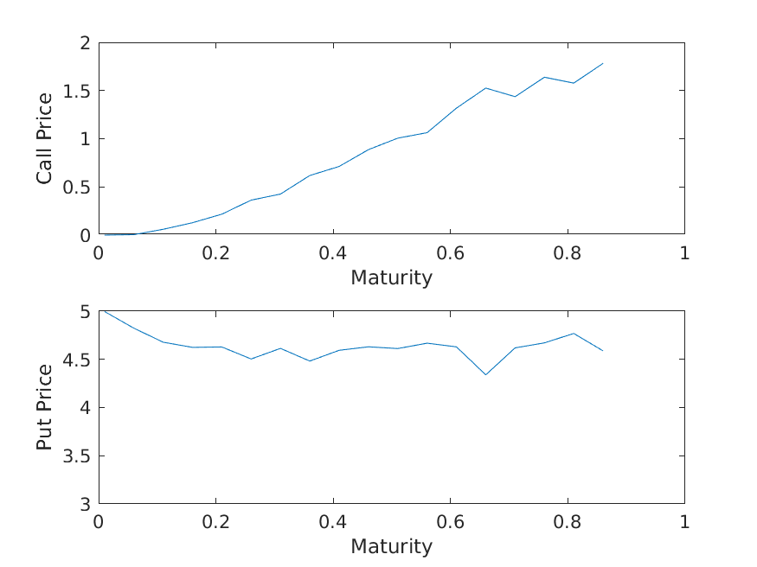
S_{red} = (S₁ + S₂ )/2
Where S_{red} = Prices with reduced variance,
S ₁, S₂ = Usual Stock prices following GBM,

The advantage of using these variance reduction techniques is to decrease the time of the above algorithms.

Stock prices following GBM require generation of more number of paths for smoother graphs (sensitivity graphs) as they have high variance. To reduce the strokes in the graphs( sensitivity graphs as they should be ideally continuous) and to make the curve more smoother we require more number of paths.

Whereas in Stock prices with reduced variance, this is not the case, only a few number of paths are sufficient to get the sensitivity graph smoother.

Variance using normal methods:183.9574
Variance using variance reduction techniques: 84.6114

