Financial Engineering
Lab
(MA374)

Neelabh Tiwari
160123024
Department of Mathematics
IIT Guwahati

Assignment - 4
(31 January 2019)

- Question 1

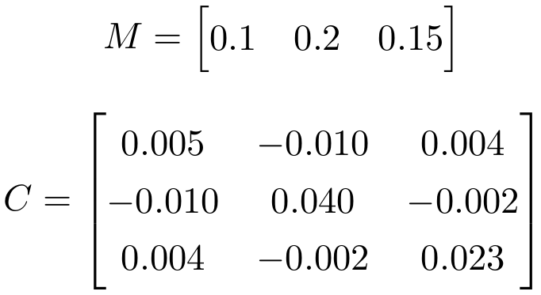

a) Markowitz Efficient Frontier -
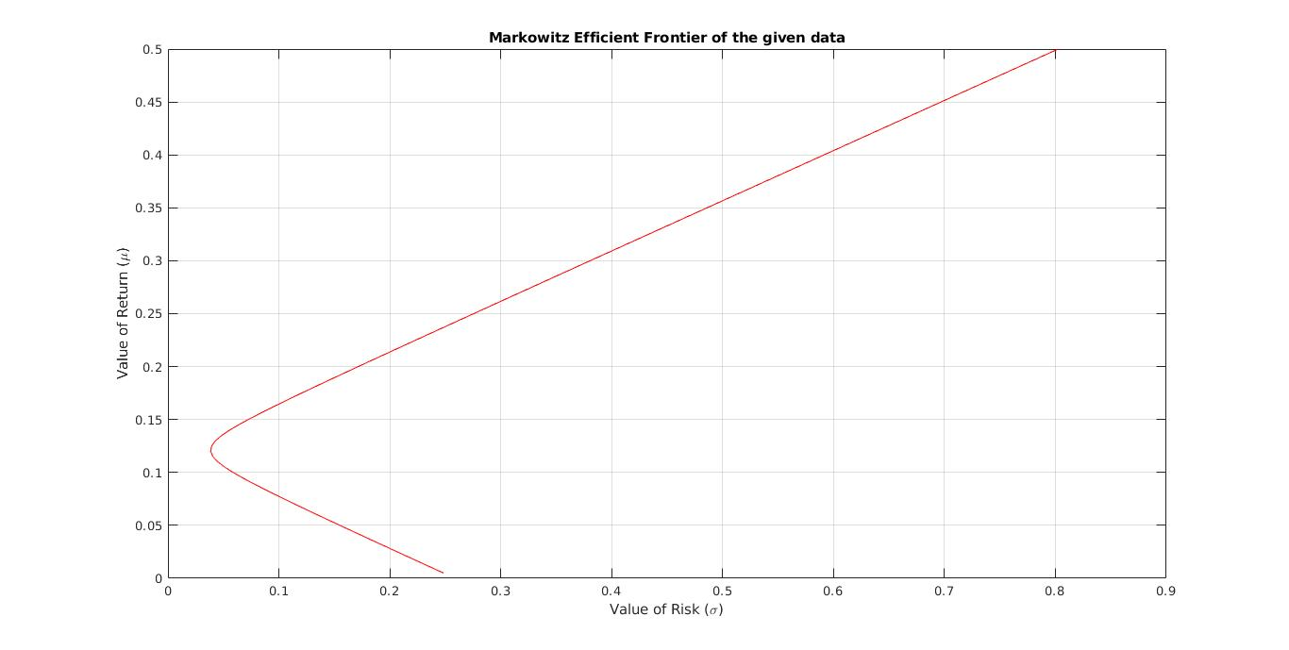
b) Weights, return and risk of the portfolios -
Return - Risk - W1 - W2 - W3
0.05 0.1550 1.8349 -0.1651 -0.6697
0.10 0.0587 1.1193 0.1193 -0.2385
0.15 0.0724 0.4037 0.4037 0.1927
0.20 0.1714 -0.3119 0.6881 0.6239
0.25 0.2755 -1.0275 0.9725 1.0550
0.30 0.3805 -1.7431 1.2569 1.4862
0.35 0.4859 -2.4587 1.5413 1.9174
0.40 0.5913 -3.1743 1.8257 2.3486
0.45 0.6969 -3.8899 2.1101 2.7798
0.50 0.8025 -4.6055 2.3945 3.2110
c) Risk = 15% (given) -

Maximum Return Portfolio for 15 % risk --
Return = 0.1896
Weights : -0.1624, 0.6287, 0.5338

Minimum Return Portfolio for 15 % risk --
Return = 0.0524
Weights : 1.7998, -0.1512, -0.6486

d) Return = 18% (given) -

Risk for 18 % return = 13.0568 % --
Weights : -0.0257, 0.5743, 0.4514

e) μ_{rf} = 10% (given) -

For 10 % risk-free return --
Weights : 0.5938, 0.3281, 0.07811
Return on market portfolio = 0.1367
Risk on market portfolio = 5.0811% (0.0508)

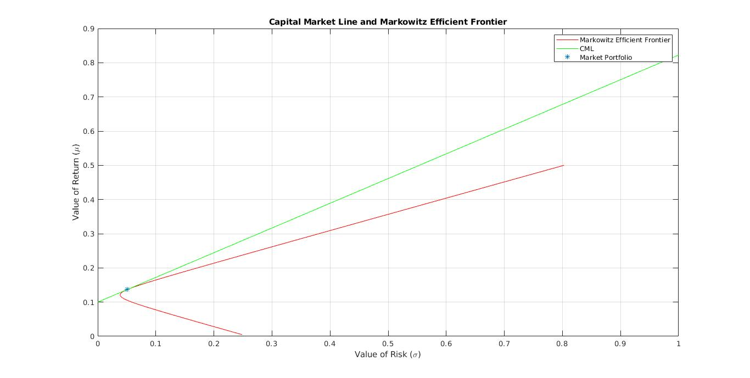
Capital Market Line (CML) -
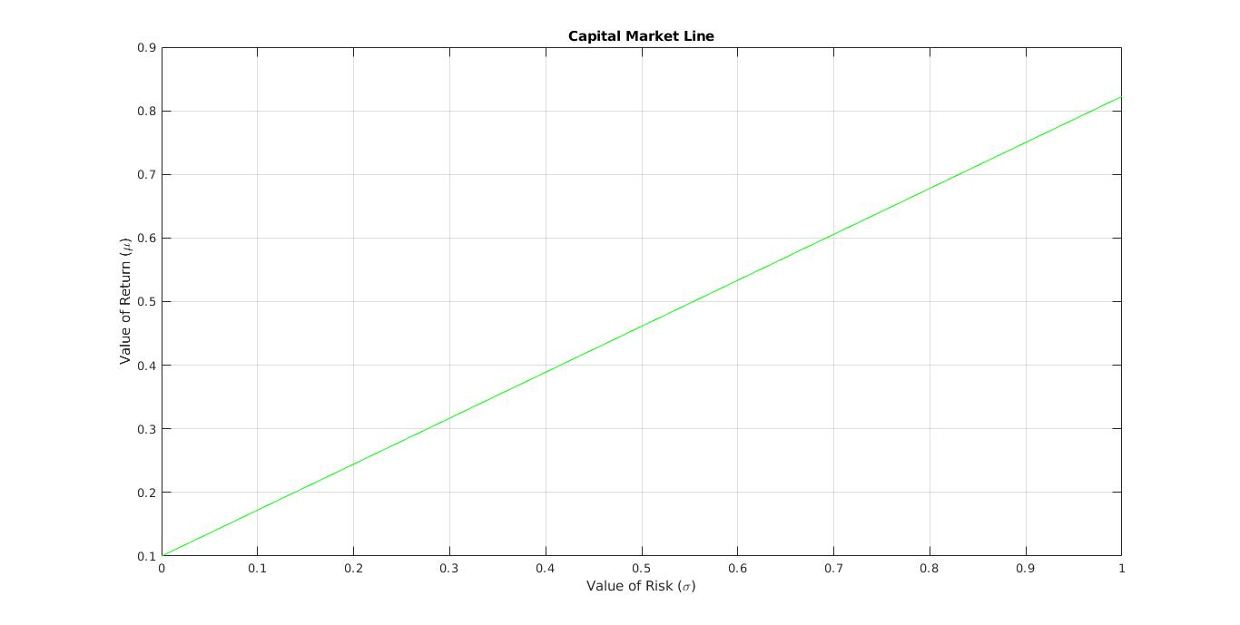
f) Portfolios (consisting of both risky and risk free assets) with the risk
at 10% and 25% -

Portfolio for 10 % risk -- (Weights)
Risk-Free Asset : -0.9681
Risky Assets Weights : 1.1685, 0.6458, 0.1538

Portfolio for 25 % risk -- (Weights)
Risk-Free Asset : -3.9202
Risky Assets Weights : 2.9213, 1.6144, 0.3844

- Question 2

10 stocks were chosen having 247 data points. These stocks are listed on NSE. Data is taken from NSE official website for the dates 02-02-2018 to 01-02-2019 (247 working days). Data Can be found in the file ‘data.csv’.
Stocks chosen are as following -

Asian Paints, Bharti Airtel, Cipla, IOC, JSW Steel, Maruti Udyog Ltd., NTPC, ONGC, SBI and Wipro

a) Markowitz Efficient Frontier -
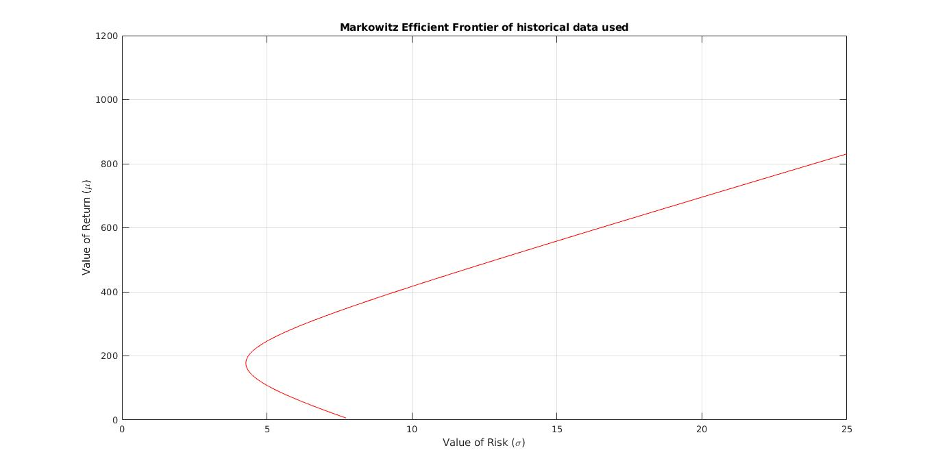
b) μ_{rf} = 7% (given)

Weights : 0.0585, 0.0043, -0.0107, 0.0393, -0.0736, 0.0019, 1.0588,
-0.2668, 0.0286, 0.1596
Return on market portfolio = 249.6149
Risk on market portfolio = 507.3437% (5.0734)

c) Capital Market Line (CML) -
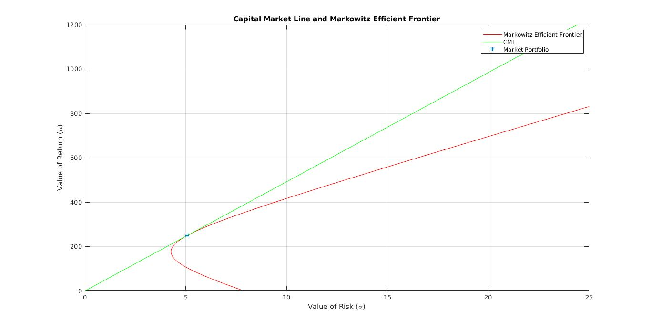
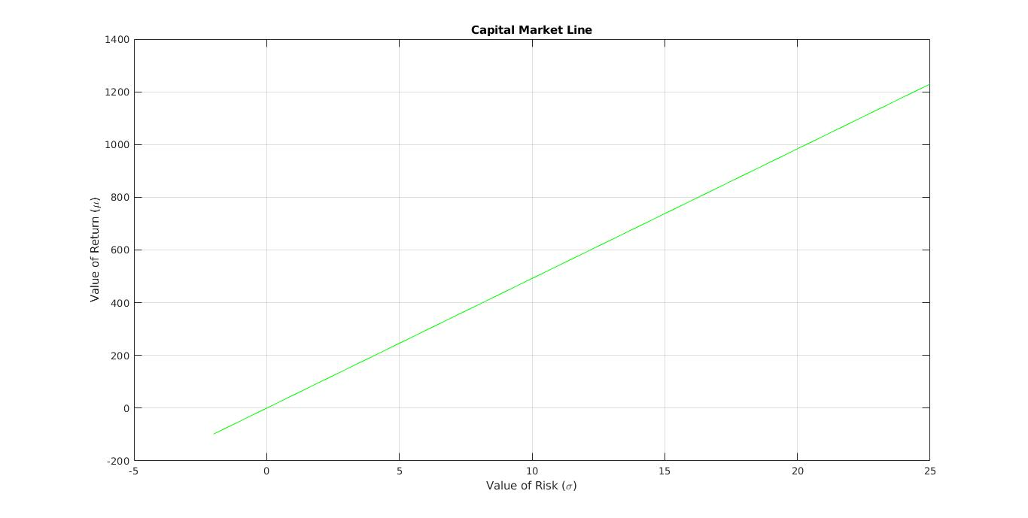

d) Security Market Line (SML) -

