Financial Engineering
Lab
(MA374)

Neelabh Tiwari
160123024
Department of Mathematics
IIT Guwahati

Assignment - 6
(21 February 2019)

I have collected and compiled data for 20 Stocks in NSE and 20 in BSE (first 10 are in Nifty and Sensex Indices respectively).

All the graphs for 40 companies can be found in included folders -
1. Ques 1 Plots – Prices Vs time
2. Ques 2 Plots – Normalized return Vs time
3. Ques 3 Plots – Normalized Log return Vs time
4. Ques 4 Plots – Prediction of 4th Year Prices based on 3-year data (Daily)
5. Ques 5a Plots – Prediction of 4th Year Prices based on 3 year data
(Weekly)
6. Ques 5b Plots - Prediction of 4th Year Prices based on 3 year data
(Monthly)

Companies (tickers) Used from NSE –

Included in Nifty 50 - ASPN,AXBK,BAJA,BPCL,CIPL,COAL,HLL,INFY,PGRD,ZEE
Not Included in Nifty 50 -
BOB,BOSH,CRSL,DLF,IDBI,JNSP,LTFH,PCJE,TVSM,VODA

Companies (tickers) Used from BSE –

Included in Sensex 30 -
AXBK,HDFC,ICBK,ITC,MRTI,RELI,SBI,SUN,TAMO,YESB
Not Included in Sensex 30 -
ALBK,APLH,CBI,COLG,GAIL,NEST,TMIN,TTCH,VOLT,WHIR

To avoid redundancy, I have included only representative plots from both the indices. From BSE I have included plots for Axis Bank (AXBK), HDFC, Sun Pharmaceuticals (SUN). From NSE, I have included plots for Asian Paints (ASPN), IDBI and Jindal Steel (JNSP).

To verify plots for any other company, please refer the aforementioned respective folders.

- Question 1
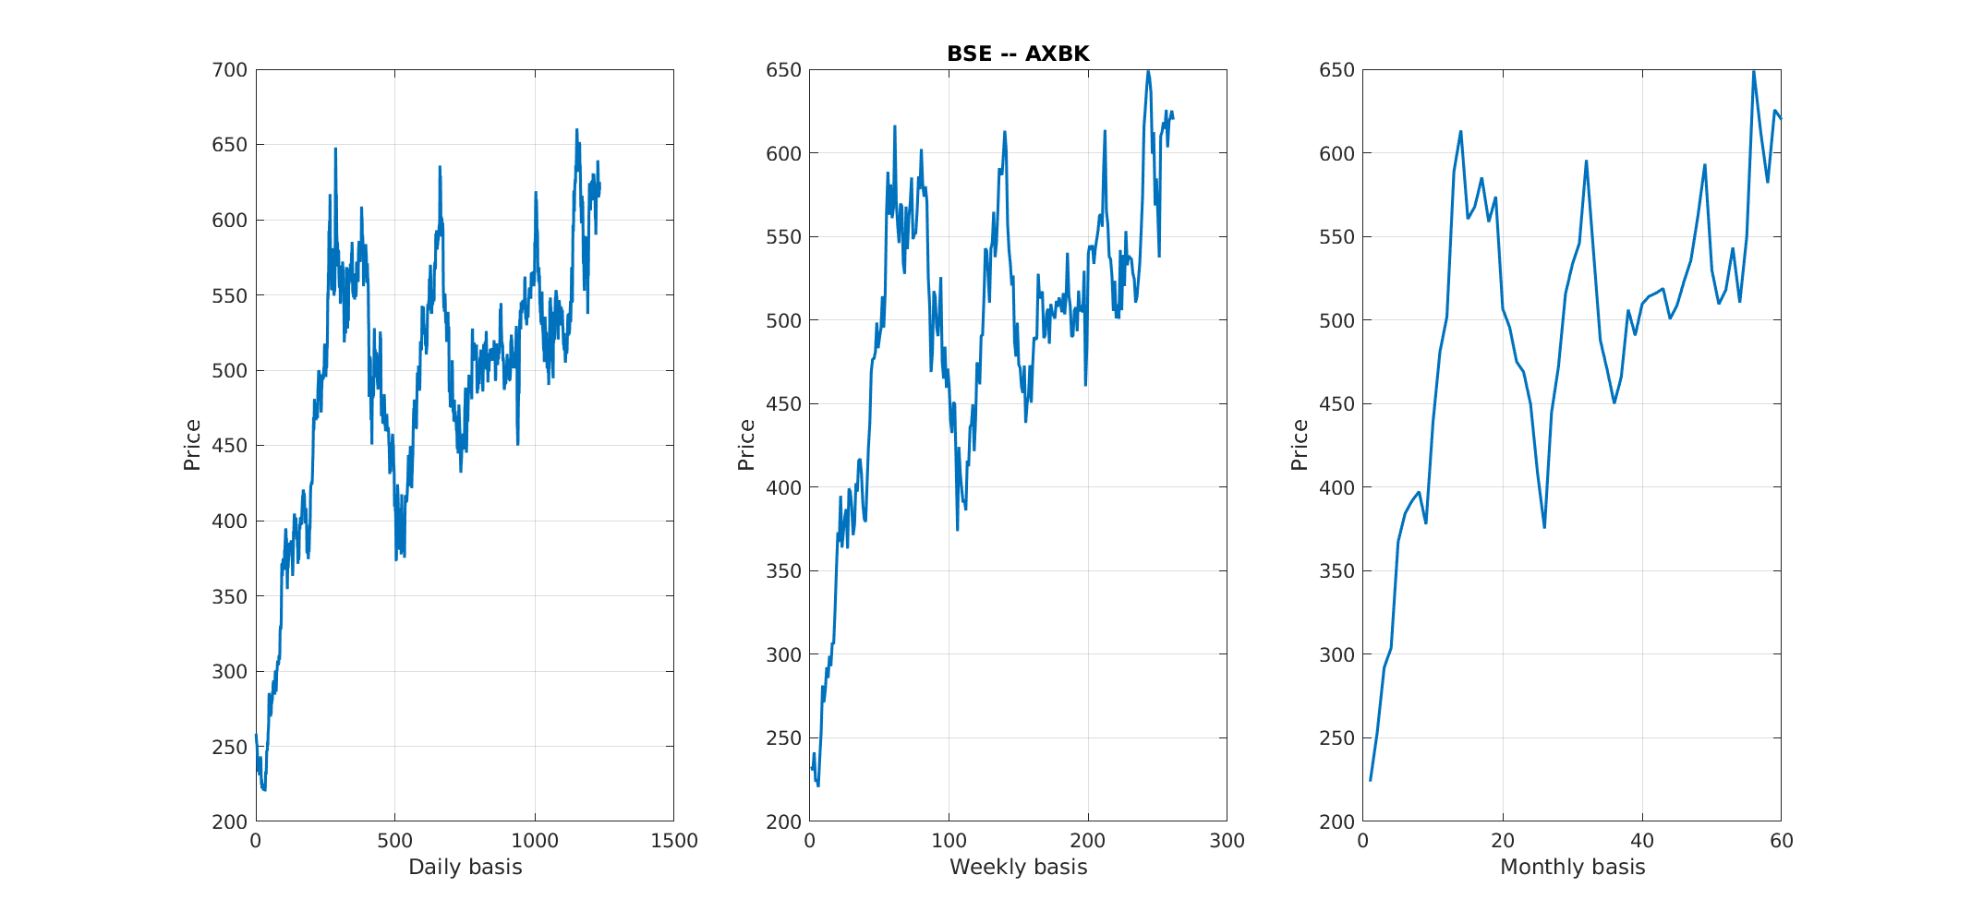
BSE -

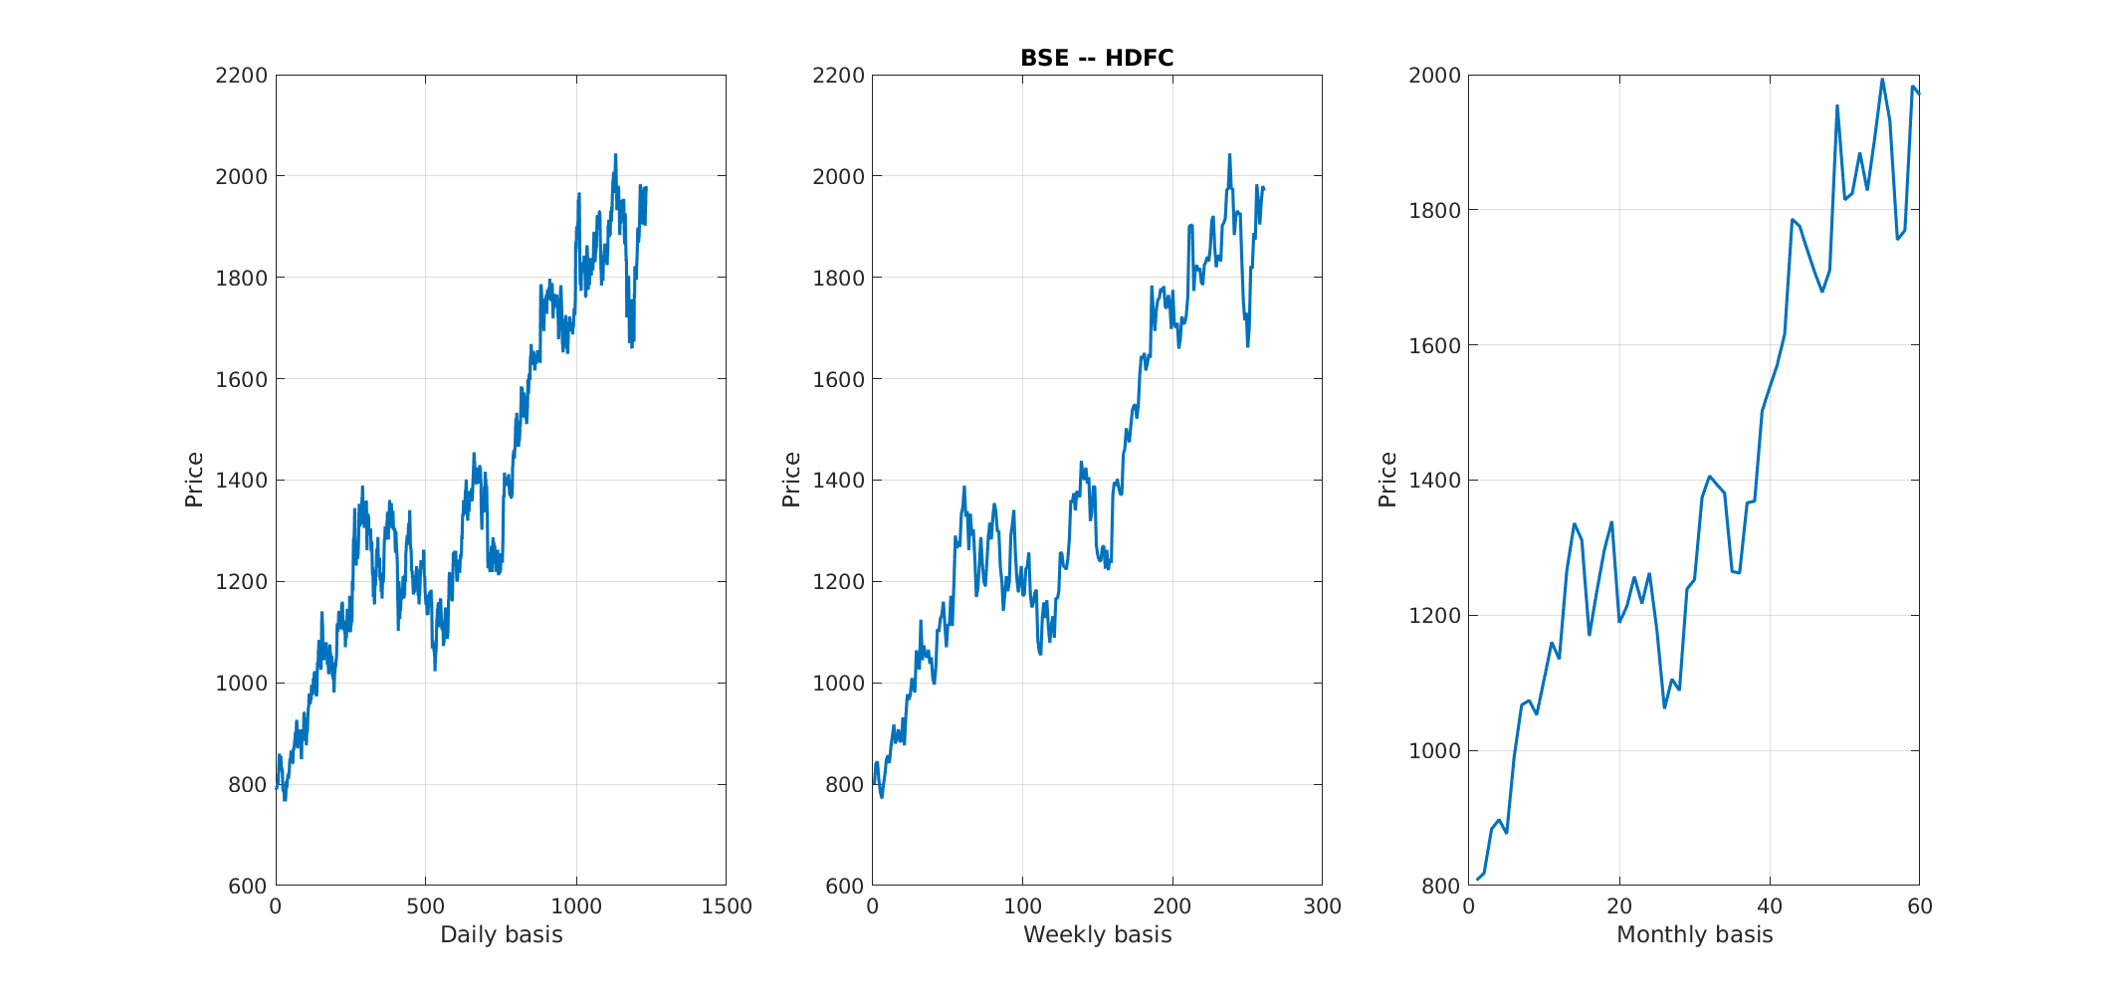
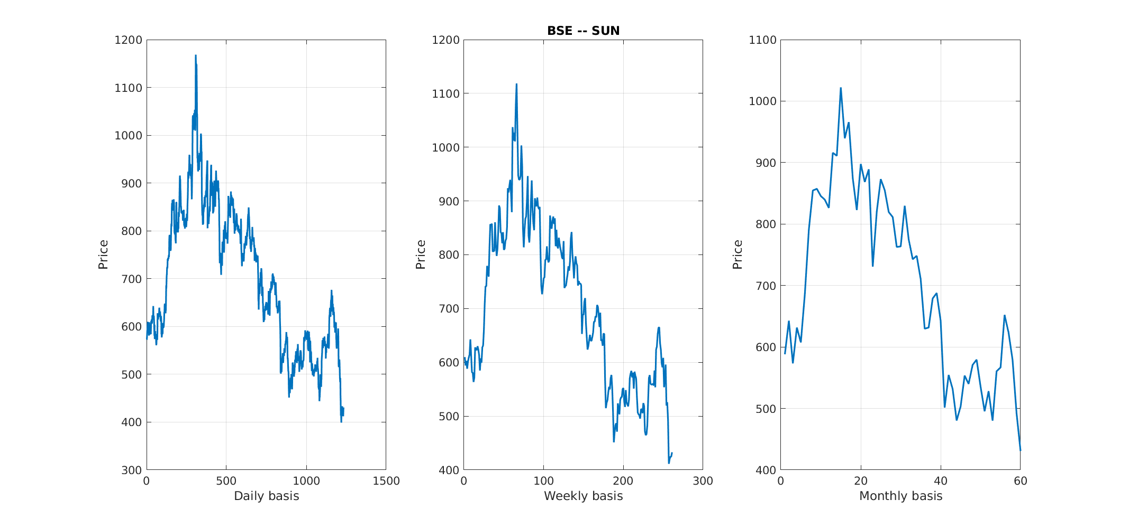

NSE -

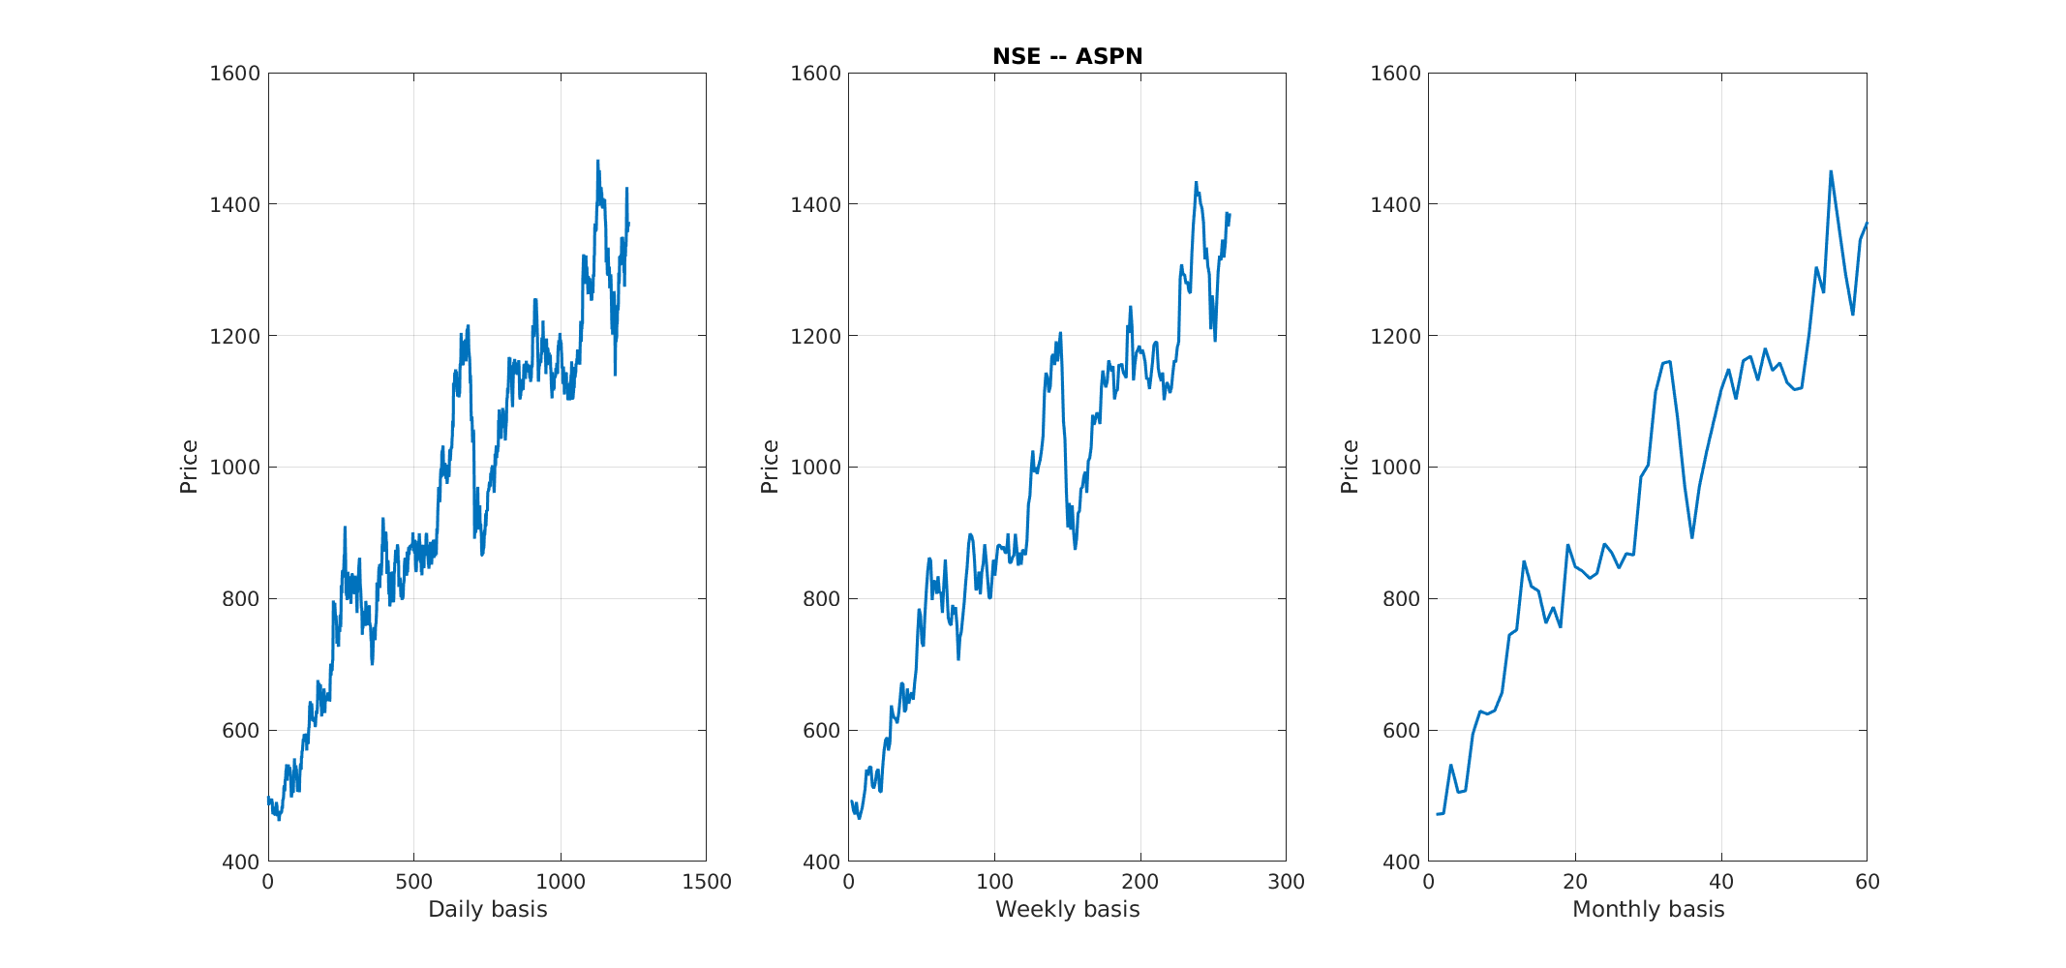

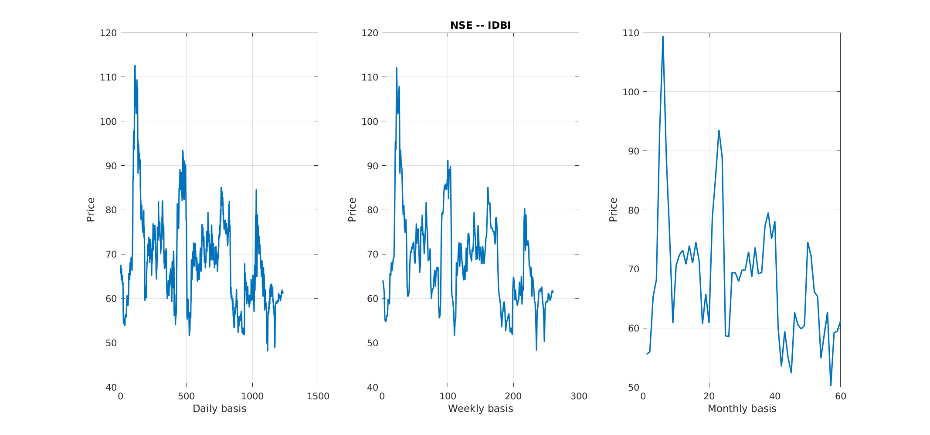

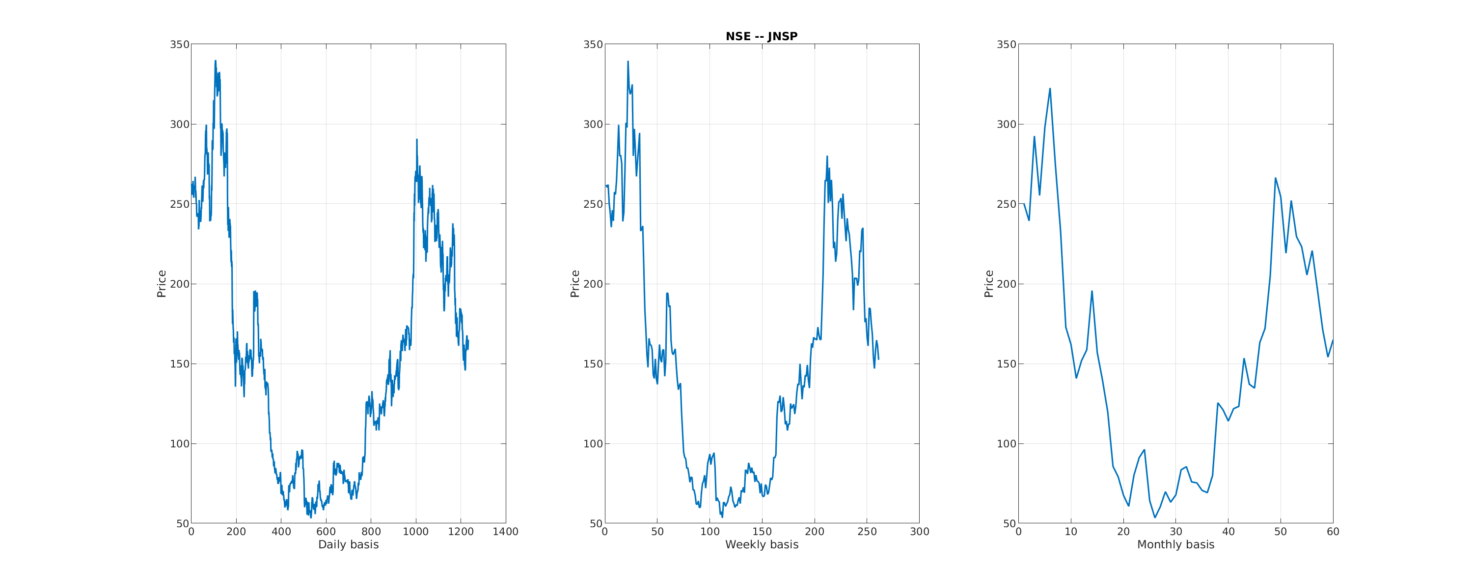

- Question 2
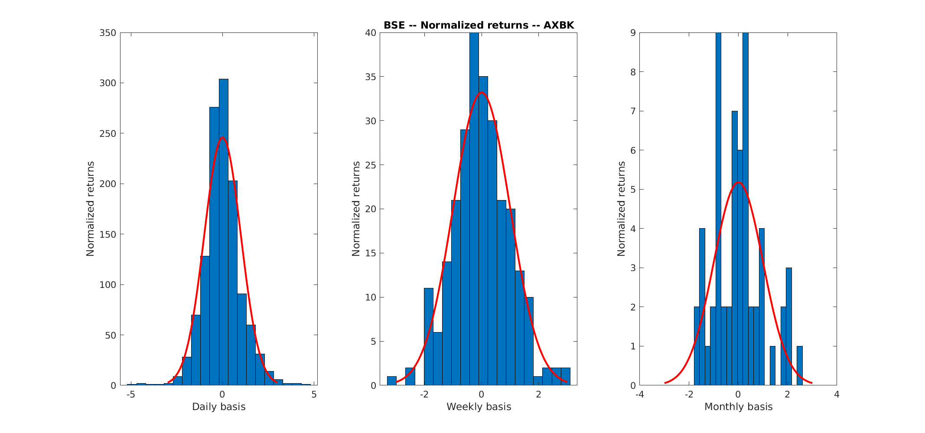
BSE -

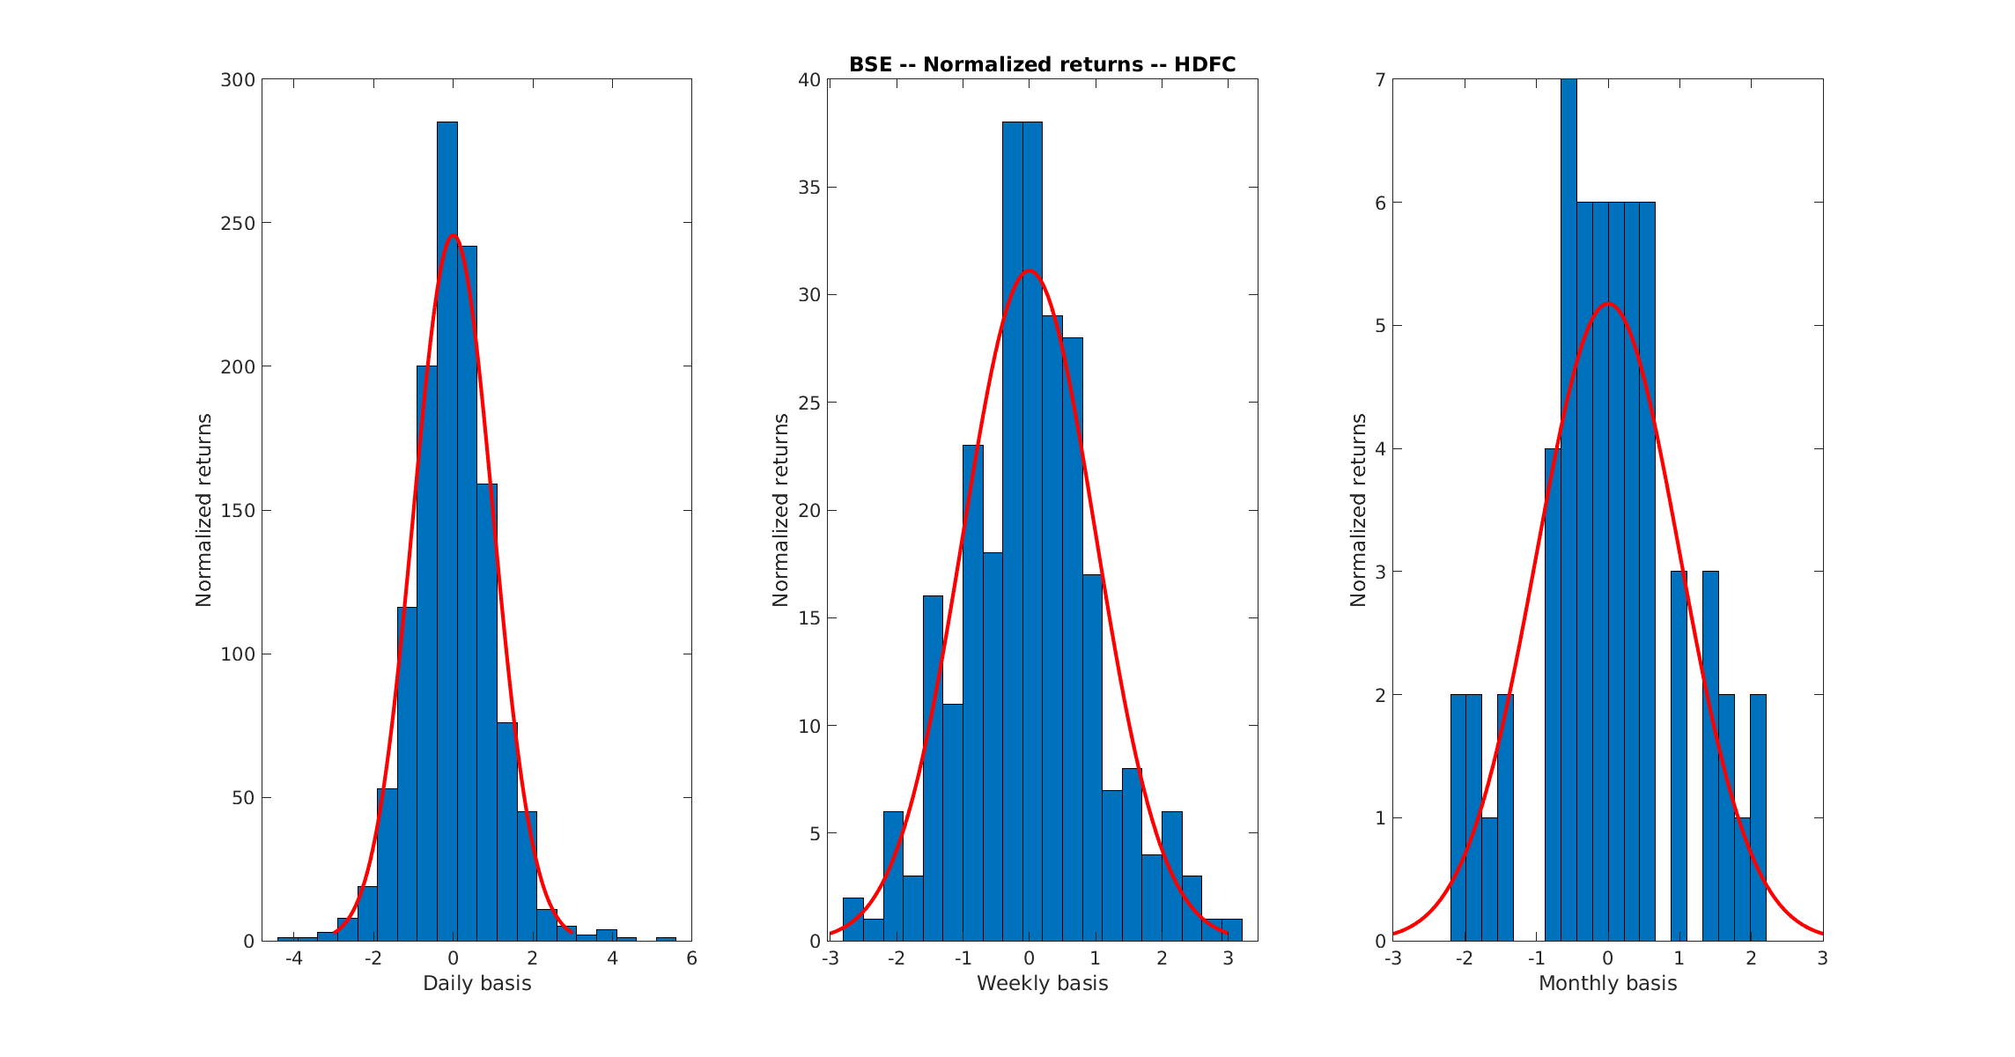
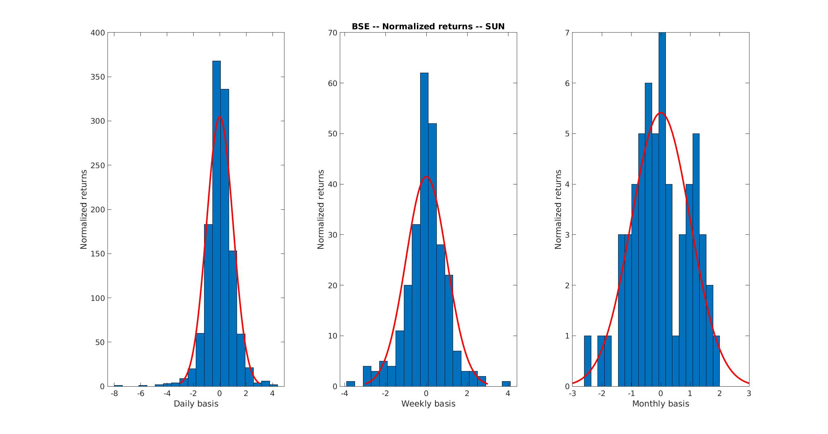

NSE -

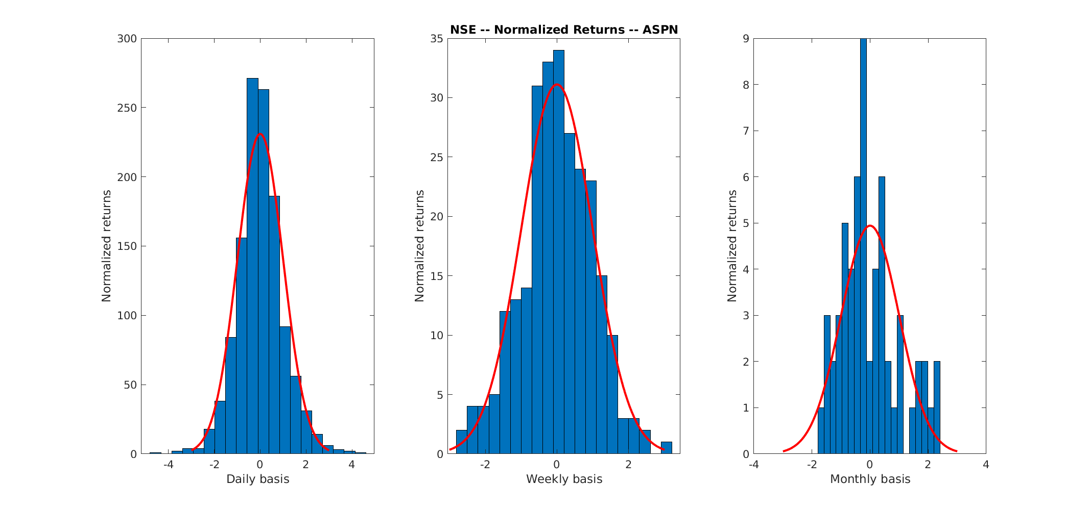

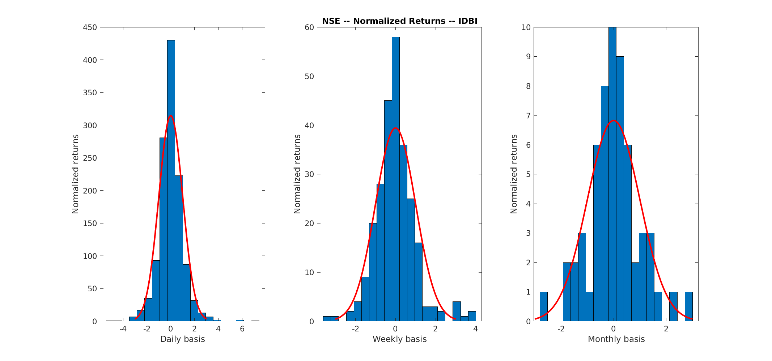
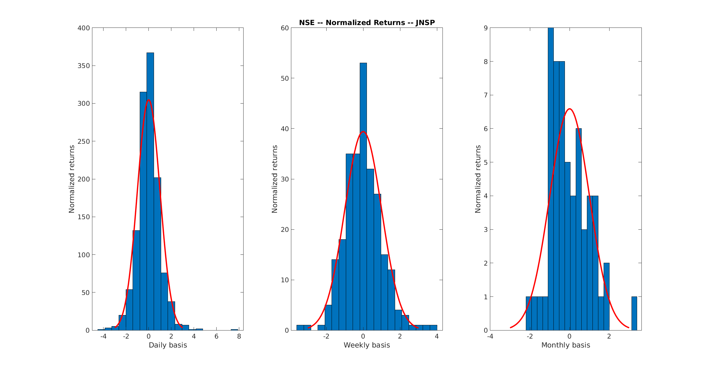

In practical world, there are jumps in the market for which the main cause is the company's decisions and economic fluctuations which can’t be incorporated using naive Gaussian distribution. There are many models which uses Poisson processes and Levy-processes with gaussian superimposed on them and such models are used frequently to capture such fluctuations. Anyways, here, at tails, the gaussian goes to zero but the stock can go even to much more higher value due to reasons given above which is the main cause for those bars at the extremes.

- Question 3
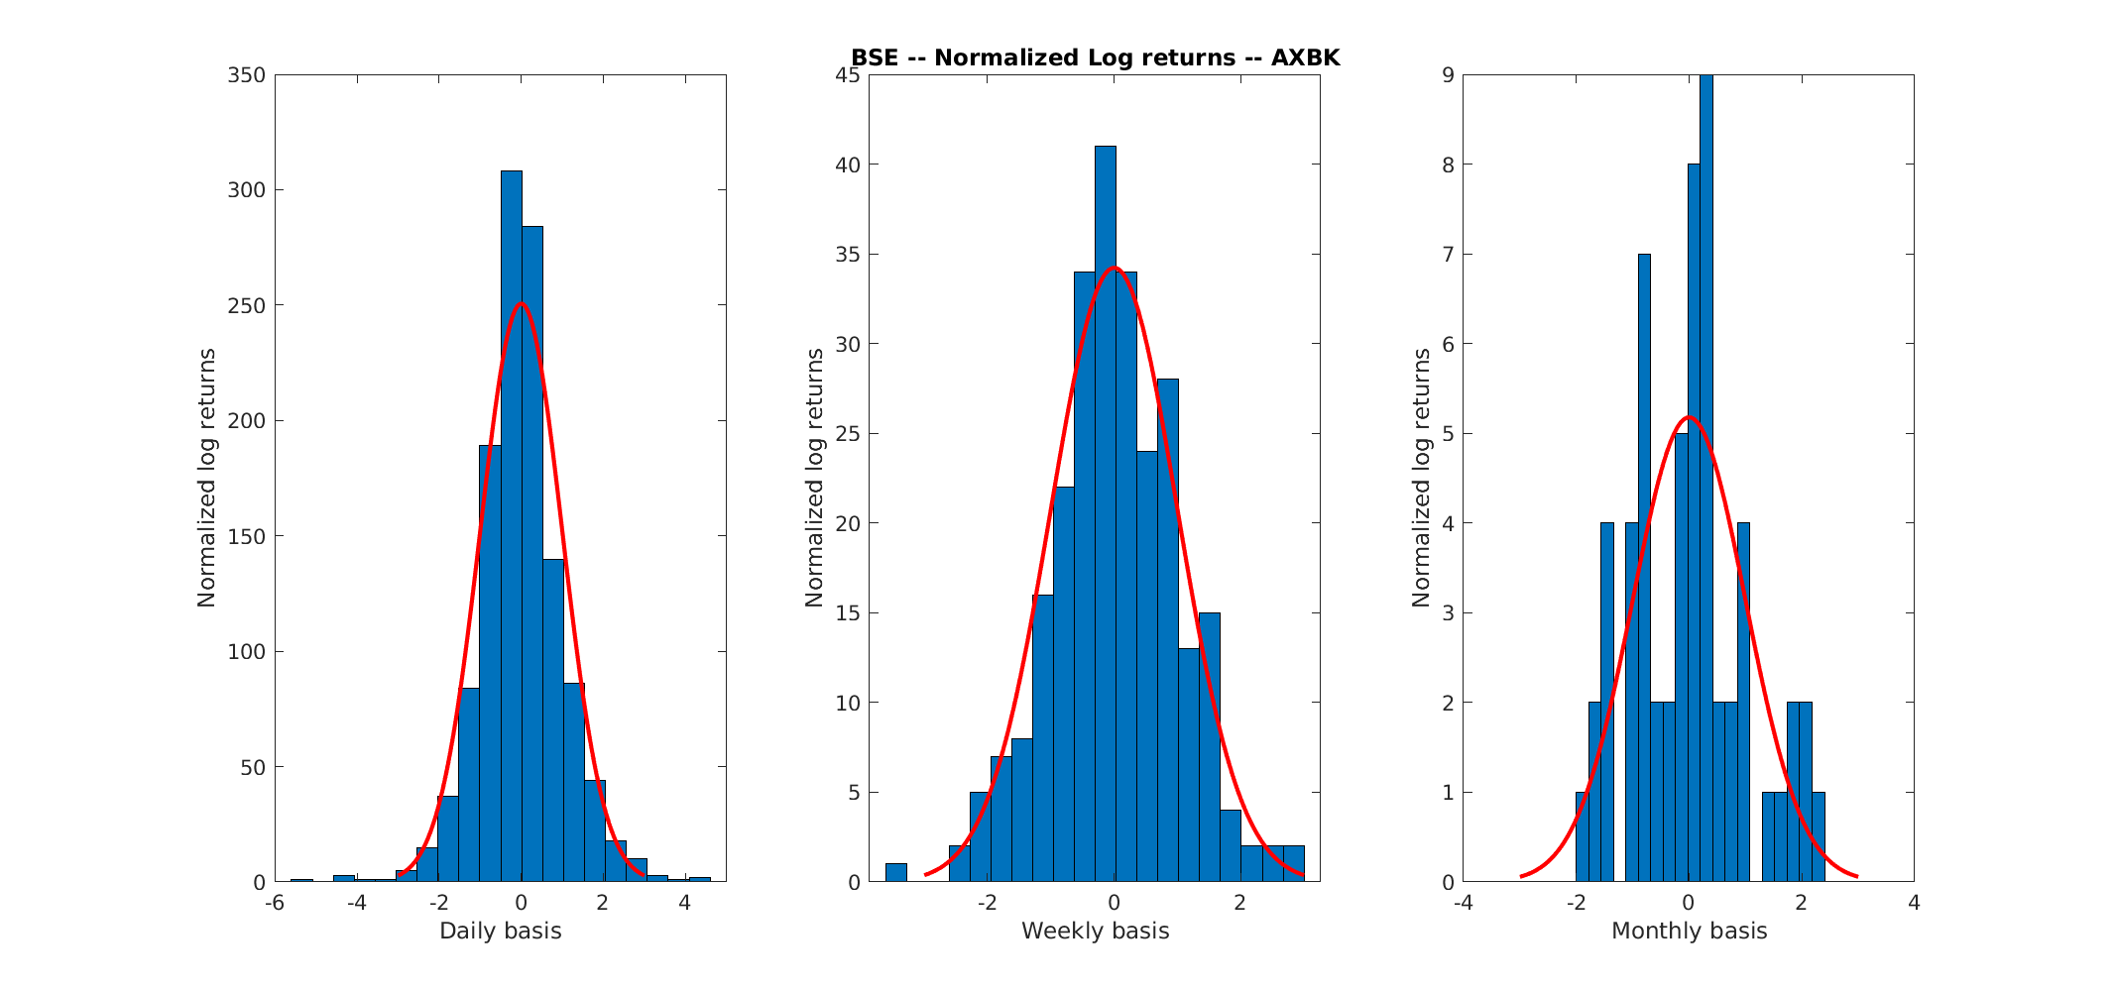
BSE -

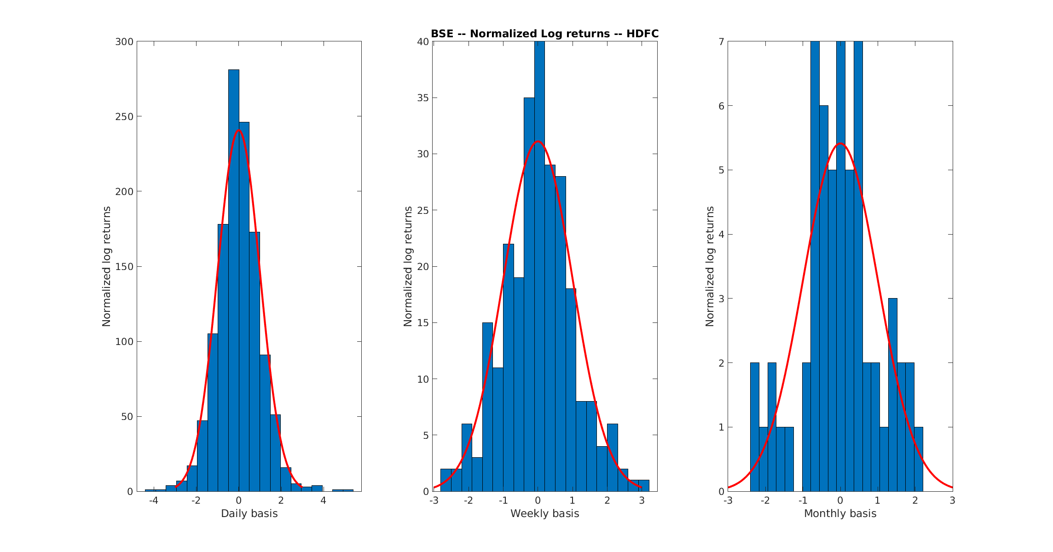
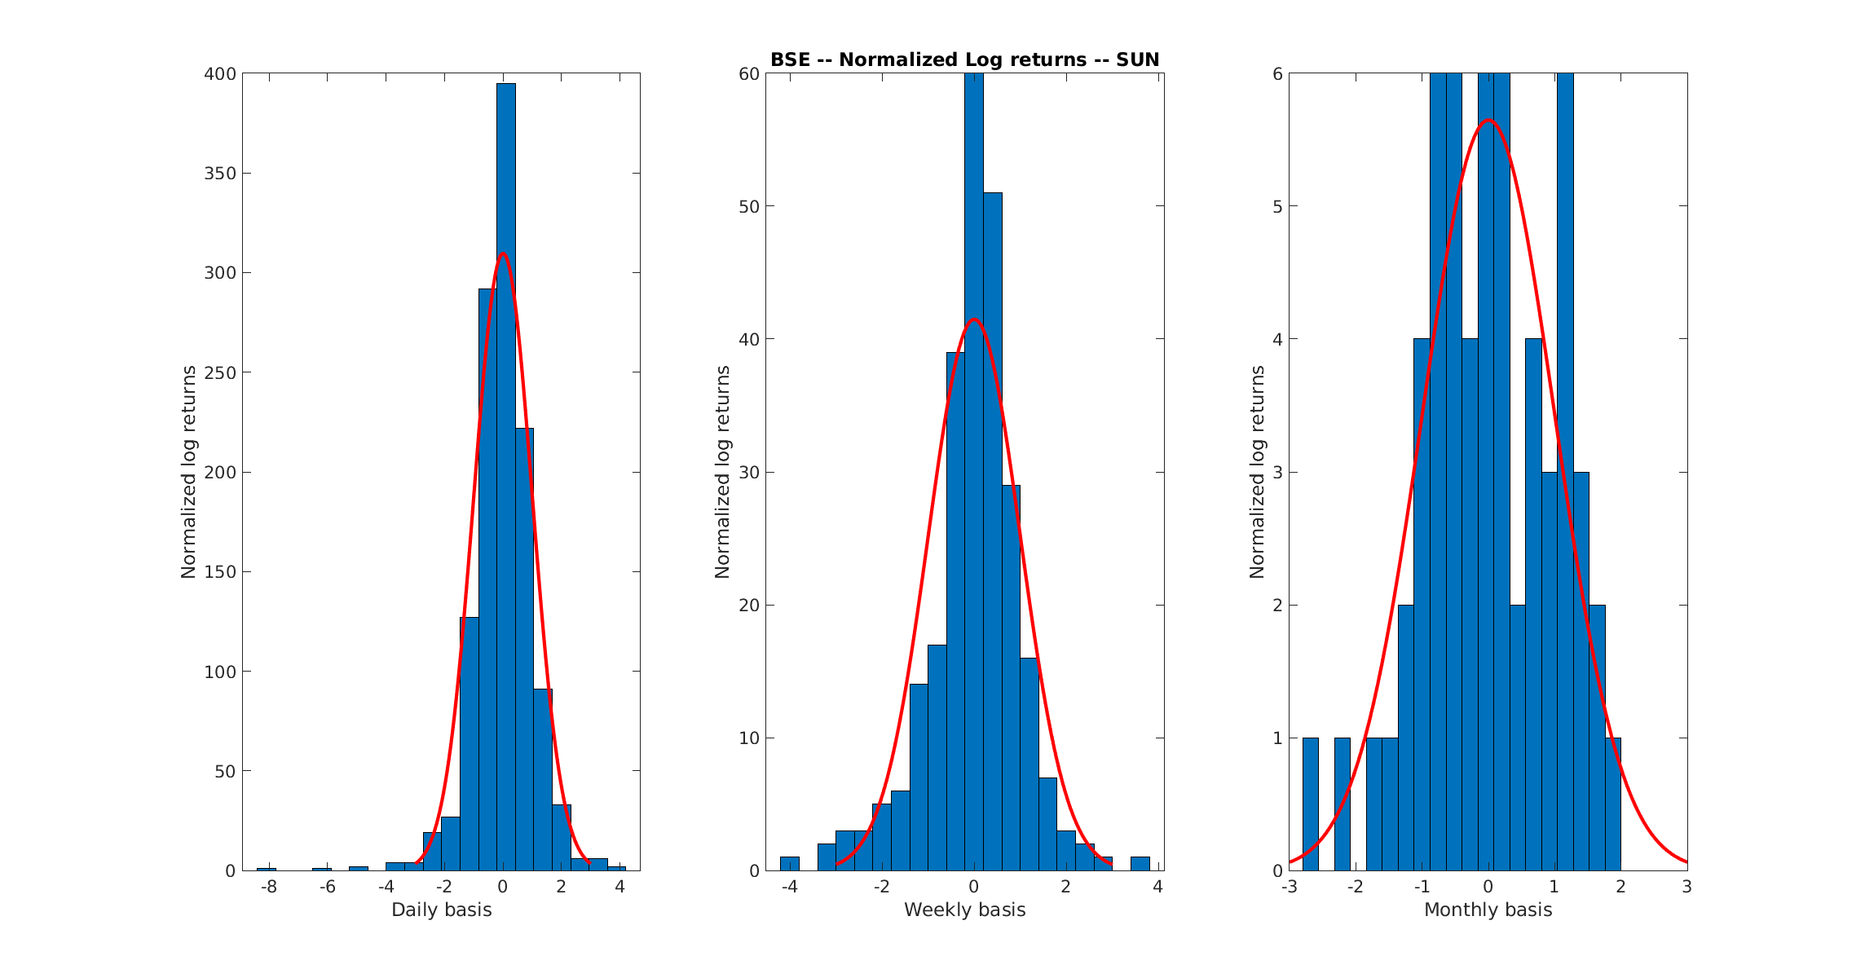

NSE -

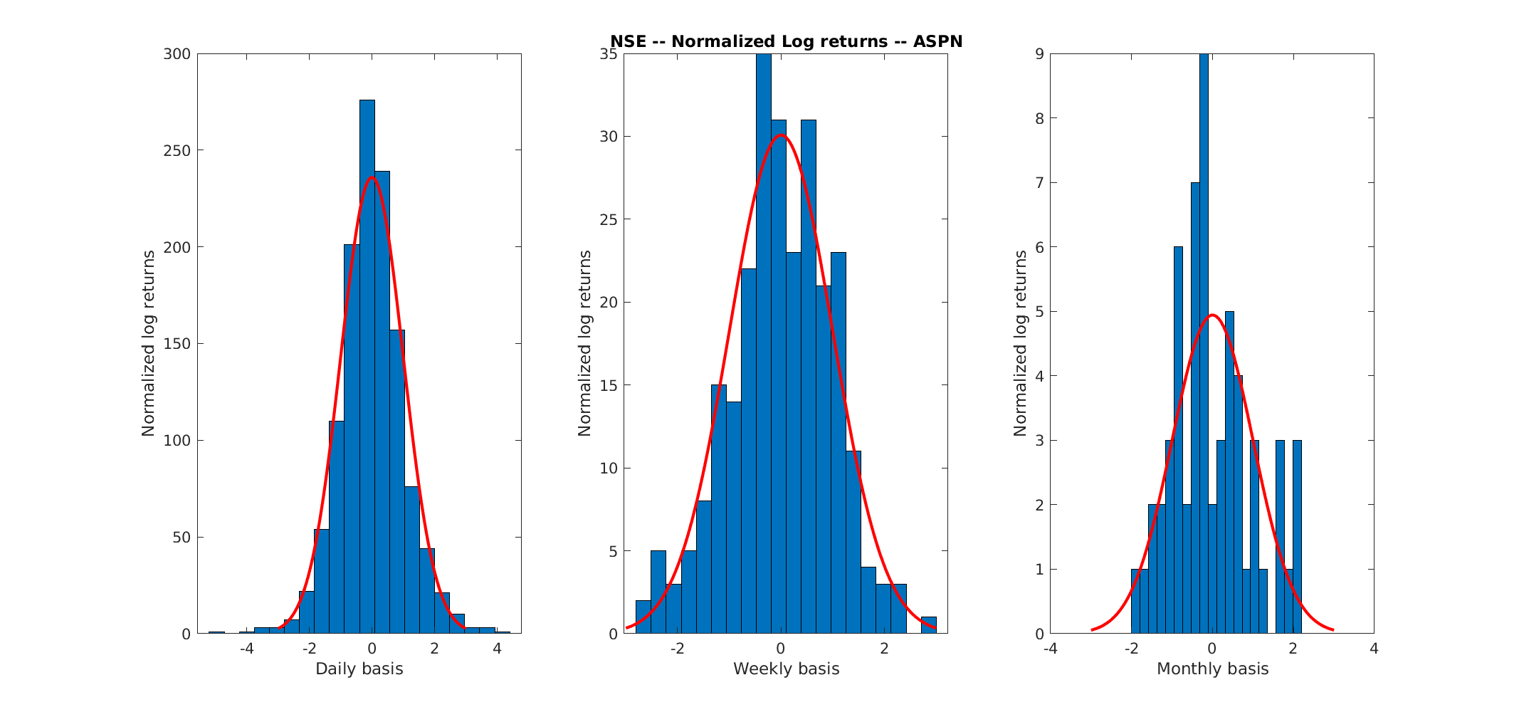

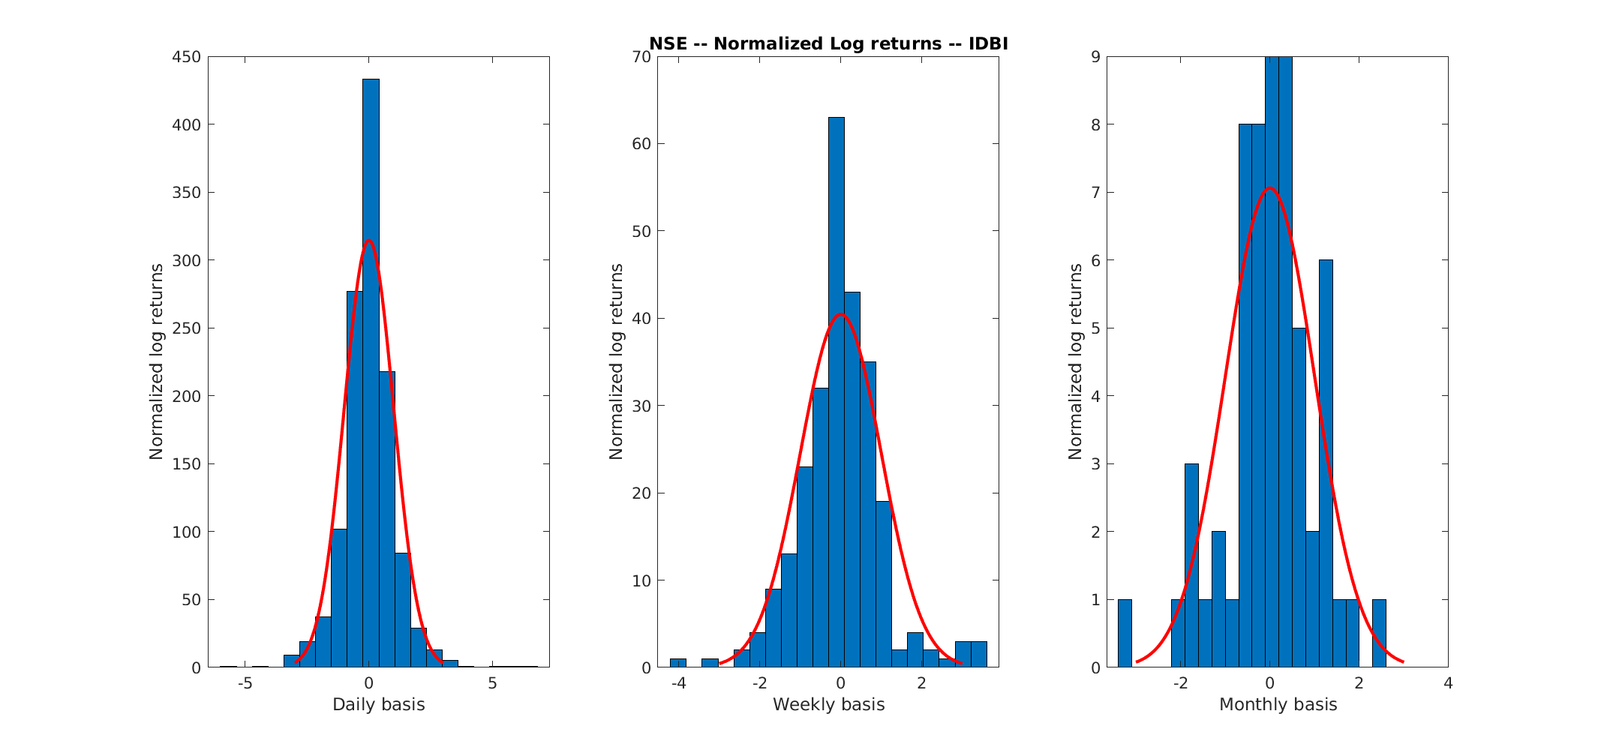

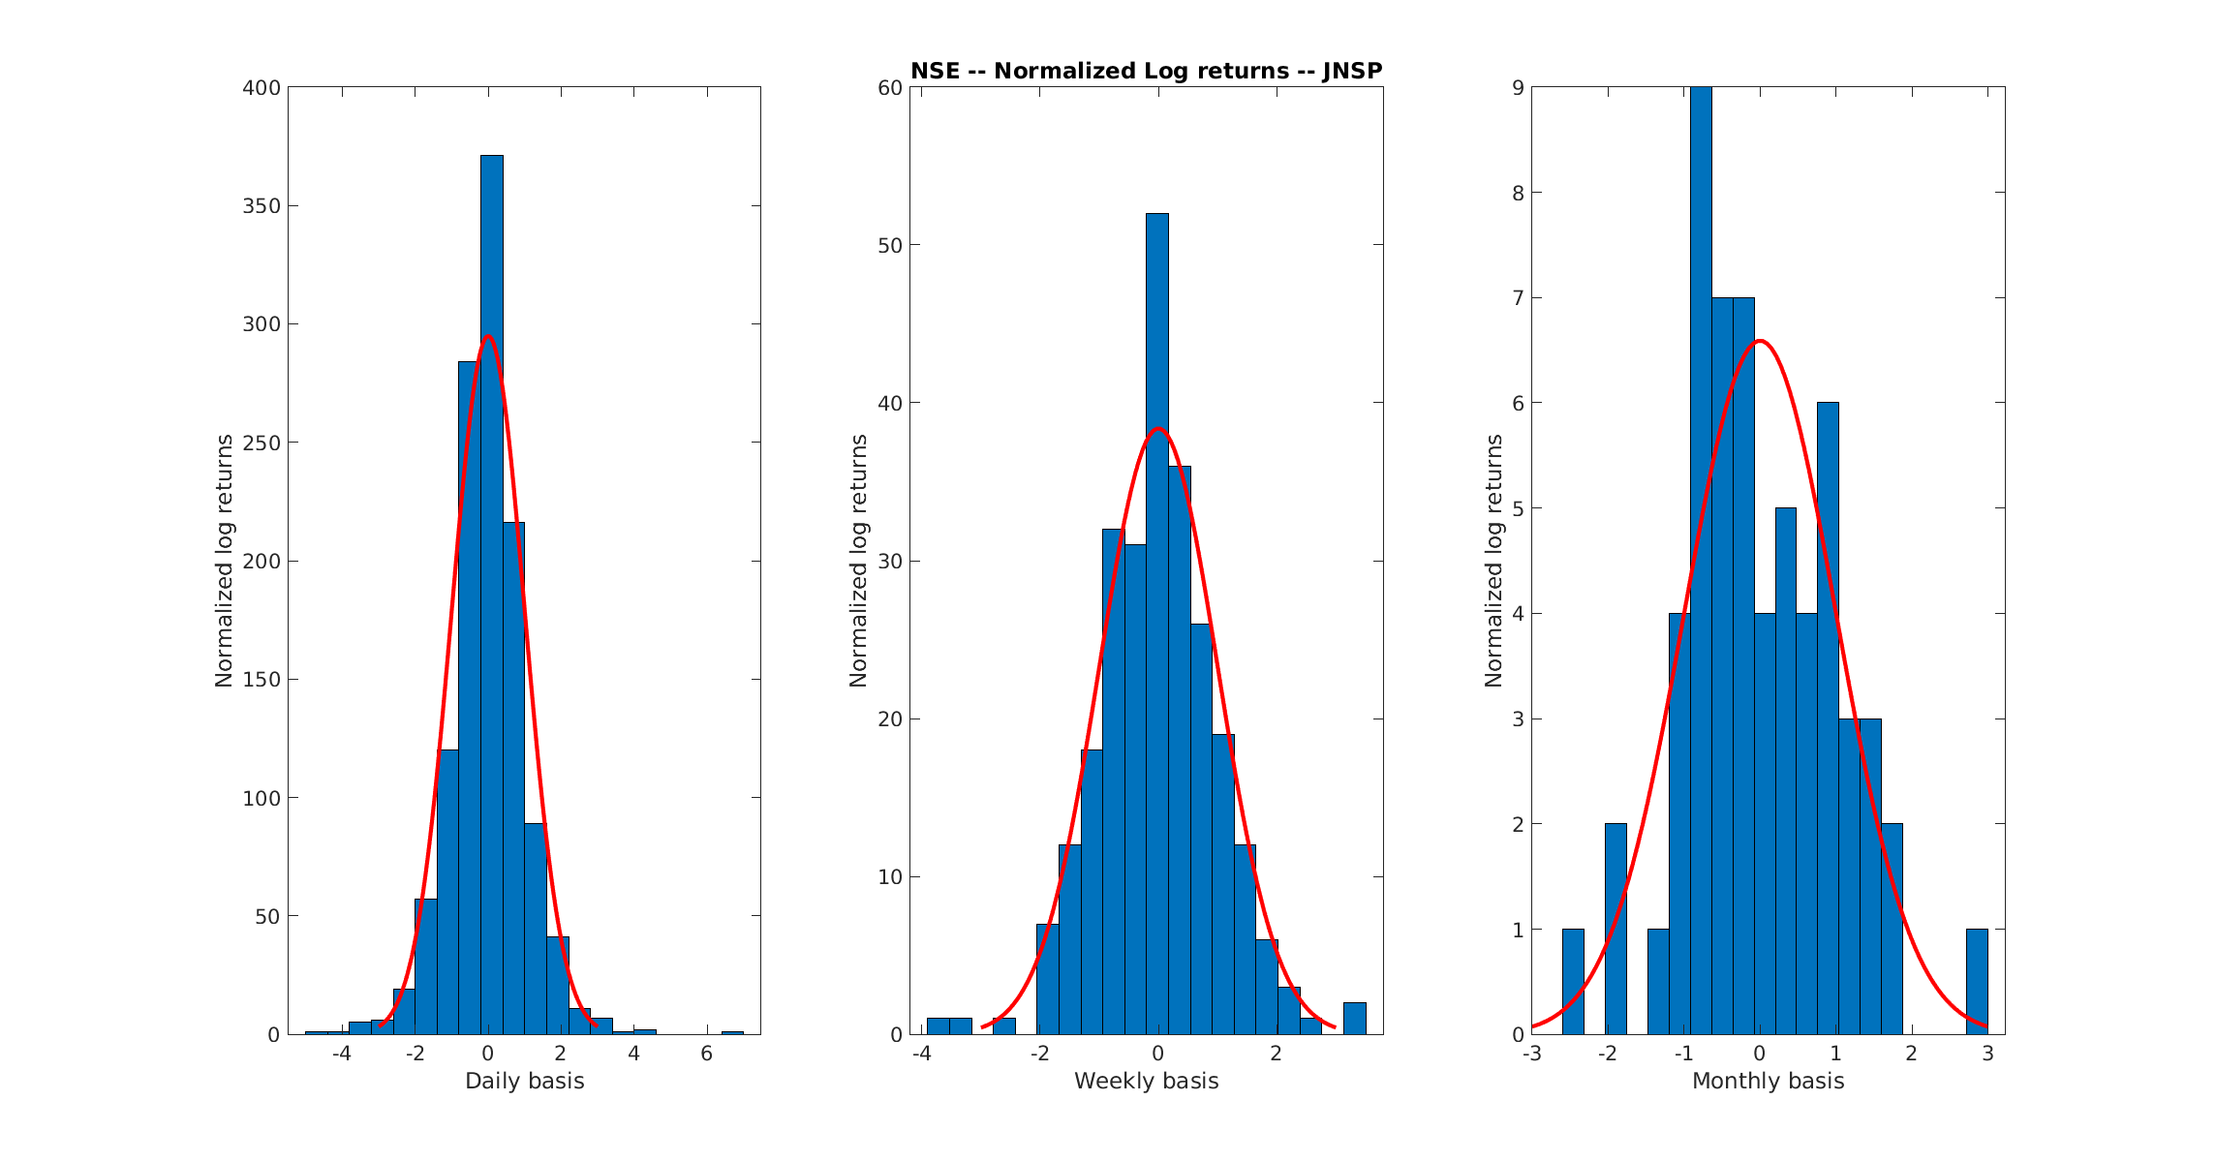

- Question 4
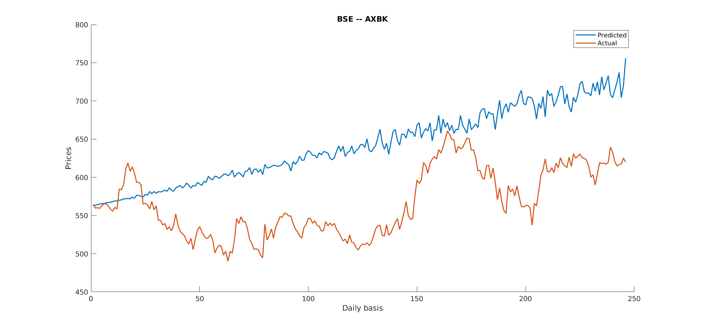
BSE -

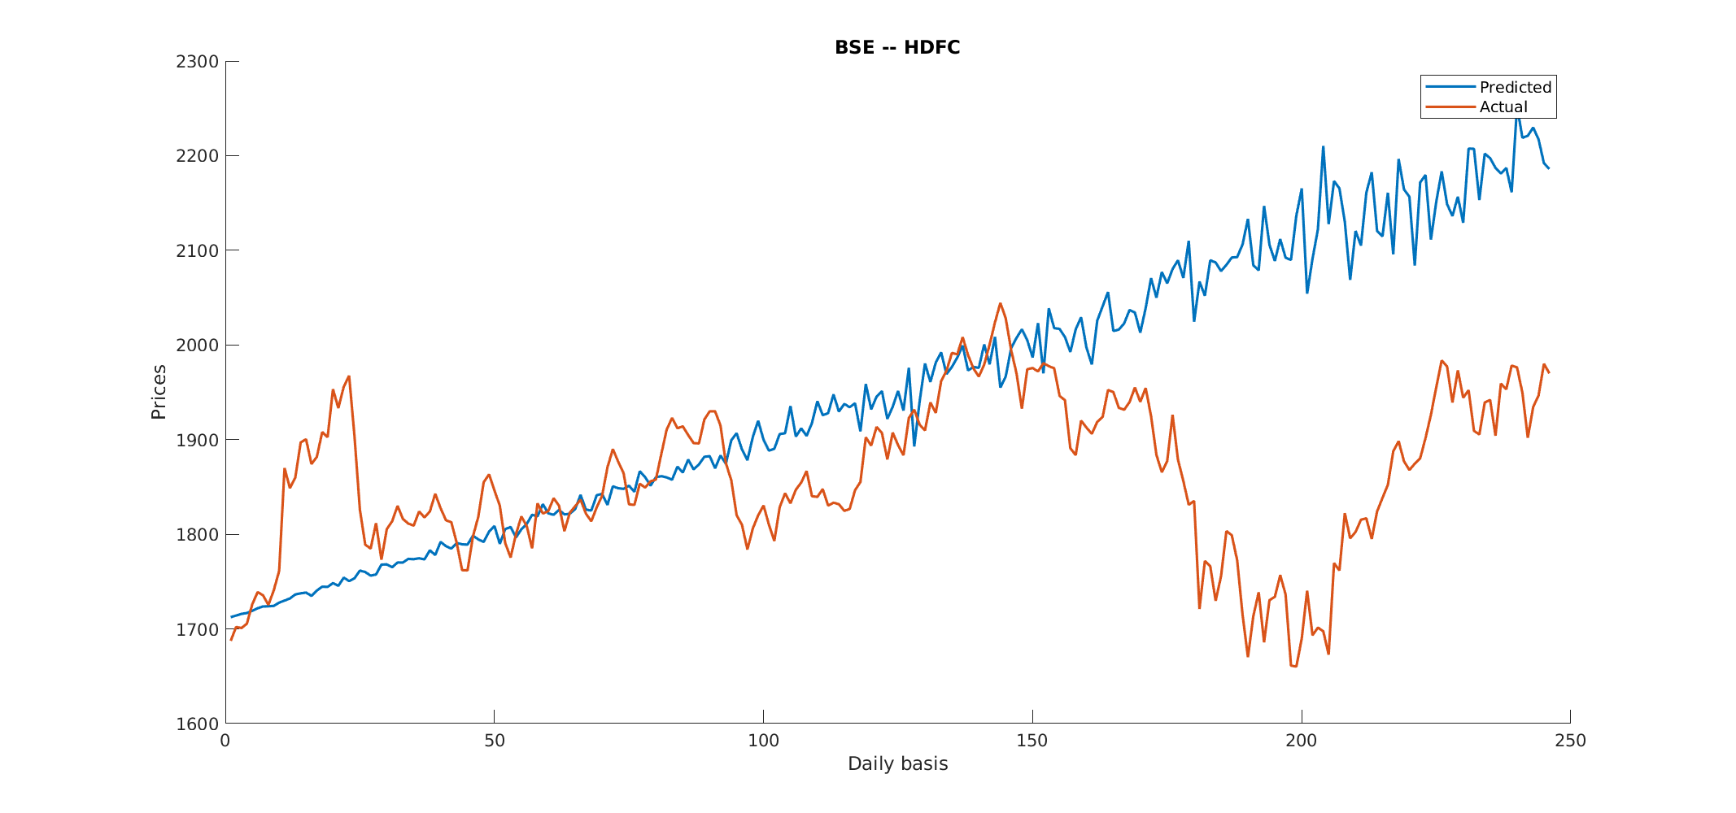
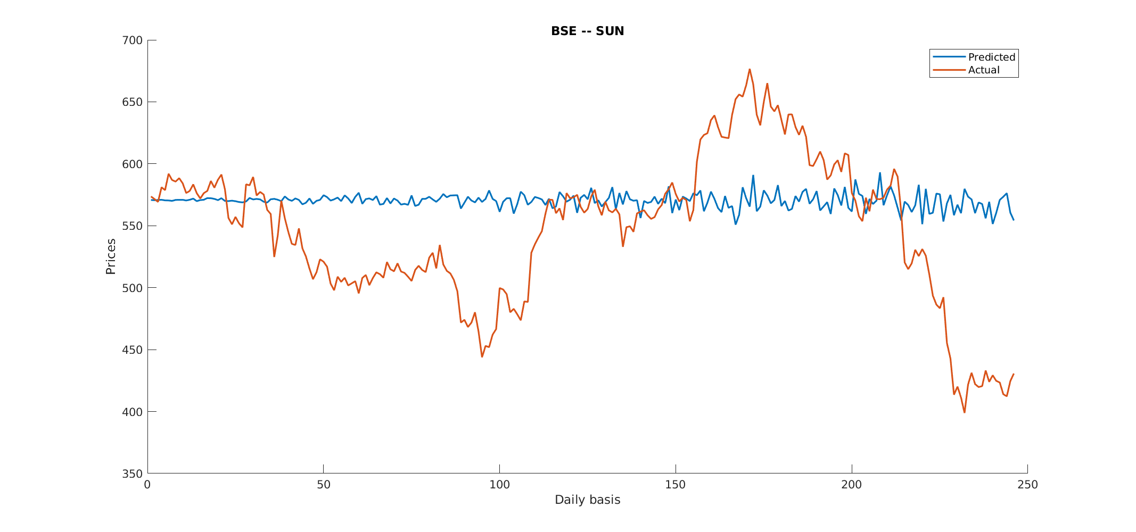

NSE -

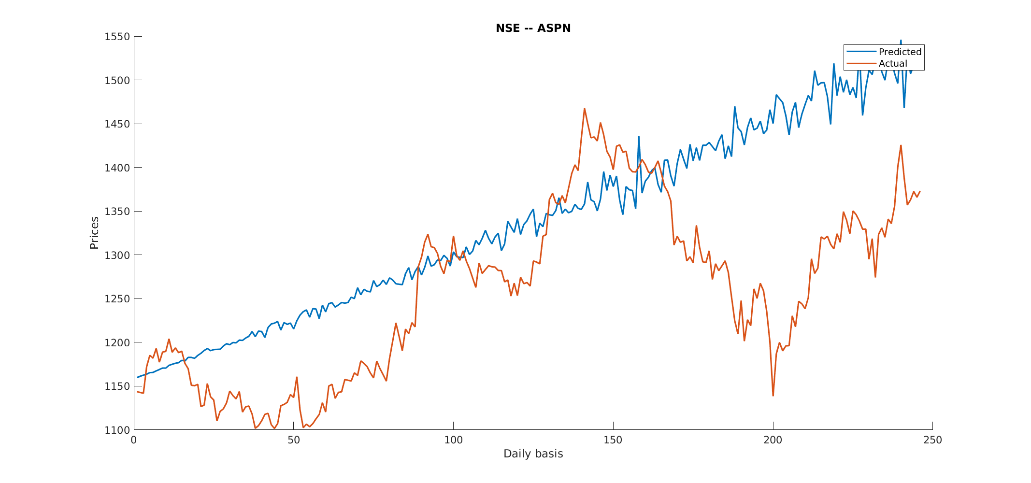

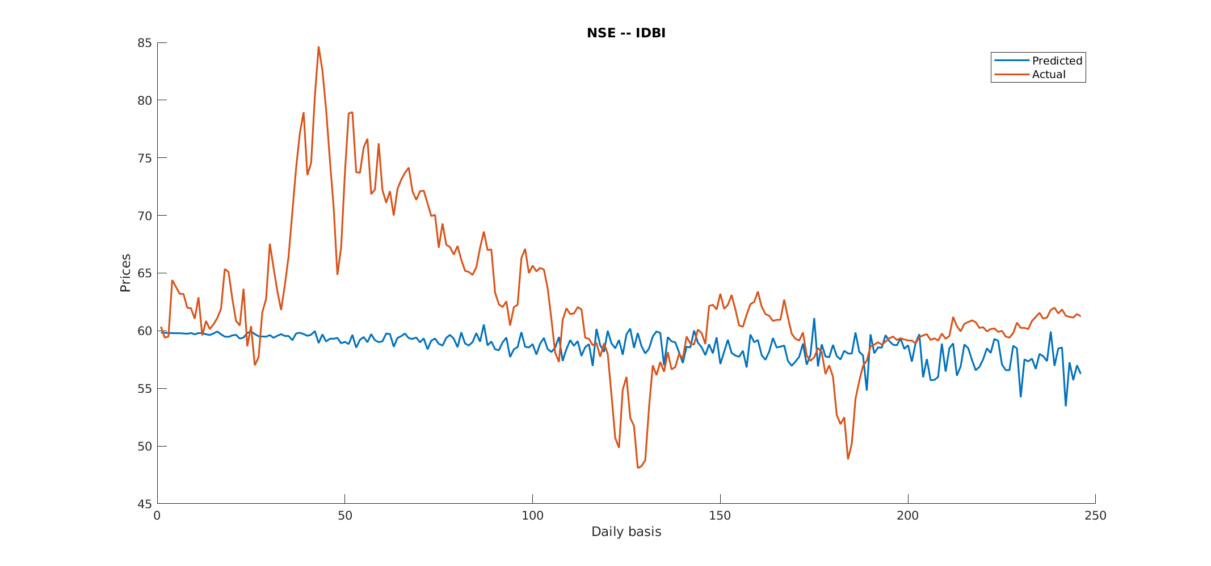

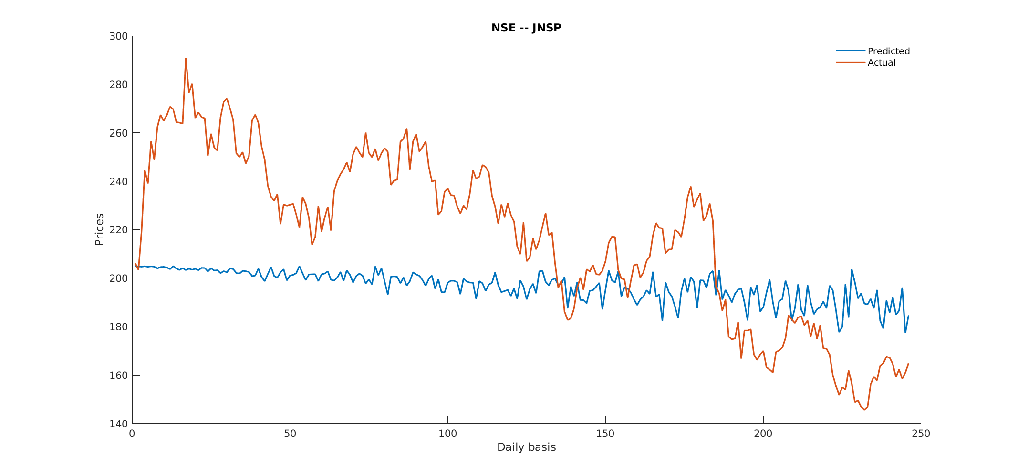

- Question 5a - (Weekly)
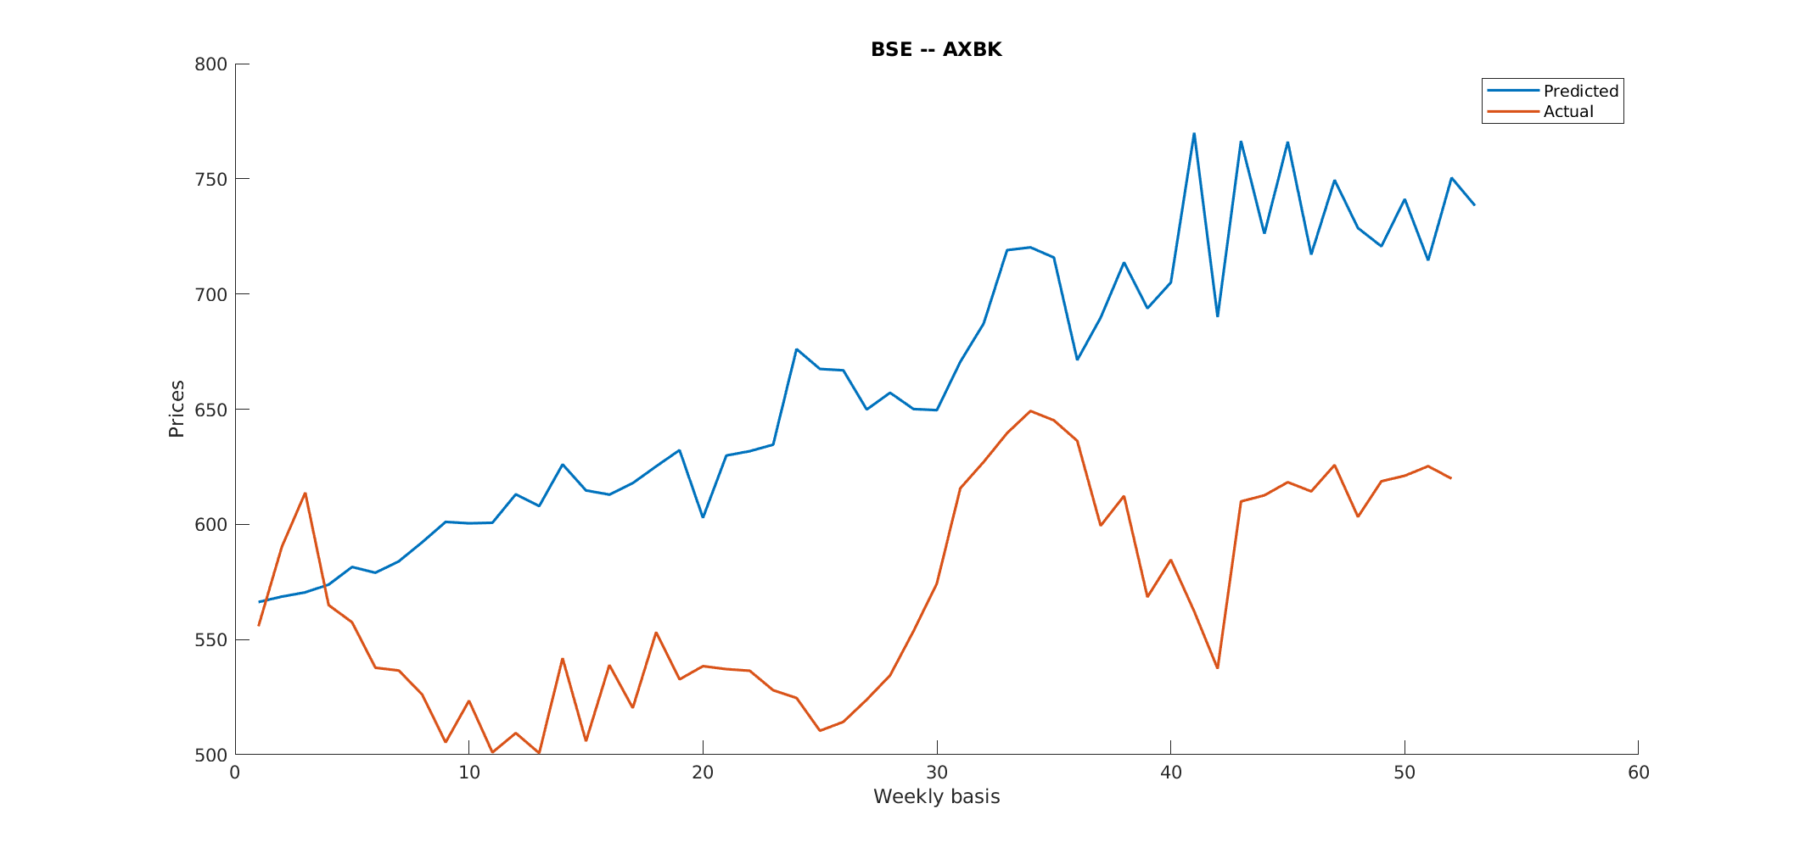
BSE -

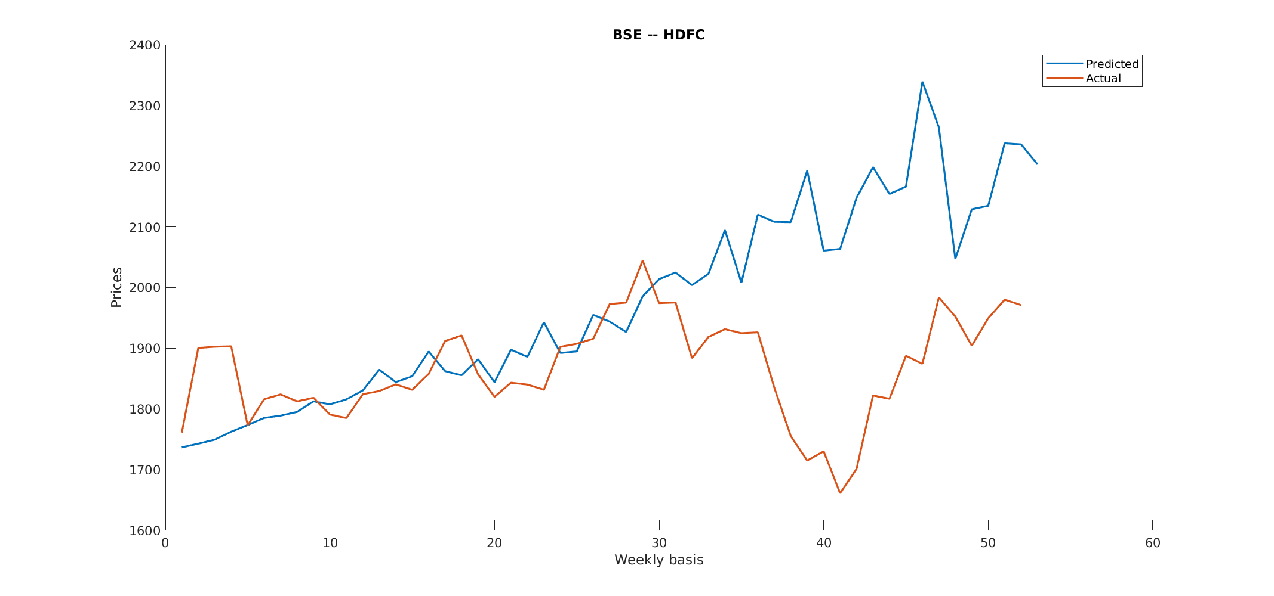
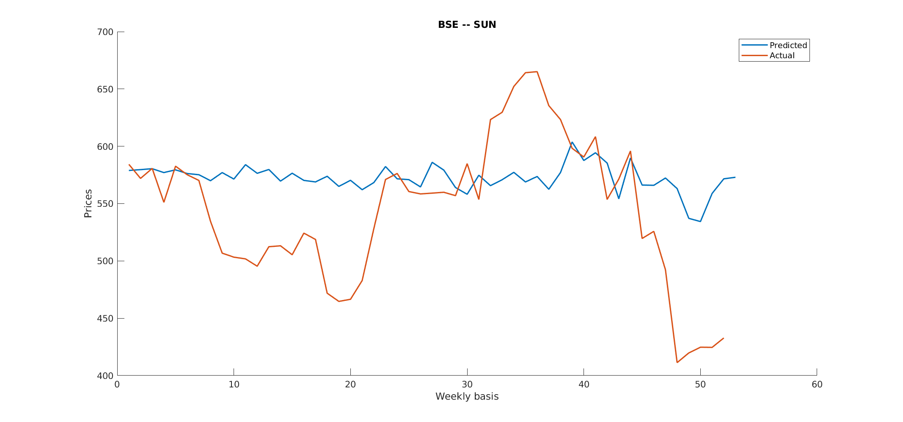

NSE -

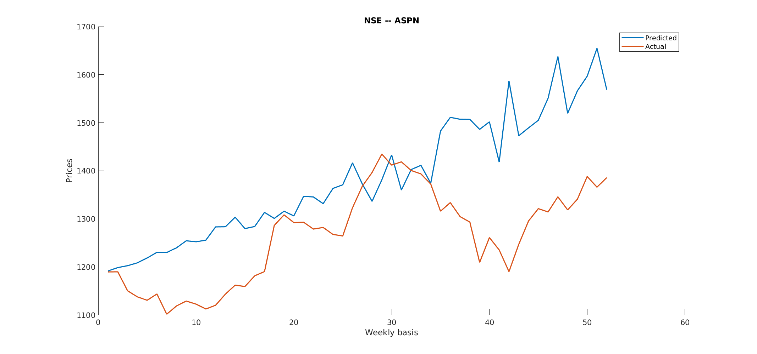

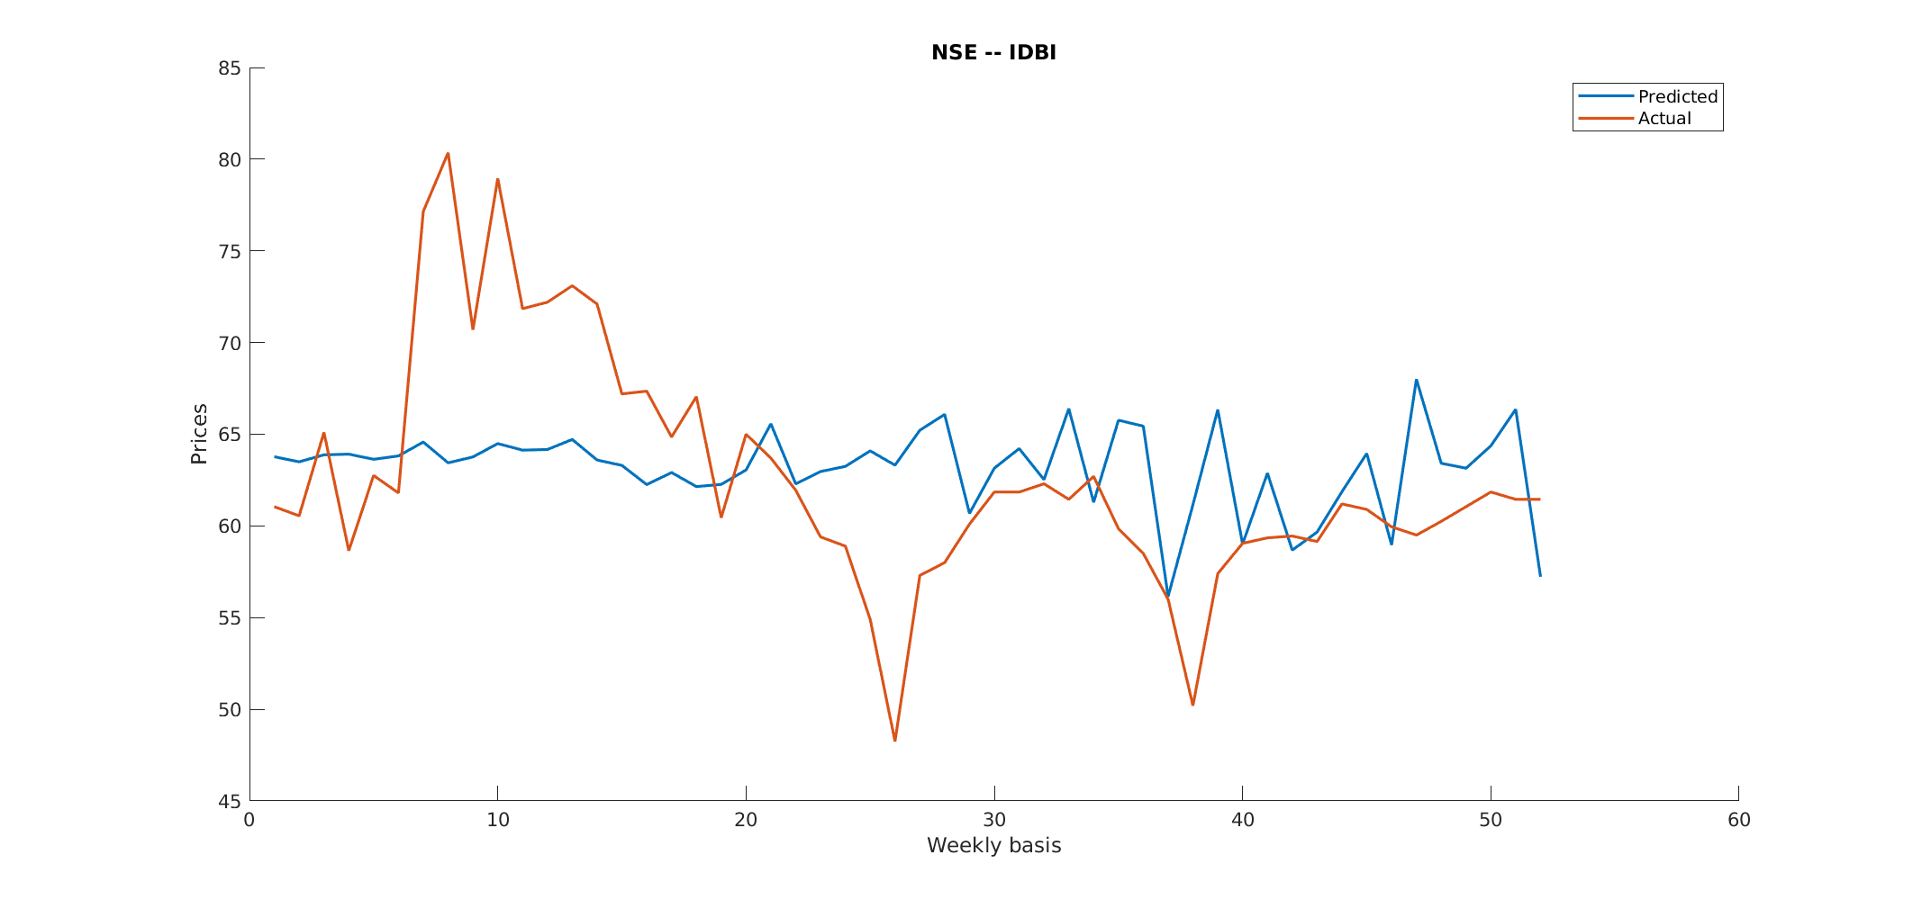

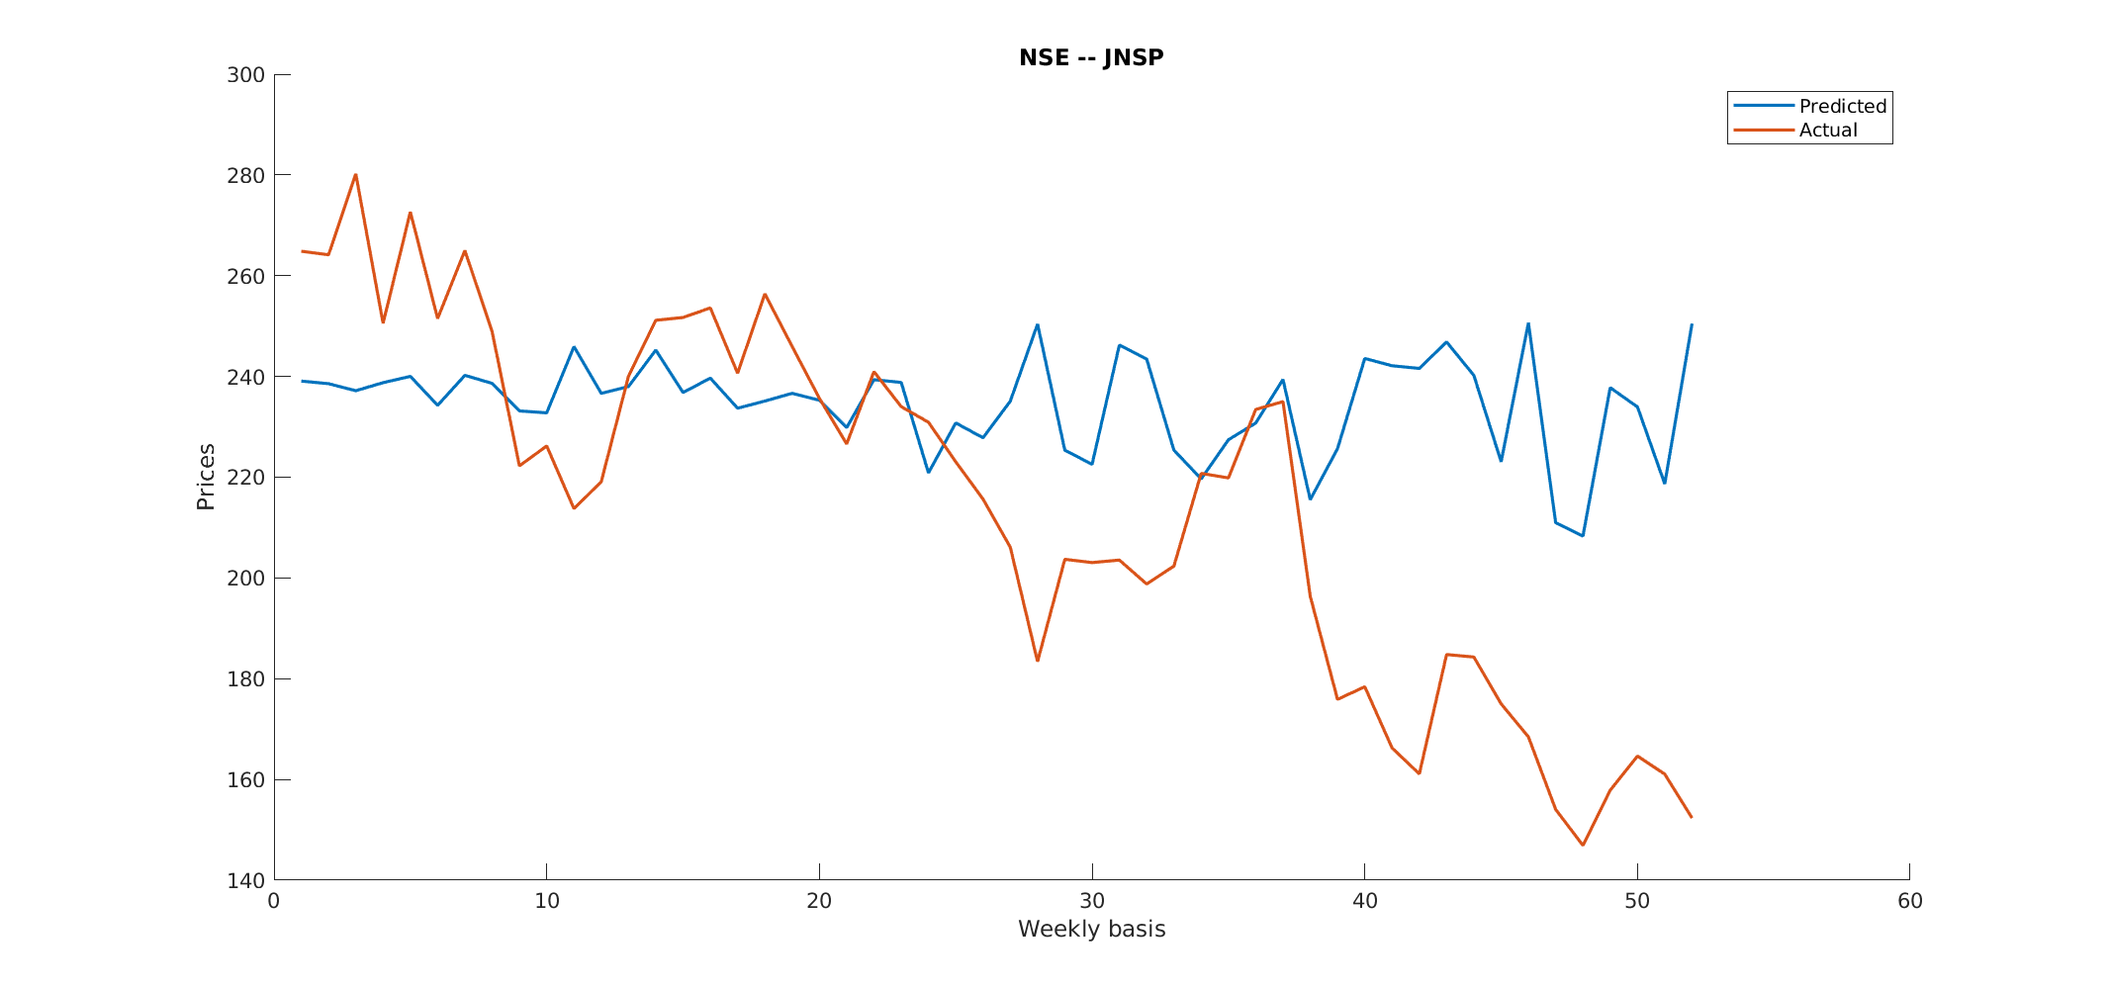

- Question 5b - (Monthly)
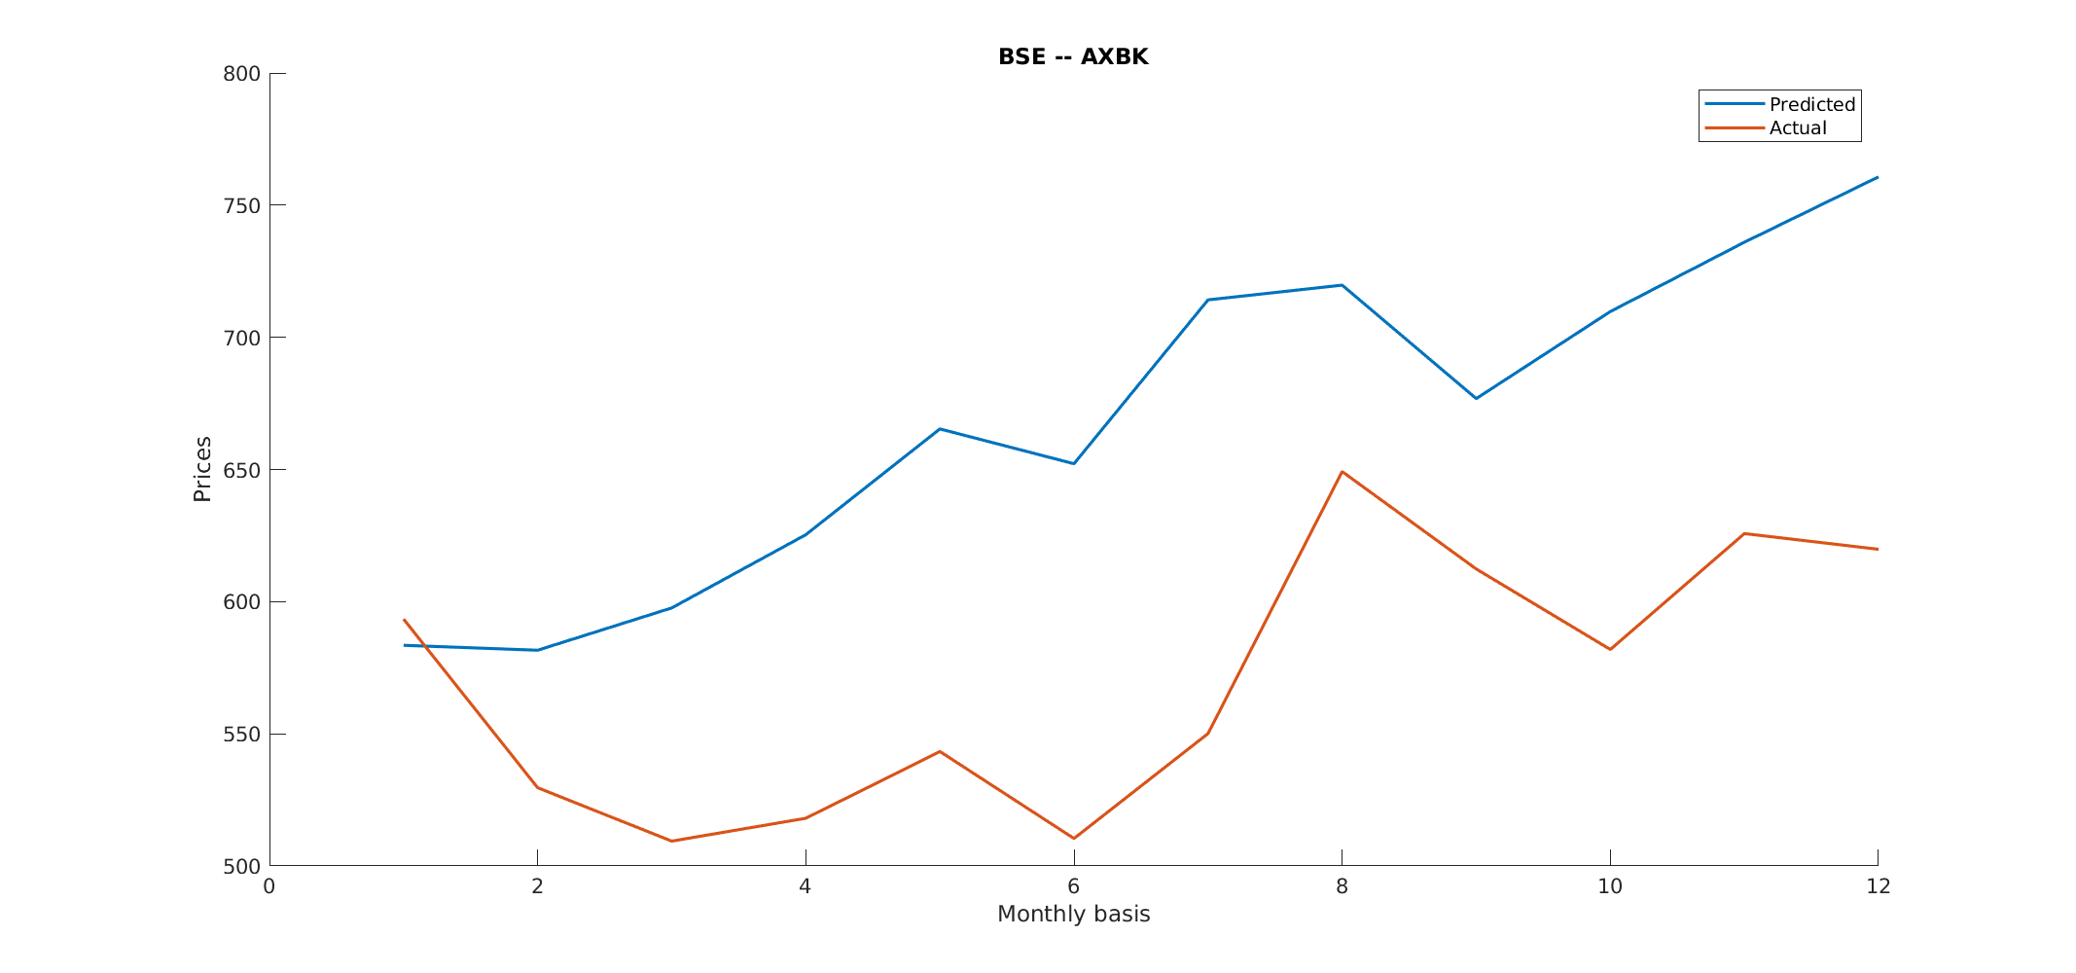
BSE -

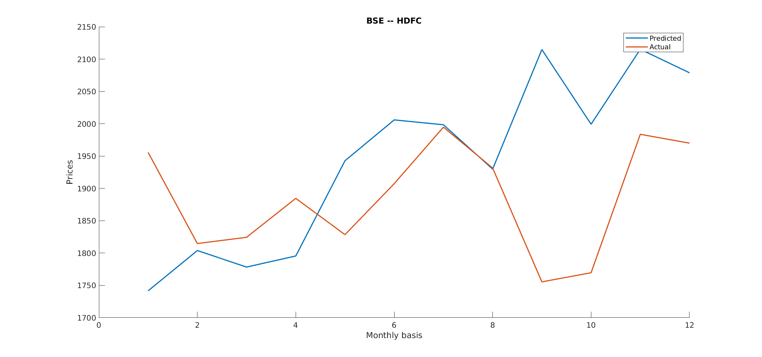
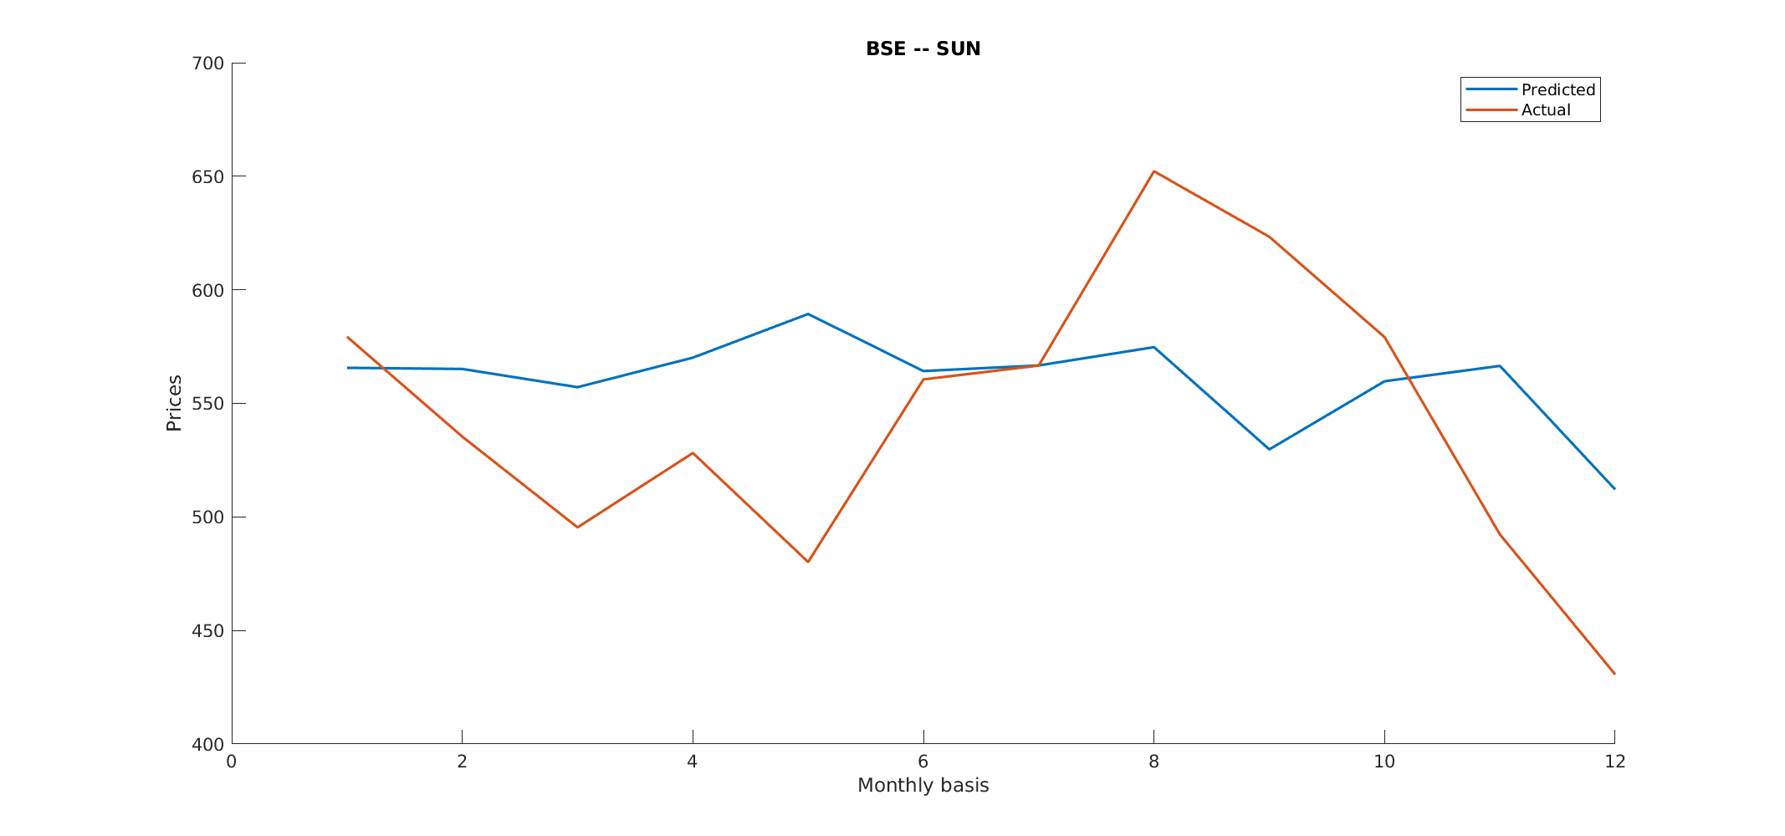

NSE -

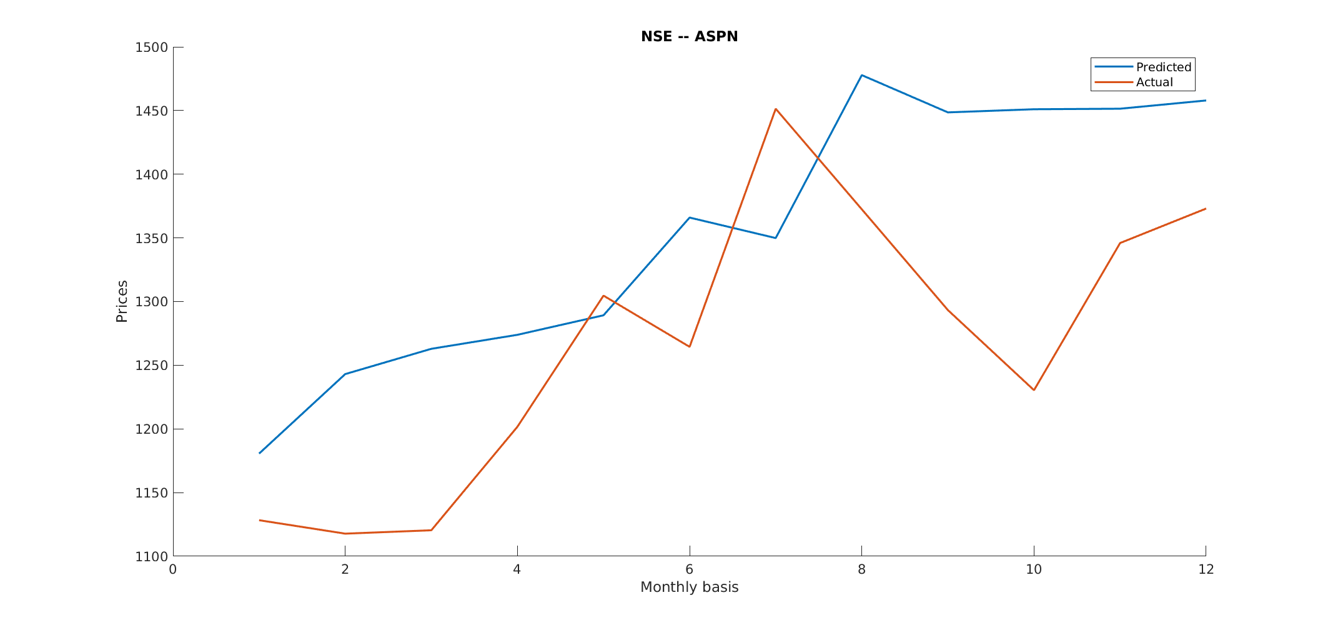

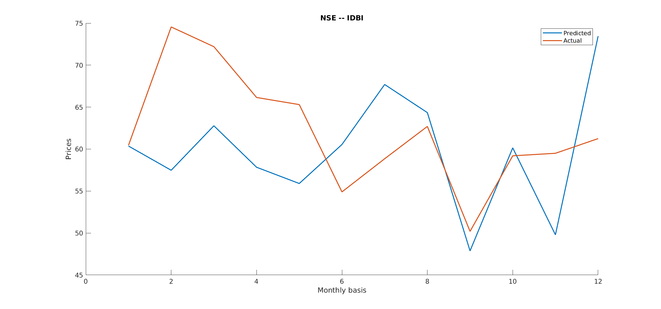

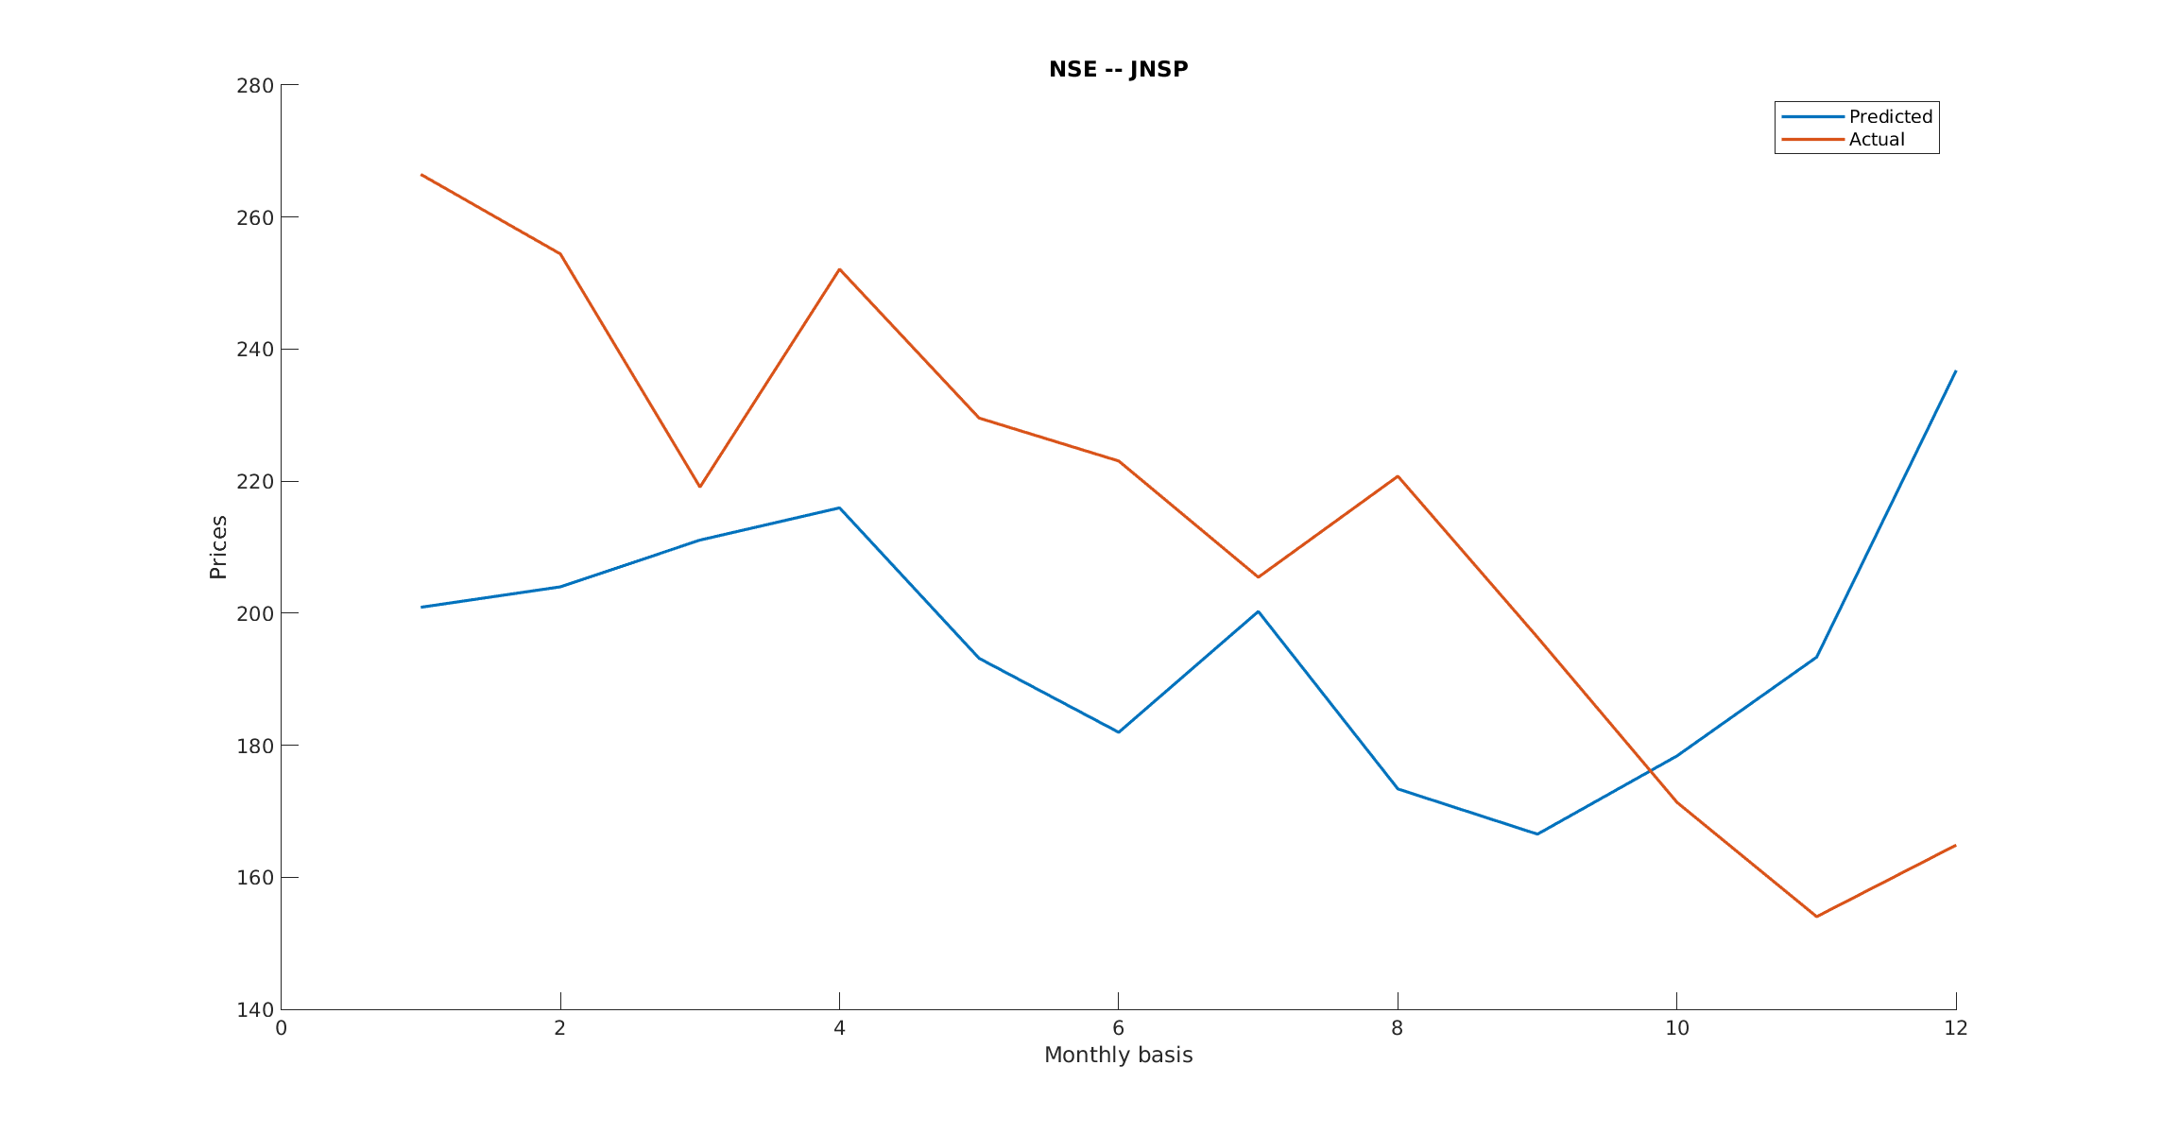

Concept and formula on which question 4 and 5 are based

First mean (μ) and sigma (σ) are calculated on data from 3 year data (2014 to 2017). It is to be noted that mean (μ) should be calculated as annualized value. Now to predict stock price data for the year 2018, following formula is applied -

S(t) = S(0) x e^{(σ x W(t) + (μ – (σ^2)/2) x t)}

Here W(t) ~ N(0,t)
and t = 1/246, 2/246, 3/246, ...... (For Daily data prediction)
and t = 1/246, 2/246, 3/246, ...... (For Weekly data prediction)
and t = 1/246, 2/246, 3/246, ...... (For Monthly data prediction)

