LAB 01

- Question 1

a) Observations for the following values: a=6, b=0, m=11

X₀^{values} | 1st Value | 2nd value | 3rd value | 4th value | 5th value | 6th value | 7th value | 8th value | 9th value | 10th value
0 | 0 | 0 | 0 | 0 | 0 | 0 | 0 | 0 | 0 | 0
1 | 6 | 3 | 7 | 9 | 10 | 5 | 8 | 4 | 2 | 1
2 | 1 | 6 | 3 | 7 | 9 | 10 | 5 | 8 | 4 | 2
3 | 7 | 9 | 10 | 5 | 8 | 4 | 2 | 1 | 6 | 3
4 | 2 | 1 | 6 | 3 | 7 | 9 | 10 | 5 | 8 | 4
5 | 8 | 4 | 2 | 1 | 6 | 3 | 7 | 9 | 10 | 5
6 | 3 | 7 | 9 | 10 | 5 | 8 | 4 | 2 | 1 | 6
7 | 9 | 10 | 5 | 8 | 4 | 2 | 1 | 6 | 3 | 7
8 | 4 | 2 | 1 | 6 | 3 | 7 | 9 | 10 | 5 | 8
9 | 10 | 5 | 8 | 4 | 2 | 1 | 6 | 3 | 7 | 9
10 | 5 | 8 | 4 | 2 | 1 | 6 | 3 | 7 | 9 | 10

We observe that for each seed value (x₀ = 0 to 10), random numbers generated by the method of Linear Congruence generation range from 1 to 10 i.e. all values from 1 to m-1 are generated before repetition of values are observed.
Hence period length for this generator is 10 (m-1) i.e. a
full period.

b) Observations for the following values: a=3, b=0, m=11

X₀^{values} | 1st Value | 2nd value | 3rd value | 4th value | 5th value | 6th value | 7th value | 8th value | 9th value | 10th value
0 | 0 | 0 | 0 | 0 | 0 | 0 | 0 | 0 | 0 | 0
1 | 3 | 9 | 5 | 4 | 1 | 3 | 9 | 5 | 4 | 1
2 | 6 | 7 | 10 | 8 | 2 | 6 | 7 | 10 | 8 | 2
3 | 9 | 5 | 4 | 1 | 3 | 9 | 5 | 4 | 1 | 3
4 | 1 | 3 | 9 | 5 | 4 | 1 | 3 | 9 | 5 | 4
5 | 4 | 1 | 3 | 9 | 5 | 4 | 1 | 3 | 9 | 5
6 | 7 | 10 | 8 | 2 | 6 | 7 | 10 | 8 | 2 | 6
7 | 10 | 8 | 2 | 6 | 7 | 10 | 8 | 2 | 6 | 7
8 | 2 | 6 | 7 | 10 | 8 | 2 | 6 | 7 | 10 | 8
9 | 5 | 4 | 1 | 3 | 9 | 5 | 4 | 1 | 3 | 9
10 | 8 | 2 | 6 | 7 | 10 | 8 | 2 | 6 | 7 | 10

We observe that for each seed value (x₀ = 0 to 10), Linear Congruence generator generates 5 distinct values and then values are repeated. Thus period length for each seed value is 5.

c) Generators with higher period length are preferred. Largest possible period length for a Linear congruence generator can be m-1 (10 in this case). Period length of second case (a=3) is greater than first case (a=6). Thus a Linear congruence generator with a=6, b=0, m=11 is a better choice over a linear congruence generator with a=3, b=0, m=11.
- Question 2
a) Sample seed values (X₀) are 5,6,7,8,9.
Frequences of numbers generated in the ranges 0 − 0.05, 0.05 − 0.10, 0.10 − 0.15, ...are as following:
_{Range} ^{Seed(X0)} | 5 | 6 | 7 | 8 | 9
0.00-0.05 | 12248 | 12248 | 12248 | 12248 | 12248
0.05-0.10 | 12247 | 12247 | 12247 | 12247 | 12247
0.10-0.15 | 12247 | 12247 | 12247 | 12247 | 12247
0.15-0.20 | 12247 | 12247 | 12247 | 12247 | 12247
0.20-0.25 | 12247 | 12247 | 12247 | 12247 | 12247
0.25-0.30 | 12248 | 12248 | 12248 | 12248 | 12248
0.30-0.35 | 12247 | 12247 | 12247 | 12247 | 12247
0.35-0.40 | 12247 | 12247 | 12247 | 12247 | 12247
0.40-0.45 | 12247 | 12247 | 12247 | 12247 | 12247
0.45-0.50 | 12247 | 12247 | 12247 | 12247 | 12247
0.50-0.55 | 12248 | 12248 | 12248 | 12248 | 12248
0.55-0.60 | 12247 | 12247 | 12247 | 12247 | 12247
0.60-0.65 | 12247 | 12247 | 12247 | 12247 | 12247
0.65-0.70 | 12247 | 12247 | 12247 | 12247 | 12247
0.70-0.75 | 12247 | 12247 | 12247 | 12247 | 12247
0.75-0.80 | 12248 | 12248 | 12248 | 12248 | 12248
0.80-0.85 | 12247 | 12247 | 12247 | 12247 | 12247
0.85-0.90 | 12247 | 12247 | 12247 | 12247 | 12247
0.90-0.95 | 12247 | 12247 | 12247 | 12247 | 12247
0.95-1.00 | 12247 | 12247 | 12247 | 12247 | 12247

b) Bar Diagrams of frequencies (number of values
falling in a range) vs ranges (0 − 0.05, 0.05 − 0.10, 0.10 − 0.15, ..) for X₀=5, a=1597, b=51749, m=244944:

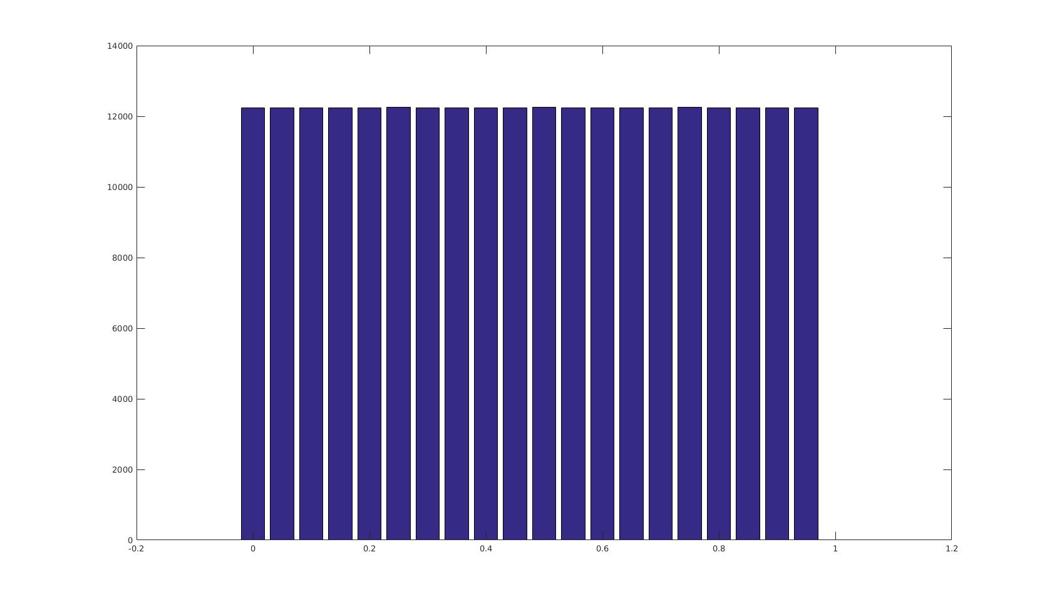
Figure 2.1

We observed that frequences of random numbers generated in given ranges for different seed values are same. Thus, bar diagram for any arbitrary seed value (X₀) will be identical to figure 2.1.

c) We observe that since value of k i.e. the number of values generated is very high, linear congruence generator is able to generate numbers having almost identical frequencies in same-length subintervals. This property is known as uniformity. Thus this model will be preferred choice to generate uniform random variables.
- Question 3
a) Scatter plot with co-ordinates (U_{i-1},U_{i}) having a=1229, b=1, Seed (X₀) = 1 and m=2048:

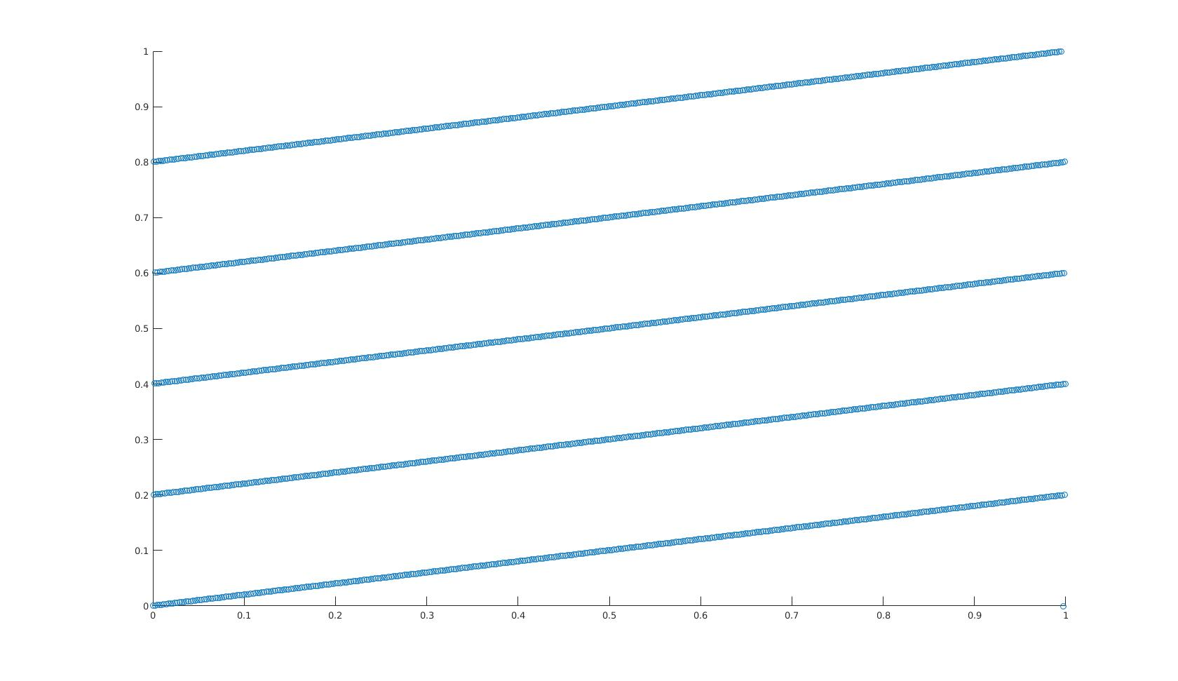
Figure 3.1 two-dimensional graph with the points (U_{i−1},U_{i} )

b) We observe that scatter plots obtained for different seed values (X₀) were identical in nature and orientation. The plots are 5 parallel lines originating from 0,0.2,0.4,0.6,0.8.
The 5 lines were seperated by same distance. The distance between these lines are an important factor in computing the effectiveness of Linear Congruence Generator. According to Spectral test, the further apart the lines are, the worse the generator is.

