LAB 02

- Question 1

a) Values are generated for the following seed values U_{o}=0.5756 and U₁=0.4534

Number of values generated are 1000, 10000 and 100000.
Following plots were obtained on plotting (U_{i},U_{i+1},U_{i+2}) in the unit cube :

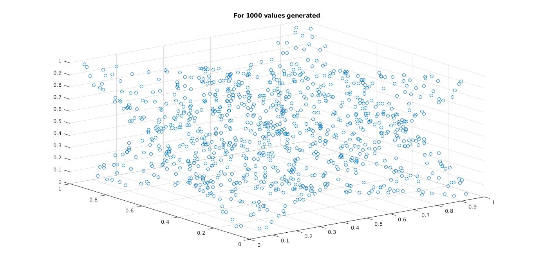

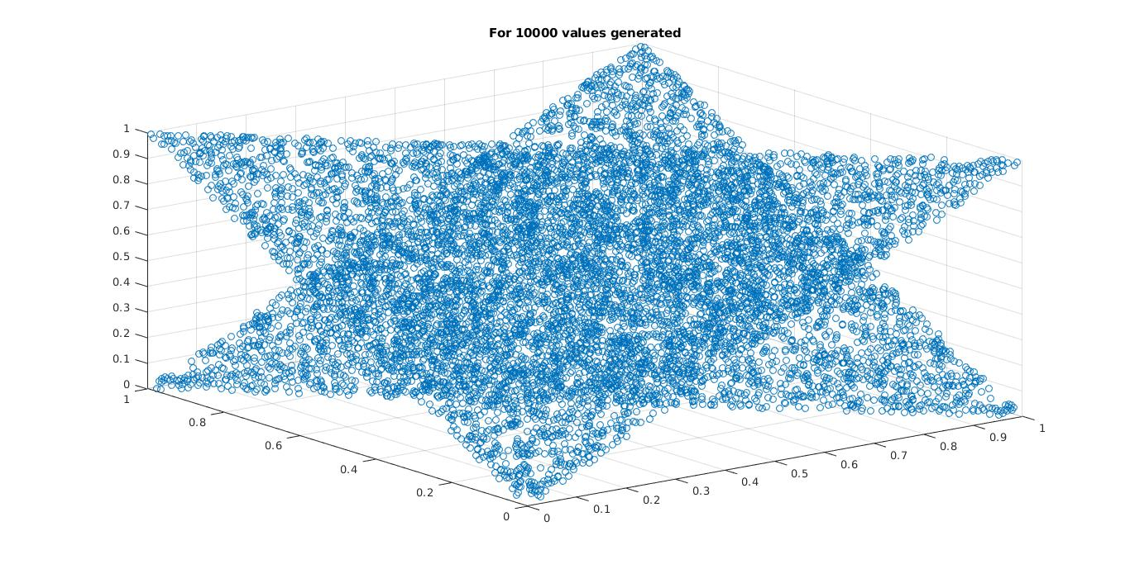

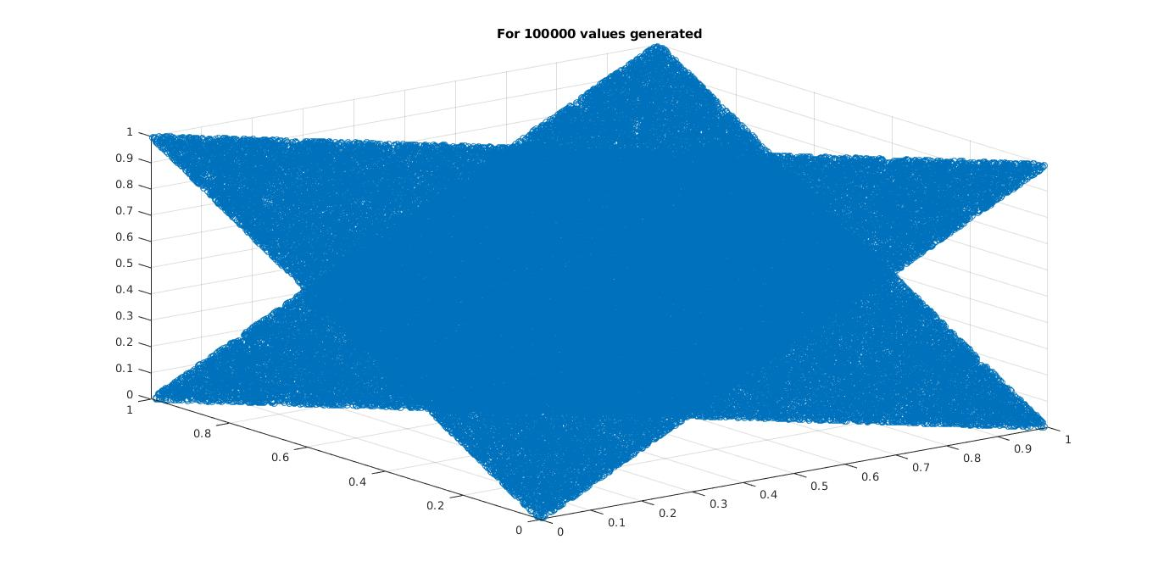
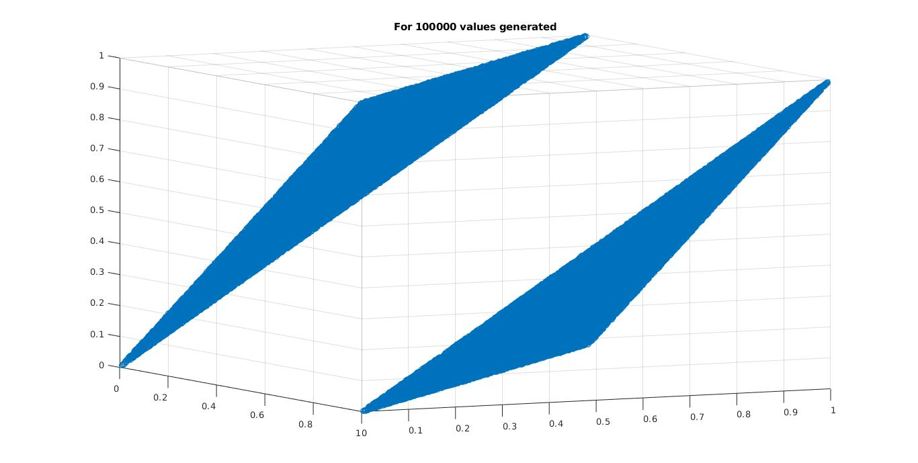
b) Observations and Generator’s effectiveness Analysis:
- We observe that the density of points in the scatter plot increases as the number of values generated increases. This reaffirms the fact the values generated are more random if their number is high.
- Further We observe that scatter plot generated by plotting (U_{i},U_{i+1},U_{i+2}) is a pair of parrallel planes.
- Effectiveness of a generaor is measured by following two propertirs of U_{i}’s generated:
- Each U_{i} should be uniformly distributed between 0 and 1.
- The U_{i} are mutually independent.
From the scatter plot generated it is observed that the triplet
(U_{i},U_{i+1},U_{i+2}) will lie on either of two fixed planes in an unit cube. This implies that if we are having the values of U_{i} and U_{i+1}; we can predict the value of U_{i+2}. Hence this shows that values generated are not mutually independent. Thus, this generator is not a very good generator for uniform distribution.
- Question 2

a) First 17 values of U_{i} for given generator are generated by Linear congruence Generator having parameters a=34, b-0, m=345 and initial seed X₀ = 3, 5 and 5 for 1000,10000,100000 values generated respectively.
The 1000, 10000 and 100000 values of floating point numbers U_{i} were generated using recursion:
U_{i+1} = (U_{i−17} − U_{i−5}) with condition that if U_{i} < 0, then set U_{i} = U_{i + 1}

b) Following plots were obtained on plotting (U_{i},U_{i+1}):

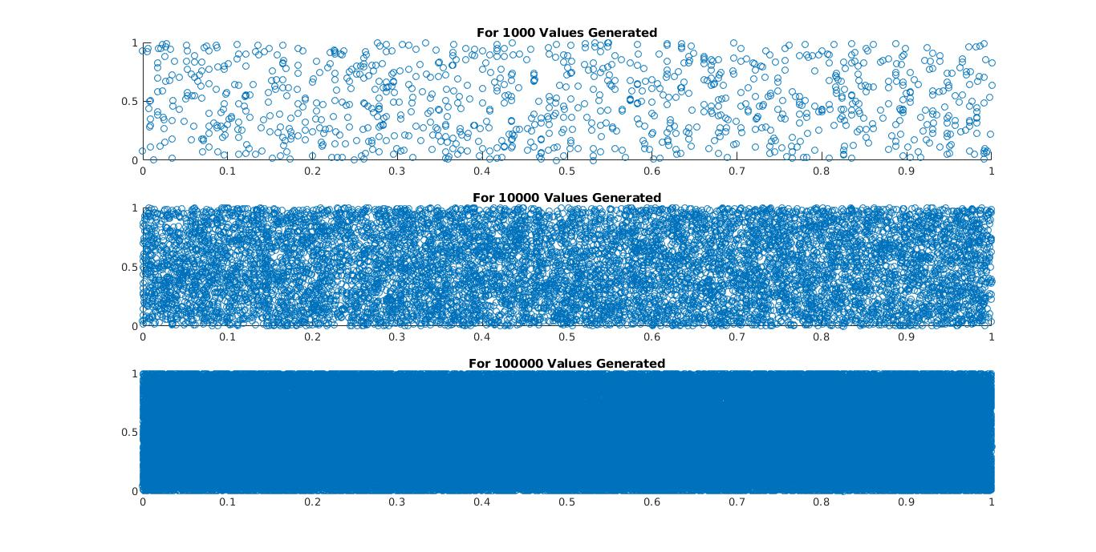

c) Following bar diagrams were obtained on plotting U_{i} with respect to i:
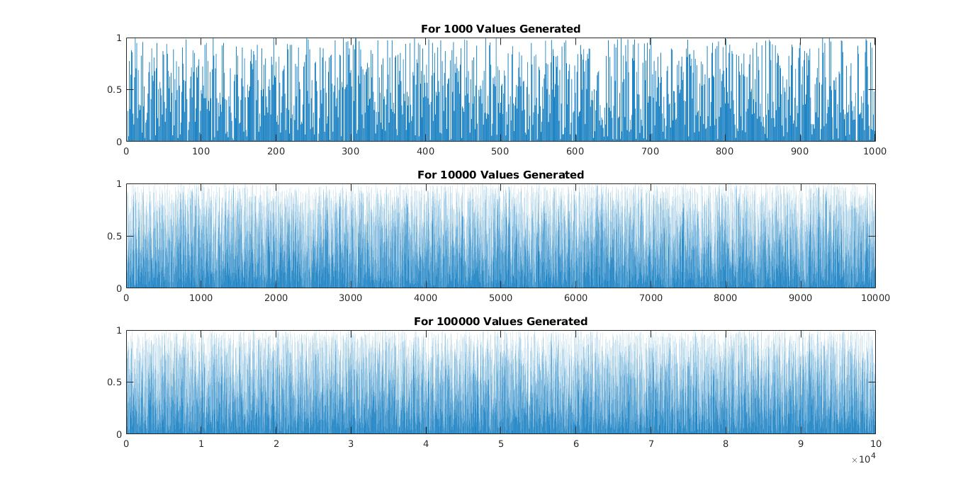
d) Following plots were obtained on plotting (U_{i},U_{i+1},U_{i+2}):
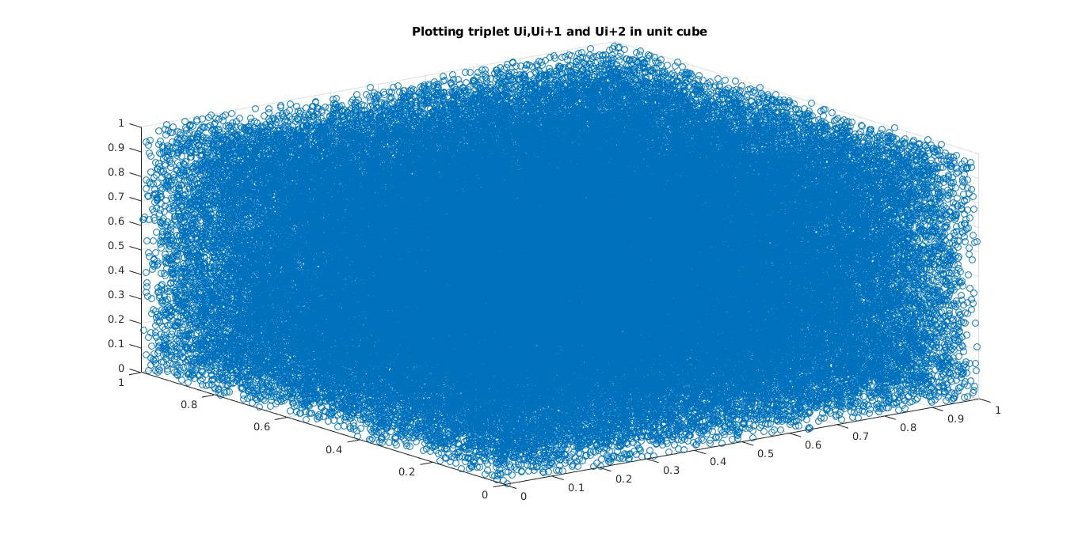

e) Observations:

By plotting (U_{i},U_{i+1}), it is observed that values generated do not follow any relation that could make them predictable. Same behaviour is observed if we plot the triplet of (U_{i},U_{i+1},U_{i+2}).

On analysis of bar diagrams of U_{i}, it is observed that values generated by given generator are indeed random since they follow the properties:

- Each U_{i} should be uniformly distributed between 0 and 1.
- The U_{i} are mutually independent.

Thus, the generator following the recursion rule
Ui+1 ₌ (Ui−17 ₋ U_{i}−5) is a good random generator for uniform distribution and is recommandable.

- Question 3

a) We have the exponentional distribution
F(x) = 1 − e^{−x/θ} , x ≥ 0

Value of θ is taken to be π (Pi).
Mean = θ ~ 3.1415
Variance = θ² ~ 9.8690

Generation of uniformly distributed random variables U_{i} are done by following generator:
First 17 values of U_{i} are generated by Linear congruence Generator having parameters a=34, b-0, m=345 and initial seed X₀ = 3, 5 and 5 for 1000,10000,100000 values generated respectively.
The 1000, 10000 and 100000 values of floating point numbers U_{i} were generated using recursion:

U_{i+1} = (U_{i−17} − U_{i−5}) with condition that if U_{i} < 0, then set U_{i} = U_{i + 1}

b) Random Variable X was generated by exponential distribution using algorithm:
X = −θlog(1 − U), where U ∼ U[0, 1].

The generation was done for 1000,10000,100000 number of values of U. Further a CDF was plotted for generated random variable X and following mean and variance data was observed:

For 1000 Values of Ui:
Mean = 3.3263
Variance = 26.5953
For 10000 Values of Ui:
Mean = 3.1109
Variance = 10.4612
For 100000 Values of Ui:
Mean = 3.1333
Variance = 9.9210

c) The Cumulative distribution function of generated random variable X are plotted for the value of x ranging between 0 and 40 with frequency calculted in 0.1 length ranges.

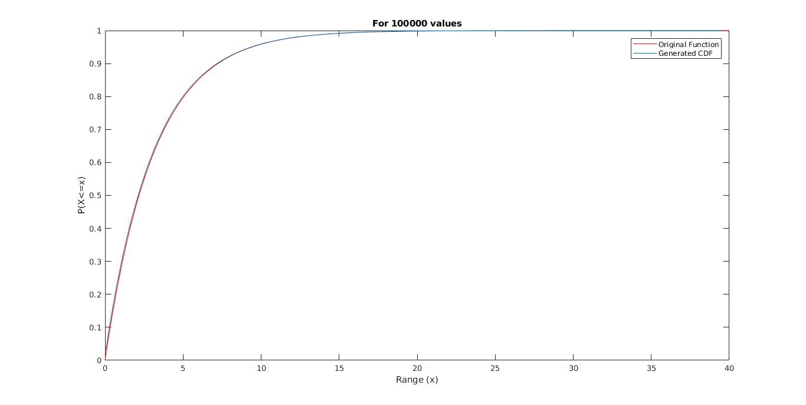

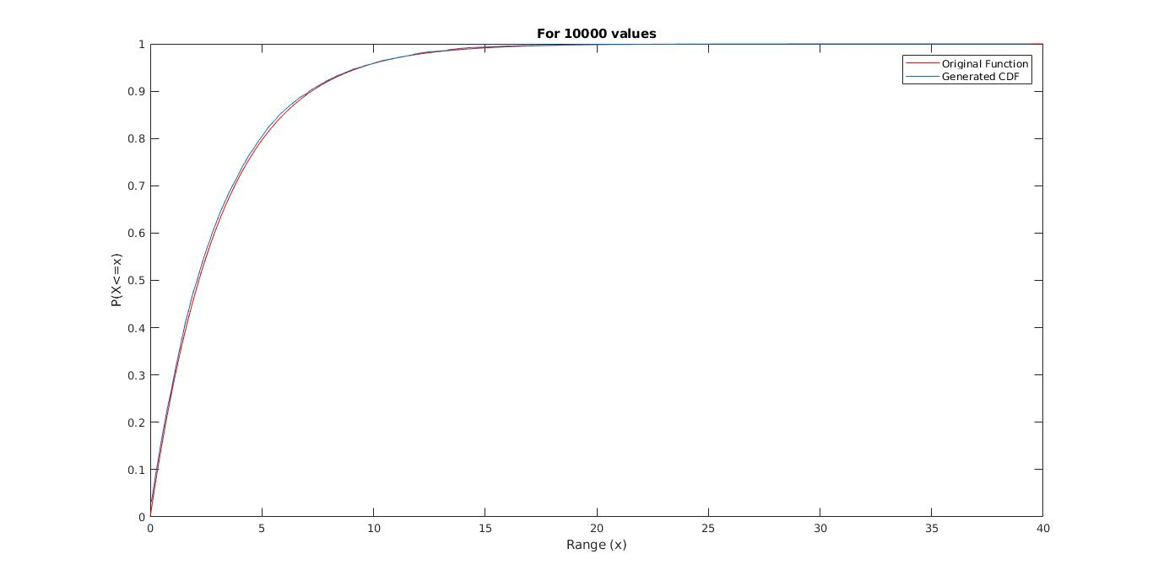

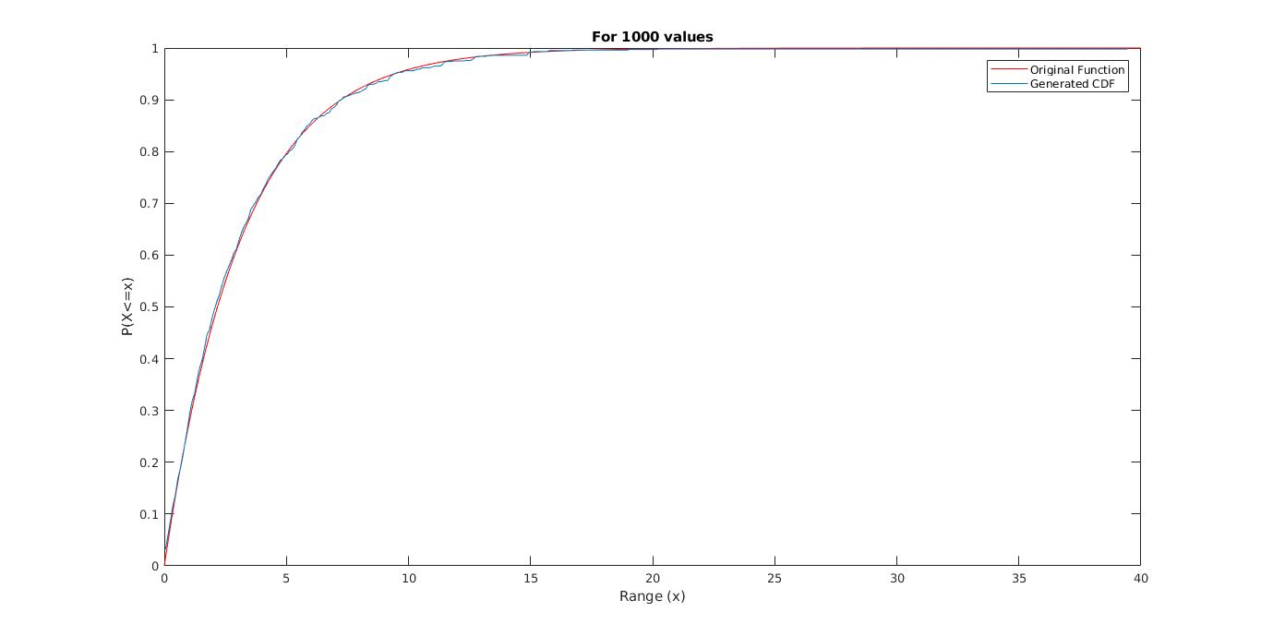
d) Observations:

i. From the plots, It is observed that cumulative distribution function for genrated random variable X is identical to the exponential CDF from which X was generated using the Inverse Transform Method. It reaffirms the fact that F⁻¹(U) where U ∼ U[0, 1] is a sample from F(x).

ii. Further it is observed that CDF generated approach the theoritical exponential plot as the number of values generated of X increaces from 1000 to 100000.

iii. The same phenomenan is observed in the values of mean and variance of generated random variable X. Mean and Variance for theoritical exponential distribution function is 3.1415 and 9.8690 respectively. The mean and variance of generated random variable X approach these values as the number of values generated of X increaces from 1000 to 100000.

- Question 4

a) We have the Arcsin law distribution
F(x) = (2/π) arc sin√x , 0 ≤ x ≤ 1.

Mean = 0.5
Variance = 0.125

Generation of uniformly distributed random variables U_{i} are done by following generator:
First 17 values of U_{i} are generated by Linear congruence Generator having parameters a=34, b-0, m=345 and initial seed X₀ = 3, 5 and 5 for 1000,10000,100000 values generated respectively.
The 1000, 10000 and 100000 values of floating point numbers U_{i} were generated using recursion:

U_{i+1} = (U_{i−17} − U_{i−5}) with condition that if U_{i} < 0, then set U_{i} = U_{i + 1}

b) Random Variable X was generated by Arcsin Law distribution using algorithm:
X = sin² (Uπ/2) = 1/2 − 1/2cos(Uπ), where U ∼ U[0, 1].

The generation was done for 1000,10000,100000 number of values of U. Further a CDF was plotted for generated random variable X and following mean and variance data was observed:

For 1000 Values of Ui:
Mean = 0.5004
Variance = 0.1243
For 10000 Values of Ui:
Mean = 0.4961
Variance = 0.1241
For 100000 Values of Ui:
Mean = 0.4987
Variance = 0.1251

c) The Cumulative distribution function of generated random variable X are plotted for the value of x ranging between 0 and 1 with frequency calculted in 0.01 length ranges.

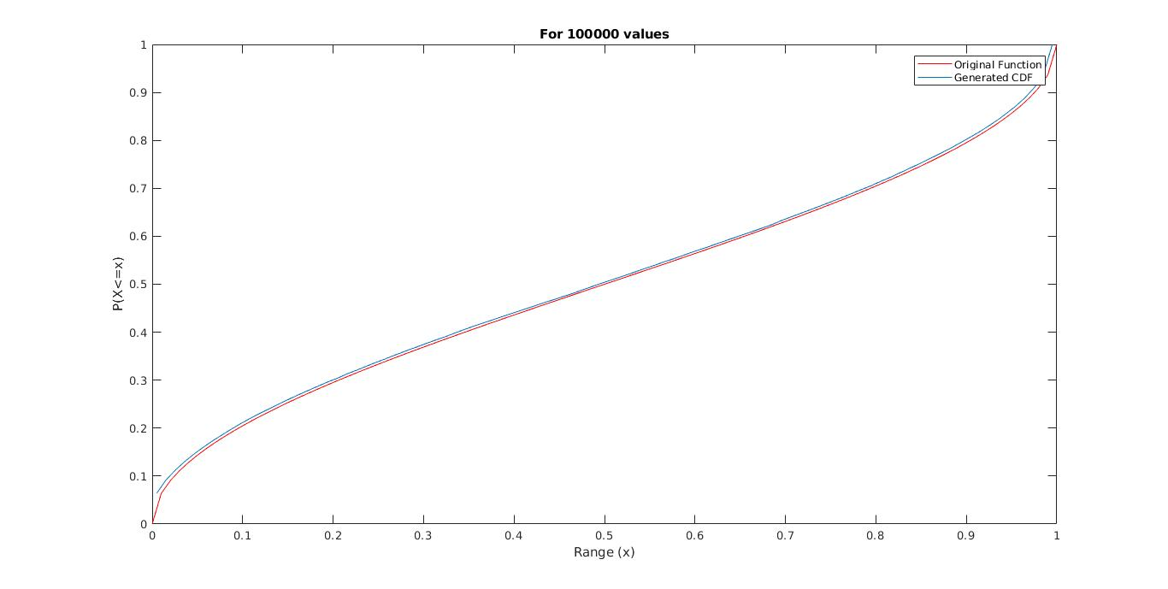

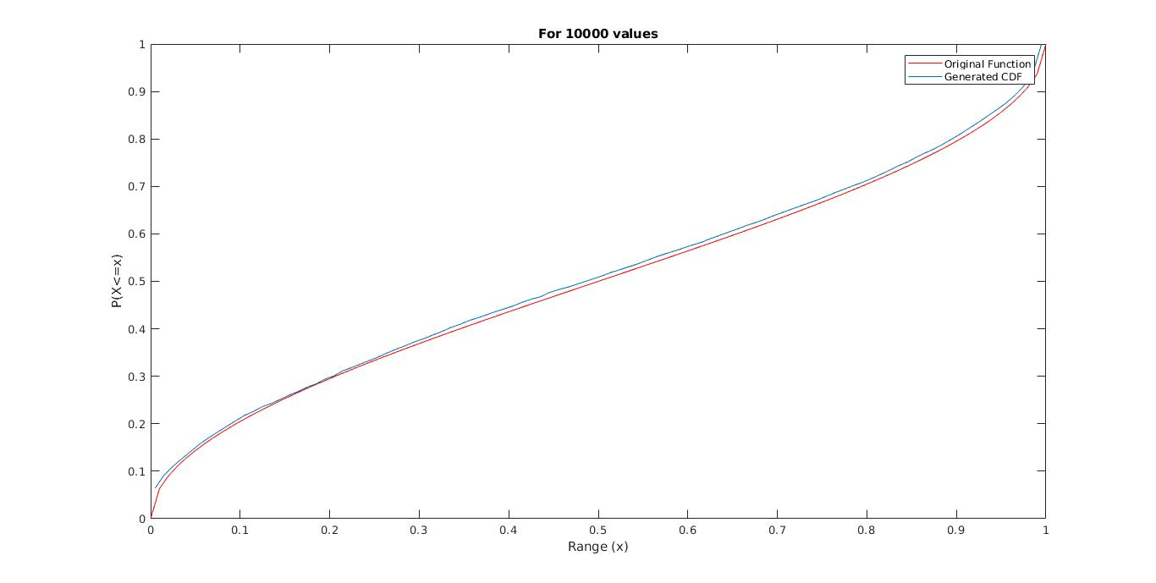
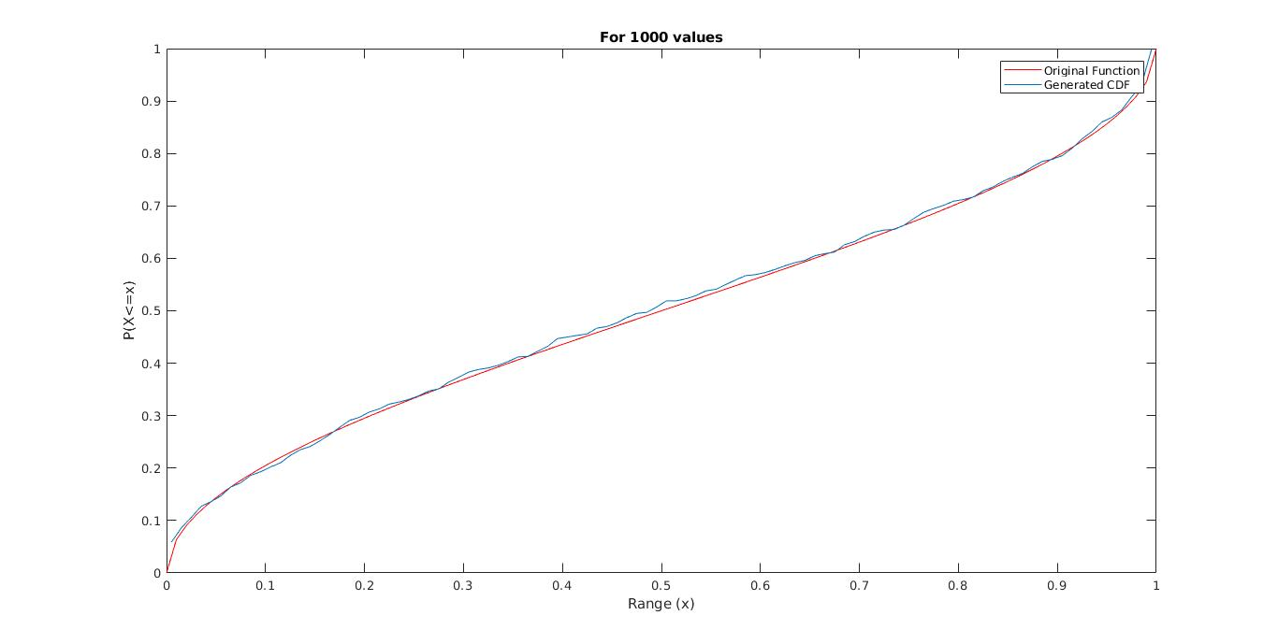

d) Observations:

i. From the plots, It is observed that cumulative distribution function for genrated random variable X is identical to the Arcsin Law CDF from which X was generated using the Inverse Transform Method. It reaffirms the fact that F⁻¹(U) where U ∼ U[0, 1] is a sample from F(x).

ii. Further it is observed that CDF generated approach the theoritical Arcsin Law plot as the number of values generated of X increaces from 1000 to 100000.

iii. The same phenomenan is observed in the values of mean and variance of generated random variable X. Mean and Variance for theoritical exponential distribution function is 0.5 and 0.125 respectively. The mean and variance of generated random variable X approach these values as the number of values generated of X increaces from 1000 to 100000.

