LAB 03

- Question 1

b) Following are the frequencies and probabilities of generated random variables in one of the program runs:

- For number of values generated = 10000000
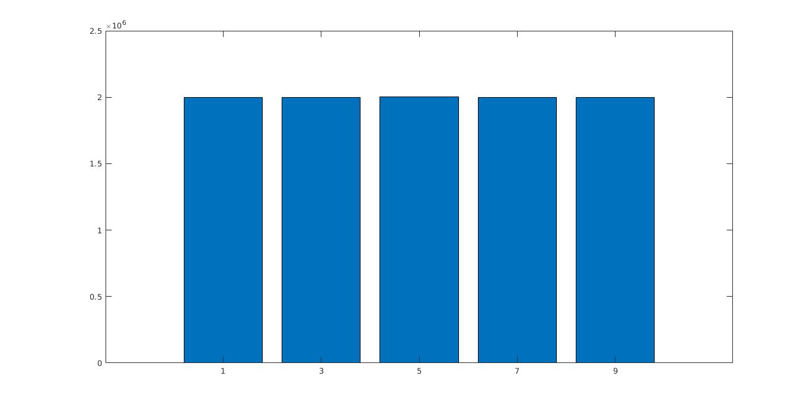

- For numer of values generated = 10000
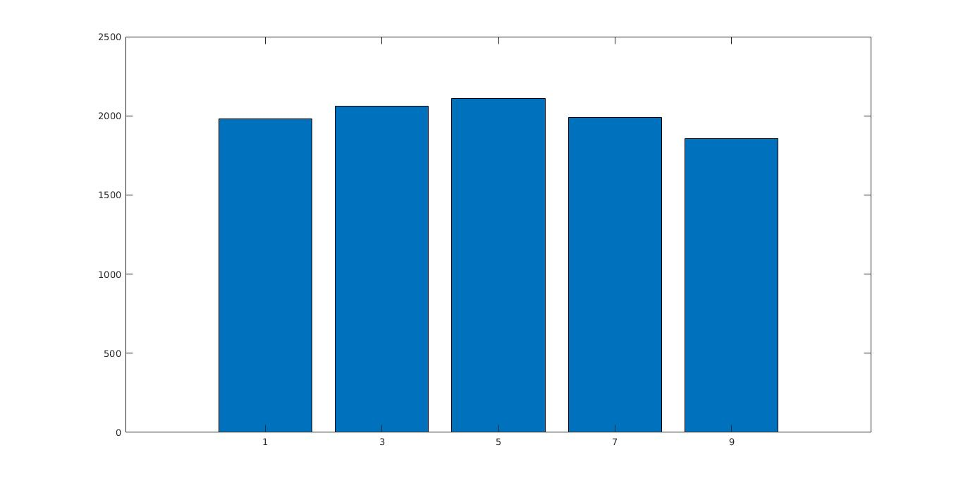
- For numer of values generated = 1000
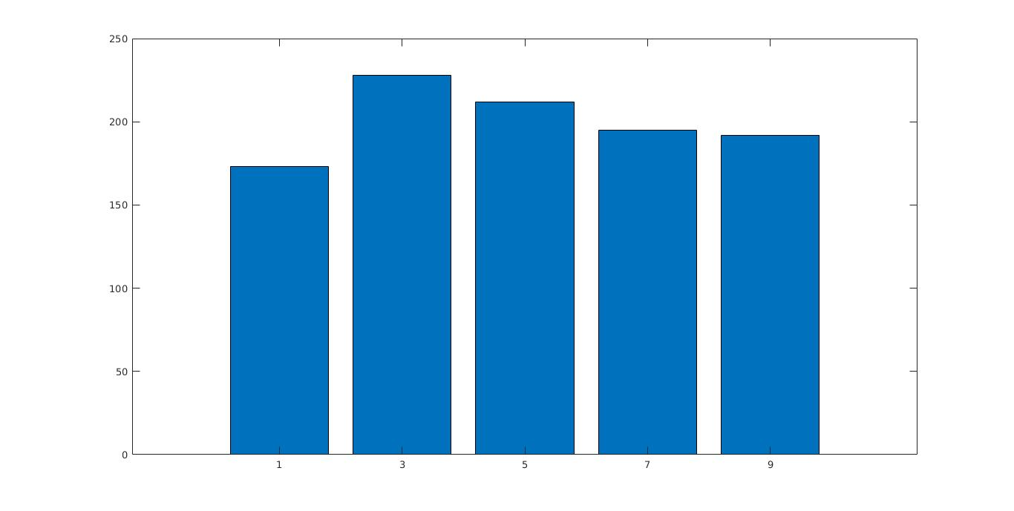

For numer of values generated = 10000000
Value of Random Variable (X) | Frequency | Probability of appearance
1 | 1999308 | 0.1999
3 | 2002418 | 0.2002
5 | 2001819 | 0.2002
7 | 1998465 | 0.1998
9 | 1997990 | 0.1998

For numer of values generated = 10000
Value of Random Variable (X) | Frequency | Probability of appearance
1 | 2021 | 0.2021
3 | 2041 | 0.2041
5 | 1998 | 0.1998
7 | 1996 | 0.1996
9 | 1944 | 0.1944

For numer of values generated = 1000
Value of Random Variable (X) | Frequency | Probability of appearance
1 | 173 | 0.1730
3 | 198 | 0.1980
5 | 203 | 0.2030
7 | 220 | 0.2200
9 | 206 | 0.2060

Clearly it is observed that as we increase the number of values generated from 1000 to 10000000, probability distribution of generated values converge to discrete uniform distribution on {1, 3, 5, 7, 9}. This is deduced by the bar graphs and frequency table of generated values in one of the program run.

- Question 2
We are given the following target distribution f(x) :
f(x) = 20x(1−x)³
We will use the acceptance-rejection method taking U[0,1] as the known density function g.
a) ∀ x ∈ [0,1], a smallest c such that f(x)≤cg(x) is 2.109375
which is the supremum of f(x)/g(x) in [0,1] since g being a U[0,1] has g(x) = 1 ∀ x ∈ [0,1].
So smallest constant c = 2.109375
b) Convergence Analysis of Generated Values:
From the graphs, it is clear that as we increase the value of c, cumulative distribution function of generated random variable X (of f(x)) diverge from the expected C.D.F. computed by integrating given density function f(x). Expected C.D.F –
F(x)=-4x⁵+15x⁴-20x³+10x² ∀ x ∈ [0,1]
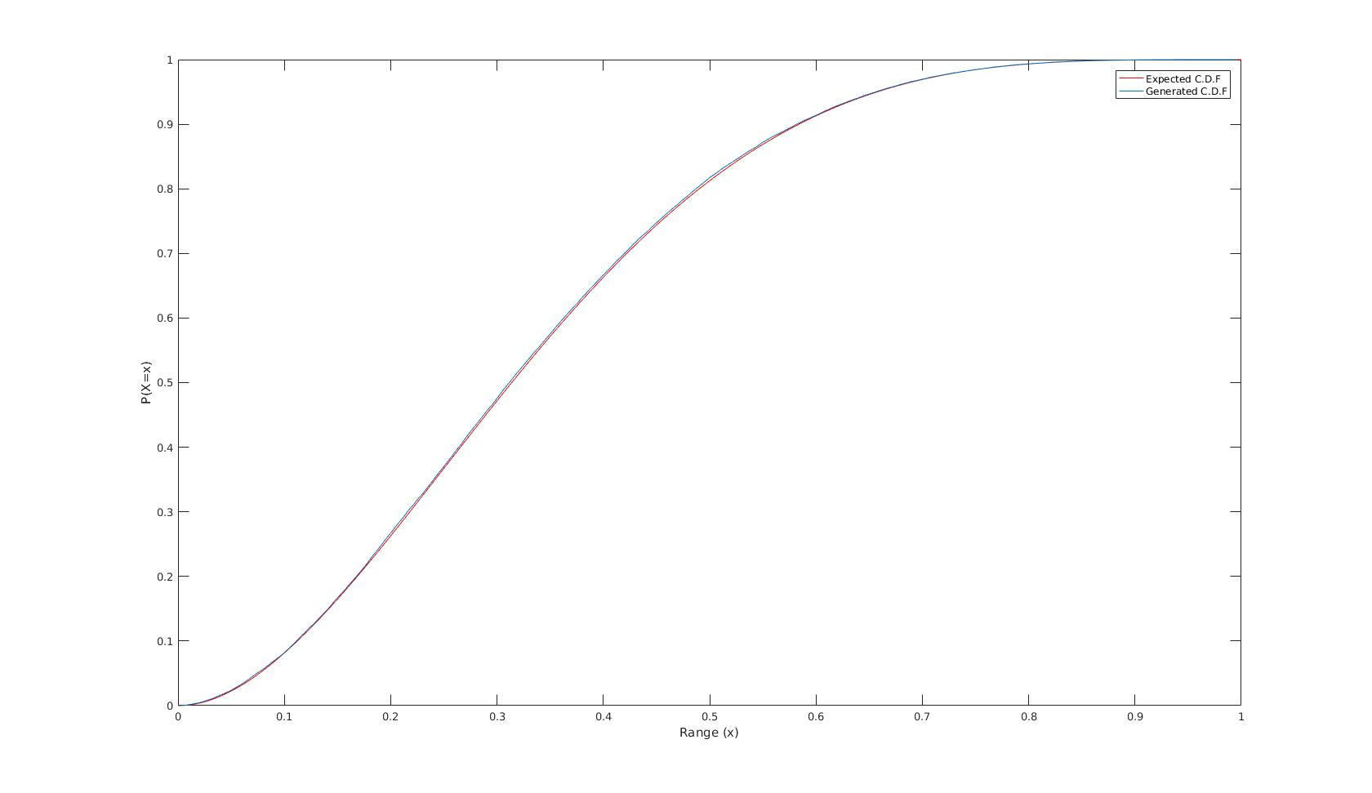
For c=2.109375 :
For c=2 :
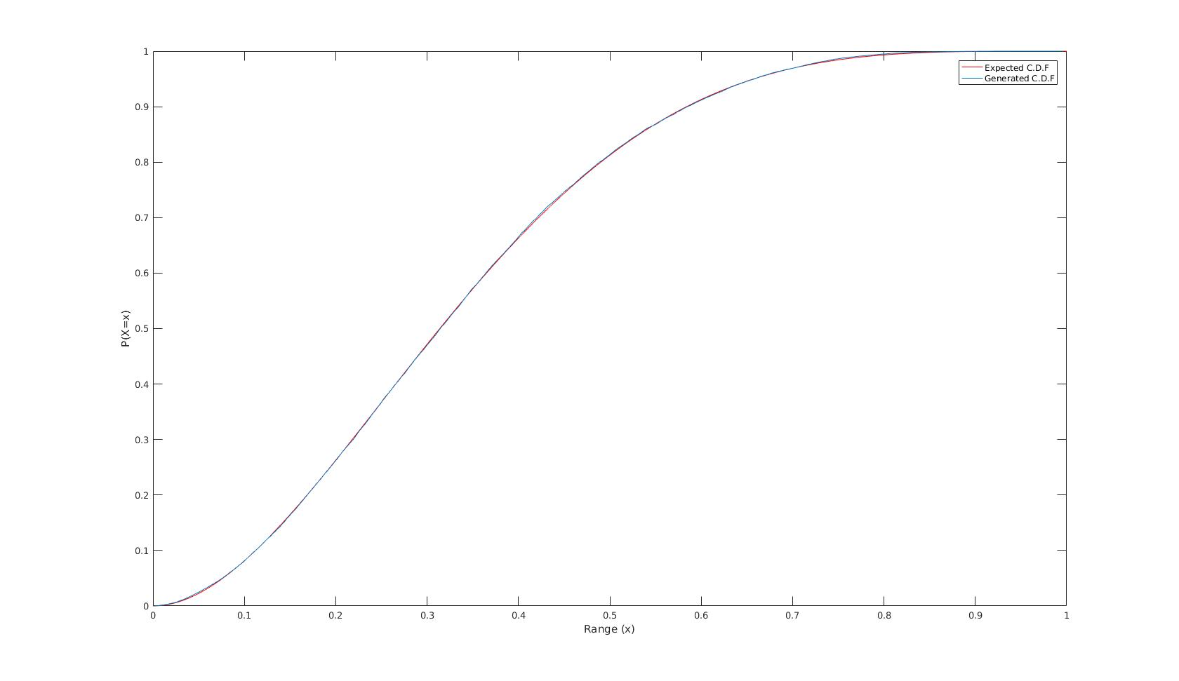
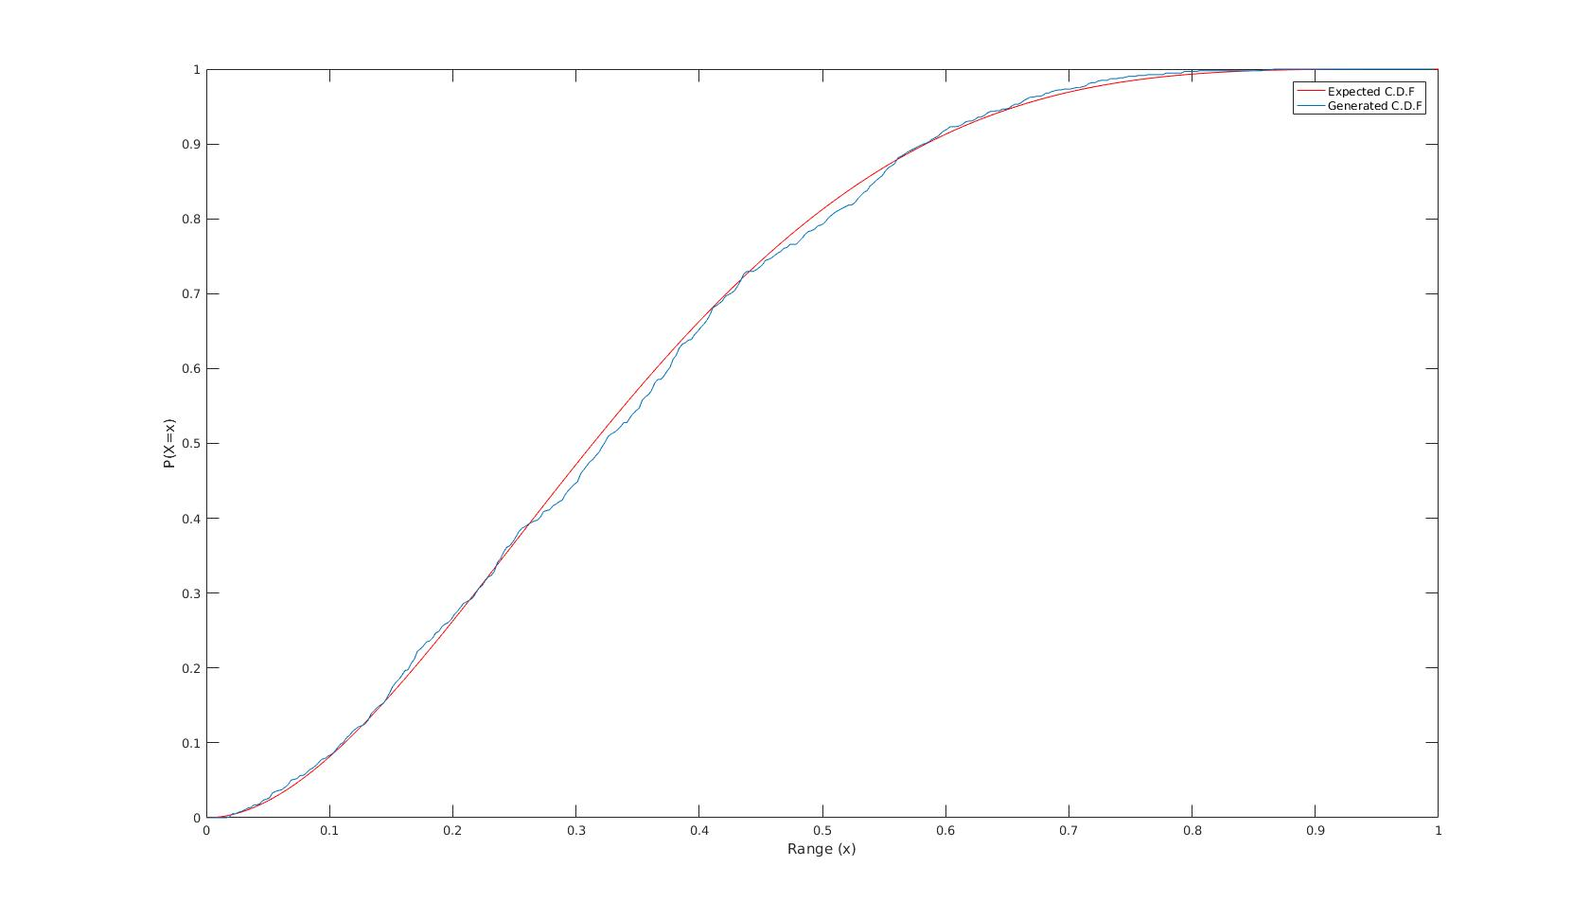
For c=10 :

Number of iterations to find one variate were random in nature. Also number of variates of f(x) accepted from variates of g(x) were also about (1/c)^{th} fraction of total number of generated variates of g(x). When number of values generated of g(x) variates was 1,00,000 following are the number of accepted variates of f(x) in various program runs :

- 47299
- 47716
- 47427
- 47669

These frequencies are in vicinity of (1/2.109375) X 100000
i.e. 47407.

c) For our chosen value of c i.e. 2.109375, average of number or iterations required to find one variate from density f(x) was calculated as 2.1118 in one of the program run. In all other program runs, value of average of number of iterations were found to be very close to value of c i.e. 2.109375. Some average values observed in different program runs :

- 2.1118
- 2.1195
- 2.1166
- 2.0978

d) In previous program runs, value of c was chosen as smallest possible. On choosing 2 higher values of c, following observations were made :

- Number of variates of f(x) accepted from variates of g(x) were observed to be about (1/c)^{th} fraction of total number of generated variates of g(x). But since we increased the value of c, values generated of f(x) variates were less which decreased the efficiency of the random variate (of f(x)) generator.

- value of average of number of iterations were observed to be deviating from the value of c as we increase the value of c. For eg. In one of the program run for c=100, average=108.24 but for c=5 average=5.0222.

- Question 3

We are given a pmf f(x) on random variable X that takes the values 1,2,...,10 with probabilities 0.11, 0.12, 0.09, 0.08, 0.12, 0.10, 0.09, 0.09, 0.10, 0.10. We will use the acceptance-rejection method taking integer DU[1,10] as the known density function g(x).

a) ∀ integer x ∈ [1,10], a smallest c such that f(x)≤cg(x) is 1.2 which is the supremum of f(x)/g(x) in [1,10] since g being a integer DU[0,1] has g(x) = 0.1 ∀ integer x ∈ [1,10].
So smallest constant c = 1.2.

b) Random sample from f(x) was generated using the acceptance-rejection method. The number of variates of f(x) accepted from variates of g(x) were about (1/c)^{th} fraction of total number of generated variates of g(x). When number of values generated of g(x) variates was 1,00,000 following are the number of accepted variates of f(x) in various program runs :

- 83325
- 83240
- 83399
- 83150

These frequencies are in vicinity of (1/1.2) X 100000
i.e. 83333.

c) Effeciency Analysis of Generator :
Probability of appearance of various values (1,2,3...,10) generated are expected to be around 0.11, 0.12, 0.09, 0.08, 0.12, 0.10, 0.09, 0.09, 0.10, 0.10 respectively for an efficient generation. Following observations are made for different values of c :

For c=1.2
Value of Random Variable (X) | Expected P(X=x) | Generated P(X=x)
1 | 0.11 | 0.1076
2 | 0.12 | 0.1211
3 | 0.09 | 0.0897
4 | 0.08 | 0.0792
5 | 0.12 | 0.1216
6 | 0.10 | 0.1002
7 | 0.09 | 0.0909
8 | 0.09 | 0.0907
9 | 0.10 | 0.0985
10 | 0.10 | 0.1003

For c=2
Value of Random Variable (X) | Expected P(X=x) | Generated P(X=x)
1 | 0.11 | 0.1094
2 | 0.12 | 0.1219
3 | 0.09 | 0.0893
4 | 0.08 | 0.0812
5 | 0.12 | 0.1209
6 | 0.10 | 0.0991
7 | 0.09 | 0.0893
8 | 0.09 | 0.0908
9 | 0.10 | 0.0979
10 | 0.10 | 0.1002

For c=10
Value of Random Variable (X) | Expected P(X=x) | Generated P(X=x)
1 | 0.11 | 0.1079
2 | 0.12 | 0.1171
3 | 0.09 | 0.0896
4 | 0.08 | 0.0805
5 | 0.12 | 0.1202
6 | 0.10 | 0.1001
7 | 0.09 | 0.0887
8 | 0.09 | 0.0927
9 | 0.10 | 0.1013
10 | 0.10 | 0.1019

Number of variates of f(x) accepted from variates of g(x) were observed to be about (1/c)^{th} fraction of total number of generated variates of g(x). But clearly since we increased the value of c, values generated of f(x) variates were less which decreased the efficiency of the random variate (of f(x)) generator. Hence as as we increase the value of c from the smallest possible 1.2, probabilities generated are observed to be more deviated as compared to expected values.

