LAB 04

- Question 1

a) We will be generating random variable from the beta distribution using acceptance-rejection method for various values of α₁ and α₂.

Number of values of testing uniform random variable is taken to be 100000.

I. For α₁ = 3 and α₂ = 5
Point of Maxima (X*) = (α₁−1)/(α₁+α₂−2) = 0.3333
c = f(X*) = 11.5226

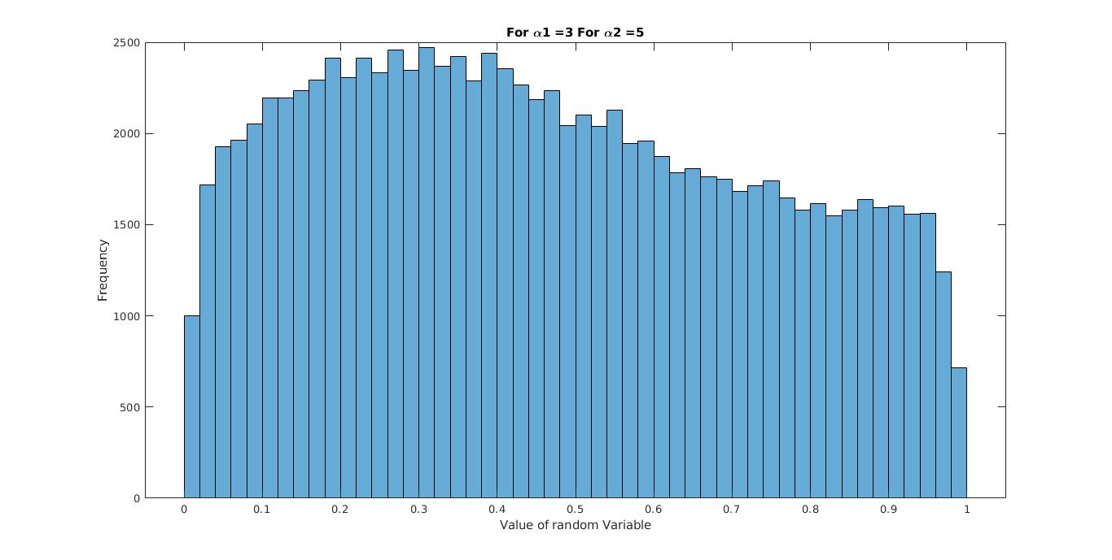
II. For α₁ = 1 and α₂ = 10
Point of Maxima (X*) = (α₁−1)/(α₁+α₂−2) = 0
c = f(X*) = 10.0
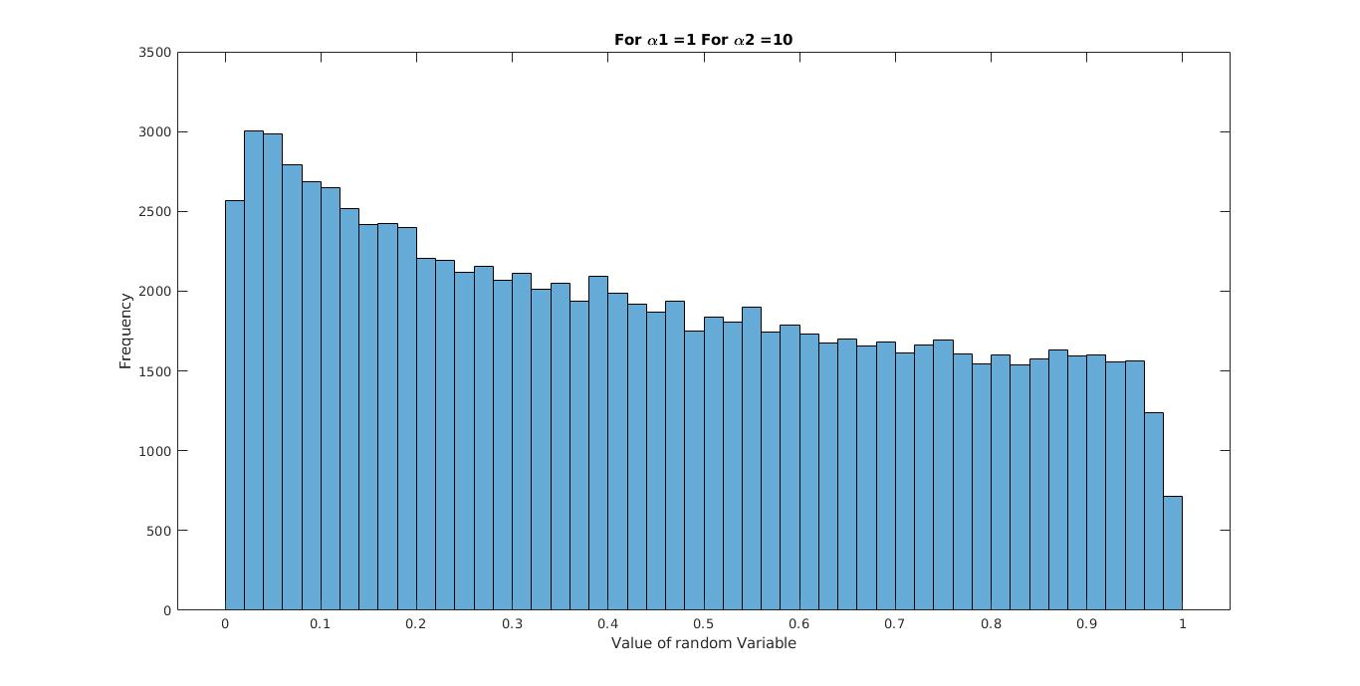
III. For α₁ = 2 and α₂ = 4
Point of Maxima (X*) = (α₁−1)/(α₁+α₂−2) = 0.2500
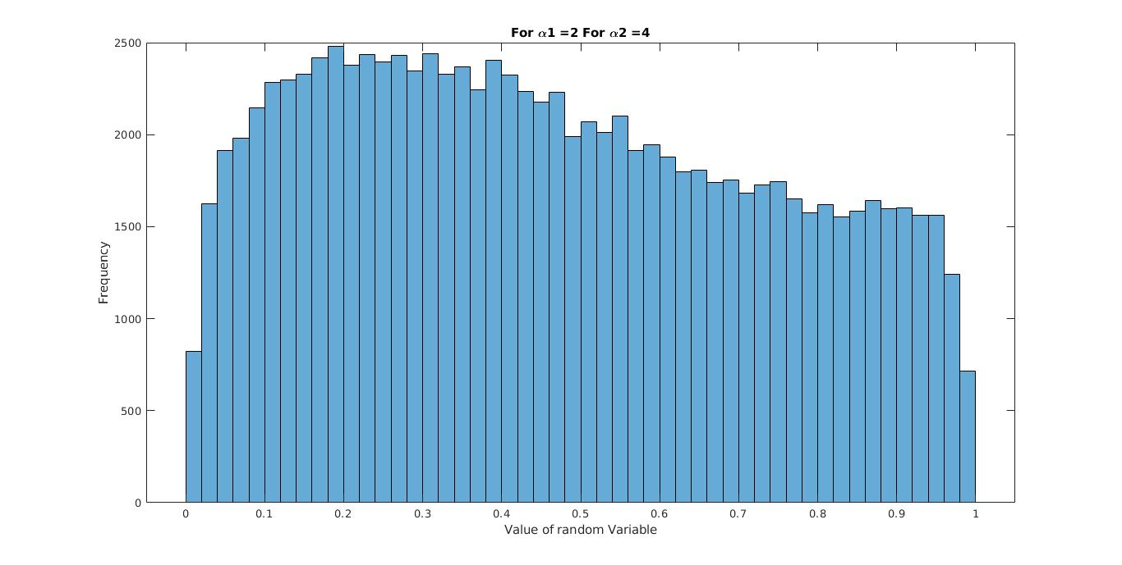
c = f(X*) = 4.9219
IV. For α₁ = 1.5 and α₂ = 1.5
Point of Maxima (X*) = (α₁−1)/(α₁+α₂−2) = 0.5000
c = f(X*) = 0.5274
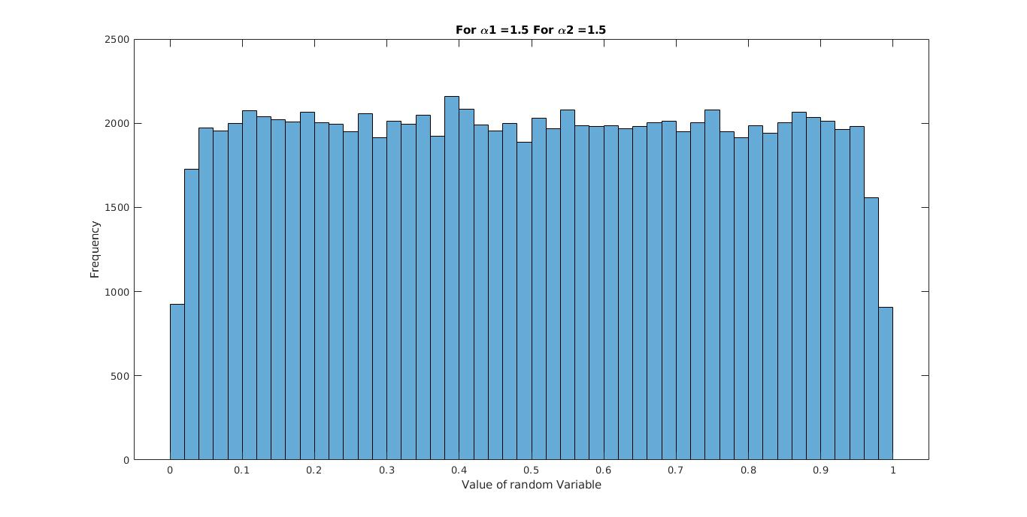
V. For α₁ = 2.0 and α₂ = 2.3
Point of Maxima (X*) = (α₁−1)/(α₁+α₂−2) = 0.4348
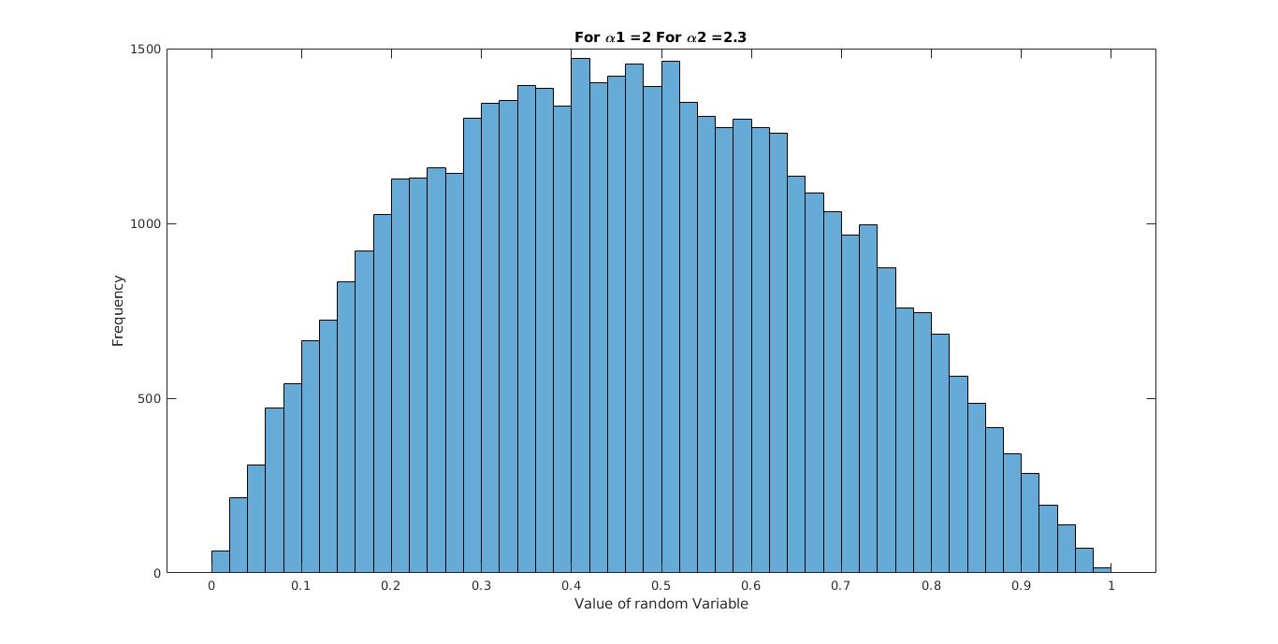
c = f(X*) = 2.1824

b) OBSERVATIONS AND ANALYSIS:

- We observe that frequencies of the values generated varied with the values of α₁ and α₂ in the following manner :

a) The historgram was observed to be skewed towards left if the value of α₁ taken is less that α_{2.}

b) The histogram was observed to be skewed towards right if the value of α1 taken is less that α1.

- Further following observations were made for cases where α₁ = α₂ :

a) The frequencies of values generated were observed to be almost equally distributed and skewness of historgram was negligible.

b) Further spread of frequencies for different values of equal α₁ and α₂ were also observed to be similar.

