LAB 05

- Question 1

a) The observed mean and variance of generated normal random variables from N(0,1) are as following:

Using Box-Mueller Method
No of values generated | Mean | Variance
100 | 0.0293 | 0.8329
10000 | 0.0134 | 0.9990

Theoretical mean = 0
Theoretical variance = 1

Observed mean for 100 values = 0.0293
Observed variance for 100 values = 0.8392
Absolute Error in Mean = 2.93%
Absolute Error in Variance = 16.71%

Observed mean for 10000 values = 0.0134
Observed variance for 10000 values = 0.9990
Absolute Error in Mean = 1.34%
Absolute Error in Variance = 0.1%

Clearly, it is observed that as the number of values generated increaces from 100 to 10000, observed values of mean and variance approach corresponding theoritical values. This is justified due to decrease in absolute error in the two cases.

Using Marsaglia and Bray Method
No of values generated | Mean | Variance
100 | 0.0609 | 0.8858
10000 | -0.0024 | 1.0212

Theoretical mean = 0
Theoretical variance = 1

Observed mean for 100 values = 0.0609
Observed variance for 100 values = 0.8858
Error in Mean = 6.09%
Error in Variance = 11.42%

Observed mean for 10000 values = -0.0024
Observed variance for 10000 values = 1.0212
Error in Mean = 0.24%
Error in Variance = 2.12%

Clearly, it is observed that as the number of values generated increaces from 100 to 10000, observed values of mean and variance approach corresponding theoritical values. This is justified due to decrease in absolute error in the two cases.

b) Following two-dimensional graphs were obtained on plotting sampled values w.r.t their frequency:
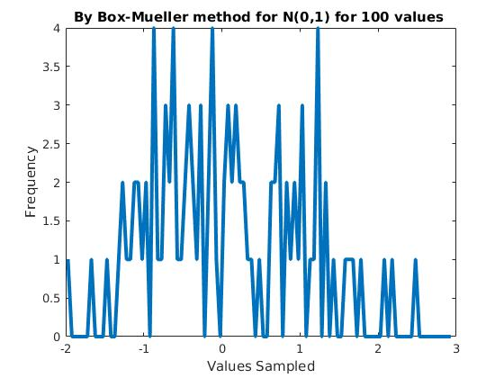
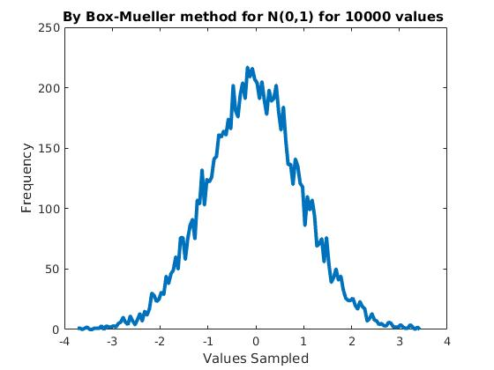
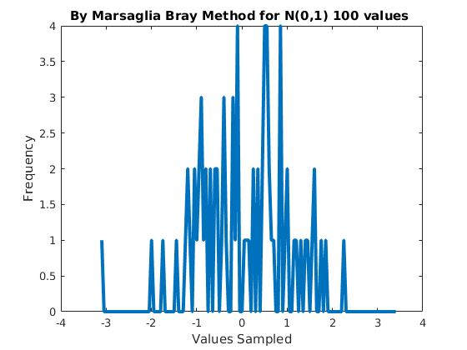
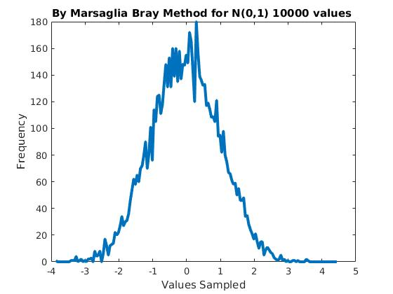

c) Following density functions were observed for values generated from N(0,5) and N(5,5). They have been plotted on the same graph along with the theorititcal Normal density function given by:

f(x) = (1/(√(2*п)*σ²))*e^{-((x-μ)*(x-μ)/(2* σ*σ ))}
For a normal distribution N(μ,σ²)

If we know N(0,1), then N(μ,σ²) = σ N(0,1) + μ
Using the above results samples were generated from N(0,5) and N(5,5).

In all Graphs -
Red Curve : Theoritical Density Function
Blue Curve : Density Function for generated values

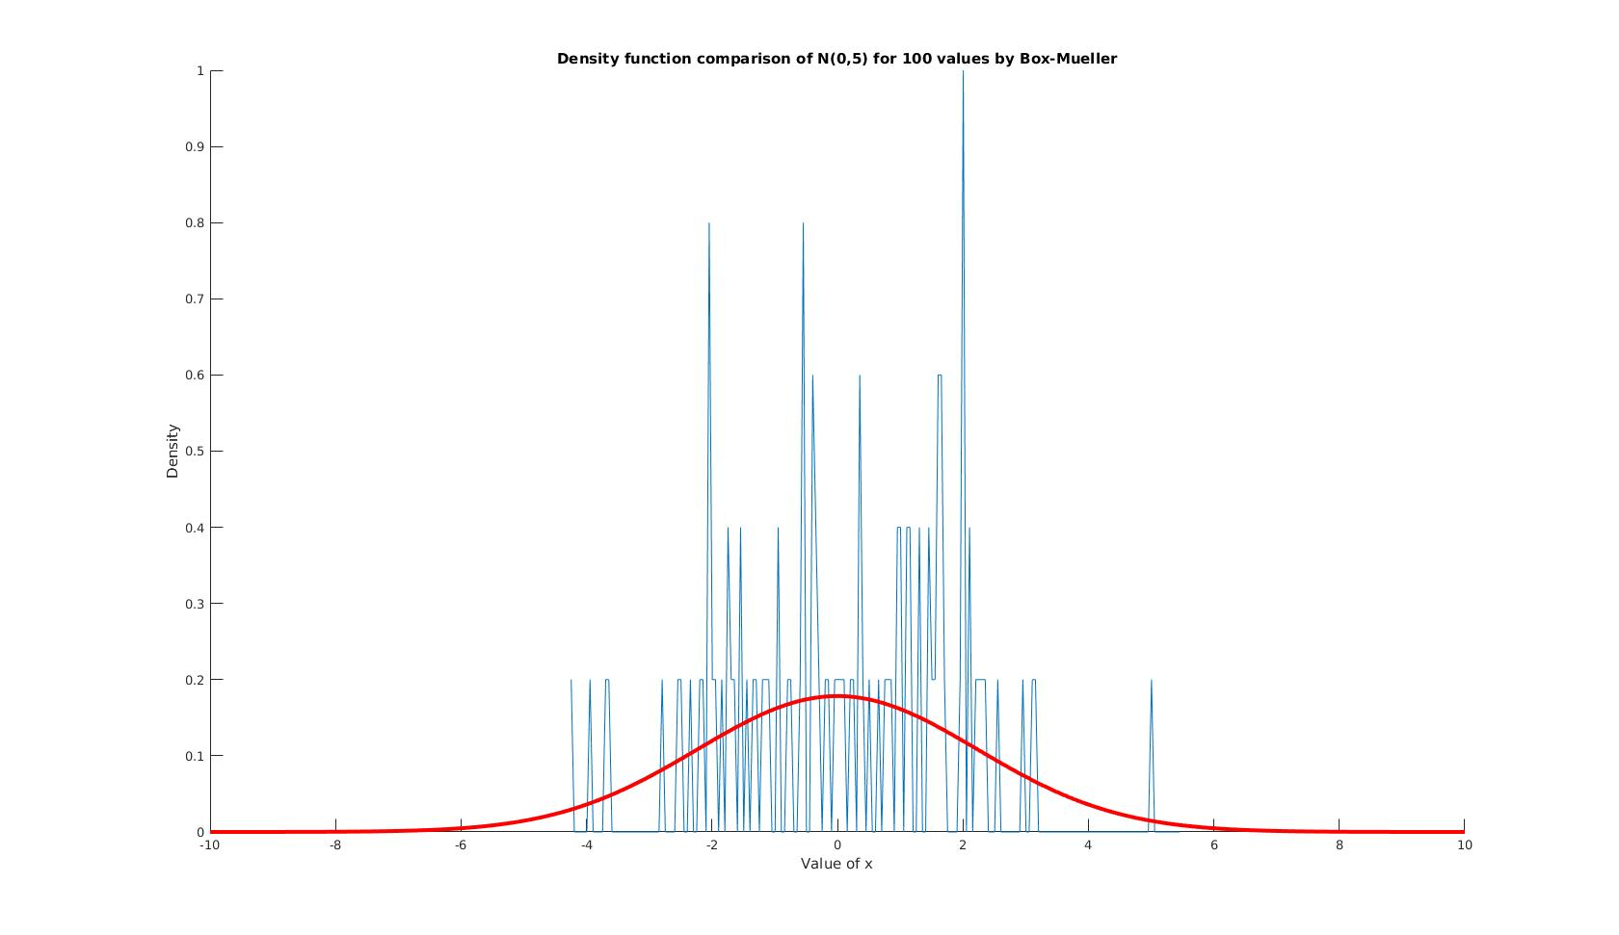

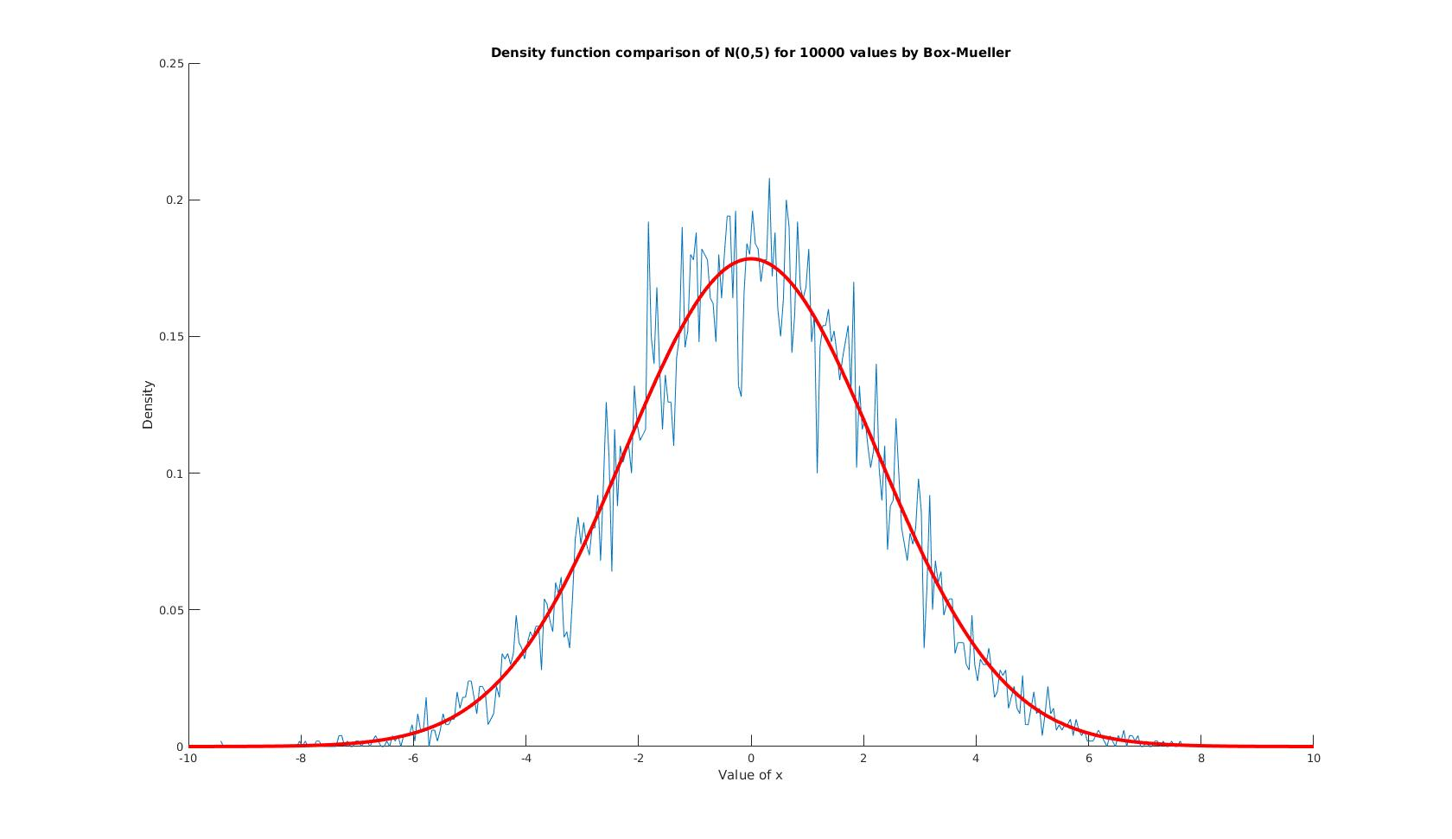
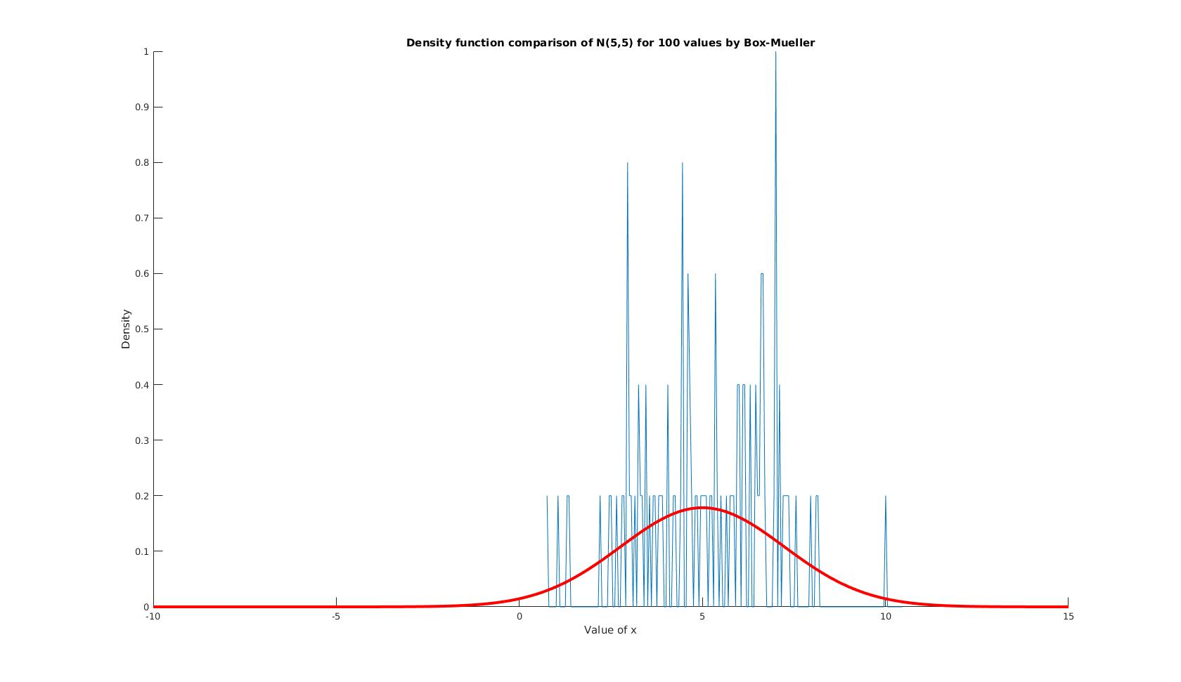
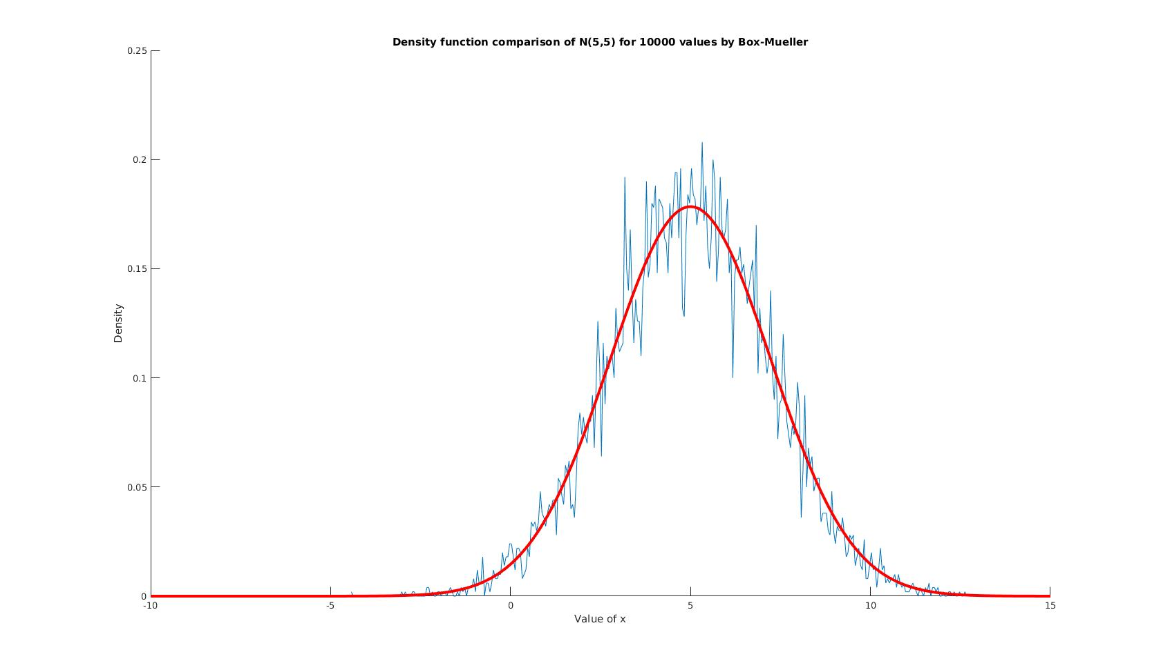
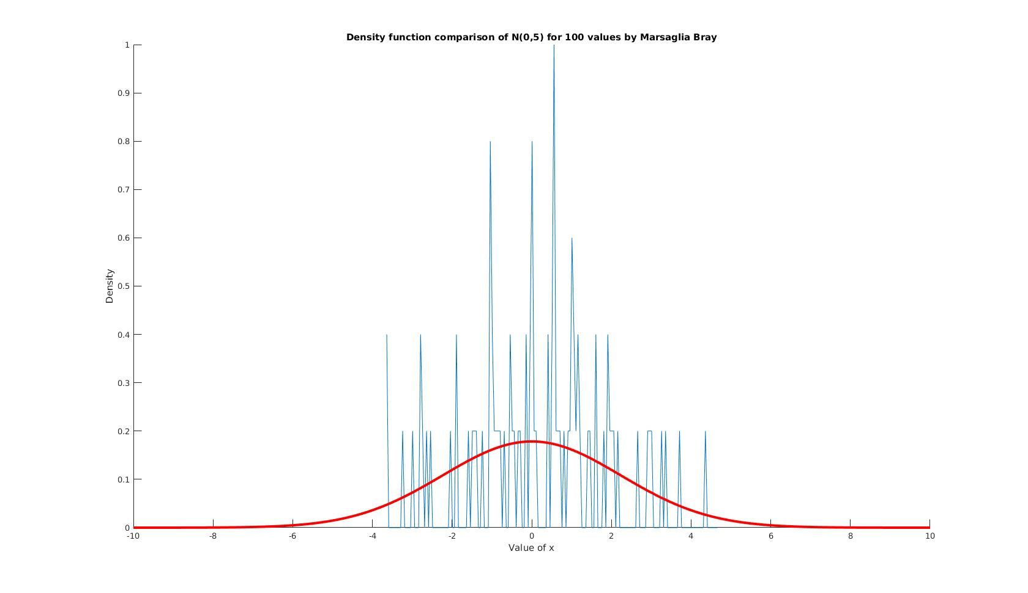
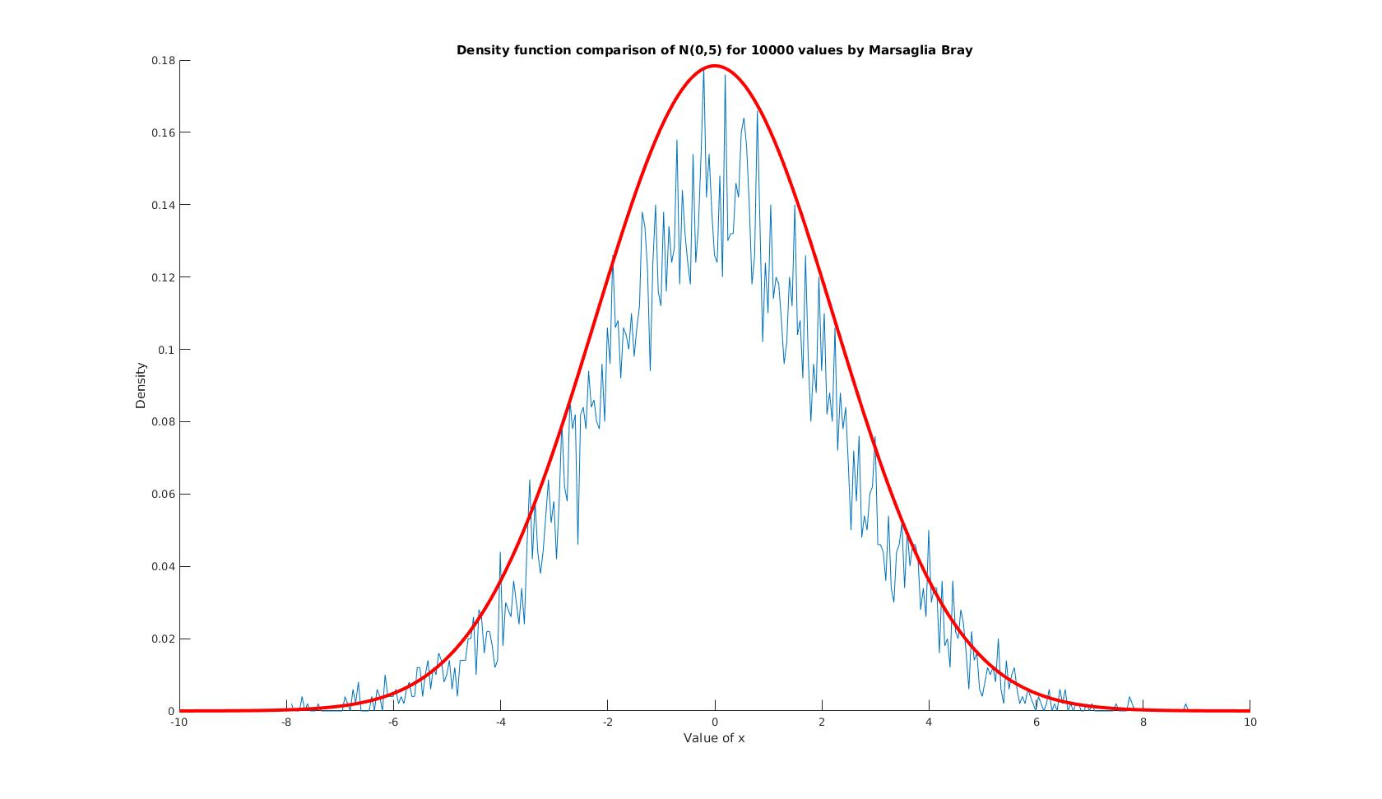
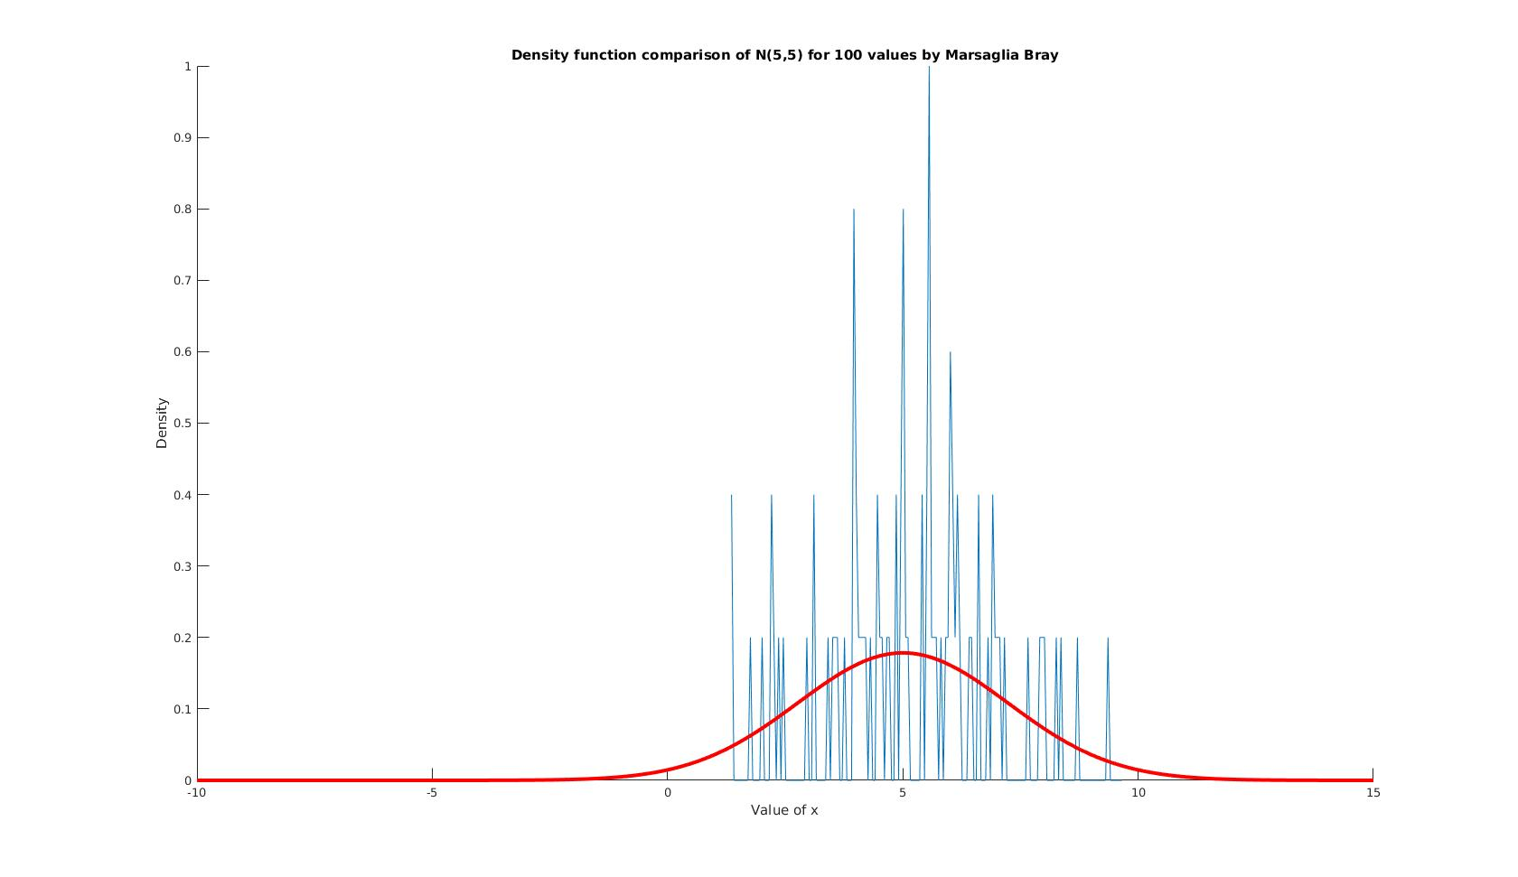

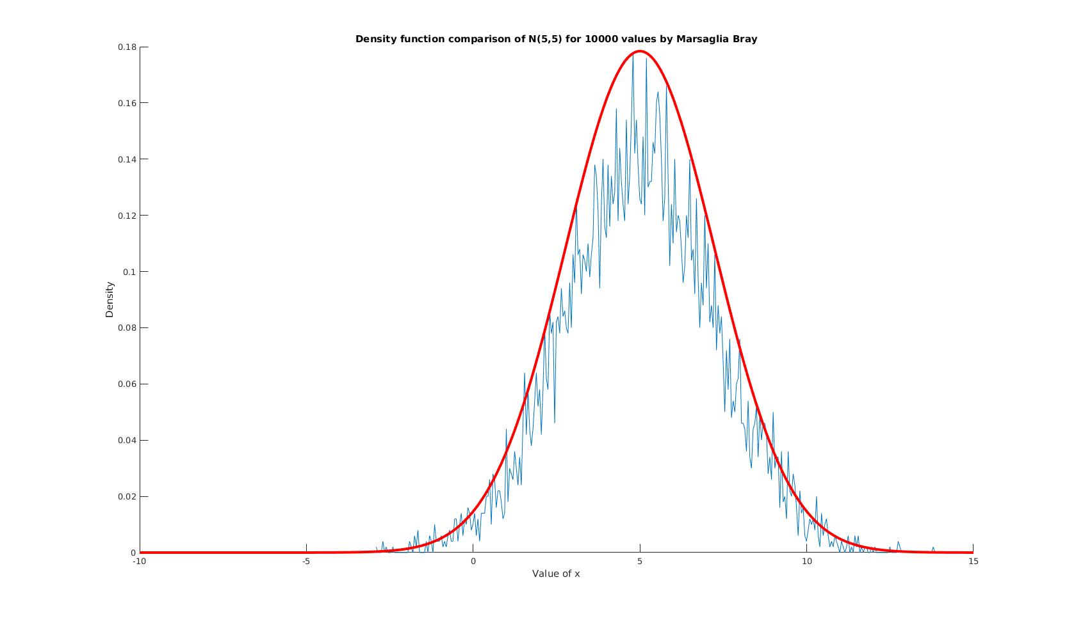

Observations:

i) There is high deviation observed in density function for 100 values generated w.r.t their corresponding theoritical density function.

ii) The density function for 10000 values generated approach the theoritical density function as seen in above graphs by both Box-Mueller and Marsaglia Bray method.

iii) We observe that as the number of values generated from N(0,5) and N(5,5) increase from 100 to 10000, density function of generated values approach theoritical normal density function.

d) Computation Time Analysis:

Following are the computation time for some sample runs of the program:

For 100 Values Generated
Box-Mueller Method | Marsaglia and Bray method
0.002045 seconds | 0.000843 seconds
0.000177 seconds | 0.000198 seconds
0.000283 seconds | 0.000189 seconds

For 10000 Values Generated
Box-Mueller Method | Marsaglia and Bray method
0.001330 seconds | 0.001792 seconds
0.001323 seconds | 0.001734 seconds
0.001351 seconds | 0.001788 seconds

Theoritically it is expected that Marsaglia and Bray method should have lesser computation time than Box-mueller method becauses it bypasses the calculation of sin and cos functions. Although in the practical run of the program, it is observed that in most sample runs, computation time of Marsaglia and Bray method exceeds that of Box- Mueller method. A possible explanation of this observation is that in Marsaglia and Bray method, a loop is used which reject values in some iterations thus giving no contribution to the generated values. Thereby increasing the computation time.

e) The observed proportion of values rejected are as following:
1-π/4 ≈ 0.2142
No of values generated | Proportion of values rejected | % Deviation from 0.2142
100 | 0.2200 | 2.70%
10000 | 0.2101 | 1.91%

Thus it is observed that as the number of values generated increaces from 100 to 10000, the proportion of values rejected approaches (1-π/4) ≈ 0.2142 .

