LAB 06

- Following histograms were obtained for various values of a and 1000 generated values of X :

a) a = -0.5
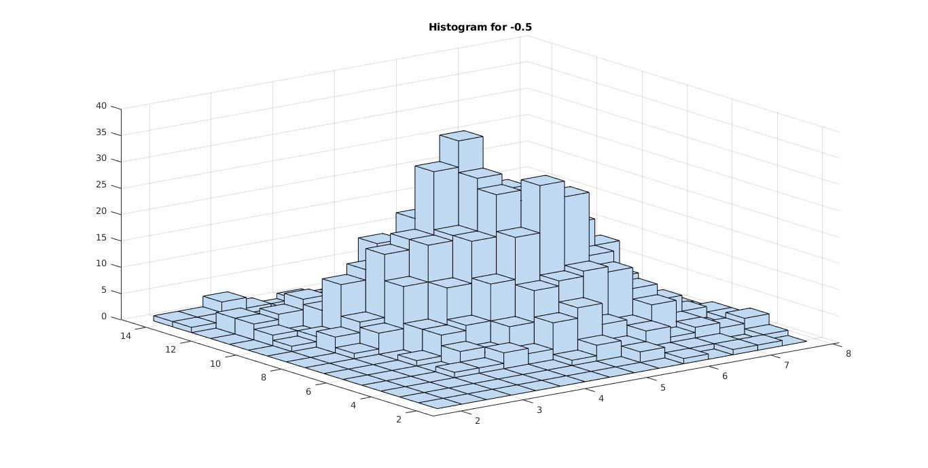

b) a = 0
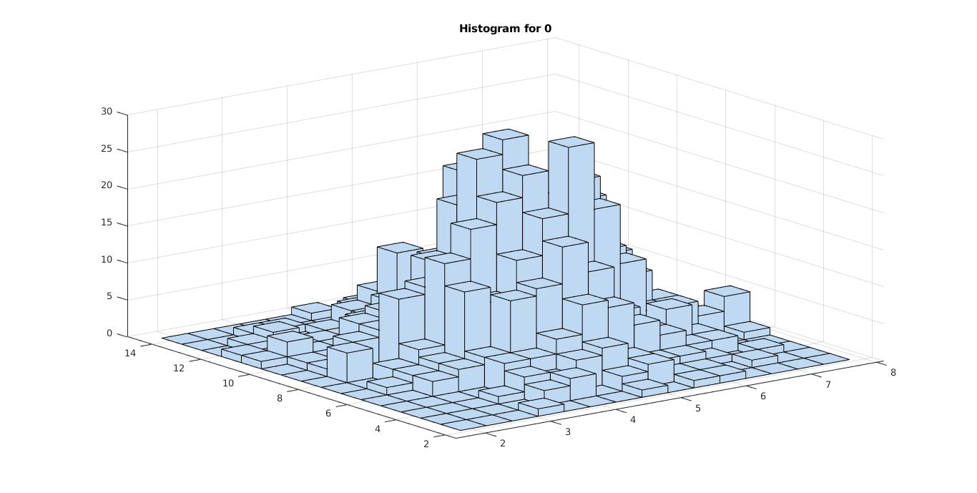
c) a = 0.5
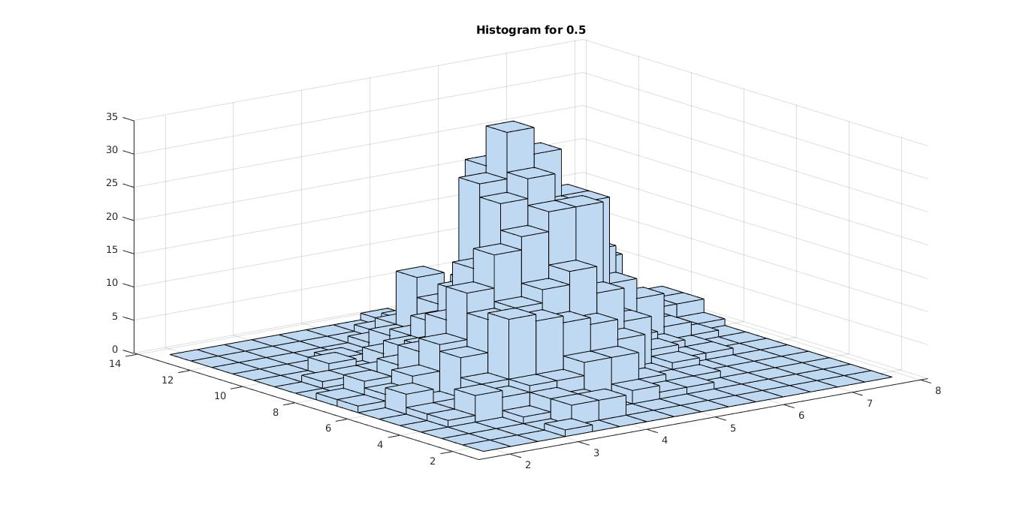

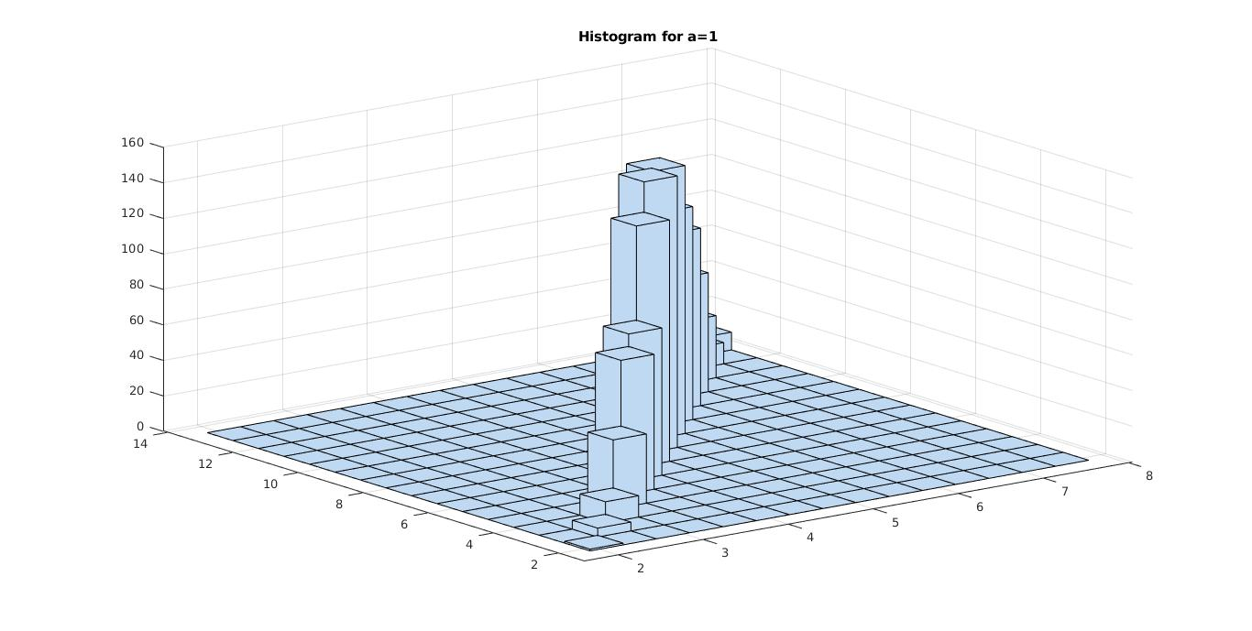
d) a = 1

Since for a=1,Sigma matrix is singular, it’s determinant is zero and it does not qualify as a covariance matrix.

- Actual Densities and Simulated densities surface plots are as following :
a) a = -0.5
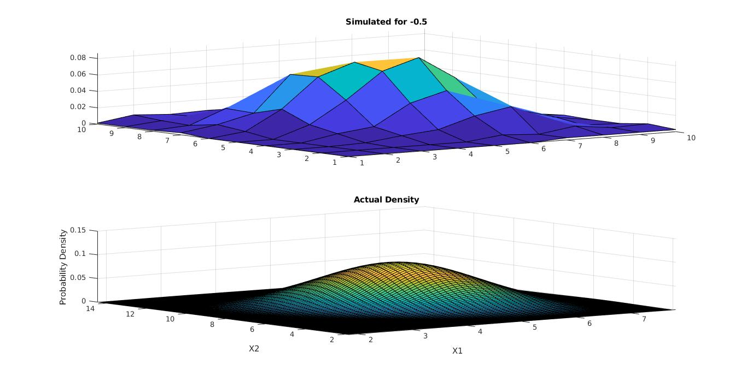
b) a = 0
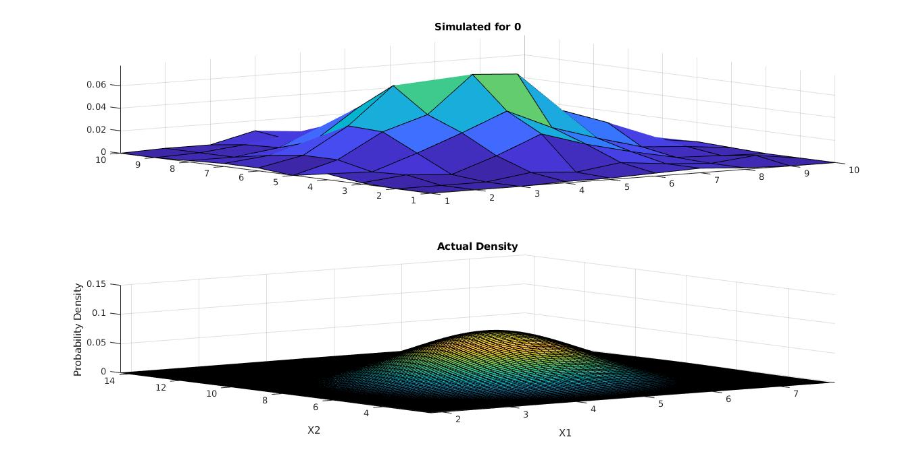

c) a = 0.5
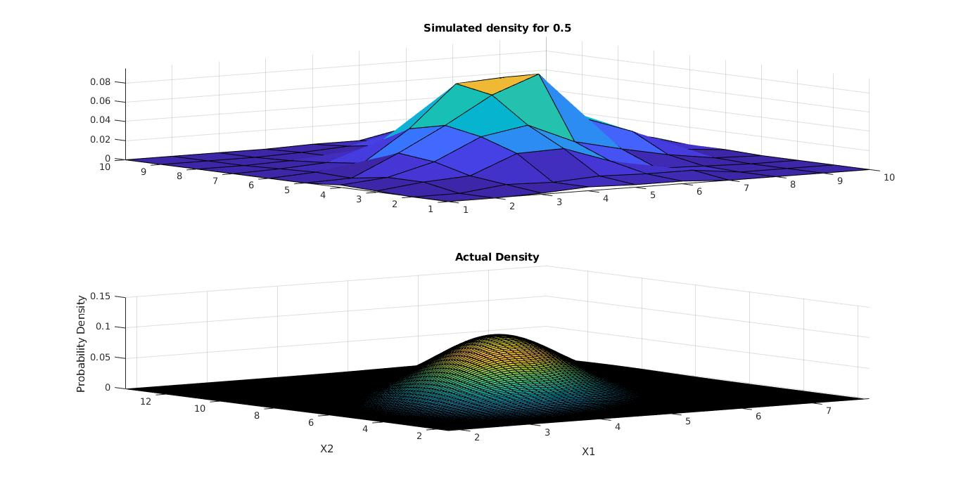
d) a = 1

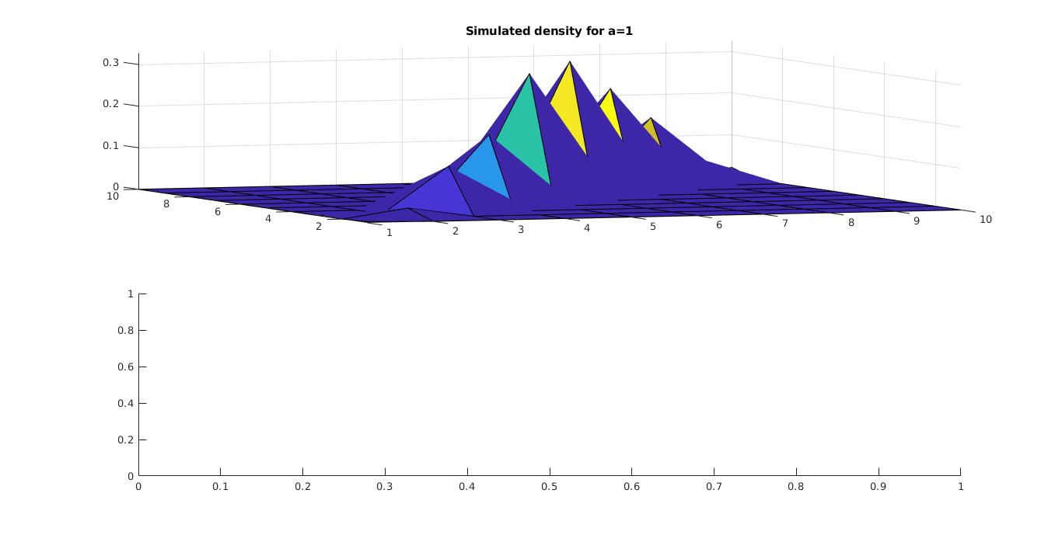
Since for a=1,Sigma matrix is singular, it’s determinant is zero and it does not qualify as a covariance matrix.

- Actual Marginal Densities and Simulated Marginal densities are plotted are as following :

a) a = -0.5
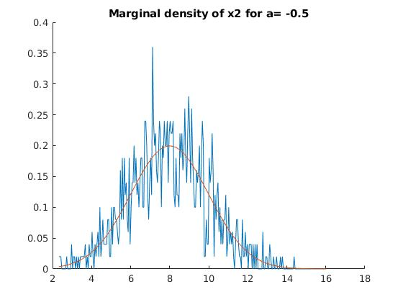
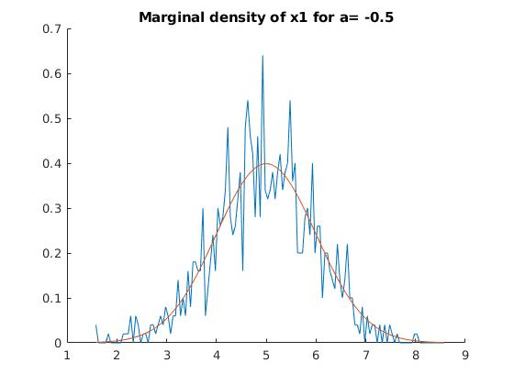
a) a = 0
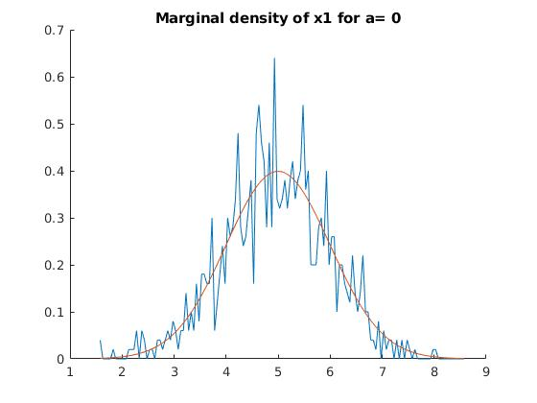
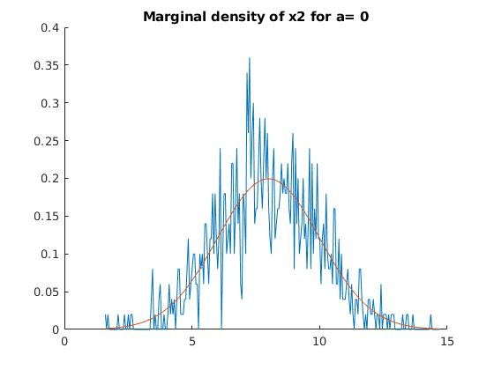
a) a = 0.5
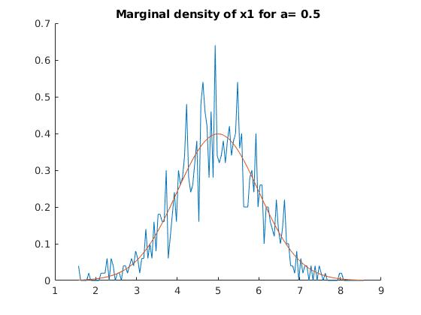
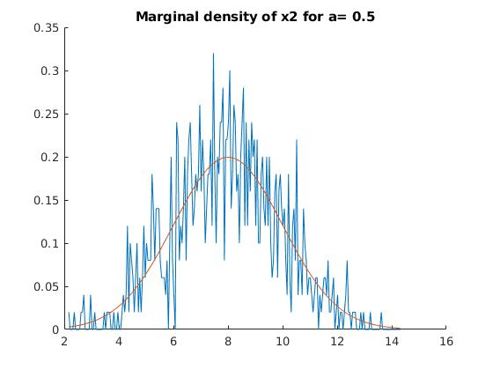
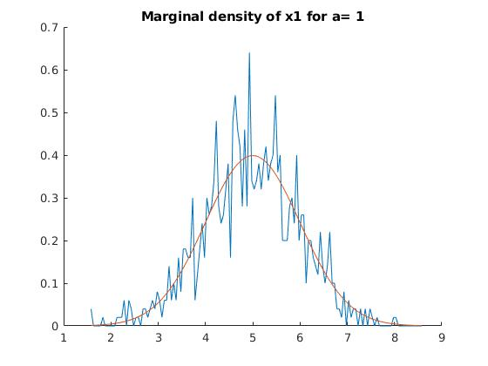
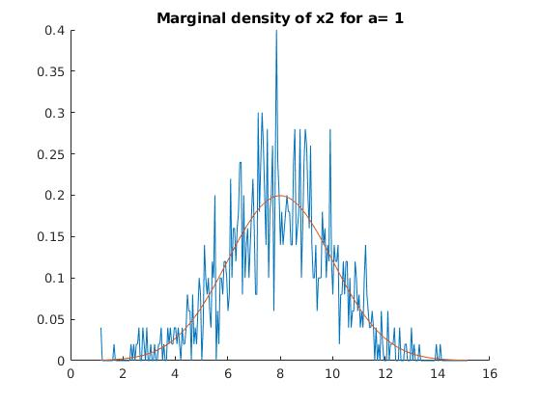
a) a = 1

