LAB 07

- Question 1

a) 50 random numbers from geometric distribution were generated using p=0.10 (i.e. q=0.90). Following numbers were generated -

[1] 3 18 2 6 9 3 6 3 5 3 35 4 7 5 14 6 49 16 2
[20] 1 11 5 3 8 40 6 23 12 12 4 6 17 3 7 25 14 13 4
[39] 5 19 6 1 4 11 5 6 11 49 2 2

b) Following Probabliity mass function plots were obtained:

i) Actual PMF (using formula f(x;p) = pq^{i−1} i = 1, 2,.. :
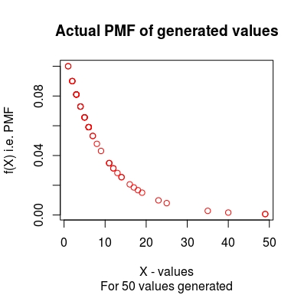

ii) Observed PMF of generated values :
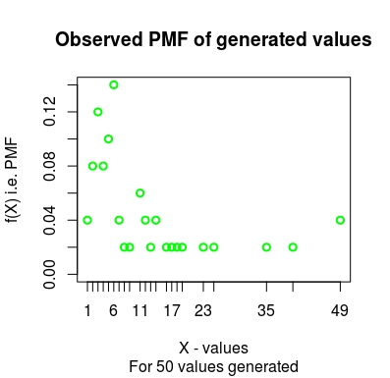

iii) Comparision of actual and observed PMF of generated values :
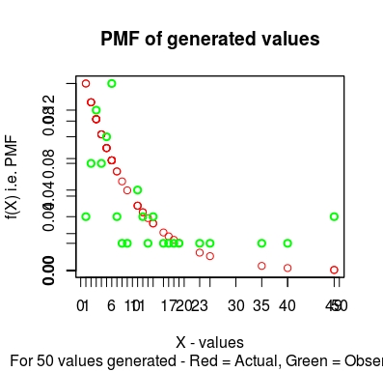

c) Clearly the generator is not a very effective generator. This is because we are generating very small number of values (50). Following PMF plots were obtained on generating 5000 values. Clearly the effectiveness of this generator has improved a lot as compared to the previous generation of only 50 values.

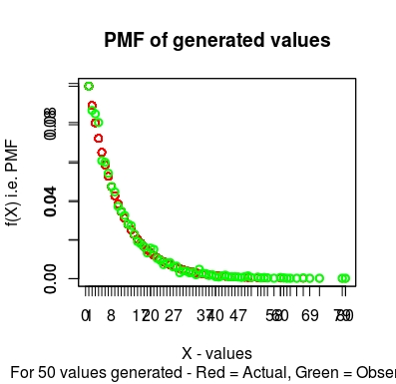

- Question 2

a) 50 random numbers from poisson distribution were generated using lambda = 2. Following numbers were generated -

[1] 1 1 3 1 1 4 2 2 3 5 0 2 2 2 3 5 2 1 4 3 1 2 2 0 3 5 2 2
[29] 1 1 1 2 0 1 1 1 1 0 1 1 1 0 2 0 2 0 4 1 1 1

b) Following Probabliity mass function plots were obtained:

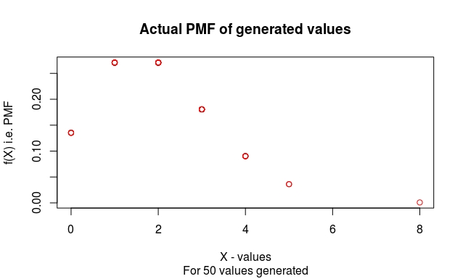
i) Actual PMF
(using formula p(x;λ)=(e^{−λ} . λ^{x})/ x! For x=0,1,2,⋯ :

ii) Observed PMF of generated values :
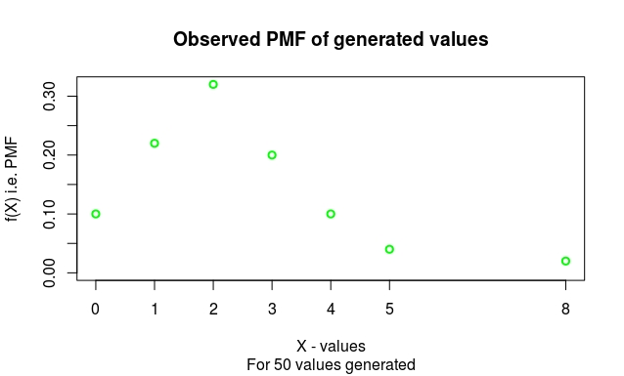
iii) Comparision of actual and observed PMF of generated values :
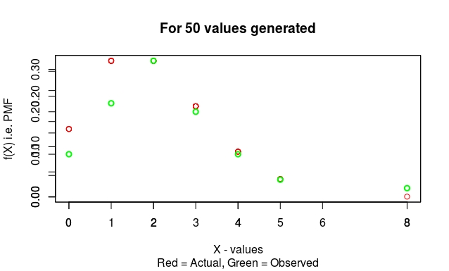

c) The Cumulative distribution function (C.D.F) is obtained as following :

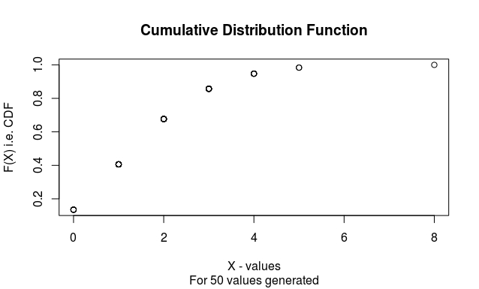

- Question 3

a) Histogram of values generated from given combined Weibull distributions is obtained as following:

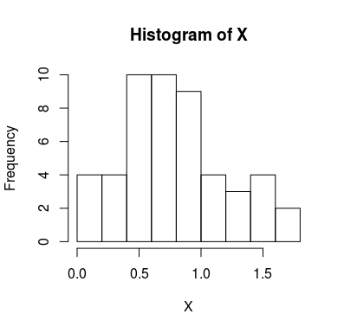

b) Following values of random numbers were obtained :

[1] 0.83925726 0.41079610 1.00268672 0.74750769 1.05002166 0.85075608 0.34496807 0.51778569 0.80269776 0.09518866 1.38311380
[12] 1.08399700 1.52843972 0.53623370 1.29632881 1.06444148 0.49107025 0.84908362 0.70643110 0.58465278 0.89313997 1.72461580
[23] 0.89952058 0.39444415 0.74217452 0.68599033 0.99960771 0.43828689 0.09415538 0.90062901 0.78257078 0.42791910 0.14865832
[34] 1.41123901 1.25974793 0.66744460 0.29787157 0.85816720 0.23680531 0.57443983 1.49988446 0.65417661 1.62516470 0.18045894
[45] 0.60636043 0.54061122 0.71401921 0.55928042 0.68276807 1.49334371

