LAB 09

- Question 1

10 sample paths for the standard Brownian Motion in the time interval [0,5] were generated and following values were obtained in one of the sample run of the program:
Exp[W(2)] = 0.1632837
Exp[W(5)] = -0.3610785
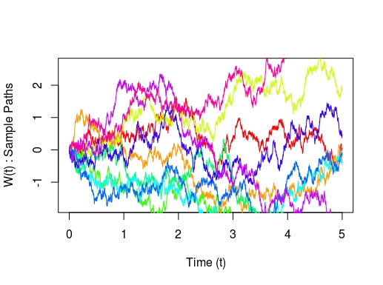
Generated Sample paths of standard Brownian Motion

- Question 2

10 sample paths for the Brownian motion X~(BM(µ,σ²)) in the time interval [0,5] were generated using X(0)=5, µ=0.06 and σ=0.3 and following values were obtained in one of the sample run of the program:

Exp[X(2)] = 5.064602
Exp[X(5)] = 4.94676
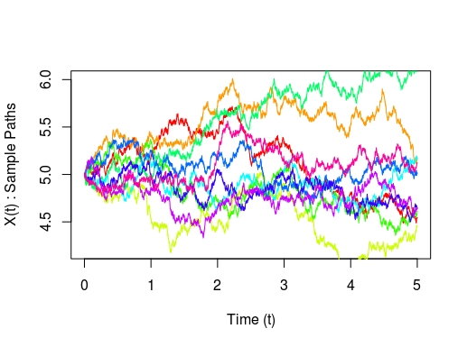

Generated Sample paths of Brownian motion (BM(µ,σ²))

- Question 3

10 sample paths for the Brownian motion Y~(BM(µ,σ²)) in the time interval [0,5] were generated using Y(0)=5,
µ(t) = 0.0325 − 0.05t, σ(t) = 0.012 + 0.0138t + 0.00125t² and Euler’s approximations and following values were obtained in one of the sample run of the program :

Exp[Y(2)] = 4.957307
Exp[Y(5)] = 4.581593
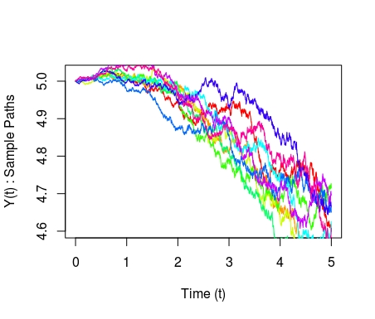

Generated Sample paths of Brownian motion (BM(µ,σ²))

