LAB 12

- Question 1

a) Following are the first 25 values of Van der Corput Sequence:

0.50000 0.25000 0.75000 0.12500 0.62500 0.37500 0.87500 0.06250 0.56250 0.31250 0.81250 0.18750 0.68750 0.43750 0.93750 0.03125 0.53125 0.28125 0.78125 0.15625 0.65625 0.40625 0.90625 0.09375 0.59375

b) The plot of overlapping pairs (X_{i} , X_{i+1}) for first 1000 values of Van der Corput Sequence are as following:
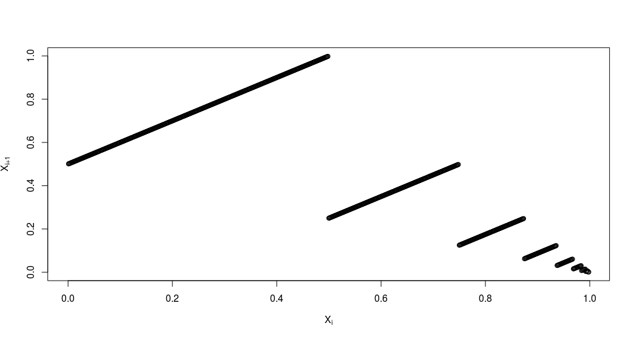
Observations :
The generator is not very efficient as the values are predictable because (X_{i},X_{i+1}) plot is not uniformly
distributed in the 2-D plane.

c) Sampled Distribution for first 100 values of Van der Corput sequence is as following:
Histogram
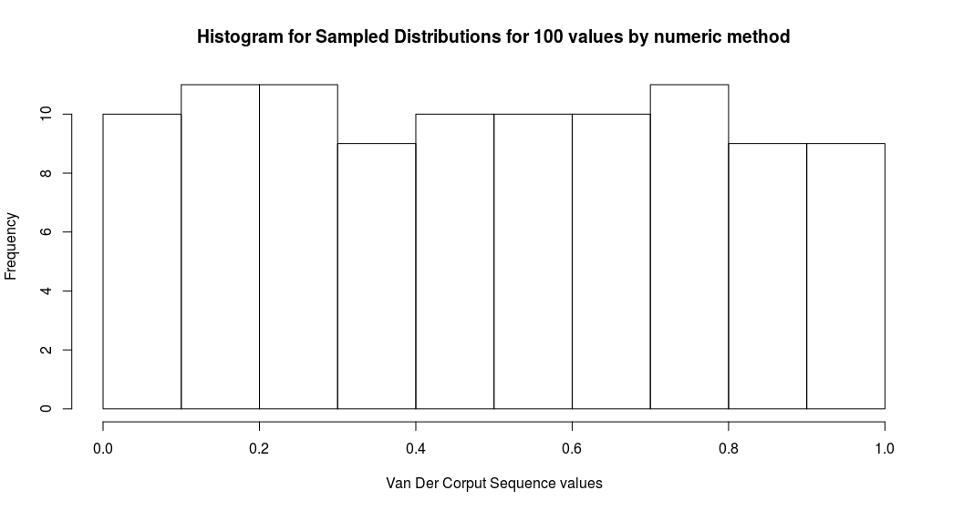
Cumulative Distribution
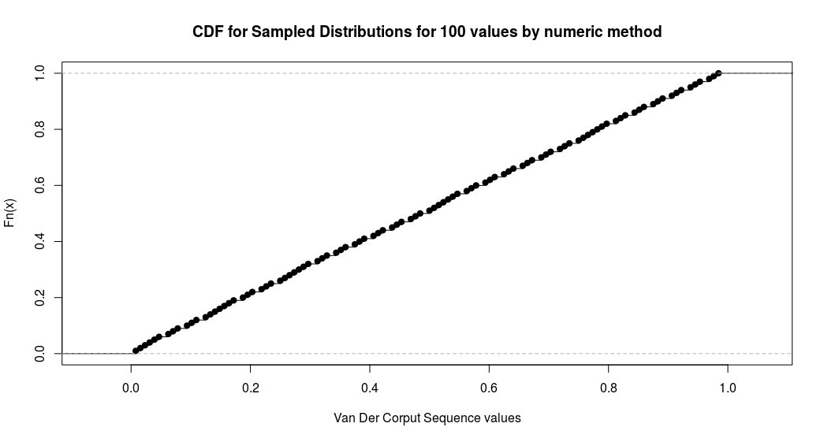
d) Sampled Distribution for first 100000 values of Van der Corput sequence is as following:
Histogram

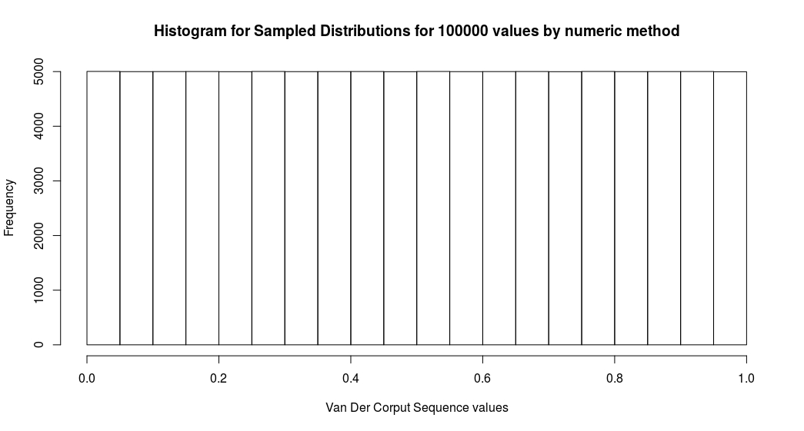
Cumulative Distribution

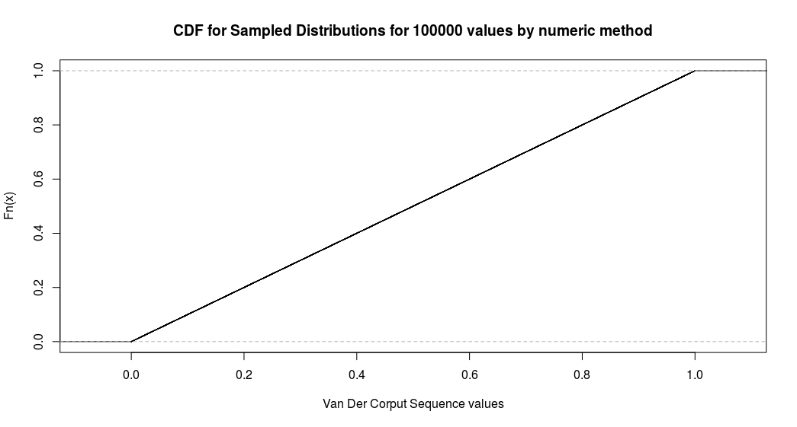
e) 100 and 100000 values were generated using the following LGC :
X_{i+1} = (a * X_{i} + b) mod m
U_{i} = X_{i}/m
where X₀ (seed) = 1, a = 1597, b = 51749, m = 244944

Comparison between numerical generation and Linear congruence generation:

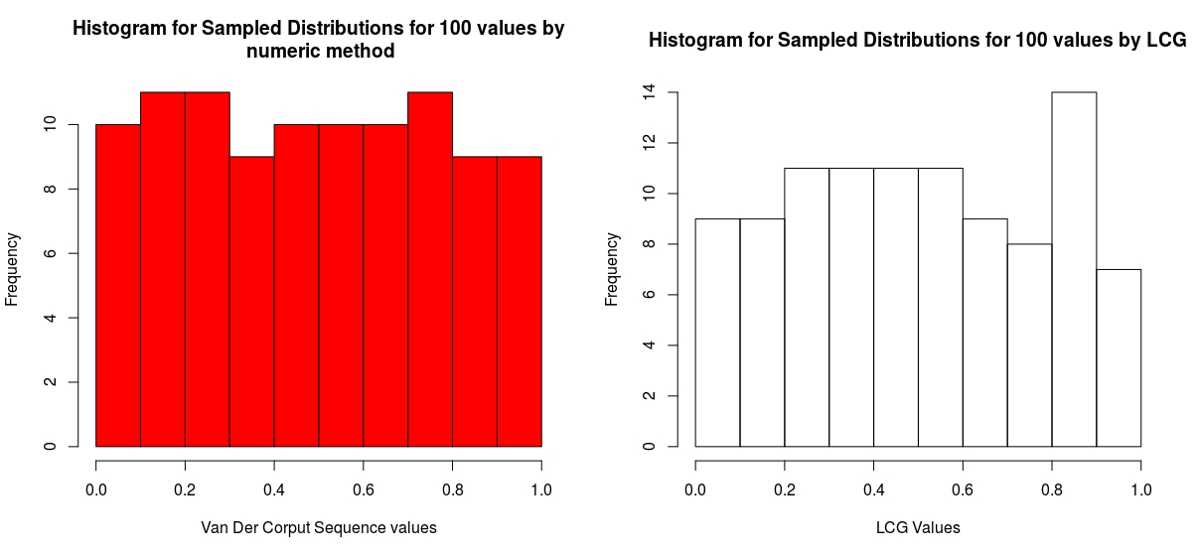

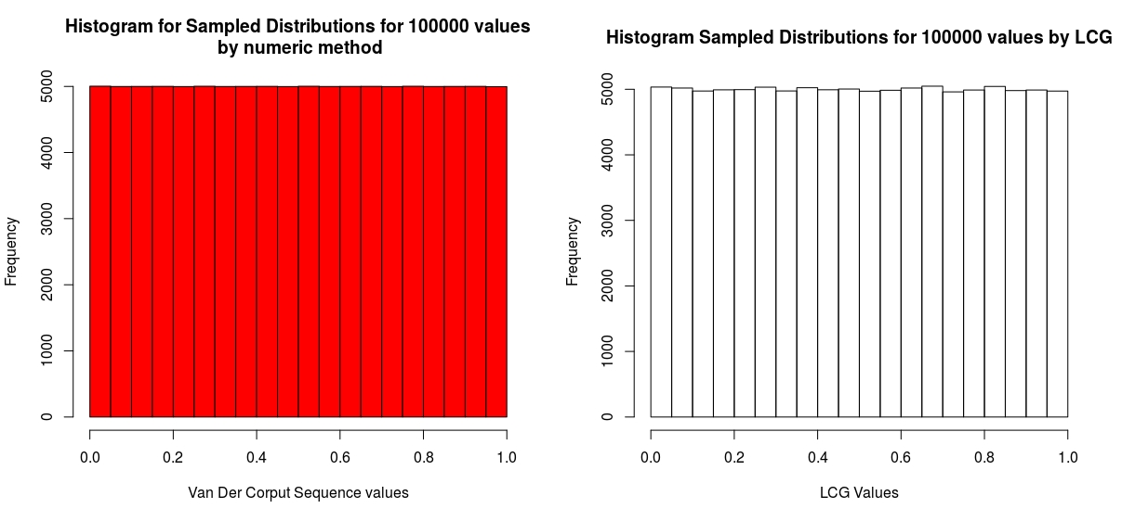
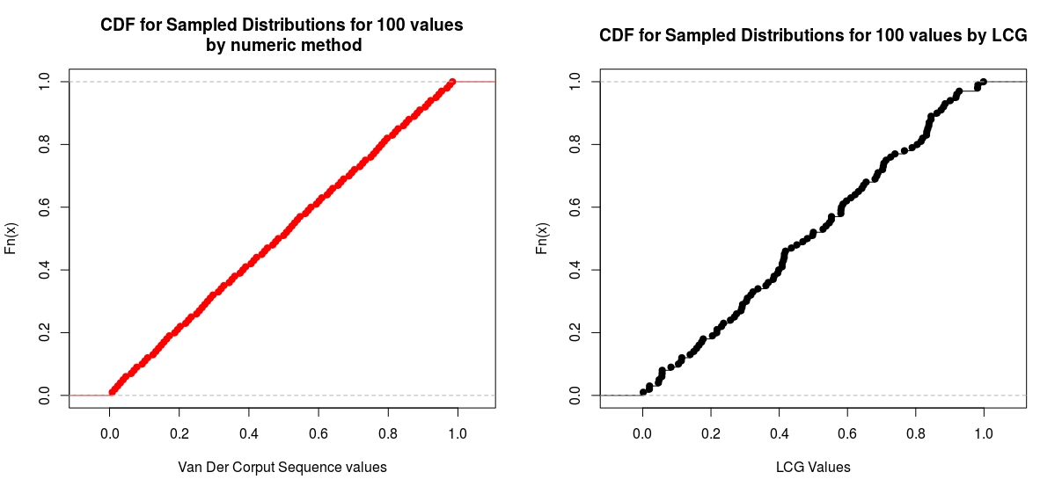
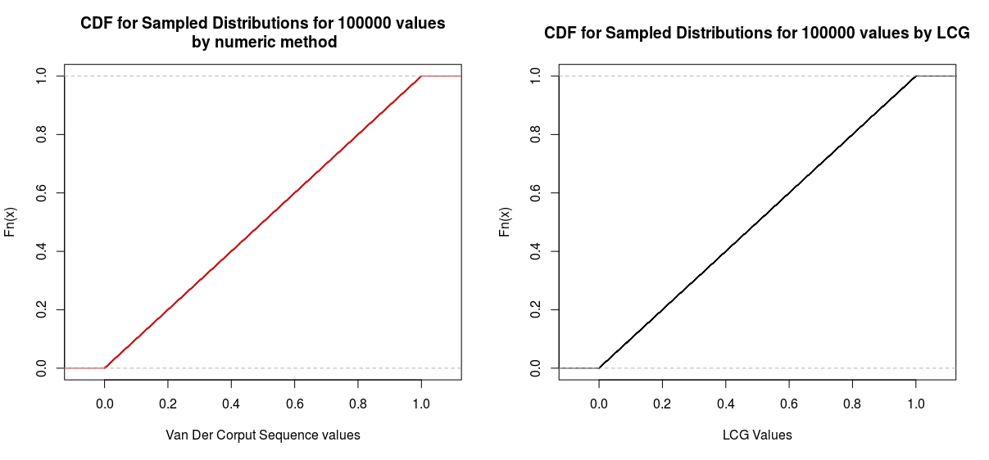
Observations :
Values generated by numeric method are more uniform and
the variance/error in numerically generated values are less
than that of linear congruence generation.

- Question 2
Following plots were obtained for Halton sequence
X_{i} = ( φ₂(i) , φ₃(i) ) (as points in R2 )
for the 100 and 100000 values respectively:
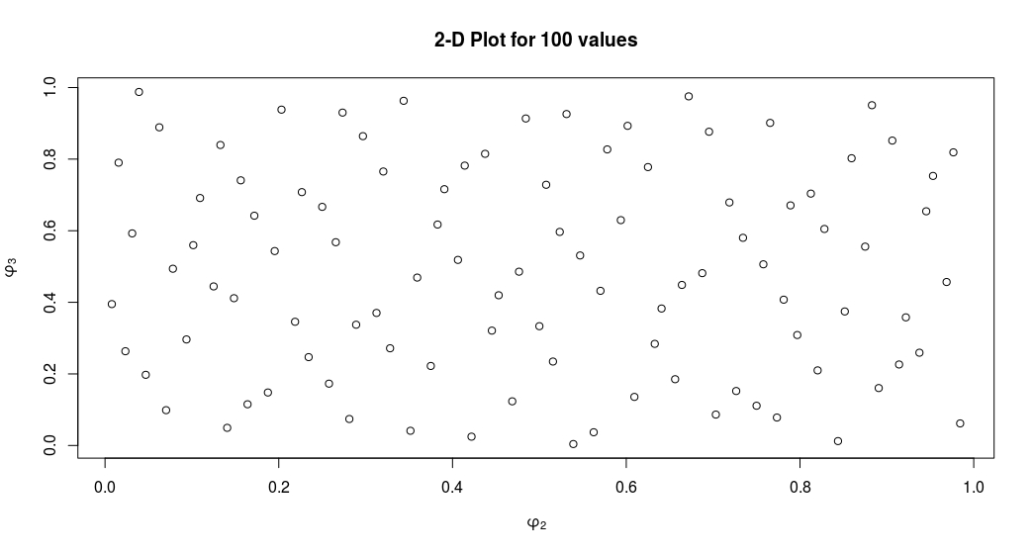
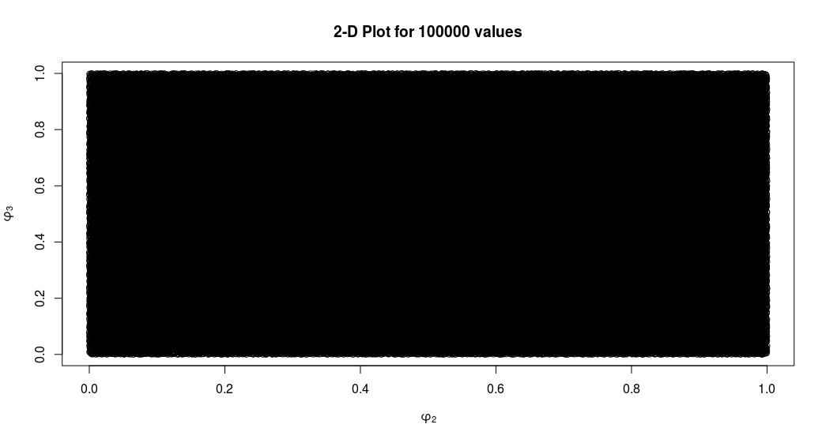

Observations :

The generated points are in the range [0,1] and the distribution is closer to uniform. Since we are generating in 2 dimension, error/variance of generated values will be less that of numeric method.

