**Module: 1 (HTML)**

1. **Are the HTML tags and elements the same thing?**

No, they are not a same thing. **HTML** Tags are the starting and ending parts of an HTML element. They begin with < symbol and end with > symbol. Whatever written inside < and > are called tags.  
**Example:** <br>, <div>

While, **HTML ele**ments enclose the contents in between the tags. They consist of some kind of structure or expression. It generally consists of a start tag, content and an end tag.

**Example:** <b>This is the content </b>. Here “<b>” is the start tag, “this is the content” is content and “</b>” is the end tag.

1. **What are tags and attributes in HTML?**

Tags and attributes are the basis of HTML. They work together but perform different functions.

HTML Tags are used to mark up the start of an HTML element and they are usually enclosed in angle brackets. Such as: <h1>.

Most tags must be opened <h1> and closed </h1> in order to function.

On the other hand, HTML Attributes contain additional pieces of information. Attributes take the form of an opening tag and additional info is placed inside.

An example of an attribute is:

<img src="mydog.jpg" alt="A photo of my dog.">

In this instance, the image source (src) and the alt text (alt) are attributes of the <img> tag.

**3. What are void elements in HTML?**

Most of the HTML elements are surrounded by start and end tags to specify the starting and end of the element.

There is a special group of elements that only have start tags and does not contain any content within it, these elements are called void elements. Void elements doesn’t have ending tags and can only have attributes but do not contain any kind of content. These elements can have backslash before ending of start tag but that is completely optional. Example of such elements are <br>, <hr>, <img>, <input>, <link>, <base>, <embed>, <col>, <track>, <source> etc.

**Characteristics:**

* Void elements do not have end tags.
* Void elements cannot have content inside it.
* Void elements have attributes.
* Void elements cannot be nested.

**4)What are HTML Entities?**

An HTML **entity** is a piece of text ("string") that begins with an ampersand (&) and ends with a semicolon (;). Entities are frequently used to display reserved characters (which would otherwise be interpreted as HTML code), and invisible characters (like non-breaking spaces). You can also use them in place of other characters that are difficult to type with a standard keyboard.

**Example:** -&nbsp:, &amp;, &lt;

**5) What are different types of lists in HTML?**

There are three types of lists in HTML:

* Unordered list or Bulleted list (ul)
* Ordered list or Numbered list (ol)
* Description list or Definition list (dl)

**6) What is the ‘class’ attribute in HTML?**

The class attribute specifies one or more class names for an element.

The class attribute is mostly used to point to a class in a style sheet. However, it can also be used by a JavaScript (via the HTML DOM) to make changes to HTML elements with a specified class.

**7) What is the difference between the ‘id’ attribute and the ‘class’ attribute of HTML elements?**

**HTML id Attribute:** The id attribute is a unique identifier that is used to specify the document. It is used by CSS and JavaScript to perform a certain task for a unique element. In CSS, the id attribute is written using the # symbol followed by id.

**Syntax:**

<element id="id_name">

**HTML class Attribute:** The class attribute is used to specify one or more class names for an HTML element. The class attribute can be used on any HTML element. The class name can be used by CSS and JavaScript to perform certain tasks for elements with the specified class name. The class name in CSS stylesheet using **“.”** symbol.

**Syntax:**

<element class="class_name">

**8) What are the various formatting tags in HTML?**

Different formatting tags in HTML are

1. **<b> and <strong> Tags:**Both tags are used to make the text bold. The text content of the tag is shown as important information on the webpage.
2. **<i> and <em> Tags:**Both tags are used to make the text italic and emphasized. Both the element has opening and closing tags.
3. **<small> and <big> Tags:**The <small> tag is used to set small font-size whereas <big> tag is used to set big font-size.
4. **<sup> and <sub> Tags:**The <sup> tag is used to superscript a text whereas <sub> tag is used to subscript a text.
5. **<ins> and <del> Tag:**The <ins> tag is used to underline a text marking the part as inserted or added. It also has an opening and a closing tag. This tag is mainly used in text in place of deleted text whereas <del> tag is used to delete the text it adds a strike line on the text.
6. **HTML <mark> Tag:**The <mark> tag is used to highlighting a text. It has an opening and closing tag.

**9) How is Cell Padding different from Cell Spacing?**

**Cellpadding**:

Cellpadding specifies the space between the border of a table cell and its contents (i.e.) it defines the whitespace between the cell edge and the content of the cell.

**Syntax:**

**<table cellpadding="value" >......</table>**

where, value determines the padding

(Space between the border of a table and its content)

**Cell spacing:**

Cell spacing specifies the space between cells (i.e.) it defines the whitespace between the edges of the adjacent cells.

**Syntax:**

**<table cell spacing="value" >......</table>**

where, value determines the padding

(Space between adjacent cells)

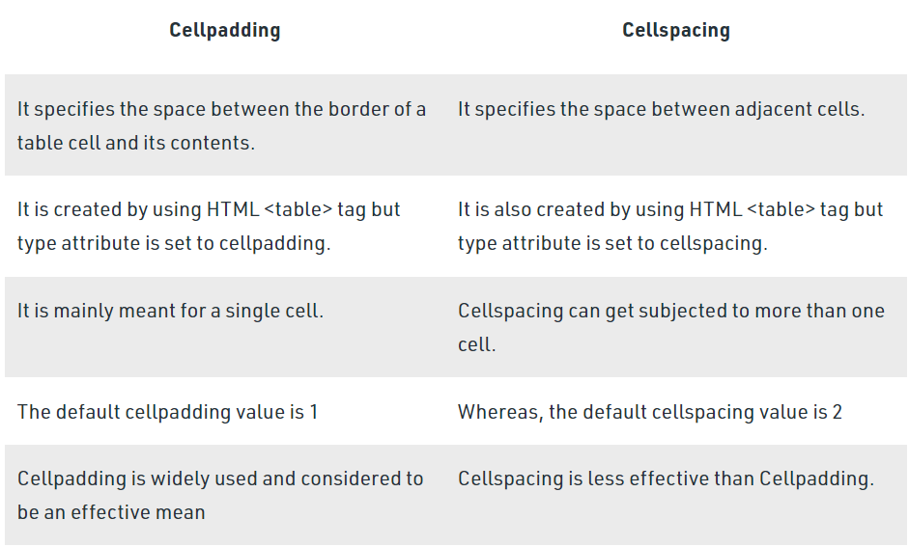

**10) How can we club two or more rows or columns into a single row or column in an HTML table?**

It can be done by using the***row span***and *C****ol span*** attribute in HTML.  The *row span* is used to merge or combine the number of cells in a row whereas the *Col span* is used to merge column cells in a table.

**11) What is the difference between a block-level element and an inline element?**

**Block elements:**They consume the entire width available irrespective of their sufficiency. They always start in a new line and have top and bottom margins. It does not contain any other elements next to it.

**Examples of Block elements:**

* **<h1>-<h6>:**This element is used for including headings of different sizes ranging from 1 to 6.
* **<div>:**This is a container tag and is used to make separate divisions of content on the web page.
* **<hr>:**This is an empty tag and is used for separating content by horizontal lines.
* **<li>:**This tag is used for including list items of an ordered or unordered list.
* **<ul>:**This tag is used to make an unordered list.
* **<ol>:**This tag is used to make an ordered list.
* **<p>:**This tag is used to include paragraphs of content in the webpage.
* **<table>:**This tag is used for including the tables in the webpage when there is a need for tabular data.

**Inline elements:**Inline elements occupy only enough width that is sufficient to it and allows other elements next to it which are inline. Inline elements don’t start from a new line and don’t have top and bottom margins as block elements have.

Examples of**Inline elements**:

* **<a>:**This tag is used for including hyperlinks in the webpage.
* [**<br>**](https://www.geeksforgeeks.org/html-brgt-tag/)**:**This tag is used for mentioning line breaks in the webpage wherever needed.
* [**<script>**](https://www.geeksforgeeks.org/html-script-tag/)**:**This tag is used for including external and internal JavaScript codes.
* [**<input>**](https://www.geeksforgeeks.org/html-input-tag/)**:**This tag is used for taking input from the users and is mainly used in forms.
* [**<img>**](https://www.geeksforgeeks.org/html-img-tag/)**:**This tag is used for including different images in the webpage to add beauty to the webpage.
* [**<span>**](https://www.geeksforgeeks.org/span-tag-html/)**:** This is an inline container that takes necessary space only.
* [**<b>**](https://www.html.am/html-codes/text/html-bold.cfm)**:** This tag is used in places where bold text is needed.
* [**<label>**](https://www.geeksforgeeks.org/html-label-tag/)**:**The tag in HTML is used to provide a usability improvement for mouse users i.e., if a user clicks on the text within the <label> element, it toggles the control.

**12) How to create a Hyperlink in HTML?**

HTML links are hyperlinks. You can click on a link and jump to another document. When you move the mouse over a link, the mouse arrow will turn into a little hand.

HTML Links - Syntax

The HTML <a> tag defines a hyperlink. It has the following syntax:

<a href="*url*">*link text*</a>

The most important attribute of the <a> element is the href attribute, which indicates the link's destination.

The *link text* is the part that will be visible to the reader.

Clicking on the link text, will send the reader to the specified URL address.

### **Example**

This example shows how to create a link to W3Schools.com:

<a href="https://www.w3schools.com/">Visit W3Schools.com! </a>

 By default, links will appear as follows in all browsers:

* An unvisited link is underlined and blue
* A visited link is underlined and purple
* An active link is underlined and red

**13) What is the use of an iframe tag?**

The iframe in HTML stands for **Inline Frame**. The” iframe” tag defines a rectangular region within the document in which the browser can display a separate document, including scrollbars and borders. An inline frame is used to embed another document within the current HTML document. The HTML iframe name attribute is used to specify a reference for an <Iframe> element. The name attribute is also used as a reference to the elements in JavaScript. The iframe is basically used to show a webpage inside the current web page. The ‘src ‘attribute is used to specify the URL of the document that occupies the iframe.

**Syntax:**

<iframe src="URL" title="description"></iframe>

**14) What is the use of a span tag? Explain with example?**

The **HTML span** element is a generic*inline container* for inline elements and content. It is used to group elements for styling purposes (by using the class or id attributes), A better way to use it when no other semantic element is available.

The**span tag** is a paired tag means it has both open (<) and closing (>) tags, and it is mandatory to close the tag. The span tag is used for the grouping of inline elements & this tag does not make any visual change by itself. span is very similar to the [div tag](https://www.geeksforgeeks.org/div-tag-html/), but div is a**block-level** tag and span is an**inline tag**.

**Syntax:**

<span class="">Some Text</span>

Example: By using <span> tag, we can reduce code and HTML Attributes, see the below example that will display the same output as the above example with using <span> tag by applying CSS in a span tag.

**15) How to insert a picture into a background image of a web page?**

Background images are used to make a website more interactive and attractive. It can be applied in many stylings.

**Approach:**

* In the [body](https://www.geeksforgeeks.org/html-body-tag/) tag, specify a background image in the [background attribute](https://www.geeksforgeeks.org/html-body-background-attribute/) by passing the URL of the image or location path.
* Adding [CSS](https://www.geeksforgeeks.org/css-tutorials/) styling properties.

**Syntax:**

<body background = "URL or path" > Website Body </body>

**16) How are active links different from normal links?**

An **active** text or graphic **link** on a Web page. Clicking the **link** redirects the user to another Web page or a document or image. Live **links** are also placed into email, allowing recipients of the message to immediately go to a website or open an attached document or image.

The default color for **normal** and **active links** is blue. Some browsers recognize an **active link** when the mouse cursor is placed over that **link**; Others recognize **active links** when the **link** has the focus. Those that don't have a mouse cursor over that **link** is considered a **normal link**.

**17) What are the different tags to separate sections of text?**

The **<br>** tag is one way to separate the lines of text. There are other tags like the <p> tag and <blockquote> tag that are also used to separate sections of text.

**18) What is SVG?**

SVG stands for Scalable Vector Graphics. SVG is used to define vector-based graphics for the Web. SVG defines the graphics in XML format. Every element and every attribute in SVG files can be animated

SVG Advantages

Advantages of using SVG over other image formats (like JPEG and GIF) are:

* SVG images can be created and edited with any text editor
* SVG images can be searched, indexed, scripted, and compressed
* SVG images are scalable
* SVG images can be printed with high quality at any resolution
* SVG images are zoomable
* SVG graphics do NOT lose any quality if they are zoomed or resized
* SVG is an open standard
* SVG files are pure XML

**19) What is difference between HTML and XHTML?**

HTML is short for Hypertext Markup Language. It is used to create websites and web applications. Let’s break it down, so we understand the name better:

* Hypertext: Hypertext refers to the “text wrapped within a text.” It is very similar to hyperlinks and contains an underlying text that, when clicked, redirects to a new webpage.
* Markup language: A markup language is not necessarily a programming language. Instead, it is used to apply formatting and layout to a simple text document. This leads to more interactive and dynamic text content.

While, XHTML stands for Extensible Hypertext Markup Language. XHTML is almost similar to HTML but it is stricter than HTML. It is swift, accurate, easily maintained, convertible, and formatted. All major browsers support XHTML.

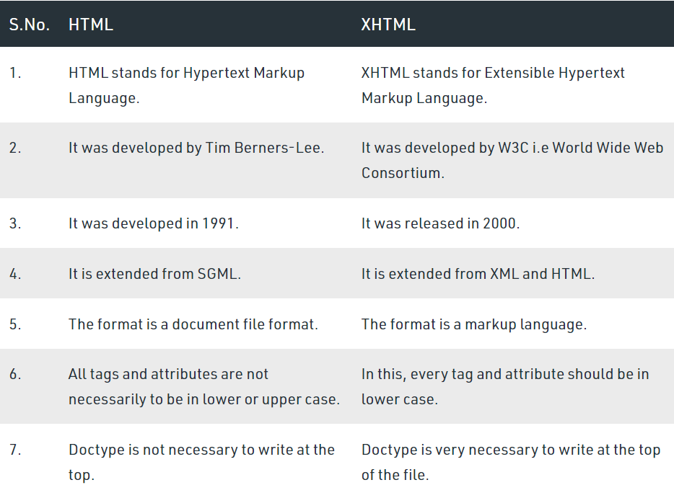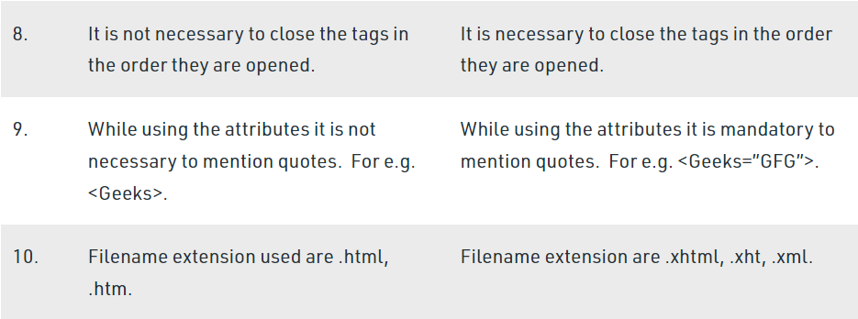

**20) What are logical and physical tags in HTML?**

Physical and Logical tags are used in HTML for better visibility and understanding of the text by the user on the web page. However, both tags differ from each other as suggested by their names.

**Logical Tags:**

Logical Tags are used in HTML to display the text according to the logical styles. Following are the Logical tags commonly used in HTML.

**Logical Tags**

| Tag | Description |
| --- | --- |
| <abbr> | Defines an abbreviation |
| <acronym> | Defines an acronym |
| <address> | Defines an address element |
| <cite> | Defines citation |
| <code> | Defines computer code text |
| <blockquote> | Defines a long quotation |
| <del> | Defines text |

**Physical Tags**

Physical Tags are used in HTML to provide actual physical formatting to the text. Following are the Physical tags commonly used in HTML.

**Physical Tags**

| Tag | Description |
| --- | --- |
| <b> | Defines **bold**text |
| <big> | Defines big text |
| <i> | Defines *italic*text |
| <small> | Defines small text |