**EMBEDDED SYSTEMS DESIGN (UCS** **704)**

**Assignments 1 to 12**

**Submitted by:**

**(102103186) GUNAAYAT KAUR**

**BE Fourth Year- COE**

**Submitted to:**

**Dr. Manisha**



**Computer Science and Engineering Department**

**Thapar Institute of Engineering and Technology, Patiala**

**NOVEMBER 2024**

**EXPERIMENT 1**

**HELLO WORLD**

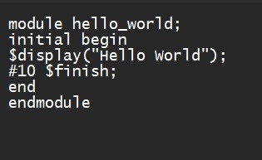

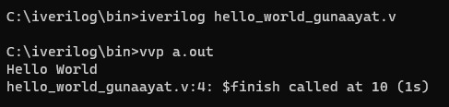

**AND GATE**

**Program 1**

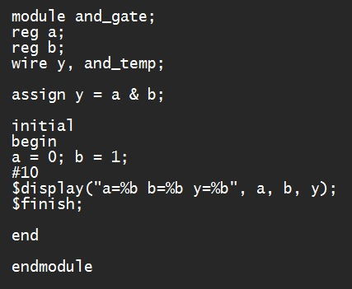

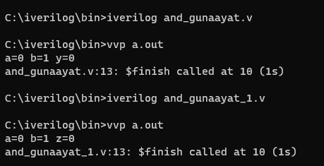

**Program 2**

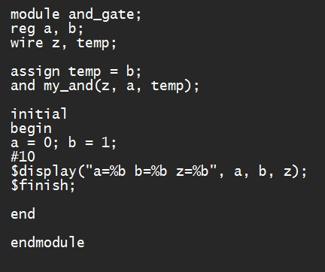



**Program 3**

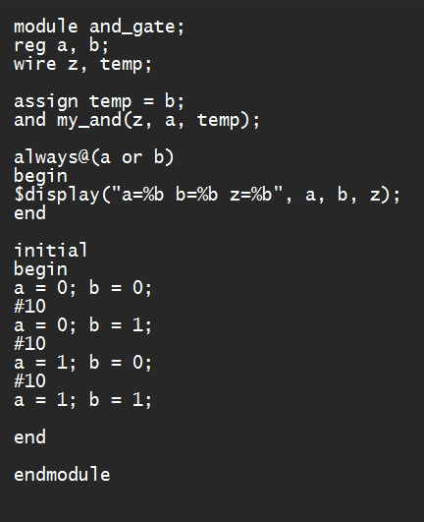

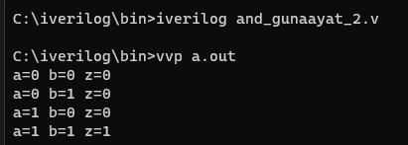

**AND and NOT**

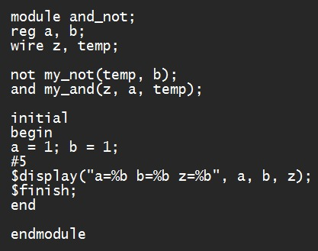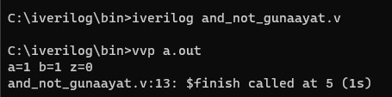

**Assignment Question**

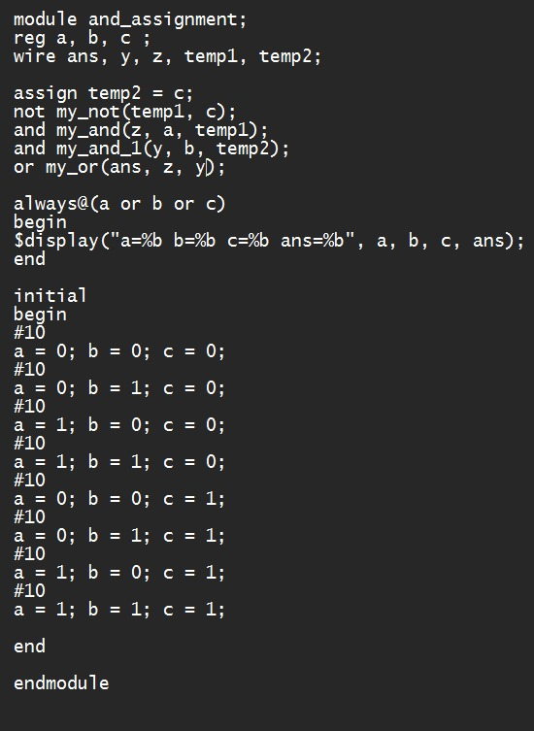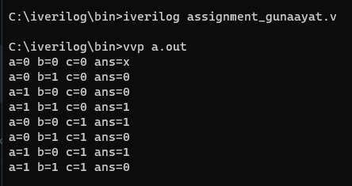

**EXPERIMENT 2**

**AND GATE**

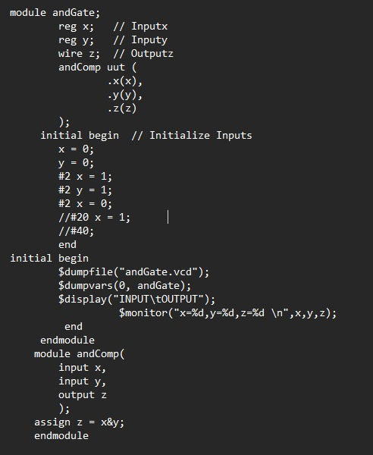

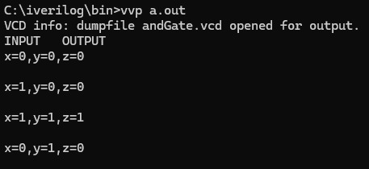

**HALF ADDER**

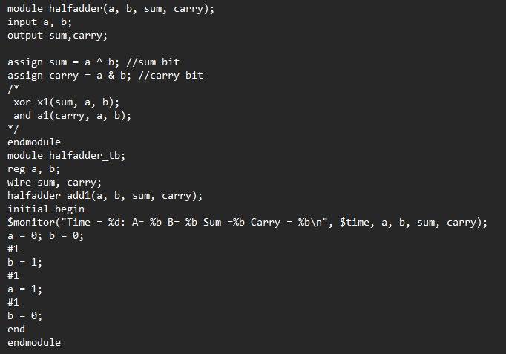

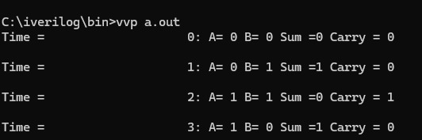

**EXPERIMENT 3**

**FULL ADDER**

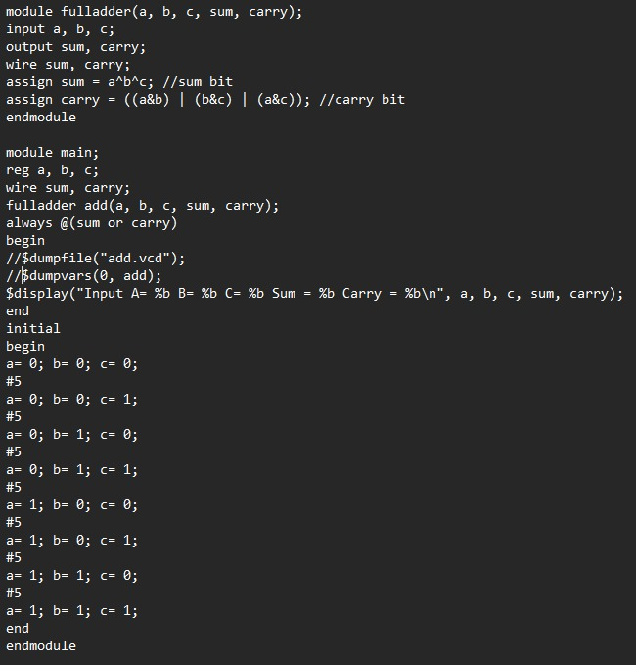

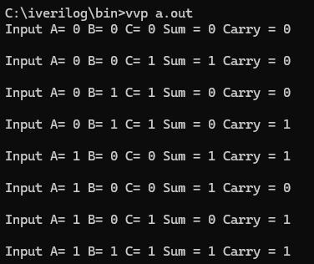

**EXPERIMENT 4**

**HALF SUBTRACTOR**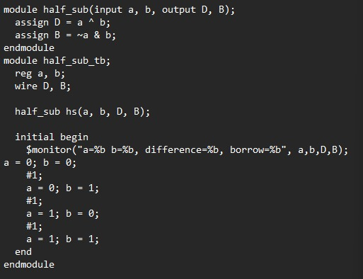

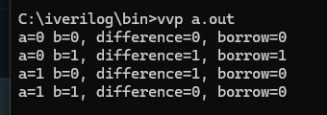

**EXPERIMENT 5**

**NUMBER CONVERTER**

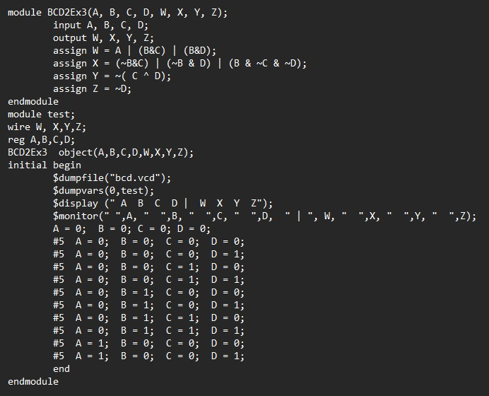

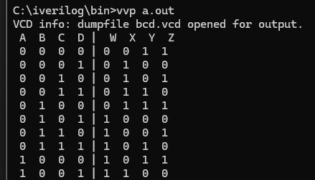

**EXPERIMENT 6**

**MULTIPLEXER**

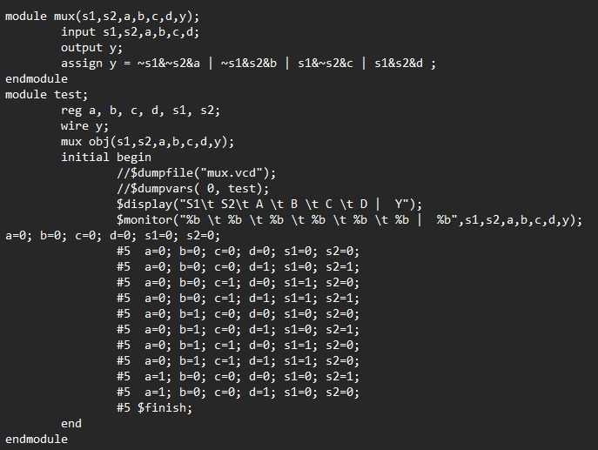

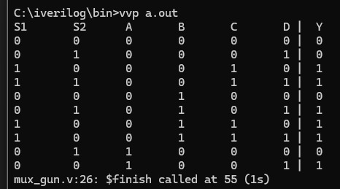

**EXPERIMENT 7**

**DEMULTIPLEXER**

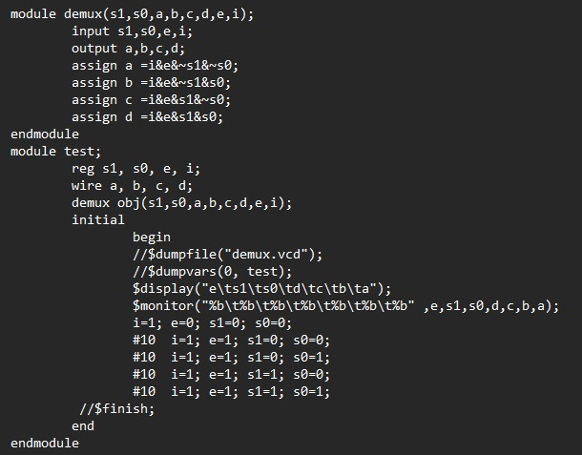

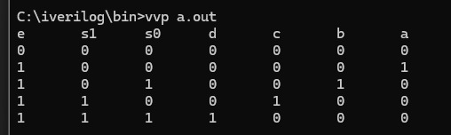

**EXPERIMENT 8**

**DECODER**

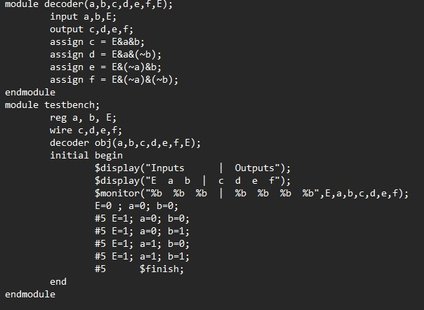

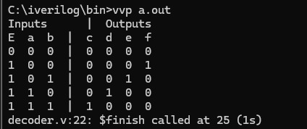

**EXPERIMENT 9**

**ENCODER**

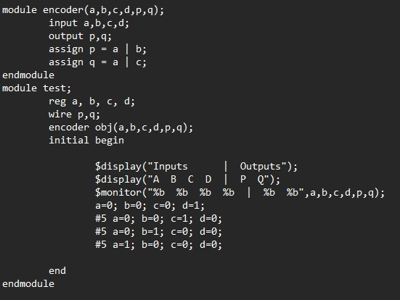

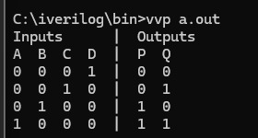

**EXPERIMENT 10**

**D FLIP FLOP USING NAND GATE**

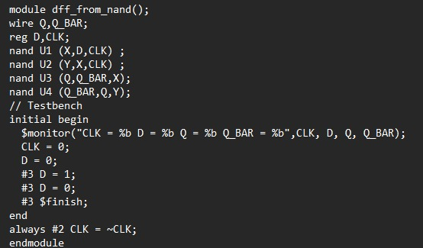

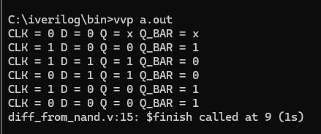

**ASYNCHRONOUS D FLIP FLOP**

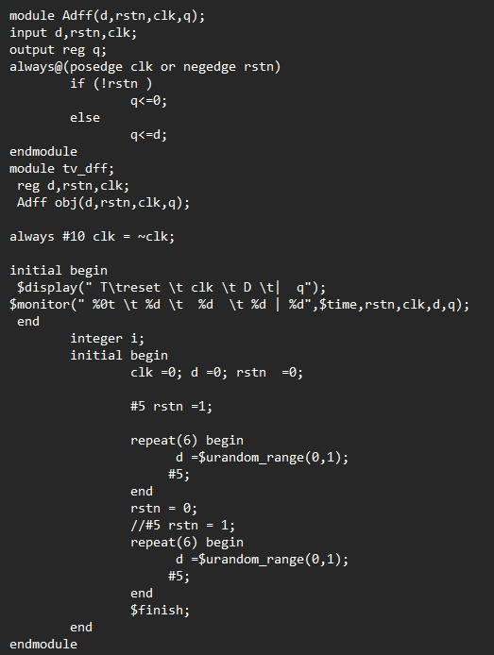

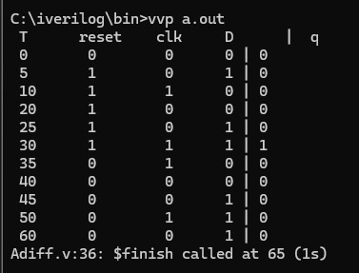

**SYNCHRONOUS D FLIP FLOP**

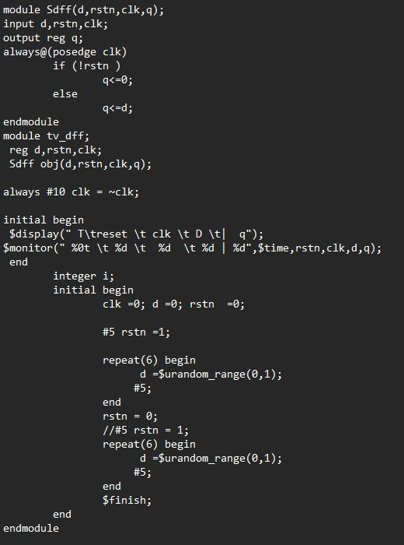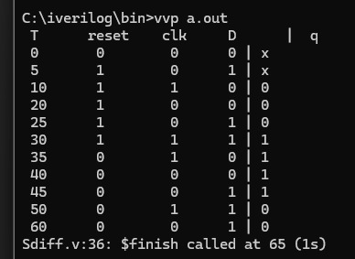

**EXPERIMENT 11**

**JK FLIP FLOP**

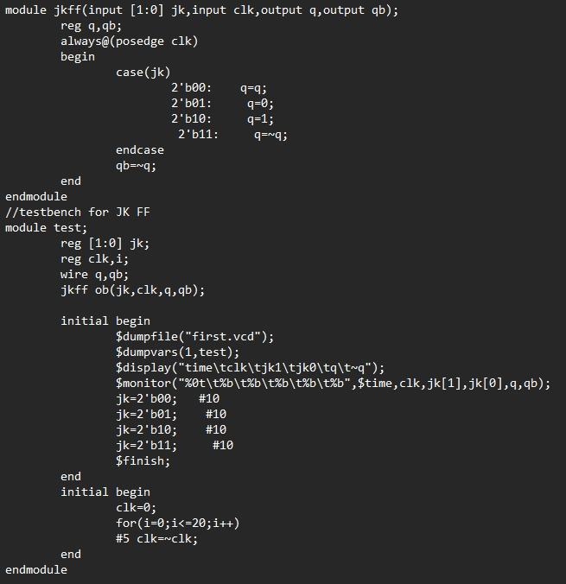

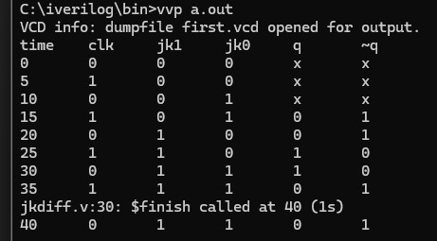

**EXPERIMENT 12**

**UP COUNTER/ DOWN COUNTER**

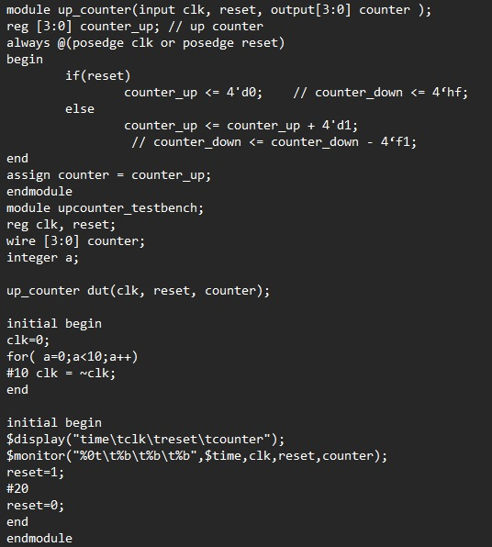

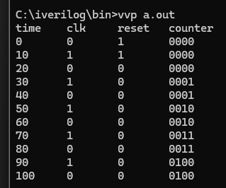

**UP - DOWN COUNTER**

