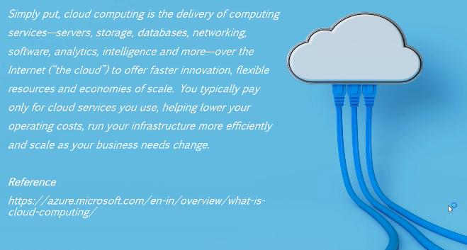

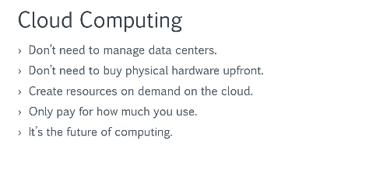

* <https://azure.microsoft.com/en-us/>

Microsoft Azure provides cloud computing services to Build, deploy and manage Applications

* Free subscription: using Microsoft/Git account, and a credit card details registration and ur phone number.
* 200 USD credited

More details and FAQ on free account at below link

<https://azure.microsoft.com/en-us/free/>

* <https://portal.azure.com/?quickstart=true#home>

[singh.neelam26@gmail.com](mailto:singh.neelam26@gmail.com)

neelam26@2021

**Resource and Resource Groups:**

Resource: whatever we create using azure provided products, is called a Resource.

E.g. a Database sql server, a Virtual machine etc.

Resource Group: A container which has multiple resources. Logically grouping multiple resources under a group. It simplifies managing all resources under a resource group. Like permission, delete etc….

**Azure Regions:**

<https://azure.microsoft.com/en-us/global-infrastructure/geographies/>

<https://azure.microsoft.com/en-us/global-infrastructure/services/>

Whenever we do use azure services, we need to choose a region in which it should get hosted.

Why? Though we are using cloud computing facility but at the end somewhere everything managed physically, and that’s why we need to select region for most of the services.

**Azure Subscription:**

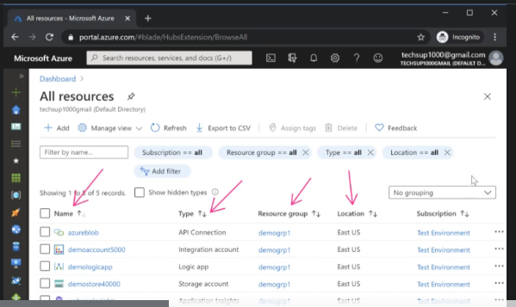

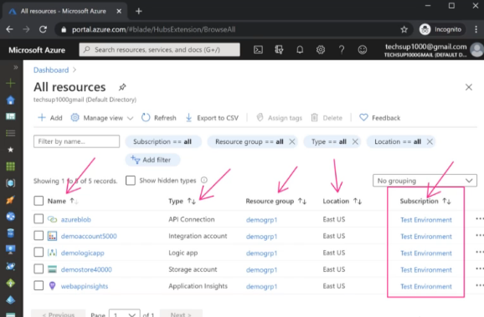

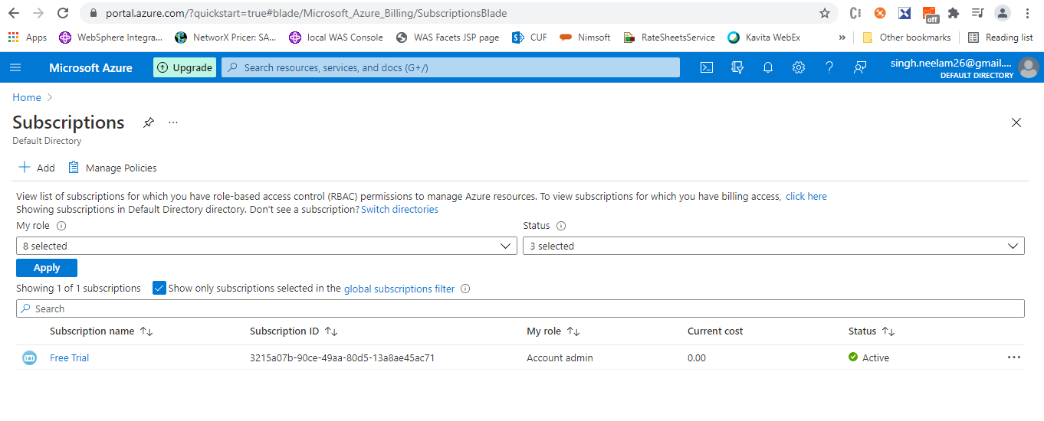

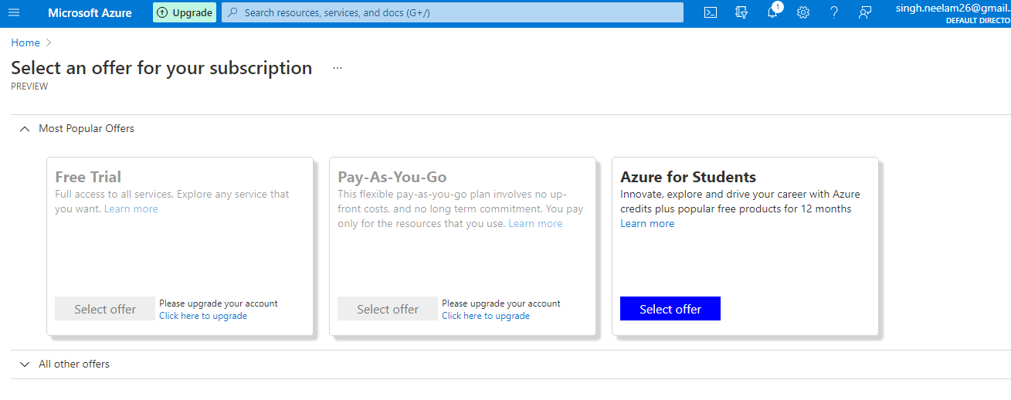

**Azure Core Services**

1. **Virtual Machine Service: Windows and Linux**

When a company manages Virtual machine infrastructure

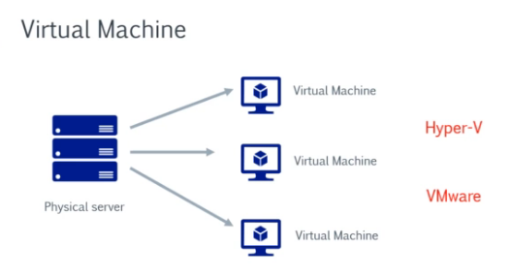

<https://www.parallels.com/blogs/ras/hyper-v-vs-vmware/>

Azure Virtual Machine Service

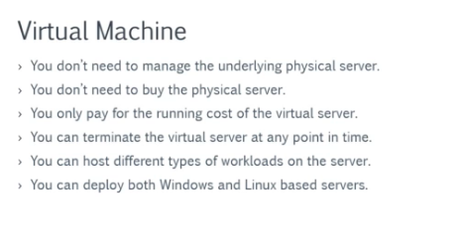

* Deploying a Windows Virtual Machine

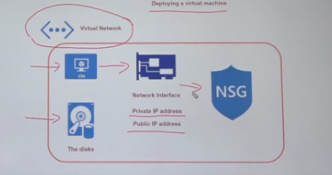

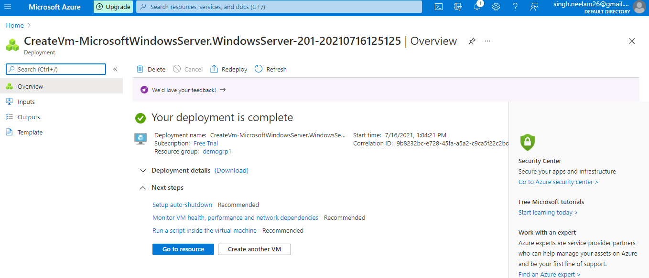

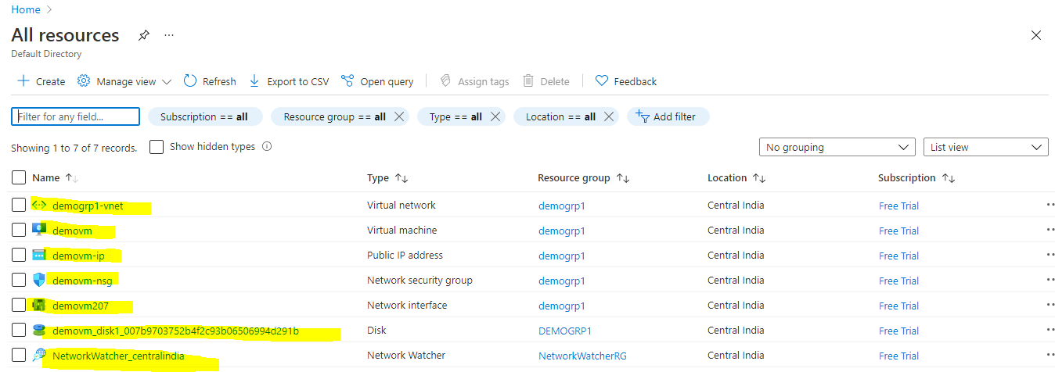

* Connecting to Windows Virtual Machine

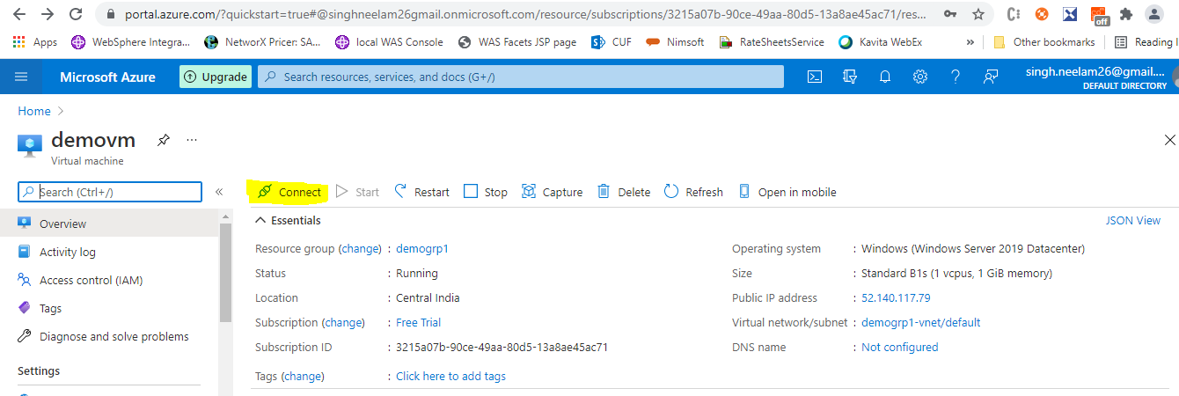

* Installing IIS Web server

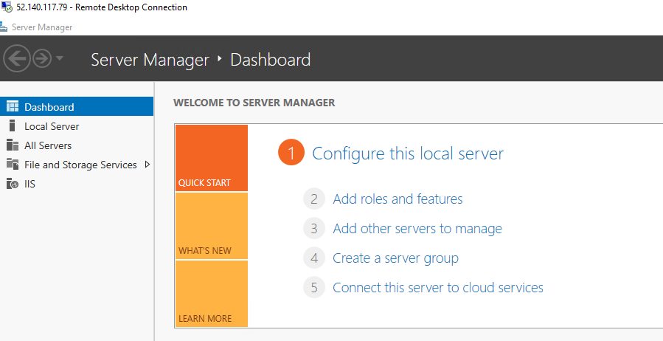

* Virtual Machine Types

<https://azure.microsoft.com/en-us/pricing/details/virtual-machines/series/>

* Costing

<https://azure.microsoft.com/en-us/pricing/calculator/>

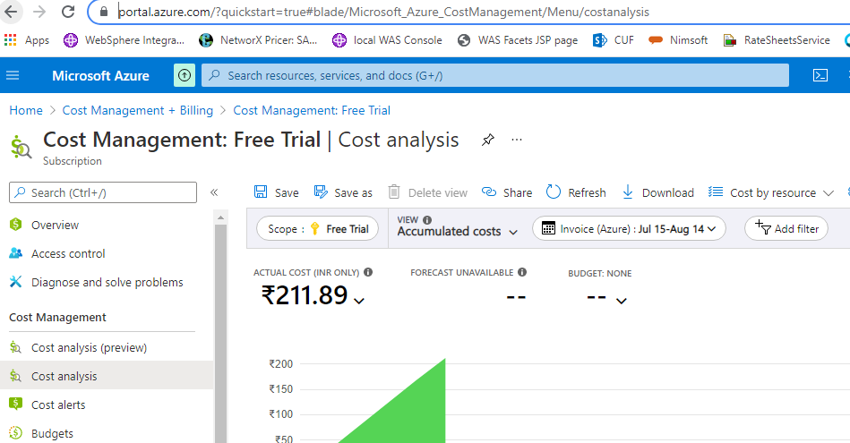

* State Of Virtual Machine: start and stop + Public IP address vs static IP address

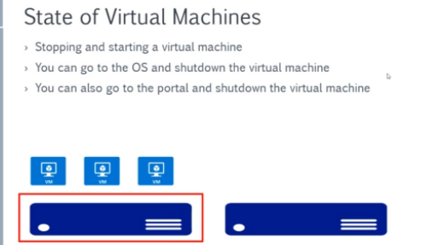

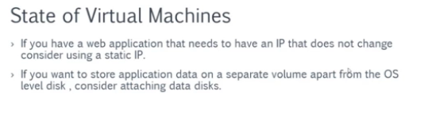

* Azure Marketplace for Virtual Machines: customized solutions can be added to subscription.

<https://azuremarketplace.microsoft.com/en-us/marketplace/>

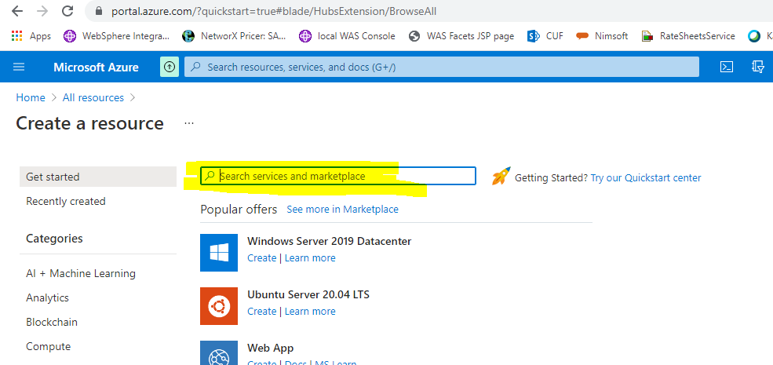

* Availability Sets: An architecture/way to provide support to VM’s on which our applications running. Availability of physical servers within same Data Center. It’s our responsibility to assign availability sets to VM.

Availability Sets can only be assigned to VM while creation, not to existing ones.

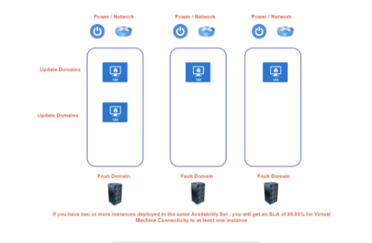

Set of VM’s can fall under🡪

Update Domain

Fault Domain

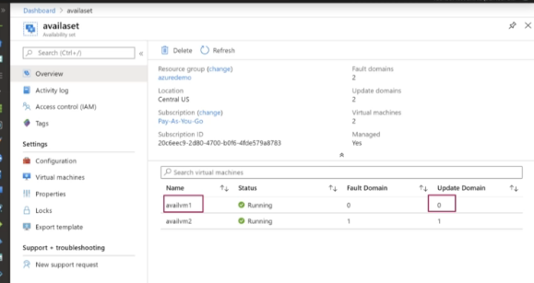

* Availability Zones: availability of Data Center’s within same region. It’s our responsibility to assign availability sets to VM.

Availability Sets can only be assigned to VM while creation, not to existing ones.

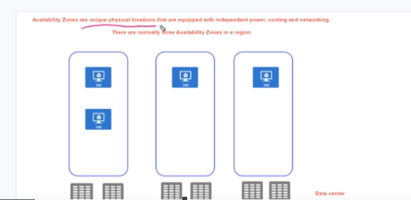

**Availability Sets/Zones would be only useful if we do have more than one VM’s where our underlying Application/Service is deployed.

* Azure Dedicated Hosts: Maintained by Large Organizations. Only Organizations created/assigned VM’s will run. Hosts Maintenance controlled by owner organization.
* Deleting Resources:

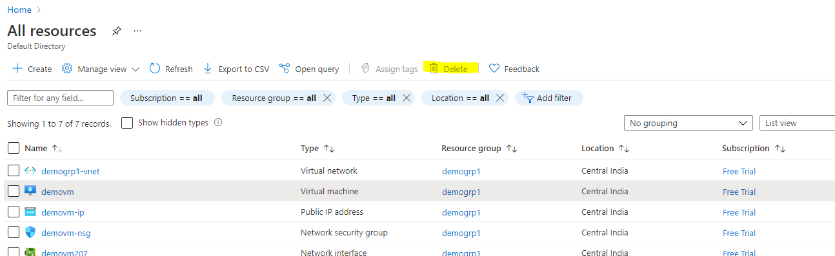

* Workload: Are unit of functionalities that we want to host on Azure service.

E.g. a Web application/service, Database server etc.

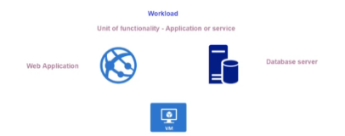

1. **Networking Service**

Azure Virtual networking services, allows other resources to communicate between them.

While creating VM, we can choose same region/ resource group virtual networking.

* Virtual Network Creation

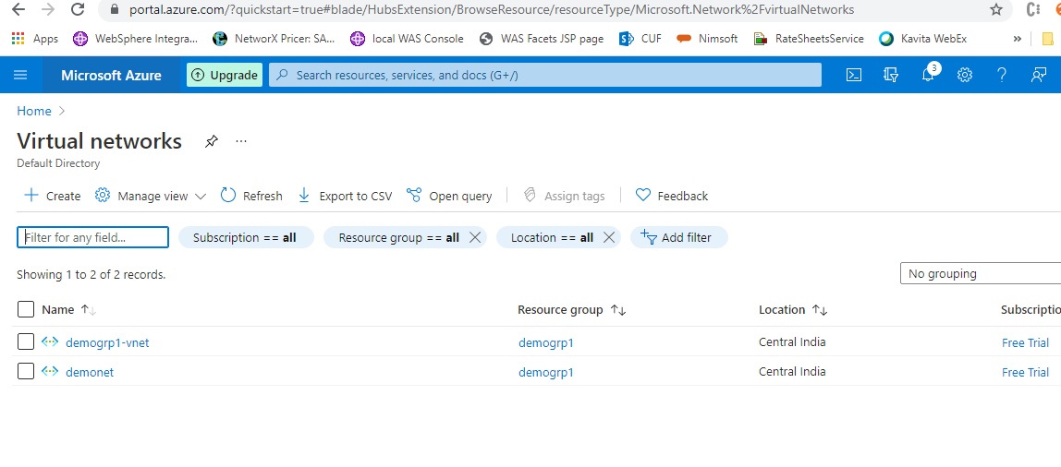

* Communication between VM’s:
* By Default VM’s on same virtual network can communicate with each other through port 80. And same allowed through NSG(network security group)
* VM’s on different virtual network can communicate through network peering.
* Network Security Group(NSG):
* Is kind of firewall which controls in/out traffic to virtual network.
* It can be applied to network interface card of vm or entire subnet (affects all VM’s present on that subnet)

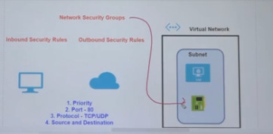

* InBound NSG
* OutBound NSG

