# Power quality events classification using convolutional neural network for real time recorded data.

##### **Santhosh K G Manikonda, Student Member, IEEE*, Nandani Shakshi**, Neelam Bugalia^, Rachna Meshram**^^ **and Dattatraya N Gaonkar, Senior Member, IEEE**

* Department, Institute Name

** Department, Institute Name, if any

DOI: 10.29322/IJSRP.X.X.2018.pXXXX

***Abstract*-** Power quality maintenance has become one of the most important aspect of today’s industry due to the growth in the use of power electronic and microprocessor based equipment everywhere. This makes it vital to identify and classify any type discrepancies, which is generally termed as Power quality events in the system. In this paper, a CNN model is used to classify these events. We have included real time recorded voltage waveform data in our dataset. Apart from this, data is generated through numerical models for a combination of two events happening simultaneously. A new approach called Markov transition field is used for feature extraction to convert our time series data in images. The model is trained and tested using this dataset. Then the performance of the model is evaluated based on the results obtained.

1. **Introduction**

A

s we move forward in the future, the demand for clean power is growing every day. Due to this, the complexity and interconnectedness of power grids has increased so does the irregularities in the power supply. These irregularities are termed as PQ events and they generally occur due to inconsistency in the voltage or current such as dip, increase or sometimes change in frequency or involvement harmonics and oscillatory transients. These failures could lead to the tripping of the protection equipment, which results in an interruption in the power supply. These events can cause severe and irreversible damage to the system if not been identified and acted on properly. In the earlier times, these events were eliminated manually but nowadays due to vast industries and more complicated grids, it becomes impossible to identify and eliminate each and every event.. Thus, it has become absolutely necessity to design an automatic system to detect and classify them within a justified timeframe to make proper adjustments and avoid any major incidents. Machine learning and signal processing has been proven to be few of the best techniques to classify these events. For these, generally feature extraction is done using various methods following training and testing is done on a model to classify the events, which usually consist of a pattern recognition process. Feature extraction is done to extract certain special features from the data, which is usually the voltage or current waveforms to identify any specific event. We have seen use of FFT [0], Wavelet transform based methods (1) (2) (3) applied to extract features from our time series data. After the dataset is ready, it will be trained and tested by different classification techniques such as neural networks, support vector machine or genetic algorithm based classification system. Among these, neural network has been widely used for classification because it’s non-linear decision boundaries and control over relationship between variables. Use of different neural network models such CNN (1), LSTM (2) or VGG16 (3) has been implemented in previous research.

In this paper, we are using a combination of field recorded data and numerically modeled data to make our dataset. A new feature extraction technique called Markov transition field is used, which converts the time series to an image by illustrating a field of transitional probabilities for a discretized time series. A CNN Model is used to train and test our dataset for classification of the power quality events.

The rest of the paper is organized as following. In sec I, Introduction and previous research on PQ events classification is discussed, In sec II, a brief overview of the whole process is discussed, In sec III, Raw data generation, In sec IV, Feature extraction technique to convert our time series into images to make the dataset is discussed, In sec V, the CNN model structure is discussed and finally in last sec VI, the result and conclusion based on the results is given and any future development that could be done is discussed.

.

**II. METHODOLOGY**

The use of a CNN Model is incorporated in this paper to train and test the dataset. The complete process of classification of PQ events is done in three steps. First we have collected data from the PQube map and generated the rest of the data from python scripts. A CNN Model requires its dataset in image format, thus once our data was ready, we converted them into images using Markov transition field method. Then, the CNN model was trained and tested using this dataset. The whole process can be depicted by following flow diagram:

Collecting data from PQube

Training and testing CNN with images

Transforming Time series data to images

Generating data using Python

i) Process of classifying PQ events

**III. DATASET**

The dataset is generated through feature extraction from our raw time series data. This raw data comprises of two parts:

**I. REAL TIME DATA**

This data is collected from an online website named map.pqube.com, which is a free, cloud-based map of PQubes placed around the world, which displays real time power quality data directly from the PQube. A PQube is a low-cost, high-precision energy and power quality monitor manufactured by a company named PSL. It is used in semiconductor tools, MRI scanners, space rocket building machines, wind and solar converters, and anywhere power sensitive instruments are involved. This online data is provided by the customers of PSL (Power standard lab) who have agreed to make their data public. As this data constitutes of real time disturbances happened in all these places, it would take us a step closer to implementing these classification techniques in real time to identify different PQube events. Here we have taken data for following events

i) Abnormal frequency: It includes data from both under frequency and over frequency disturbances.

ii) Waveform Distortion: Any steady-state deviation from an ideal sine wave of power frequency is considered as distortion in the signal.

iii) Voltage sag

iv) Voltage swell

While studying the above real time data, we identified few unique disturbances which were a combination of two power quality events happening at the same time. Below is a plot of one such disturbance. Here we have under voltage and under frequency occurring simultaneously.

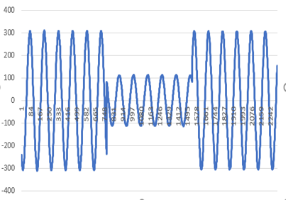

ii) Under Voltage and under frequency

**II GENERATED DATA**

As discussed earlier, we saw how combination of two events can occur and it’s crucial to identify both of them. Hence, we have generated the dataset for combination of two PQ events using numerical models in python scripts. Research is proven that numerically modeled data is comparable to the simulated data or the data recorded in real time. Here we have generated our data for following events:

i) Over voltage and over frequency: The numerical model is following:

$V=\left(V_{m}+V_{r}\right)\sin\left(2π\left(f+f_{r}\right)t+ φ\right)+noise$

Where,

Vm = Peak voltage

Vr = Rise in voltage

f = Fundamental frequency

fr  = Rise in frequency

φ = Phase angle

ii) Under voltage and under frequency: The numerical model is following:

$V=\left(V_{m}-V_{d}\right)\sin\left(2π\left(f-f_{d}\right)t+ φ\right)+noise$

Where,

Vd = Drop in voltage

fd  = Drop in frequency

iii) Transients and flickers: The numerical model is below:

$V=V_{m}+F_{m}\sin{(2πf_{f}t+ φ)\sin\left(2πft+φ\right)}$

$+ \left(u_{t_{1}}-u_{t_{s}}\right)T_{m}\sin\left(2πf_{osc}t\right)e^{-Pt_{1}}+noise$

Where,

Fm =Flicker magnitude (6-10 % of nominal voltage )

ff  = Flicker frequency (10 Hz)

$T_{m}$ = Transient magnitude (1.4 times of nominal voltage)

$f_{osc}$ = Transient oscillatory frequency (400 Hz)

P = Transient settling rate (0.015)

$t_{s}$ = Transient settling time

$t_{1}$ = Transient starting time

and $u_{t_{1}},u_{t_{s}}$ are step functions defined as following:

$u_{t_{1}}$ = $\left\{\begin{matrix}1 t≥t_{1} \\ 0 else \end{matrix}\right.$

$u_{t_{s}}$ = $\left\{\begin{matrix}1 t≥t_{s} \\ 0 else \end{matrix}\right.$

**IV. FEATURE EXTRACTION**

Here we have converted our time series data into images using Markov transition field method. For a time series X, we make a Markov transition matrix W. First we find Q quantile bins and allocate each xi to its bin qj (j ∈ [1, Q]). Then we make a Q x Q adjacency matrix W, which is done by counting the transitions between the quantile bins by the approach of first order Markov chain along the time axis. Each element in W matrix is the frequency by which a point in any one of the quantile i.e. qi is followed by a point in another quantile. To obtain the matrix W, we have normalize it with Σjwij = 1. We can see that this loses the effect of distribution of X and temporal dependency on time steps ti. Here due to loss of temporal dependency, we are losing important information in W. Hence, we will use following Markov Transition field, which surmounts this flaw:

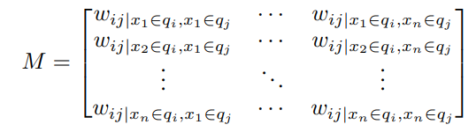

Here we first generate the Q x Q Markov transition matrix W similar to earlier by dividing our data into Q quantile bins. The quantile bins that contain the data at time stamp i and j are qi and qj (j ∈ [1, Q]). Each element Mij in the MTF matrix denotes the transition probability of qi⟷qj. We basically spread out matrix which contains the transition probability on the magnitude axis into the MTF matrix by considering the temporal positions.

The MTF encodes the multi-span transition probabilities of our raw data by allocating the probability from the quantile at time step i to the quantile at time step j at each pixel Mij. The transition probability between the points with time interval k is defined by Mi,j||i-j|=k. For example, Mij|j-i =1 represents the transition process along the time axis with a skip step. When k = 0, the special case of the main diagonal denotes the probability from each quantile to itself (the self-transition probability) at time step i. Further MTF size is reduced by averaging the pixels in each non-overlapping $mxm$   patch with the blurring kernel ${\{\frac{1}{m^{2}}\}}_{mxm}$  to manage the image size and make our computation efficient, which is basically aggregating the transition probabilities in each subsequence of length m together. The whole procedure of encoding time series into images can be depicted in following:

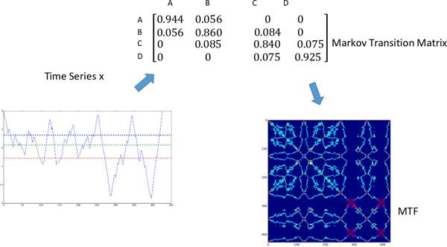

We are using 2-D time series data to convert to images, which consists of all 3 phase line to line voltage values. Below are few images that we have gotten after encoding our data using MTF:

**V. CNN STRUCTURE**

Convolutional neural networks are considered to be one of the best neural networks for image recognition and classification. A CNN structure usually contains one or more convolutional layer or subsampling layer followed by one or more fully connected layers.

VI RESULTS

VII CONCLUSION