Index
S.No. | Content | Page No.
1. | CERTIFICATE | I
2. | DECLARATION | II
3. | ACKNOWLEDGEMENT | III
4. | PLAGIARISM | IV
4. | INTRODUCTIO N OF MIICROP ROJECT | 1
5. | BODY(CODE ) | 2
6. | OUTPUT | 19
7. | CONCLUSION AND REFERRANCE | 20

- INTRODUCTION OF MICRO PROJECT
A personal portfolio website is a simple webpage that showcases skills, projects, achievements, and contact information. This micro project helps in understanding how HTML is used to structure a webpage and how CSS is used to style it. The goal was to create a responsive and visually appealing portfolio that represents my work in a professional way.
S.NO. | TECHNOLGY USED | DISCRIPTION
1. | HTML | It provides structure and content of a webpage.
2. | CSS | CSS is used to style and visually lay out the content defined by HTML.

2.2.Body (Code):
<source code>
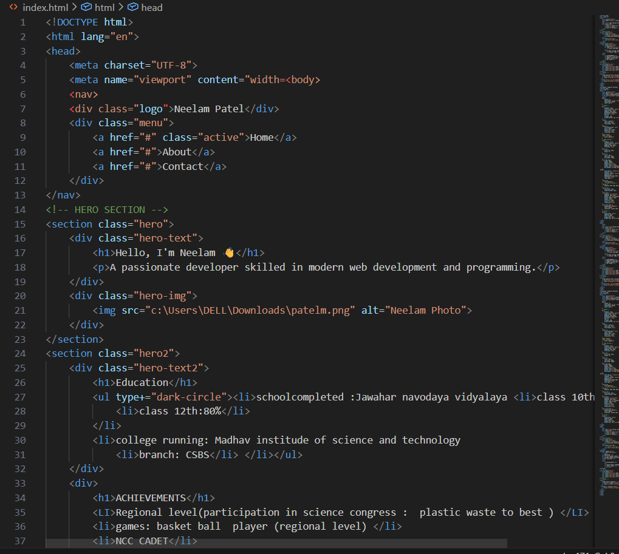
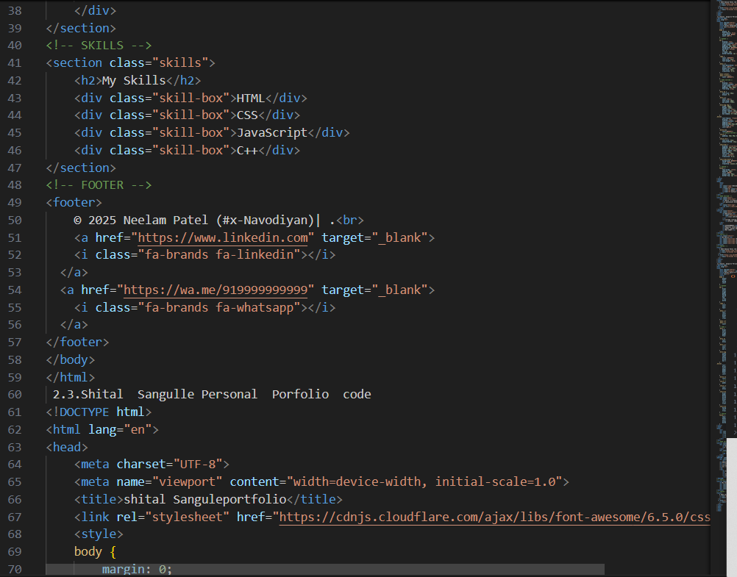
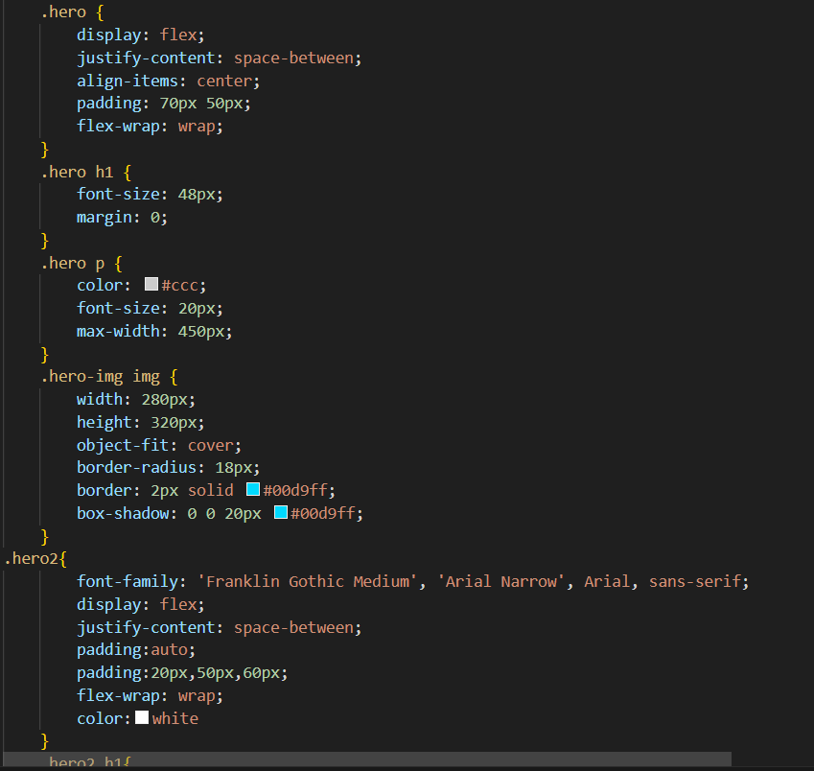

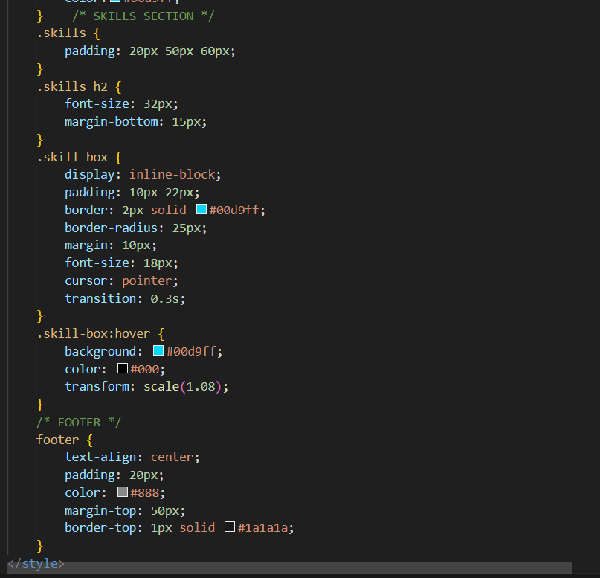
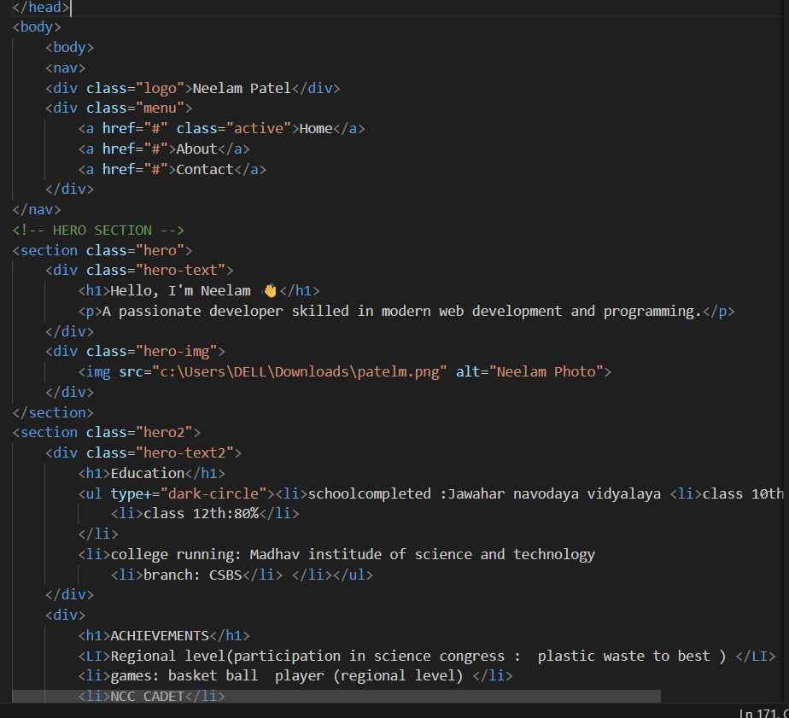
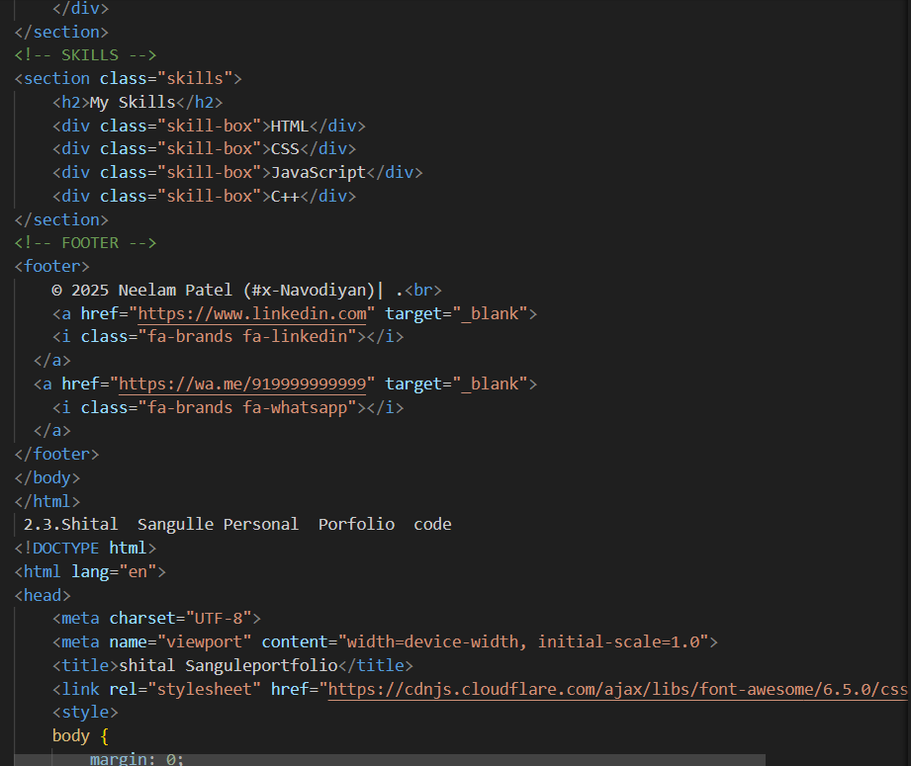

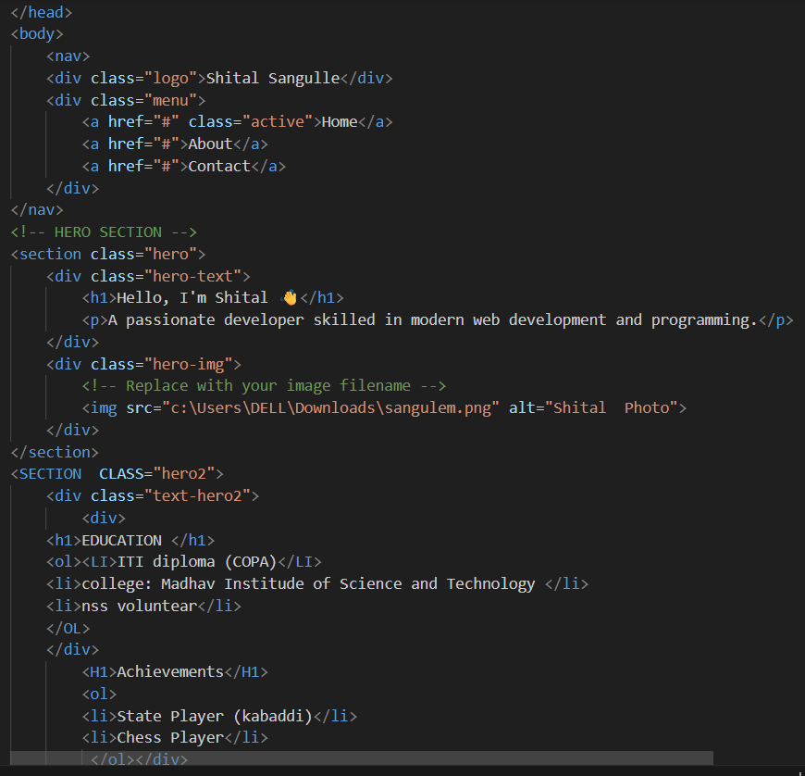
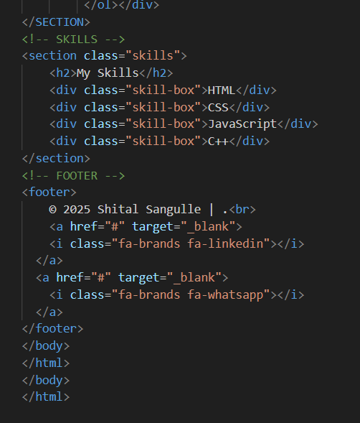

3.4.Saved this file by these name
- First webpage= micro.html
- Second webpage=N1micro.html
- Third webpage = S1micro.html

4. Output (Sreenshots of webpages):
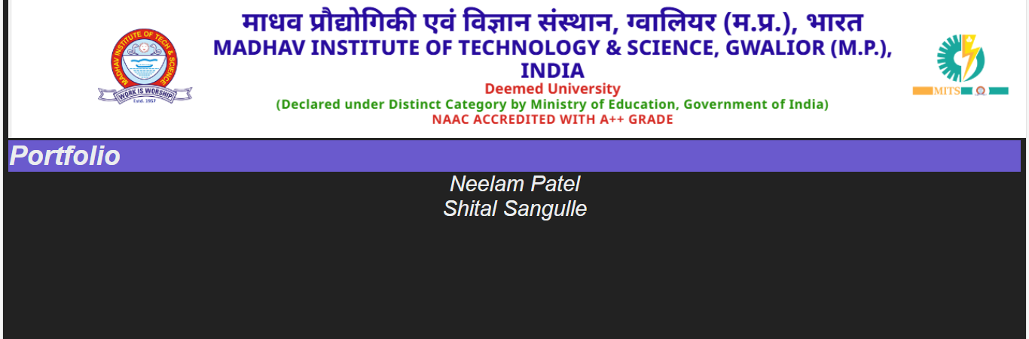

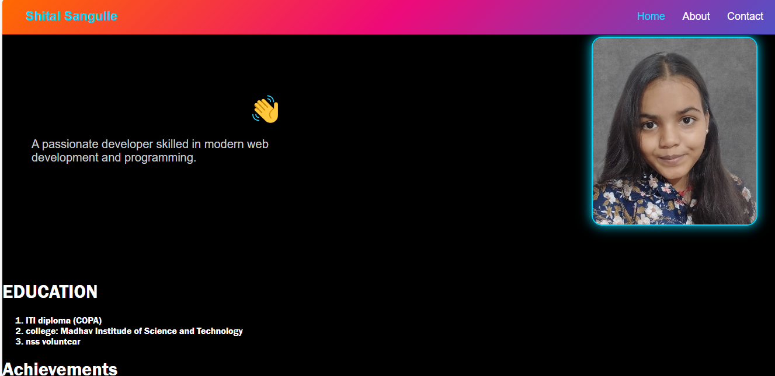

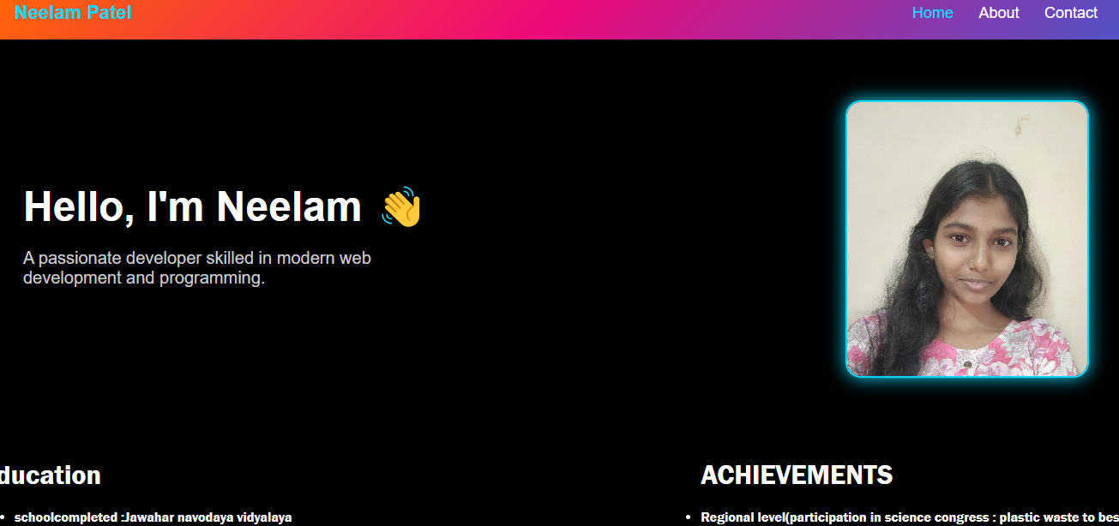

8.Conclusion :
This project helped me create a simple and effective personal portfolio using HTML and CSS .through this project work, I learned how to structure a webpage and connected to each other , apply style .
This portfolio highlights my education Skills , Achievements ,and personal details in a page .
After completing this micro project I am able to build my confidence in front-end Development .
Overall this project successfully demonstrate my ability to develop a responsive appealing static webpage.

Reference:
- Youtube
- Chatgpt
- Classnotes and teacher guidance
- Online code editors(vs code)

