

Nadimpalli Satyanarayana Raju Institute of Technology
(Autonomous)
Sontyam 531 173, Andhra Pradesh

AGENTIC AI

Report

Summer Internship II

Submitted by

Adapa Dharani
(23NU1A0501)

in partial fulfillment for the award of the degree of
BACHELOR OF TECHNOLOGY

in

Department of Computer Science & Engineering

MAY – JULY, 2026

Nadimpalli Satyanarayana Raju Institute of Technology
(Autonomous)
Sontyam 531 173, Andhra Pradesh

AGENTIC AI

Report

Summer Internship II

Carried out at

CodeCraft Learning Hub Pvt. Ltd., Remote

in partial fulfilment for the award of the degree of
BACHELOR OF TECHNOLOGY

in

Department of Computer Science & Engineering

MAY - JULY,2026

BONAFIDE CERTIFICATE

Certified that this internship report Agentic AI. Is the bonafide work of “Adapa Dharani” who carried out Summer internship under our supervision at M/S Name of the company

Signature of the Faculty supervisor Signature of the Industry Supervisor
L.T. Priyanka Ch. Suresh Kumar
Asst. Professor Program Manager
CSE CODECRAFT LEARNING-HUB PVT LTD.

Signature of the Head of the Department
Dr. RAYUDU SRINIVAS
Professor and Head of Department
CSE

Table of Contents
No. | Description | Page Number
 | Name of the Company | CodeCraft Learning Hub Pvt Ltd
 | Company URL | https://www.codecraftlearning.net
1 | Profile of the Company | v
2 | Certificate of Summer Internship II | vi
3 | Learning Outcomes of Summer Internship | 1
4 | Program Outcomes Addressed (List) | 2 - 3
5 | Abstract | 6
6 | Detailed Internship work | 7 - 8
7 | Learning Outcomes (PO – wise)
7 | PO #1 | 9
7 | PO #2 | 10
7 | PO #3 | 11
7 | PO #4 | 12
7 | PO #5 | 13
7 | PO #6 | 14
7 | PO #7 | 15
7 | PO #8 | 16
7 | PO #9 | 17
7 | PO #10 | 18
7 | PO #11 |  | 19
7 | PSO #1 & #2 | 20 - 21
8 | Rubrics (Internal Review & Final Presentation Review) | 22
9 | Feedback  Write your experience with the company | 23
10 | Photo(s) of your internship experience/Product/Other related | 24

PROFILE OF THE COMPANY

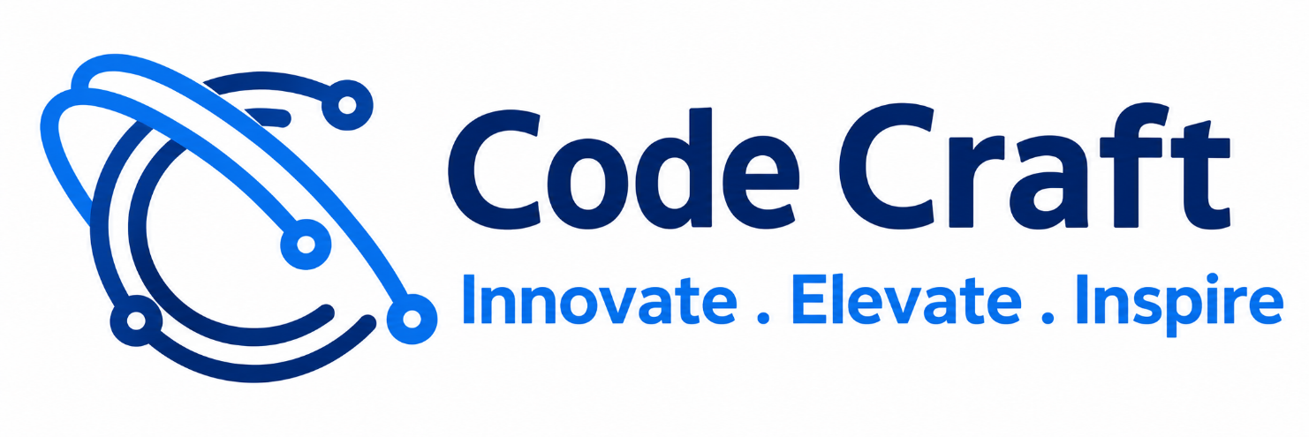

CodeCraft Learning Hub is a technical training and education institute focused on helping students and professionals develop practical software and technology skills. Its main areas of focus include Data Science, Artificial Intelligence, Machine Learning and software-related technologies.

They provide:
- Data Science training.
- Artificial Intelligence (AI) training.
- Machine Learning (ML) courses.
- Agentic AI training.
- Data Analytics training.
- Real-world project-based learning.
- Career-oriented skill development.
- Power BI and Business Intelligence training.
- Webinars and masterclasses.
Mission
To provide high-quality, industry-relevant education that bridges the gap between academic knowledge and practical skills.
The company aims to equip students with the tools and knowledge required to excel in their careers and drive innovation in Data Science and AI.
Vision:
To revolutionize education by providing innovative, accessible, and personalized learning experiences that empower every student to reach their goals.

CERTIFICATE OF SUMMER INTERNSHIP-II

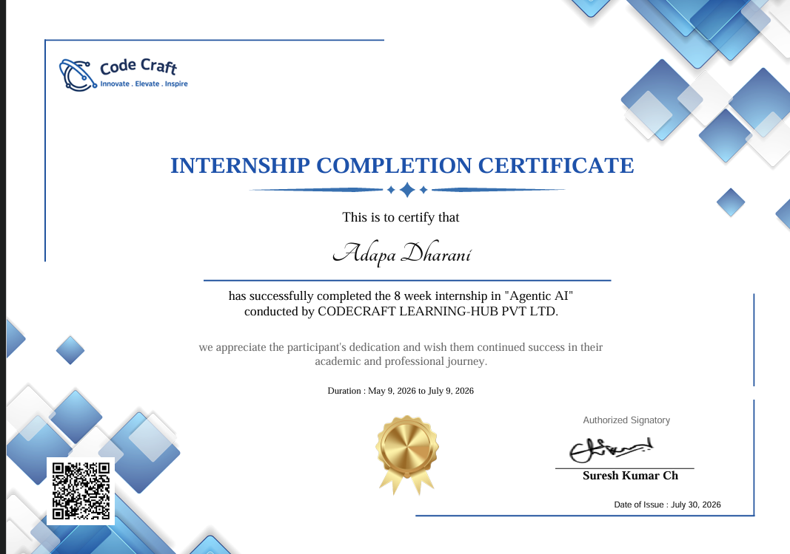

Acknowledgement

We would like to take this opportunity to express my deepest gratitude to my internship supervisor, L.T. Priyanka, Asst. Professor, CSE, N S Raju Institute of Technology (A), Visakhapatnam, who has persistently and determinedly guided me during the whole course of this project. It would have been very difficult to complete this project without his/her enthusiastic support, insight and advice. We are extremely thankful to Dr. RAYUDU SRIVINAS, Professor & Head of CSE Department for providing excellent lab facilities which were helpful in successful completion of my internship program. Our utmost thanks also to all the Trainers of the Company for their support throughout my Summer Internship and Internship Institute Level Coordinators, Dr. P.N.E. Naveen, lead, Assoc. Prof. of ME and Mrs. P. Kavya, Co Lead, Asst. Prof. of CSE (Data Science).

We take immense pleasure in thanking Dr. S. Sambhu Prasad, Principal, N S Raju Institute of Technology (A), Sontyam, Visakhapatnam, for having permitted me to finish the Summer Internship. We thank the MANAGEMENT of N S Raju Institute of Technology (A), Sontyam, Visakhapatnam, for providing the various resources to complete the Summer Internship - II successfully. We are thankful to one and all who contributed to my work directly or indirectly.

Adapa Dharani
(23NU1A0501)
Learning Outcomes of Summer Internship
As per Curriculum

- Demonstrate the theoretical learning outcomes
- Integrate theory and practice during graduation
- Comprehend the Industry practices in the relevant and allied field of study
- Develop Communication Skills in terms of Oral, Written and graphical communications
- Develop Problem solving skills
- Develop work habits and teamwork in a multidisciplinary setting for a successful career after graduation

List of Program Outcomes

As per the Program of Study

Program Outcomes (POs) – Definitions
PO1: Engineering Knowledge | Apply knowledge of mathematics, natural science, computing, engineering fundamentals and an engineering specialization to develop solutions to complex engineering problems.
PO2: Problem Analysis | Identify, formulate, review research literature and analyse complex engineering problems, reaching substantiated conclusions with consideration for sustainable development.
PO3: Design/Development of Solutions | Design creative solutions for complex engineering problems and design/develop systems, components and processes to meet identified needs, considering public health and safety, whole-life cost, net-zero carbon, culture, society and environment, as required.
PO4: Conduct Investigations of Complex Problems | Conduct investigations of complex engineering problems using research-based knowledge, including design of experiments, modelling, analysis and interpretation of data to provide valid conclusions.
PO5: Engineering Tool Usage | Create, select and apply appropriate techniques, resources and modern engineering and IT tools, including prediction and modelling, recognizing their limitations to solve complex engineering problems.
PO6: The Engineer and the World | Analyse and evaluate societal and environmental aspects while solving complex engineering problems for their impact on sustainability, with reference to economy, health, safety, legal framework, culture and environment.
PO7: Ethics | Apply ethical principles and commit to professional ethics, human values, diversity and inclusion; adhere to national and international laws.
PO8: Individual and Collaborative Teamwork | Function effectively as an individual and as a member or leader in diverse/multidisciplinary teams.
PO9: Communication | Communicate effectively and inclusively within the engineering community and society at large, such as being able to comprehend and write effective reports and design documentation, and make effective presentations considering cultural, language and learning differences.
PO10: Project Management and Finance | Apply knowledge and understanding of engineering management principles and economic decision-making, and apply these to one's own work as a member and leader in a team, and to manage projects in multidisciplinary environments.
PO11: Life-Long Learning | Recognize the need for, and have the preparation and ability for independent and life-long learning, adaptability to new and emerging technologies, and critical thinking in the broadest context of technological change.

i) independent and life-long learning ii) adaptability to new and emerging technologies
and iii) critical thinking in the broadest context of technological change

PSO1: Recognize the need for, and have the preparation and ability to engage in independent and life-long learning in the broadest context of technological change. (Life-Long Learning)
PSO2: Ability to apply the knowledge of computing tools and techniques in the field of Data Science for solving real world problems encountered in the Software Industries maintaining the professional standards and ethics.
Sustainable Development Goals

The 17 Sustainable Development Goals (SDGs) established by the United Nations under the 2030 Agenda for Sustainable Development (2015–2030)

S. No. | SDG Number | Sustainable Development Goal
1 | SDG 1 | No Poverty
2 | SDG 2 | Zero Hunger
3 | SDG 3 | Good Health and Well-being
4 | SDG 4 | Quality Education
5 | SDG 5 | Gender Equality
6 | SDG 6 | Clean Water and Sanitation
7 | SDG 7 | Affordable and Clean Energy
8 | SDG 8 | Decent Work and Economic Growth
9 | SDG 9 | Industry, Innovation and Infrastructure
10 | SDG 10 | Reduced Inequalities
11 | SDG 11 | Sustainable Cities and Communities
12 | SDG 12 | Responsible Consumption and Production
13 | SDG 13 | Climate Action
14 | SDG 14 | Life Below Water
15 | SDG 15 | Life on Land
16 | SDG 16 | Peace, Justice and Strong Institutions
17 | SDG 17 | Partnerships for the Goals

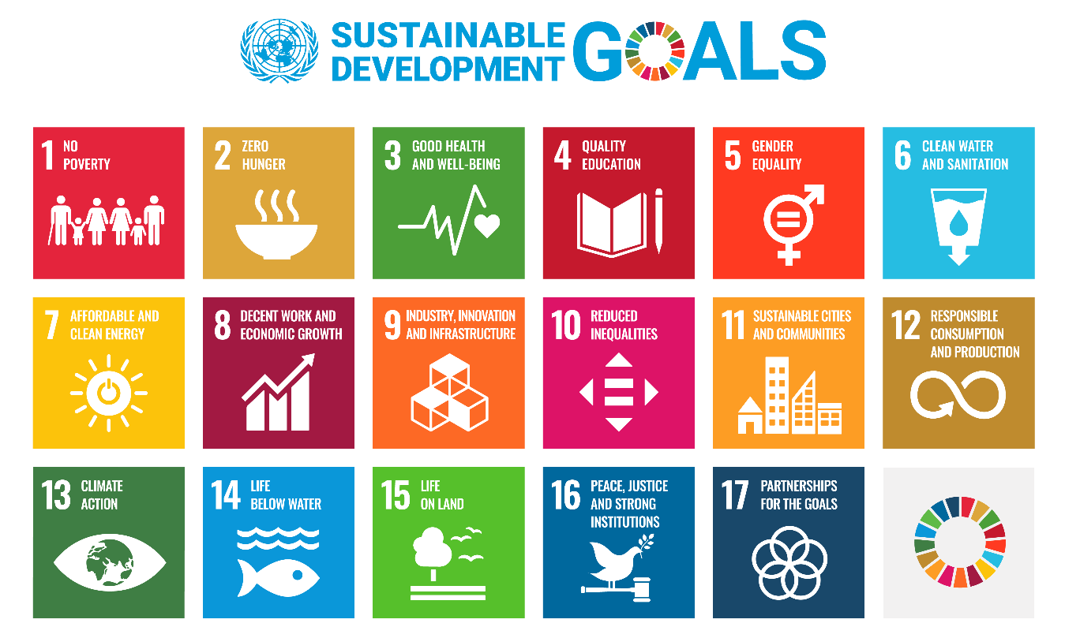

How many SDGs mapped for your internship:

List of SDGs mapped for your internship | Justification based on the internship
SDG 4 - Quality Education | Quality Education: Learning emerging technologies such as Agentic AI, LLMs, RAG and Python supports continuous technical education and skill development.
SDG 8 - Decent Work and Economic Growth | AI-powered applications and workflow automation can improve productivity, support digital skills and contribute to technology-driven employment opportunities.
SDG 9 – Industry, Innovation and Infrastructure | Exploring AI application development, API integration and automated workflows contribute to innovation and the development of intelligent digital infrastructure.
SDG 10 – Reduced Inequalities | AI-based applications can improve access to information and digital services when designed to be accessible and inclusive for users with different backgrounds and abilities.
SDG 12 – Responsible Consumption and Production | Workflow automation and efficient use of computing resources can reduce repetitive manual operations and unnecessary resource consumption.
SDG 16 – Peace, Justice and Strong Institutions | Understanding responsible AI, data privacy, secure API usage and reliable information generation supports transparent and accountable technology practices.
SDG 17 – Partnerships for the Goals: | Learning to integrate different APIs, AI services and automation platforms demonstrates how collaboration between technological tools and service providers can support shared objectives.

Abstract

The internship at CodeCraft Learning Hub Pvt. Ltd., undertaken as an Agentic AI Summer Intern from May to July 2026, provided an opportunity to gain practical knowledge and industry-oriented exposure to Artificial Intelligence and modern software development technologies. The primary focus of the internship was to understand the concepts, tools and techniques involved in developing AI-powered applications, integrating Large Language Models and automating software workflows.

During the internship, I explored Python programming, Large Language Models (LLMs), Retrieval-Augmented Generation (RAG), prompt engineering, context engineering, AI API integration and workflow automation using n8n. These technologies form an important part of modern intelligent application development. The learning activities helped me understand how language models process user instructions, generate responses and utilize contextual information to perform different tasks.

Particular attention was given to understanding Retrieval-Augmented Generation, which combines information retrieval techniques with language generation to provide responses using relevant external knowledge sources. Prompt engineering and context engineering were explored to understand how structured instructions and appropriate contextual information influence the quality and relevance of AI-generated outputs. Additionally, Python and API integration concepts provided an understanding of how AI services can be incorporated into software applications.

The internship also introduced workflow automation through n8n, demonstrating how different services, APIs and operations can be connected to create structured automated processes. This provided insight into reducing repetitive manual activities and improving operational efficiency through automation.

Throughout the internship, I developed a better understanding of AI application architecture, system integration, technical problem-solving and the limitations of AI-generated information. I also gained awareness of responsible AI practices, data privacy, secure API usage and professional ethics.

Overall, this internship strengthened my technical foundation and improved my ability to understand and work with emerging technologies. The knowledge gained provides a foundation for further exploration of Agentic AI, intelligent automation and AI-driven software development.

Detailed Internship Work

1. Introduction and Internship Overview
I completed my internship at CodeCraft Learning Hub Pvt. Ltd. as an Agentic AI Summer Intern from May to July 2026. The internship focused on understanding modern Artificial Intelligence technologies and their applications in software development. It provided exposure to the tools and techniques used to build intelligent applications, integrate language models and automate repetitive operations. The internship helped me understand how theoretical computer science concepts can be applied to practical technology requirements.

2. Python Programming and AI Application Development
Python programming formed an important foundation for understanding AI-based application development. During the internship, I explored the role of Python in implementing application logic, processing information and interacting with AI services. I strengthened my understanding of how programming concepts can be used to organize application components and support intelligent functionalities. I also gained an understanding of how Python-based applications can communicate with external services through APIs.

3. Large Language Models (LLMs)
I explored Large Language Models and their role in modern Artificial Intelligence applications. I learned how these models process natural language inputs, understand contextual information and generate human-readable responses. The learning activities introduced me to the capabilities of LLMs in text generation, question answering, information processing and conversational applications.
I also understood that language models have certain limitations, including inaccurate responses, outdated information and the possibility of generating unsupported content. This helped me recognize the importance of validating AI-generated information before using it in practical applications.

4. Prompt Engineering
Prompt engineering was another important area covered during the internship. I learned how to create structured and meaningful instructions to guide the behaviour of Large Language Models. I explored how prompt clarity, task descriptions, input formatting and constraints can influence the quality of generated responses.
I understood that poorly structured prompts may produce irrelevant or incomplete results, whereas clear instructions with defined objectives can improve response consistency. This knowledge helped me understand the importance of effective communication between users and AI systems.

5. Context Engineering
I gained an understanding of context engineering and its importance in developing reliable AI applications. Context engineering involves organizing and providing relevant information to a language model so that it can generate responses based on the requirements of a particular task.
I explored the relationship between user instructions, background information and contextual data. I learned that providing relevant context helps reduce ambiguity and improves the usefulness of generated responses. This concept is particularly important in applications where AI systems need to work with specific information rather than relying only on general model knowledge.

6. Retrieval-Augmented Generation (RAG)
I studied Retrieval-Augmented Generation, a technique that combines information retrieval with language generation. I understood how external knowledge sources can be used to provide relevant information to language models before generating responses.
The learning process introduced me to the general RAG workflow, including document preparation, information processing, retrieval of relevant content and response generation using the retrieved context. I also understood that the quality of retrieved information directly influences the relevance and accuracy of the final response.
This concept demonstrated how AI applications can be designed to answer questions using domain-specific or external knowledge sources.

7. API Integration and AI Services
I explored the role of Application Programming Interfaces (APIs) in connecting software applications with external AI services. I learned how applications communicate with AI models by sending requests and receiving responses through APIs.
This provided an understanding of service integration, request-response communication, authentication requirements and the importance of handling API responses correctly. I also recognized the need to protect API credentials and follow service usage guidelines while developing AI-powered applications.

8. Workflow Automation Using n8n
I was introduced to n8n, a workflow automation platform that allows different applications and services to communicate through interconnected workflow nodes. I explored how triggers, processing nodes and API connections can be organized to automate sequences of operations.
This helped me understand how repetitive manual activities can be converted into structured automated workflows. I also learned about the importance of workflow sequencing, data flow between nodes and handling execution errors. The experience demonstrated how automation can improve efficiency and reduce unnecessary manual intervention.

9. Technical Skills and Professional Learning
Throughout the internship, I developed technical understanding, analytical thinking and independent learning abilities. Exploring unfamiliar technologies encouraged me to refer to technical documentation, understand implementation concepts and evaluate different approaches. I also gained awareness of responsible AI development, data privacy, information security and the importance of validating generated outputs.

Learning Outcomes

PO#1: Engineering Knowledge

During my internship at CodeCraft Learning Hub Pvt. Ltd., I applied the engineering knowledge acquired through my Computer Science and Engineering curriculum to understand and develop solutions involving Artificial Intelligence and modern computing technologies. As an Agentic AI Summer Intern, I worked with concepts such as Python programming, Large Language Models (LLMs), Retrieval-Augmented Generation (RAG), prompt engineering, context engineering and AI-based application development. These activities helped me connect theoretical knowledge of programming, algorithms, data structures and computer science fundamentals with practical engineering applications.

I gained an understanding of how LLMs process natural language inputs, generate responses and use contextual information to perform different tasks. While working with RAG concepts, I explored how external knowledge sources can be integrated with language models to improve the relevance and accuracy of generated responses. I also applied my understanding of APIs to connect AI services with application workflows and enable communication between different software components.

Furthermore, I explored n8n for workflow automation and learned how multiple services, triggers and processing steps can be integrated into automated systems. This strengthened my understanding of software architecture, system integration and computational problem-solving.

The internship also helped me understand the mathematical and computational foundations behind intelligent systems, including data processing, logical operations and model-based reasoning. I learned to select suitable technologies based on the requirements of a particular task rather than relying only on theoretical concepts.

Overall, the internship strengthened my engineering fundamentals and demonstrated how knowledge of computer science can be applied to develop practical AI-driven solutions. It improved my ability to translate academic concepts into technical implementations and prepared me to work with emerging technologies in the software industry.

PO #2: Problem Analysis

During my internship at CodeCraft Learning Hub Pvt. Ltd., I developed problem-analysis skills by working with Artificial Intelligence concepts and understanding how technical requirements can be translated into practical solutions. As an Agentic AI Summer Intern, I explored LLM-based applications, Retrieval-Augmented Generation, prompt engineering, context engineering and automated workflows. Each of these areas required identifying the actual problem, understanding its requirements and determining an appropriate technical approach.

While working with Large Language Models, I understood that the quality of an AI-generated response depends on several factors, including the clarity of the input prompt, the availability of relevant context and the structure of the instructions. I learned to identify problems such as incomplete responses, irrelevant information and inconsistent outputs. I explored how prompt modifications and context management could improve the response quality.

During my learning and implementation of RAG concepts, I examined the limitations of relying entirely on the knowledge already available within a language model. I understood how retrieving relevant external information can help address knowledge gaps and provide more contextually appropriate responses. This encouraged me to analyse information sources, retrieval requirements and response relevance before selecting an approach.

I also worked with API integration and n8n automation concepts, where understanding the sequence of operations, identifying workflow dependencies and analysing possible failures were important. I learned to examine individual workflow steps and understand how an error in one component could affect the complete process.

The internship improved my ability to break complex technical requirements into smaller, manageable problems. It also encouraged logical reasoning, critical thinking and systematic evaluation of different approaches. Overall, I gained practical exposure to analysing engineering problems, identifying their underlying causes and selecting suitable AI and software technologies to develop effective solutions.

PO #3: Design/Development of Solutions

During my internship at CodeCraft Learning Hub Pvt. Ltd., I gained practical exposure to designing and developing technology-based solutions using Artificial Intelligence and automation. As an Agentic AI Summer Intern, I explored the development of AI-driven applications using Python, Large Language Models, Retrieval-Augmented Generation, prompt engineering, context engineering and API integration. These technologies helped me understand how software components can be combined to address real-world requirements.

I learned that developing an effective AI application requires more than simply connecting a language model to an interface. It involves identifying user requirements, selecting suitable AI services, designing appropriate prompts, managing contextual information and establishing communication between different components. I explored these aspects while learning to develop structured AI application workflows.

My exposure to Retrieval-Augmented Generation helped me understand how external knowledge sources can be incorporated into AI systems to provide more relevant responses. I also explored prompt and context engineering techniques to improve the interaction between users and language models. These concepts demonstrated how the design of input structures and information flow influences the overall functionality of an intelligent application.

Additionally, I worked with n8n workflow automation concepts to understand how repetitive operations can be converted into structured automated processes. I learned to organize workflow nodes, configure connections and integrate APIs to coordinate different services. This provided practical knowledge of designing modular workflows that can be modified and extended according to changing requirements.

Throughout the internship, I understood the importance of considering usability, reliability, maintainability and resource efficiency while developing software solutions. I also learned that technical decisions should be based on the intended application and its functional requirements.

Overall, the internship improved my ability to approach software development systematically, design AI-based workflows and understand the complete process of transforming technical requirements into functional solutions.

PO #4: Conduct Investigations of Complex Problems

During my internship at CodeCraft Learning Hub Pvt. Ltd., I developed investigative and analytical skills by exploring the working principles, capabilities and limitations of modern Artificial Intelligence technologies. As an Agentic AI Summer Intern, I studied Large Language Models, Retrieval-Augmented Generation, prompt engineering, context engineering, Python-based AI applications and workflow automation. These activities required experimentation, observation and evaluation to understand how different approaches influence system performance.

While exploring LLM-based applications, I examined how variations in prompts and contextual information could produce different responses. I learned to compare outputs, identify inconsistencies and understand the factors that influence response relevance. This helped me recognize that AI-generated results must be evaluated rather than accepted without verification.

My exposure to RAG introduced me to the investigation of information retrieval and response-generation processes. I explored how relevant external information can support language models and how the quality of retrieved information affects the final output. I also developed an understanding of the importance of examining information sources and maintaining relevant context when building AI applications.

During API integration and n8n workflow exploration, I learned to investigate the behaviour of connected components. I understood how input values, API responses, authentication requirements and workflow execution sequences influence the overall result. When a workflow does not behave as expected, examining individual steps helps identify the source of the problem.

The internship encouraged me to follow a systematic approach involving understanding the problem, exploring available technical methods, testing different configurations and evaluating the resulting behaviour. It also improved my ability to interpret technical information and draw conclusions based on observed results.

Overall, the internship provided practical exposure to research-oriented problem investigation. It strengthened my analytical thinking, experimental approach and ability to evaluate AI-based solutions before considering them suitable for practical applications.

PO #5: Engineering Tool Usage

During my internship at CodeCraft Learning Hub Pvt. Ltd., I gained practical experience using modern engineering and information technology tools for Artificial Intelligence development, API integration and workflow automation. As an Agentic AI Summer Intern, I explored Python, Large Language Models, AI APIs, Retrieval-Augmented Generation techniques, prompt engineering, context engineering and the n8n automation platform. These tools helped me understand how different technologies can be integrated to develop intelligent applications.

Python was an important programming technology in my internship because of its usefulness in application logic, data processing and AI-related development. I strengthened my understanding of how programming concepts can be applied when interacting with AI services and developing application workflows. I also explored AI APIs to understand how external language models and other services can be accessed through software applications.

My exposure to LLMs and RAG helped me understand the tools and techniques used to build applications that generate responses using language models and external information. I learned that selecting an appropriate model or service depends on factors such as application requirements, response quality, available context and computational limitations.

I also explored n8n as a workflow automation tool. It helped me understand how different applications and services can communicate through nodes, triggers and API connections. I learned how automation tools can reduce repetitive manual operations and coordinate multiple tasks within a single workflow.

Along with learning these tools, I understood their limitations. AI-generated responses may contain inaccurate information, API services may have usage restrictions, and automated workflows may fail because of incorrect configurations or connectivity issues. Therefore, I recognized the importance of testing, validation and monitoring.

Overall, the internship improved my confidence in selecting and using appropriate engineering tools. It also helped me understand that modern software development requires continuous learning and responsible use of technology to produce reliable and efficient solutions.

PO #6: The Engineer and the World

During my internship at CodeCraft Learning Hub Pvt. Ltd., I developed an understanding of how Artificial Intelligence and automation technologies influence society, businesses and the environment. As an Agentic AI Summer Intern, I explored LLM-based applications, RAG systems, prompt engineering, API integration and automated workflows. This experience helped me recognize that engineering solutions should not be evaluated only on their technical functionality but also on their broader impact.

Artificial Intelligence has the potential to improve productivity by automating repetitive tasks, supporting information retrieval and assisting users in making informed decisions. Through my exposure to AI applications and n8n automation, I understood how technology can reduce manual effort and improve the efficiency of different processes. At the same time, I learned that automation should be implemented carefully, particularly when systems handle important information or influence decisions affecting people.

I also developed awareness of privacy and information security considerations while working with AI APIs and contextual information. Applications that process user inputs or external data must handle information responsibly. Sensitive information should be protected, and access to data should be controlled according to application requirements. Similarly, AI-generated responses should be reviewed when accuracy is important.

Another important aspect I understood was the environmental and economic impact of computing resources. AI systems can require significant computational power, so selecting suitable models, avoiding unnecessary processing and designing efficient workflows can contribute to more responsible technology usage.

The internship also helped me understand the importance of accessibility and usability when developing technology-based applications. Software solutions should be designed to support users with different levels of technical knowledge and should provide understandable and useful interactions.

Overall, this experience helped me recognize the responsibility of engineers in developing technologies that benefit society. I gained awareness of the relationship between technical innovation, economic efficiency, privacy, safety and environmental sustainability.

PO #7: Ethics

During my internship at CodeCraft Learning Hub Pvt. Ltd., I understood the importance of professional ethics, responsible technology usage and ethical decision-making while working with Artificial Intelligence and automation technologies. As an Agentic AI Summer Intern, I explored LLMs, RAG, prompt engineering, context engineering, Python-based applications and API integration. These technologies provided opportunities to understand the ethical responsibilities associated with developing and using intelligent systems.

One of the important ethical considerations I learned was the need to maintain data privacy and confidentiality. AI applications may process user inputs, documents and other contextual information. Such information must be handled responsibly, and sensitive data should not be exposed unnecessarily. I understood the importance of using appropriate authentication mechanisms, restricting access to information and following the privacy requirements associated with the services being used.

I also recognized the importance of accuracy and transparency in AI-generated outputs. Large Language Models may occasionally produce incorrect, misleading or unsupported information. Therefore, AI-generated responses should be verified before being used for important decisions. I learned that developers should not present generated information as completely reliable without proper validation.

Another important aspect was responsible API usage and compliance with service guidelines. AI services and automation platforms have their own usage conditions, access restrictions and security requirements. Developers must follow these conditions and avoid unauthorized access, misuse of information or inappropriate handling of credentials.

During the internship, I also understood the value of professional conduct, discipline, accountability and respect for different perspectives. Working in a technology-oriented learning environment encouraged me to approach tasks honestly, accept feedback and continuously improve my technical understanding.

Overall, the internship strengthened my awareness of ethical responsibilities in engineering. It helped me understand that developing intelligent applications requires not only technical knowledge but also integrity, privacy awareness, accountability and respect for human values and applicable laws.

PO #8: Individual and Collaborative Teamwork

During my internship at CodeCraft Learning Hub Pvt. Ltd., I improved my ability to work independently while understanding the importance of collaboration in a professional engineering environment. As an Agentic AI Summer Intern, I explored technologies such as Python, Large Language Models, Retrieval-Augmented Generation, prompt engineering, context engineering, API integration and n8n workflow automation. Learning and applying these technologies required independent technical exploration as well as an understanding of how individual contributions fit into broader development activities.

I developed the habit of independently studying unfamiliar concepts, referring to technical documentation and experimenting with different approaches to understand how AI-based systems operate. Since technologies such as RAG and Agentic AI involve multiple interconnected concepts, I learned to divide larger technical tasks into smaller activities and complete them systematically. This improved my self-management, responsibility and ability to solve technical challenges independently.

The internship also helped me understand the importance of collaborative learning. In a professional technology environment, developers and team members may have different areas of expertise. Sharing technical knowledge, discussing implementation approaches and understanding feedback can help improve the quality of engineering work. I recognized that effective teamwork requires active listening, clear communication, mutual respect and willingness to consider alternative solutions.

While exploring API integration and workflow automation, I understood how different software components must work together to achieve a common objective. This strengthened my appreciation of coordination and dependency management in software development.

I also learned the importance of accepting suggestions, communicating difficulties and maintaining professional discipline while completing assigned activities. These experiences helped me become more adaptable when working with unfamiliar technologies and technical requirements.

Overall, the internship improved my ability to function as an independent learner and a collaborative engineering team member. It strengthened my responsibility, cooperation, adaptability and readiness to contribute effectively in multidisciplinary software development environments.

PO #9: Communication

During my internship at CodeCraft Learning Hub Pvt. Ltd., I improved my technical communication skills by learning to understand, interpret and communicate information related to Artificial Intelligence and software development. As an Agentic AI Summer Intern, I explored technologies such as Python, Large Language Models, Retrieval-Augmented Generation, prompt engineering, context engineering, AI APIs and n8n workflow automation. Understanding these technologies required the ability to express technical concepts clearly and communicate implementation-related information effectively.

One of the important areas I explored was prompt engineering. This helped me understand how clearly structured instructions and well-defined inputs influence the responses generated by language models. I learned that effective communication with AI systems requires clarity, appropriate context and logically organized instructions. These principles also improved my understanding of how to communicate technical requirements in software development.

My exposure to RAG and AI application development helped me become familiar with technical terminology and the processes involved in intelligent application workflows. I developed a better understanding of how information flows between different components, how APIs exchange data and how automated workflows execute a sequence of operations. This knowledge improved my ability to explain technical processes in a structured manner.

The internship also highlighted the importance of communicating technical problems clearly. When an application or workflow does not produce the expected result, explaining the issue, identifying the affected component and describing the observed behaviour are important for effective troubleshooting.

I also recognized the importance of documentation in software development. Maintaining clear descriptions of technical approaches, configurations and workflow structures makes systems easier to understand, maintain and improve.

Overall, the internship strengthened my ability to communicate technical information, understand engineering discussions and explain software-related concepts. It improved my confidence in expressing ideas and reinforced the importance of clear, professional and inclusive communication when working with colleagues, mentors and technical teams.

PO #10: Project Management and Finance

During my internship at CodeCraft Learning Hub Pvt. Ltd., I developed an understanding of project management principles and their importance in the development of Artificial Intelligence applications and automated software solutions. As an Agentic AI Summer Intern, I explored Python, LLMs, RAG, prompt engineering, context engineering, API integration and n8n workflow automation. These activities helped me understand how technical tasks must be organized, planned and executed to achieve the intended objectives.

I learned that developing an AI-based application involves multiple stages, including requirement understanding, technology selection, workflow design, implementation, testing and evaluation. Each stage contributes to the successful completion of the overall development process. I understood the importance of identifying task dependencies and organizing activities in a logical sequence, particularly when integrating multiple APIs and automation components.

My exposure to n8n helped me understand how workflows can be structured into individual operations and connected to perform automated tasks. This demonstrated the importance of planning execution sequences and managing dependencies between different services. Similarly, working with AI APIs introduced me to considerations such as service availability, usage limitations and integration requirements.

I also gained awareness of the economic aspects of technology development. AI services may involve API usage charges, computational expenses and infrastructure requirements. Therefore, selecting suitable models, avoiding unnecessary API requests and designing efficient workflows can help control operational costs. I understood that a technically functional solution should also be practical and economical.

The internship encouraged me to approach technical activities with discipline, manage learning tasks systematically and focus on completing objectives within available time. It also helped me recognize the importance of quality evaluation and continuous improvement before considering a solution complete.

Overall, this internship strengthened my understanding of engineering project management, resource utilization, cost awareness and task coordination. It demonstrated how management principles contribute to developing efficient, maintainable and economically practical software solutions.

PO #11: Life-Long Learning

During my internship at CodeCraft Learning Hub Pvt. Ltd., I recognized the importance of continuous learning and adaptability in the rapidly evolving field of Computer Science and Engineering. As an Agentic AI Summer Intern from May to July 2026, I gained exposure to emerging technologies such as Large Language Models, Retrieval-Augmented Generation, prompt engineering, context engineering, AI API integration and n8n workflow automation. This experience demonstrated that engineering knowledge must be continuously updated to remain relevant in the technology industry.

Before the internship, my academic learning provided a foundation in programming, computing concepts and software development. However, working with modern AI technologies introduced me to concepts that required additional independent learning and practical exploration. I understood that learning a new technology involves more than knowing its definition; it requires understanding its working principles, identifying its applications and exploring its limitations through practical experimentation.

I developed an interest in independently exploring technical documentation, understanding new tools and experimenting with different implementation approaches. Learning about LLMs and RAG helped me recognize the importance of staying updated with advancements in AI and machine learning. Similarly, exploring n8n and API integration demonstrated how different technologies can be combined to create new software capabilities.

The internship also improved my ability to adapt when facing unfamiliar technical requirements. I learned to approach new concepts with curiosity, break complicated topics into manageable sections and gradually develop practical understanding. I also recognized that feedback and continuous evaluation are important for improving technical knowledge and professional performance.

Furthermore, I understood that emerging technologies introduce new opportunities as well as challenges. Engineers must continuously develop their technical skills, analytical thinking and problem-solving abilities to respond effectively to technological changes.

Overall, this internship strengthened my commitment to lifelong learning. It motivated me to continue exploring Artificial Intelligence, Agentic AI, automation and software engineering while improving my ability to learn independently and adapt to future technological developments.

PSO #1: Life-Long Learning

During my internship at CodeCraft Learning Hub Pvt. Ltd., I recognized the importance of continuous learning and the ability to adapt to technological advancements in the field of Computer Science and Engineering. As an Agentic AI Summer Intern, I gained exposure to emerging technologies such as Python programming, Large Language Models (LLMs), Retrieval-Augmented Generation (RAG), prompt engineering, context engineering, AI API integration and n8n workflow automation. This experience helped me understand that the software industry continuously evolves and that engineers must regularly update their knowledge and technical skills.

My academic background provided a foundation in programming, data structures, algorithms and software development. However, exploring Agentic AI and modern AI application development introduced me to several new concepts that required independent learning and practical exploration. I learned to understand unfamiliar technologies by referring to technical documentation, studying implementation approaches and experimenting with different configurations.

I also understood that working with AI technologies requires continuous learning because new models, frameworks, tools and development techniques are introduced frequently. My exposure to LLMs and RAG helped me recognize the importance of understanding how intelligent systems work, their practical applications and their limitations. Similarly, learning n8n and API integration improved my ability to explore tools that simplify software development and automate repetitive tasks.

The internship encouraged me to develop independent problem-solving habits, technical curiosity and adaptability. I learned to approach unfamiliar challenges systematically, identify the knowledge required and improve my understanding through continuous practice.

Overall, this internship strengthened my commitment to lifelong learning and professional development. It motivated me to continue improving my skills in Artificial Intelligence, Agentic AI, Data Science and software engineering. I understood that continuous learning is essential for remaining technically competent and contributing effectively to the rapidly changing software industry.

PSO #2: Application of Computing Tools and Techniques in Data Science

During my internship at CodeCraft Learning Hub Pvt. Ltd., I gained practical exposure to applying computing tools and techniques to develop Artificial Intelligence-based solutions for real-world software requirements. As an Agentic AI Summer Intern, I explored Python programming, Large Language Models (LLMs), Retrieval-Augmented Generation (RAG), prompt engineering, context engineering, AI API integration and n8n workflow automation. These technologies helped me understand how computational methods can be used to process information, generate intelligent responses and automate software operations.

Python provided a foundation for understanding AI application development and implementing programming logic. I explored how AI services can be integrated into software applications through APIs and how different components communicate to perform specific operations. My exposure to LLMs helped me understand natural language processing capabilities and their applications in intelligent software systems.

I also studied Retrieval-Augmented Generation, which combines information retrieval with language generation. Through this concept, I understood how external knowledge sources can be used to provide relevant contextual information to language models. This approach is useful in applications that require information-based responses rather than depending entirely on the model's existing knowledge.

Additionally, I explored prompt engineering and context engineering to understand how structured instructions and relevant information influence AI-generated outputs. My experience with n8n introduced me to workflow automation, where different services and APIs can be connected to perform tasks with reduced manual intervention.

The internship also helped me understand professional responsibilities while developing software solutions. I recognized the importance of data privacy, secure API usage, output validation, responsible AI practices and compliance with professional standards. I learned that intelligent applications must be reliable, efficient and developed with consideration for ethical requirements.

Overall, the internship improved my understanding of applying computing tools and AI techniques to software industry requirements. It strengthened my ability to connect programming knowledge with practical AI applications and prepared me to contribute to technology-driven solutions while maintaining professional standards and ethics.

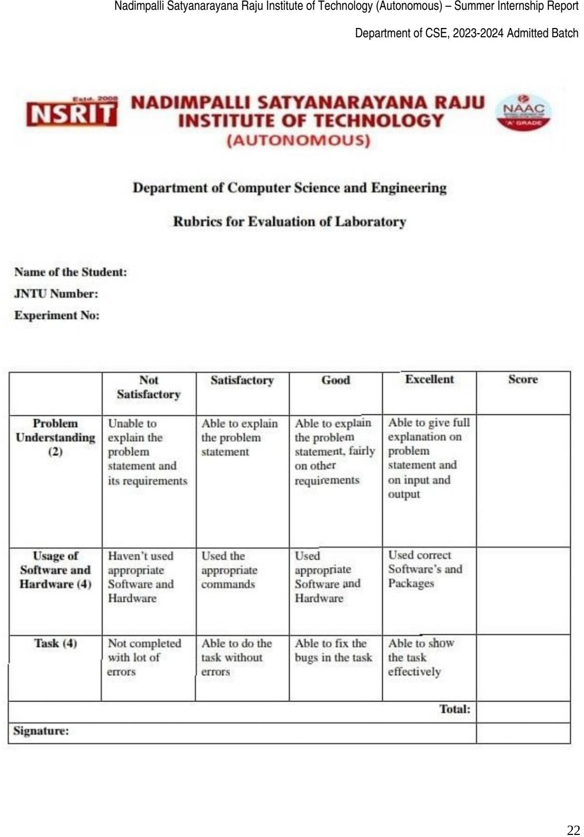

Overall Feedback

My internship at CodeCraft Learning Hub Pvt. Ltd. as an Agentic AI Summer Intern from May to July 2026 was a valuable learning experience that helped me connect my academic knowledge with emerging technologies used in the software industry. The internship provided an opportunity to explore Artificial Intelligence, Large Language Models (LLMs), Retrieval-Augmented Generation (RAG), prompt engineering, context engineering, Python programming, API integration and workflow automation using n8n.

One of the most valuable aspects of this internship was gaining an understanding of how AI technologies can be used to develop intelligent applications and automate complex tasks. Learning about LLMs helped me understand their capabilities in natural language processing and content generation. Exploring RAG provided knowledge of integrating external information with language models to improve the relevance of generated responses. Similarly, learning prompt and context engineering helped me understand the importance of structured instructions and relevant information in obtaining better AI outputs.

The exposure to n8n and API integration improved my understanding of connecting different applications and services through automated workflows. It also helped me recognize the importance of logical thinking, system integration and efficient task execution in software development.

The internship strengthened my technical knowledge, independent learning abilities, problem-solving approach and adaptability to new technologies. It also increased my awareness of responsible AI development, data privacy and professional ethics.

Overall, my experience at CodeCraft Learning Hub Pvt. Ltd. was beneficial in developing my technical foundation and professional confidence. It motivated me to explore Agentic AI and advanced software development further. The knowledge and experience gained through this internship will support my academic progress and future career opportunities in the technology industry.

Screenshorts:



