# Issues

* Hard of hearing accessibility
  + Subtitles?
* Obesity & physical health
* Mental health
* Student mental health (health & education?)
* Rising global temperatures
* Single use plastic
* People with disabilities
  + Visible
  + Nonvisible
* Covid-19
* Human trafficking (child, sex, & labor)
  + Awareness campaign

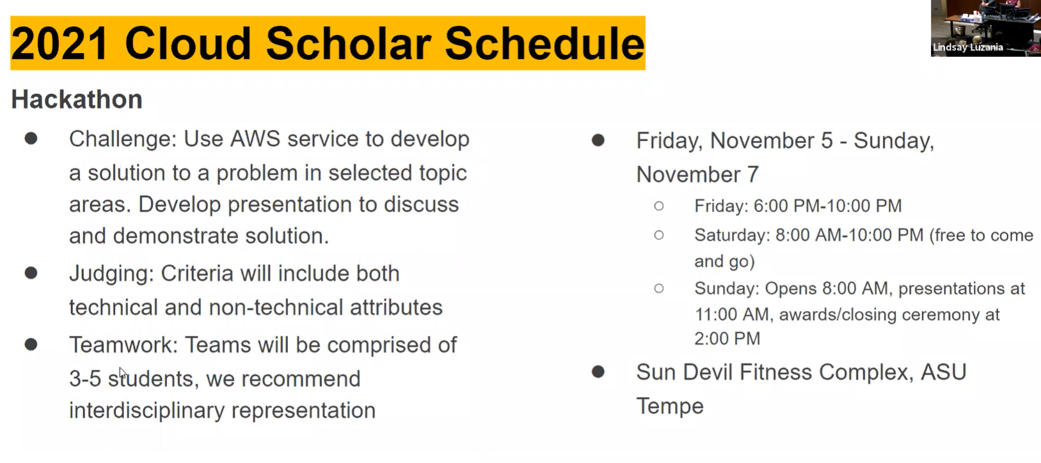

# Methods

* Accessing and presenting database information

# Resources

* [ASU Accessibility](https://accessibility.asu.edu/)
* [ASU School of Sustainability](https://schoolofsustainability.asu.edu/)
* [ASU Inclusion & Diversity](https://inclusion.asu.edu/)
* [AWS Sustainability in the Cloud](https://sustainability.aboutamazon.com/environment/the-cloud?energyType=true)
* [AWS Sustainability Energy](https://aws.amazon.com/energy/sustainability/)
* [AWS Inclusion, Diversity, & Equity](https://aws.amazon.com/diversity-inclusion/)
* [AWS Education](https://aws.amazon.com/education)
* [AWS Health](https://aws.amazon.com/health/)
* [What is API design?](https://www.redhat.com/en/topics/api/what-is-api-design) (great for checking if our api & presentation are good)
* API Gateway stuff
  + [Building an API in Node.js using AWS λ, API Gateway, and Serverless](https://medium.com/tech-at-nordstrom/building-a-rest-api-in-node-js-using-aws-services-mongodb-and-serverless-framework-9e0530baaa3f)
  + [Getting started with API Gateway](https://docs.aws.amazon.com/apigateway/latest/developerguide/getting-started.html) (!!!)
  + [What does an API gateway do?](https://www.redhat.com/en/topics/api/what-does-an-api-gateway-do)

- - - - - - - - -

# Accessibility

# Diversity, Equity, and Access

# Education

# Health

# Sustainability

- - - - - - - - -

# Idea

Food labeling

* Diets & Dietary restrictions
  + Vegan, Vegetarian, Allergies, Calories/Nutrition Info, Gluten-free, Keto, Lactose Intolerance
* Health, Accessibility, Sustainability?

# Goals

Technical

* Create an API!
  + Create the minimum, presentable project by 3pm Saturday

Non-technical

* Address an important social issue!

# Group Conventions

* Naming: undercase_underscore
* “Free” (gluten free, dairy free, etc.)

# Presentation

