A problem to test candidate’s

* Problem solving ability
* Python coding ability
* Data analysis ability

You are given a csv file which holds daily weather data for a location. You are required to

1. Extract latitude and longitude values from the first column Loc_ID (a combination index holding latitude, longitude and planting date information, the format is ‘latitude_longitude_plantingDate’).

1. Calculate daily GDD values for crop winter wheat
2. Sum up daily GDD values to generate accumulated GDD values on daily basis
3. Calculate day length values for each day using the latitude, longitude and day of the year

The expected output is as following:

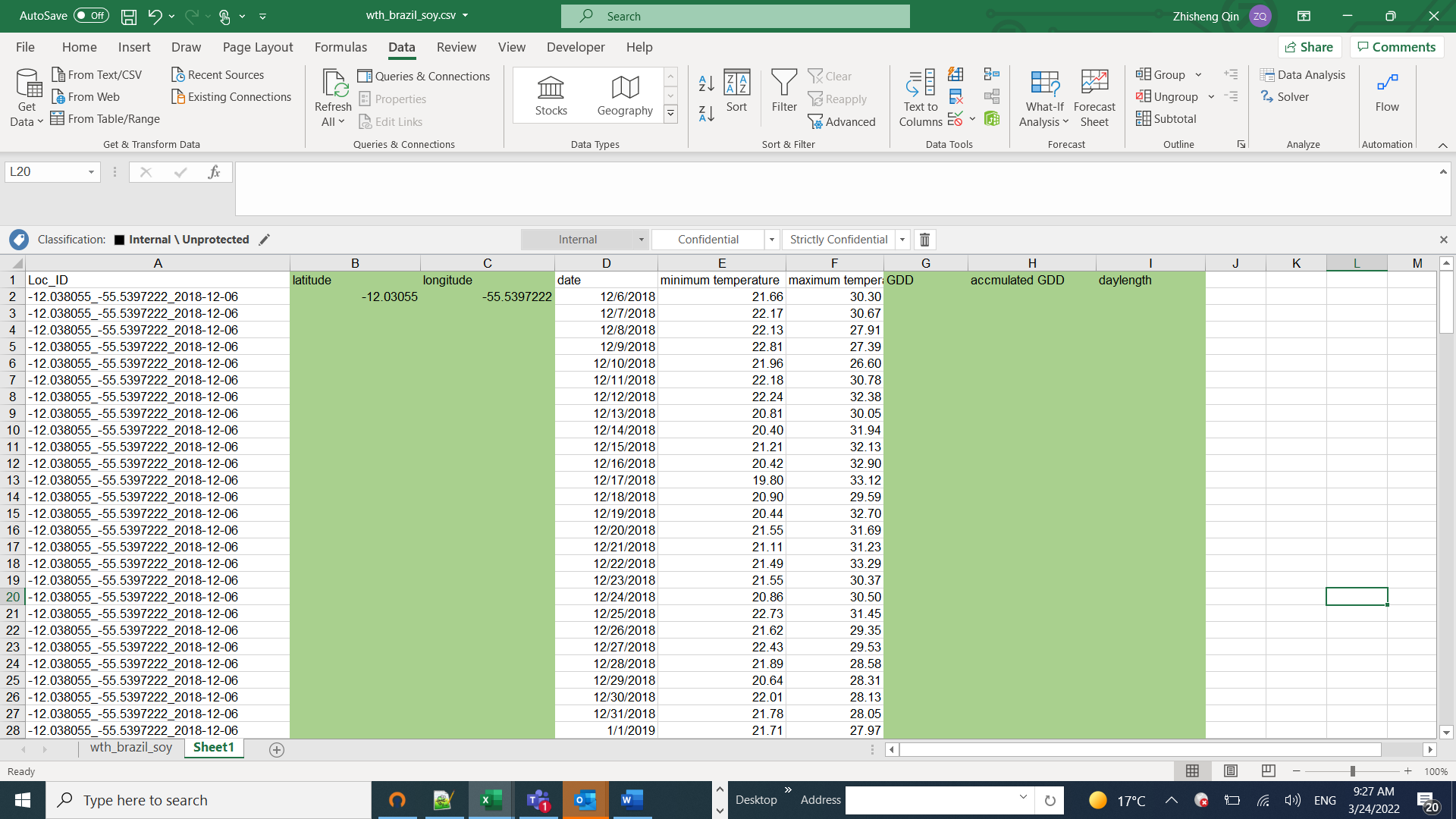

Please note: the columns highlighted in green are the ones you need to fill up values using your python code.

Attention:

1. This task requires you to search internet to find out and study the concept of GDD (Growing Degree Days), and accumulated GDD, and its relevance to model crop growth stage. Hint: for winter wheat, to calculate GDD, you can use 0 as lower threshold temperature and 30 as upper threshold.
2. Don’t be overwhelmed. Do your best and see how much you can accomplish. Perfect solution to this problem is not required at level of internship
3. You may use pandas, numpy, and matplotlib libraries
4. Bonus work: plot GDD, accumulated GDD and daylength using python