

**PROJECT PROTOTYPE PDF**

**Team Details:**

* **Team Name: TriCore Blaster**
* **Team Member - 1:**
  + **Name: RITURAJ**
  + **Email Id: ritutajd.das007@gmail.com**
  + **Contact Number: 8550966167**
* **Team Members - 2:**
  + **Name: AMIT SOREN**
  + **Email Id: btech10223.20@bitmesra.ac.in**
  + **Contact Number: 7294879980**
* **Team Members - 3:**
  + **Name: NEELESH RANJAN**
  + **Email Id: btech10212.20@bitmesra.ac.in**
  + **Contact Number: 9470514719**

**Project Details:**

**Domain: EMBEDDED**

**Project Name: SMART SCREEN**

**Theme: SMART DEVICES**

**Problem Statement / Objective:**

The project name is “Smart Screen” and is based on the voice control and wireless technology via Bluetooth and can be operated with the help of mobile phone. By this project it is indicated that the wired technology has become out dated and it is the time to rely on the wireless devices and systems.

**Solution To the Problem / Objective Stated:**

The project is basically a voice controlled wireless smart screen. The screen takes the voice as input and according to the input it displays the output on the screen. This will save the time of user and all the processes are little bit faster because the input is of the voice form. Also, it can be operated with the mobile phone via Bluetooth.

**Description Of The Project:**

SMART SCREEN

The SMART SCREEN constitutes of “ARDUINO UNO “, “BLUETOOH HC-06”, “LM016L- 16X2 LCD DISPLAY”, “RED-LED-42 no’s”.

COM Port- 3 - Incoming

Virtual Baud Rate – 9600

The display has the capacity to display with the help of red leds according to the voice commands given to it with the help of mobile phone via Bluetooth.

PROJECT CODE

 

**SMART SCREEN**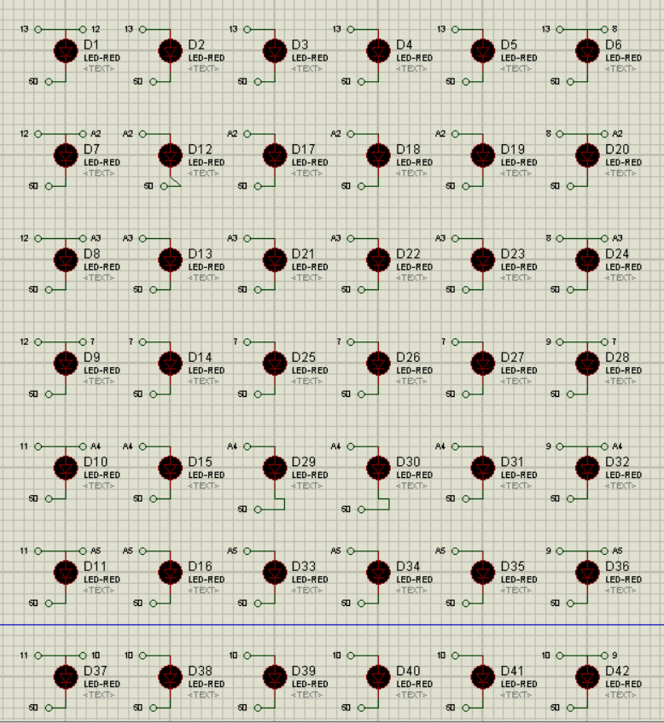

**SIMULATION IMAGE** 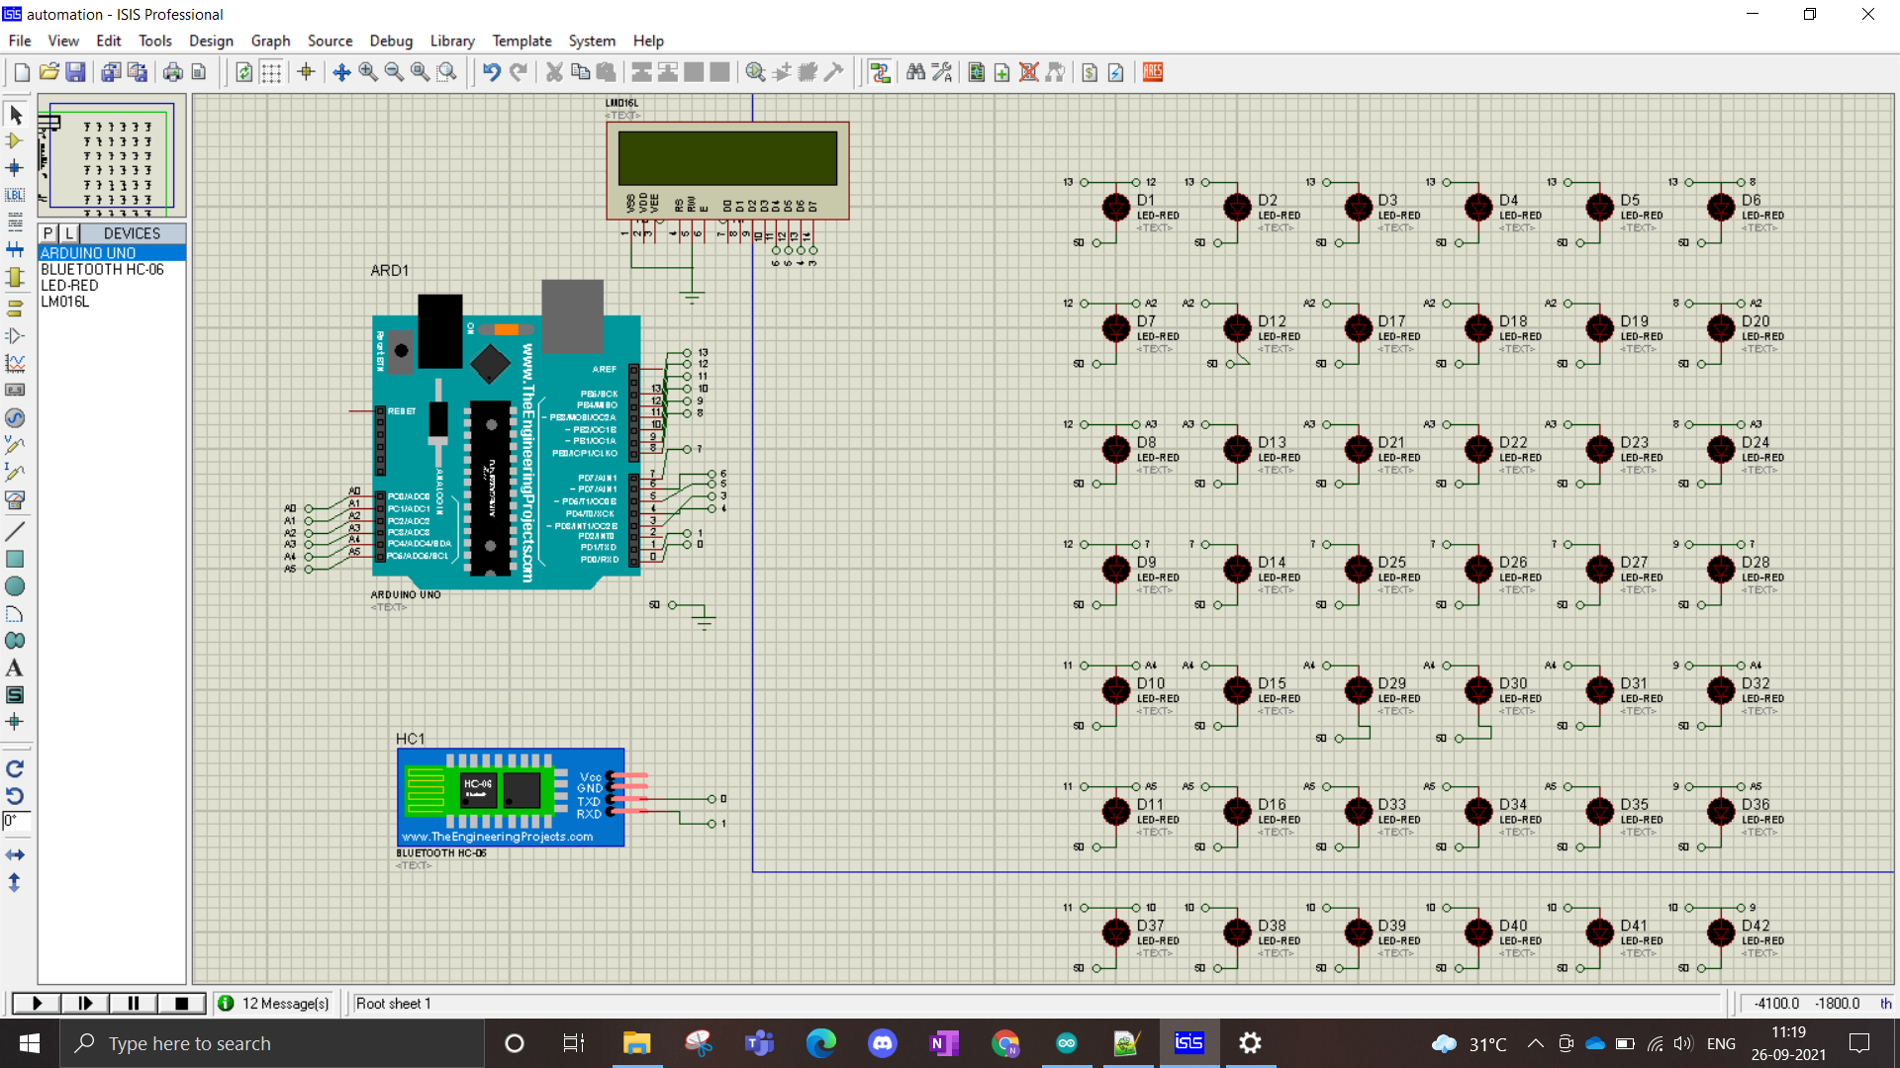

INPUT – “2+3”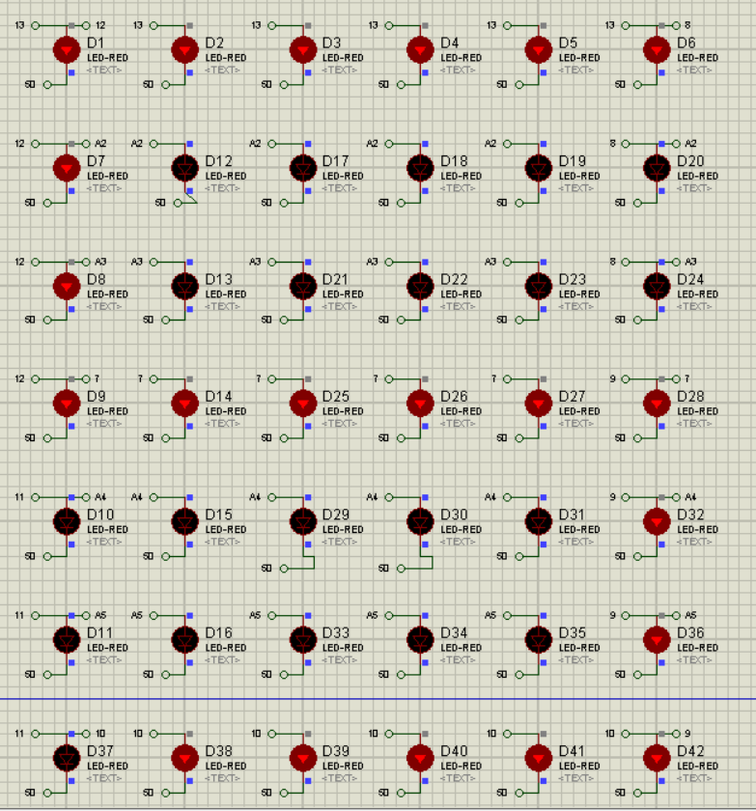

INPUT- “4+4”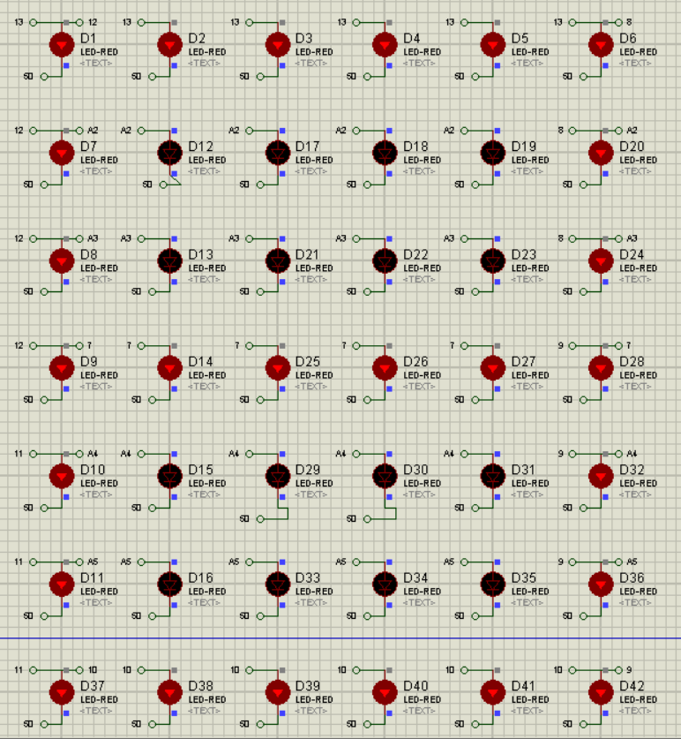

INPUT- “light on”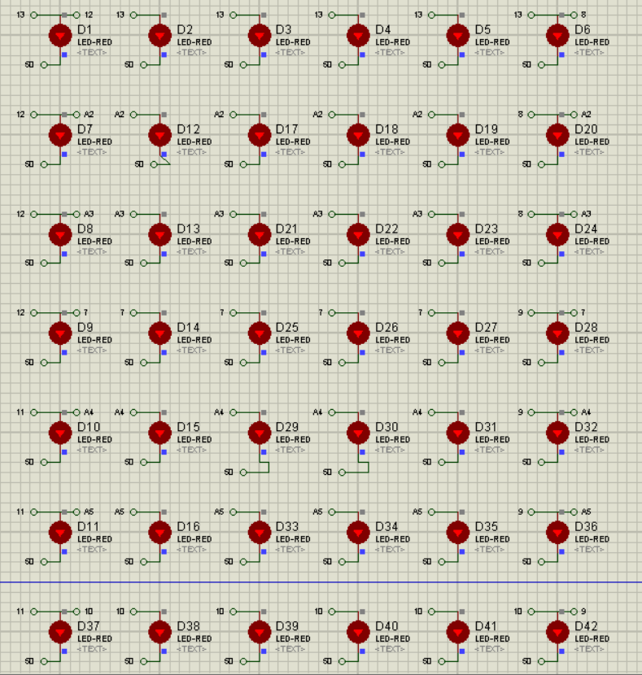

INPUT- “display patterns”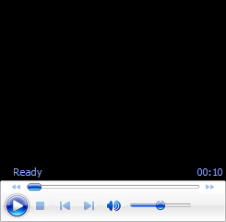

**Feasibility and Applicability:**

**Usability:**

Displaying numbers, light on and off, displaying different patterns, single digit sum calculator, blinking lights.

* **Specify Features:**

Voice controlled through google assistant, completely wireless, can be controlled through your mobile phone, has the range of that of the specified Bluetooth chip installed on the laptop and mobile phone, as the screen if of LED type so it is an power efficient device.

* **Scalability:**

This project can work in a large scale because it is completely wireless and voice controlled through mobile phones via Bluetooth.

* **How Realistic to Achieve/Make:**

This project can be easily made by using the hardware components used in the simulation and are easily available and cost effective. This project consists of all the basic components present in an Arduino kit.

* **Economic Sustainability:**

As state, this project is a cost effective one as it consists of all the basic components present in an Arduino kit and are easily available.

* **Environment Sustainability:**

The project is a voice controlled wireless device so will reduce the cost of wires and somewhat become cost effective but as it is wireless one so there will be definitely some kind of radiations present nearby.

* **Any Threat/Risk/Problem that you can foresee?:**

There is definitely no reason of any risk while implementing this project. Moreover, it is an eco-friendly one.

* **Any Improvement in your project you foresee to implement in future:**

The capability of this “Smart Screen” can be taken more and more by further coding the Arduino board and adding more lines to the present code in the way you want to display on the screen with voice control.

THANK YOU