Homework 1

1. Solve Kleinberg and Tardos, Chapter 1, Exercise 1. (5pts)

False. Consider the case with *n* = 2, with two men *m*1 and *m*2 and two women *w*1 and *w*2, where *m*1 ranks *w*1 first, *w*1 ranks *m*2 first, *m*2 ranks *w*2 first, and *w*2 ranks *m*1 first. Then there does not exist a pair (*m, w*) such that *m* ranks *w* first and *w* ranks *m* first, so there does not exist a stable matching that contains (*m, w*).

Rubric (5pt):

* + 2 pt: Correctly identifies the statement is false.
  + 3 pt: Provides a correct counterexample as explanation.

1. Determine whether the following statement is true or false. If it is true, give an example. If it is false, give a short explanation. (5pts)

For some *n ≥* 2, there exists a set of preferences for *n* men and *n* women such that in the stable matching returned by the G-S algorithm when men are proposing, every woman is matched with their most preferred man, even though that man does not prefer that woman the most.

True: Consider the following set of preferences among *n* = 3 men and women:

| Men | Preferences | Women | Preferences |
| --- | --- | --- | --- |
| 1 | C > A > B | A | 1 > 2 > 3 |
| 2 | A > B > C | B | 2 > 3 > 1 |
| 3 | A > C > B | C | 3 > 1 > 2 |

Then an execution of the G-S algorithm may proceed as follows:

1. Man 1 proposes to woman *C*, who accepts.
2. Man 2 proposes to woman *A* who accepts.
3. Man 3 proposes to woman *A*, who rejects.
4. Man 3 proposes to woman *C*, who accepts, freeing man 1.
5. Man 1 proposes to woman *A*, who accepts, freeing man 2.
6. Man 2 proposes to woman *B*, who accepts.

Then the algorithm terminates with man 1, 2, and 3 matched with woman *A*, *B*, and *C*, respectively. Note that every woman is matched with their most preferred man, even though that man does not prefer that woman the most.

Rubric (5pt):

* + 2 pt: Correctly identifies the statement is true.
  + 3 pt: Provides a correct example and explanation

1. Solve Kleinberg and Tardos, Chapter 1, Exercise 4. (15pts)

***You will see variations of this problem throughout the semester, so spend time on it! :)

We will use a variation of the G-S algorithm, then show that the solution returned by this algorithm is a stable matching. In the following algorithm, we use hospitals in the place of men; and students in the place of women, with respect to the earlier version of the G-S algorithm given in Chapter 1. This algorithm terminates in *O*(*mn*) steps because each hospital offers a position to a student at most once, and in each iteration some hospital offers a position to some student.

The algorithm terminates by producing a matching *M* for any given preference list. Suppose there are *p >* 0 positions available at hospital *h*. The algorithm terminates with all of the positions filled, since, any hospital that did not fill all of its positions must have offered them to every student. Every student who rejected must be committed to some other hospital. Thus, if *h* still has available positions, it would mean total number of available positions is strictly greater than *n*, the number of students. This contradicts the assumption given, proving that all the positions get filled.

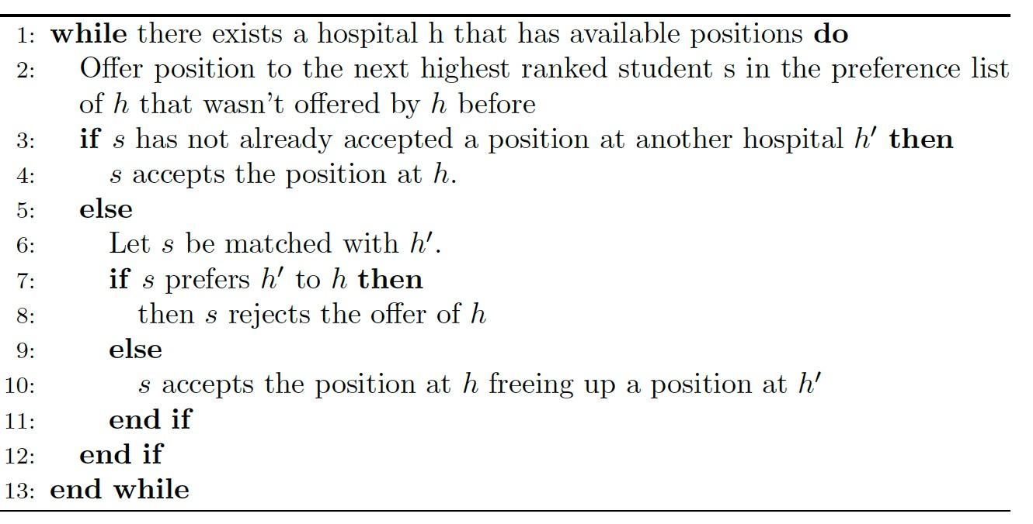

The assignment is stable. Suppose that the matching *M* produced by our adapted G-S algorithm contains one or more instabilities. If the instability was of the first type (a student *s′* was preferred over a student *s* by a hospital *h* but was not admitted), then *h* must have made an offer to *s* before *s′* who wasn’t offered, which is a contradiction because *h* prefers *s′* to *s*. Thus, the instability was not of the first type.

If the instability was of the second type (there are student *s* and *s′* currently at hospitals *h* and *h′* respectively, and there’s a swap mutually beneficial to *h* and *s′*), then *h* must not have admitted *s′* when it considered it before *s*, which implies that *s′* prefers *h′* to *h*, a contradiction. Thus, the instability was not of the second type. Thus, the matching was stable. Thus at least one stable matching always exists (and it is produced by the adapted G-S algorithm as above).

Rubric (15pts):

* + 8pts: Algorithm
    - 1pt: Loop condition (line 1)
    - 2 pts: hospitals offer next highest ranked student (line 2)
    - 2pts: case that s is free (lines 3-4)
    - 3pts: cases if s is at another h’
  + 7pts: Proof
    - 1 pt: Algorithm terminates in finite steps (optional to mention in O(mn) steps)
    - 2pts: All positions get filled
    - 2pts: Explain why no instability of first type
    - 2pts: Explain why no instability of second type

1. Solve Kleinberg and Tardos, Chapter 1, Exercise 8. (10pts)

***Hint: This problem requires a thorough step by step understanding of Gale Shapley.

***Note: This is an existence proof, so one example is sufficient.

Assume we have three men *m*1, *m*2, and *m*3 and three women *w*1, *w*2, and *w*3 with preferences as given in the table below.

Column *w*3 shows the true preferences of woman *w*3, while in column *w′* she pretends she prefers man *m*3 to *m*1.

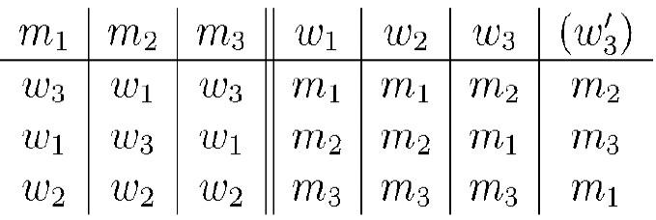

First let us consider one possible execution of the G-S algorithm with the true preference list of *w*3.

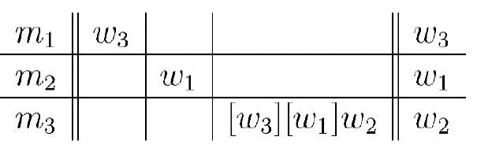

First *m*1 proposes to *w*3, then *m*2 proposes to *w*1. Then *m*3 proposes to *w*2 and *w*1 and gets rejected, finally proposes to *w*2 and is accepted. This execution forms pairs (*m*1, *w*3), (*m*2, *w*1) and (*m*3, *w*2), thus pairing *w*3 with *m*1, who is her second choice. Now consider execution of the G-S algorithm when *w*3 pretends she prefers *m*3 to *m*1 (see column *w′* ).

Then the execution might look as follows:

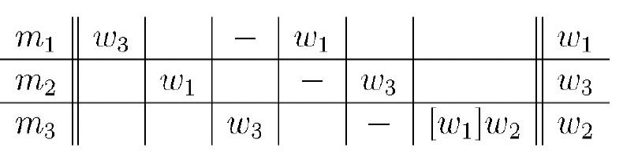

Man *m*1 proposes to *w*3, *m*2 to *w*1, then *m*3 to *w*3. She accepts the proposal, leaving *m*1 alone. Then *m*1 proposes to *w*1 which causes *w*1 to leave her current partner *m*2, who consequently proposes to *w*3 (and that is exactly what *w*3 prefers). Finally, the algorithm pairs up *m*3 (recently left by *w*3) and *w*2. As we see, *w*3 ends up with the man *m*2, who is her true favorite. Thus we conclude that by falsely switching order of her preferences, a woman may be able to get a more desirable partner in the G-S algorithm.

Rubric (10pts):

* 2 pts: Correctly identifies the statement is true.
* 8 pts: Provides a correct explanation and example

**UNGRADED PRACTICE PROBLEMS**

1. Determine whether the following statement is true or false. If it is true, give a short explanation. If it is false, give a counterexample.

For all *n ≥* 2, there exists a set of preferences for *n* men and *n* women such that in the stable matching returned by the G-S algorithm when men are proposing, every woman is matched with their least preferred man.

True: One example occurs when every woman has a different least favorite man, who happens to prefer her over all other women. In this case, each man proposes to and engages their most preferred woman and the engagement is never broken.

2. Solve Kleinberg and Tardos, Chapter 1, Exercise 2. (5pts)

True. Suppose *S* is a stable matching where *m* and *w* are not paired with each other. Suppose that instead *m* is matched with *w′* and *w* is matched with *m′*. Then the pairing (*m, w*) is an instability with respect to *S*, since *m* prefers *w* over *w′* and *w* prefers *m* over *m′*, contradicting the stability of *S*. Thus, every stable matching must contain (*m, w*).

Rubric (5pt):

* + 2 pt: Correctly identifies the statement is true.
  + 3 pt: Provides a correct explanation.