Canonical regression tests miss behaviour-changing faults in computational neuron models: a preregistered held-out evaluation

Title page
Title. Canonical regression tests miss behaviour-changing faults in computational neuron models: a preregistered held-out evaluation
Authors.
Neel Gurram¹ · Samyak Singh¹ · Naithik Somisetti²
¹ Florida Atlantic University, Jupiter, FL, USA
² Florida Atlantic University, Boca Raton, FL, USA
Corresponding author. Neel Gurram, gurramn2025@fau.edu
ORCID. Neel Gurram https://orcid.org/0009-0009-2441-0825 · Samyak Singh https://orcid.org/0009-0003-5825-3975 · Naithik Somisetti https://orcid.org/0009-0009-6638-678X
Acknowledgements. We thank the Open Source Brain and NeuroML communities for maintaining the public model repositories this study depends on. [Add any teacher, mentor or institutional acknowledgement.]

Abstract
Computational neuron models are routinely modified: refactored, converted between units, and ported between formats and simulators. The usual check that such a change preserved behaviour is to re-run the single simulation shipped with the model, a canonical regression test. How much protection that gives has never been measured. We seeded 120 controlled single-site faults into six NeuroML neuron models that were never used during method development, together with 48 behaviour-preserving transformations and 18 numerical stress tests, and compared the canonical test against a three-protocol current-clamp battery selected in advance on seven development models. Detection used electrophysiological features with tolerances calibrated against each model's own discretisation error, and required reproduction at two integration step sizes. The design, endpoint, thresholds and analysis were preregistered before any held-out model was simulated. Of 82 faults that changed behaviour, the canonical test detected 69 (0.841) and the battery 80 (0.976), a paired difference of 0.134 (95% cluster-bootstrap interval 0.013 to 0.221). No behaviour-preserving transformation was flagged by any strategy (0 of 48). Six faults on three models escaped the canonical test on both its summary features and its full voltage trace; all six were detected by the battery. Losses were concentrated in mild faults (0.70 versus 0.95). A single shipped simulation is not sufficient evidence that a modified neuron model still behaves as before.
Keywords. Neuron model validation · Regression testing · Mutation testing · NeuroML · Electrophysiological features · Preregistration

1 Introduction
Computational models of single neurons are long-lived research artefacts. A published model is typically re-implemented, converted between description languages, refactored, ported to another simulator, or edited to change a parameter, often by people other than its original authors. Standardised formats and shared repositories have made this reuse routine: NeuroML describes models in a simulator-independent form (Sinha et al., 2025), and repositories such as NeuroML-DB and Open Source Brain host and characterise large numbers of them (Birgiolas et al., 2023). Most published models ship with a harness that reproduces one reference simulation.
Each modification raises the same question: does the edited model still behave like the original? In practice the answer usually rests on a canonical regression test. The shipped simulation is re-run and its output compared with a stored reference, sometimes automatically, as in the Open Source Brain model validation framework (Marin & Gleeson, 2026). A model that passes is treated as unchanged.
This is a reasonable heuristic, but its protective value has not been quantified. A single stimulus probes a small part of a neuron's input–output behaviour. A change to a slowly activating current may be invisible during a brief current step and obvious during a long one. A shift in a channel's activation curve may alter behaviour only near threshold, or only under a slowly rising input. Work on constructing neuron models has long recognised that the choice of stimulus determines which properties a model is constrained by (Druckmann et al., 2011; Van Geit et al., 2016; Reva et al., 2023), and validation suites such as NeuronUnit and HippoUnit compare models with experimental data under multiple protocols (Gerkin et al., 2019; Sáray et al., 2021; Appukuttan & Davison, 2022). What is missing is a measurement of how often the canonical test misses a change that does alter behaviour, and whether a small, fixed set of additional protocols closes that gap on models it was not designed for.
Software engineering offers a direct way to ask this. Mutation testing seeds known faults into a system and measures which tests detect them (Papadakis et al., 2019); it has been applied to scientific software (Hook & Kelly, 2009; Kelly et al., 2011) and to simulation models of dynamic systems (Zhan & Clark, 2005; Matinnejad et al., 2019). Regression test selection chooses a small suite that retains most of the fault-detecting power of a larger one (Yoo & Harman, 2012). Behaviour-preserving transformations, the counterpart of mutants, check that a suite does not raise false alarms, an idea close to metamorphic testing (Segura et al., 2016). None of this has been used to quantify the protection that canonical regression gives neuron models.
We therefore asked two questions. First, what fraction of behaviour-changing faults does the canonical regression test detect? Second, does a compact battery of perturbation protocols, chosen on one set of models, detect faults the canonical test misses on models it has never seen? To keep the answer honest we separated development from evaluation: every method choice was fixed on development models, the evaluation models and one mutation family were held out, and the design was preregistered before any held-out simulation. We committed in advance to publishing either outcome, including the outcome that canonical regression is adequate.

2 Materials and Methods

2.1 Design and preregistration
The study had a development phase and a single confirmatory evaluation. During development we built and tested the pipeline on seven models in two pilots (Section 2.8) and fixed every parameter: the candidate protocols, the features, the tolerance rule, the fault operators and severities, the classification rules, and the analysis. We then hash-locked the configuration, assigned six models and one mutation family to a held-out set, and registered the design at AsPredicted (#312455, 19 September 2026) before any held-out model was mutated or simulated. The registration states the development results already known and the direction in which they pointed. The confirmatory evaluation was released only after the registration was verified, and it ran once. Any change to a locked file blocks the evaluation; this mechanism refused one launch (Section 4.4).

2.2 Models
Candidate models came from public NeuroML repositories and were screened on thirteen prespecified criteria applied to the unmodified model only: recorded provenance, redistribution rights, required files, NeuroML validity, unattended execution, an interpretable voltage trace, a resolvable recording location, a measurable rheobase with spiking at twice rheobase, deterministic re-execution, feature stability under refinement, a runtime budget, at least three applicable mutation operators, and compatibility with every protocol (Online Resource 1). Screening examined reference behaviour only; no mutation outcome was available at screening.
Six models from four source families met all criteria and came from sources never used in development (Table 1). All are single-compartment conductance-based cells, because the reference simulator integrates single-compartment NeuroML models directly. Development used seven further models from other sources (Section 2.8).

2.3 Faults and controls
Faults were single, documented edits to a model's NeuroML files, produced by operators in three families. Biophysical: scaling a maximal conductance, shifting a reversal potential, scaling membrane capacitance, scaling a gate time constant. Reference: pointing a channel density at a different channel, omitting an include, duplicating a conductance, swapping in a channel of the same ion species. Kinetics (held out from protocol selection): shifting a gate's activation midpoint, scaling its slope, shifting the midpoint of a forward rate.
Magnitude operators were applied at two prespecified severities, mild and strong, defined by bands of
ln k | for multiplicative changes and of millivolts for shifts. Sites were chosen by a seeded generator

fixed before generation. Every edit records the file, element, attribute, and old and new values.
Two further strata were generated and analysed separately. Controls were eight kinds of behaviour-preserving transformation per model: unit conversion, whitespace reformatting, added comments, equivalent numeric literals, consistent renaming of an identifier, moving a component into an included file, reordering independent elements, and writing an inherited default explicitly. Numerical stress tests changed the integration step, the solver setting or the recording resolution; these probe numerical robustness and are never counted as semantic faults. The frozen generator produced 186 variants: 120 faults, 48 controls and 18 numerical stress tests.

2.4 Protocols and features
The canonical test was each model's shipped harness, run unchanged. The candidate protocols were eight current-clamp stimuli scaled to each model's measured rheobase: a weak step (0.5 × rheobase), a rheobase search, a step at 2 × rheobase, a long step (1.5 × rheobase, 2 s), a ramp from 0 to 3 × rheobase over 1 s, a hyperpolarising step, a rebound protocol, and a short suprathreshold pulse (3 ms at 10 × rheobase). Every protocol began with a 300 ms settling period.
Features were extracted with the eFEL library (Mandge et al., 2026): spike count, first-spike latency, last interspike interval, adaptation index, action-potential amplitude and afterhyperpolarisation depth for spiking protocols, and steady-state voltage and deflection for subthreshold protocols. A feature defined in one model and undefined in the other counted as a difference.

2.5 Tolerances and the detection rule
Each feature difference was compared with a tolerance calibrated on the unmodified model,
τ = max(absolute floor, relative term × |f_h|, 3 × |f_h − f_h/2|),
where f_h and f_h/2 are the reference feature at the nominal step h (0.005 ms) and at half that step. The final term makes the threshold at least three times the model's own discretisation error, so a difference the solver could produce by itself cannot count. Floors and relative terms were fixed per feature before any held-out simulation (Online Resource 1).
A strategy detected a fault when one of its protocols showed a difference beyond tolerance, for the same protocol and feature, at h and at h/2. Faults that the canonical test missed but another protocol detected were re-simulated at h/4 for confirmation.
Full voltage traces were compared as a separate validation level that is never merged with the feature comparison. A trace differed when its spike count differed, when any spike time shifted by more than τ_shift = max(0.5 ms, 3 × the reference's own h versus h/2 shift), or when the root-mean-square difference exceeded τ_rmse = max(0.5 mV, 3 × the reference's own h versus h/2 value). A model whose canonical trace tolerance could not be calibrated would be reported as unclassifiable at that level.

2.6 Classification and protocol selection
Each fault was classified in order: structurally invalid, non-executable, numerically unstable, equivalent within the tested domain (no reproducible feature difference on any protocol), non-equivalent and detected by the canonical test, or non-equivalent but missed by it (silent under canonical). Faults in the last two classes are admissible: they changed behaviour, and they form the denominator of the primary endpoint.
The battery was selected on the development models alone, by greedy maximum coverage of their admissible faults under a budget of k = 4 protocols, with ties broken by cost and then by identifier. The kinetics family was excluded from selection. The greedy rule stopped at three protocols, because a fourth added no coverage: the long step, the 2 × step, and the ramp.

2.7 Endpoints and statistical analysis
The primary endpoint was the paired difference in detection rate between the selected battery and the canonical test, Δ = DR_battery − DR_canonical, over admissible held-out faults. The battery was evaluated without the canonical protocol, so the comparison is between two alternative checks rather than between a test and a superset of it. We prespecified Δ ≥ 0.10 as the smallest material difference, and a canonical detection rate ≥ 0.95 as the criterion for calling canonical regression adequate.
The interval for Δ was a cluster percentile bootstrap resampling base models (B = 10,000, seed 20260917), as registered. Supporting tests were an exact McNemar test on discordant pairs, which treats faults as independent, and an exact cluster permutation test on per-model differences, which does not. Because two pairs of models share a source, we additionally report the bootstrap with source family as the cluster. The result was prespecified as inconclusive if more than 10% of controls were flagged, if more than half of apparent canonical survivors failed h/4 confirmation, or if at least 25% of tolerance entries were excluded for refinement instability.
Prespecified secondary analyses were: detection by random protocol batteries matched for size (all 56 three-protocol subsets of the eight candidates) and for cost (10,000 random batteries within the selected battery's budget); the silent-survival rate; control false-positive rates; detection by mutation family and severity; coverage against the number of protocols; cost per detection; and robustness to tolerance multipliers of 0.5, 1, 2 and 4. Analyses added after the confirmatory run are labelled exploratory (Sections 3.7 and 4.4).

2.8 Development work
Two pilots preceded the evaluation and are reported descriptively (Online Resource 2). In the first (two closely related models, 22 admissible faults) the canonical test detected all 22 and the battery 19. In the second (five further models, 88 primary semantic faults, 40 controls) canonical detection counting either validation level was 0.921; nine faults were missed at feature level, two of which also survived full-trace comparison, and no control was flagged. During the second pilot we found and corrected an analysis defect that had counted faults as full-trace survivors on a model whose canonical trace tolerance could not be calibrated; the correction, which introduced the unclassifiable category of Section 2.5, was made before the evaluation and is part of the frozen pipeline. Operator validation had observed the canonical outcome of nine second-pilot faults before that pilot ran, so the pilot is reported both over all faults and over the 79 unexposed ones. No held-out model is affected: none was mutated before the confirmatory run.

2.9 Software, reproducibility and use of AI tools
The method is implemented in NexClamp (version 0.2.0.dev0), an open-source Python package (Apache-2.0) that runs the protocols, extracts the features, calibrates the tolerances, generates the faults and controls, selects the battery, classifies the outcomes and seals each campaign. Simulations used jNeuroML 0.14.0 and jLEMS 0.12.0 on Temurin JDK 21.0.12.1+1, with Python 3.12.10, pyNeuroML 1.3.22, libNeuroML 0.6.7, eFEL 5.7.34 and NumPy 2, on twelve parallel workers. Every simulation is stored write-once under a content-addressed identifier together with its inputs, software versions and outputs. The confirmatory campaign was archived and sealed after completion (17,424 files, each with a SHA-256 checksum), and the pipeline refuses to write into a sealed campaign.
Use of AI tools. The analysis software, parts of the documentation and drafts of this manuscript were produced with the assistance of a large language model (Claude, Anthropic), used under author direction and logged throughout the project. All AI-assisted code was reviewed and tested by the authors; every number reported here is produced by deterministic, version-controlled code from recorded outputs, and the authors verified the outputs against the raw records. The authors take full responsibility for the content of this article. No AI system is an author.

3 Results

3.1 Attrition and controls
Of 120 faults, 114 were schema-valid, 112 executed, 109 were numerically stable, and 82 changed behaviour and are admissible; 27 were equivalent within the tested domain (Fig. 5, Table 2). If faults whose only detected change appeared in the full voltage trace are also counted, 94 changed behaviour; we report the frozen feature-level definition (82) as primary and give both.
No control was flagged by any strategy: 0 of 48 at feature level and 0 of 48 at trace level (exact 95% upper bound 0.074), including at half the calibrated tolerance. None of the prespecified inconclusive conditions occurred: no control was flagged, 0 of 18 apparent canonical survivors failed h/4 confirmation, and no tolerance entry was excluded for refinement instability.

3.2 Primary endpoint
The canonical test detected 69 of 82 admissible faults (0.841, 95% cluster interval 0.78–0.91) and the selected battery 80 of 82 (0.976, 0.92–1.00) (Fig. 1). Paired counts were: both 67, battery only 13, canonical only 2, neither 0. The difference was Δ = 0.134, 95% cluster-bootstrap interval 0.013 to 0.221 (Fig. 2). The exact McNemar test gave p = 0.007; the cluster permutation test, with six clusters and a smallest attainable p of 0.031, gave p = 0.156. With source family as the cluster the interval was 0.040 to 0.232, flagged by the analysis code as unreliable because only four clusters remain.
The battery detected more faults than the canonical test on five of the six models, by two to four faults each. On traub2005_testseg_all the canonical test detected all 12 admissible faults and the battery 10; the two it missed, a shifted gate midpoint and a shifted reversal potential, were detected only by the canonical protocol.
Against the preregistered criteria: the point estimate exceeds the material difference of 0.10 and the interval excludes zero, but its lower end lies below 0.10, so a material advantage is supported by the estimate without being established by the interval. Canonical regression did not meet the adequacy criterion of 0.95.

3.3 Faults that escape the canonical test entirely
The feature comparison is one way to read the canonical simulation; its full voltage trace is another. Of the 94 faults with any detected change, the canonical features detected 69 and the canonical full trace 87 (features only 1, trace only 19, either 88, neither 6; Fig. 3). The trace comparison was calibrated on all six models and fired on 11 to 17 faults per model, so it was an active test rather than an inert one.
Six faults were missed by the canonical test at both levels: four on hay2011_soma, one on bbp2015_soma and one on migliore2005_ca1_soma (Table 3). All six were detected by the battery, reproducibly at h, h/2 and h/4, through changes in spike count or spike timing. They include a 10% increase in the high-voltage-activated calcium conductance of the Hay cell, which reduced the number of spikes during the long step from 14 to 13 while leaving the canonical simulation within tolerance; two changes to the slow M-current (halving its conductance; shifting its reversal potential by −10 mV) that altered spike timing under the 2 × step; and changes to calcium- and A-type potassium-channel gating kinetics that altered spike count or timing under the long step and the ramp. These cases meet the criterion for hidden drift fixed before the second pilot: at least two confirmed full-trace survivors across at least two models.

3.4 Where canonical testing falls short
The canonical test's losses were concentrated in mild faults, which it detected at 0.70 against the battery's 0.95; for strong faults the rates were 0.97 and 1.00 (Table 4). By fault type it missed most often after changes to maximal conductance (0.65 versus 1.00) and to gate time constants (2 of 5 versus 5 of 5). The silent-survival rate, the fraction of admissible faults missed by the canonical test, was 0.159 (95% cluster interval 0.089–0.222). No fault was detected by the canonical protocol at h only.
For the held-out kinetics family, which protocol selection never saw, the canonical test detected 0.864 and the battery 0.955 (22 faults; Δ = 0.091, interval −0.10 to 0.22, flagged unreliable because few models contributed discordant faults). We therefore draw no conclusion about generalisation to the unseen family. For the families seen during development the difference was 0.150 (interval 0.036 to 0.232).

3.5 Protocol selection, coverage and cost
The selected battery detected more faults than 55 of the 56 possible three-protocol batteries drawn from the same candidates (mean 0.846; share at least as good as the selected battery 0.018) and than 97% of 10,000 random batteries of equal cost (mean 0.909; share at least as good 0.030) (Fig. 4). Selection on development models therefore transferred to unseen models. The long step alone reached 90% of the coverage achieved by all protocols combined, and the three selected protocols reached 95%; 100% is not reached without the canonical protocol, because two faults were detected only by it. Per variant the battery cost 1.0 million integration cell-steps against 0.31 million for the canonical test (3.3 ×), and per detected fault 1.03 million against 0.36 million.

3.6 Tolerance sensitivity
Across tolerance multipliers of 0.5, 1, 2 and 4, no control was flagged at any multiplier, while the fraction of faults silent under the canonical test rose from 0.087 to 0.116, 0.152 and 0.203 as tolerances loosened (computed over all 138 faults and stress tests). The main finding does not depend on the tolerance being tight.

3.7 Cross-simulator reproduction (exploratory)
The evaluation used one simulator. To test whether the reference behaviour is simulator-specific, each held-out model was exported to NEURON and its canonical simulation re-run under NEURON 9.0.2. All six models exported, compiled and ran. Spike counts were identical in every case (7, 5, 9, 4, 7 and 4), and matched each model's own published NEURON reference. The largest difference in any spike time was 0.009 to 0.182 ms and whole-trace differences were 0.19 to 2.18 mV root-mean-square, consistent with two integrators rather than two behaviours. This check was added after the confirmatory run and is descriptive: the study's tolerances are calibrated within one integrator and do not transfer across two. It supports the reference simulations against which detections are measured; it does not re-test the faults.

3.8 Verification of the fault sample
Two kinds of check were applied to a sample of 25 faults: the preregistered random sample of 20 plus the six canonical survivors, one of which fell in both.
Automated re-check. Working from the raw files rather than the pipeline's summaries, the edit, the class and every detection were re-derived for all 25. For each fault, the differences between the edited and the unmodified model files were exactly the recorded edit and matched the operator's declared meaning; the class re-derived correctly; all recorded feature detections recomputed from the per-run feature files; spike-count detections were confirmed by recounting spikes directly from the stored voltage traces; and all 227 full-trace detections recomputed.
Human audit. Two of the authors audited the same 25 faults from a self-contained packet containing, for each fault, the exact before-and-after lines of the edited model file, the recorded evidence and a plot of the original against the edited model. They answered three questions per fault: whether the edit matches its label, whether the assigned class is plausible, and whether the detection is plausible. The returned packets, the extracted verdicts and the auditors' notes are published with the data.
Neither auditor judged any edit to be mislabelled (Q1: 41 of 50 answers "yes", 9 "unsure", none "no") or any class implausible except one marking discussed below (Q2: 47 "yes", 2 "unsure", 1 "no"). The two auditors gave identical verdicts on 24 of 25 faults for each question. Their reservations fell into three groups.
Mechanism wording. Four "unsure" answers concern the gate-time-constant operator, which scales a gate's rates through a Q10 setting rather than multiplying the time constant directly, so neither auditor could confirm the exact factor from the edit alone. One further "unsure" concerns a 10 mV reversal-potential shift described in the packet as "a few mV". Both are descriptions in the audit materials rather than defects in the faults; the mechanism is documented and the implementation was confirmed by the automated re-check. We have revised both descriptions.
An option the form lacked in practice. Most "no" answers to the detection question fall on faults with no recorded detection at all, where the intended answer was "not applicable"; one auditor wrote "Q3 is N/A" while marking "no". These are therefore not disputes about the evidence. The form offered "not applicable" only for that question and the instruction was evidently not clear enough.
Two substantive flags, both checked. Both auditors noticed feature rows whose tolerance is infinite and judged, correctly, that such a row can never be exceeded. Seven of 342 tolerance entries are infinite, all of them where the feature is undefined in the reference at both step sizes (for example, first-spike latency on a protocol in which the reference does not spike). Those rows are reached only through the preregistered definedness rule, under which a feature defined in one model and undefined in the other counts as a difference: all 24 detections involving such a row are definedness mismatches and none claims a numeric exceedance. One auditor also flagged a case where a 5 mV reversal shift produced a very large change in interspike interval as disproportionate; the model's persistent sodium conductance makes this plausible, and the detection reproduced at both step sizes.
One marking is unresolved: on a numerical stress test, one auditor marked the class implausible while writing that the class "is satisfied". We report the marking as returned rather than reinterpreting it. [Awaiting that auditor's confirmation before submission.]
The two auditors are authors of this article, so the audit is independent of the analysis software and of each other, but not of the author list. They worked separately and simultaneously in one room, under the observation of the first author, so that neither could consult the other, and neither had access to the automated re-check or to any other result while auditing. Both nevertheless answered "no" to the packet's compound statement "I worked alone and did not see the automated check"; the supervising author has recorded that this reflects a mis-marked statement rather than shared or assisted work, and the returned packets are published unmodified so that readers can see the original marks.

4 Discussion
On six neuron models never used to develop the method, re-running the shipped simulation missed about one in six faults that changed the model's behaviour, while a three-protocol battery chosen in advance missed two of 82. Six faults went unnoticed by the canonical test even when its entire voltage trace was compared, which is the strictest form a canonical regression test can take. No behaviour-preserving transformation was flagged by anything. The pilots had suggested that canonical testing was nearly sufficient; the preregistered held-out evaluation, registered with that expectation stated, did not bear this out.

4.1 Why the misses happen, and what to do about them
The pattern of misses is intelligible. The canonical harnesses are short: their stimulus windows span 60 to 300 ms, and the depolarising steps in four of the six models last 60 to 100 ms. Faults that act slowly, such as a change to the M-current or to a calcium conductance that shapes adaptation, alter firing only as a step continues, near threshold, or under a slowly rising input. The long step, the stronger step and the ramp sample exactly those regimes. Faults with large effects were caught by almost any check; the gap lies in mild faults, which are also the kind most likely to be introduced unnoticed by a unit conversion or a hand edit.
Two practical consequences follow. First, most of the canonical test's shortfall at feature level is recovered by comparing its full voltage trace (88 of 94 against 69 of 94), at no additional simulation cost. Tools that compare only summary features of the shipped simulation should compare traces as well. Second, the remaining misses require other stimuli, and a short battery suffices: the long step alone reached 90% of the achievable coverage, and the three selected protocols cost about three times the canonical simulation, which is small against the effort of reusing a model.

4.2 Relation to existing work
The result is consistent with work on constructing neuron models, where the stimulus set determines which properties a model is constrained by (Druckmann et al., 2011; Van Geit et al., 2016; Reva et al., 2023), and with multi-protocol validation suites that compare models with experimental data (Gerkin et al., 2019; Sáray et al., 2021; Appukuttan & Davison, 2022). Those tools ask whether a model matches biology. Our question is narrower and complementary: whether a modified model still matches its own original. We show that this question, usually answered with one simulation, needs more than one. Methodologically the study imports mutation testing and test selection from software engineering (Papadakis et al., 2019; Yoo & Harman, 2012) into neuron model validation, with behaviour-preserving transformations as the specificity control (Segura et al., 2016).

4.3 Limitations
The evaluation used six models from four source families, so the intervals are wide and the model-level permutation test is underpowered by construction; the interval for Δ excludes zero but does not establish a material advantage. All models are single-compartment, so dendritic faults were out of scope. The faults were evaluated in a single simulator, although every held-out model's reference behaviour reproduced in NEURON (Section 3.7). Faults were synthetic single-site edits; real modification errors may be larger, compound or correlated. Admissibility depends on the definition used (82 at feature level, 94 including trace-only changes), and both are reported. The result for the held-out kinetics family is inconclusive. The frozen generator produced 186 variants against a preregistered estimate of roughly 100 to 150, and selection produced a three-protocol battery under a four-protocol budget; both are reported as they occurred. The human audit found no mislabelled edit and no misclassified fault, but it was carried out by two of the authors rather than by people outside the study, and its independence is qualified as described in Section 3.8.

4.4 Deviations from the registration
All deviations are logged with dates and reasons (Online Resource 2). Those bearing on the evaluation: (i) the runtime screening criterion was raised from 1,800 s to 4,200 s per variant before any held-out model was mutated, because the lower budget left no eligible models; (ii) the registration estimated roughly 100 to 150 variants and the frozen generator produced 186; (iii) the battery contains three protocols under the registered budget of four; (iv) two co-authors joined after registration; (v) a hash-locked planning document was edited after the freeze to add them, the integrity check refused to start the evaluation, and the document was restored byte-for-byte before the run, with no change to any hypothesis, endpoint, split or analysis; (vi) source-family clustering is reported as a sensitivity analysis alongside the registered model-level clustering; and (vii) the cross-simulator check (Section 3.7) was added after the confirmatory run and is exploratory.

5 Conclusions
A canonical regression test is not sufficient evidence that a modified neuron model still behaves as before. On unseen models it missed about one in six behaviour-changing faults, some of which its full voltage trace also missed. Comparing that trace, rather than only its summary features, recovers much of the gap at no extra cost, and a short battery of standard current-clamp protocols recovers nearly all of it without false alarms. We recommend both as routine checks whenever neuron models are edited, converted or ported.

Information Sharing Statement
NexClamp, the software used for every step of this study, is open-source under the Apache-2.0 licence and is distributed from a public repository (https://github.com/neelgurram/nexclamp) with installation and usage documentation; the exact version that produced the results reported here is archived with a persistent identifier ([Zenodo DOI], version 0.2.0.dev0). The frozen study configuration, the model manifest with per-model licences and pinned upstream commits, the preregistration record, every per-variant record (edits, classifications, detections, tolerances), the analysis outputs, and the scripts that regenerate every table and figure in this article are included in that archive. The complete raw simulation output of the confirmatory campaign (17,424 files, 4.1 GB, including all voltage traces) is deposited as a separate archived dataset (https://doi.org/10.5281/zenodo.22928016) together with the SHA-256 manifest that verifies it. The preregistration is publicly readable at https://aspredicted.org/q2ag7w.pdf (AsPredicted #312455).
All neuron models analysed here are third-party open-source NeuroML models, redistributed under their own licences (MIT or GPL-2.0) with their source repositories and commit identifiers recorded in Online Resource 1: the Hay et al. (2011) and Blue Brain (Markram et al., 2015) channel sets, the Traub et al. (2005) test cells, the Smith et al. (2013) channel set, and the Migliore et al. (2005) CA1 cell, all obtained from Open Source Brain. Simulations used jNeuroML 0.14.0/jLEMS 0.12.0 and, for the exploratory cross-simulator check, NEURON 9.0.2, all publicly available.

Statements and Declarations
Funding. This research received no specific grant from any funding agency in the public, commercial or not-for-profit sectors.
Competing interests. The authors declare no competing financial or non-financial interests.
Ethics approval. Not applicable. The study involved no human participants, no animals and no personal data; it analyses published computational models only.
Consent to participate / Consent for publication. Not applicable.
Author contributions. Neel Gurram: conceptualisation, methodology, software, investigation, formal analysis, data curation, validation, visualisation, project administration, writing (original draft, and review and editing). Samyak Singh: formal analysis, validation, writing (review and editing). Naithik Somisetti: formal analysis, validation, writing (review and editing). All authors read, critically revised and approved the final manuscript and agree to be accountable for all aspects of the work.
Data availability. All data supporting the results are publicly archived as described in the Information Sharing Statement: derived per-variant records and analysis outputs in the software and results archive ([Zenodo DOI]), and the complete raw simulation output in the dataset archive (https://doi.org/10.5281/zenodo.22928016). No restrictions apply.
Code availability. NexClamp is available under Apache-2.0 at https://github.com/neelgurram/nexclamp and archived at [Zenodo DOI]. The exact commit, configuration hashes and environment used for the confirmatory campaign are recorded in the archive and in Online Resource 1.

References
Appukuttan, S., & Davison, A. P. (2022). Reproducing and quantitatively validating a biologically-constrained point-neuron model of CA1 pyramidal cells. Frontiers in Integrative Neuroscience, 16. https://doi.org/10.3389/fnint.2022.1041423
Birgiolas, J., Haynes, V., Gleeson, P., Gerkin, R. C., Dietrich, S. W., & Crook, S. (2023). NeuroML-DB: Sharing and characterizing data-driven neuroscience models described in NeuroML. PLOS Computational Biology, 19(3), e1010941. https://doi.org/10.1371/journal.pcbi.1010941
Druckmann, S., Berger, T. K., Schürmann, F., Hill, S., Markram, H., & Segev, I. (2011). Effective Stimuli for Constructing Reliable Neuron Models. PLoS Computational Biology, 7(8), e1002133. https://doi.org/10.1371/journal.pcbi.1002133
Gerkin, R. C., Birgiolas, J., Jarvis, R. J., Omar, C., & Crook, S. M. (2019). NeuronUnit: A package for data-driven validation of neuron models using SciUnit [Preprint]. bioRxiv. https://doi.org/10.1101/665331
Hay, E., Hill, S., Schürmann, F., Markram, H., & Segev, I. (2011). Models of Neocortical Layer 5b Pyramidal Cells Capturing a Wide Range of Dendritic and Perisomatic Active Properties. PLoS Computational Biology, 7(7), e1002107. https://doi.org/10.1371/journal.pcbi.1002107
Hook, D., & Kelly, D. (2009). Mutation Sensitivity Testing. Computing in Science & Engineering, 11(6), 40-47. https://doi.org/10.1109/MCSE.2009.200
Kelly, D., Gray, R., & Shao, Y. (2011). Examining random and designed tests to detect code mistakes in scientific software. Journal of Computational Science, 2(1), 47-56. https://doi.org/10.1016/j.jocs.2010.12.002
Mandge, D., Tuncel, A., Jaquier, A., Kilic, I., Damart, T., Markram, H., Van Geit, W., & Ranjan, R. (2026). eFEL: electrophysiology feature extraction library. Bioinformatics, 42(6). https://doi.org/10.1093/bioinformatics/btag328
Marin, B., & Gleeson, P. (2026). OSB Model Validation (OMV) (Version 0.4.0) [Computer software]. GitHub. https://github.com/OpenSourceBrain/osb-model-validation
Markram, H., Muller, E., Ramaswamy, S., Reimann, M. W., Abdellah, M., Sanchez, C. A., Ailamaki, A., Alonso-Nanclares, L., Antille, N., Arsever, S., Kahou, G. A. A., Berger, T. K., Bilgili, A., Buncic, N., Chalimourda, A., Chindemi, G., Courcol, J., Delalondre, F., Delattre, V., ..., & Schürmann, F. (2015). Reconstruction and Simulation of Neocortical Microcircuitry. Cell, 163(2), 456-492. https://doi.org/10.1016/j.cell.2015.09.029
Matinnejad, R., Nejati, S., Briand, L. C., & Bruckmann, T. (2019). Test Generation and Test Prioritization for Simulink Models with Dynamic Behavior. IEEE Transactions on Software Engineering, 45(9), 919-944. https://doi.org/10.1109/TSE.2018.2811489
Migliore, M., Ferrante, M., & Ascoli, G. A. (2005). Signal Propagation in Oblique Dendrites of CA1 Pyramidal Cells. Journal of Neurophysiology, 94(6), 4145-4155. https://doi.org/10.1152/jn.00521.2005
Papadakis, M., Kintis, M., Zhang, J., Jia, Y., Le Traon, Y., & Harman, M. (2019). Mutation Testing Advances: An Analysis and Survey. Advances in Computers, 112, 275-378. https://doi.org/10.1016/bs.adcom.2018.03.015
Reva, M., Rössert, C., Arnaudon, A., Damart, T., Mandge, D., Tuncel, A., Ramaswamy, S., Markram, H., & Van Geit, W. (2023). A universal workflow for creation, validation, and generalization of detailed neuronal models. Patterns, 4(11), 100855. https://doi.org/10.1016/j.patter.2023.100855
Sáray, S., Rössert, C. A., Appukuttan, S., Migliore, R., Vitale, P., Lupascu, C. A., Bologna, L. L., Van Geit, W., Romani, A., Davison, A. P., Muller, E., Freund, T. F., & Káli, S. (2021). HippoUnit: A software tool for the automated testing and systematic comparison of detailed models of hippocampal neurons based on electrophysiological data. PLOS Computational Biology, 17(1), e1008114. https://doi.org/10.1371/journal.pcbi.1008114
Segura, S., Fraser, G., Sanchez, A. B., & Ruiz-Cortes, A. (2016). A Survey on Metamorphic Testing. IEEE Transactions on Software Engineering, 42(9), 805-824. https://doi.org/10.1109/TSE.2016.2532875
Sinha, A., Gleeson, P., Marin, B., Dura-Bernal, S., Panagiotou, S., Crook, S., Cantarelli, M., Cannon, R. C., Davison, A. P., Gurnani, H., & Silver, R. A. (2025). The NeuroML ecosystem for standardized multi-scale modeling in neuroscience. eLife, 13. https://doi.org/10.7554/eLife.95135
Smith, S. L., Smith, I. T., Branco, T., & Häusser, M. (2013). Dendritic spikes enhance stimulus selectivity in cortical neurons in vivo. Nature, 503(7474), 115-120. https://doi.org/10.1038/nature12600
Traub, R. D., Contreras, D., Cunningham, M. O., Murray, H., LeBeau, F. E. N., Roopun, A., Bibbig, A., Wilent, W. B., Higley, M. J., & Whittington, M. A. (2005). Single-Column Thalamocortical Network Model Exhibiting Gamma Oscillations, Sleep Spindles, and Epileptogenic Bursts. Journal of Neurophysiology, 93(4), 2194-2232. https://doi.org/10.1152/jn.00983.2004
Van Geit, W., Gevaert, M., Chindemi, G., Rössert, C., Courcol, J., Muller, E. B., Schürmann, F., Segev, I., & Markram, H. (2016). BluePyOpt: Leveraging Open Source Software and Cloud Infrastructure to Optimise Model Parameters in Neuroscience. Frontiers in Neuroinformatics, 10. https://doi.org/10.3389/fninf.2016.00017
Yoo, S., & Harman, M. (2012). Regression testing minimization, selection and prioritization: a survey. Software Testing, Verification and Reliability, 22(2), 67-120. https://doi.org/10.1002/stvr.430
Zhan, Y., & Clark, J. A. (2005). Search-based mutation testing for Simulink models. In Proceedings of the 7th Annual Conference on Genetic and Evolutionary Computation (GECCO '05) (pp. 1061-1068). https://doi.org/10.1145/1068009.1068188

Figure captions
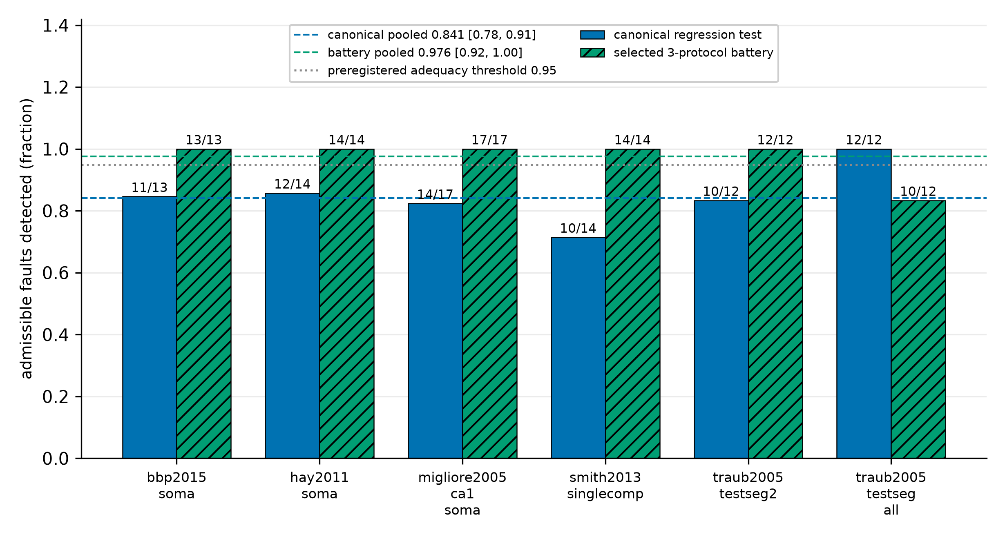
Fig. 1 Detection of admissible faults on each held-out model. Bars show the fraction detected by the canonical regression test (solid) and by the selected three-protocol battery (hatched); counts above each bar are detected/admissible. Dashed lines mark the pooled rates with their 95% cluster-bootstrap intervals (canonical 0.841, battery 0.976); the dotted line marks the preregistered adequacy threshold of 0.95. n = 82 faults on six models never used in development; a detection must reproduce at h and h/2
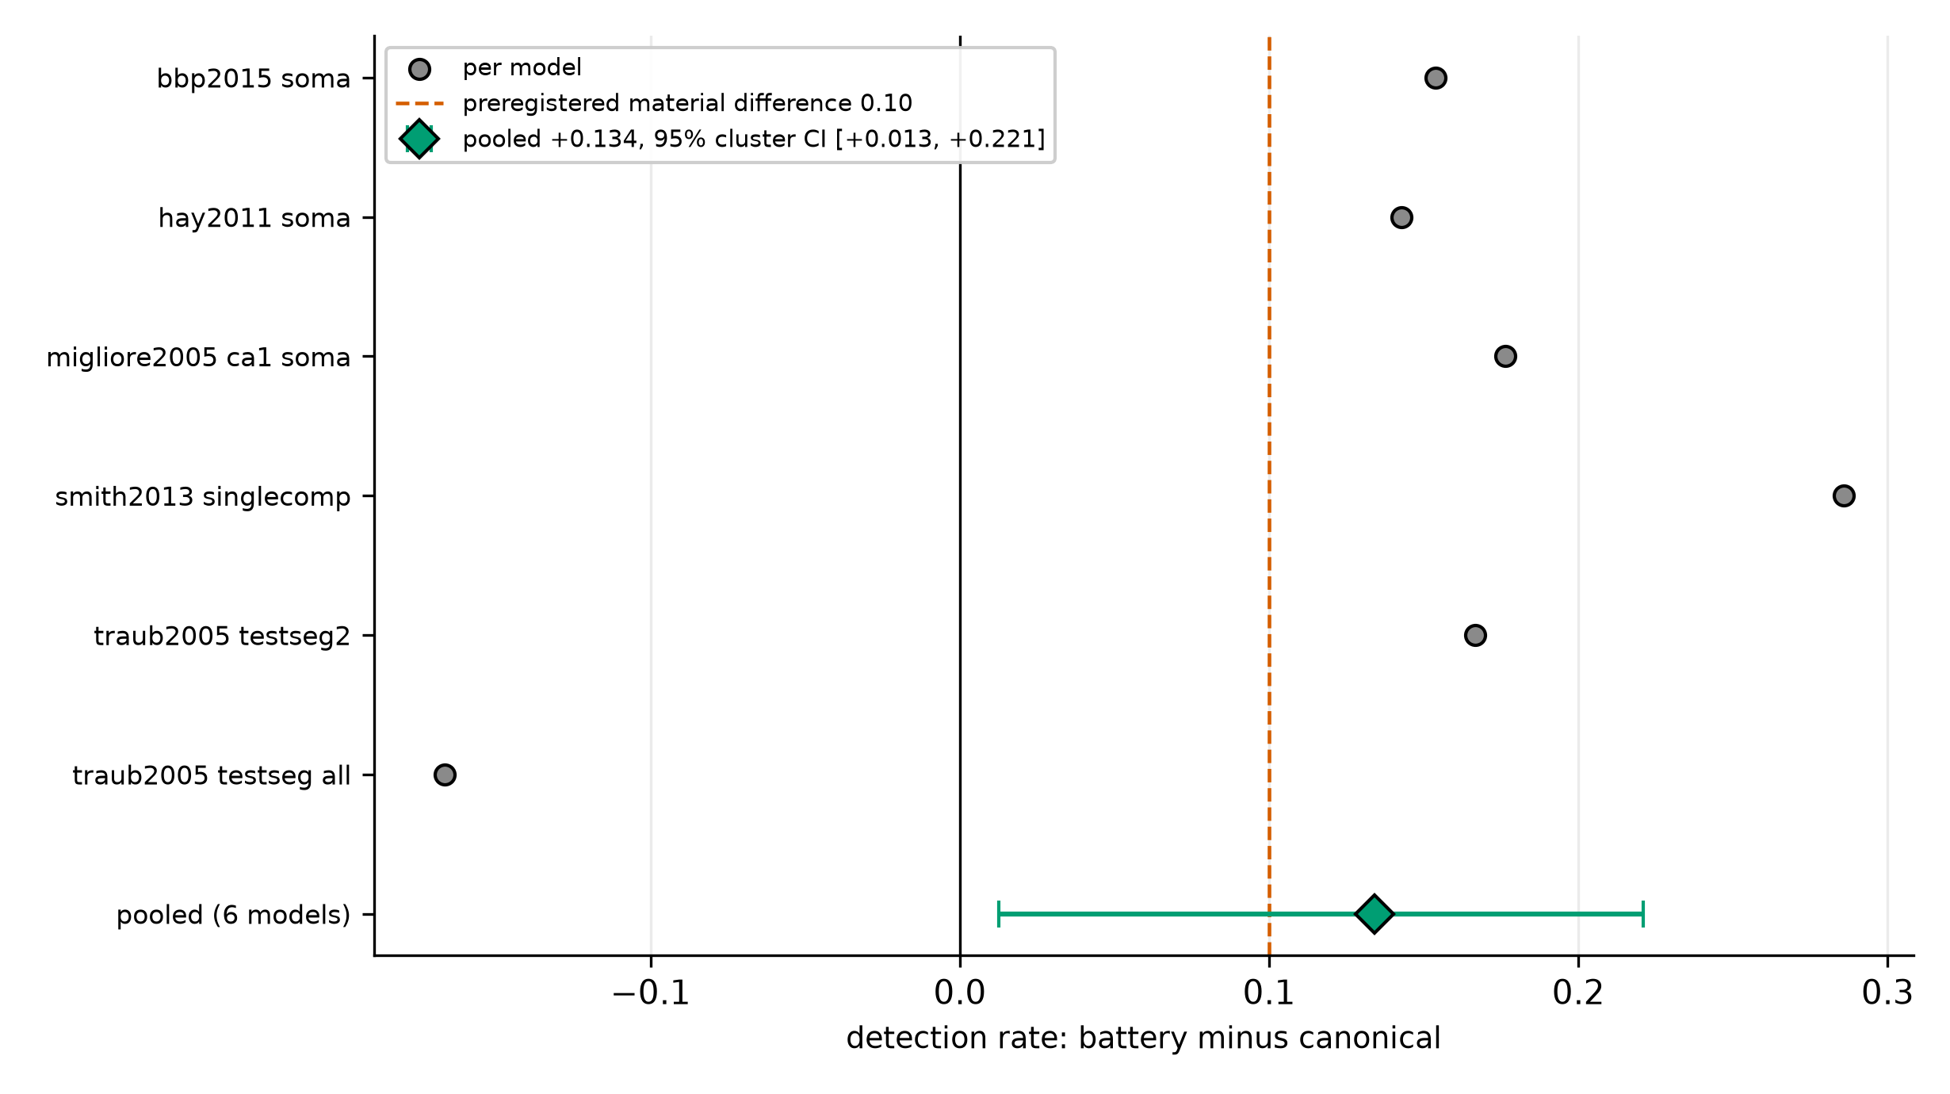
Fig. 2 Primary endpoint. Grey circles show the per-model difference in detection rate (battery minus canonical); the green diamond shows the pooled difference with its 95% cluster-bootstrap interval (0.134; 0.013 to 0.221). The dashed vertical line marks the preregistered material difference of 0.10. The interval excludes zero; its lower end lies below 0.10. Exact McNemar p = 0.007 treating faults as independent; exact cluster permutation p = 0.156 over six models, for which the smallest attainable p is 0.031
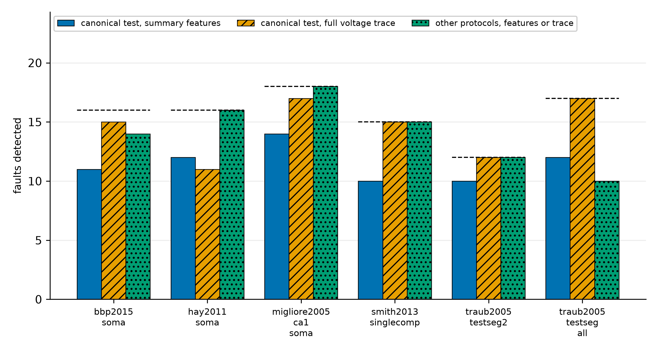
Fig. 3 Validation levels, reported separately and never merged: faults detected by the canonical test's summary features, by the canonical test's full voltage trace, and by the other protocols, for each model. Dashed lines mark the number of faults with any detected change (n = 94 in total). Six faults escape the canonical test at both levels
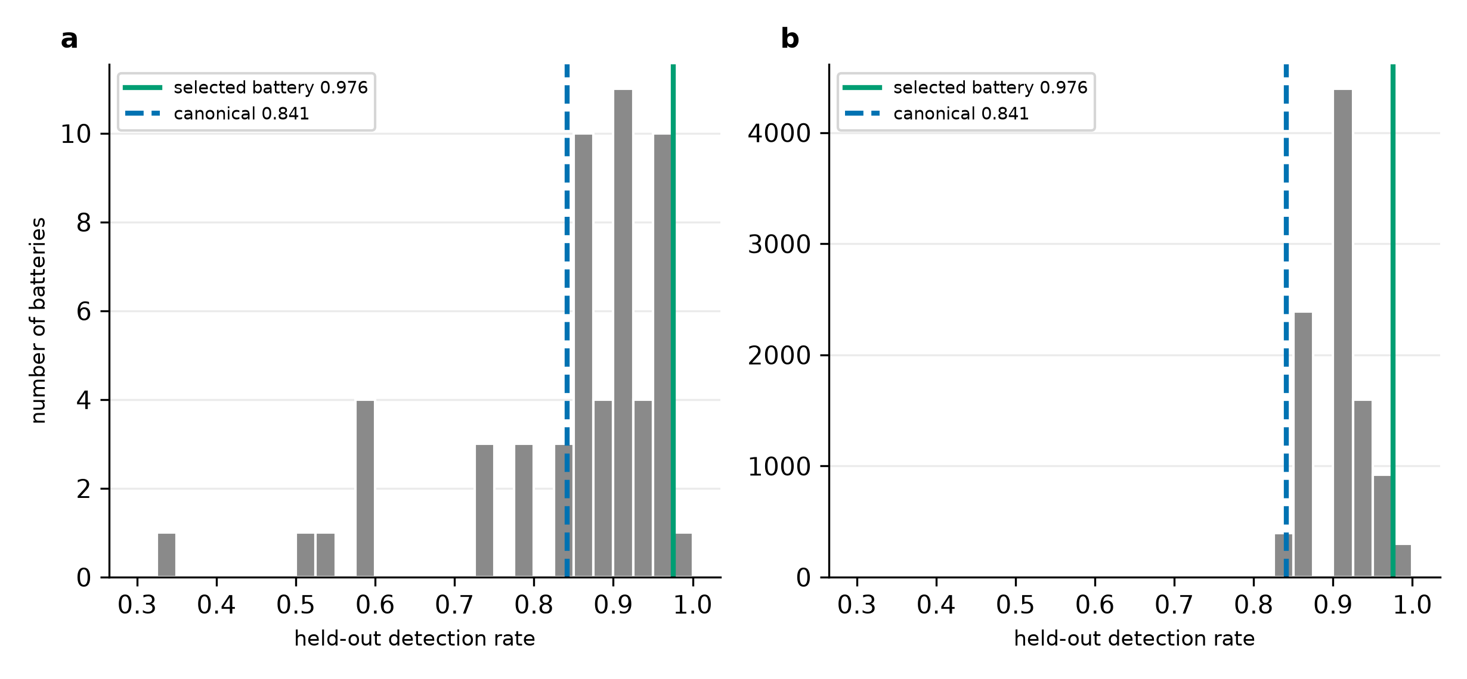
Fig. 4 Held-out detection rate of random protocol batteries compared with the selected battery. a All 56 possible three-protocol batteries drawn from the eight candidates. b 10,000 random batteries within the selected battery's computational budget. Vertical lines mark the selected battery (0.976) and the canonical test (0.841). The share of random batteries at least as good as the selected one is 0.018 in a and 0.030 in b
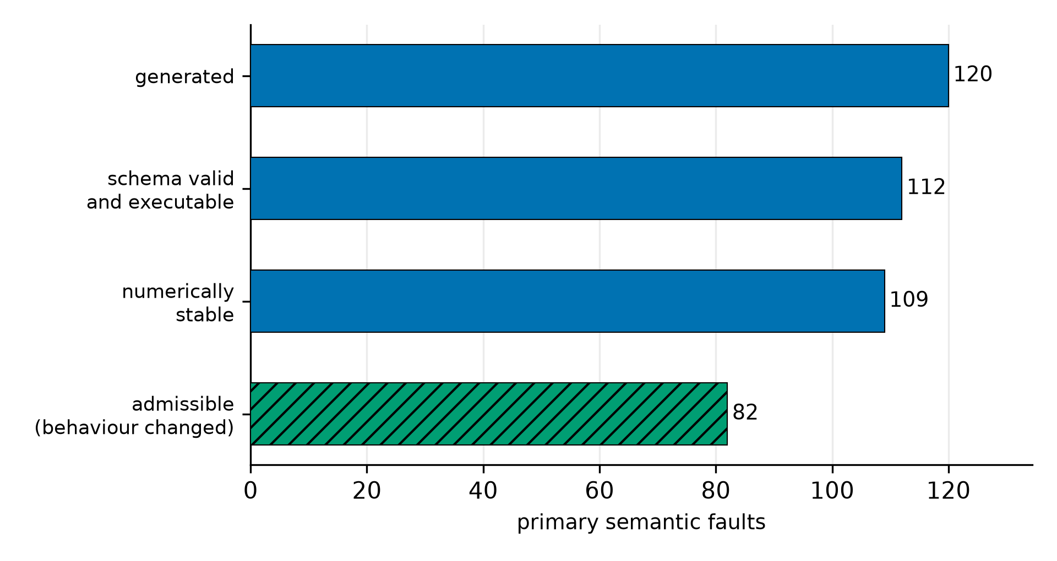
Fig. 5 Attrition of the 120 primary semantic faults through schema validation, execution, numerical stability and admissibility, with the exact count at each stage

Tables
Table 1 Held-out models: source, channel complement and canonical stimulus
Model | Source | Channels (summary) | Canonical stimulus
hay2011_soma | Hay et al. (2011) layer-5b pyramidal channel set | Na, K, Ca (HVA, LVA), Ih, SK, M; Ca pool | −0.01 nA at 100–200 ms; +0.05 nA at 300–400 ms
bbp2015_soma | Markram et al. (2015) Blue Brain channel set | as Hay, plus NaTs2_t and Kd | as above
traub2005_testseg2 | Traub et al. (2005) channel test cell 2 | Na and K subset; no Ca, no Ih | +0.08 nA at 20–80 ms
traub2005_testseg_all | Traub et al. (2005) all-channel test cell | adds Ca, AHP and anomalous rectifier; Ca pool | +0.08 nA at 20–80 ms
smith2013_singlecomp | Smith et al. (2013) layer-2/3 pyramidal channel set | Na, Kv, M, K(Ca), Ca, T | shipped step (analysis window 100–400 ms)
migliore2005_ca1_soma | Migliore et al. (2005) CA1 pyramidal soma | Na (two types), K (A, DR), Ih | +0.038 nA at 20–80 ms

hay2011_soma and bbp2015_soma share most of a channel set and the two Traub cells come from one publication, so the six models form four source families.
Table 2 Attrition of the 120 primary semantic faults
Stage | Count
Faults generated | 120
Schema-valid | 114
Executable | 112
Numerically stable | 109
Admissible (behaviour changed; frozen feature-level definition) | 82
Equivalent within the tested domain | 27

Table 3 The six faults missed by the canonical test on both summary features and full voltage trace
Fault | Model | Edit | Detected by (level)
scale_conductance (mild) | hay2011_soma | Ca_HVA conductance × 1.1 | long step: spike count, last interspike interval; ramp: spike timing
scale_conductance (strong) | hay2011_soma | M-current conductance × 0.5 | 2 × step: spike timing (trace)
shift_reversal (strong) | hay2011_soma | M-current reversal −85 → −95 mV | 2 × step: spike timing (trace)
scale_gate_time_constant (mild) | hay2011_soma | Ca_HVA activation rates × 1.25 | long step: spike count; ramp: spike timing
scale_gate_time_constant (mild) | bbp2015_soma | Ca_HVA activation rates × 1.25 | long step: spike count; ramp: spike timing
scale_gate_time_constant (mild) | migliore2005_ca1_soma | A-type K (kad) gate Q10 × 0.8 | 2 × step, long step, ramp: spike timing, trace RMS

Table 4 Detection by fault group (admissible faults)
Group | n | Canonical | Battery
All | 82 | 0.841 | 0.976
Mild severity | 40 | 0.700 | 0.950
Strong severity | 31 | 0.968 | 1.000
No severity (reference swaps) | 11 | 1.000 | 1.000
Maximal conductance | 17 | 0.647 | 1.000
Gate time constant | 5 | 0.400 | 1.000
Gate voltage dependence (includes the held-out kinetics family) | 22 | 0.864 | 0.955
Reversal potential | 15 | 0.933 | 0.933
Passive membrane | 12 | 1.000 | 1.000
Mechanism composition | 11 | 1.000 | 1.000

