Human audit packet
Neuron model validation study: held-out evaluation
For Samyak Singh and Naithik Somisetti · 25 faults · prepared 2026-09-22
Auditor name
Date completed
I worked alone and did not see the automated check (Yes / No)

1. What you are doing and why
We took six published computer models of single neurons and made small, deliberate edits ("faults") to them. Then we checked whether the usual test (re-running the one simulation shipped with each model, called the canonical test) notices the change, and whether a short set of extra stimuli does better.
The paper can only rely on these faults if a person has checked that they are what the software says they are. That is your job. You are checking three things for each fault: was the edit made as labelled, is the category it was put in believable, and is the evidence that it was detected believable.
Your answers are the independent check. Disagreeing with the software is a useful result, not a failure. If something looks wrong or you are not sure, say so.

2. Rules
- Work on your own. Do not compare answers with each other until you have both submitted.
- Do not ask Neel or any AI tool what the answer should be. Use only this packet. (A separate automated check exists; you will see it after you submit, so it cannot influence you.)
- "Unsure" is an allowed answer. Guessing "yes" is worse than an honest "unsure".
- Write a short note whenever you answer No or Unsure, saying what you saw.
- Expected time: about 1 to 2 hours. You do not need to finish in one sitting.

3. The ten-minute background
Neuron model. A set of equations describing how a nerve cell's voltage changes. Its ion channels (sodium, potassium, calcium and others) let current in or out. Each channel has settings such as how many channels there are (conductance), the voltage their current pushes toward (reversal potential), and how fast their gates open and close.
Stimulus (protocol). A pattern of current injected into the cell, like a step or a ramp. The cell responds by changing voltage and, if pushed hard enough, firing spikes (sharp upward blips, the tall lines in the graphs).
Features. Numbers measured from the voltage: how many spikes, when the first spike happens, the gaps between spikes, spike height, and so on.
Tolerance. How big a difference must be before it counts. It is set from the original model alone, so that tiny numerical noise never counts as a change.
h and h/2. The simulation is run twice, with a normal time step (h) and half that step (h/2). A difference only counts as a detection if it shows up at both. Some faults were checked a third time at h/4.
Two separate kinds of evidence. The assigned class is decided from the summary features only. Separately, the whole voltage trace is compared (spike count, spike timing, overall voltage difference). These are kept apart on purpose. So a fault can be class 4 ("no feature change") and still show whole-trace differences: that means the change was only visible in the raw trace. This is expected, not a contradiction.
The stimuli used:
Name in the tables | What it is
P00_canonical | the canonical test: the simulation shipped with the model
P02_weak_step | weak step: a small current step at half the firing threshold
P03_rheobase | rheobase search: finds the smallest current step that makes the cell fire
P04_step_2x | 2x step: a current step at twice the firing threshold, 0.5 s
P05_long_step | long step: a current step at 1.5x the firing threshold, held for 2 s
P06_ramp | ramp: current rising steadily from 0 to 3x the firing threshold over 1 s
P07_hyperpolarizing_step | hyperpolarising step: a negative current step
P08_rebound | rebound: a negative step, then release
P09_short_pulse | short pulse: a 3 ms strong pulse

Categories (the "assigned class"):
Class | Meaning
1_structurally_invalid | the edited model file is no longer valid NeuroML
2_non_executable | the edited model would not run
3_numerically_unstable | the edited model ran but its numbers blew up
4_equivalent_within_tested_domain | no reproducible change in any summary feature (behaviour looks unchanged)
5_non_equivalent | behaviour changed, and the canonical test caught it
6_silent_under_canonical | behaviour changed, but the canonical test missed it (another protocol caught it)

4. How to answer the three questions

Question 1: Does the edit match its label?
Each fault page shows the exact lines of the model file before (−, red) and after (+, green) the edit. Check that the change is what the label says. For example, "multiply conductance by 0.5" should turn 0.0675 into 0.03375 in the condDensity value of one channel, and nothing else should change. Answer No if the numbers do not match the label, the wrong thing changed, or extra things changed.

Question 2: Is the assigned class plausible?
Compare the class with the feature evidence (the first evidence table). Remember that the class ignores whole-trace differences (section 3). If the class says the canonical test missed it, the canonical test (P00_canonical) should not appear among the detections at both h and h/2, but some other stimulus should. If the class says it would not run, there should be no measurements. If it says no change, there should be no detections at both step sizes.

Question 3: Is the detection plausible?
Look at the evidence tables and the graph. A detection means the difference is bigger than the tolerance, at h and at h/2. In the graph, black is the original model and orange dashed is the edited one: where they separate, the behaviour changed. For the key faults, the top graph (canonical test) should look nearly identical while the lower graph shows the difference. Answer N/A if nothing was detected.

5. How to submit
- Save a copy of this document with your name in the file name, for example Audit_Packet_Samyak.docx.
- Fill in the yellow box on the first page: your name, the date, and whether you worked alone.
- Each fault's section ends with a yellow answer box. Type an X in one cell per row, and write a note whenever you answer No or Unsure.
- Send your finished document back to Neel. Only then compare answers with each other.

6. Summary of the faults
# | Group | Model | Change | Assigned class
1 | key fault (headline claim) | hay2011_soma | scale_conductance | 6_silent_under_canonical
2 | key fault (headline claim) | hay2011_soma | scale_conductance | 4_equivalent_within_tested_domain
3 | key fault (headline claim) + random sample | hay2011_soma | scale_gate_time_constant | 6_silent_under_canonical
4 | key fault (headline claim) | migliore2005_ca1_soma | scale_gate_time_constant | 4_equivalent_within_tested_domain
5 | key fault (headline claim) | bbp2015_soma | scale_gate_time_constant | 6_silent_under_canonical
6 | key fault (headline claim) | hay2011_soma | shift_reversal | 4_equivalent_within_tested_domain
7 | random sample | smith2013_singlecomp | duplicate_conductance | 4_equivalent_within_tested_domain
8 | random sample | migliore2005_ca1_soma | duplicate_conductance | 5_non_equivalent
9 | random sample | traub2005_testseg2 | increase_dt | 6_silent_under_canonical
10 | random sample | smith2013_singlecomp | increase_dt | 6_silent_under_canonical
11 | random sample | traub2005_testseg_all | scale_capacitance | 5_non_equivalent
12 | random sample | traub2005_testseg_all | scale_capacitance | 5_non_equivalent
13 | random sample | migliore2005_ca1_soma | scale_conductance | 5_non_equivalent
14 | random sample | bbp2015_soma | scale_conductance | 6_silent_under_canonical
15 | random sample | migliore2005_ca1_soma | scale_conductance | 6_silent_under_canonical
16 | random sample | traub2005_testseg2 | scale_conductance | 5_non_equivalent
17 | random sample | bbp2015_soma | scale_gate_slope | 5_non_equivalent
18 | random sample | smith2013_singlecomp | scale_gate_time_constant | 6_silent_under_canonical
19 | random sample | traub2005_testseg_all | shift_forward_rate_midpoint | 5_non_equivalent
20 | random sample | traub2005_testseg2 | shift_gate_midpoint | 5_non_equivalent
21 | random sample | migliore2005_ca1_soma | shift_gate_midpoint | 5_non_equivalent
22 | random sample | traub2005_testseg_all | shift_reversal | 5_non_equivalent
23 | random sample | bbp2015_soma | solver_config | 4_equivalent_within_tested_domain
24 | random sample | hay2011_soma | wrong_channel | 2_non_executable
25 | random sample | migliore2005_ca1_soma | wrong_compatible_component | 3_numerically_unstable

Fault 1 of 25
Fault ID | m-scale_conductance-211745202a
Group | key fault (headline claim)
Model | Hay et al. 2011 layer-5 pyramidal cell (soma only) (hay2011_soma)
Label (what the edit claims to be) | scale_conductance: multiply one ion channel's maximal conductance (how many channels there are) by a factor; factor 1.1
Severity | mild
Run status | ok
Assigned class | 6_silent_under_canonical: behaviour changed, but the canonical test missed it (another protocol caught it)
Detected (features) by | P05_long_step

The exact change (Question 1)
File: neuroConstruct/generatedNeuroML2/Soma_AllCML.cell.nml
@@ -84,5 +84,5 @@
<!--Reversal potential for ca in Ca_HVA will be calculated by Nernst equation from internal & external calcium-->

- <channelDensityNernst condDensity="0.992 mS_per_cm2" id="Ca_HVA_all" ionChannel="Ca_HVA" ion="ca"/>
+ <channelDensityNernst condDensity="1.0912 mS_per_cm2" id="Ca_HVA_all" ionChannel="Ca_HVA" ion="ca"/>

Evidence (Questions 2 and 3)
Feature differences that exceeded tolerance:
Step | Stimulus | Feature | Original | Edited | Difference | Tolerance
h | P05_long_step | last_isi | 143 | 148.3 | 5.33 | 3.03
h | P05_long_step | spike_count | 14 | 13 | 1 | 0.5
h/2 | P05_long_step | last_isi | 144 | 149.3 | 5.36 | 3.03
h/2 | P05_long_step | spike_count | 14 | 13 | 1 | 0.5

Whole-voltage-trace differences that exceeded tolerance:
Step | Stimulus | Measure | Original | Edited | Difference | Tolerance
h | P05_long_step | spike count | 14 | 13 | 1 | 0.5
h | P06_ramp | spike timing (largest shift, ms) | – | – | 7.177 | 3.955
h/2 | P05_long_step | spike count | 14 | 13 | 1 | 0.5
h/2 | P06_ramp | spike timing (largest shift, ms) | – | – | 7.155 | 3.955
h/4 | P05_long_step | spike count | 14 | 13 | 1 | 0.5
h/4 | P06_ramp | spike timing (largest shift, ms) | – | – | 7.146 | 3.955

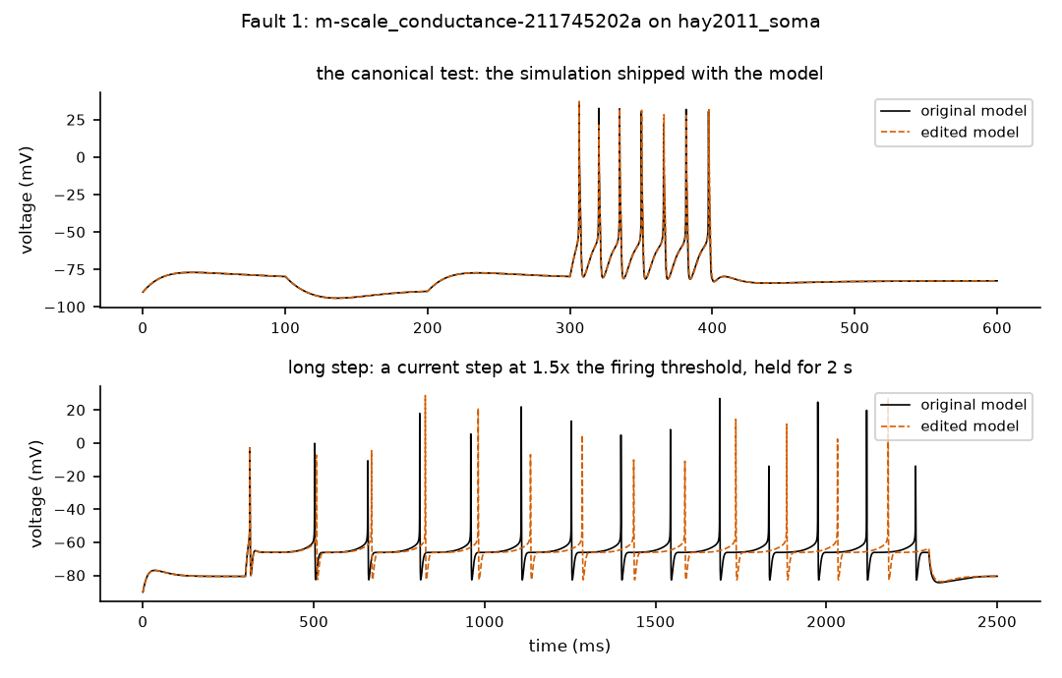
Black: original model. Orange dashed: edited model. Where the lines separate, the behaviour changed.

Your answers for fault 1 (type X) | Yes | No | Unsure | N/A
Q1 Edit matches its label? |  |  |  | –
Q2 Assigned class plausible? |  |  |  | –
Q3 Detection plausible?
Confidence: type X under one | High | Medium | Low | –
Notes (required for any No or Unsure):

Fault 2 of 25
Fault ID | m-scale_conductance-75492a609a
Group | key fault (headline claim)
Model | Hay et al. 2011 layer-5 pyramidal cell (soma only) (hay2011_soma)
Label (what the edit claims to be) | scale_conductance: multiply one ion channel's maximal conductance (how many channels there are) by a factor; factor 0.5
Severity | strong
Run status | ok
Assigned class | 4_equivalent_within_tested_domain: no reproducible change in any summary feature (behaviour looks unchanged)
Detected (features) by | nothing

The exact change (Question 1)
File: neuroConstruct/generatedNeuroML2/Soma_AllCML.cell.nml
@@ -65,5 +65,5 @@
<channelDensity condDensity="0.2 mS_per_cm2" id="Ih_all" ionChannel="Ih" ion="hcn" erev="-45.0 mV"/>

- <channelDensity condDensity="0.0675 mS_per_cm2" id="Im_all" ionChannel="Im" ion="k" erev="-85.0 mV"/>
+ <channelDensity condDensity="0.03375 mS_per_cm2" id="Im_all" ionChannel="Im" ion="k" erev="-85.0 mV"/>

<channelDensity condDensity="2.23 mS_per_cm2" id="K_Pst_all" ionChannel="K_Pst" ion="k" erev="-85.0 mV"/>

Evidence (Questions 2 and 3)
No feature differences exceeded tolerance.
Whole-voltage-trace differences that exceeded tolerance:
Step | Stimulus | Measure | Original | Edited | Difference | Tolerance
h | P04_step_2x | spike timing (largest shift, ms) | – | – | 5.773 | 3.496
h/2 | P04_step_2x | spike timing (largest shift, ms) | – | – | 5.768 | 3.496
h/4 | P04_step_2x | spike timing (largest shift, ms) | – | – | 5.765 | 3.496

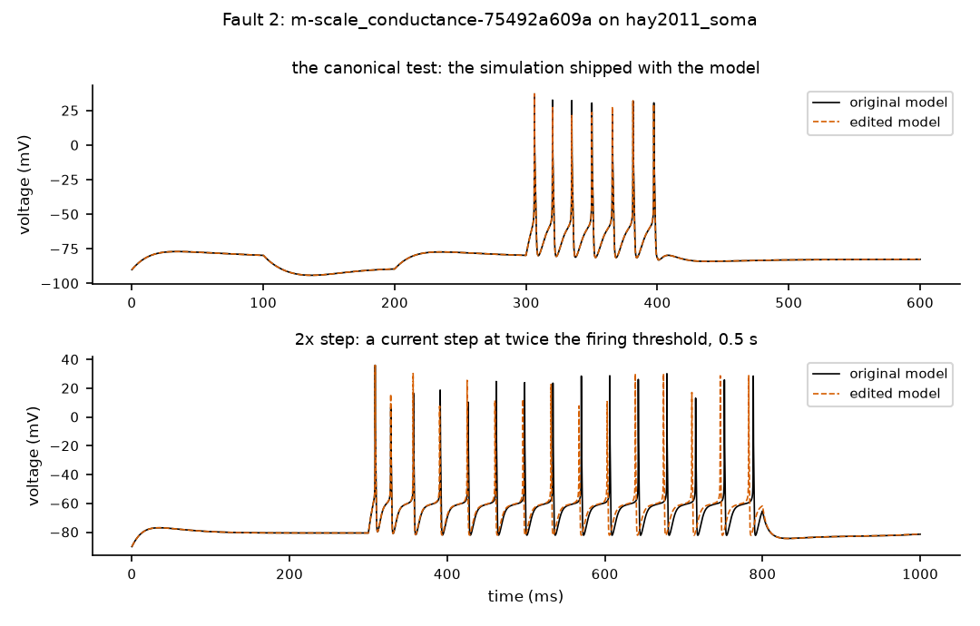
Black: original model. Orange dashed: edited model. Where the lines separate, the behaviour changed.

Your answers for fault 2 (type X) | Yes | No | Unsure | N/A
Q1 Edit matches its label? |  |  |  | –
Q2 Assigned class plausible? |  |  |  | –
Q3 Detection plausible?
Confidence: type X under one | High | Medium | Low | –
Notes (required for any No or Unsure):

Fault 3 of 25
Fault ID | m-scale_gate_time_constant-02eb4e0b90
Group | key fault (headline claim) + random sample
Model | Hay et al. 2011 layer-5 pyramidal cell (soma only) (hay2011_soma)
Label (what the edit claims to be) | scale_gate_time_constant: make one channel gate open and close faster or slower (scale its time constant); factor 1.25
Severity | mild
Run status | ok
Assigned class | 6_silent_under_canonical: behaviour changed, but the canonical test missed it (another protocol caught it)
Detected (features) by | P05_long_step

The exact change (Question 1)
File: neuroConstruct/generatedNeuroML2/Ca_HVA.channel.nml
@@ -36,6 +36,6 @@

<gate id="m" type="gateHHrates" instances="2">
- <forwardRate type="HHExpLinearRate" rate="0.209per_ms" scale="3.8mV" midpoint="-27mV"/>
- <reverseRate type="HHExpRate" rate="0.94per_ms" scale="-17mV" midpoint="-75mV"/>
+ <forwardRate type="HHExpLinearRate" rate="0.26125per_ms" scale="3.8mV" midpoint="-27mV"/>
+ <reverseRate type="HHExpRate" rate="1.175per_ms" scale="-17mV" midpoint="-75mV"/>
</gate>

Evidence (Questions 2 and 3)
Feature differences that exceeded tolerance:
Step | Stimulus | Feature | Original | Edited | Difference | Tolerance
h | P05_long_step | last_isi | 143 | 153.4 | 10.44 | 3.03
h | P05_long_step | spike_count | 14 | 13 | 1 | 0.5
h/2 | P05_long_step | last_isi | 144 | 154.4 | 10.38 | 3.03
h/2 | P05_long_step | spike_count | 14 | 13 | 1 | 0.5

Whole-voltage-trace differences that exceeded tolerance:
Step | Stimulus | Measure | Original | Edited | Difference | Tolerance
h | P05_long_step | spike count | 14 | 13 | 1 | 0.5
h | P06_ramp | spike timing (largest shift, ms) | – | – | 13.8 | 3.955
h/2 | P05_long_step | spike count | 14 | 13 | 1 | 0.5
h/2 | P06_ramp | spike timing (largest shift, ms) | – | – | 13.59 | 3.955
h/4 | P05_long_step | spike count | 14 | 13 | 1 | 0.5
h/4 | P06_ramp | spike timing (largest shift, ms) | – | – | 13.5 | 3.955

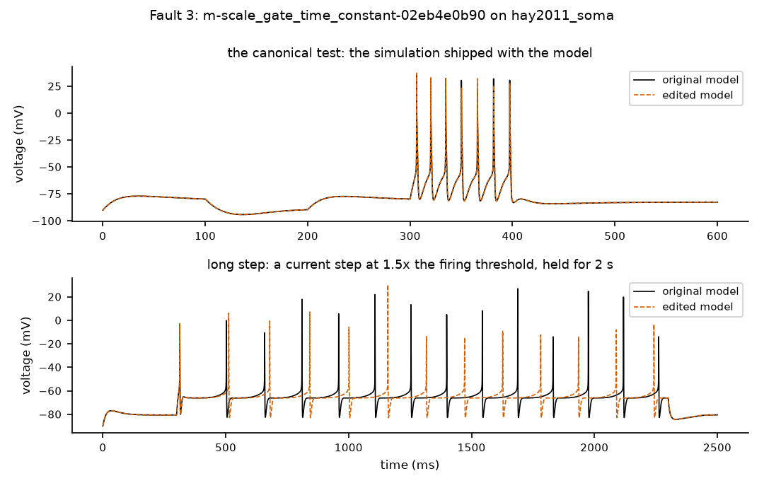
Black: original model. Orange dashed: edited model. Where the lines separate, the behaviour changed.

Your answers for fault 3 (type X) | Yes | No | Unsure | N/A
Q1 Edit matches its label? |  |  |  | –
Q2 Assigned class plausible? |  |  |  | –
Q3 Detection plausible?
Confidence: type X under one | High | Medium | Low | –
Notes (required for any No or Unsure):

Fault 4 of 25
Fault ID | m-scale_gate_time_constant-31e82d8467
Group | key fault (headline claim)
Model | Migliore et al. 2005 hippocampal CA1 pyramidal cell (soma only) (migliore2005_ca1_soma)
Label (what the edit claims to be) | scale_gate_time_constant: make one channel gate open and close faster or slower (scale its time constant); factor 0.8
Severity | mild
Run status | ok
Assigned class | 4_equivalent_within_tested_domain: no reproducible change in any summary feature (behaviour looks unchanged)
Detected (features) by | nothing

The exact change (Question 1)
File: neuroConstruct/generatedNeuroML2/kad.channel.nml
@@ -40,5 +40,5 @@

<gate id="l" type="gateHHtauInf" instances="1">
- <q10Settings type="q10Fixed" fixedQ10="1"/>
+ <q10Settings type="q10Fixed" fixedQ10="0.8"/>
<timeCourse type="kad_l_tau_tau"/>
<steadyState type="kad_l_inf_inf"/>

Evidence (Questions 2 and 3)
No feature differences exceeded tolerance.
Whole-voltage-trace differences that exceeded tolerance:
Step | Stimulus | Measure | Original | Edited | Difference | Tolerance
h | P04_step_2x | overall voltage difference (RMS, mV) | 0 | 12.83 | 12.83 | 8.749
h | P04_step_2x | spike timing (largest shift, ms) | – | – | 2.581 | 0.5184
h | P05_long_step | spike timing (largest shift, ms) | – | – | 13.69 | 4.506
h | P06_ramp | overall voltage difference (RMS, mV) | 0 | 13.15 | 13.15 | 6.268
h | P06_ramp | spike timing (largest shift, ms) | – | – | 2.402 | 0.5781
h/2 | P04_step_2x | overall voltage difference (RMS, mV) | 0 | 12.8 | 12.8 | 8.749
h/2 | P04_step_2x | spike timing (largest shift, ms) | – | – | 2.581 | 0.5184
h/2 | P05_long_step | spike timing (largest shift, ms) | – | – | 13.72 | 4.506
h/2 | P06_ramp | overall voltage difference (RMS, mV) | 0 | 13.11 | 13.11 | 6.268
h/2 | P06_ramp | spike timing (largest shift, ms) | – | – | 2.398 | 0.5781
h/4 | P04_step_2x | overall voltage difference (RMS, mV) | 0 | 12.78 | 12.78 | 8.749
h/4 | P04_step_2x | spike timing (largest shift, ms) | – | – | 2.582 | 0.5184
h/4 | P05_long_step | spike timing (largest shift, ms) | – | – | 13.74 | 4.506
h/4 | P06_ramp | overall voltage difference (RMS, mV) | 0 | 13.09 | 13.09 | 6.268
(1 more rows not shown)

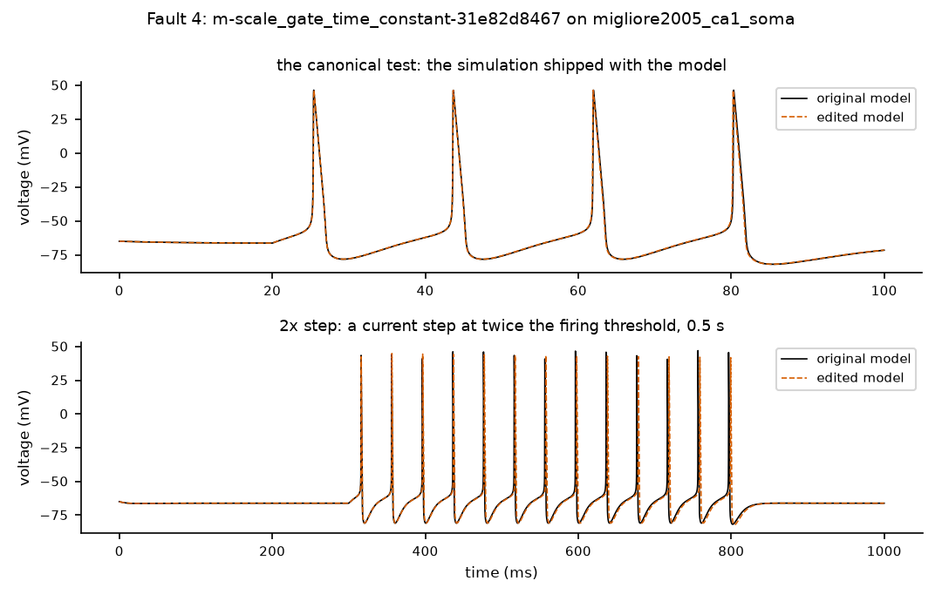
Black: original model. Orange dashed: edited model. Where the lines separate, the behaviour changed.

Your answers for fault 4 (type X) | Yes | No | Unsure | N/A
Q1 Edit matches its label? |  |  |  | –
Q2 Assigned class plausible? |  |  |  | –
Q3 Detection plausible?
Confidence: type X under one | High | Medium | Low | –
Notes (required for any No or Unsure):

Fault 5 of 25
Fault ID | m-scale_gate_time_constant-de97b02e71
Group | key fault (headline claim)
Model | Blue Brain Project 2015 cortical cell (soma only) (bbp2015_soma)
Label (what the edit claims to be) | scale_gate_time_constant: make one channel gate open and close faster or slower (scale its time constant); factor 1.25
Severity | mild
Run status | ok
Assigned class | 6_silent_under_canonical: behaviour changed, but the canonical test missed it (another protocol caught it)
Detected (features) by | P05_long_step

The exact change (Question 1)
File: NMC/NeuroML2/Ca_HVA.channel.nml
@@ -36,6 +36,6 @@

<gate id="m" type="gateHHrates" instances="2">
- <forwardRate type="HHExpLinearRate" rate="0.209per_ms" scale="3.8mV" midpoint="-27mV"/>
- <reverseRate type="HHExpRate" rate="0.94per_ms" scale="-17mV" midpoint="-75mV"/>
+ <forwardRate type="HHExpLinearRate" rate="0.26125per_ms" scale="3.8mV" midpoint="-27mV"/>
+ <reverseRate type="HHExpRate" rate="1.175per_ms" scale="-17mV" midpoint="-75mV"/>
</gate>

Evidence (Questions 2 and 3)
Feature differences that exceeded tolerance:
Step | Stimulus | Feature | Original | Edited | Difference | Tolerance
h | P05_long_step | last_isi | 118.7 | 127.3 | 8.59 | 2.373
h | P05_long_step | spike_count | 16 | 15 | 1 | 0.5
h/2 | P05_long_step | last_isi | 118.9 | 127.4 | 8.52 | 2.373
h/2 | P05_long_step | spike_count | 16 | 15 | 1 | 0.5

Whole-voltage-trace differences that exceeded tolerance:
Step | Stimulus | Measure | Original | Edited | Difference | Tolerance
h | P05_long_step | spike count | 16 | 15 | 1 | 0.5
h | P06_ramp | spike timing (largest shift, ms) | – | – | 8.159 | 2.334
h/2 | P05_long_step | spike count | 16 | 15 | 1 | 0.5
h/2 | P06_ramp | spike timing (largest shift, ms) | – | – | 8.087 | 2.334
h/4 | P05_long_step | spike count | 16 | 15 | 1 | 0.5
h/4 | P06_ramp | spike timing (largest shift, ms) | – | – | 8.052 | 2.334

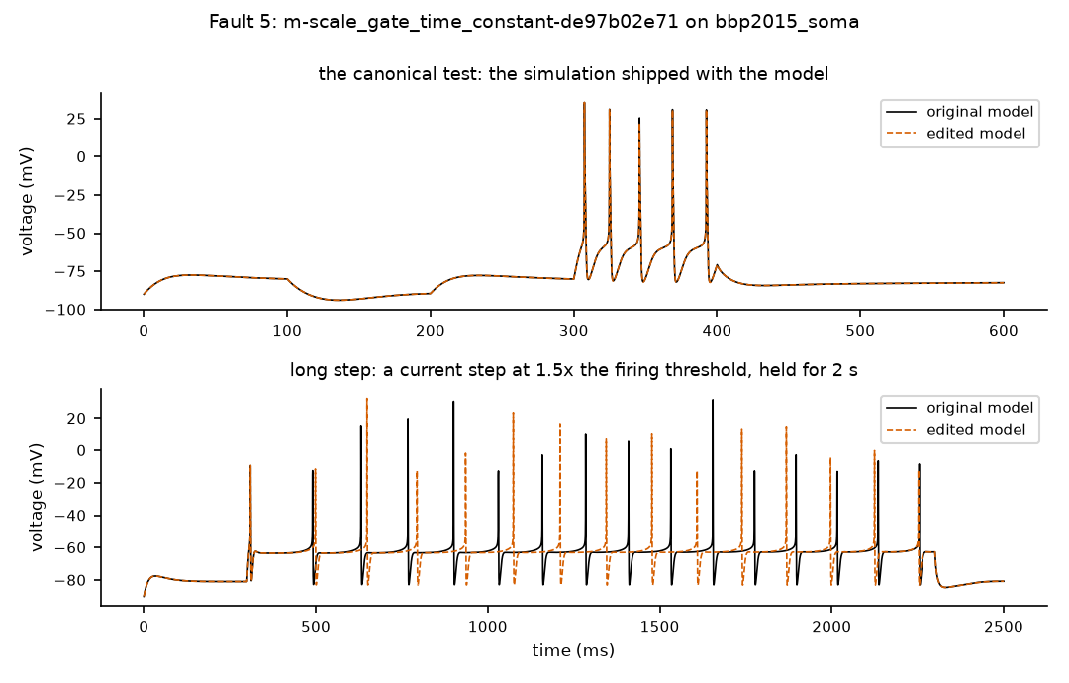
Black: original model. Orange dashed: edited model. Where the lines separate, the behaviour changed.

Your answers for fault 5 (type X) | Yes | No | Unsure | N/A
Q1 Edit matches its label? |  |  |  | –
Q2 Assigned class plausible? |  |  |  | –
Q3 Detection plausible?
Confidence: type X under one | High | Medium | Low | –
Notes (required for any No or Unsure):

Fault 6 of 25
Fault ID | m-shift_reversal-e5f14f8fb3
Group | key fault (headline claim)
Model | Hay et al. 2011 layer-5 pyramidal cell (soma only) (hay2011_soma)
Label (what the edit claims to be) | shift_reversal: shift one channel's reversal potential (the voltage its current pushes toward) by a few mV
Severity | strong
Run status | ok
Assigned class | 4_equivalent_within_tested_domain: no reproducible change in any summary feature (behaviour looks unchanged)
Detected (features) by | nothing

The exact change (Question 1)
File: neuroConstruct/generatedNeuroML2/Soma_AllCML.cell.nml
@@ -65,5 +65,5 @@
<channelDensity condDensity="0.2 mS_per_cm2" id="Ih_all" ionChannel="Ih" ion="hcn" erev="-45.0 mV"/>

- <channelDensity condDensity="0.0675 mS_per_cm2" id="Im_all" ionChannel="Im" ion="k" erev="-85.0 mV"/>
+ <channelDensity condDensity="0.0675 mS_per_cm2" id="Im_all" ionChannel="Im" ion="k" erev="-95.0 mV"/>

<channelDensity condDensity="2.23 mS_per_cm2" id="K_Pst_all" ionChannel="K_Pst" ion="k" erev="-85.0 mV"/>

Evidence (Questions 2 and 3)
No feature differences exceeded tolerance.
Whole-voltage-trace differences that exceeded tolerance:
Step | Stimulus | Measure | Original | Edited | Difference | Tolerance
h | P04_step_2x | spike timing (largest shift, ms) | – | – | 4.622 | 3.496
h/2 | P04_step_2x | spike timing (largest shift, ms) | – | – | 4.635 | 3.496
h/4 | P04_step_2x | spike timing (largest shift, ms) | – | – | 4.642 | 3.496

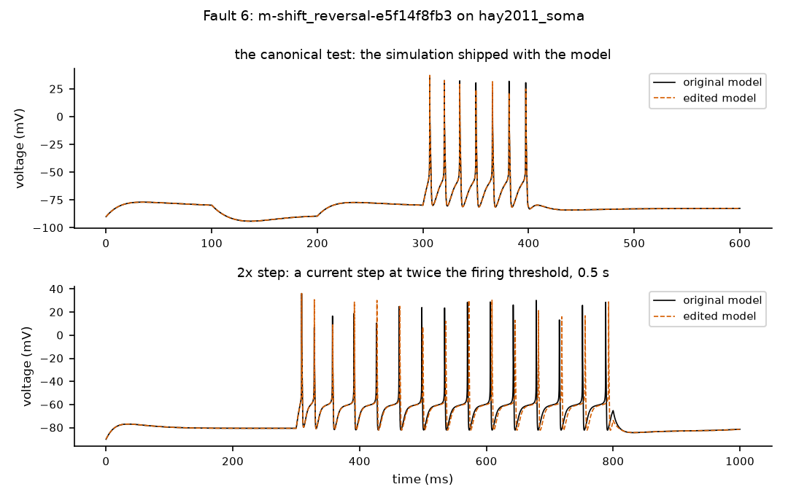
Black: original model. Orange dashed: edited model. Where the lines separate, the behaviour changed.

Your answers for fault 6 (type X) | Yes | No | Unsure | N/A
Q1 Edit matches its label? |  |  |  | –
Q2 Assigned class plausible? |  |  |  | –
Q3 Detection plausible?
Confidence: type X under one | High | Medium | Low | –
Notes (required for any No or Unsure):

Fault 7 of 25
Fault ID | m-duplicate_conductance-49ae908693
Group | random sample
Model | Smith et al. 2013 layer-2/3 pyramidal cell (one compartment) (smith2013_singlecomp)
Label (what the edit claims to be) | duplicate_conductance: add a second copy of one channel (roughly doubles it)
Severity | not_applicable
Run status | ok
Assigned class | 4_equivalent_within_tested_domain: no reproducible change in any summary feature (behaviour looks unchanged)
Detected (features) by | nothing

The exact change (Question 1)
File: NeuroML2/singleCompAllChans.cell.nml
@@ -47,4 +47,5 @@
<channelDensity condDensity="2.2e-4 S_per_cm2" id="km_all" ionChannel="km" ion="k" erev="-90 mV"/>
<channelDensity condDensity="0.5e-4 S_per_cm2" id="ca_all" ionChannel="ca" ion="ca" erev="140.0 mV"/>
+ <channelDensity condDensity="0.5e-4 S_per_cm2" id="ca_all_dup" ionChannel="ca" ion="ca" erev="140.0 mV"/>
<channelDensity condDensity="3.0e-4 S_per_cm2" id="kca_all" ionChannel="kca" ion="k" erev="-90 mV"/>
<channelDensity condDensity="0.0003 S_per_cm2" id="it_all" ionChannel="it" ion="ca" erev="140.0 mV"/>

Evidence (Questions 2 and 3)
No feature differences exceeded tolerance.
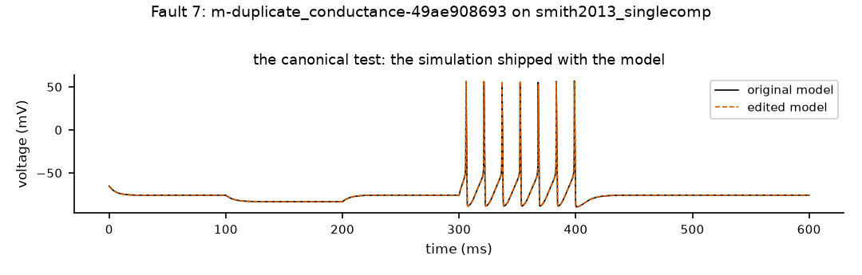
Black: original model. Orange dashed: edited model. Where the lines separate, the behaviour changed.

Your answers for fault 7 (type X) | Yes | No | Unsure | N/A
Q1 Edit matches its label? |  |  |  | –
Q2 Assigned class plausible? |  |  |  | –
Q3 Detection plausible?
Confidence: type X under one | High | Medium | Low | –
Notes (required for any No or Unsure):

Fault 8 of 25
Fault ID | m-duplicate_conductance-f1055b2803
Group | random sample
Model | Migliore et al. 2005 hippocampal CA1 pyramidal cell (soma only) (migliore2005_ca1_soma)
Label (what the edit claims to be) | duplicate_conductance: add a second copy of one channel (roughly doubles it)
Severity | not_applicable
Run status | ok
Assigned class | 5_non_equivalent: behaviour changed, and the canonical test caught it
Detected (features) by | P00_canonical, P03_rheobase, P04_step_2x, P05_long_step, P06_ramp, P09_short_pulse

The exact change (Question 1)
File: neuroConstruct/generatedNeuroML2/SomaOnly_allCml.cell.nml
@@ -77,4 +77,6 @@
<channelDensity condDensity="10.0 mS_per_cm2" id="kdr_all" ionChannel="kdr" ion="k" erev="-90.0 mV"/>

+ <channelDensity condDensity="10.0 mS_per_cm2" id="kdr_all_dup" ionChannel="kdr" ion="k" erev="-90.0 mV"/>
+
<channelDensity condDensity="25.0 mS_per_cm2" id="na3_all" ionChannel="na3" ion="na" erev="50.0 mV"/>

Evidence (Questions 2 and 3)
Feature differences that exceeded tolerance:
Step | Stimulus | Feature | Original | Edited | Difference | Tolerance
h | P00_canonical | ahp_depth | -11.85 | -16.48 | 4.627 | 0.5927
h | P00_canonical | last_isi | 18.33 | 19.41 | 1.08 | 0.5
h | P03_rheobase | rheobase | 5.806e-4 | 6.830e-4 | 1.025e-4 | 6.830e-5
h | P04_step_2x | ahp_depth | -14.78 | -18.77 | 3.991 | 0.7388
h | P04_step_2x | first_spike_latency | 16.07 | 17.58 | 1.51 | 0.5
h | P04_step_2x | last_isi | 40.06 | 41.4 | 1.34 | 0.8012
h | P04_step_2x | spike_count | 13 | 12 | 1 | 0.5
h | P05_long_step | ahp_depth | -15.07 | -18.99 | 3.914 | 0.7537
h | P05_long_step | first_spike_latency | 23.15 | 26.93 | 3.78 | 0.5
h | P05_long_step | last_isi | 51.51 | 54.38 | 2.87 | 1.03
h | P05_long_step | spike_count | 39 | 37 | 2 | 0.5
h | P06_ramp | first_spike_latency | 396.2 | 450.3 | 54.06 | 7.924
h | P06_ramp | spike_count | 16 | 15 | 1 | 0.5
h | P09_short_pulse | ahp_depth | -16 | -19.59 | 3.588 | 0.8001
h/2 | P00_canonical | ahp_depth | -11.8 | -16.45 | 4.642 | 0.5927
h/2 | P00_canonical | last_isi | 18.32 | 19.4 | 1.08 | 0.5
(12 more rows not shown)

Whole-voltage-trace differences that exceeded tolerance:
Step | Stimulus | Measure | Original | Edited | Difference | Tolerance
h | P00_canonical | overall voltage difference (RMS, mV) | 0 | 21.21 | 21.21 | 4.056
h | P00_canonical | spike count | 4 | 3 | 1 | 0.5
h | P04_step_2x | overall voltage difference (RMS, mV) | 0 | 16.81 | 16.81 | 8.749
h | P04_step_2x | spike count | 13 | 12 | 1 | 0.5
h | P05_long_step | spike count | 39 | 37 | 2 | 0.5
h | P06_ramp | overall voltage difference (RMS, mV) | 0 | 14.66 | 14.66 | 6.268
h | P06_ramp | spike count | 16 | 15 | 1 | 0.5
h | P09_short_pulse | overall voltage difference (RMS, mV) | 0 | 1.587 | 1.587 | 1.226
h/2 | P00_canonical | overall voltage difference (RMS, mV) | 0 | 21.19 | 21.19 | 4.056
h/2 | P00_canonical | spike count | 4 | 3 | 1 | 0.5
h/2 | P04_step_2x | overall voltage difference (RMS, mV) | 0 | 16.75 | 16.75 | 8.749
h/2 | P04_step_2x | spike count | 13 | 12 | 1 | 0.5
h/2 | P05_long_step | spike count | 39 | 37 | 2 | 0.5
h/2 | P06_ramp | overall voltage difference (RMS, mV) | 0 | 14.61 | 14.61 | 6.268
(2 more rows not shown)

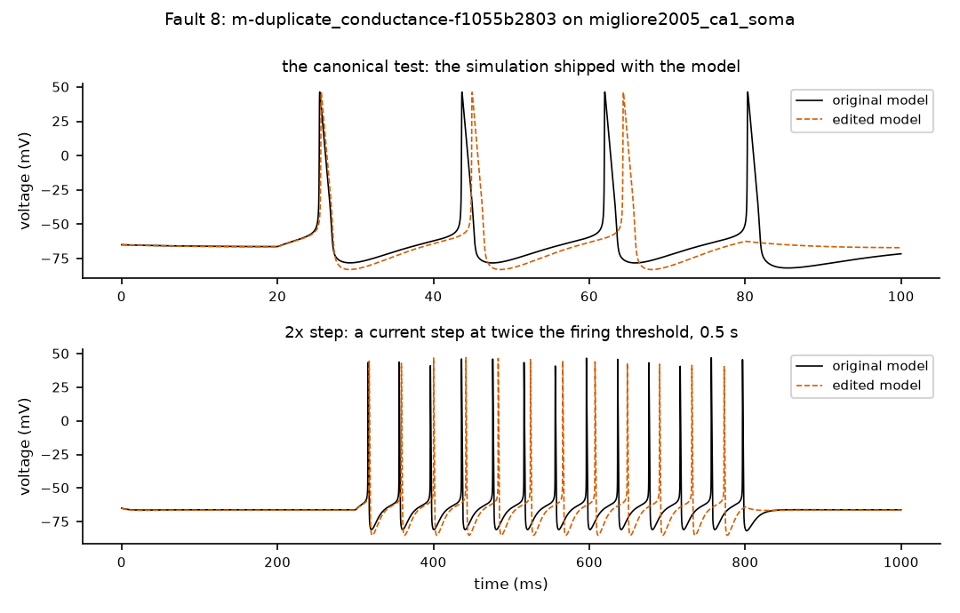
Black: original model. Orange dashed: edited model. Where the lines separate, the behaviour changed.

Your answers for fault 8 (type X) | Yes | No | Unsure | N/A
Q1 Edit matches its label? |  |  |  | –
Q2 Assigned class plausible? |  |  |  | –
Q3 Detection plausible?
Confidence: type X under one | High | Medium | Low | –
Notes (required for any No or Unsure):

Fault 9 of 25
Fault ID | m-increase_dt-1086ebecdc
Group | random sample
Model | Traub et al. 2005 test cell 2 (sodium/potassium channels) (traub2005_testseg2)
Label (what the edit claims to be) | increase_dt: make the simulation time step larger (a numerical stress test, not a model fault); factor 4
Severity | strong
Run status | ok
Assigned class | 6_silent_under_canonical: behaviour changed, but the canonical test missed it (another protocol caught it)
Detected (features) by | P04_step_2x, P05_long_step, P09_short_pulse

The exact change (Question 1)
File: neuroConstruct/generatedNeuroML2/LEMS_SomaTest.xml
@@ -1,4 +1,3 @@
- <Lems xmlns="http://www.neuroml.org/lems/0.7.2" xmlns:xsi="http://www.w3.org/2001/XMLSchema-instance"
- xsi:schemaLocation="http://www.neuroml.org/lems/0.7.2 https://raw.githubusercontent.com/LEMS/LEMS/development/Schemas/LEMS/LEMS_v0.7.2.xsd">
+ <Lems xmlns="http://www.neuroml.org/lems/0.7.2" xmlns:xsi="http://www.w3.org/2001/XMLSchema-instance" xsi:schemaLocation="http://www.neuroml.org/lems/0.7.2 https://raw.githubusercontent.com/LEMS/LEMS/development/Schemas

<Target component="sim1" reportFile="simulator.props" timesFile="time.dat"/>
@@ -38,5 +37,5 @@
<!--Note: this could be: Simulation id="sim1" ... , but Component type="Simulation" ...
is used to allow validation of this file according to the LEMS schema specified above...-->
- <Component type="Simulation" id="sim1" length="100.0ms" step="0.001ms" target="network_Thalamocortical">
+ <Component type="Simulation" id="sim1" length="100.0ms" step="0.004ms" target="network_Thalamocortical">

<Display id="CG_tester_v" title="Thalamocortical: TestNML2, CG_tester, VOLTAGE" xmin="-0.010000001" xmax="0.11000001" ymin="-0.104" ymax="0.064" timeScale="1s">

Evidence (Questions 2 and 3)
Feature differences that exceeded tolerance:
Step | Stimulus | Feature | Original | Edited | Difference | Tolerance
h | P04_step_2x | ahp_depth | -5.433 | -9.857 | 4.424 | 1.145
h | P04_step_2x | ap_amplitude | 76.68 | 79.82 | 3.13 | 1.896
h | P05_long_step | ahp_depth | -5.301 | -9.83 | 4.529 | 1.153
h | P05_long_step | ap_amplitude | 77.27 | 80.35 | 3.078 | 1.983
h | P09_short_pulse | ahp_depth | -8.488 | -11.64 | 3.149 | 1.087
h | P09_short_pulse | ap_amplitude | 90.84 | – | – | 1.817
h/2 | P04_step_2x | ahp_depth | -5.052 | -6.419 | 1.367 | 1.145
h/2 | P04_step_2x | spike_count | 18 | 19 | 1 | 0.5
h/2 | P05_long_step | ahp_depth | -4.917 | -6.305 | 1.388 | 1.153
h/2 | P09_short_pulse | ahp_depth | -8.126 | -9.304 | 1.178 | 1.087

Whole-voltage-trace differences that exceeded tolerance:
Step | Stimulus | Measure | Original | Edited | Difference | Tolerance
h | P00_canonical | overall voltage difference (RMS, mV) | 0 | 7.838 | 7.838 | 4.39
h | P09_short_pulse | overall voltage difference (RMS, mV) | 0 | 0.7114 | 0.7114 | 0.5
h/2 | P04_step_2x | spike count | 18 | 19 | 1 | 0.5

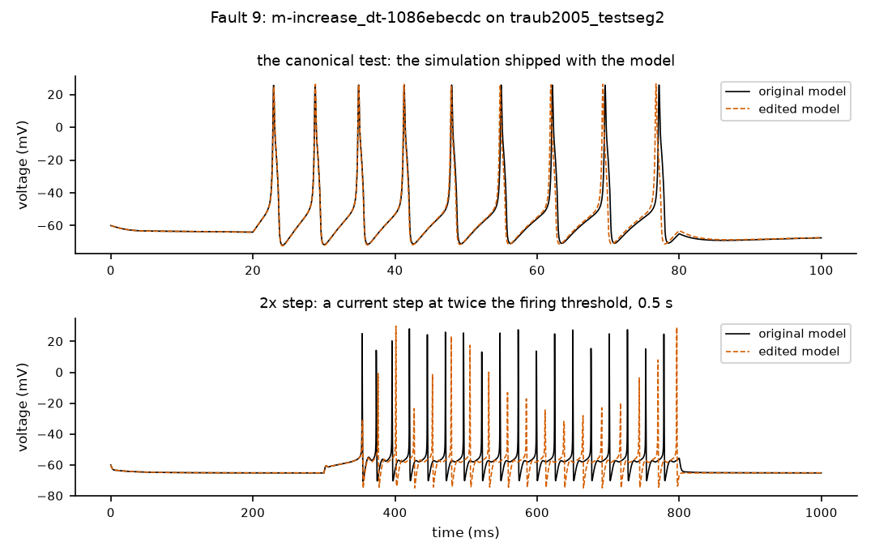
Black: original model. Orange dashed: edited model. Where the lines separate, the behaviour changed.

Your answers for fault 9 (type X) | Yes | No | Unsure | N/A
Q1 Edit matches its label? |  |  |  | –
Q2 Assigned class plausible? |  |  |  | –
Q3 Detection plausible?
Confidence: type X under one | High | Medium | Low | –
Notes (required for any No or Unsure):

Fault 10 of 25
Fault ID | m-increase_dt-9ff98cb7be
Group | random sample
Model | Smith et al. 2013 layer-2/3 pyramidal cell (one compartment) (smith2013_singlecomp)
Label (what the edit claims to be) | increase_dt: make the simulation time step larger (a numerical stress test, not a model fault); factor 4
Severity | strong
Run status | ok
Assigned class | 6_silent_under_canonical: behaviour changed, but the canonical test missed it (another protocol caught it)
Detected (features) by | P09_short_pulse

The exact change (Question 1)
File: NeuroML2/LEMS_singleCompAllChans.xml
@@ -22,14 +22,14 @@
<!--Note: this could be: Simulation id="sim1" ... , but Component type="Simulation" ...
is used to allow validation of this file according to the LEMS schema specified above...-->
- <Component type="Simulation" id="sim1" length="600ms" step="0.001 ms" target="net">
+ <Component type="Simulation" id="sim1" length="600ms" step="0.004 ms" target="net">

- <Display id="" title="v" xmin="0" xmax="600" ymin="-100.0" ymax="100" timeScale="1ms">
+ <Display id="" title="v" xmin="0" xmax="600" ymin="-100.0" ymax="100" timeScale="1ms">
<Line id="VOLTAGE" timeScale="1ms" quantity="pop0/0/cell/v" scale="1 mV" color="#000000"/>
</Display>
<Display id="d2" title="Ca current density (uA_per_cm2)" timeScale="1ms" xmin="0" xmax="600" ymin="0" ymax="3">
- <Line id="Ca iDensity" quantity="pop0/0/cell/biophys/membraneProperties/ca_all/iDensity" scale="1uA_per_cm2" color="#00ff00" timeScale="1ms"/>
+ <Line id="Ca iDensity" quantity="pop0/0/cell/biophys/membraneProperties/ca_all/iDensity" scale="1uA_per_cm2" color="#00ff00" timeScale="1ms"/>
</Display>
<Display id="d3" title="Internal Ca concentration (mM)" timeScale="1ms" xmin="0" xmax="600" ymin="0" ymax="30">
- <Line id="caConc" quantity="pop0/0/cell/caConc" scale="1e-6 mM" color="#ff0000" timeScale="1ms"/>
+ <Line id="caConc" quantity="pop0/0/cell/caConc" scale="1e-6 mM" color="#ff0000" timeScale="1ms"/>
</Display>
<OutputFile id="outf" fileName="jlems_sccct.dat">

Evidence (Questions 2 and 3)
Feature differences that exceeded tolerance:
Step | Stimulus | Feature | Original | Edited | Difference | Tolerance
h | P04_step_2x | ahp_depth | -12.95 | 134.5 | 147.4 | 0.6473
h | P09_short_pulse | ahp_depth | -13.72 | 123.2 | 137 | 0.6861
h | P09_short_pulse | ap_amplitude | 134.2 | – | – | 2.683
h/2 | P09_short_pulse | ap_amplitude | 133.8 | – | – | 2.683

Whole-voltage-trace differences that exceeded tolerance:
Step | Stimulus | Measure | Original | Edited | Difference | Tolerance
h | P00_canonical | overall voltage difference (RMS, mV) | 0 | 4.237 | 4.237 | 3.009
h | P04_step_2x | spike timing (largest shift, ms) | – | – | 5.715 | 3.078
h | P06_ramp | spike timing (largest shift, ms) | – | – | 5.6 | 3.018
h | P09_short_pulse | overall voltage difference (RMS, mV) | 0 | 0.8654 | 0.8654 | 0.7748

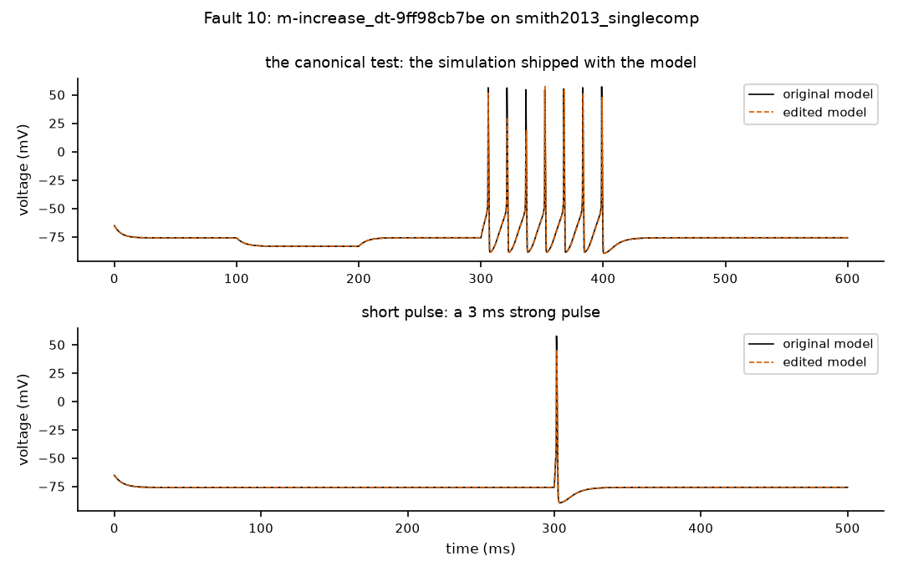
Black: original model. Orange dashed: edited model. Where the lines separate, the behaviour changed.

Your answers for fault 10 (type X) | Yes | No | Unsure | N/A
Q1 Edit matches its label? |  |  |  | –
Q2 Assigned class plausible? |  |  |  | –
Q3 Detection plausible?
Confidence: type X under one | High | Medium | Low | –
Notes (required for any No or Unsure):

Fault 11 of 25
Fault ID | m-scale_capacitance-8d53b9976a
Group | random sample
Model | Traub et al. 2005 test cell with almost all channels (traub2005_testseg_all)
Label (what the edit claims to be) | scale_capacitance: multiply the membrane capacitance by a factor; factor 0.8
Severity | mild
Run status | ok
Assigned class | 5_non_equivalent: behaviour changed, and the canonical test caught it
Detected (features) by | P00_canonical, P04_step_2x, P05_long_step, P06_ramp, P09_short_pulse

The exact change (Question 1)
File: neuroConstruct/generatedNeuroML2/TestSeg_all.cell.nml
@@ -136,5 +136,5 @@
<spikeThresh value="0 mV"/>

- <specificCapacitance value="1.0 uF_per_cm2"/>
+ <specificCapacitance value="0.8 uF_per_cm2"/>

<initMembPotential value="-60.0 mV"/>

Evidence (Questions 2 and 3)
Feature differences that exceeded tolerance:
Step | Stimulus | Feature | Original | Edited | Difference | Tolerance
h | P00_canonical | adaptation_index | 0.5217 | 0.5962 | 0.07448 | 0.05217
h | P00_canonical | ahp_depth | -8.248 | -10.33 | 2.078 | 0.5
h | P00_canonical | ap_amplitude | 74.71 | 80.05 | 5.339 | 1.494
h | P00_canonical | first_spike_latency | 2.95 | 2.27 | 0.68 | 0.5
h | P04_step_2x | ahp_depth | -3.064 | -11.19 | 8.125 | 1.146
h | P04_step_2x | first_spike_latency | 29.1 | 2.61 | 26.49 | 0.582
h | P05_long_step | ahp_depth | -2.799 | -5.095 | 2.296 | 1.173
h | P05_long_step | ap_amplitude | 72.99 | 75.78 | 2.787 | 1.46
h | P05_long_step | first_spike_latency | 42.89 | 41.71 | 1.18 | 0.8578
h | P05_long_step | last_isi | 24.47 | 22.67 | 1.8 | 1.11
h | P05_long_step | spike_count | 83 | 90 | 7 | 3
h | P06_ramp | spike_count | 70 | 78 | 8 | 3
h | P09_short_pulse | ahp_depth | -2.698 | -4.395 | 1.697 | 1.327
h | P09_short_pulse | ap_amplitude | 96.16 | 99.1 | 2.943 | 1.923
h/2 | P00_canonical | adaptation_index | 0.5215 | 0.596 | 0.07453 | 0.05217
h/2 | P00_canonical | ahp_depth | -8.214 | -10.29 | 2.074 | 0.5
(12 more rows not shown)

Whole-voltage-trace differences that exceeded tolerance:
Step | Stimulus | Measure | Original | Edited | Difference | Tolerance
h | P00_canonical | overall voltage difference (RMS, mV) | 0 | 14.87 | 14.87 | 1.009
h | P00_canonical | spike timing (largest shift, ms) | – | – | 3.909 | 0.5
h | P09_short_pulse | overall voltage difference (RMS, mV) | 0 | 2.463 | 2.463 | 0.5
h/2 | P00_canonical | overall voltage difference (RMS, mV) | 0 | 14.87 | 14.87 | 1.009
h/2 | P00_canonical | spike timing (largest shift, ms) | – | – | 3.903 | 0.5
h/2 | P09_short_pulse | overall voltage difference (RMS, mV) | 0 | 2.451 | 2.451 | 0.5

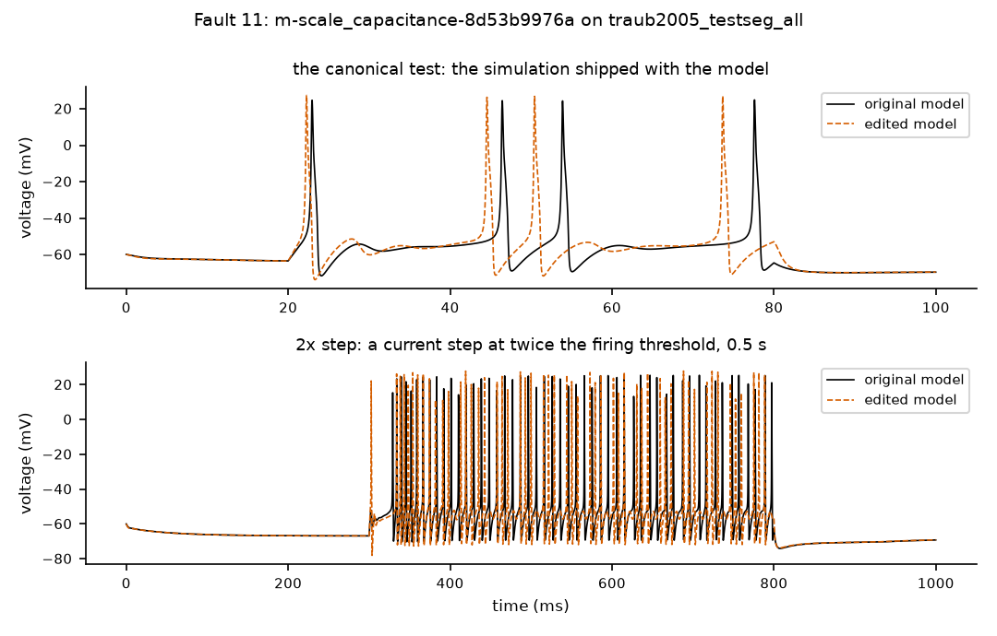
Black: original model. Orange dashed: edited model. Where the lines separate, the behaviour changed.

Your answers for fault 11 (type X) | Yes | No | Unsure | N/A
Q1 Edit matches its label? |  |  |  | –
Q2 Assigned class plausible? |  |  |  | –
Q3 Detection plausible?
Confidence: type X under one | High | Medium | Low | –
Notes (required for any No or Unsure):

Fault 12 of 25
Fault ID | m-scale_capacitance-8f1d58bf3d
Group | random sample
Model | Traub et al. 2005 test cell with almost all channels (traub2005_testseg_all)
Label (what the edit claims to be) | scale_capacitance: multiply the membrane capacitance by a factor; factor 0.5
Severity | strong
Run status | ok
Assigned class | 5_non_equivalent: behaviour changed, and the canonical test caught it
Detected (features) by | P00_canonical, P04_step_2x, P05_long_step, P06_ramp, P09_short_pulse

The exact change (Question 1)
File: neuroConstruct/generatedNeuroML2/TestSeg_all.cell.nml
@@ -136,5 +136,5 @@
<spikeThresh value="0 mV"/>

- <specificCapacitance value="1.0 uF_per_cm2"/>
+ <specificCapacitance value="0.5 uF_per_cm2"/>

<initMembPotential value="-60.0 mV"/>

Evidence (Questions 2 and 3)
Feature differences that exceeded tolerance:
Step | Stimulus | Feature | Original | Edited | Difference | Tolerance
h | P00_canonical | adaptation_index | 0.5217 | 0.03545 | 0.4862 | 0.05217
h | P00_canonical | ahp_depth | -8.248 | -14.57 | 6.322 | 0.5
h | P00_canonical | ap_amplitude | 74.71 | 96.16 | 21.45 | 1.494
h | P00_canonical | first_spike_latency | 2.95 | 1.4 | 1.55 | 0.5
h | P00_canonical | last_isi | 23.7 | 4.67 | 19.03 | 0.5
h | P00_canonical | spike_count | 4 | 6 | 2 | 0.5
h | P04_step_2x | ahp_depth | -3.064 | -14.86 | 11.79 | 1.146
h | P04_step_2x | ap_amplitude | 71.33 | 97.08 | 25.74 | 1.427
h | P04_step_2x | first_spike_latency | 29.1 | 1.43 | 27.67 | 0.582
h | P04_step_2x | spike_count | 51 | 63 | 12 | 3
h | P05_long_step | ahp_depth | -2.799 | -15.34 | 12.54 | 1.173
h | P05_long_step | ap_amplitude | 72.99 | 94.65 | 21.66 | 1.46
h | P05_long_step | first_spike_latency | 42.89 | 2.04 | 40.85 | 0.8578
h | P05_long_step | last_isi | 24.47 | 4.97 | 19.5 | 1.11
h | P05_long_step | spike_count | 83 | 96 | 13 | 3
h | P06_ramp | spike_count | 70 | 95 | 25 | 3
(20 more rows not shown)

Whole-voltage-trace differences that exceeded tolerance:
Step | Stimulus | Measure | Original | Edited | Difference | Tolerance
h | P00_canonical | overall voltage difference (RMS, mV) | 0 | 17.29 | 17.29 | 1.009
h | P00_canonical | spike count | 4 | 6 | 2 | 0.5
h | P09_short_pulse | overall voltage difference (RMS, mV) | 0 | 4.265 | 4.265 | 0.5
h | P09_short_pulse | spike timing (largest shift, ms) | – | – | 0.8742 | 0.5
h/2 | P00_canonical | overall voltage difference (RMS, mV) | 0 | 16.98 | 16.98 | 1.009
h/2 | P00_canonical | spike count | 4 | 6 | 2 | 0.5
h/2 | P09_short_pulse | overall voltage difference (RMS, mV) | 0 | 4.264 | 4.264 | 0.5
h/2 | P09_short_pulse | spike timing (largest shift, ms) | – | – | 0.8786 | 0.5

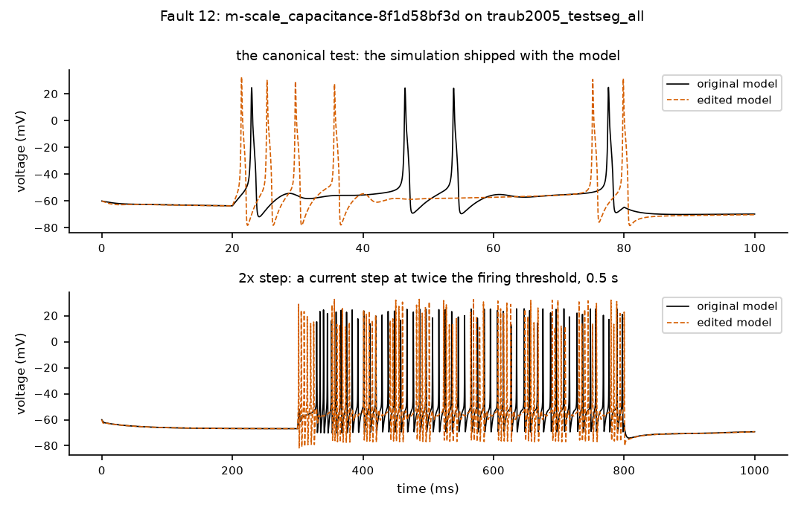
Black: original model. Orange dashed: edited model. Where the lines separate, the behaviour changed.

Your answers for fault 12 (type X) | Yes | No | Unsure | N/A
Q1 Edit matches its label? |  |  |  | –
Q2 Assigned class plausible? |  |  |  | –
Q3 Detection plausible?
Confidence: type X under one | High | Medium | Low | –
Notes (required for any No or Unsure):

Fault 13 of 25
Fault ID | m-scale_conductance-056f6e95e6
Group | random sample
Model | Migliore et al. 2005 hippocampal CA1 pyramidal cell (soma only) (migliore2005_ca1_soma)
Label (what the edit claims to be) | scale_conductance: multiply one ion channel's maximal conductance (how many channels there are) by a factor; factor 2
Severity | strong
Run status | ok
Assigned class | 5_non_equivalent: behaviour changed, and the canonical test caught it
Detected (features) by | P00_canonical, P02_weak_step, P03_rheobase, P04_step_2x, P05_long_step, P06_ramp, P07_hyperpolarizing_step, P08_rebound, P09_short_pulse

The exact change (Question 1)
File: neuroConstruct/generatedNeuroML2/SomaOnly_allCml.cell.nml
@@ -69,5 +69,5 @@
<membraneProperties>

- <channelDensity condDensity="0.05 mS_per_cm2" id="hd_all" ionChannel="hd__vhalflmin73" ion="hd" erev="-30.0 mV"/>
+ <channelDensity condDensity="0.1 mS_per_cm2" id="hd_all" ionChannel="hd__vhalflmin73" ion="hd" erev="-30.0 mV"/>

<channelDensity condDensity="30.0 mS_per_cm2" id="kad_all" ionChannel="kad" ion="k" erev="-90.0 mV"/>

Evidence (Questions 2 and 3)
Feature differences that exceeded tolerance:
Step | Stimulus | Feature | Original | Edited | Difference | Tolerance
h | P00_canonical | adaptation_index | – | 2.134e-13 | – | inf
h | P00_canonical | ahp_depth | -11.85 | -16.24 | 4.387 | 0.5927
h | P00_canonical | first_spike_latency | 5.42 | 2.72 | 2.7 | 0.5
h | P00_canonical | last_isi | 18.33 | 17.23 | 1.1 | 0.5
h | P00_canonical | spike_count | 3 | 4 | 1 | 0.5
h | P02_weak_step | spike_count | 0 | 11 | 11 | 0.5
h | P02_weak_step | steady_state_voltage | -65.02 | -65.67 | 0.6437 | 0.5
h | P03_rheobase | rheobase | 5.806e-4 | 0 | 5.806e-4 | 6.830e-5
h | P04_step_2x | ahp_depth | -14.78 | -16.69 | 1.917 | 0.7388
h | P04_step_2x | first_spike_latency | 16.07 | 16.9 | 0.83 | 0.5
h | P04_step_2x | last_isi | 40.06 | 29.47 | 10.59 | 0.8012
h | P04_step_2x | spike_count | 13 | 17 | 4 | 0.5
h | P05_long_step | ahp_depth | -15.07 | -16.97 | 1.9 | 0.7537
h | P05_long_step | first_spike_latency | 23.15 | 19.71 | 3.44 | 0.5
h | P05_long_step | last_isi | 51.51 | 32.76 | 18.75 | 1.03
h | P05_long_step | spike_count | 39 | 61 | 22 | 0.5
(34 more rows not shown)

Whole-voltage-trace differences that exceeded tolerance:
Step | Stimulus | Measure | Original | Edited | Difference | Tolerance
h | P00_canonical | overall voltage difference (RMS, mV) | 0 | 28.66 | 28.66 | 4.056
h | P00_canonical | spike timing (largest shift, ms) | – | – | 5.987 | 0.5
h | P02_weak_step | overall voltage difference (RMS, mV) | 0 | 14.62 | 14.62 | 0.5
h | P02_weak_step | spike count | 0 | 19 | 19 | 0.5
h | P04_step_2x | overall voltage difference (RMS, mV) | 0 | 20.18 | 20.18 | 8.749
h | P04_step_2x | spike count | 13 | 25 | 12 | 0.5
h | P05_long_step | spike count | 39 | 69 | 30 | 0.5
h | P06_ramp | overall voltage difference (RMS, mV) | 0 | 19.93 | 19.93 | 6.268
h | P06_ramp | spike count | 16 | 38 | 22 | 0.5
h | P07_hyperpolarizing_step | overall voltage difference (RMS, mV) | 0 | 9.833 | 9.833 | 0.5
h | P07_hyperpolarizing_step | spike count | 0 | 8 | 8 | 0.5
h | P08_rebound | overall voltage difference (RMS, mV) | 0 | 10.46 | 10.46 | 0.5
h | P08_rebound | spike count | 0 | 10 | 10 | 0.5
h | P09_short_pulse | overall voltage difference (RMS, mV) | 0 | 13.68 | 13.68 | 1.226
(16 more rows not shown)

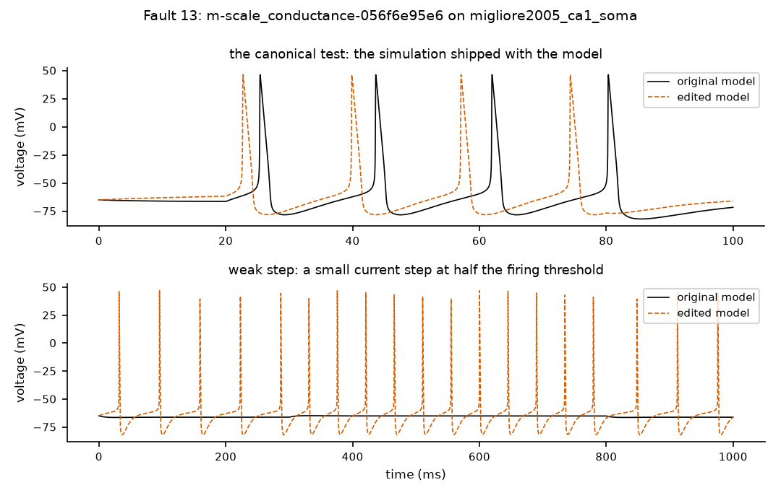
Black: original model. Orange dashed: edited model. Where the lines separate, the behaviour changed.

Your answers for fault 13 (type X) | Yes | No | Unsure | N/A
Q1 Edit matches its label? |  |  |  | –
Q2 Assigned class plausible? |  |  |  | –
Q3 Detection plausible?
Confidence: type X under one | High | Medium | Low | –
Notes (required for any No or Unsure):

Fault 14 of 25
Fault ID | m-scale_conductance-2956a62118
Group | random sample
Model | Blue Brain Project 2015 cortical cell (soma only) (bbp2015_soma)
Label (what the edit claims to be) | scale_conductance: multiply one ion channel's maximal conductance (how many channels there are) by a factor; factor 0.9
Severity | mild
Run status | ok
Assigned class | 6_silent_under_canonical: behaviour changed, but the canonical test missed it (another protocol caught it)
Detected (features) by | P04_step_2x

The exact change (Question 1)
File: NMC/NeuroML2/Soma_AllNML2.cell.nml
@@ -88,5 +88,5 @@
<channelDensity condDensity="293.0 mS_per_cm2" id="SKv3_1_all" ionChannel="SKv3_1" ion="k" erev="-85.0 mV"/>

- <channelDensityNernst condDensity="3.43 mS_per_cm2" id="Ca_LVAst_all" ionChannel="Ca_LVAst" ion="ca"/>
+ <channelDensityNernst condDensity="3.087 mS_per_cm2" id="Ca_LVAst_all" ionChannel="Ca_LVAst" ion="ca"/>

<channelDensityNernst condDensity="0.992 mS_per_cm2" id="Ca_HVA_all" ionChannel="Ca_HVA" ion="ca"/>

Evidence (Questions 2 and 3)
Feature differences that exceeded tolerance:
Step | Stimulus | Feature | Original | Edited | Difference | Tolerance
h | P04_step_2x | spike_count | 30 | 29 | 1 | 0.5
h/2 | P04_step_2x | spike_count | 30 | 29 | 1 | 0.5

Whole-voltage-trace differences that exceeded tolerance:
Step | Stimulus | Measure | Original | Edited | Difference | Tolerance
h | P00_canonical | overall voltage difference (RMS, mV) | 0 | 7.042 | 7.042 | 1.567
h | P00_canonical | spike timing (largest shift, ms) | – | – | 2.613 | 0.5
h | P04_step_2x | spike count | 30 | 29 | 1 | 0.5
h | P05_long_step | spike timing (largest shift, ms) | – | – | 21.71 | 9.523
h | P06_ramp | spike timing (largest shift, ms) | – | – | 3.08 | 2.334
h/2 | P00_canonical | overall voltage difference (RMS, mV) | 0 | 7.045 | 7.045 | 1.567
h/2 | P00_canonical | spike timing (largest shift, ms) | – | – | 2.615 | 0.5
h/2 | P04_step_2x | spike count | 30 | 29 | 1 | 0.5
h/2 | P05_long_step | spike timing (largest shift, ms) | – | – | 21.77 | 9.523
h/2 | P06_ramp | spike timing (largest shift, ms) | – | – | 3.097 | 2.334
h/4 | P00_canonical | overall voltage difference (RMS, mV) | 0 | 7.046 | 7.046 | 1.567
h/4 | P00_canonical | spike timing (largest shift, ms) | – | – | 2.616 | 0.5
h/4 | P04_step_2x | spike timing (largest shift, ms) | – | – | 7.297 | 3.458
h/4 | P05_long_step | spike timing (largest shift, ms) | – | – | 21.81 | 9.523
(1 more rows not shown)

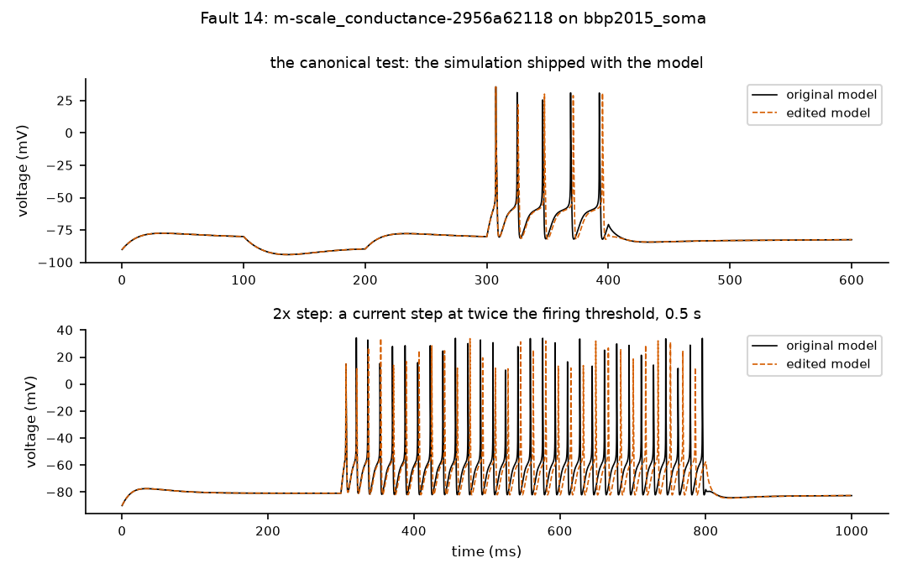
Black: original model. Orange dashed: edited model. Where the lines separate, the behaviour changed.

Your answers for fault 14 (type X) | Yes | No | Unsure | N/A
Q1 Edit matches its label? |  |  |  | –
Q2 Assigned class plausible? |  |  |  | –
Q3 Detection plausible?
Confidence: type X under one | High | Medium | Low | –
Notes (required for any No or Unsure):

Fault 15 of 25
Fault ID | m-scale_conductance-c2b2371643
Group | random sample
Model | Migliore et al. 2005 hippocampal CA1 pyramidal cell (soma only) (migliore2005_ca1_soma)
Label (what the edit claims to be) | scale_conductance: multiply one ion channel's maximal conductance (how many channels there are) by a factor; factor 0.9
Severity | mild
Run status | ok
Assigned class | 6_silent_under_canonical: behaviour changed, but the canonical test missed it (another protocol caught it)
Detected (features) by | P04_step_2x, P05_long_step, P06_ramp

The exact change (Question 1)
File: neuroConstruct/generatedNeuroML2/SomaOnly_allCml.cell.nml
@@ -77,5 +77,5 @@
<channelDensity condDensity="10.0 mS_per_cm2" id="kdr_all" ionChannel="kdr" ion="k" erev="-90.0 mV"/>

- <channelDensity condDensity="25.0 mS_per_cm2" id="na3_all" ionChannel="na3" ion="na" erev="50.0 mV"/>
+ <channelDensity condDensity="22.5 mS_per_cm2" id="na3_all" ionChannel="na3" ion="na" erev="50.0 mV"/>

<channelDensity condDensity="125.0 mS_per_cm2" id="nax_all" ionChannel="nax" ion="na" erev="50.0 mV"/>

Evidence (Questions 2 and 3)
Feature differences that exceeded tolerance:
Step | Stimulus | Feature | Original | Edited | Difference | Tolerance
h | P04_step_2x | spike_count | 13 | 12 | 1 | 0.5
h | P05_long_step | first_spike_latency | 23.15 | 23.93 | 0.78 | 0.5
h | P05_long_step | last_isi | 51.51 | 52.63 | 1.12 | 1.03
h | P05_long_step | spike_count | 39 | 38 | 1 | 0.5
h | P06_ramp | first_spike_latency | 396.2 | 407 | 10.79 | 7.924
h/2 | P04_step_2x | spike_count | 13 | 12 | 1 | 0.5
h/2 | P05_long_step | first_spike_latency | 23.11 | 23.89 | 0.78 | 0.5
h/2 | P05_long_step | last_isi | 51.56 | 52.68 | 1.12 | 1.03
h/2 | P05_long_step | spike_count | 39 | 38 | 1 | 0.5
h/2 | P06_ramp | first_spike_latency | 396.1 | 406.9 | 10.79 | 7.924

Whole-voltage-trace differences that exceeded tolerance:
Step | Stimulus | Measure | Original | Edited | Difference | Tolerance
h | P00_canonical | overall voltage difference (RMS, mV) | 0 | 4.96 | 4.96 | 4.056
h | P04_step_2x | overall voltage difference (RMS, mV) | 0 | 15.21 | 15.21 | 8.749
h | P04_step_2x | spike timing (largest shift, ms) | – | – | 6.707 | 0.5184
h | P05_long_step | spike count | 39 | 38 | 1 | 0.5
h | P06_ramp | overall voltage difference (RMS, mV) | 0 | 15.69 | 15.69 | 6.268
h | P06_ramp | spike timing (largest shift, ms) | – | – | 10.79 | 0.5781
h/2 | P00_canonical | overall voltage difference (RMS, mV) | 0 | 4.952 | 4.952 | 4.056
h/2 | P04_step_2x | overall voltage difference (RMS, mV) | 0 | 15.16 | 15.16 | 8.749
h/2 | P04_step_2x | spike timing (largest shift, ms) | – | – | 6.596 | 0.5184
h/2 | P05_long_step | spike count | 39 | 38 | 1 | 0.5
h/2 | P06_ramp | overall voltage difference (RMS, mV) | 0 | 15.64 | 15.64 | 6.268
h/2 | P06_ramp | spike timing (largest shift, ms) | – | – | 10.79 | 0.5781
h/4 | P00_canonical | overall voltage difference (RMS, mV) | 0 | 4.95 | 4.95 | 4.056
h/4 | P04_step_2x | overall voltage difference (RMS, mV) | 0 | 15.14 | 15.14 | 8.749
(4 more rows not shown)

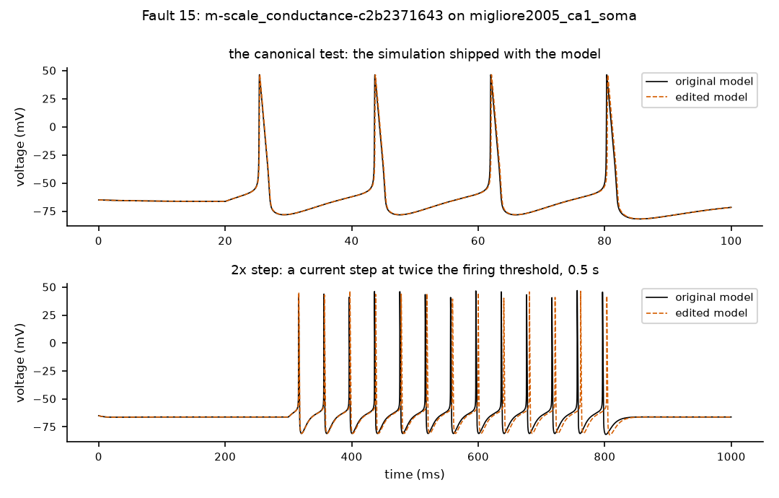
Black: original model. Orange dashed: edited model. Where the lines separate, the behaviour changed.

Your answers for fault 15 (type X) | Yes | No | Unsure | N/A
Q1 Edit matches its label? |  |  |  | –
Q2 Assigned class plausible? |  |  |  | –
Q3 Detection plausible?
Confidence: type X under one | High | Medium | Low | –
Notes (required for any No or Unsure):

Fault 16 of 25
Fault ID | m-scale_conductance-c9ac5a125c
Group | random sample
Model | Traub et al. 2005 test cell 2 (sodium/potassium channels) (traub2005_testseg2)
Label (what the edit claims to be) | scale_conductance: multiply one ion channel's maximal conductance (how many channels there are) by a factor; factor 0.5
Severity | strong
Run status | ok
Assigned class | 5_non_equivalent: behaviour changed, and the canonical test caught it
Detected (features) by | P00_canonical, P02_weak_step, P03_rheobase, P04_step_2x, P05_long_step, P06_ramp, P07_hyperpolarizing_step, P09_short_pulse

The exact change (Question 1)
File: neuroConstruct/generatedNeuroML2/TestSeg_test2.cell.nml
@@ -69,5 +69,5 @@
<channelDensity condDensity="0.1 mS_per_cm2" id="k2_all" ionChannel="k2" ion="k" erev="-95.0 mV"/>

- <channelDensity condDensity="15.0 mS_per_cm2" id="ka_all" ionChannel="ka" ion="k" erev="-95.0 mV"/>
+ <channelDensity condDensity="7.5 mS_per_cm2" id="ka_all" ionChannel="ka" ion="k" erev="-95.0 mV"/>

<channelDensity condDensity="15.0 mS_per_cm2" id="ka_ib_all" ionChannel="ka_ib" ion="k" erev="-95.0 mV"/>

Evidence (Questions 2 and 3)
Feature differences that exceeded tolerance:
Step | Stimulus | Feature | Original | Edited | Difference | Tolerance
h | P00_canonical | ahp_depth | -7.977 | -6.885 | 1.092 | 0.5
h | P00_canonical | ap_amplitude | 76.04 | 80.33 | 4.287 | 1.521
h | P00_canonical | first_spike_latency | 2.91 | 2.33 | 0.58 | 0.5
h | P00_canonical | last_isi | 7.59 | 6.74 | 0.85 | 0.5
h | P00_canonical | spike_count | 9 | 10 | 1 | 0.5
h | P02_weak_step | spike_count | 0 | 2 | 2 | 0.5
h | P02_weak_step | steady_state_voltage | -63.11 | -59.61 | 3.499 | 0.5
h | P03_rheobase | rheobase | 0.01711 | 0.007069 | 0.01004 | 3.422e-4
h | P04_step_2x | ahp_depth | -5.433 | -6.819 | 1.386 | 1.145
h | P04_step_2x | first_spike_latency | 53.73 | 21.86 | 31.87 | 1.075
h | P04_step_2x | last_isi | 25.63 | 15.8 | 9.83 | 1.29
h | P04_step_2x | spike_count | 18 | 32 | 14 | 0.5
h | P05_long_step | ahp_depth | -5.301 | -6.698 | 1.398 | 1.153
h | P05_long_step | first_spike_latency | 86.5 | 30.79 | 55.71 | 1.73
h | P05_long_step | last_isi | 46.56 | 22.43 | 24.13 | 2.61
h | P05_long_step | spike_count | 42 | 89 | 47 | 3
(24 more rows not shown)

Whole-voltage-trace differences that exceeded tolerance:
Step | Stimulus | Measure | Original | Edited | Difference | Tolerance
h | P00_canonical | overall voltage difference (RMS, mV) | 0 | 22.32 | 22.32 | 4.39
h | P00_canonical | spike count | 9 | 10 | 1 | 0.5
h | P02_weak_step | overall voltage difference (RMS, mV) | 0 | 3.586 | 3.586 | 0.5
h | P02_weak_step | spike count | 0 | 2 | 2 | 0.5
h | P04_step_2x | spike count | 18 | 32 | 14 | 0.5
h | P07_hyperpolarizing_step | overall voltage difference (RMS, mV) | 0 | 0.998 | 0.998 | 0.5
h | P08_rebound | overall voltage difference (RMS, mV) | 0 | 0.9346 | 0.9346 | 0.5
h | P09_short_pulse | overall voltage difference (RMS, mV) | 0 | 1.941 | 1.941 | 0.5
h/2 | P00_canonical | overall voltage difference (RMS, mV) | 0 | 22.33 | 22.33 | 4.39
h/2 | P00_canonical | spike count | 9 | 10 | 1 | 0.5
h/2 | P02_weak_step | overall voltage difference (RMS, mV) | 0 | 3.584 | 3.584 | 0.5
h/2 | P02_weak_step | spike count | 0 | 2 | 2 | 0.5
h/2 | P04_step_2x | spike count | 18 | 31 | 13 | 0.5
h/2 | P07_hyperpolarizing_step | overall voltage difference (RMS, mV) | 0 | 0.998 | 0.998 | 0.5
(2 more rows not shown)

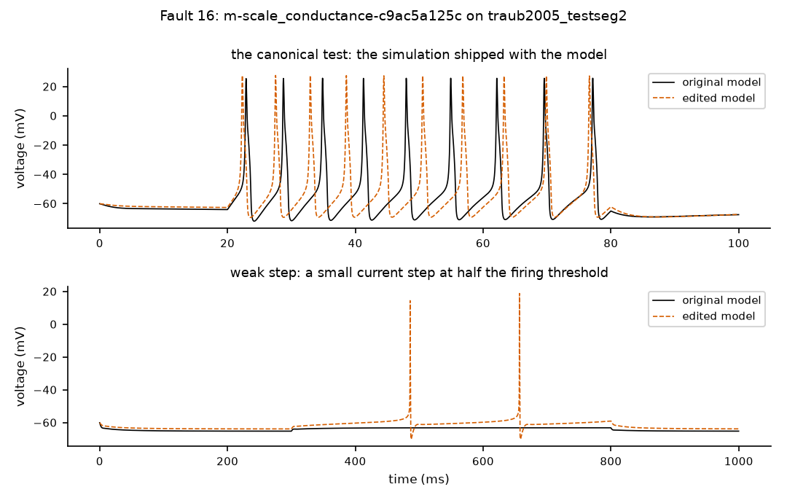
Black: original model. Orange dashed: edited model. Where the lines separate, the behaviour changed.

Your answers for fault 16 (type X) | Yes | No | Unsure | N/A
Q1 Edit matches its label? |  |  |  | –
Q2 Assigned class plausible? |  |  |  | –
Q3 Detection plausible?
Confidence: type X under one | High | Medium | Low | –
Notes (required for any No or Unsure):

Fault 17 of 25
Fault ID | m-scale_gate_slope-039828a4db
Group | random sample
Model | Blue Brain Project 2015 cortical cell (soma only) (bbp2015_soma)
Label (what the edit claims to be) | scale_gate_slope: make one channel gate's voltage dependence steeper or shallower; factor 0.8
Severity | mild
Run status | ok
Assigned class | 5_non_equivalent: behaviour changed, and the canonical test caught it
Detected (features) by | P00_canonical, P04_step_2x, P05_long_step, P07_hyperpolarizing_step, P09_short_pulse

The exact change (Question 1)
File: NMC/NeuroML2/Ih.channel.nml
@@ -28,6 +28,6 @@

<gate id="m" type="gateHHrates" instances="1">
- <forwardRate type="HHExpLinearRate" rate="0.076517per_ms" scale="-11.9mV" midpoint="-154.9mV"/>
- <reverseRate type="HHExpRate" rate="0.193per_ms" scale="33.1mV" midpoint="0mV"/>
+ <forwardRate type="HHExpLinearRate" rate="0.076517per_ms" scale="-9.52mV" midpoint="-154.9mV"/>
+ <reverseRate type="HHExpRate" rate="0.193per_ms" scale="26.48mV" midpoint="0mV"/>
</gate>

Evidence (Questions 2 and 3)
Feature differences that exceeded tolerance:
Step | Stimulus | Feature | Original | Edited | Difference | Tolerance
h | P00_canonical | ahp_depth | -0.5401 | 0.6559 | 1.196 | 0.5
h | P00_canonical | last_isi | 23.59 | 24.1 | 0.51 | 0.5
h | P04_step_2x | ahp_depth | 0.8735 | 3.67 | 2.796 | 0.5
h | P05_long_step | ahp_depth | 0.5049 | 3.214 | 2.709 | 0.5
h | P05_long_step | first_spike_latency | 10.13 | 10.9 | 0.77 | 0.5
h | P07_hyperpolarizing_step | steady_state_voltage | -97.97 | -99.4 | 1.43 | 0.5
h | P09_short_pulse | ahp_depth | -0.9664 | 1.855 | 2.821 | 0.5
h/2 | P00_canonical | ahp_depth | -0.5443 | 0.6516 | 1.196 | 0.5
h/2 | P00_canonical | last_isi | 23.58 | 24.1 | 0.52 | 0.5
h/2 | P04_step_2x | ahp_depth | 0.855 | 3.651 | 2.796 | 0.5
h/2 | P05_long_step | ahp_depth | 0.5179 | 3.232 | 2.714 | 0.5
h/2 | P05_long_step | first_spike_latency | 10.1 | 10.87 | 0.77 | 0.5
h/2 | P07_hyperpolarizing_step | steady_state_voltage | -97.97 | -99.4 | 1.43 | 0.5
h/2 | P09_short_pulse | ahp_depth | -0.995 | 1.818 | 2.813 | 0.5

Whole-voltage-trace differences that exceeded tolerance:
Step | Stimulus | Measure | Original | Edited | Difference | Tolerance
h | P00_canonical | overall voltage difference (RMS, mV) | 0 | 3.809 | 3.809 | 1.567
h | P00_canonical | spike timing (largest shift, ms) | – | – | 0.6292 | 0.5
h | P02_weak_step | overall voltage difference (RMS, mV) | 0 | 1.633 | 1.633 | 0.5
h | P04_step_2x | spike timing (largest shift, ms) | – | – | 4.53 | 3.458
h | P05_long_step | spike timing (largest shift, ms) | – | – | 22.07 | 9.523
h | P06_ramp | spike timing (largest shift, ms) | – | – | 3.322 | 2.334
h | P07_hyperpolarizing_step | overall voltage difference (RMS, mV) | 0 | 2.063 | 2.063 | 0.5
h | P08_rebound | overall voltage difference (RMS, mV) | 0 | 1.517 | 1.517 | 0.5
h | P09_short_pulse | overall voltage difference (RMS, mV) | 0 | 1.848 | 1.848 | 0.647
h/2 | P00_canonical | overall voltage difference (RMS, mV) | 0 | 3.805 | 3.805 | 1.567
h/2 | P00_canonical | spike timing (largest shift, ms) | – | – | 0.6269 | 0.5
h/2 | P02_weak_step | overall voltage difference (RMS, mV) | 0 | 1.633 | 1.633 | 0.5
h/2 | P04_step_2x | spike timing (largest shift, ms) | – | – | 4.51 | 3.458
h/2 | P05_long_step | spike timing (largest shift, ms) | – | – | 22.1 | 9.523
(4 more rows not shown)

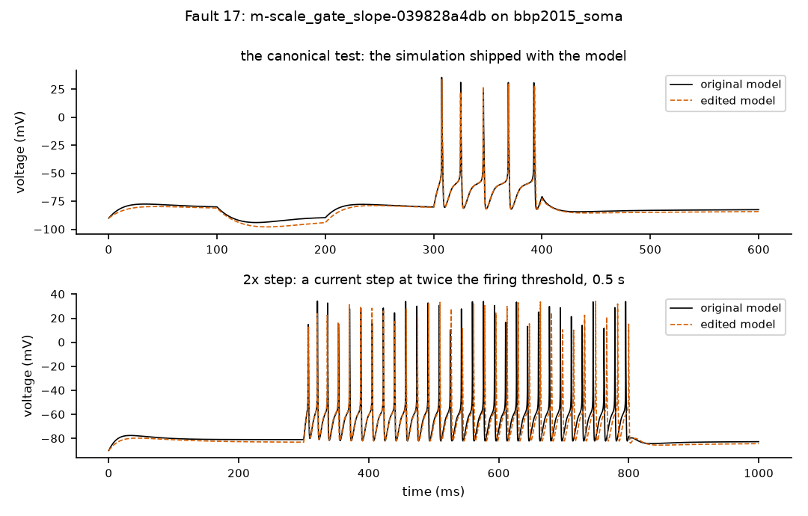
Black: original model. Orange dashed: edited model. Where the lines separate, the behaviour changed.

Your answers for fault 17 (type X) | Yes | No | Unsure | N/A
Q1 Edit matches its label? |  |  |  | –
Q2 Assigned class plausible? |  |  |  | –
Q3 Detection plausible?
Confidence: type X under one | High | Medium | Low | –
Notes (required for any No or Unsure):

Fault 18 of 25
Fault ID | m-scale_gate_time_constant-97ff619aea
Group | random sample
Model | Smith et al. 2013 layer-2/3 pyramidal cell (one compartment) (smith2013_singlecomp)
Label (what the edit claims to be) | scale_gate_time_constant: make one channel gate open and close faster or slower (scale its time constant); factor 0.5
Severity | strong
Run status | ok
Assigned class | 6_silent_under_canonical: behaviour changed, but the canonical test missed it (another protocol caught it)
Detected (features) by | P03_rheobase, P06_ramp

The exact change (Question 1)
File: NeuroML2/it.channel.nml
@@ -48,4 +48,5 @@

<gate id="h" type="gateHHtauInf" instances="1">
+ <q10Settings type="q10Fixed" fixedQ10="0.5"/>
<timeCourse type="CaT_h_tau_tau"/>
<steadyState type="HHSigmoidVariable" rate="1" scale="-5.0mV" midpoint="-78mV"/>

Evidence (Questions 2 and 3)
Feature differences that exceeded tolerance:
Step | Stimulus | Feature | Original | Edited | Difference | Tolerance
h | P03_rheobase | rheobase | 0.02165 | 0.02237 | 7.172e-4 | 4.330e-4
h | P06_ramp | first_spike_latency | 403.1 | 389.2 | 13.89 | 8.062
h | P06_ramp | spike_count | 35 | 36 | 1 | 0.5
h/2 | P03_rheobase | rheobase | 0.02165 | 0.02237 | 7.172e-4 | 4.330e-4
h/2 | P06_ramp | first_spike_latency | 403 | 389.1 | 13.88 | 8.062
h/2 | P06_ramp | spike_count | 35 | 36 | 1 | 0.5

Whole-voltage-trace differences that exceeded tolerance:
Step | Stimulus | Measure | Original | Edited | Difference | Tolerance
h | P00_canonical | overall voltage difference (RMS, mV) | 0 | 6.327 | 6.327 | 3.009
h | P06_ramp | spike count | 35 | 36 | 1 | 0.5
h/2 | P00_canonical | overall voltage difference (RMS, mV) | 0 | 6.328 | 6.328 | 3.009
h/2 | P06_ramp | spike count | 35 | 36 | 1 | 0.5
h/4 | P00_canonical | overall voltage difference (RMS, mV) | 0 | 6.328 | 6.328 | 3.009
h/4 | P06_ramp | spike count | 35 | 36 | 1 | 0.5

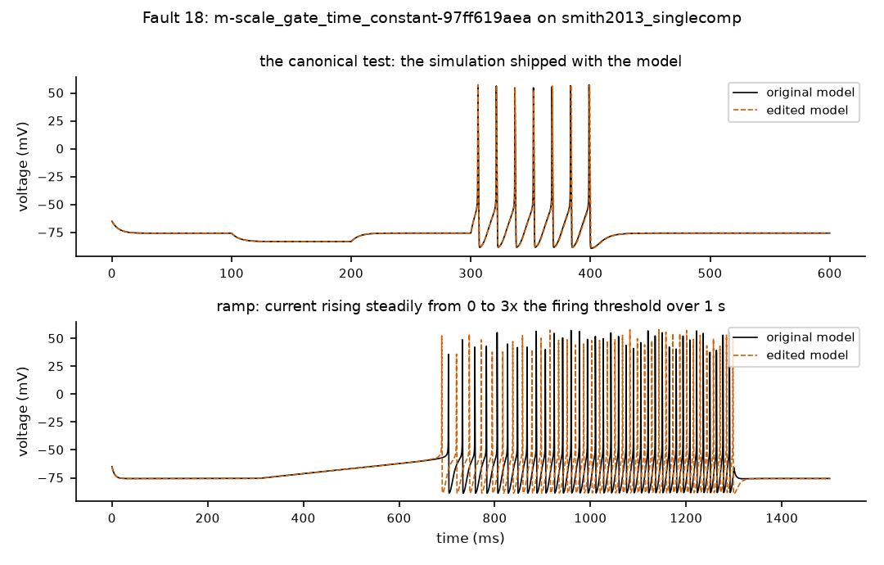
Black: original model. Orange dashed: edited model. Where the lines separate, the behaviour changed.

Your answers for fault 18 (type X) | Yes | No | Unsure | N/A
Q1 Edit matches its label? |  |  |  | –
Q2 Assigned class plausible? |  |  |  | –
Q3 Detection plausible?
Confidence: type X under one | High | Medium | Low | –
Notes (required for any No or Unsure):

Fault 19 of 25
Fault ID | m-shift_forward_rate_midpoint-3567e7da5d
Group | random sample
Model | Traub et al. 2005 test cell with almost all channels (traub2005_testseg_all)
Label (what the edit claims to be) | shift_forward_rate_midpoint: shift the voltage dependence of one gate's opening rate; shift 5 mV
Severity | mild
Run status | ok
Assigned class | 5_non_equivalent: behaviour changed, and the canonical test caught it
Detected (features) by | P00_canonical, P02_weak_step, P03_rheobase, P04_step_2x, P05_long_step, P06_ramp

The exact change (Question 1)
File: neuroConstruct/generatedNeuroML2/cal.channel.nml
@@ -44,5 +44,5 @@

<gate id="m" type="gateHHrates" instances="2">
- <forwardRate type="HHSigmoidRate" rate="1.6per_ms" scale="13.888889mV" midpoint="5mV"/>
+ <forwardRate type="HHSigmoidRate" rate="1.6per_ms" scale="13.888889mV" midpoint="10mV"/>
<reverseRate type="HHExpLinearRate" rate="0.1per_ms" scale="-5mV" midpoint="-8.9mV"/>
</gate>

Evidence (Questions 2 and 3)
Feature differences that exceeded tolerance:
Step | Stimulus | Feature | Original | Edited | Difference | Tolerance
h | P00_canonical | ahp_depth | -8.248 | -8.96 | 0.7112 | 0.5
h | P02_weak_step | steady_state_voltage | -63.19 | -62.15 | 1.043 | 0.5
h | P03_rheobase | rheobase | 0.06144 | 0.04535 | 0.01608 | 0.001229
h | P04_step_2x | ahp_depth | -3.064 | -9.667 | 6.602 | 1.146
h | P04_step_2x | ap_amplitude | 71.33 | 68.96 | 2.372 | 1.427
h | P04_step_2x | first_spike_latency | 29.1 | 3.03 | 26.07 | 0.582
h | P05_long_step | ahp_depth | -2.799 | -5.169 | 2.37 | 1.173
h | P05_long_step | first_spike_latency | 42.89 | 26.93 | 15.96 | 0.8578
h | P06_ramp | first_spike_latency | 382.9 | 288 | 94.83 | 7.657
h/2 | P00_canonical | ahp_depth | -8.214 | -8.924 | 0.7108 | 0.5
h/2 | P02_weak_step | steady_state_voltage | -63.19 | -62.15 | 1.043 | 0.5
h/2 | P03_rheobase | rheobase | 0.06144 | 0.04535 | 0.01608 | 0.001229
h/2 | P04_step_2x | ahp_depth | -2.682 | -9.322 | 6.639 | 1.146
h/2 | P04_step_2x | ap_amplitude | 71 | 68.8 | 2.204 | 1.427
h/2 | P04_step_2x | first_spike_latency | 29.03 | 2.98 | 26.05 | 0.582
h/2 | P05_long_step | ahp_depth | -2.408 | -4.797 | 2.388 | 1.173
(2 more rows not shown)

Whole-voltage-trace differences that exceeded tolerance:
Step | Stimulus | Measure | Original | Edited | Difference | Tolerance
h | P00_canonical | overall voltage difference (RMS, mV) | 0 | 12.84 | 12.84 | 1.009
h | P00_canonical | spike timing (largest shift, ms) | – | – | 1.068 | 0.5
h | P02_weak_step | overall voltage difference (RMS, mV) | 0 | 1.021 | 1.021 | 0.5
h | P07_hyperpolarizing_step | overall voltage difference (RMS, mV) | 0 | 0.654 | 0.654 | 0.5
h | P08_rebound | overall voltage difference (RMS, mV) | 0 | 0.6808 | 0.6808 | 0.5
h | P09_short_pulse | overall voltage difference (RMS, mV) | 0 | 1.064 | 1.064 | 0.5
h/2 | P00_canonical | overall voltage difference (RMS, mV) | 0 | 12.85 | 12.85 | 1.009
h/2 | P00_canonical | spike timing (largest shift, ms) | – | – | 1.071 | 0.5
h/2 | P02_weak_step | overall voltage difference (RMS, mV) | 0 | 1.021 | 1.021 | 0.5
h/2 | P07_hyperpolarizing_step | overall voltage difference (RMS, mV) | 0 | 0.654 | 0.654 | 0.5
h/2 | P08_rebound | overall voltage difference (RMS, mV) | 0 | 0.6808 | 0.6808 | 0.5
h/2 | P09_short_pulse | overall voltage difference (RMS, mV) | 0 | 1.063 | 1.063 | 0.5

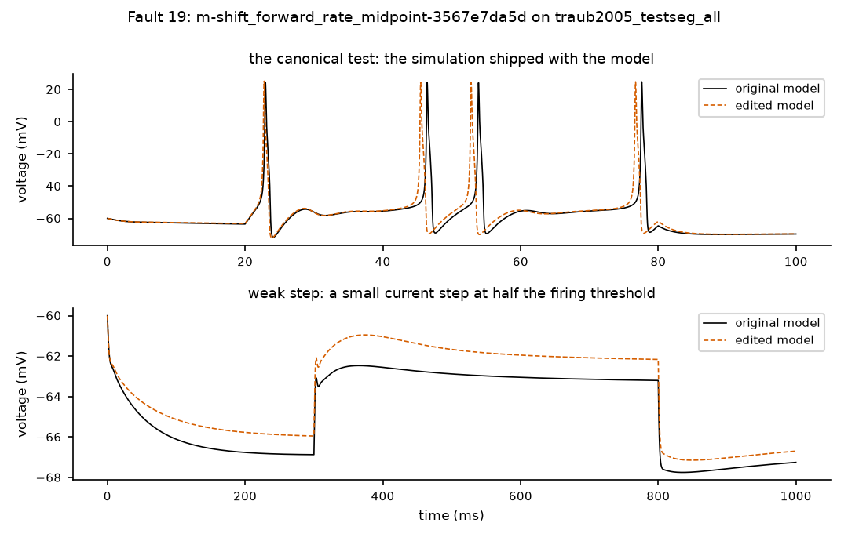
Black: original model. Orange dashed: edited model. Where the lines separate, the behaviour changed.

Your answers for fault 19 (type X) | Yes | No | Unsure | N/A
Q1 Edit matches its label? |  |  |  | –
Q2 Assigned class plausible? |  |  |  | –
Q3 Detection plausible?
Confidence: type X under one | High | Medium | Low | –
Notes (required for any No or Unsure):

Fault 20 of 25
Fault ID | m-shift_gate_midpoint-0bf496636d
Group | random sample
Model | Traub et al. 2005 test cell 2 (sodium/potassium channels) (traub2005_testseg2)
Label (what the edit claims to be) | shift_gate_midpoint: shift the voltage at which one channel gate is half open; shift 10 mV
Severity | strong
Run status | ok
Assigned class | 5_non_equivalent: behaviour changed, and the canonical test caught it
Detected (features) by | P00_canonical, P04_step_2x, P05_long_step, P06_ramp

The exact change (Question 1)
File: neuroConstruct/generatedNeuroML2/km.channel.nml
@@ -44,6 +44,6 @@

<gate id="m" type="gateHHrates" instances="1">
- <forwardRate type="HHSigmoidRate" rate="0.02per_ms" scale="5mV" midpoint="-20mV"/>
- <reverseRate type="HHExpRate" rate="0.01per_ms" scale="-18mV" midpoint="-43mV"/>
+ <forwardRate type="HHSigmoidRate" rate="0.02per_ms" scale="5mV" midpoint="-10mV"/>
+ <reverseRate type="HHExpRate" rate="0.01per_ms" scale="-18mV" midpoint="-33mV"/>
</gate>

Evidence (Questions 2 and 3)
Feature differences that exceeded tolerance:
Step | Stimulus | Feature | Original | Edited | Difference | Tolerance
h | P00_canonical | adaptation_index | 0.01794 | 0.00383 | 0.01411 | 0.01
h | P00_canonical | last_isi | 7.59 | 6.13 | 1.46 | 0.5
h | P00_canonical | spike_count | 9 | 10 | 1 | 0.5
h | P04_step_2x | adaptation_index | 0.004861 | -0.01132 | 0.01618 | 0.01
h | P04_step_2x | last_isi | 25.63 | 12.13 | 13.5 | 1.29
h | P04_step_2x | spike_count | 18 | 28 | 10 | 0.5
h | P05_long_step | last_isi | 46.56 | 27.7 | 18.86 | 2.61
h | P05_long_step | spike_count | 42 | 70 | 28 | 3
h | P06_ramp | spike_count | 27 | 41 | 14 | 3
h/2 | P00_canonical | adaptation_index | 0.01802 | 0.004069 | 0.01395 | 0.01
h/2 | P00_canonical | last_isi | 7.61 | 6.14 | 1.47 | 0.5
h/2 | P00_canonical | spike_count | 9 | 10 | 1 | 0.5
h/2 | P04_step_2x | adaptation_index | 0.004952 | -0.01113 | 0.01608 | 0.01
h/2 | P04_step_2x | last_isi | 26.06 | 12.19 | 13.87 | 1.29
h/2 | P04_step_2x | spike_count | 18 | 28 | 10 | 0.5
h/2 | P05_long_step | last_isi | 47.43 | 27.67 | 19.76 | 2.61
(2 more rows not shown)

Whole-voltage-trace differences that exceeded tolerance:
Step | Stimulus | Measure | Original | Edited | Difference | Tolerance
h | P00_canonical | overall voltage difference (RMS, mV) | 0 | 20.1 | 20.1 | 4.39
h | P00_canonical | spike count | 9 | 10 | 1 | 0.5
h | P04_step_2x | spike count | 18 | 28 | 10 | 0.5
h/2 | P00_canonical | overall voltage difference (RMS, mV) | 0 | 20.18 | 20.18 | 4.39
h/2 | P00_canonical | spike count | 9 | 10 | 1 | 0.5
h/2 | P04_step_2x | spike count | 18 | 28 | 10 | 0.5

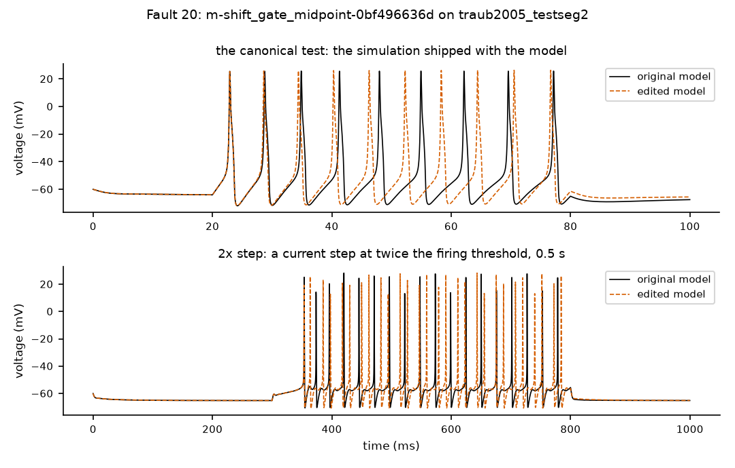
Black: original model. Orange dashed: edited model. Where the lines separate, the behaviour changed.

Your answers for fault 20 (type X) | Yes | No | Unsure | N/A
Q1 Edit matches its label? |  |  |  | –
Q2 Assigned class plausible? |  |  |  | –
Q3 Detection plausible?
Confidence: type X under one | High | Medium | Low | –
Notes (required for any No or Unsure):

Fault 21 of 25
Fault ID | m-shift_gate_midpoint-f1b7d12414
Group | random sample
Model | Migliore et al. 2005 hippocampal CA1 pyramidal cell (soma only) (migliore2005_ca1_soma)
Label (what the edit claims to be) | shift_gate_midpoint: shift the voltage at which one channel gate is half open; shift 10 mV
Severity | strong
Run status | ok
Assigned class | 5_non_equivalent: behaviour changed, and the canonical test caught it
Detected (features) by | P00_canonical, P02_weak_step, P03_rheobase, P04_step_2x, P05_long_step, P06_ramp, P09_short_pulse

The exact change (Question 1)
File: neuroConstruct/generatedNeuroML2/nax.channel.nml
@@ -34,6 +34,6 @@
<gate id="m" type="gateHHratesTau" instances="3">
<q10Settings type="q10ExpTemp" q10Factor="2" experimentalTemp="24 degC"/>
- <forwardRate type="HHExpLinearRate" rate="2.88per_ms" scale="7.2mV" midpoint="-30mV"/>
- <reverseRate type="HHExpLinearRate" rate="0.8928per_ms" scale="-7.2mV" midpoint="-30mV"/>
+ <forwardRate type="HHExpLinearRate" rate="2.88per_ms" scale="7.2mV" midpoint="-20mV"/>
+ <reverseRate type="HHExpLinearRate" rate="0.8928per_ms" scale="-7.2mV" midpoint="-20mV"/>
<timeCourse type="nax_m_tau_tau"/>
</gate>

Evidence (Questions 2 and 3)
Feature differences that exceeded tolerance:
Step | Stimulus | Feature | Original | Edited | Difference | Tolerance
h | P00_canonical | ap_amplitude | 100.1 | 93.24 | 6.9 | 2.003
h | P00_canonical | first_spike_latency | 5.42 | 15.44 | 10.02 | 0.5
h | P00_canonical | last_isi | 18.33 | 30.16 | 11.83 | 0.5
h | P00_canonical | spike_count | 3 | 2 | 1 | 0.5
h | P02_weak_step | steady_state_voltage | -65.02 | -65.99 | 0.9647 | 0.5
h | P03_rheobase | rheobase | 5.806e-4 | 0.002732 | 0.002151 | 6.830e-5
h | P04_step_2x | adaptation_index | 1.248e-5 | – | – | 0.01
h | P04_step_2x | ahp_depth | -14.78 | – | – | 0.7388
h | P04_step_2x | ap_amplitude | 100.5 | – | – | 2.009
h | P04_step_2x | first_spike_latency | 16.07 | – | – | 0.5
h | P04_step_2x | last_isi | 40.06 | – | – | 0.8012
h | P04_step_2x | spike_count | 13 | 0 | 13 | 0.5
h | P05_long_step | adaptation_index | 3.158e-13 | – | – | 0.01
h | P05_long_step | ahp_depth | -15.07 | – | – | 0.7537
h | P05_long_step | ap_amplitude | 100.4 | – | – | 2.008
h | P05_long_step | first_spike_latency | 23.15 | – | – | 0.5
(32 more rows not shown)

Whole-voltage-trace differences that exceeded tolerance:
Step | Stimulus | Measure | Original | Edited | Difference | Tolerance
h | P00_canonical | overall voltage difference (RMS, mV) | 0 | 24.75 | 24.75 | 4.056
h | P00_canonical | spike count | 4 | 2 | 2 | 0.5
h | P02_weak_step | overall voltage difference (RMS, mV) | 0 | 0.8133 | 0.8133 | 0.5
h | P04_step_2x | overall voltage difference (RMS, mV) | 0 | 11.88 | 11.88 | 8.749
h | P04_step_2x | spike count | 13 | 0 | 13 | 0.5
h | P05_long_step | spike count | 39 | 0 | 39 | 0.5
h | P06_ramp | overall voltage difference (RMS, mV) | 0 | 10.77 | 10.77 | 6.268
h | P06_ramp | spike count | 16 | 0 | 16 | 0.5
h | P09_short_pulse | overall voltage difference (RMS, mV) | 0 | 4.607 | 4.607 | 1.226
h | P09_short_pulse | spike count | 1 | 0 | 1 | 0.5
h/2 | P00_canonical | overall voltage difference (RMS, mV) | 0 | 24.74 | 24.74 | 4.056
h/2 | P00_canonical | spike count | 4 | 2 | 2 | 0.5
h/2 | P02_weak_step | overall voltage difference (RMS, mV) | 0 | 0.8133 | 0.8133 | 0.5
h/2 | P04_step_2x | overall voltage difference (RMS, mV) | 0 | 11.84 | 11.84 | 8.749
(6 more rows not shown)

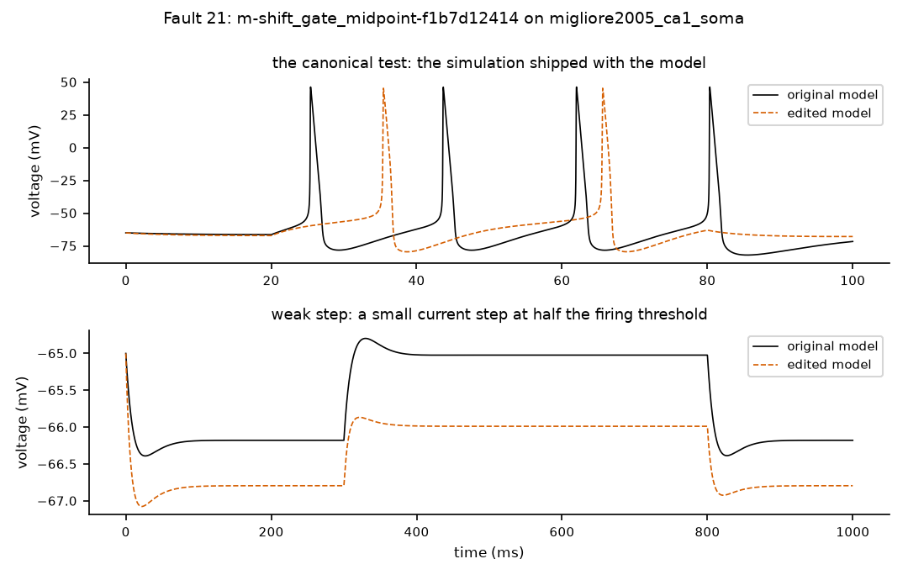
Black: original model. Orange dashed: edited model. Where the lines separate, the behaviour changed.

Your answers for fault 21 (type X) | Yes | No | Unsure | N/A
Q1 Edit matches its label? |  |  |  | –
Q2 Assigned class plausible? |  |  |  | –
Q3 Detection plausible?
Confidence: type X under one | High | Medium | Low | –
Notes (required for any No or Unsure):

Fault 22 of 25
Fault ID | m-shift_reversal-293fd11ac3
Group | random sample
Model | Traub et al. 2005 test cell with almost all channels (traub2005_testseg_all)
Label (what the edit claims to be) | shift_reversal: shift one channel's reversal potential (the voltage its current pushes toward) by a few mV
Severity | mild
Run status | ok
Assigned class | 5_non_equivalent: behaviour changed, and the canonical test caught it
Detected (features) by | P00_canonical, P05_long_step

The exact change (Question 1)
File: neuroConstruct/generatedNeuroML2/TestSeg_all.cell.nml
@@ -123,5 +123,5 @@
<channelDensity condDensity="0.033 mS_per_cm2" id="naf_tcr_all" ionChannel="naf_tcr" ion="na" erev="50.0 mV"/>

- <channelDensity condDensity="0.05 mS_per_cm2" id="nap_all" ionChannel="nap" ion="na" erev="50.0 mV"/>
+ <channelDensity condDensity="0.05 mS_per_cm2" id="nap_all" ionChannel="nap" ion="na" erev="45.0 mV"/>

<channelDensity condDensity="15.0 mS_per_cm2" id="napf_all" ionChannel="napf" ion="na" erev="50.0 mV"/>

Evidence (Questions 2 and 3)
Feature differences that exceeded tolerance:
Step | Stimulus | Feature | Original | Edited | Difference | Tolerance
h | P00_canonical | adaptation_index | 0.5217 | – | – | 0.05217
h | P00_canonical | last_isi | 23.7 | 7.61 | 16.09 | 0.5
h | P00_canonical | spike_count | 4 | 3 | 1 | 0.5
h | P05_long_step | first_spike_latency | 42.89 | 43.83 | 0.94 | 0.8578
h/2 | P00_canonical | adaptation_index | 0.5215 | – | – | 0.05217
h/2 | P00_canonical | last_isi | 23.72 | 7.61 | 16.11 | 0.5
h/2 | P00_canonical | spike_count | 4 | 3 | 1 | 0.5
h/2 | P05_long_step | first_spike_latency | 42.82 | 43.76 | 0.94 | 0.8578

Whole-voltage-trace differences that exceeded tolerance:
Step | Stimulus | Measure | Original | Edited | Difference | Tolerance
h | P00_canonical | overall voltage difference (RMS, mV) | 0 | 13.13 | 13.13 | 1.009
h | P00_canonical | spike timing (largest shift, ms) | – | – | 2.773 | 0.5
h/2 | P00_canonical | overall voltage difference (RMS, mV) | 0 | 13.13 | 13.13 | 1.009
h/2 | P00_canonical | spike timing (largest shift, ms) | – | – | 2.778 | 0.5

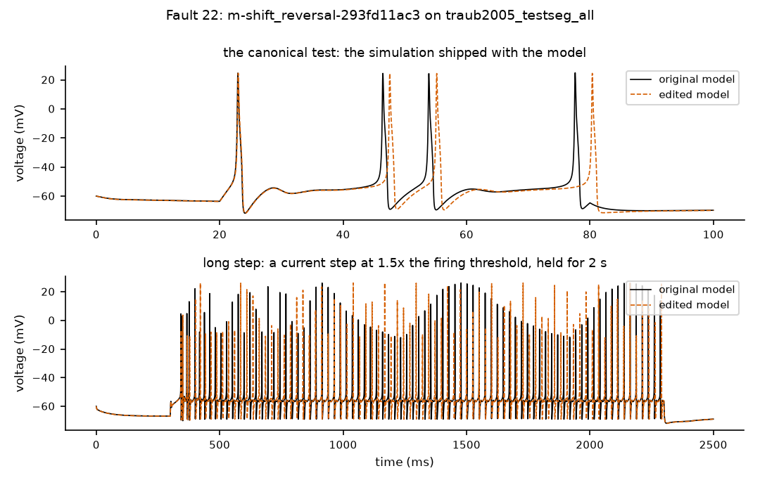
Black: original model. Orange dashed: edited model. Where the lines separate, the behaviour changed.

Your answers for fault 22 (type X) | Yes | No | Unsure | N/A
Q1 Edit matches its label? |  |  |  | –
Q2 Assigned class plausible? |  |  |  | –
Q3 Detection plausible?
Confidence: type X under one | High | Medium | Low | –
Notes (required for any No or Unsure):

Fault 23 of 25
Fault ID | m-solver_config-c16c7918b3
Group | random sample
Model | Blue Brain Project 2015 cortical cell (soma only) (bbp2015_soma)
Label (what the edit claims to be) | solver_config: change the numerical integration method (a numerical stress test)
Severity | not_applicable
Run status | ok
Assigned class | 4_equivalent_within_tested_domain: no reproducible change in any summary feature (behaviour looks unchanged)
Detected (features) by | nothing

The exact change (Question 1)
File: NMC/NeuroML2/LEMS_Soma_AllNML2.xml
@@ -36,4 +36,6 @@
is used to allow validation of this file according to the LEMS schema specified above...-->
<Component type="Simulation" id="sim1" length="600.0ms" step="0.001ms" target="network_Soma_AllNML2">
+
+ <Meta for="jlems" method="eulertree"/>

<Display id="CG_TestMod_v" title="BBP Soma VOLTAGE" xmin="-60.0" xmax="660.0" ymin="-104.0" ymax="64.0" timeScale="1ms">

Evidence (Questions 2 and 3)
No feature differences exceeded tolerance.
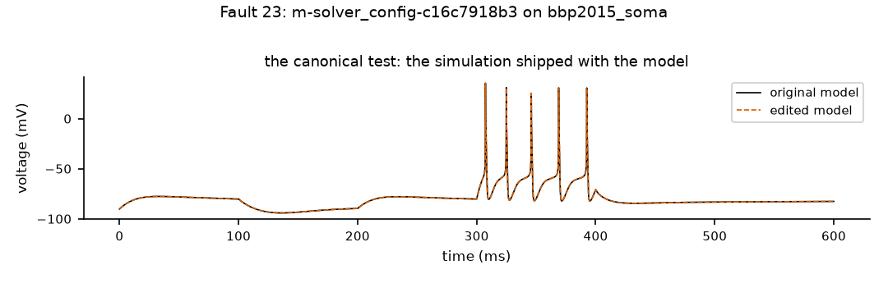
Black: original model. Orange dashed: edited model. Where the lines separate, the behaviour changed.

Your answers for fault 23 (type X) | Yes | No | Unsure | N/A
Q1 Edit matches its label? |  |  |  | –
Q2 Assigned class plausible? |  |  |  | –
Q3 Detection plausible?
Confidence: type X under one | High | Medium | Low | –
Notes (required for any No or Unsure):

Fault 24 of 25
Fault ID | m-wrong_channel-36578b9f51
Group | random sample
Model | Hay et al. 2011 layer-5 pyramidal cell (soma only) (hay2011_soma)
Label (what the edit claims to be) | wrong_channel: point a channel density at a different channel type
Severity | not_applicable
Run status | build_error
Assigned class | 2_non_executable: the edited model would not run
Detected (features) by | nothing

The exact change (Question 1)
File: neuroConstruct/generatedNeuroML2/Soma_AllCML.cell.nml
@@ -89,5 +89,5 @@
<!--Reversal potential for ca in Ca_LVAst will be calculated by Nernst equation from internal & external calcium-->

- <channelDensityNernst condDensity="3.43 mS_per_cm2" id="Ca_LVAst_all" ionChannel="Ca_LVAst" ion="ca"/>
+ <channelDensityNernst condDensity="3.43 mS_per_cm2" id="Ca_LVAst_all" ionChannel="pas" ion="ca"/>

Evidence (Questions 2 and 3)
No feature differences exceeded tolerance.
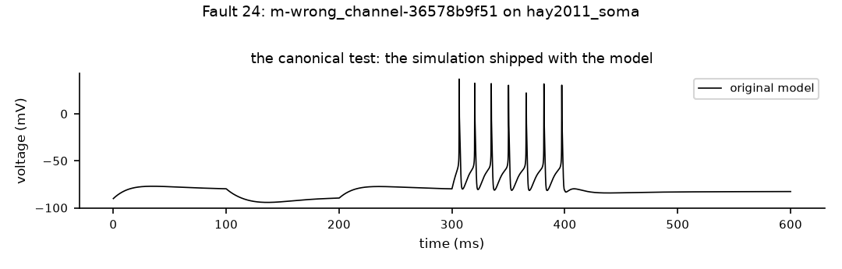
Black: original model. Orange dashed: edited model. Where the lines separate, the behaviour changed.

Your answers for fault 24 (type X) | Yes | No | Unsure | N/A
Q1 Edit matches its label? |  |  |  | –
Q2 Assigned class plausible? |  |  |  | –
Q3 Detection plausible?
Confidence: type X under one | High | Medium | Low | –
Notes (required for any No or Unsure):

Fault 25 of 25
Fault ID | m-wrong_compatible_component-0638e400a0
Group | random sample
Model | Migliore et al. 2005 hippocampal CA1 pyramidal cell (soma only) (migliore2005_ca1_soma)
Label (what the edit claims to be) | wrong_compatible_component: swap a channel for another channel of the same ion
Severity | not_applicable
Run status | numerically_unstable
Assigned class | 3_numerically_unstable: the edited model ran but its numbers blew up
Detected (features) by | nothing

The exact change (Question 1)
File: neuroConstruct/generatedNeuroML2/SomaOnly_allCml.cell.nml
@@ -75,5 +75,5 @@
<channelDensity condDensity="30.0 mS_per_cm2" id="kap_all" ionChannel="kap" ion="k" erev="-90.0 mV"/>

- <channelDensity condDensity="10.0 mS_per_cm2" id="kdr_all" ionChannel="kdr" ion="k" erev="-90.0 mV"/>
+ <channelDensity condDensity="10.0 mS_per_cm2" id="kdr_all" ionChannel="kap" ion="k" erev="-90.0 mV"/>

<channelDensity condDensity="25.0 mS_per_cm2" id="na3_all" ionChannel="na3" ion="na" erev="50.0 mV"/>

Evidence (Questions 2 and 3)
No feature differences exceeded tolerance.
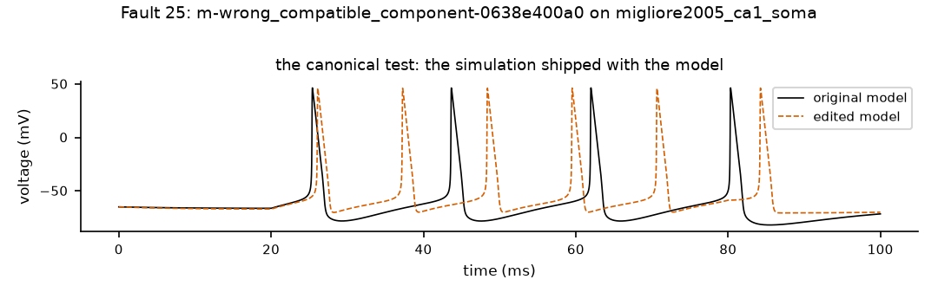
Black: original model. Orange dashed: edited model. Where the lines separate, the behaviour changed.

Your answers for fault 25 (type X) | Yes | No | Unsure | N/A
Q1 Edit matches its label? |  |  |  | –
Q2 Assigned class plausible? |  |  |  | –
Q3 Detection plausible?
Confidence: type X under one | High | Medium | Low | –
Notes (required for any No or Unsure):

