CS1437
Assignment 3 Analysis

Neelima Pandey Srivastava
nsrivastava44@gatch.edu

Abstract- In real life scenarios not all datasets available are well labelled. They are not organized, not labeled, and may contain many features that are not useful. In such situations Unsupervised Learning proves to be a very useful technique to derive useful information from data. Dimensionality reduction techniques help in reducing complexity of data by reducing dimensions to help better visualization and processing. In this assignment I have reported my findings of using these techniques on the Diabetes and Insurance datasets from Assignment 1.

- STEP 1
Unsupervised algorithms on datasets
The two datasets I have used are picked from Assignment 1.
A. Diabetes Data
Data collected by CDC over phone survey asking questions for various health indicators that can impact a person having or not having diabetes. It contains following columns:
- Diabetes_012: 0=no diabetes, 1=prediabetes, 2=diabetes
- HighBP: 0=no, 1=yes
- HighChol: 0=no, 1=yes
- CholCheck(in last 5 years): 0=, 1= yes
- BMI: Body Mass Index
- Smoker(smoked at least 100 cigarettes in life): 0 = no, 1=yes
- Stroke(ever had one): 0 = no, 1 = yes
- HeartDiseaseOrAttack(Coronary heart disease or Myocardinal infarction(MI): 0=no, 1=yes
- PhysicalActivity(in past 30 days): 0=no, 1=yes
- Fruits(1 or more per day): 0 = no, 1 =yes
- Veggies(1 or more per day): 0=no, 1=yes
- HvyAlcoholConsuption(>14 drinks men/ > 7 women): 0=no, 1=yes
- AnyHealthcare: 0=no, 1=yes
- NoDocbcCost(not able to see doctor because of cost): 0=no, 1=yes
- GenHlth(General health on scale of 1-5) 1= excellent, 5 poor
- MentHlth(mental health scale of 1-5)
- DiffWalk(difficulty walking or climbing stairs): 0=no, 1=yes
- Sex: 0=female, 1=male
- Education (scale 1-6 EDUCA): 1 = Never attended school or only kindergarten 2 = Grades 1 through 8 (Elementary) 3 = Grades 9 through 11 (Some high school) 4 = Grade 12 or GED (High school graduate) 5 = College 1 year to 3 years (Some college or technical school) 6 = College 4 years or more (College graduate)
- Age (13 level age category with 5year intervals _AGEG5YR): 1= Age 18-24, 2= Age 25-29, …13= Age 80 and older
- Income (INCOME2 scale 1-8): 1 = less than $10,000 5 = less than $35,000 8 = $75,000

Based on heat map explore the relationship between following set of variables (as they have high correlation)

Expectation Maximization (Gaussian Mixture Model):
Expectation-Maximization or EM algorithm tries to find the parameters of the Gaussian Mixtures from which the given instances are expected to be derived from. Step E makes a guess about the parameters by assigning instances to clusters and step M step updates the cluster parameters.
Sklearn’s Gaussian Mixture class implements the EM algorithm.
Goals for the Gaussian Mixture
- BIC and AIC scores
Both these scores measure how well the EM model fits the data by maximizing the likelihood function.
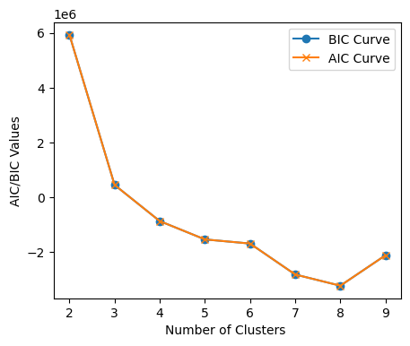
- Using Bayesian Gaussian Mixture Model (BGMM)
This model returns the weights of the clusters after the fit. The weights of unnecessary clusters are returned as zero. The following are weights returned by the BGMM for n_components = 10. The algorithm detected only 7 clusters and returned 0 values for weights for 3 components.

array([0.15, 0.02, 0. , 0.17, 0.54, 0. , 0.07, 0.02, 0. , 0.01])

I selected 7 as the number of clusters to pass to GaussianMixture model for training. BIC and AIC value after the initial rapid decrease become stable at 7.

KModes Clustering Algorithm:
All the variables in the Diabetes dataset are categorical, therefore I chose to use KModes for clustering this dataset. KModes uses mode values or most frequent values within each cluster as the measure of dissimilarity to identify clusters.

Goals for the KModes Clustering
- Elbow method plotting costs: Cost is the sum of all dissimilarities (distances) to their cluster centroids. The lower the cost, better is the clustering. Plotting the cost for k =2,3,4,5,6 gives lowest cost at 5.

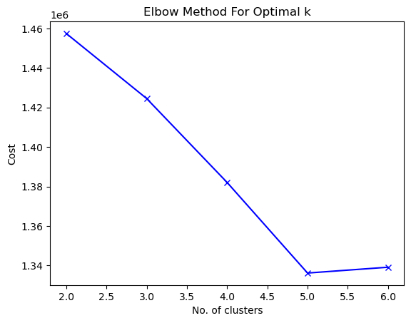
- Silhouette Coefficient: It is the measure of cohesion between data points assigned to the same cluster. For a given cluster C, Silhouette score is calculated as ratio (b-a)/max (a, b) where a is the mean intra-cluster distance for C and b is inter-cluster distance from nearest cluster. For finding Silhouette score for entire dataset for a given cluster, mean is taken over all clusters. 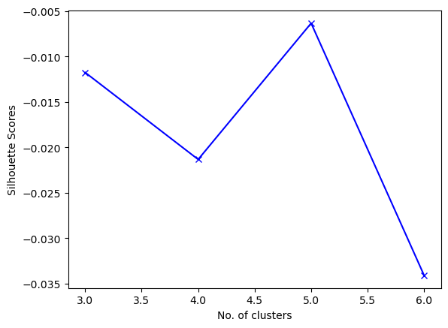A score closer to 1 is considered good clustering as this means greater cohesion between data points assigned to each cluster.

B. Car Insurance Claim Data
Car Insurance dataset contains the historical data of Cars

Goals for the Gaussian Mixture
- BIC and AIC scores
For car insurance data these plots were overlapping and showed a minimum at 11 clusters after which the curves fluctuate between minimum and a higher value.
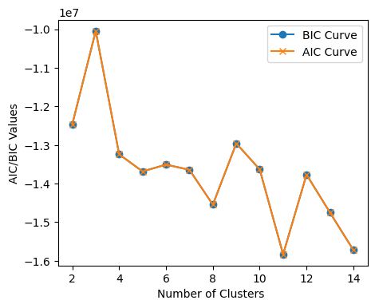

- Running BayesianGaussianMixture for n_components resulted in one cluster having 0 weights and hence.
array([0. , 0.01, 0.05, 0.01, 0.01, 0.02, 0.24, 0.3 , 0.31, 0.01, 0.01, 0.03])

I therefore decided to go with the number of clusters for the Gaussian Mixture to be 11.

II. STEP 2
dimensionality reduction

A. Principal Component Analysis (PCA)

Goals for PCA
- Explained Variance Ratio: It is the measure of proportion of the total variance in the original dataset that is explained by each principal component.

- Eigenvalues of components: Eigenvalue for any component is the measure of variance along its axis. The bigger the eigenvalue, larger is the variance covered by that component and hence it should not be dropped in the dimensionality reduction. It can be best represented by a scree plot as shown in the following figure. X-axis shows the eigenvalue number, Y-axis represents magnitude of each eigenvalue. The higher the magnitude of eigenvalue, the better is its representation of variance.

PCA for DataSet 1 (Diabetes dataset)

- Explained Variance Ratio plot
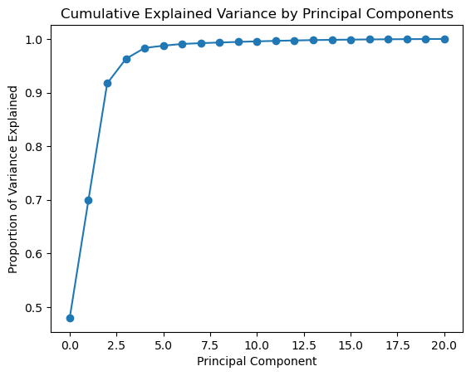
- Scree Plot
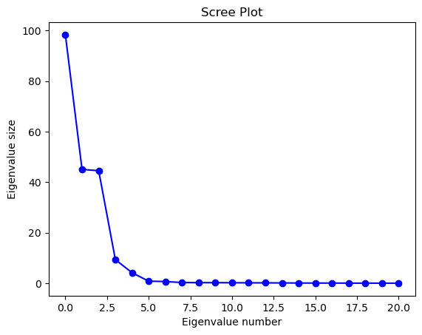

PCA for DataSet 2 (Insurance claim dataset)

- Explained Variance Ratio plot

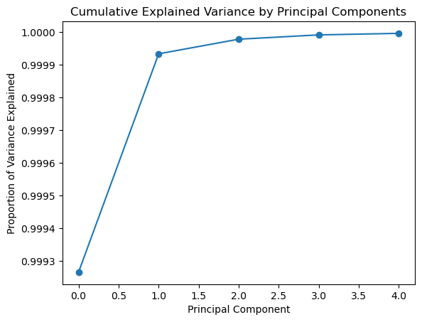
- Scree Plot

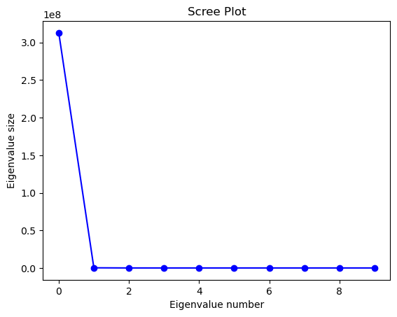

At 5 the magnitude becomes low enough to consider those components.

B. Independent Component Analysis (ICA)
ICA is a technique to find the variables that are independent of each other.

ICA for Diabetes Dataset

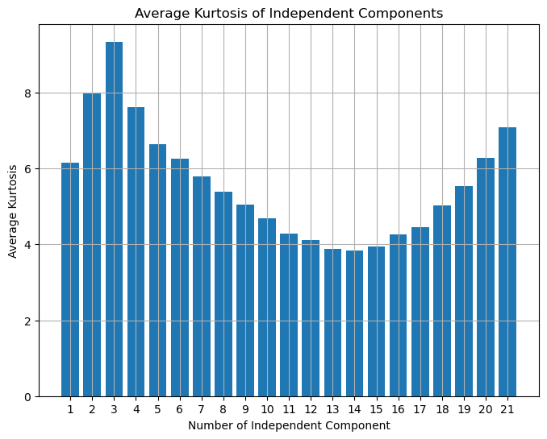

ICA for Insurance Dataset
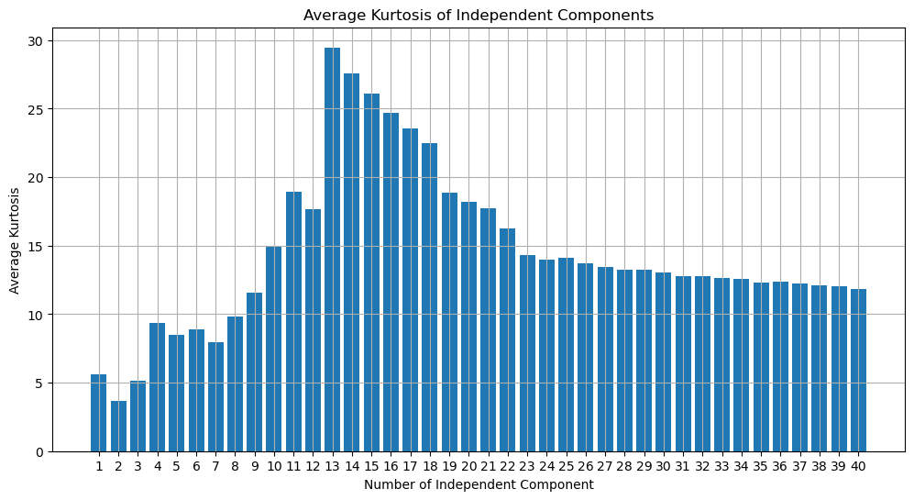

C. Random Projection (RP)
RP is the dimensionality reduction method to project high dimensional data to low dimensional space by using a randomly created projection matrix. Projection matrix R can be calculated through Gaussian distribution or sparse matrix.
For RP, Johnson-Lindenstrauss Lemma is used to identify the minimum number of final dimensions that is needed to ensure acceptable level of pair-wise distance distortion. It determines the size of lower dimensional space based only on number of points in the input space. The number of features in the original dataset is not used.
This DR technique is very useful when the number of features is very high. Following table lists the minimum number of dimensions required for different sample set sizes calculated using the sklearn library’s johnson_lindenstrauss_min_dim method:
Sample Size | Minimum Number of dimensions needed
100 | 110
1500 | 175
15000 | 230
30000 | 247
60000 | 264
120000 | 280
180000 | 290

Diabetes dataset has 183824 instances and 21 features. Insurance dataset has 46873 instances and 40 features. While trying to run RP on both the datasets I get following error:
Target dimension larger than the original dimension.
Even for a small sample size of 100 instances, the number of features that are needed is 110. The number of features I originally have are much small already. Therefore, it does not make sense to use RP any of the two datasets in my case.

D. Manifold Learning (Locally Linear Embedding- LLE)
Manifold Learning is a non-linear DR technique. It is based on the concept that dimensionality of datasets is superficially high. Same results can be obtained using lower dimension data. Lower dimensions in nonlinear space are generated using generalization of linear techniques like PCA.
I have used LLE that works on principle of preserving the linear relationship in vicinity of each data point. Mathematically it means minimizing the distances (sum of differences) between data points and weighted sum k neighboring data points.
Observations with LLE Manifold Learning
- Manifold is sensitive to scale of the features. Running LLE without the any kind of scaling resulted in continuously increasing reconstruction error. I had to run StandardScaler on the dataset, which resulted in reconstruction error to decrease.
- Memory and Computational Requirements: LLE creates a weighted adjacency matrix. For large datasets this is a huge overhead on both the memory and computational resources. Both my datasets had more than 50k instances. For tuning LLE across multiple component number, I had to run them on a subset of these datasets.
- Large number of neighbors was again giving decreasing values of reconstruction errors across different number of components. I was not able to increase the number of neighbors to more than 5.

LLE for Diabetes Dataset
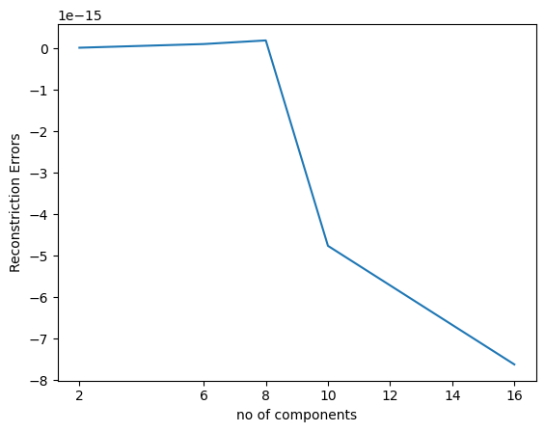

Reconstruction Error drops rapidly until for number of components value between 8 and 10. After that the rate of decrease is less steep. I have used n_components value as 10 to keep computational resources in mind given the size of dataset.

LLE for Insurance Dataset
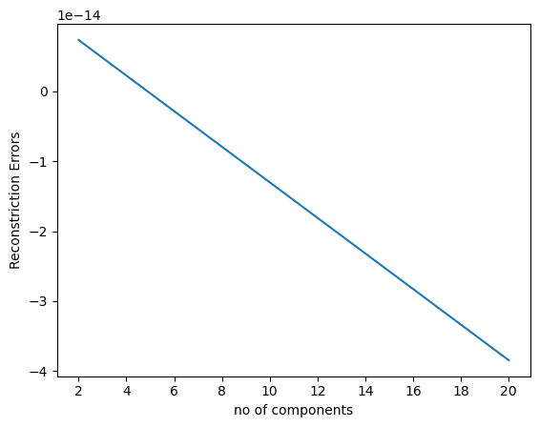
For Insurance dataset, reconstruction error continues to decrease in a linear fashion as the number of components increases.

III. STEP 3
Unsupervised learning on reduced datasets

A. EM on Diabetes data

Dimensionality Reduction | AIC /  BIC Score | BGMM Clusters
None
PCA
ICA
RP | N/A | N/A
Manifold

B. K Modes on Diabetes data
Dimensionality Reduction | Cost | Silhouette Score
None
PCA
ICA
RP | N/A | N/A
Manifold

A. EM on Insurance data
Dimensionality Reduction | AIC /  BIC Score | BGMM Clusters
None
PCA
ICA
RP | N/A | N/A
Manifold

A. K Modes on Diabetes data
Dimensionality Reduction | Cost | Silhouette Score
None
PCA
ICA
RP | N/A | N/A
Manifold

IV. STEP 4
neural network on reduced datasets

A. Diabetes dataset
Dataset | Loss | Prediction Accuracy (F1 Score)
Benchmark (No Dimensionality Reduction)
Linear DR
Non-Linear DR

B. Insurance dataset
Dataset | Loss | Prediction Accuracy (F1 Score)
Benchmark (No Dimensionality Reduction)
Linear DR
Non-Linear DR

A. Benchmark NN Output
B. Linearly Reduced NN Output
A. None Linearly Reduced NN Output

V. STEP
neural network on added unsupervised label features

Diabetes dataset
Dataset | Loss | Prediction Accuracy (F1 Score)
Benchmark (No Dimensionality Reduction)
Linear DR
Non-Linear DR

B. Insurance dataset
Dataset | Loss | Prediction Accuracy (F1 Score)
Benchmark (No Dimensionality Reduction)
Linear DR
Non-Linear DR

Manifold techniques are sensitive to scale. When I tested LLE over the training data, reconstruction was strictly increasing. Also using neighbor count to 10 was giving me a strictly increasing reconstruction plot.
her repare your paper in full-size format, on US letter paper (8.5 x 11 inches). For A4 paper, use the A4 settings. IEEE TPEL has no page limit for regular papers, but accepted papers of 9 pages and above will be subject to overlength page charges. Please note, however, IEEE Transactions on Power Electronics Letters submissions do have a page limit. Letters manuscripts with more than 4 pages will be rejected immediately. Please note, the focus of IEEE Power Electronics Letters is new ideas and specific contributions. While a Letter is expected to include a literature review and to provide sufficient results to prove the validity of the proposed concept, works that require extensive literature review, detailed and long analytical and theoretical steps, and/or extensive experimental verification and validation should be submitted as regular papers to IEEE Transactions.
Type Sizes and Typefaces: Follow the type sizes specified in Table I. As an aid in gauging type size, 1 point is about 0.35 mm. Times New Roman is the preferred font.
1) In formatting your original (8.5 x 11 inch) page, set top margin to 0.75 inch and bottom margin to 1 inch, and left and right margins to 0.625 inch. The column width is 3.5 inches. The space between the two columns is 0.25 inch.
2) A4 Margins: set top margin to 19mm and bottom margin to 43mm, and left and right margins to 13mm. The column width is 88mm. The space between the two columns is 4mm.
Paragraph indentation is 3.5 mm (0.14 in). Left- and right-justify the columns. On the last page of the paper, adjust the lengths of the columns to make them equal. Use automatic hyphenation and spell checking. Digitize or paste down figures.

TABLE I
TYPE SIZES FOR PAPERS

Type  Size  (pts.) | Appearance
Type  Size  (pts.) | Regular | Bold | Italic
6  8  9  10  11  24 | Table captions,ª table superscripts
6  8  9  10  11  24 | Section titles,ª references, tables, table names,ª first letters in table captions,ª figure captions, footnotes, text subscripts, and superscripts
6  8  9  10  11  24 |  | Abstract
6  8  9  10  11  24 | Authors’ affiliations, main text, equations |  | Subheading
6  8  9  10  11  24 | Authors’ names
6  8  9  10  11  24 | Paper title
ªUppercase

II. Additional Requirements

A. Figures and Tables
Position figures and tables at the tops and bottoms of columns. Avoid placing them in the middle of columns. Large figures and tables may span across both columns. Figure captions should be align left below the figures; table captions should be centered above. Avoid placing figures and tables before their first mention in the text. Use the abbreviation “Fig. 1,” even at the beginning of a sentence.
Figure axis labels are often a source of confusion. Use words rather than symbols. For example, write “Current,” or “Current (A)” not just “A”. Put units in parentheses. Do not label axes only with units. In the example, write “Magnetization (A/m)” or “Magnetization (A·m¹).” Do not label axes with a ratio of quantities and units. For example, write “Current (A),” not “Current/A.”
Multipliers can be especially confusing. Write “Magnetization (kA/m)” or “Magnetization (10³ A/m).” Figures labels should be legible, about 10-point type.
B. References
Number reference citations consecutively in square brackets [1]. The sentence punctuation follows the bracket [2]. Refer simply to the reference number, as in [3]. Use “Ref. [1]” or “Reference [1]” at the beginning of a sentence.
Number footnotes separately in superscripts. Place the actual footnote at the bottom of the column in which it is cited. Do not put footnotes in the reference list. Use letters for table footnotes (see Table I). IEEE Transactions no longer use a journal prefix before the volume number. For example, use “IEEE Trans. Magn., vol. 25,” not “vol. MAG-25.”
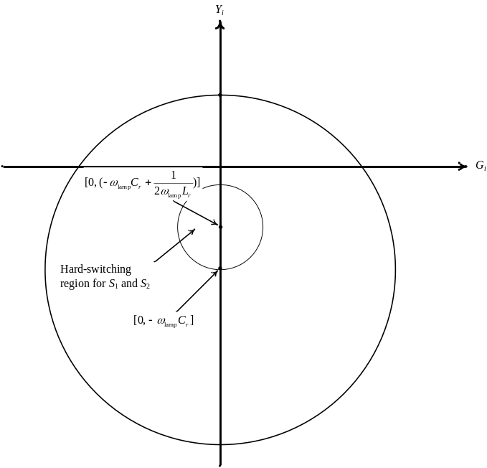
Fig. 1 Hard-switching region. (align left). Captions should be placed in text boxes. Note that “Fig.” is abbreviated and there is a period after the figure number followed by two spaces. It is good practice to explain the significance of the figure in the caption.
Give all authors’ names; use “et al.” if there are six authors or more. Papers that have not been published, even if they have been submitted for publication, should be cited as “unpublished.” Papers that have been accepted for publication should be cited as “in press.” In a paper title, capitalize the first word and all other words except for conjunctions, prepositions less than seven letters, and prepositional phrases.
For papers published in translated journals, first give the English citation, then the original foreign-language citation.

C. Abbreviations and Acronyms
Define abbreviations and acronyms the first time they are used in the text, even if they have been defined in the abstract. Abbreviations such as IEEE, SI, MKS, CGS, ac, dc, and rms do not have to be defined. Do not use abbreviations in the title unless they are unavoidable.

D. Equations
Number equations consecutively with equation numbers in parentheses flush with the right margin, as in (1). To make your equations more compact, you may use the solidus ( / ), the exp function, or appropriate exponents. Italicize Roman symbols for quantities and variables, but not Greek symbols. Use an en dash (–) rather than a hyphen for a minus sign. Use parentheses to avoid ambiguities in denominators. Punctuate equations with commas or periods when they are part of a sentence, as in
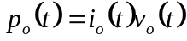. (1)

Symbols in your equation should be defined before the equation appears or immediately following. Use “(1),” DO NOT use “Eq. (1)” or “equation (1),” except at the beginning of a sentence: “Equation (1) is …”

E. Other Recommendations
The Roman numerals used to number the section headings are optional. If you do use them do not number ACKNOWLEDGMENT and REFERENCES, and begin Subheadings with letters. Use two spaces after periods (full stops). Hyphenate complex modifiers: “zero-field-cooled magnetization.” Avoid dangling participles, such as, “Using (1), the potential was calculated.” Write instead, “The potential was calculated using (1).”
Use a zero before decimal points: “0.25,” not “.25.” Use “cm³,” not “cc.” Do not mix complete spellings and abbreviations of units: “Wb/m²” or “webers per square meter,” not “webers/m².” Spell units when they appear in the text: “…a few henries,” not “…a few H.” If your native language is not English, try to get a native English-speaking colleague to proofread your paper.

III. Units

Metric units are preferred for use in IEEE publications. British units may be used as secondary units (in parentheses). An exception would be the use of British units as identifiers in trade, such as “3.5-inch disk drive.”
Avoid combining SI and CGS units, such as current in amperes and magnetic field in oersteds. This often leads to confusion because equations do not balance dimensionally. If you must use mixed units, clearly state the units for each quantity that you use in an equation.

Appendix

Appendixes, if needed, appear before the acknowledgment.

Acknowledgment
The preferred spelling of the word “acknowledgment” in American English is without an “e” after the “g.” Use the singular heading even if you have many acknowledgments. Avoid expressions such as “One of us (S.B.A.) would like to thank . . . ” Instead, write “F. A. Author thanks . . . .” In most cases, sponsor and financial support acknowledgments are placed in the unnumbered footnote on the first page, not here.

References

[1] G. Dawson and I. N. Chan, “A modified zero-voltage-switching flyback converter,” IEEE Trans. Power Electron., vol. 9, no. 2, pp. 129-135, Apr 1994.
[2] Y. Zhi, T. Kaynak, and W. Zhang, “Modified maximum power point tracking technique for wind energy application,” IEEE Trans. Power Electron., vol. 27, no. 7, pp. 3023-3027, Jul 2012.
[3] F. Zhang, “A new high power factor AC-AC inverter,” IEEE Power Electron. Lett., vol. 1, no. 5, pp. 10–13, Mar. 2000.

